BEXIS 2.12.1

Visualization Module

User Guide

Authors

Nafiseh Navabpour, Roman Gerlach

Contact

Website: <http://bexis2.uni-jena.de>

Email: bexis-support@uni-jena.de

Phone: +49-(0)3641-948968

Acknowledgement

The development of the BEXIS 2 software would not be possible without the German Research Foundation (DFG) funding the BEXIS++ project. BEXIS++ is a collaboration of the Friedrich-Schiller-University Jena (Dept. of Computer Science, Dept. for Geography), the Max-Planck-Institute for Biogeochemistry Jena, the Technical University Munich (Dept. Ecology and Ecosystem Management), the Gesellschaft für wissenschaftliche Datenverarbeitung mbH Göttingen (GWDG), and the Georg-August-University Göttingen.

Content

1. Overview 3

2. Select Ranges 3

2.1. Select category 3

2.2. Select Time 4

2.3. Time Slider 5

# 1. Overview

Visualization or in other words the visual representation of data in an easily comprehensible form is the feature of the visualization module for BEXIS2. User of BEXIS2 is able to get a quick overview of the system behavior with looking at diagrams. Visualization is accessible through setup in the main menu.

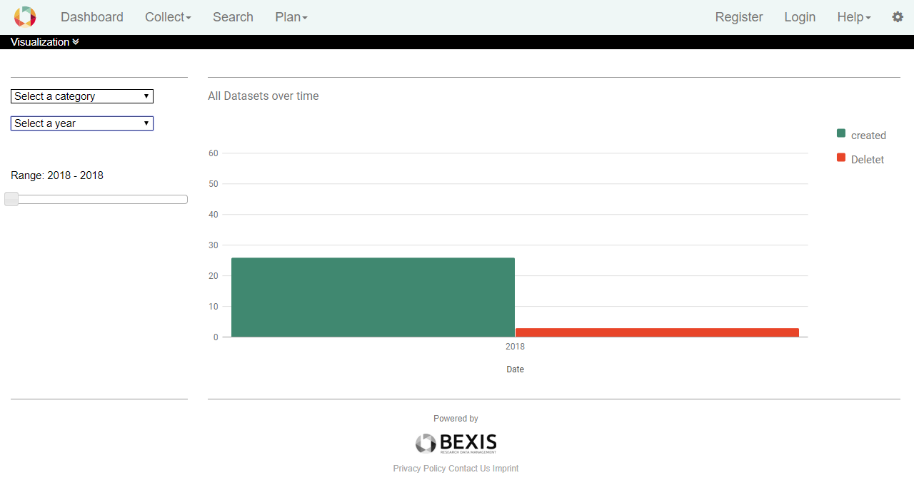

# 2. Select Ranges

Visualization provides histograms depend on the selected ranges in different dropdown lists or sliders. There are two different lists to control the diagram. One is to select a category, means the kind of data such as created or deleted datasets and one is to select a special year. A time slider helps user to restrict time.

## 2.1. Select category

On the first view, when the selector shows “Select a category”, you can see a histogram with data of created and deleted datasets. The current version of the BEXIS2 makes you able to see the statistic of system activities, created datasets and deleted datasets over time.

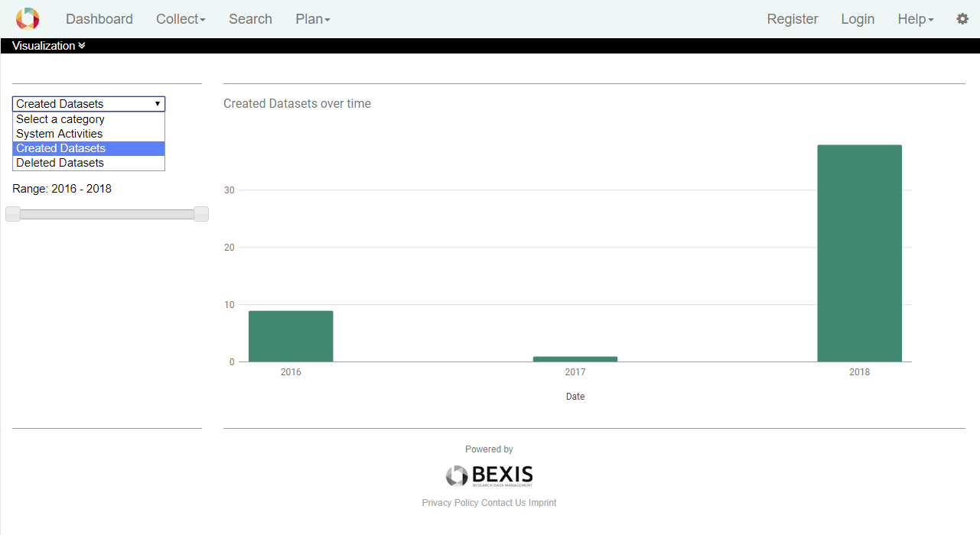

## 2.2. Select Time

In the drop-down "Select a year”, you can find the list of years. By default, the chart displays the data distribution over the entire time from the first dataset creation.

Select a specific year shows the statistic for only that year, separated in twelve months.

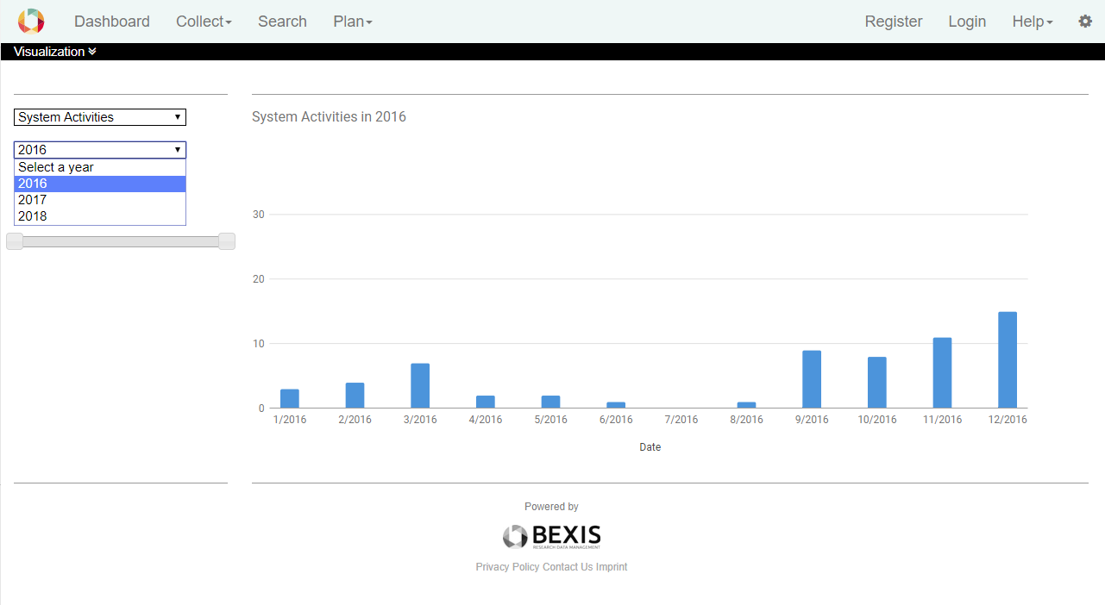

## 2.3. Time Slider

If you do not like to see all data behaviour from the first activity to the end, you can select a period by the help of the time slider.

