ECE-111 Advanced Digital Design Projects
Homework-3a:
Develop SystemVerilog RTL model for 4-bit Johnson Counter and perform following mentioned :
- Synthesize Johnson counter
- Run simulation using Johnson counter testbench provided
- Review synthesis results (resource usage and RTL netlist/schematic)
  - Note : Explanation of resource usage in report is not mandatory to provide.
- Review input and output signals in simulation waveform.
About Johnson Counter :
- Similar to Straight Ring counter with below mentioned difference
- Johnson counter connects the complement of the output of the last shift register to the input of the first register and circulates a stream of ones followed by zeros around the ring
- Johnson Counter has 2N states (if N is 4, then total states for counting is 8. And 4-bit pattern will repeat after 8 cycles).
4-bit Johnson Counter with initial load count value = 4’b0000

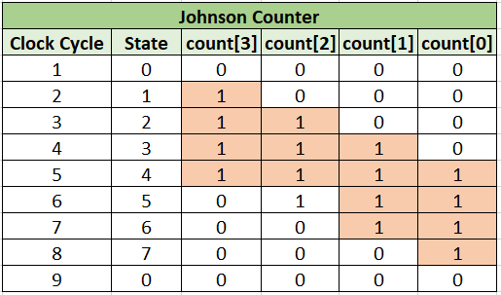

4-bit pattern repeats every 8 cycles

HW-3b:
Report the output sequence if we preload with one of the 8 remaining states not covered by preloading with 0000.

Homework Submission :
Submit report (PDF file) which should include:
- Snippet of SystemVerilog design code
- RTL netlist viewer schematic and Synthesis resource usage
  - Optional: Resource usage explanation and post mapping schematic
- Simulation snapshot and explain simulation result to confirm it works as a Johnson counter
- For part 3-b, the sequence of count[3:0] values, in binary.

Note:
- When creating RTL model for Johnson Counter, name SystemVerilog Module name as : johnson_counter

- Assume below mentioned Primary Ports for Johnson Counter
  - Input clk (clock)
  - Input clear (asynchronous reset / negedge signal)
  - Input preset (synchronous and active low signal)
  - Input load_cnt (value gets loaded when !preset)
  - Output count (output count value)

Johnson Counter
clk
clear
count[0]
count[1]
count[2]
count[3]
preset
load_cnt

4-bit pattern repeats every 8 cycles

Lab3.zip folder posted on Piazza and Canvas has johnson_counter_testbench.sv testbench code to simulate with johnson counter SystemVerilog module.
Note :
- 3-a: Assume initial load_cnt signal value is set to 4’b0000 in testbench code provided.
- 3-b: Students update johnson_counter_testbench.sv code for initial load_cnt value !0.

