ECE-111 Advanced Digital Design Projects
Develop a parameterized SystemVerilog RTL model for N-bit Linear Feedback Shift Register (LFSR) :
- N is a parameter and the design should support the following values of N: 2,3,4,5,6,7,8
- In the same SystemVerilog module implement a max-length LSFR pseudo-random generation polynomial to support each of the above mentioned all N values. Details about LFSR given in the section titles “About LFSR” below
- Use XOR implementation for LFSR SystemVerilog RTL model development
- Synthesize LFSR and run simulation using LSFR testbench provided
- Testbench is provided for 4-bit LSFR. In testbench file parameter N can be set to values between 2 and 8 (both inclusive)
- Review synthesis results (resource usage and RTL netlist/schematic) for N=4
- Review input and output signals in simulation waveform for N=4 and N=7.
- NOTE: The checker in the provided test bench automatically tests any case for N= 2 to 8, inclusive. Make sure your design works properly in all 7 cases.
About LFSR :
- LFSR is a n-bit counter exhibiting pseudo-random behavior.
  - Random numbers from LSFR are generated based on initial values loaded to LFSR (known as a seed value)
  - For each initial seed value there is a deterministic repeating pattern of counting
  - It requires much less hardware than a conventional ripple adder counter
  - Built from simple shift-registers with a small number of xor gates.
    - N-bit LSFR would require N of flip-flops
    - maximal length N-bit LSFR will generate deterministic repeating sequence of 2^{N}-1 data patterns

- An LFSR is type of a shift register which performs following mentioned steps:
  - Does exclusive-or (xor or xnor) of bits at given tap positions in shift register
  - Shifts the bits one position to the left
  - Replaces the vacated bit with the output of exclusive-or (xor) function

- The LFSR is maximal-length if and only if the corresponding feedback polynomial is primitive. This means that the following conditions are necessary (but not sufficient):
  - The number of taps selected for parity feedback is even
  - The set of taps is setwise co-prime. i.e., there must be no divisor other than 1 common to all taps.

- For part 1, table of primitive polynomials from which maximum-length LFSRs can be constructed are given below and in the references. (This is a partial table. For example there are 6 feedback polynomial options which make a 6-tap LFSR into a maximal length device.)
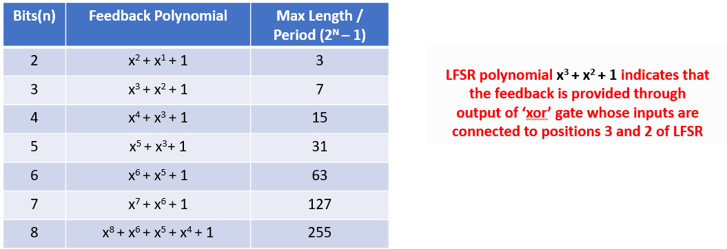
(Table. 1)
- Example of 4-bit LFSR pseudo random generation:
  - Circuit counts through (2⁴-1)=15 different non-zero bit patterns.
  - Polynomial for maximum-length 4-bit LSFR is : x⁴ + x³ + 1
  - To implement this polynomial, output of FF4 and FF3 are taped and exclusive-or using its current values before left-shifting
  - LSB bits 0 to 2 are left-sifted by one position
  - Vacated LSB bit-0 is replaced with output of exclusive-or

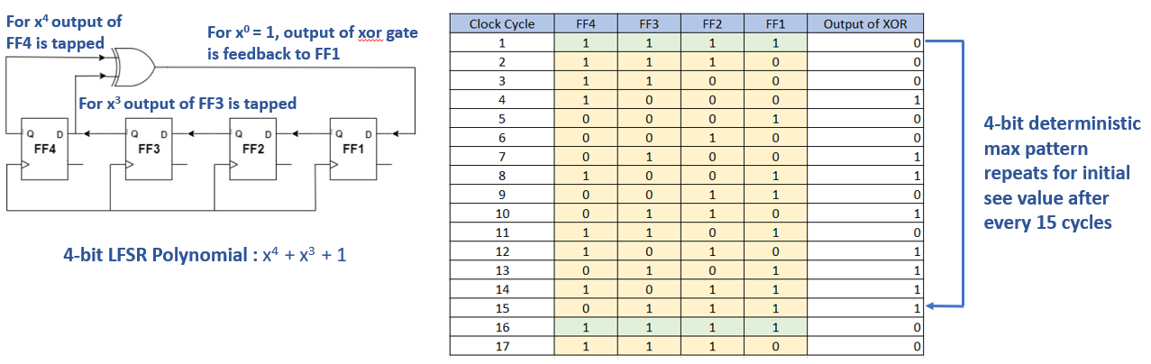

Homework Submission :
Submit report (PDF file) which should include:
- Verify brief project description
- Synthesis resource usage and schematic generated from RTL netlist viewer for N=4
- Simulation snapshot and explain simulation result to confirm it works as a LFSR
  - End-of-run portion of simulation snapshot should be presented for N=4 and N=7.)
    - We reserve the right to test your work for any N = [2, 3, … , 8]
  - This test bench includes a checker which displays “SUCCESS!!” if it worked properly
- As always, submit all of your SystemVerilog code, including the exact test bench you used.
Note:
- Part 1: When creating RTL model for LFSR, name SystemVerilog Module name as : lfsr

- Assume below mentioned Primary Ports for lfsr
  - Input clk (clock)
  - Input reset (synchronous reset / active low)
    - Resets tap pattern to the default value (table 1)
    - Resets starting value and lfsr_data to all 1s
  - Input[1:0] load (synchronous / active high) either starting value or LFSR tap pattern
    - load[1] for starting value
    - load[0] for tap pattern
  - Input seed_mask (initial LFSR value or tap pattern, depending on load)
  - Output lfsr_data (parallel output of all Flipflops of shift register)
  - Output lfsr_done (once N-bit battern generation is completed and lfsr_data = seed_data, lfsr_done goes high for one clock cycle

LFSR
clk
reset_n
lfsr_data[0]
lfsr_data[1]
….
lfsr_data[N]
load_seed
seed_data[N-1 :0]
lfsr_done

4-bit pattern repeats every 8 cycles

Lab5 folder on Canvas has lfsr_testbench.sv testbench code to simulate the lfsr SystemVerilog module. It also has lsfr.sv starter file with primary port list. Students will add implementation of lfsr code.
Assume initial seed_data value is set to 4’b1111, as in testbench code provided, but your design should work for any arbitrary non-zero seed. Students can update lfsr_testbench.sv code to change parameter N value. Test all 7 scenarios for LFSR length (N= 2, …, 8) and various seed values, but you need submit only N=4 and N=7 simulation results, and N=4 synthesis results, as mentioned above. Note that the test bench will test your work by printing “SUCCESS” if you return to the seed value at the appropriate time.
Part 1 writeup:
1. Show proof of simulation success for each N = 2, 3, …, 8
2. Summarize logic synthesis results for N = 6, including resource utilization, netlist (Playground) or RTL viewer, and clock rate.

Part 2 -- Going further, for insight:
Experiment with different feedback polynomials and starting values. Any nonzero starting value should work, but only a small subset of possible feedback polynomials will yield a maximal length sequence that walks through all 2**N-1 possible nonzero state values.

Writeup:
This table lists the number of maximal length tap feedback patterns for each length of LFSR from 2 though 8. For each length, fill in the feedback polynomials themsleves. We have given you a start in part 1, with one feedback polynomial for each length N= 2, 3, …, 8.

