ECE-111 Advanced Digital Designs
Homework-6a:
Develop SystemVerilog RTL model for N-bit gray-code to binary value conversion:
- Simulation: Use testbench provided and write code that works for any value of N. Set N=16 for simulation.
- Review input and output signals in simulation waveform.
- Synthesis: Set N=16 and report resource usage, RTL netlist/schematic, clock rate (if using Quartus)
About Gray Code and Conversion to Binary Value :
- Gray code named after Frank Gray, is an ordering of the binary numeral system such that two successive numbers differ in only one bit
  - Gray code was originally designed to prevent spurious output from electromechanical switches
  - Gray codes are widely used to facilitate error correction in digital communication applications, also for “gas gauges” in asynchronous FIFOs, and to minimize switching “glitches” in digital-to-analog converters
- Gray code to Binary Value Conversion
  - MSB of the binary code is always equal to the MSB of the given binary number.
  - Other bits of the output binary value can be obtained by XORing gray code bit at that index and binary bit at next index.
  - Use below mentioned 4-bit Gray code to Binary conversion equation, circuit and truth table as a reference for SystemVerilog code development.

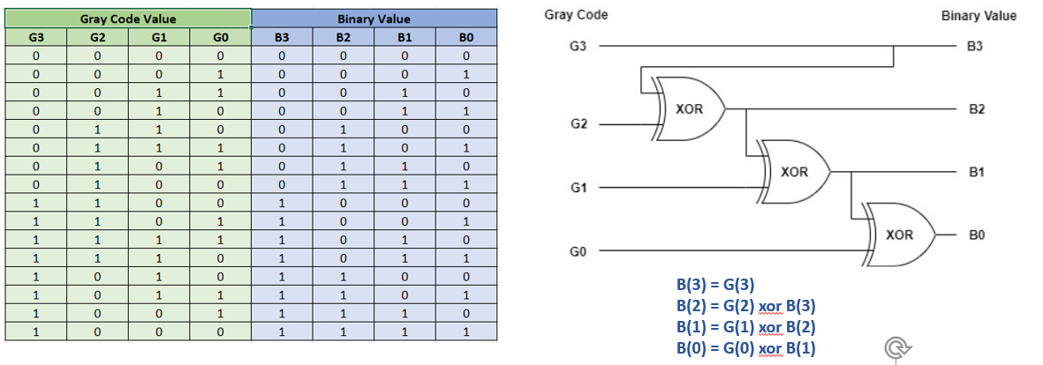
Note :
When simulating gray to binary code, ensure binary values for given gray code in waveform is reflected as per the truth table above.

When creating RTL model for gray code to binary value conversion, name SystemVerilog Module name as : gray_code_to_binary_convertor
Assume below mentioned Primary Ports for gray_code_to_binary_convertor
- Input clk (clock): input and output should be registered. (That way we can get a timing estimate.)
- Input rstn (asynchronous reset / negedge signal)
- Input gray_value (N-bit input gray code signal)
- Output binary_value (N-bit output converted binary value signal)

gray_code_to_binary_convertor
clk
rstn
gray_value[N-1 :0]
binary_value[N-1:0]

Note : Testbench for gray_code_to_binary_convertor and empty RTL module with primary ports for design is provided in Lab6/gray_code_to_binary_convertor folder.

Homework-6b:
Develop SystemVerilog RTL model for N-bit Carry Lookahead Adder(CLA):
- Synthesize code (N=4, N=32) and simulate using testbench provided (N=32)
- Carry Lookahead adder requires fulladder logic module. Full adder systemverilog code is provided in labs folder.
- Testbench is provided for N-bit carry lookahead adder
- Review synthesis results (resource usage and RTL netlist/schematic) for 4-bit & 32-bit CLA
- Review input and output signals in simulation waveform.
Carry Look Ahead Adder :
- A Carry lookahead Adder is made of a number of full adders cascaded together.
- Carry lookahead adder is similar to ripple carry adder with the difference that it calculates the carry bit before the full adder is done with its operation.
- Advantage of carry lookahead adders is that they add two numbers faster than ripple carry adders.
- The drawback is that carry lookahead adders takes more logic.
- For faster performance when adding two number select carry lookahead adder implementation and for more lower resource usage select ripple carry adder implementation
- The figure below shows 4 full-adders connected together to produce a 4-bit lookahead carry adder.

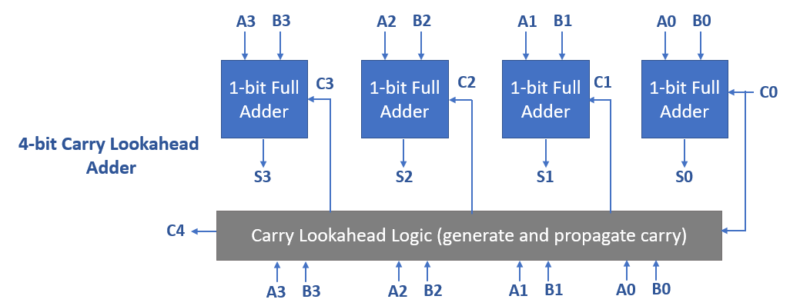

By pre-computing the carry equation, addition of input values can be generated faster. Below mentioned equations can be used to compute carryout.
- Generate Carry G(i) = A(i).B(i)
- Propagate Carry P(i) = A(i) + B(i) (called "propagate carry")
- Carry out C(i+1) = G(i) + P(i).C(i)
Note: In SystemVerilog code, above mentioned G, P and C formulas should be implemented for Carry generation which represents the gray box in above mentioned diagram.
For each stage of full adder, Carryout can be computed independently (no ripple) using G(i), P(i) and C(i+1) formulas.
For example, for 4-bit carry lookahead adder, lets compute carryout from first stage of A0 and B0 addition :
- G(0) = A(0). B(0)
- P(0) = A(0) + B(0)
- C(1) = G(0) + P(0).C(0) (Note : C(0) is Carryin to first stage fulladder)
- Further replacing G(0) and P(0) in C(1) equation we can get :
  - C(1) = (A(0). B(0)) + (A(0) + B(0)).C(0)
  - Note : Carryout, C(1) is dependent on A0, B0, C0 (same as Cin) values which are known upfront. Hence as the first stage full adder is adding A0 and B0, Carryout can be generated simultaneously using above mentioned equation.
Similary, C(2), C(3), C(4) formulas can be created which would be function of known values of A, B and Cin inputs.

Refer to youtube video on CarryLook Ahead Adder for further understanding :
- https://youtu.be/6kTdgkbYZqA

When creating RTL model for carry lookahead adder, name SystemVerilog Module name as : carry_lookahead_adder
Assume below mentioned Primary Ports for carry_look_ahead_adder
- Inputs A and B (these are values to be added using carry look ahead adder logic)
- Input CIN (carryin to first stage of fulladder instance in carry look ahead adder)
- Output result (result of A[N-1:0] + B[N-1:0] + CIN)
  - Note: Output signal result MSB bit includes final stage fulladder carryout

carry_lookahead_adder
A[N-1:0]
B[N-1:0]
CIN
result[N:0]

Note : Testbench for carry_lookahead_adder and empty RTL module with primary ports for design is provided in Lab6/carry_lookahead_adder folder.

Homework-6c:
Develop SystemVerilog RTL model for Clock divided by N
- Synthesize code and run simulation using testbench provided (N=4)
- Testbench is provided for clock divided by 4
- Review synthesis results (resource usage and RTL netlist/schematic)
- Review input and output signals in simulation waveform.
See below reference snapshot for expected output clkout signal.
Note : in diagram below (example for N=3) clkout signal period is 3 times clkin signal period.
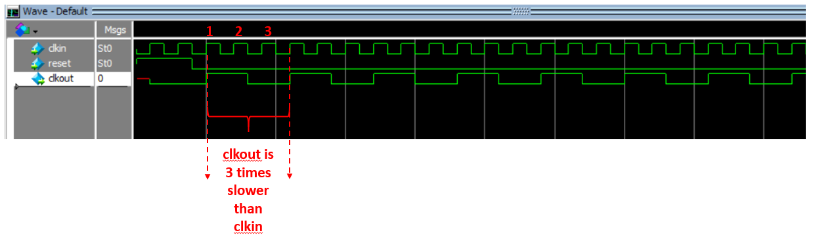
Assume below mentioned Primary Ports for clock_divide_by_N:
- Input clkin (input faster clock which needs to be divided)
- Input reset (synchronous reset and high reset)
- Output clkout (N times divided clkout signal)

clock_divide_by_N
clkin
reset
clkout

Note : Testbench for clock_divide_by_N is provided in Lab6 folder.

Homework Submission :
Final report (PDF file) which should include:
- SystemVerilog design and testbench code
- Synthesis resource usage and schematic generated from RTL netlist viewer
- Simulation snapshot and explain simulation result to confirm :
  - correct conversion of binary to gray code conversion
  - correct behavior of carry lookahead adder
  - clock divided by N
- Resource usage explanation and post mapping schematic are optional to submit.

Note:
- In same PDF report, all three homework solutions (6a, 6b and 6c) can be submitted

