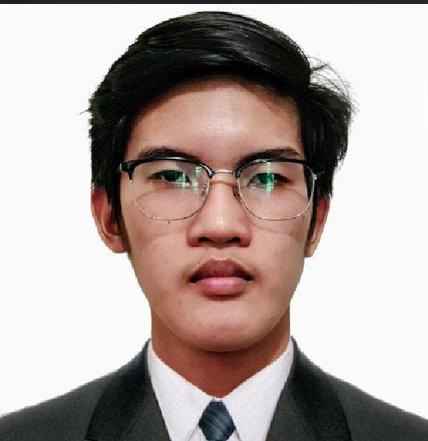

candido.davidbryanb@gmail.com

DAVID BRYAN B. CANDIDO

#148B Murphy St. New Kalalake Olongapo City, Zambales, 2200

(+63) 993-579-1335

**PERSONAL DATA**

DATE OF BIRTH:

PLACE OF BIRTH:

AGE:

HEIGHT:

WEIGHT:

SEX:

CIVIL STATUS:

CITIZENSHIP:

RELIGION:

LANGUAGES:

FATHER’S NAME:

MOTHER’S NAME:

March 29, 2002

Norzagaray Bulacan

23

5’8

60

Male

Single

Filipino

Catholic

Tagalog, English

Eutiquio Candido

Conchita Candido

**PROFESSIONAL SUMMARY**

Motivated IT student with skills in programming, web development, and multimedia. Eager to apply knowledge through collaborative and meaningful projects.

**EDUCATIONAL BACKGROUND**

2020 - Current

**Bachelor of Science in Information Technology**

Gordon College – Sports Complex, Donor St., East Tapinac, Olongapo City

2018 - 2020

**Senior High School - Diploma**

Mondriaan Aura College – Subic Bay Freeport Zone

2014 - 2018

**Junior High School - Diploma**

Kalalake National High School – 14th Street, New Kalalake, Olongapo, Zambales

**TECHNICAL SKILLS**

* **Programming Languages**: C#, Java, PHP, HTML, CSS
* **Frameworks & Tools:** React Native, Laravel
* **Multimedia & Design:** Photoshop, Filmora
* **Office Software:** Microsoft Word, PowerPoint