

Dark ages: Zulphier

A RTS City builder by David C



April 13, 2023

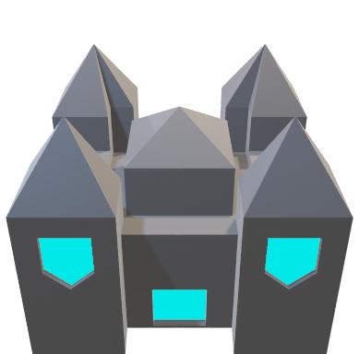

About Zulphier?

Zulpheir is a single player real time strategy city builder. This game was created as a capstone project for a class and is a steppingstone for another game called Stronghold 2 Red Steel. This game is to help understand how to utilize tiles in a tile-based game so that this can be transferred to SH2’s overworld.

# Inspirations

A list of games that has inspired this game.

## Master of Monsters – Saga Genesis

Master of Monsters is a turn-based strategy game where you play as a Master who must defeat their opponents to take place as King of the Monsters. This game inspired the Dungeon aspect of the game mostly the conquering of towers to gain more mana to summon or cast spells against your opponent.

## Dwarf Fortress – PC

Dwarf Fortress is a Fantasy City Builder famous for its complex intricacies that also curses it with infamy for its steep learning curve. This game inspired the people aspect of the game where each person within the game world is their own individual.

## The Battle for Polytopia – Mobile, PC

The Battle for Polytopia is a turn-based conquest game where you and your opponent’s fight to conquer each other to be the last on the board. This game inspired the building aspect of the game.

## Unknown Game – Saga Genesis

This game that I forgot the name of nor can I find was an action platformer / city management game where you play as a god who must protect their village from monsters. With the village comes great powers that can enhanced the god who must travel the dangerous land to vanquish the evil that lurks through the world. This game has heavily inspired this game as most mechanics can be traced back here for the most part.

Lore

# Story

On the plane of Daomos, a great evil came fourth form the depths of the sky’s black curtain. This evil raised monster and corrupted the life anywhere it had dungeon in its grand destructive aura. The land once peaceful now torn apart like an autumn tree and its leaves. This chaotic mass of spectral malice had no end to its burning blood lust. From the ashes of the few surviving kingdoms, they united to vanquish this dark tyrant once and for all. Together they created Champions matching a god and with these champions imprisoned the mass into the core of their plane. Milina has passed since this event; scholars have lost the records for such things and remnants have since been overtaken by the earth or other living things. Though sights of dark structures have appeared around the plane secreting a dark presence from within its gaping entrance.

Gameplay

In Zephier the player must conquer their dungeon to expand their territory. To conquer a dungeon the player must make a team of heroes to venture int the depths of the dungeon beating bosses and enemies getting knowledge, resources, and prisoners back from the dungeons into your towns. To get heroes, you must get people and to get people you must have an economy. To develop an economy, you must use your starting people to create jobs like fishing, mining, farming, and resource gathering. Migrants will come to take refuge within your town and from there your town will grow. Now to make heroes you train a militia and from the militia you select 4 who will venture into the depths of the dungeon.

The game revolves around the player managing resources and building effectively to last long enough to create a party of heroes to beat the dungeon winning a game. These systems will be discussed further into the document as there is a lot about the system that can’t be condensed into a single or 3 pages.

1. Resources
2. Tiles
3. Buildings

Gameplay - Resources

Resources are what the player must collect to do anything within the world. Effective use of resources will make the game easier and allow for more dynamic towns. There are 5 resources in the game that the player must keep an eye on.

1. Money
2. Population
3. Wood
4. Food
5. Minerals

As of right now money and food serve no purpose as I’m trying to figure out what to do with them.

# Population

Population is how many people are inside of your small settlement. You can assign people to do jobs that will produce resources or send them to the dungeon to gather loot. In the future people will be used to convert tiles and build.

# Wood & Minerals

These resources are used in construction such as houses, roads, and later equipment.

Gameplay- Tiles

Tiles are the board of the world. Being able to have buildings and make up the landscape around. The are three types of tiles in the game, that are being generated, player made, and others. Each has a specific use in the game.

The Future of Zulpheir

# Road Map

## The People Update

This will add people into the game with their own stats, inventory, and names. This will also introduce migrant waves to the game.

## The Nations Update

This will add selectable nations to the game that will add special new people, buildings, and tiles to change how the player interacts with the world.

## The Invasion Update

This will add invasions to the game where hordes of monsters come and try to destroy your settlement, this will also add new buildings such as towers, walls, and other defensive buildings.