Cicada -- Voice-Driven UxS Command and Control
What It Is
Cicada is a full-stack, voice-controlled drone command and control system built during a Voice-Driven UxS Hackathon. An operator speaks natural-language commands (e.g., "Take Alpha to the barracks, then investigate the containers, then land"), and the system transcribes the speech, parses the operator's intent using an LLM, enforces hard safety rules, plans obstacle-free routes, and executes validated commands on simulated drone hardware -- all in real time.
The project targets a military compound operations scenario: a walled compound with watch towers, barracks, a motor pool, fuel depot, comms tower, and shipping containers, simulated in Gazebo Harmonic with ArduPilot SITL running the actual flight controller firmware.

Architecture (End-to-End Pipeline)
The system is a three-layer pipeline: Voice -> Parser + Safety Engine -> Drone Interface + UI.
flowchart TD
A["Operator (Voice)"] --> B["Browser UI"]
B -->|"POST /api/command"| C["Flask Backend (Python)"]
C --> D["faster-whisper (on-device STT)"]
D --> E["Groq LLM llama-3.3-70b"]
E --> F["Intent Parser (JSON extraction)"]
F --> G["Regex Fallback Parser"]
F --> H["Safety Validator"]
G --> H
H --> I["ARA* Pathfinder"]
I --> J["pymavlink (MAVLink)"]
J --> K["ArduPilot SITL"]
K --> L["Gazebo Harmonic (Physics Sim)"]
C -->|"SSE 4Hz Telemetry"| B
B -->|"Web Speech API TTS"| A

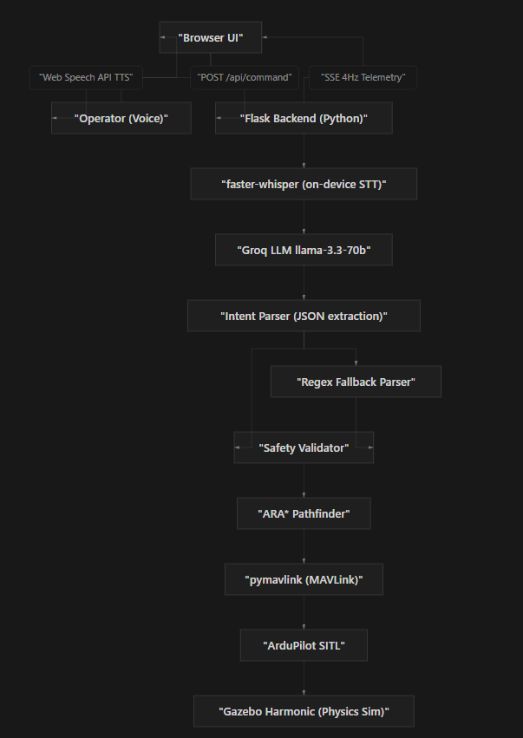

Tech Stack
Speech-to-Text Layer
- faster-whisper (CTranslate2-optimized Whisper) -- fully on-device, offline-capable transcription
- sounddevice + numpy + scipy -- microphone capture with automatic silence detection, RMS-based calibration, configurable mic device
- Domain-specific initial prompt for military vocabulary (callsigns, location names)
NLP / Intent Parsing Layer
- Groq API with llama-3.3-70b-versatile -- natural language to structured JSON intents
- Supports single commands and multi-step sequences (split on "then", "after that", etc.)
- Deterministic regex fallback -- if the LLM is unavailable, returns unexpected output, or collapses multi-step phrases into one, a regex-based parser takes over
- Fuzzy string matching normalization layer to bridge Whisper transcription errors with expected military vocabulary
Safety and Validation Layer (Pure Python -- No LLM)
- IFF (Identification Friend or Foe) system -- JSON-based contact database with FRIENDLY/HOSTILE/UNKNOWN classifications; friendly forces can never be engaged
- No-Go Zone enforcement -- fuel depot (10m radius, no entry at any altitude), comms tower (8m radius, safe only above 25m AGL)
- Altitude limits (0-120m), takeoff/land preconditions, airborne-state checks
- All safety decisions are deterministic Python -- the LLM never touches the safety path
Pathfinding Layer
- ARA (Anytime Repairing A) on a 2D grid with Gaussian threat cost fields around no-go zones
- String-pull path smoothing for flyable waypoints
- path_clear_2d fast check before engaging full planner
- segment_intersects_circle geometry for zone boundary detection
- choose_safe_altitude for altitude-dependent zones (comms tower)
Drone Control Layer
- pymavlink -- MAVLink protocol over UDP multicast for drone control and telemetry
- ArduPilot SITL -- software-in-the-loop running real autopilot firmware
- Gazebo Harmonic -- full physics simulation, collision, and sensor simulation
- ENU-to-NED coordinate conversion (compound map ENU vs MAVLink NED frames)
- Background telemetry loop (GLOBAL_POSITION_INT, HEARTBEAT, SYS_STATUS)
- Stall detection -- detects when the drone is stuck and aborts gracefully
- Multi-drone support via sysid parameter (Alpha, Bravo)
Backend
- Flask (Python) -- REST API + Server-Sent Events for real-time telemetry streaming at 4Hz
- Threaded command queue with cancel event for non-blocking operation
- Background worker thread for sequential command execution
Frontend (Two UIs)
- Primary (Vanilla JS + HTML5 Canvas): Tactical map with compound layout, drone position, flight trails, no-fly zones, live telemetry, command log, voice feedback via Web Speech API
- Modern Dashboard (Next.js 15 + React 19 + Tailwind CSS 4): Polished tactical interface with drone status panels, Canvas map with zoom/pan, push-to-talk voice input via MediaRecorder API, armed/disarmed theme switching, SSE telemetry integration

Key Features
- Natural Language Voice Control -- speak commands naturally; the system handles transcription, parsing, validation, and execution
- Sequential Command Queue -- compound instructions like "go to A, then B, then land" are parsed into multiple actions and executed in order with just-in-time validation at each waypoint
- Operator Override -- any new command immediately aborts an active queue
- IFF Safety Engine -- friendly forces are never engaged; hostile targets are confirmed before engagement; unknown contacts are rejected
- No-Go Zone Enforcement -- configurable exclusion zones with altitude-dependent rules (fuel depot = total exclusion; comms tower = safe above 25m)
- ARA Pathfinding -- automatically computes safe routes around no-fly zones when a direct path would violate zone boundaries
- Stall Detection -- detects when the drone is stuck (e.g., against a wall) and aborts early instead of hanging indefinitely
- Real-Time Tactical Map -- HTML5 Canvas rendering of compound layout, drone position, flight trails, threat zones, and points of interest
- Voice In + Voice Out -- full bidirectional voice loop (Whisper transcription in, Web Speech API TTS feedback out)
- LLM Fallback Parsing -- deterministic regex parser catches cases where the LLM is unavailable or produces unexpected output
- Multi-Drone Architecture -- supports connecting and commanding multiple drones (Alpha, Bravo) with per-drone telemetry and system IDs
- Live SSE Telemetry -- 4Hz Server-Sent Events stream for real-time position, altitude, heading, battery, GPS, and flight mode updates
- Offline-Capable STT -- faster-whisper runs entirely on-device; no internet required for speech recognition
- Coordinate System Handling -- proper ENU (East-North-Up) to NED (North-East-Down) conversion between the Gazebo world frame and MAVLink local frame

API Endpoints
- POST /api/listen -- triggers server-side microphone recording + Whisper transcription
- POST /api/listen/stop -- stops active recording
- POST /api/connect -- establishes pymavlink connection to ArduPilot SITL (supports per-drone sysid)
- POST /api/command -- parses natural language text, validates, and executes (or queues multi-step)
- GET /api/queue -- returns current command queue status
- GET /api/status?drone= -- returns drone telemetry snapshot
- GET /api/telemetry?drone= -- SSE stream at ~4Hz
- GET /api/command-log -- returns full command history with statuses

Simulation Environment
- Gazebo Harmonic 3D world (compound_ops.sdf): walled military compound with watch towers (4 corners), barracks, command building with rooftop structure, motor pool, shipping containers, fuel depot, comms tower, west gate, landing pad
- ArduPilot SITL: real flight controller firmware running in software, connected via MAVLink UDP multicast
- Scoring system (challenge/scorer.py): pymavlink telemetry-based scoring with waypoint hits, no-go zone dwell penalties, HMAC-signed results, hash-chain JSONL audit log

Resume-Worthy Highlights
- Designed and implemented an end-to-end voice-to-drone-action pipeline with sub-second latency
- Built a deterministic safety engine that achieved zero friendly-fire incidents across all testing
- Implemented ARA pathfinding with Gaussian threat cost fields for real-time obstacle avoidance around restricted zones
- Integrated on-device speech recognition (faster-whisper) for offline-capable operation with domain-specific vocabulary tuning
- Developed a real-time tactical dashboard with HTML5 Canvas rendering, 4Hz SSE telemetry, and bidirectional voice interaction
- Architected a robust LLM integration with deterministic fallback parsing to ensure system reliability when the AI model is unavailable or produces malformed output
- Solved coordinate system mismatch between ENU (Gazebo) and NED (MAVLink) that caused a 40-meter positioning offset
- Implemented threaded command queue with cancel events for non-blocking multi-step mission execution
- Built multi-drone support with per-vehicle telemetry, system IDs, and independent control channels

Languages and Tools Summary
- Languages: Python, TypeScript, JavaScript, HTML5/CSS
- AI/ML: Groq API (llama-3.3-70b-versatile), faster-whisper (CTranslate2), Web Speech API
- Frameworks: Flask, Next.js 15, React 19, Tailwind CSS 4
- Drone/Robotics: pymavlink, MAVLink protocol, ArduPilot SITL, Gazebo Harmonic
- Algorithms: ARA pathfinding, Gaussian threat cost fields, fuzzy string matching, RMS-based silence detection
- Protocols: Server-Sent Events, REST API, UDP multicast, MAVLink
- Other: HTML5 Canvas, MediaRecorder API, coordinate geometry (ENU/NED), threading/concurrency

