**Work Hours Report**

|  |  |  |  |
| --- | --- | --- | --- |
| Date | Employee | Client | Hours Worked |
| 2024-01-01 | Carlos Mendoza | Future Vision | 4.87 |
| 2024-01-02 | Andrea López | SecureData Ltd | 6.69 |
| 2024-01-03 | Jorge Castillo | Innova Corp | 3.67 |
| 2024-01-04 | Sofía Ramírez | Future Vision | 9.2 |
| 2024-01-05 | Carlos Mendoza | Global Market | 9.15 |
| 2024-01-06 | Jorge Castillo | Innova Corp | 3.53 |
| 2024-01-07 | Andrea López | Global Market | 5.59 |
| 2024-01-08 | Sofía Ramírez | Innova Corp | 4.55 |
| 2024-01-09 | Andrea López | SecureData Ltd | 9.16 |
| 2024-01-10 | Carlos Mendoza | Innova Corp | 3.95 |
| 2024-01-11 | David Caleb | Innova Corp | 9.5 |
| 2024-01-12 | Sofía Ramírez | Tech Solutions | 5.14 |
| 2024-01-13 | David Caleb | Tech Solutions | 3.36 |
| 2024-01-14 | Sofía Ramírez | SecureData Ltd | 8.75 |
| 2024-01-15 | Sofía Ramírez | Innova Corp | 7.32 |
| 2024-01-16 | David Caleb | Future Vision | 6.14 |
| 2024-01-17 | Andrea López | Global Market | 6.11 |
| 2024-01-18 | Sofía Ramírez | SecureData Ltd | 9.36 |
| 2024-01-19 | Jorge Castillo | Global Market | 5.5 |
| 2024-01-20 | Andrea López | Global Market | 3.43 |
| 2024-01-21 | David Caleb | Global Market | 8.27 |
| 2024-01-22 | David Caleb | Future Vision | 9.88 |
| 2024-01-23 | Sofía Ramírez | SecureData Ltd | 5.47 |
| 2024-01-24 | Jorge Castillo | Global Market | 9.88 |
| 2024-01-25 | Sofía Ramírez | Global Market | 3.75 |
| 2024-01-26 | Carlos Mendoza | Future Vision | 3.78 |
| 2024-01-27 | Carlos Mendoza | Tech Solutions | 8.14 |
| 2024-01-28 | Sofía Ramírez | Tech Solutions | 4.0 |
| 2024-01-29 | Andrea López | SecureData Ltd | 7.85 |
| 2024-01-30 | Jorge Castillo | Global Market | 9.24 |

**Hours Worked Over Time**

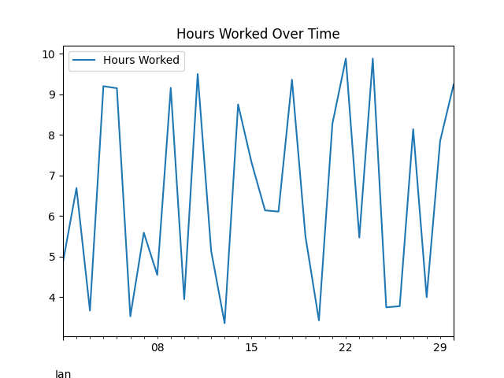

**Total Hours Worked by Employee**

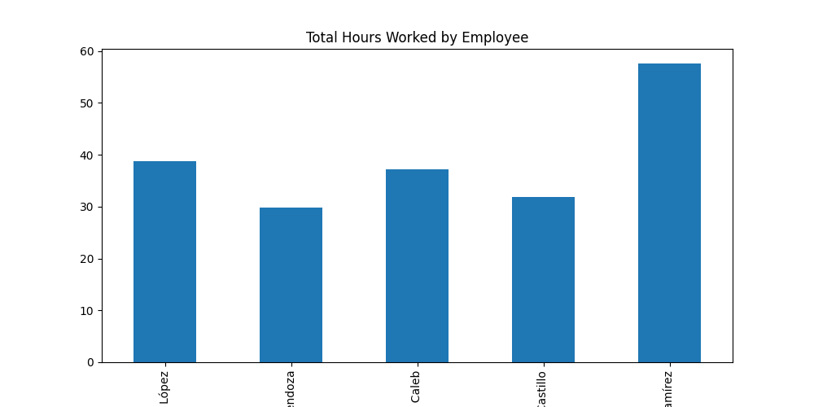

**Hours Worked by Client**

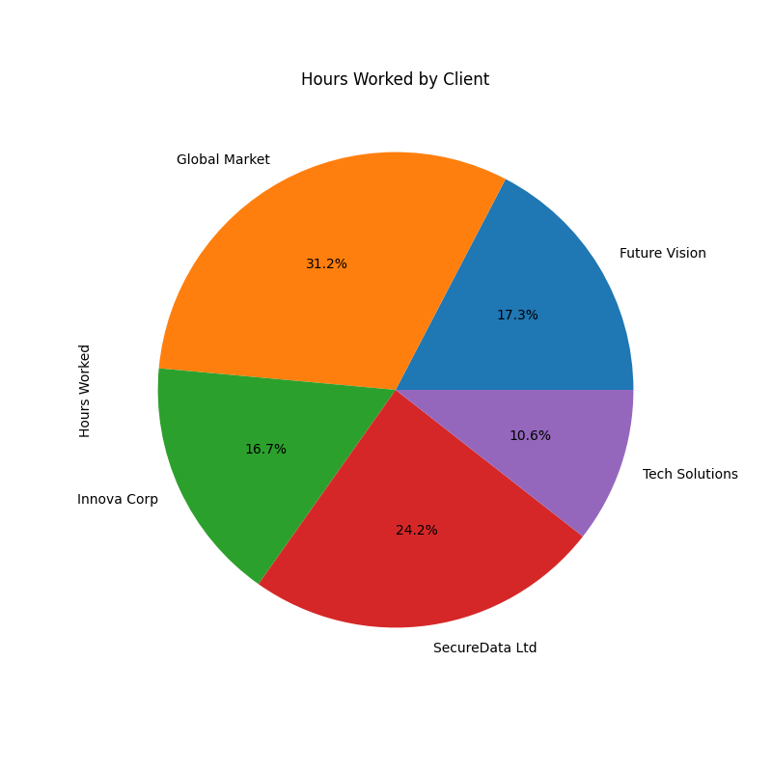

**Distribution of Hours Worked**

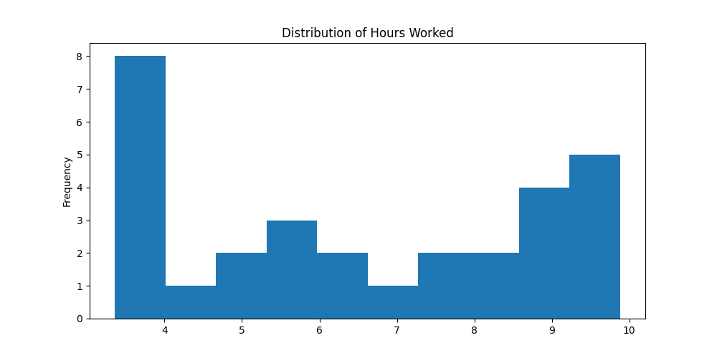

**Hours Worked vs Date**

