Work Hours Report
Date | Employee | Client | Hours Worked
2024-01-01 | Carlos Mendoza | Future Vision | 4.87
2024-01-02 | Andrea López | SecureData Ltd | 6.69
2024-01-03 | Jorge Castillo | Innova Corp | 3.67
2024-01-04 | Sofía Ramírez | Future Vision | 9.2
2024-01-05 | Carlos Mendoza | Global Market | 9.15
2024-01-06 | Jorge Castillo | Innova Corp | 3.53
2024-01-07 | Andrea López | Global Market | 5.59
2024-01-08 | Sofía Ramírez | Innova Corp | 4.55
2024-01-09 | Andrea López | SecureData Ltd | 9.16
2024-01-10 | Carlos Mendoza | Innova Corp | 3.95
2024-01-11 | David Caleb | Innova Corp | 9.5
2024-01-12 | Sofía Ramírez | Tech Solutions | 5.14
2024-01-13 | David Caleb | Tech Solutions | 3.36
2024-01-14 | Sofía Ramírez | SecureData Ltd | 8.75
2024-01-15 | Sofía Ramírez | Innova Corp | 7.32
2024-01-16 | David Caleb | Future Vision | 6.14
2024-01-17 | Andrea López | Global Market | 6.11
2024-01-18 | Sofía Ramírez | SecureData Ltd | 9.36
2024-01-19 | Jorge Castillo | Global Market | 5.5
2024-01-20 | Andrea López | Global Market | 3.43
2024-01-21 | David Caleb | Global Market | 8.27
2024-01-22 | David Caleb | Future Vision | 9.88
2024-01-23 | Sofía Ramírez | SecureData Ltd | 5.47
2024-01-24 | Jorge Castillo | Global Market | 9.88
2024-01-25 | Sofía Ramírez | Global Market | 3.75
2024-01-26 | Carlos Mendoza | Future Vision | 3.78
2024-01-27 | Carlos Mendoza | Tech Solutions | 8.14
2024-01-28 | Sofía Ramírez | Tech Solutions | 4.0
2024-01-29 | Andrea López | SecureData Ltd | 7.85
2024-01-30 | Jorge Castillo | Global Market | 9.24
Hours Worked Over Time
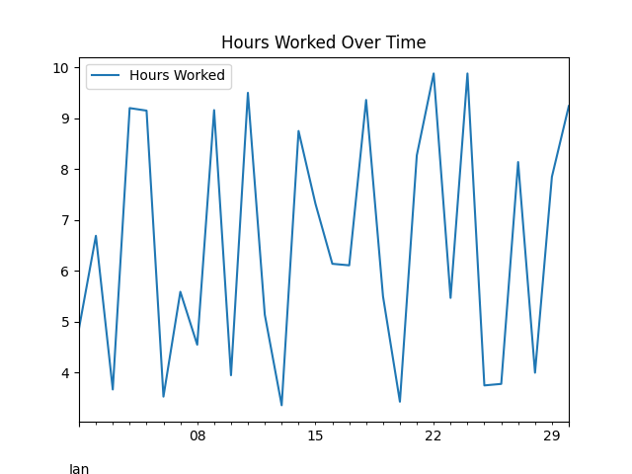
Total Hours Worked by Employee
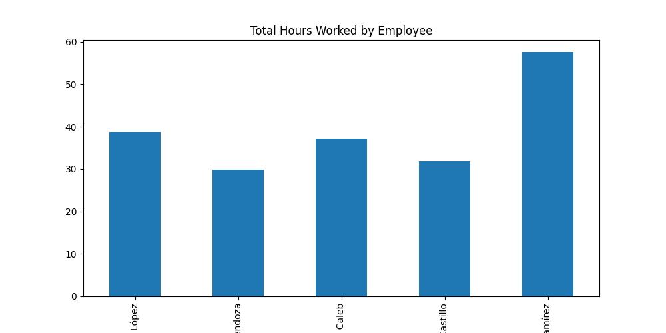
Hours Worked by Client
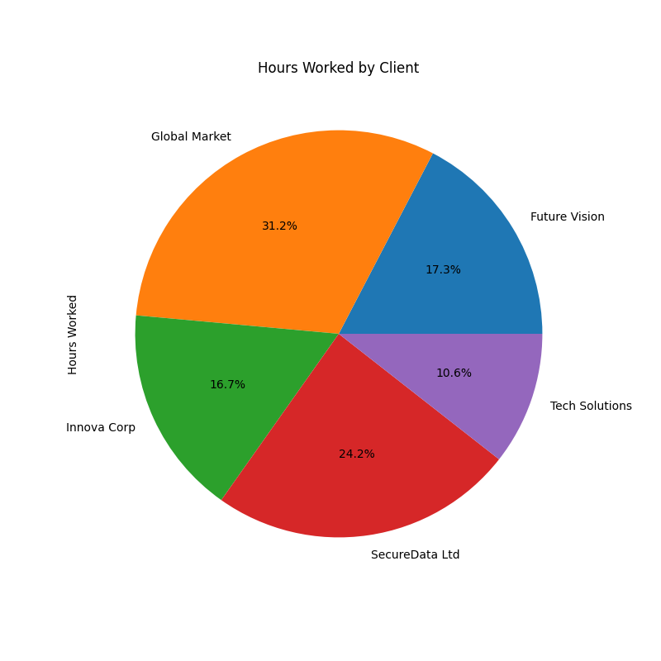
Distribution of Hours Worked
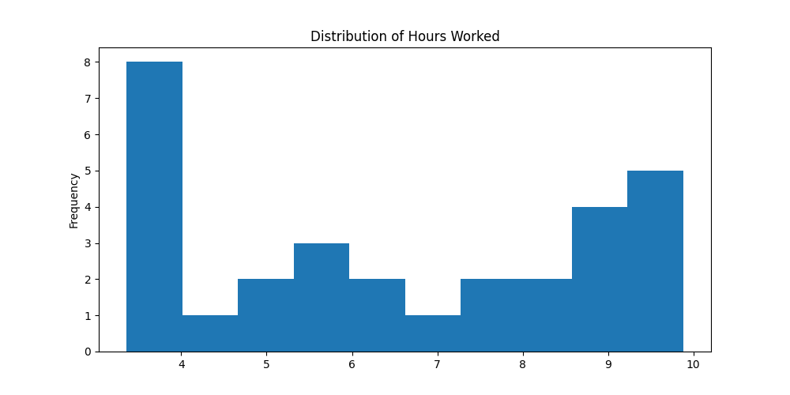
Hours Worked vs Date
