

|  |
| --- |
| Capstone Project  2020 |
|  |
| 23 marzo  Schools and enviroment  Creado por: David Charif |

# Schools and enviroment

|  |
| --- |
| Which are the most common venues near schools? The relationship between the enviroment and the schools could affect the students, but since we are not looking for GPA of each one, we are going to look how the venues are distributed in 100 schools, to see if some share some values and with Kcluster we are going to plot those results in a map.  **Area of interest**  -Parents who would like to know what venues are near to the school in order to select better  -Cluster the schools for insings in venues |
|  |
| Since the data set has 200 schools we are going to limit the result to 100 schools. |

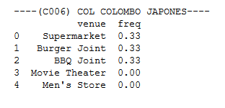

Looking this preliminar data, show us how differents are the first 6 values, but we can notice how the food its always near.

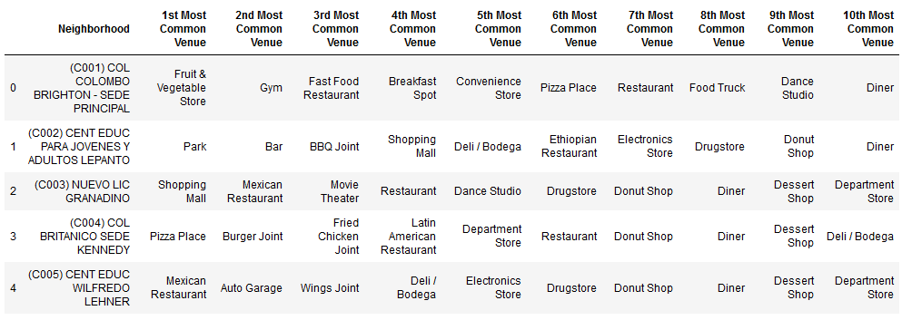

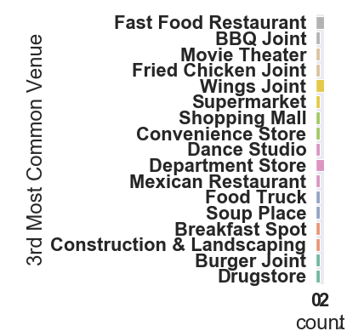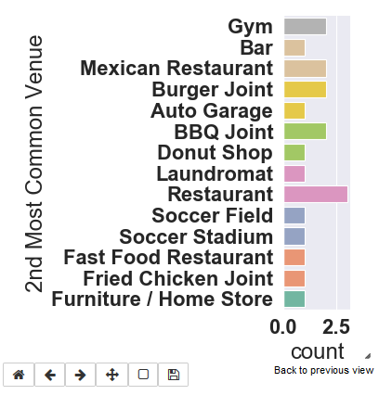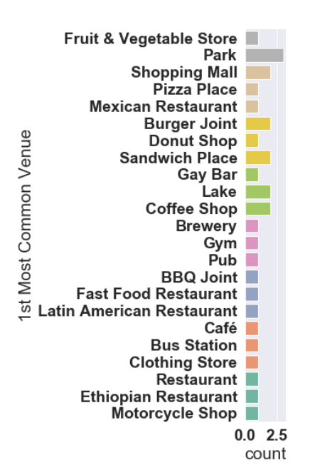Grouping the results from 30 schools we can saw more detailed data

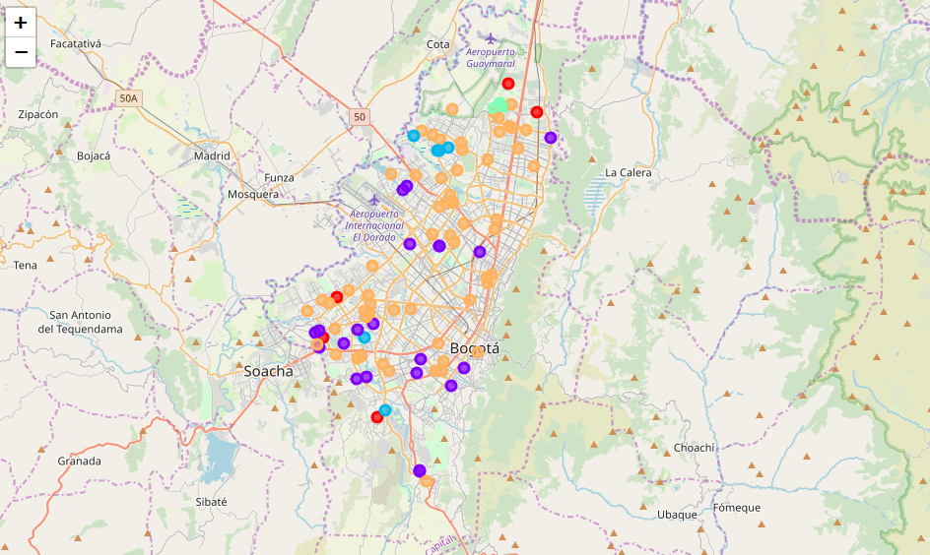

Ploting the results we can notate that the orange cluster (5) has the mayority of schools, along with the purple cluster (2)

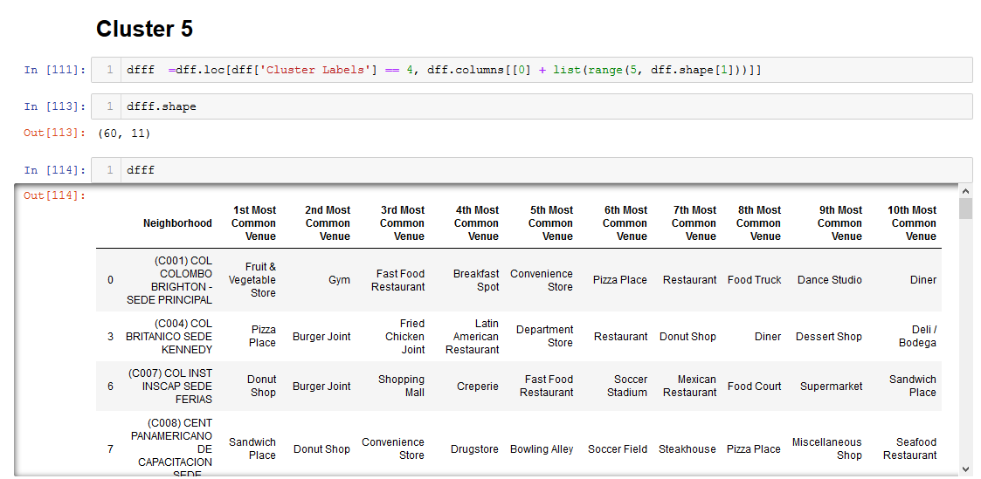

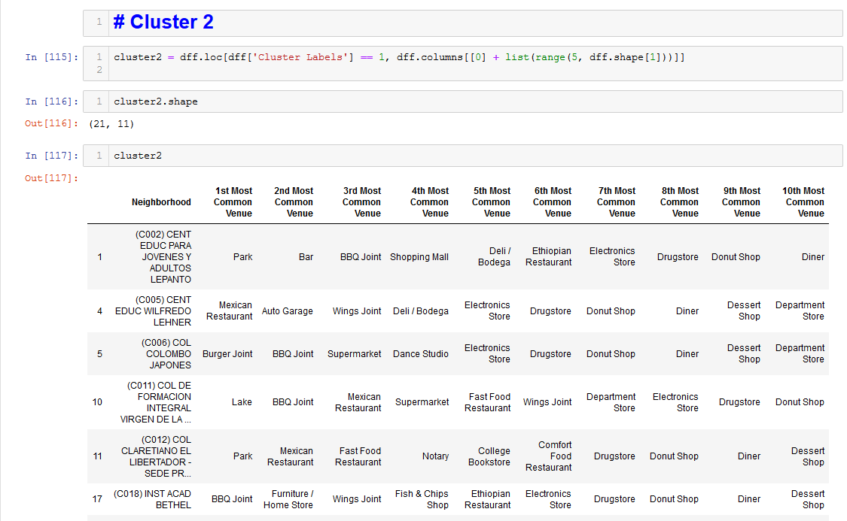

The cluster 5 groups the food related venues, this means that the schools are located near a commercial area, not very quiet, the cluster 2 represent new venues like Electrics store, Notary, HomeStore this cluster is even more commercial since has more variety inside.

The blue dots cluster(3) represent a more ideal area to study, even when is mixed with local bussiness the park is the most common venue.

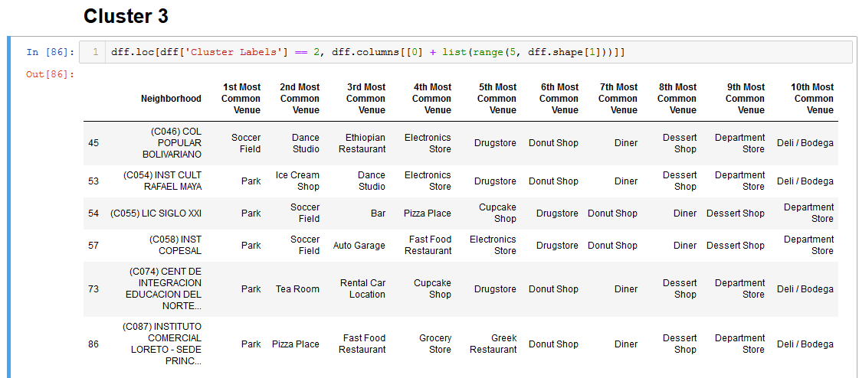

The red dots cluster(1) one of the littles with only 5 schools are related with big commerce, Shopping malls, dance studio and departament store, which could indicate the delevopment near the schools

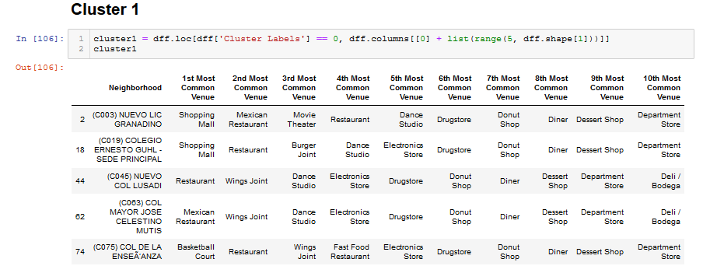

The green dots cluster(4) represent the most expensive schools in relation with the other ones, since the four schools are near each other all share a Tennis Court, in this cluster we can not say that is a local commertial area

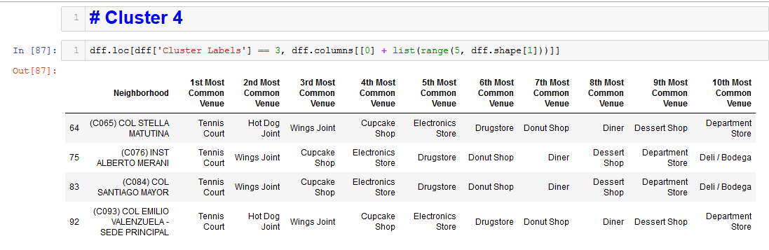

Conclusion

The near venues of the schools are related with the neighborhood and with the bussiness around, some areas are residential, which could be more peaceful for the students. The cluster organization groups the schools according to the related area, while we could expect that the parks were directly related with schools we can see that only 6 schools of 100 have one near.

We cannot negate that in bogota, a lot of schools are in a commertial area, exposing the students to not recommendable venues, like bars and fast food.