

**CORE CURRICULUM**

**Marketing**

Sunil Gupta, Series Editor

**■HARVARD**

**EBUSINESS**

**PUBLiSHING**

**+ INTERACTIVE ILLUSTRATIONS**

**Segmentation**

**and Targeting**

**SUNIL GUPTA**

HARVARD BUSINESS SCHOOL

8219 I Published: June 30, 2014

This document is authorized for educator review use only by GIANCARLO POGGIO, Universidad Francisco Marroquin (UFM) until Aug 2018. Copying or posting is an infringement of

copyright. [Permissions@hbsp.harvard.edu](mailto:Permissions%40hbsp.harvard.edu) or 617.783.7860



**Table of Contents**

**1 Introduction .......................................................................................................3**

**2 Essential Reading**

**2.1 Segmentation Fundamentals**

**What Is Segmentation?**

**Why Segment the Market?**

**Characteristics of a Useful Segmentation**

**2.2 How to Segment Consumers**

**Who Are the Customers?**

**What Is Customer Purchase Behavior? 10**

**Why Do Customers Buy a Particular Product? 11**

**2.3 Targeting 12**

**2.4 Ethical and Privacy Issues 14**

**2.5 From Segmentation and Targeting to Strategy Formation 15**

**3 Supplemental Reading 18**

**3.1 Cluster Analysis 18**

**3.2 Preference-Based Segmentation 18**

**3.3 Response-Based Segmentation 20**

**4 Key Terms 21**

**5 For Further Reading 21**

**6 Endnotes22**

**7 Index24**

This reading contains links to online interactive illustrations and video, denoted by the

icons above. To access these exercises, you will need a broadband Internet connection.

Verify that your browser meets the minimum technical requirements by visiting <http://hbsp.harvard.edu/list/tech-specs>.

Sunil Gupta, Edward W. Carter Professor of Business Administration, Harvard Business School, developed this Core Reading with the assistance of writer Katherine Dowd.

Copyright © 2014 Harvard Business School Publishing Corporation. All rights reserved. To order copies or request permission to reproduce materials (including posting on academic websites), call 1-800-545-7685 or go to <http://www.hbsp.harvard.edu>.

8219 | Core Reading: SEGMENTATION AND TARGETING

2

This document is authorized for educator review use only by GIANCARLO POGGIO, Universidad Francisco Marroquin (UFM) until Aug 2018. Copying or posting is an infringement of

copyright. [Permissions@hbsp.harvard.edu](mailto:Permissions%40hbsp.harvard.edu) or 617.783.7860

**o**



five-star

W

1

**1 INTRODUCTION**

hen booking accommodations, would you prefer to stay in a

or a three-star hotel? Would you prefer a room at

the hotel’s luxury level, with breakfast and snacks included, or a basic room with no view? Do you think those preferences have

anything to do with the kind of computer you use when searching for

hotels

online?

Marketers think

so. In fact,

when booking through the

online travel website <Orbitz.com>, identical searches for hotels, cars, and flights performed by a Mac user and a PC user often produce different lists of results.

Why the difference? In 2011, Orbitz made a discovery while searching past transaction data: The average Mac user would pay between $20 and $30 more per night on hotel rooms than the average PC user. Similarly, Mac users had a 40% higher chance of selecting a four- or five-star hotel. Even when choosing to stay in the same hotel, a Mac user would often pick a more expensive class of room than a PC user. While Orbitz always offered the same prices for the identical rooms to each user, it would show a Mac user a more upscale selection of hotels in certain markets, such as Miami Beach, Florida, and Baton Rouge, Louisiana, with rooms that cost 10% to 13% more than those shown to a PC user.

Increasingly,

organizations

are recognizing

differences

in customer

preferences

and

needs when designing

their

product offerings.

The marketing

process

of segmentation,

targeting,

and positioning

(or STP) identifies

a firm’s potential

customers,

selects

which

customers a firm should pursue, and formulates its value proposition for its target customers **(Exhibit** 1).

**EXHIBIT 1** Segmentation, Targeting, and Positioning (STP)

**SEGMENTATION**

GroupCpstomArs^ascd'

on sifnifar needs

**TARGETING**

Assess attractiveness

of each segment

**POSITIONING**

Define value proposition

for target segments

Profilkeash sej

:nt

Select segments to

target

Develop an action plan

The first

step of the process,

*segmentation,*

groups customers with similar

needs into

*customer segments* and then determines the characteristics of customers in those segments. For example, a company that sells packaged tea leaves might uncover two customer segments—

price-insensitive

customers

and relatively

price-sensitive

customers.

These

price-sensitive

customers may have lower incomes but perhaps buy tea frequently and know a lot about the product category.

The next step is *targeting,*

or selecting segments that the firm wants to focus on for its

products or services. This is done based on the attractiveness of segments (such as size and

potential profitability), intensity of competition, and a firm’s capability to serve customers in

each segment. The tea company might decide to focus only on the price-insensitive customers

8219 | Core Reading: SEGMENTATION AND TARGETING

This document is authorized for educator review use only by GIANCARLO POGGIO, Universidad Francisco Marroquin (UFM) until Aug 2018. Copying or posting is an infringement of

copyright. [Permissions@hbsp.harvard.edu](mailto:Permissions%40hbsp.harvard.edu) or 617.783.7860

**w**



by offering a premium product. For these customers, the company might offer an attractive tin containing loose tea mixed with bits of fruits and flowers, or a tin filled with individual, pyramid-shaped linen sachets. Or it might aim for both segments by offering two different tea products, perhaps targeting the price-sensitive segment with tea packaged in a box containing simple, flow-through paper teabags.

The final

step is *positioning,*

or formulating the firm’s value proposition for the target

segments, and developing an action plan for them. In our example, the tea company may position its high-priced product as a premium/luxury product designed for the consumer with

good taste,

while its low-priced tea could be positioned

as a good value for the smart

consumer. This positioning is communicated to consumers through the ways in which the product is designed, packaged, distributed, and advertised.

In this reading we will

focus mainly on segmentation and targeting.

(Positioning—the

third phase of the STP process shown in Exhibit 1—will be discussed in detail in a separate reading. See *Core Reading: Brand Positioning* [HBP No. 8197].) We begin the Essential Reading with a look at why segmentation is important, what constitutes a good segmentation, and how to actually go about segmenting customers. From there we will move on to how to select target segments. Next we examine the ethical and privacy issues surrounding the process of segmenting and targeting, followed by a look at how to formulate a marketing strategy

based on segmentation and targeting

choices. Finally,

the Supplemental Reading examines

three analytical methods commonly used to carry out segmentation.

**2 ESSENTIAL READING**

**2Jl Segmentation Fundamentals**

\ \ i

**What Is ^Segmentation?**

At its most basic, segmentation is simply separation of a heterogeneous group of customers with different needs into homogenous subgroups or segments of customers with similar needs

and preferences. This allows firms to tailor needs of each segment.

their

products and services to better meet the

Without segmentation, companies will

often overlook opportunities

as they continue to

provide a single solution for everybody. For example, if half of a tea company’s customers liked iced tea and the other half liked hot tea, producing tea that brewed only at a lukewarm temperature would not appeal to either group. Segmentation also informs a company about

potential

new opportunities.

Segments with unmet needs are opportunities

that can drive

business strategy and new product development.

Note that firms

do not *create*

segments;

they only *uncover*

them.

(See

the sidebar

“Segmenting Patients.”) The market

consists

of consumers with heterogeneous

segments,

regardless

of whether

or not a firm

decides

to segment

the market.

Indeed,

different

companies may segment the same market differently, depending on how they view consumers and their needs.

8219 | Core Reading: SEGMENTATION AND TARGETING

This document is authorized for educator review use only by GIANCARLO POGGIO, Universidad Francisco Marroquin (UFM) until Aug 2018. Copying or posting is an infringement of

copyright. [Permissions@hbsp.harvard.edu](mailto:Permissions%40hbsp.harvard.edu) or 617.783.7860

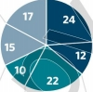

2

**Segmenting Patients**

In 2005, management consulting firm McKinsey & Company conducted a study to understand the attitudes of people with hypertension (high blood pressure) toward the disease in order to improve their compliance with treatment. Using a survey of 810 patients, McKinsey uncovered six patient segments, based on their attitudes and self-reported adherence to medication regimens. The segments ranged from proactive patients (24%), who actively managed their health and considered medication critical to controlling their blood pressure, to skeptics (17%), who did not trust their physicians and did not consider high blood pressure a serious condition (see **Exhibit 2).**

**EXHIBIT 2** Characteristics of Hypertension Patients and Their Adherence to Medication Regimens, by Segment (Percentage of Total)

**Skeptical (5-24% adherent)**

• Don't trust physicians

• View medications negatively; very concerned about long-term health risks

• Don't think high blood pressure is very serious **Resigned (13-45% adherent)**

• Afraid of consequences of high blood

pressure but do not manage health

actively

• Feel it is too much trouble to live a

healthy lifestyle

• Have no routine; often careless about

taking medications

**Confused (37-56% adherent)**

• Feel they have little control over their health • Have many unanswered questions about

high blood pressure

• Have had bad experiences with doctors;

do not understand their instructions

**Proactive (76-91% adherent)**

• Very active in managing their health

■ Think medications are critical in controlling

high blood pressure

■ Have excellent relationship with physician

**Confident (69-82% adherent)**

• Rarely think about risks of high blood pressure

■ Confident in ability to control their high blood pressure and overall health

• Think medications are important; have no concerns about taking them

• Less reliant on physicians

**Concerned (47-64% adherent)**

• Very concerned about risks of high blood pressure

• Consider medications important but worry about their long-term health risks; prefer to change lifestyle

**■ Most adherent ■ Moderately adherent I Least adherent**

**100% = 810 patients**

Source: Adapted from exhibit from "Getting Patients to Take Their Medicine,” June 2006, McKinsey & Company. Reprinted by permission.

The study found that *concerned patients* were more likely to respond to information about

their medication’s safety, while the compliance of *confident patients* was influenced more by

programs that reward consistent, long-term usage. This insight can help pharmaceutical

companies and policy makers design better programs to improve drug adherence.

**Why Segment the Market?**

Segmentation benefits both the customers and organizations in a number of ways **(Exhibit 3).**

Customers benefit from products and services tailored to their

needs because they provide

convenience, save time, and enrich the customer experience. Henry Ford, the founder of Ford Motor Company, once said, “Any customer can have a car painted in any color that he wants

so long as it is black.”

Automobile companies have come a long way, from mass producing

the same car for everyone

to producing a product line with many models that satisfy

customers with different needs. Digital technology and customer-level data have allowed firms

to customize solutions for individual customers—such as when <Amazon.com>recommends a

book based on your online purchase history, or the video-subscription service Netflix suggests

movies for you to watch based on past viewing behavior.

8219 | Core Reading: SEGMENTATION AND TARGETING

This document is authorized for educator review use only by GIANCARLO POGGIO, Universidad Francisco Marroquin (UFM) until Aug 2018. Copying or posting is an infringement of

copyright. [Permissions@hbsp.harvard.edu](mailto:Permissions%40hbsp.harvard.edu) or 617.783.7860

CH



3

4

5

**EXHIBIT 3** Benefits of Segmentation to Organizations and Customers

**Benefits to the Organization**

Identification of unfulfilled needs

Better product design

□ More targeted promotions

□ Increased customer satisfaction

**Sustainable Profit Growth**

**Benefits to the Customer**

□ Convenience and time savings □ Tailored productsand services

□ Relevant offers

□ Personalized experience

**Compelling Customer Experiences**

For example, as a result of market segmentation, Amazon offers “Amazon Mom,” a service aimed at the new parent segment. During what could be a sleepless and overwhelming period in parents’ lives, Amazon saves them time and money with automatic suggestions about what

new parents

might buy, based on the purchase

history

of other parents;

discounts

and

automatic

shipping on commonly used items

like diapers

and baby wipes;

free

two-day

shipping for a set amount of time after signing up; and the convenience of being able to order from the comfort of one’s home 24 hours a day.

Organizations

benefit

from segmentation

because

it helps them identify

underserved

customers and unfulfilled customer needs. Better products and services result when compa­

nies aim to satisfy these segments. Segmentation also allows firms to better target their promo­

tions and customize their products; both strategies increase customer satisfaction. Gaining a

growing number of satisfied customers is a good way to achieve sustainable profit growth. **Characteristics of a** Uj **ul Segmentation**

There are often multiple ways to segment a market; however, for a segmentation to be useful,

it must be identifiable, substantial, accessible, stable, differentiable, and actionable.

*• Identifiable.* An organization should be able to identify customers in each segment and

to measure their characteristics, such as demographics or usage behavior. In Africa, for

example, Procter & Gamble and Unilever target low-income consumers by selling small

packets of products, such as detergent or salt, at small kiosks.

*• Substantial.* Although the increasing availability of data makes it possible to create

microsegments, it’s usually not cost-effective to target small segments. To be useful, a

segment therefore needs to be substantial—large enough for a firm to serve profitably.

Consider Coca-Cola’s 2004 launch of Coke C2, a beverage aimed at 20- to 40-year-old

males who liked the taste of regular Coke but not the calories and who disliked the taste

and female association of Diet Coke. Coke C2 tasted like regular Coke but had half the

calories and carbohydrates. The drink was not a success, however; the intended male

target audience was looking for a full-flavored drink with no calories, not reduced

calories, and market data showed that any product sales of Coke C2 were just

cannibalizing sales of existing Coca-Cola beverages. Not long after its launch, Coke C2

was replaced with the more successful brand, no-calorie Coke Zero.

*• Accessible.* There is not much value in creating a segmentation scheme if an

organization cannot reach the segments. To be accessible, a segment needs to be

reachable through communication and distribution channels independent of other

segments. For example, young consumers, who increasingly use social media, have

become more accessible to firms that are eager to engage them via Facebook, Twitter,

and blogs.

8219 | Core Reading: SEGMENTATION AND TARGETING

This document is authorized for educator review use only by GIANCARLO P0GGI0, Universidad Francisco Marroquin (UFM) until Aug 2018. Copying or posting is an infringement of

copyright. [Permissions@hbsp.harvard.edu](mailto:Permissions%40hbsp.harvard.edu) or 617.783.7860

□ □

cn



6

7

8

*• Stable.* A segment should be stable over a long enough period of time that any market­

ing effort would be successful and profitable. For example, lifestyle is often used as a segmentation variable but the stability of lifestyle segments in the international context appears to be low. Many experts believe in the global convergence of consumer needs and wants, which also suggests that international segments may be very dynamic and constantly evolving.

*• Differentiable.* Consumers in a segment should have similar needs, and these needs

should differ from the needs of consumers in other segments. In Japan, for example,

there is a new market segment for alcohol-free drinks, from nonalcoholic beer to

wine to gin and tonic mixes. Sales in this segment doubled between 2009 and 2012 to

12 million cases of beverages and are expected to grow another 10% to 20% in 2013.

Sapporo released a premium, beer-flavored beverage to meet the demand, and Suntory

and Kirin are also releasing nonalcoholic beers.

*• Actionable.* An organization should be able to create products and marketing programs

for attracting and serving customers in the segments identified. For example, a leading

U.S. insurance company spent a lot of time and money on segmentation, only to realize later that it could neither identify customers in those segments nor design any specific actions to target them. Not surprisingly, it abandoned its segmentation effort.

**2.2 How to Segment Consumers**

There are a number of different ways to segment consumers, such as age, income, usage rate,

lifestyle, etc. **Exhibit 4** lists

the common segmentation variables for consumer products, and

**Exhibit 5** shows typical variables used to segment business markets.

**EXHIBIT 4** Major Segmentation Variables for Consumer Markets

**Geographic**

**Demographics**

**Psychographics**

**Behavioral**

**Benefits Sought**

Country, region, city, urban/rural, climate

Age, income, gender, generation, marital status, family size, occupation, education, ethnicity, religion

Lifestyle, personality, activities, interests, opinions

Usage rate, loyalty, product knowledge, involvement, purchase occasion, buying stage Convenience, value, safety, status

**EXHIBIT 5** Major Segmentation Variables for Business Markets

**Geographic**

**"Firmographics”**

**Buying Approach**

**Behavioral**

**Benefits Sought**

Country, region, city, urban/rural

Industry, firm size, global/regional, ownership

Centralized or decentralized purchase, purchase policies, involvement of decision makers Volume, purchase frequency, attitude toward risk, loyalty, urgency

Price, product quality, service, relationship

Source: Republished with permission of Lexington Books, from *Segmenting the Industrial Market* by Thomas V. Bonoma and Benson P. Shapiro,

1983; permission conveyed through Copyright Clearance Center, Inc.

8219 | Core Reading: SEGMENTATION AND TARGETING

This document is authorized for educator review use only by GIANCARLO POGGIO, Universidad Francisco Marroquin (UFM) until Aug 2018. Copying or posting is an infringement of

copyright. [Permissions@hbsp.harvard.edu](mailto:Permissions%40hbsp.harvard.edu) or 617.783.7860



9

Given this long list

of segmentation

variables,

which variable

should be used?

Segmentation is more of an art than science, so it is hard to give a precise answer to this question. However, it is helpful to group these segmentation variables into three categories of *who* buys, *what* they buy, and *why* they buy it **(Exhibit 6).**

**EXHIBIT 6** Bases for Segmentation

**WHY**

**WHAT**

**WHO**

**Why do customers make the decisions they do'** Needs, preferences, decision process

**What have the customers done?** Usage, loyalty, profitability

**Who are the customers?**

Demographics, media habits, lifestyle

**Who Are the Customers?**

While the ultimate

goal of segmentation is to group consumers with similar

needs and

preferences,

often it is easy to form these

groups on the basis

of readily

available

and

identifiable information about consumers, such as their

age, income, education, lifestyle,

or

family size. In business to business (B2B) segmentation, the equivalent characteristics could be

type of industry

or size

of business.

This identifiable

information

makes the task of

segmentation easy and actionable, and the manager hopes that consumers’ demographic and

related characteristics correlate highly with their

needs and preferences. For example, low-

income consumers are more likely to be price-sensitive and to look for value brands than high-income consumers.

Note,

too, that it is quite common to use a combination

of various

demographic,

geographic, and lifestyle factors to segment a market.

Here are a few examples of how various companies have segmented their markets, not

always successfully:

*• By demographics.* In March 2013, the computation software manufacturer Wolfram

Research offered the standard edition of its program, Mathematica, at a price of $2,495.

However, it also offered a student version with limited features at less than half the price

of its standard version. Wolfram knows that students cannot afford the higher priced

version and perhaps would not need to use all the sophisticated features of the standard

product. The company wants students to start using its software, so they become

accustomed to its product and become regular customers later on when they graduate.

Or consider the pen manufacturer Bic, which in 2012 released a line of “Bic Cristal

for Her” pens, which were designed to be thinner and were produced in a palette of soft

colors. They were also priced higher than regular pens. Women were offended,

however, by the suggestion that they might use pens differently from men and would be

willing to pay more. There was an intense backlash, including creatively expressed

opinions of the pens through Amazon reviews, which then spread rapidly on

Facebook. The pen market was not as heterogeneous along gender lines as Bic had

anticipated. (See the sidebar “Segmenting U.S. Millennials” for more about

segmentation by demographics.)

8219 | Core Reading: SEGMENTATION AND TARGETING

This document is authorized for educator review use only by GIANCARLO POGGIO, Universidad Francisco Marroquin (UFM) until Aug 2018. Copying or posting is an infringement of

copyright. [Permissions@hbsp.harvard.edu](mailto:Permissions%40hbsp.harvard.edu) or 617.783.7860

**co**

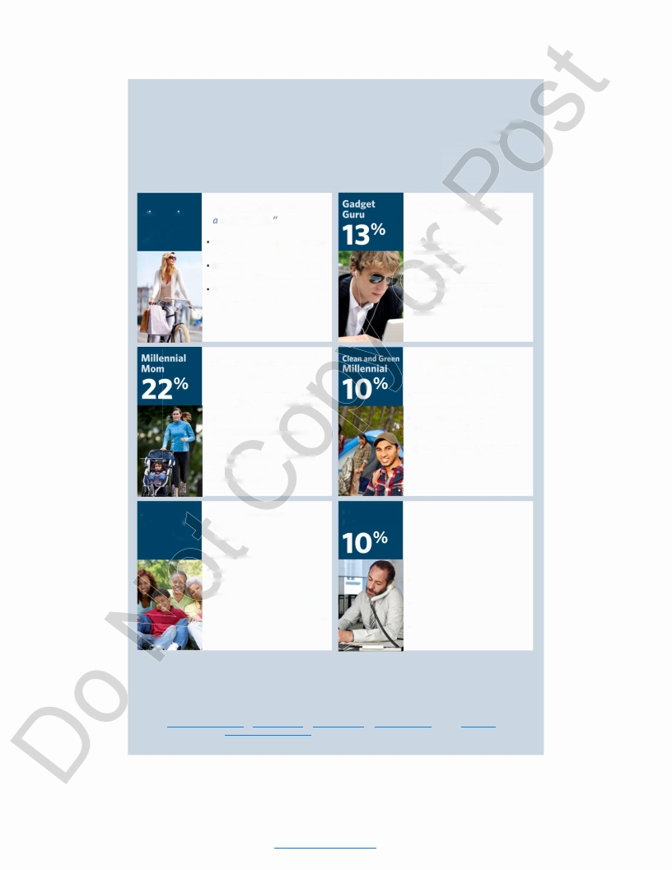

**Segmenting U.S. Millennials**

In 2012, Boston Consulting Group (BCG) used consumer lifestyles to segment U.S. millennials (people between the ages of 16 and 34 at the time of the study) into six distinct segments. BCG found that while all millennials often showed a strong affinity for technology, they differed markedly in their attitudes and behaviors **(see Exhibit 7).**

**EXHIBIT 7** Six

**Hip-ennial**

**29%**

**Anti­**

**Millennial**

Segments of Millennials

*"I can make the wor Id*

*better place.*

Cautious consumer, globally aware,

charitable, and information-hungry

Greatest user of social media but does not push/contribute content

Female-dominated, below-average

employment (many are students

and homemakers)

*"I love to work out, travel, and pamper my baby."*

• Wealthy, family-oriented, works out, confident, and digitally savvy

• High online intensity

• Highly social and information- hungry

• Can fee! isolated from others by her daily routine

• Older, highest income

*"I'm too busy taking care of my business and my family*

**Old School**

**Millennial**

*"It's a great day to be me."*

■ Successful, wired, free-spirited,

confident, and at ease

• Feels this is his best decade

• Greatest device ownership,

pushes/contributes to content

• Male-dominated, above-average

income, single

*"I take care of myself and the world around me."*

• Impressionable, cause-driven,

healthy, green, and positive

• Greatest contributor of content, usually cause-related

• Male-dominated, youngest, more likely to be Hispanic, full-time students

*"Connecting on Facebook is*

*too impersonal. Let's meet*

**16**

I

**%**

*to worry about much else."* • Locally minded, conservative

' • Does not spend more for green products and services

fl • Seeks comfort and familiarity over excitement/change/interruption

• Slightly more female, more likely to be Hispanic and from the western United States

*up for coffee instead!"*

• Not wired, cautious consumer, and charitable

• Confident, independent, and self­ directed

• Spends least amount of time online, reads

• Older, more likely to be Hispanic

While these segments are interesting and different in their attitudes, for them to be useful, a

firm has to be able to clearly identify and access these segments—and be able to design

distinct products and marketing programs for each segment.

Source: *The Millennial Consumer: Debunking Stereotypes. ©* 2012, The Boston Consulting Group. Photos, from top left to bottom right: © <iStock.com/Squaredpixels>, © <iStock.com/sstop>, © <iStock.com/jMichl>, © <iStock.com/Pamela>Moore, © <iStock.com/>monkeybusinessimages, © <iStock.com/audioundwerbung>.

8219 | Core Reading: SEGMENTATION AND TARGETING

9

This document is authorized for educator review use only by GIANCARLO POGGIO, Universidad Francisco Marroquin (UFM) until Aug 2018. Copying or posting is an infringement of

copyright. [Permissions@hbsp.harvard.edu](mailto:Permissions%40hbsp.harvard.edu) or 617.783.7860



10

11

12

*• By geographies.* McDonald s customizes its burger classics and other menu items regionally and seasonally to meet varying geographic tastes and customs. For example, McDonald’s serves lobster rolls in Maine during the summer, sells durian milkshakes in Singapore, excludes beef from its menu in India, and keeps pork out of its restaurants in Israel and some Muslim countries.

*• By psychographics.* By assessing intangible consumer characteristics such as lifestyle, personality, interests, values, and attitudes, psychographics allows companies to segment customers by traits that are not easily identified. For example, PRIZM, a system offered by Nielsen (a U.S.-based market research company) to client companies, is a commonly used lifestyle segmentation scheme that groups consumers into 11 lifestage

groups and 14 social groups.

Another company, Kenya-based CfC Stanbic Bank,

segments African customers for loans based not only on repayment rate of previous entrepreneurial seed loans, but also on results from “psychometric” testing of loan candidates. This includes anything from motivation questionnaires to reasoning tests— which gathers useful information not usually found on a loan application.

GE Healthcare provides a good example of customer segmentation. Click on **Video 1** to view the beginning of a six-part video mini-case study on how the company developed and applied segmentation for its Imaging Systems business.

**VIDEO 1** GE Healthcare Case: Part 1

http://bit.ly/hbsp2pJBRkg

*Scan this QR code, click the icon, or use this link to access the video:* bit.ly/hbsp2pJBRkg

**What Is Customer Purchase Behavior?**

While

“who” variables

focus on customer

characteristics,

“what” variables

emphasize

customers’ purchase behavior. In the age of big data, it is easy for firms to collect and store

transaction

data,

web traffic,

multichannel

buying patterns,

and a host of other purchase-

related information. This allows firms to segment customers based on variables such as how

recently

and frequently

they made purchases,

their

brand loyalty,

or their

share

of wallet

(money a customer spends with a firm as a share of all the money spent on that category).

Since consumers’ past purchase behavior is generally

a good predictor

of future

behavior,

purchase-based

segmentation provides

firms

with an actionable

strategy

to target

the right

customers.

Companies such as L.L.Bean that have traditionally used catalogs to reach their customers

often segment them based on three

factors,

called

RFM: *recency, frequency,* and *monetary*

*value* of purchases. This approach is commonly used in database marketing and is easy to

implement for companies who track

their

customers’ transaction

data.

Research has shown

that segments based on this RFM model correlate well with customers’ future purchases.

Customer loyalty—or the likelihood

that a customer

will

return

to buy a company’s

products

over those of a competitor’s—is another

important

variable

for segmentation.

A

study of the banking markets

in Belgium,

Germany, and Italy

revealed

that loyal bank

customers bought 40% more products and generated 30% to 70% more value for the banks

over the life

of their

relationship

when compared to average bank customers.

This study

**o**

suggested segmenting bank customers based on the bank’s share of wallet and their loyalty to the bank. Customers with high share of wallet, but low loyalty, are valuable customers who are at risk of defecting, so a bank should invest resources to improve its relationship with them.

Please click on **Video 2** to begin Part 2 of the GE Healthcare case, on the customer buying process.

**VIDEO 2** GE Healthcare Case: Part 2

http://bit.ly/hbsp2uoAugd

*Scan this QR code, click the icon, or use this link to access the video:* <http://bit.ly/hbsp2uoAugd>

8219 | Core Reading: SEGMENTATION AND TARGETING

10

This document is authorized for educator review use only by GIANCARLO POGGIO, Universidad Francisco Marroquin (UFM) until Aug 2018. Copying or posting is an infringement of

copyright. [Permissions@hbsp.harvard.edu](mailto:Permissions%40hbsp.harvard.edu) or 617.783.7860

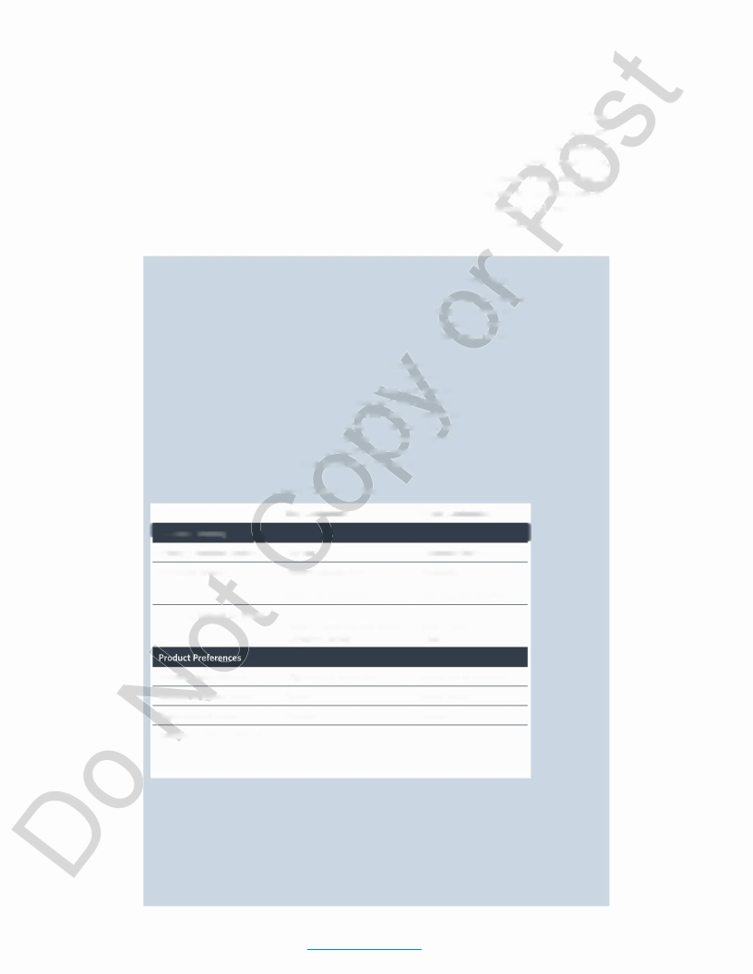

**Why Do Customers Buy a Particular Product?**

While studying consumers’ past purchase behavior and loyalty is a good way to assess their future purchase behavior, it is only through knowing *why* consumers make the decisions they

do that we can truly understand

their

needs and preferences—the fundamental

bases

of

segmentation.

Such insight

helps firms

convert

nonloyal consumers into loyal consumers,

design new products

to appeal

to new groups of consumers, or change their

marketing

strategy to increase share and profitability. (See the sidebar “Segmentation in the Business-to-

Business Market” for an example of how understanding

customer needs and segmenting

customers

based on them improved

performance

at Hill-Rom,

a healthcare

equipment

manufacturer.)

**Segmentation in the Business-to-Business Market**

In 2000, Hill-Rom, a healthcare equipment manufacturer and service provider in the business- to-business (B2B) market, aligned its sales force by segmenting its customers based on the size of the healthcare facility using data such as the number of staffed beds. Since hospital size was likely to influence client spending on healthcare equipment, this segmentation and sales force strategy seemed logical.

In early 2001, a new CEO took over Hill-Rom and reexamined customers’ buying behavior. A study commissioned by the company unveiled eight segments that were later grouped into two large groups for ease of implementation. These two groups consisted of *key* customers and *prime* customers. For example, key customers were looking for a comprehensive solution and viewed purchases as investments. They had higher capita! expenditure on medical prod­ ucts and on average replaced products 40% sooner than did prime customers. The primary decision maker, the purchase drivers, and the important brand factors were quite different for these two groups (see **Exhibit 8).** Facility size was no longer the driving factor—there were 50-bed and 250-bed nursing facilities in the same segment.

**EXHIBIT 8** Hill-Rom ’s New Customer Segments

**Key Customers**

**Prime Customers**

**I Decision Making**

**\ \**

**I 1**

**1**

**Primary decision maker**

**Purchase drivers**

**Deciding factors on brand**

Nurses

Patient satisfaction

Physician requirements

Return on investment

Performance

Administrators

Necessity

Low maintenance costs

Low risk, low liability

Reliability

Source: Reprinted

Patient outcomes

Caregiver safety

and safety

Ease of use

Price

from "How You

Slice It: Smarter

Segmentation for

Your Sales Force”

by Ernest

**Product configuration**

**System or Stand-alone**

High-end to moderate

System

Moderate to low-end

Stand-alone

Waaser, Marshall

Dahneke, Michael

Pekkarinen, and

Michael Weissel,

*Harvard Business*

**Replacement cycle**

**Required response times:**

**Product service**

**Shipment lead time**

Shorter

Shorter

Longer

Longer

Longer

Shorter

*Review,* March

2004. Copyright

© 2004 by the

Harvard Business

School Publishing

Corporation; all

rights reserved.

Further research revealed that the company was selling to both segments in the same man­ ner, resulting in overall high sales costs. For example, the cost of sales to prime customers was four to five times higher than it was for key customers, because the sales force was try­ ing to sell prime customers a level of service and innovation that they neither valued nor could afford.

The company restructured its sales force to better align it with the two segments. Within two years, customer satisfaction improved significantly, revenue per employee increased by 11%, and operating income per employee increased by 51%.

8219 | Core Reading: SEGMENTATION AND TARGETING

11

This document is authorized for educator review use only by GIANCARLO POGGIO, Universidad Francisco Marroquin (UFM) until Aug 2018. Copying or posting is an infringement of

copyright. [Permissions@hbsp.harvard.edu](mailto:Permissions%40hbsp.harvard.edu) or 617.783.7860

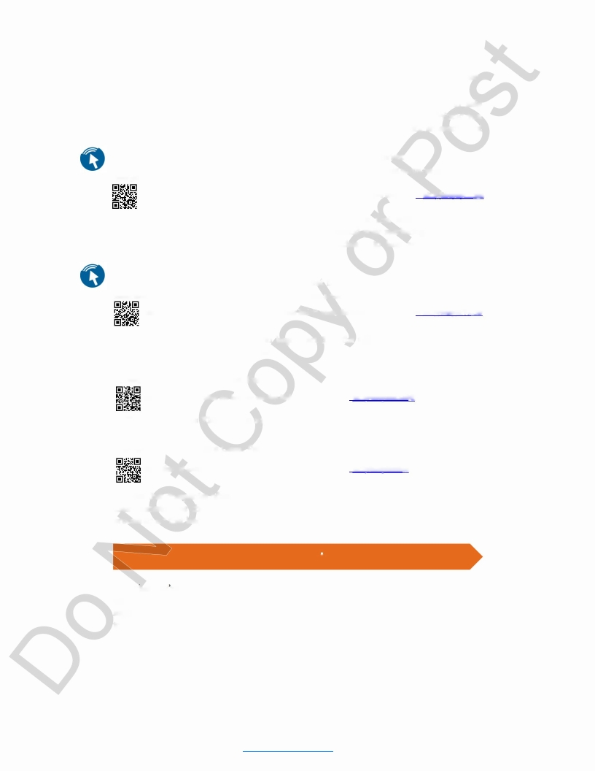

**o o**

13

Consider the following exercises and how asking *why* can yield deep insights about consumer buying behavior.

Imagine that you have been hired as a consultant by a dog food manufacturer to heip complete a segmentation study. How would you segment the dog food market? Would you segment the dogs, the owners, or both? Click on **Interactive Illustration 1** for an example of how this market could be segmented.

**INTERACTIVE ILLUSTRATION 1** Segmenting the Dog Food Market

Source: Reprinted from Harvard Business School, "General Foods: Opportunities in the Dog Food Market," HBS No. 578-162 by Scott Ward. Copyright © 1978 by the President and Fellows of Harvard College; all rights reserved.

http://bit.ly/hbsp2pHLtgd

*Scan this QR code, click the text above, or use this link to access the interactive illustration:* bit.ly/hbsp2pHLtgd

What is the best way to segment the market for products

that enable at-home early

pregnancy testing in a cost-effective manner? And how would your marketing strategy differ

for the various segments? Click on **Interactive Illustration**

**2** to help work through this

dilemma.

**INTERACTIVE ILLUSTRATION 2**

Segmenting the Market for Early Pregnancy Test Devices

Source: Exhibit from "A Segmentation You Can Act On," August 1999, McKinsey & Company. Reprinted by permission. http://bit.ly/hbsp2IVa1dv

*Scan this QR code, click the text above, or use this link to access the interactive illustration:* bit.ly/hbsp2IValdv

Please click on the **Video 3** icon to begin Part 3 of the GE Healthcare case, on better understanding the needs of the customer.

**VIDEO 3** GE Healthcare Case: Part 3

http://bit.ly/hbsp2uoAuNf

*Scan this QR code, click the icon, or use this link to access the video:* bit.ly/hbsp2uoAuNf

Please click on the **Video 4** icon to begin Part 4 of the GE Healthcare case, on the basis of

GE’s segmentation.

**VIDEO 4** GE Healthcare Case: Part 4

http://bit.ly/hbsp2utt0c4

*Scan this QR code, click the icon, or use this link to access the video:* bit.ly/hbsp2utt0c4

Note that companies often use a combination of *who, what,* and *why* variables to segment their markets. The choice of variables and how they combine to form segments makes this process an art that leads different companies to segment the same market quite differently.

**2.3 Targeting**

Now that you ve segmented your market based on *who, what,* and *why,* how do you decide which segments to choose? Targeting involves evaluating the attractiveness of each market segment, selecting one or more segments to pursue, and then designing marketing programs to serve them. The goal is to select segments that improve the organization’s chances of maximizing its long-term profitability in those segments.

A firm’s choice of target segments depends on the level of segmentation in a particular

situation

or marketplace, which ranges from mass market to customization, or one-to-one

marketing.

8219 | Core Reading: SEGMENTATION AND TARGETING

12

This document is authorized for educator review use only by GIANCARLO POGGIO, Universidad Francisco Marroquin (UFM) until Aug 2018. Copying or posting is an infringement of

copyright. [Permissions@hbsp.harvard.edu](mailto:Permissions%40hbsp.harvard.edu) or 617.783.7860



14

15

16

Some markets may be *undifferentiated,* meaning that there are virtually no differences in the needs of customers. In these markets, companies may decide to adopt a *mass-marketing* approach by designing the same product for everyone. Large global firms such as Coca-Cola

tend to follow this approach by appealing to the largest

number of customers via broad

distribution

and mass

communication.

This approach

allows

firms

to reach

the largest

potential market at low cost because of economies of scale in product design and marketing. The risk, however, is that competitors (e.g., Snappie or Poland Spring) are able to nibble at the edges of large firms like Coca-Cola by carving out a niche for themselves.

On the other extreme, companies can customize their products and services for individual customers. Firms’ ability to collect immense amounts of data and reach customers in real time

through the Internet

can enable

*one-to-one*

*marketing*

and *mass customization.*

Thus

companies are able to offer customers the ability to design or personalize their own products on a mass scale, effectively turning customers into a “segment of one.” Levi’s now offers customizable jeans, Google’s Gmail offers ads based on the content of an individual’s emails,

home improvement

retailer

Lowe’s can match

a paint color to a fabric

swatch,

and

<Shutterfly.com>allows customers to design their

own holidays cards,

calendars,

and photo

books. IBM even offers a medical app that draws on extensive medical research and patient

cases.

The app, based on data compiled by IBM’s Watson supercomputer, can be accessed

through any computer

or tablet

and offers

personalized

recommendations

on cancer

treatments for oncology patients based on their medical records and insurance.

But mass

customization

is not suited

for all products.

It is appropriate

either

for

technology products and services where the cost of a new product version is virtually zero (e.g., a personalized ad) or for industries where flexible manufacturing technologies exist to make customized products in a cost-effective manner, and where customers are willing to pay

a premium for products and sendees tailored to their

needs.

Paying more for customized

jeans that look good and fit well is more appealing to many customers than paying more for customized toilet paper or laundry detergent. For most products, the reality falls somewhere in between these two extremes of *mass customization* and *mass production,* and that is why segmentation remains a very important and powerful concept in marketing.

When choosing among segments, it is tempting for a company to target segments that are large, have high growth potential, and where the share of the company’s brands is low. The implicit assumption in this choice is that the firm has a lot more room to grow in a large segment with low share. But the segment share for a company might be small because its products do not appeal to that segment or because of intense competition in that segment.

In general, three factors should influence the selection of segments **(Exhibit 9).** First, a firm should consider the *characteristics of various segments,* such as how large they are, how fast they are growing, and how profitable they are likely to be. Second, the firm should consider *its*

*own competencies and resources* that are available

to address the needs of the different

segments. Even if a segment is large and growing, a firm may not have the capability to address the needs of this segment. Managers should also consider their long-term objective in pursuing a segment; for example, they may want to target a small and emerging segment, since it may allow their organization to build unique skills that provide it with a strong competitive advantage in the future. In this case, the choice of target segment may be driven less by profits and more by the desire to learn and develop long-term skills. Finally, a firm should consider *current and potential competition* in each segment. A large and growing segment is likely to draw attention from many competitors, which may eventually lead to a price war and low margins. Sometimes it may be better to pursue a small niche segment that does not attract the attention of large and powerful competitors.

8219 | Core Reading: SEGMENTATION AND TARGETING

13

This document is authorized for educator review use only by GIANCARLO POGGIO, Universidad Francisco Marroquin (UFM) until Aug 2018. Copying or posting is an infringement of

copyright. [Permissions@hbsp.harvard.edu](mailto:Permissions%40hbsp.harvard.edu) or 617.783.7860



17

**EXHIBIT 9** Selecting Target Segments

**Segment**

**Characteristics**

■

■

■

Segment size

Growth rate

Profitability

**Competition**

• Competitors' strengths

• Competitive intensity

■ Competitors' resources

**Company Fit**

■ Objectives

• Competencies

• Resources

These criteria may lead a firm to choose one or more segments. Small firms or firms with a

unique product (e.g.,

Ferrari) may choose to focus on a single segment and pursue a *niche*

strategy. This strategy allows a firm to have a dominant share in its segment, and even if this segment is small in size, it can have high profit margins.

Some companies target

multiple

segments simultaneously,

often by designing

different

products

to meet the needs of different

segments. Automobile companies target

multiple

segments with sports cars, minivans, hybrid cars, sports utility vehicles, and so on. Sometimes companies design a strategy with a sequential entry into multiple segments. In such a case, a firm may start by building a strong position in one segment of the market and slowly expand its reach in adjacent segments. For example, Porsche started with an exclusive focus on the sports car segment and later expanded its product line with the launch of Porsche Cayenne, a midsize luxury crossover (station wagon), and Porsche Panamera, a four-door luxury sedan.

In some cases firms may decide to target *all* segments in the market. For example, Sansiri,

a residential

housing developer in Thailand, targeted market segments along the full price

range—high, medium, and low—and supplied all types of housing—houses, townhouses, and

condos.

This strategy is often used to preempt the competition from gaining a foothold in

any of the segments and later encroaching on a firm’s more profitable markets. Even so, the approach not only requires significant investment but also carries a risk of failure because of its lack of focus.

**2.4 Ethical and Privacy Issues**

As technology

improves

and makes it easier

for companies to reach

customers

on an

individual basis, how far should a company go? Even if it is possible to segment and target at a

micro level,

certain considerations such as public reaction, privacy, and ethical concerns—

such as those raised by targeting children—should be taken into account when finalizing a strategy.

For example, online retailers can tell

if customers have come from competitors’ websites

and can offer lower prices if they feel the customer is comparison shopping. This approach, however, if discovered, may not sit well with loyal customers paying the higher prices. In 2000,

8219 | Core Reading: SEGMENTATION AND TARGETING

14

This document is authorized for educator review use only by GIANCARLO POGGIO, Universidad Francisco Marroquin (UFM) until Aug 2018. Copying or posting is an infringement of

copyright. [Permissions@hbsp.harvard.edu](mailto:Permissions%40hbsp.harvard.edu) or 617.783.7860



18

19

20

Amazon conducted such a price test

on DVDs, sparking a backlash from consumers. Jeff

Bezos, Amazon’s CEO, later apologized and called this experiment a mistake.

In late 1999, Coca-Cola Company faced a similar backlash when it designed a vending machine that could change prices depending on the weather; presumably consumers should be willing to pay more on a hot, humid day than on a cold, dry day. When the public reacted

in disbelief

and indignation,

Coke abandoned its technologically

advanced

vending

machines.

Firms increasingly mine customers’ purchase data to target

them, but this tactic

raises

privacy concerns among consumers. In 2012, the retailer Target set out to identify when a customer was in her second trimester of pregnancy in order to have a head-start wooing new

parents (a very lucrative

segment) who had highly flexible

brand loyalties.

The company

developed a pregnancy-prediction score based on the purchase of certain products, such as unscented lotion and vitamins, which allowed it to estimate a due date for the baby. Armed

with this information,

Target used a specific

schedule to send certain

coupons to attract

pregnant women to the stores. Once in the stores, women would receive a broader array of

coupons at checkout

for things they might need in addition

to baby products,

such as

groceries and clothing. This worked quite well for a year, until a father of a high-school

student

walked into a Target

store,

furious

that the company was sending his daughter

coupons for baby supplies. This incident made Target reconsider the public relations risk of

customization,

even though it turned out that Target

was actually

right—the teen was

pregnant and had not told her parents.

**2.5 From Segmentation and Targeting**

**□ Su ateg^ Formation**

Segmentation and targeting significantly influences an organization’s resource allocation and marketing strategy. Specifically, this process can influence the organization’s product, pricing, communication, sales force, and customer management strategies.

*Product strategy.* Gap Inc. has mapped out a product-line strategy based on its consumers’ shared values of being urban and fashionable, but has differentiated its offerings based on age, aspirations, and income. While Gap’s apparel is moderately priced, clothing at Old Navy, its

sister

store,

is aimed at younger people and is even more affordable.

Gap Inc.’s top-end

clothing store, Banana Republic, is aimed at people with even higher incomes and aspirations. For the bargain hunters in each category, the Gap and Old Navy brands also offer outlet stores, which sell their own lines of clothes as well as extras from the regular stores. Gap Inc. ’s brand family also includes Athleta, a store that carries a line of athletic wear, and Piperlime, an

online boutique that sells

designer

shoes,

bags, and women’s clothing.

All of these

are

examples of product strategy in the clothing business. But we can see similar strategies played out in other industries, such as automobile companies, which typically offer different products to appeal to different segments. Similarly, we saw in Interactive Illustration 2 how Quidol

introduced two pregnancy test

packages to appeal to two segments of women, those who

hoped to be pregnant and those who feared they were pregnant. Finally, a strategy used in an age-old industry, book publishing, delays the production of soft cover versions of books to ensure that publishers extract higher prices from the most avid readers, who are willing to pay more for the hard cover versions.

*Pricing*

*strategy.*

Airlines

segment their

customers into leisure

and business

travelers.

Eeisure

travelers

are price-sensitive,

while

business

travelers

care

more about schedule,

8219 | Core Reading: SEGMENTATION AND TARGETING

15

This document is authorized for educator review use only by GIANCARLO POGGIO, Universidad Francisco Marroquin (UFM) until Aug 2018. Copying or posting is an infringement of

copyright. [Permissions@hbsp.harvard.edu](mailto:Permissions%40hbsp.harvard.edu) or 617.783.7860



**oo**

21

frequent flier miles, and the ability to book at the last minute. It is difficult to identify leisure

or business

travelers

based on demographics

or similar

variables.

Consequently,

airlines

devised their strategy of offering lower prices for leisure travelers who are willing to book several weeks in advance and to stay overnight on Saturday—factors that are less appealing to business travelers. Customers from each segment could pay very different prices for the same seat on the same flight. Supermarkets, on the other hand, offer coupons to appeal to price­ sensitive customers who take the time and effort to clip and redeem coupons, while customers who are not price-sensitive pay the regular price. In this way, coupons serve as a tool that allows a company’s customers to self-select into price-sensitive and price-insensitive segments.

*Communication strategy.*

Knowing the target

audience for a product helps advertising

agencies design appropriate ads and choose the right media. Toyota’s Tundra truck appeals to consumers who must transport and carry heavy loads as part of their jobs, so its ads highlight the toughness of its trucks on construction sites. These ads would appear in magazines or on TV shows that this target audience is most likely to read and watch. Apple computer ads highlight the attitude and profile of its customers by comparing a hip and unflappable Mac

user with a bumbling PC nerd.

Similarly,

companies that are trying to reach

younger

audiences are investing more advertising dollars

into digital

and mobile channels, such as

Facebook and Google, where these groups spend so much time.

*Salesforce*

*and channel strategy.*

Business-to-business

companies

often segment

their

customers based on the volume of transactions and their potential value to the firm, as we saw earlier in the case of Hill-Rom, the healthcare equipment manufacturer. Many companies set up different channels with different sales teams to target each segment. For example, national account teams call on service-oriented customers who want and value consultation with the sales team, while low-value, infrequent customers are serviced either by a different sales team

that is more transaction-focused

less.

or by independent manufacturer representatives

that cost

*Customer management strategy.*

As mentioned earlier,

companies such as L.L.Bean use

customers’ past purchase

behavior

and RFM segmentation

(how recently

or frequently

purchases were made or the monetary value of the purchase) to decide which customers

should receive

catalogs

and how frequently.

Airlines’ loyalty

programs reward their

best

customers by offering them free upgrades, lounge access, and priority boarding.

At this point, we present the final two parts of the GE Healthcare case. **Video 5** describes how segmentation changed GE Healthcare’s business strategy, while **Video 6** illustrates how GE Healthcare changed to achieve an actionable segmentation.

**VIDEO 5** GE Healthcare Case: Part 5

http://bit.ly/hbsp2uo6JfB

*Scan this QR code, click the icon, or use this link to access the video:* bit.ly/hbsp2uo6JfB

**ViDEO 6** GE Healthcare Case: Part 6

http://bit.ly/hbsp2utt5fS

*Scan this QR code, click the icon, or use this link to access the video:* bit.ly/hbsp2utt5fS

For a more in-depth discussion of the various aspects of marketing strategy, see *Core Read­ ing: Framework for Marketing Strategy Formation* (HBP No. 8153). For a final example of how

segmentation can differentiate

and improve a company’s marketing strategy

and business

performance, see the sidebar, “Segmentation, Targeting, and Strategy Formation at the Gas Pump.”

8219 | Core Reading: SEGMENTATION AND TARGETING

16

This document is authorized for educator review use only by GIANCARLO POGGIO, Universidad Francisco Marroquin (UFM) until Aug 2018. Copying or posting is an infringement of

copyright. [Permissions@hbsp.harvard.edu](mailto:Permissions%40hbsp.harvard.edu) or 617.783.7860



**Segmentation, Targeting, and**

**Strategy Formation at the Gas Pump**

In the early 1990s, price wars at the gas pump threatened the profitability of oil companies,

as gas stations often matched prices to the penny, which significantly eroded their margins.

Oil companies inherently assumed that consumers were extremely price-sensitive, and that

small differences in price would drive them away to competitors. To better understand its

customers and their price sensitivity, Mobil conducted a study of 2,000 customers and

uncovered the following five segments.

**Road Warriors** (16% of buyers). Customers, such as salespeople, who used their cars as part

of their profession. They typically drove between 25,000 and 50,000 miles a year, tended to

be middle-aged men with higher incomes who preferred credit cards to cash, liked to buy

food during their visit, and would use the car wash from time to time.

**True Blues** (16% of buyers). Brand-loyal and occasionally station-loyal consumers, with

moderate to high incomes, who preferred to pay in cash and buy premium gas.

**Generation F3** (27% of buyers). Upwardly mobile young consumers who drove often and

habitually purchased a lot of snacks. Roughly 50% were under 25 years old.

**Homebodies** (21% of buyers). Stay-at-home mothers who valued gas station proximity, either

to their homes or to their normal travel routes for their children’s activities.

**Price Shoppers** (20% of buyers). Customers on a budget who rarely bought premium gas

and were usually not brand- or station-loyal.

What surprised Mobil was that only 20% of customers were Price Shoppers, and they spent

an average of $700 per year. In contrast, Road Warriors spent as much as $1,200 annually on

gas and were not particularly price-sensitive. Instead of low prices, these customers were

looking for well-lit gas stations that were open long hours, offered snacks and drinks, and

made it easy for them to get in and get out quickly., -

This insight led Mobil to focus on the 80% of the non-price-sensitive market. Mobil

redesigned its gas stations with better lighting, kept many of its stations open 24 hours, and

offered a larger variety of snacks and drinks, which were high-margin items. It also started

Mobil Speedpass, which was linked to customers’ credit cards and offered contactless

payment at the pump. Once Mobil decided to focus on segments that were not price­

sensitive, it increased its average price at the pump by two cents a gallon. These changes led

to more than a 20% increase in sales and an extra $118 million in annual earnings.

Source: Adapted from Allanna Sullivan, "Mobil Bets Drivers Pick Cappuccino Over Low Prices," *The Wall Street Journal,* January 30,1995, section B1.

Customers differ

in their

preferences, and it is critical

for a company to understand these

differences and to design products and marketing strategies that appeal to different consumer

groups. Therefore

segmentation,

or the process

of finding groups of consumers

with

homogeneous needs, is one of the most fundamental concepts in marketing. Segmentation can be done using a variety of variables such as demographics or purchase behavior. The process

of segmentation remains more of an art than science,

however, and a manager’s careful

judgment is needed. Once segments are defined, the company needs to decide which segments it wants to pursue and how it wishes to position its products in those segments. (Positioning will be discussed in detail in *Core Reading: Brand Positioning* [HBP No. 8197].) The process of targeting depends on three major factors: segment characteristics (e.g., its size and growth); fit

with company resources

and capabilities;

and the competitive

intensity

in the various

segments. After

selecting

the target

segments, a firm designs its products and marketing

programs to specifically meet the needs of the chosen segments. 8219 | Core Reading: SEGMENTATION AND TARGETING

17

This document is authorized for educator review use only by GIANCARLO POGGIO, Universidad Francisco Marroquin (UFM) until Aug 2018. Copying or posting is an infringement of

copyright. [Permissions@hbsp.harvard.edu](mailto:Permissions%40hbsp.harvard.edu) or 617.783.7860

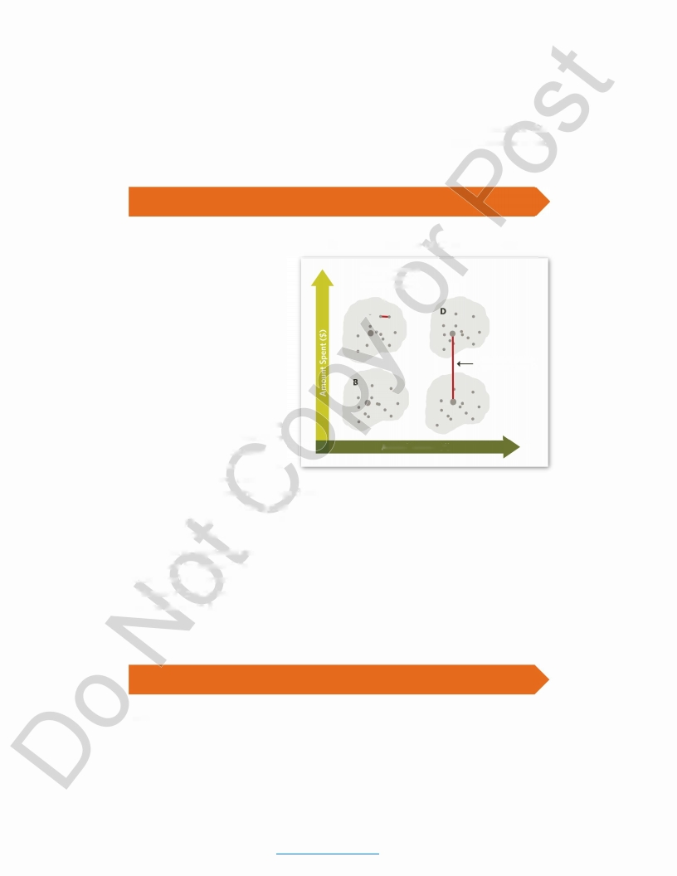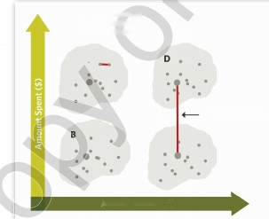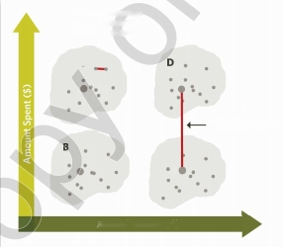

**3 SUPPLEMENTAL READING**

What analytical

methods do companies use to identify

their

customer segments? In this

section we briefly describe three commonly used segmentation techniques: cluster analysis, preference-based segmentation, and response-based segmentation.

**3.1 Cluster Analysis**

Cluster analysis is a method to group customers based on a set of variables so that customers in one group are similar to each other but are different from customers in another group. For example, if a company decides to segment its customers based on their annual income and the amount of money they spent on the company’s product last year, then we can plot each customer in a two- dimensional space, as shown in **Exhibit 10.** Cluster analysis then attempts to group these customers and determine the number of

**EXHIBIT 10** An Example of Cluster Analysis

Distance between

two customers in

the same segment

J

Distance between

segments C and D

**Annual Income ($)**

clusters or groups so that the

distance between two customers

in a cluster is small, but the average distance between the two groups is large. In Exhibit 10, Cluster A (Segment A) is the group of customers with low incomes but high expenditures on

the company’s products,

while Segment C represents

high-income consumers who spend

relatively less on the company’s products.

In general, segmentation is carried out with more than two variables. For example, a firm may decide to segment its customers based on several demographics (e.g., age, income, and occupation) and several purchase behavior characteristics (e.g., RFM). Cluster analysis creates a “distance” metric between these multiple variables and creates groups in a manner similar to the one shown in Exhibit 10.

**3.2 Preference-Based Segmentation**

Ideally,

segments highlight

how customers

in different

groups differ

in their

needs and

preferences.

There

are two broad approaches

in performing

such a preference-based

segmentation. The first

approach, called

the *multi-attribute*

*model,* explicitly

asks consumers

about their preferences for a variety of attributes that a manager may consider relevant for their purchase decision. For example, in choosing a mobile phone, consumers may consider the brand (e.g., Apple or Samsung), screen size, data storage capacity, price, and the number

8219 | Core Reading: SEGMENTATION AND TARGETING

18

This document is authorized for educator review use only by GIANCARLO POGGIO, Universidad Francisco Marroquin (UFM) until Aug 2018. Copying or posting is an infringement of

copyright. [Permissions@hbsp.harvard.edu](mailto:Permissions%40hbsp.harvard.edu) or 617.783.7860

>

**n**

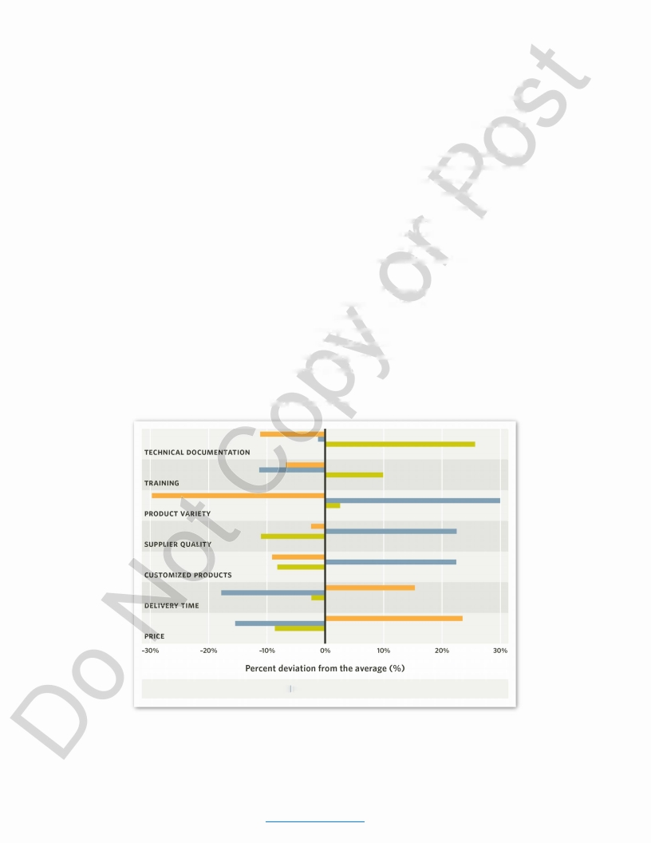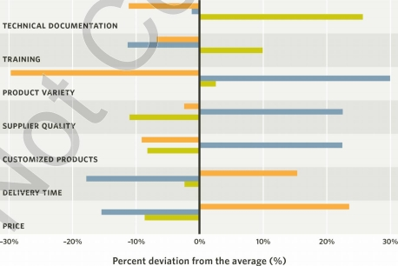

of apps available for the operating system. A survey would then ask consumers to divide 100

points across these attributes

in the order of importance, and then group consumers with

similar preferences. As a result, we may find that 30% of consumers find price to be the most important variable, that 20% choose mobile phones primarily on the basis of brands, and so on. (See *Core Reading: Creating Customer Value* [HBP No. 8176].)

While this method is simple, it is often difficult for consumers to articulate the relative im­

portance of various product attributes.

The second approach, called *conjoint*

*analysis,*

works

around this problem by forcing consumers to make tradeoffs between several pairs of prod­

ucts that differ on a carefully designed combination of attributes.

For example, would you

choose a house with a large kitchen but a small backyard or a similar house with a small kitchen but large backyard? Your choice tells researchers about your preferences and what you consider more important. Repeated paired comparisons of this kind can be used to infer how a consumer weighs different attributes. Consumers can then be grouped into different seg­ ments based on the similarity of their preferences. (See *Core Reading: Marketing Intelligence* [HBP No. 8191].)

**Exhibit 11** shows the results of three segments for a B2B company derived from conjoint

analysis.

The bars in this chart

show the percentage

deviation

of a segment’s attribute

importance from that of the average customer. Segment A (labeled as the price group) is more sensitive to price and delivery time than the average customer; Segment B gives greater weight

to customized products, supplier

quality,

and product variety

(therefore

called

the product

group); and Segment C cares

more about training

and technical

documentation than the

average customer (hence labeled as the service group).

**EXHIBIT 11** Preference-Based Segmentation for a B2B Company

■ Price segment (A) I Product segment (B)

■ Service segment (C)

8219 | Core Reading: SEGMENTATION AND TARGETING

19

This document is authorized for educator review use only by GIANCARLO POGGIO, Universidad Francisco Marroquin (UFM) until Aug 2018. Copying or posting is an infringement of

copyright. [Permissions@hbsp.harvard.edu](mailto:Permissions%40hbsp.harvard.edu) or 617.783.7860



**3.3 Response-Based Segmentation**

*a*

While preference-based segmentation can assess

how consumers may respond to a firm’s

offerings such as price discounts, these results are based on customer-stated intentions in a survey or a conjoint experiment. If a firm has data on consumers’ past purchases, it can predict their response to marketing actions based on their actual purchase behavior and then segment customers based on, for example, their price sensitivity.

This approach is simple if we have a large data series for each consumer that would allow us to run a statistical analysis, such as *regression analysis,* to infer each individual consumer’s price sensitivity, which in turn can be used as a variable in a cluster analysis for segmentation. In reality, this is rarely the case, however. Often consumers only buy from a company a few times a year, and the data series are not long enough to do individual-level analysis. Using data from many years is also problematic, since consumer behavior may change over time.

In such cases we can use a statistical technique called *latent class analysis* that allows us to

infer

latent,

or hidden, segments from limited individual-level

data.

Assume we randomly

divide consumers into two groups and run a regression on each group separately to assess its price sensitivity. We may find that Group 1 is more price-sensitive than Group 2. We then go back to each customer in Group 1 and statistically assess his or her chance of belonging to this group. For example, if a customer has always bought at regular price, she probably does not belong to the price-sensitive Group 1. In such a case, this person is reassigned to Group 2, and the process is repeated. Research has shown that this iterative process eventually converges to give us the appropriate allocation of consumers in the two groups and the price sensitivity of the two segments. Since our choice of two segments was arbitrary, the process is repeated with

three

or more segments, and statistical

measures are used to assess

the right number of

segments.

8219 | Core Reading: SEGMENTATION AND TARGETING

20

This document is authorized for educator review use only by GIANCARLO POGGIO, Universidad Francisco Marroquin (UFM) until Aug 2018. Copying or posting is an infringement of

copyright. [Permissions@hbsp.harvard.edu](mailto:Permissions%40hbsp.harvard.edu) or 617.783.7860



4 **KEY TERMS**

**conjoint analysis** A market research technique that asks customers to make a series of trade-offs between component attributes; analysis of these trade-offs helps companies determine how to develop and price the features of products and services.

**latent class analysis** A statistical method for identifying unmeasured class membership among subjects using categorical and/or continuous observed variables.

**mass customization** A product delivery approach utilizing flexible, computer-aided manufacturing systems. Each customer can select and customize the product’s final features to his or her individual preferences.

**multi-attribute model** An approach that analyzes a consumer’s evaluation of an object

**one-to-one-marketing** A marketing approach based on customer relationship management (CRM), emphasizing

personalized relationships with individual

customers.

**positioning** Defining a value proposition for the target segments; differentiating a product or service (or its brand) from others in the perception of consumers.

**segmentation** A marketing planning process that involves dividing a broad target market into subsets or groups of consumers who have common needs or characteristics,

**targeting** Selecting the potential customer segments to whom a company wishes to sell products or services, after an analysis of each segment’s attractiveness.

(product, brand, service, etc.) as a function of

the beliefs that he or she has toward the object

on various attributes and the importance of

these attributes.

5 **FOR FURTHER READING**

Kumar, Nirmalya. “From Market Segments to Strategic Segments.” In *Marketing as Strategy.* Boston: Harvard Business Review Press, 2004.

Quelch, John A., and Katherine E. Jocz. “How to Market in a Downturn.” *Harvard Business Review* 87 (April 2009): 52-62.

Yankelovich, Daniel, and David Meer. “Rediscovering Market Segmentation.” *Harvard Business Review* 84 (February 2006): 122-131.

8219 | Core Reading: SEGMENTATION AND TARGETING

21

This document is authorized for educator review use only by GIANCARLO POGGIO, Universidad Francisco Marroquin (UFM) until Aug 2018. Copying or posting is an infringement of

copyright. [Permissions@hbsp.harvard.edu](mailto:Permissions%40hbsp.harvard.edu) or 617.783.7860



6 **ENDNOTES**

1 Dana Mattioli, “On Orbitz, Mac Users Steered to Pricier Hotels,” *The Wall Street Journal,* August 23, 2012, <http://online.wsj.com/news/articles/SB10001424052702304458604577488822667325882>, accessed

February 5, 2014.

2 Henry Ford and Samuel Crowther, *My Life and Work* (Garden City, NY: Doubleday, Page & Company, 1922), p. 72.

3 Philip Kotler and Kevin Lane Keller, *Marketing Management,* 14th ed. (Upper Saddle River, NJ: Prentice Hall, 2012), pp. 231-232.

4 Grant Hatch, Pieter Becker, and Michelle van Zyl, “The Dynamic African Consumer Market: Exploring Growth Opportunities in Sub-Saharan Africa,” September 7, 2011, <http://www.accenture.com/>SiteCollectionDocuments/Local_South_Africa/PDF/Accenture-The-Dynamic-African-Consumer-Market-

Exploring-Growth-Opportunities-in-Sub-Saharan-Africa.pdf, accessed July 5,2013.

5 Joan Schneider and Julie Hall, “Why Most Product Launches Fail,” *Harvard Business Review* 89 (April 2011): 21-23.

6 Jan-Benedict E. M. Steenkamp and Frenkel Ter Hofstede, “International Market Segmentation: Issues and Perspectives,” *International Journal of Research in Marketing* 19 (September 2002): 185-213.

7 *The Nikkei Weekly* (Japan), “Alcohol-free Booze Boom Creates New Market Segment,” April 9, 2012, p. JEJ.

8 John Forsyth, Sunil Gupta, Sudeep Haidar, Anil Kaul, and Keith Kettle, “A Segmentation You Can Act On,” *McKinsey Quarterly* 3 (1999): 6-15.

9 Tim Nudd, “ ‘Bic for Her’ Pens Deluged with Sarcastic Reviews on Amazon,” *Adweek,* August 27, 2012, <http://www.adweek.com/adfreak/bic-her-pens-deluged-sarcastic-reviews-amazon-143145>, accessed February 5, 2014; <Amazon.com>, “BIC Cristal For Her Ball Pen, 1.0mm, Black, 16ct (MSLP16-Blk),” Customer Reviews <http://www.amazon.eom/BIC-Cristal-l-0mm-Black-MSLP16-Blk/dp/B004F9QBE6/>ref=sr_l_l?ie=UTF8&qid=1360879826&sr=81&keywords=bic+for+her, accessed February 5, 2014.

10 The Nielsen Company, “Nielsen PRIZM Lifestage Groups,” <http://www.claritas.com/MyBestSegments/>Default.jsp?ID=7010&menuOption=learnmore&pageName=PRIZM%2BLifestage%2BGroups&segSystem =PRIZM, accessed February 5, 2014; The Nielsen Company, “Nielsen PRIZM Social Groups,” [http://www.claritas.com/MyBestSegments/Default.jsp?ID=7020&menuOption=learnmore&pageName=](http://www.claritas.com/MyBestSegments/Default.jsp%3FID%3D7020%26menuOption%3Dlearnmore%26pageName%3D) PRIZM%2BSocial%2BGroups&segSystem=PRIZM, accessed February 5, 2014.

11 Grant Hatch, Pieter Becker, and Michelle van Zyl, “The Dynamic African Consumer Market: Exploring Growth Opportunities in Sub-Saharan Africa,” September 7, 2011, <http://www.accenture.com/>SiteCollectionDocuments/Local_South_Africa/PDF/Accenture-The-Dynamic-African-Consumer-Market- Exploring-Growth-Opportunities-in-Sub-Saharan-Africa.pdf, accessed July 5, 2013.

12 Marc Beaujean, Vincent Cremers, and Francisco Pedro Goncalves Pereira, “How European Banks Can Profit from Loyal Customers,” *McKinsey Quarterly* (November 2005): 16-19.

13 Philip Kotler and Kevin Lane Keller, *Marketing Management,* 14th ed. (Upper Saddle River, NJ: Prentice Hall, 2012), pp. 233-234.

14 Casey Johnston, “IBM’s Supercomputer: Jeopardy Was Too Easy, Time to Cure Cancer,” *Ars Technica,* February 8, 2013, [http://arstechnica.com/science/2013/02/ibms-supercomputer-jeopardy-was-too-easy- time-to-cure-cancer/](http://arstechnica.com/science/2013/02/ibms-supercomputer-jeopardy-was-too-easy-time-to-cure-cancer/), accessed February 5, 2014.

15 Paul Zipkin, “The Limits of Mass Customization,” *MIT Sloan Management Review* 42 (Spring 2001): 81-87.

16 Michael E. Porter, “The Five Competitive Forces That Shape Strategy,” *Harvard Business Review* 86 (January 2008): 78-93.

8219 | Core Reading: SEGMENTATION AND TARGETING

22

This document is authorized for educator review use only by GIANCARLO POGGIO, Universidad Francisco Marroquin (UFM) until Aug 2018. Copying or posting is an infringement of

copyright. [Permissions@hbsp.harvard.edu](mailto:Permissions%40hbsp.harvard.edu) or 617.783.7860



17 Somluck Srimalee, “Sansiri Goes for All Market Segments,” *The Nation* (Thailand), January 18, 2012, <http://www.nationmultimedia.com/business/Sansiri-goes-for-all-market-segments-30173935.html>,

accessed January 12, 2014.

18 “Bezos Calls Amazon Experiment ‘A Mistake,’ ” *Puget Sound Business Journal,* September 28, 2000, <http://www.bizjournals.com/seattle/stories/2000/09/25/daily21.html>, accessed January 12, 2014.

19 Charles King and Das Narayandas, “Coca-Cola’s New Vending Machine (A): Pricing to Capture Value, or Not?” HBS No. 500-068 (Boston: Harvard Business School, 2000).

20 Charles Duhigg, “How Companies Learn Your Secrets,” *The New York Times,* February 19, 2012, [http://www.nytimes.com/2012/02/19/magazine/shopping-habits.html?pagewanted=all&_r=0](http://www.nytimes.com/2012/02/19/magazine/shopping-habits.html%3Fpagewanted%3Dall%26_r%3D0), accessed

February 5, 2014.

21 Tim Nudd, “Apple’s ‘Get a Mac,’ the Complete Campaign,” *Adweek,* April 13, 2011, at <http://www.adweek.com/adfreak/apples-get-mac-complete-campaign-130552>, accessed February 5, 2014.

8219 | Core Reading: SEGMENTATION AND TARGETING

23

This document is authorized for educator review use only by GIANCARLO POGGIO, Universidad Francisco Marroquin (UFM) until Aug 2018. Copying or posting is an infringement of

copyright. [Permissions@hbsp.harvard.edu](mailto:Permissions%40hbsp.harvard.edu) or 617.783.7860



7 **INDEX**

accessible segments, 6

actionable segments, 7, 16

airline industry, 15-16

<Amazon.com>, 5, 6, 15

apparel industry, 15

Apple Inc., 16, 18

automobile industry, 5, 14, 15, 16

banking industry, 10

behavioral variable, 7

benefits of segmentation, 5-6

benefits sought variable, 7

Bic brand pens, 8

book publishing industry, 15

Boston Consulting Group (BCG), 9

brand loyalty, 10, 11, 15,17

business strategy, 15-18

business to business (B2B) market, 8, 11, 19 buying behavior, 10-12, 16

CfC Stanbic Bank, 10

channel strategy, 16

cluster analysis, 18

Coca-Cola Company, 6, 13,15

communication strategy, 16

competencies, 13, 17

competition, 3, 13, 14-15,17

computer industry, 13, 16

conjoint analysis, 19, 21

customer data, 3, 5, 6,10,11,13,15, 20 customer loyalty, 10,11,14-15, 16, 17 customer management strategy, 16

customer preferences, 18-19

customer purchase behavior, 10-12,16

customer segments, 3,17

customer value proposition, 3, 4, 21

customization, 5, 6,10, 12-13,15, 19

data collection and analysis, 3, 5, 6, 10, 11, 13, 15, 20

demographics variables, 6, 7, 8-9,16, 17,18 design of products, 3, 4, 8, 9, 11, 13, 14, 17 differentiable segments, 7

ethical issues, 14-15

Exxon Mobil Corporation, 17

Facebook, 6, 8, 16

Ford Motor Company, 5

Gap Inc., 15

GE Healthcare, 10, 16

geographic variable, 7, 10

Google, 13, 16

healthcare industry, 10, 11, 12, 16 Hill-Rom, Inc., 11, 16

hospital industry, 5

housing industry, 14, 19

IBM, 13

identifiable segments, 6

international segments, 7

Japan, 7

key customers, 11

L.L.Bean, Inc., 10,16

latent class analysis, 20, 21

lifestyle variables, 7, 8, 10

Lowe’s, 13

marketing, 3, 4, 7, 9, 11, 12-13, 15-17, 20 market research, 10, 21

market share, 10, 11,13,14

mass customization, 13, 15, 21

mass marketing, 12,13

mass production, 13

McDonald’s, 10

McKinsey & Company, 5

millennial demographic segment, 9

Mobil Corporation, 17

multi-attribute model, 18-19, 21

Netflix, 5

new parent segment, 6

Nielsen Company, 10

objectives, 13

oil industry, 17

one-to-one-marketing, 12, 13, 21

Orbitz Worldwide, Inc., 3

pen industry, 8

Porsche AG, 14

positioning, 3, 4,17, 21

preference-based segmentation, 18-19 price sensitivity, 3-4, 8,15,16, 17, 19, 20 pricing strategy, 3, 8,14,15-16, 17

8219 | Core Reading: SEGMENTATION AND TARGETING

24

This document is authorized for educator review use only by GIANCARLO POGGIO, Universidad Francisco Marroquin (UFM) until Aug 2018. Copying or posting is an infringement of

copyright. [Permissions@hbsp.harvard.edu](mailto:Permissions%40hbsp.harvard.edu) or 617.783.7860



prime customers, 11

privacy issues, 14-15

Procter & Gamble Company, 6

product design, 3,4, 8, 9,11, 13,14, 17 product strategy, 15

psychographics variable, 7, 10

purchase behavior, 10-12, 16

regression analysis, 20

resources, 13, 17

response-based segmentation, 20

RFM (recency, frequency, and monetary value of purchases) model, 10, 16, 18

salesforce strategy, 16

Sansiri PCL, 14

Sapporo Breweries Limited, 7

segmentation, 3, 4, 17, 21

segmentation, bases for, 8

segmentation, benefits of, 5-6

segmentation, characteristics of, 6-7

segmentation, definition, 4, 21

segmentation, reasons for using, 4 segmentation, targeting, and positioning

(STP), 3-4

segmentation, uncovering, 4, 5

segmentation, variables in, 7-8

segment characteristic, 6-7,13-14,17

<Shutterfly.com>, 13

social media, 6

software industry, 8

stable segments, 7

strategy formation, 15-18

substantial segments, 6

supermarket industry, 16

Target Corporation, 15

targeting, 3-4, 12-14, 17, 21 Toyota Motor Company, 16

Twitter Inc., 6

undifferentiated markets, 13

Unilever, 6

value proposition, 3, 4, 21

*what* variables, 8, 10, 12

*who* variables, 8-10,12

why variables, 8,11-12

Wolfram Research, 8

8219 | Core Reading: SEGMENTATION AND TARGETING

25

This document is authorized for educator review use only by GIANCARLO POGGIO, Universidad Francisco Marroquin (UFM) until Aug 2018. Copying or posting is an infringement of

copyright. [Permissions@hbsp.harvard.edu](mailto:Permissions%40hbsp.harvard.edu) or 617.783.7860