**David Corzo – 20190432 – HOL – CI**

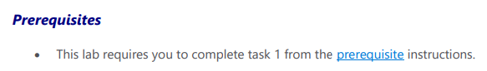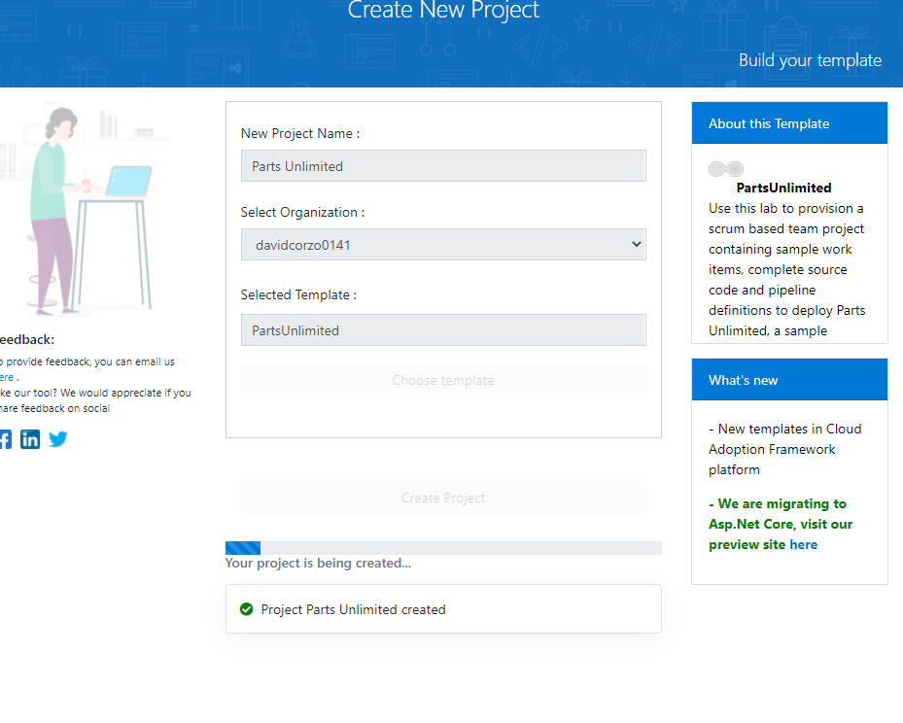**Task 1: Creating a basic build pipeline from a template:**

Build the pipeline.

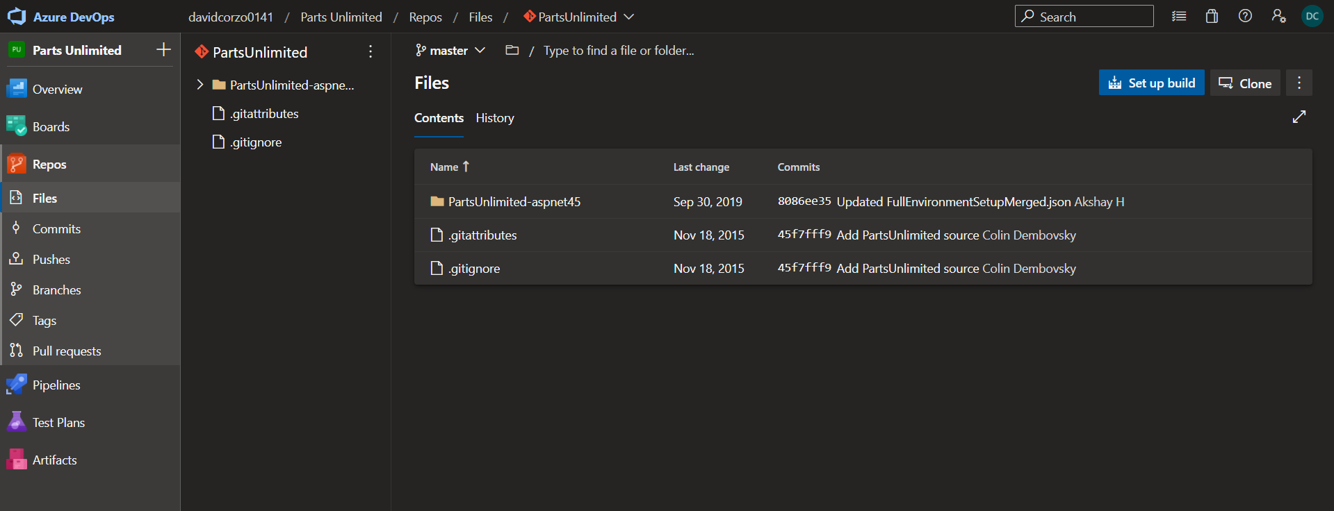

YAML line built.

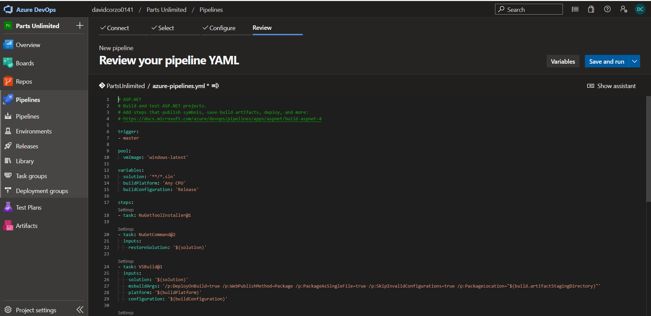

Pipeline.

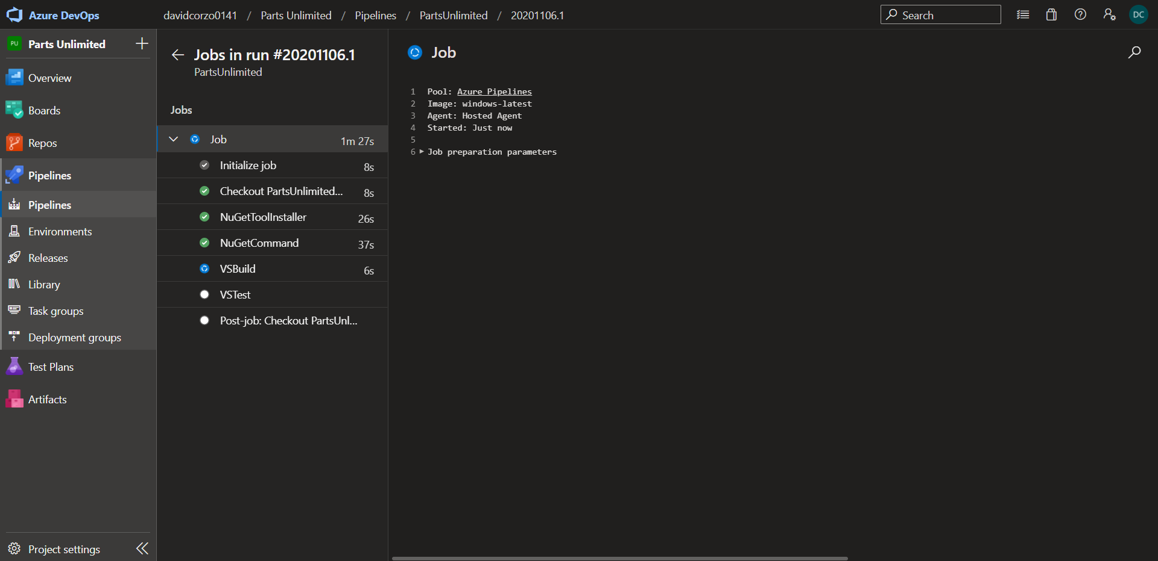

Save and enqueue:

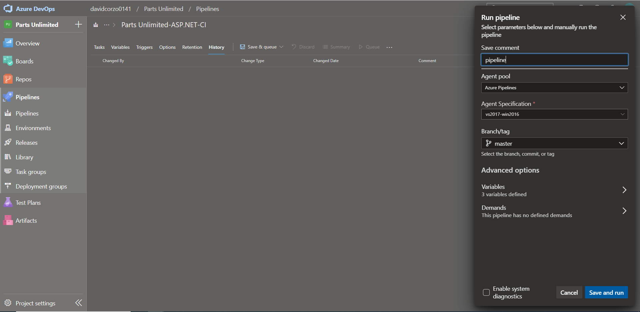

## Task 2: Tracking and reviewing a build

Build.

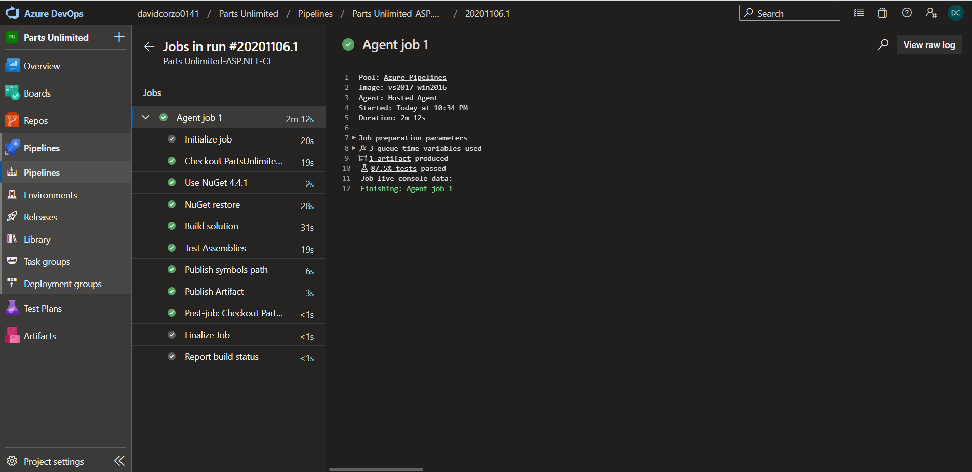

Summary.

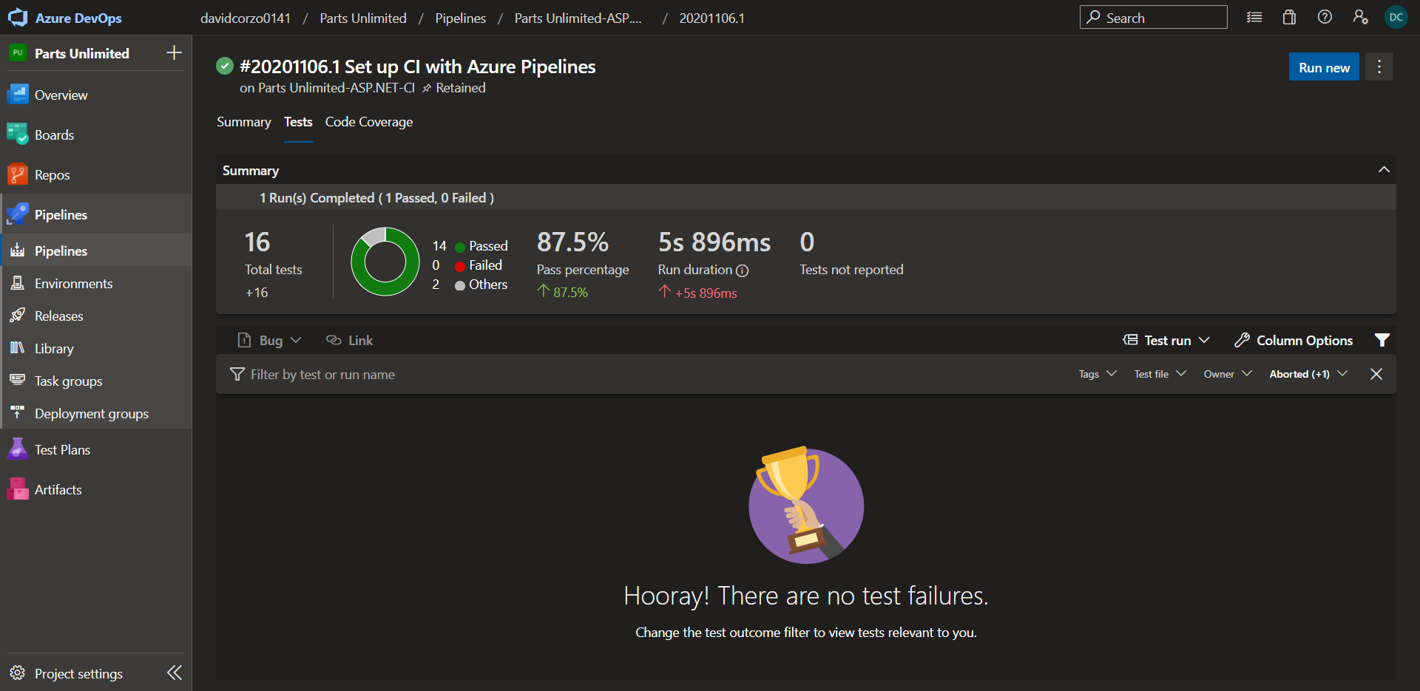

## Task 3: Invoking a continuous integration build

Commiting HTML.

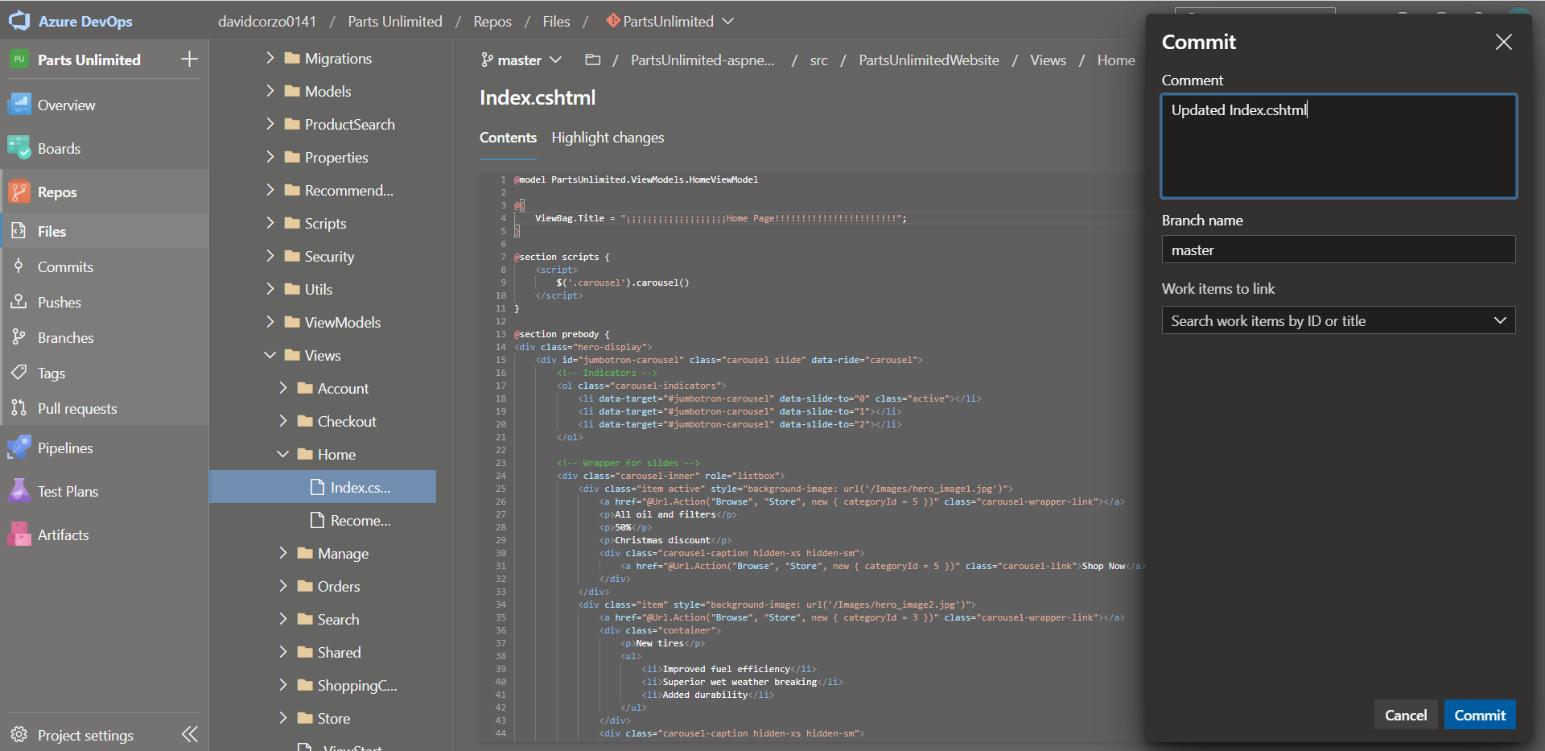

CI Build, HTML commited.

