Protection diodes on the amplifier outputs
version 13 March 2017

Table of Contents
How the ADC dies ? 1
Standard protection diodes 2
Schottky diodes measurements 4
Switching on / off disabling power supplies 4
Effect on signal 8
Comparison 8 ch pulse 14

How the ADC dies ?
From the data sheet :

(Analog Input Voltage (AIN , AIN–, PAR/SER, SENSE) (Note 3)........... –0.3V to (VDD + 0.2V)

But note 3 says :
Note 3: When these pin voltages are taken below GND or above VDD, they
will be clamped by internal diodes. This product can handle input currents
of greater than 100mA below GND or above VDD without latchup.

In "worse" case (short to -3V ) with 200 ohm series at the ADC gives 3/ 100 = 30 mA. So this should not kill the ADC. IF all outputs of the amplifier are at -3V then ( .3 V * 0.03 * 8 =) 720mW .
As these test are done at room temperature I would not expect we heat up so much the chip that it dies fast.
And this is worse case . More realistic is -1 V and 200 ohm series restance ( 3mA , 120mW) .
So not clear why the ADC input dies.

Still to avoid problems using clamp diodes was suggested.

Standard protection diodes
( February 2017)

In the figure below you see
ch 1( blue ) +5V
ch 2 ( light blue ) -3V ( -3V is enabled by the +5V output)
ch 4 (green) one of the outputs of the amplifiers with protection diodes
( without protection diodes it goes to ~ -1V)
This is when the power enable goes to high impedance. ( don't expect any difference if it is drive to 0 )

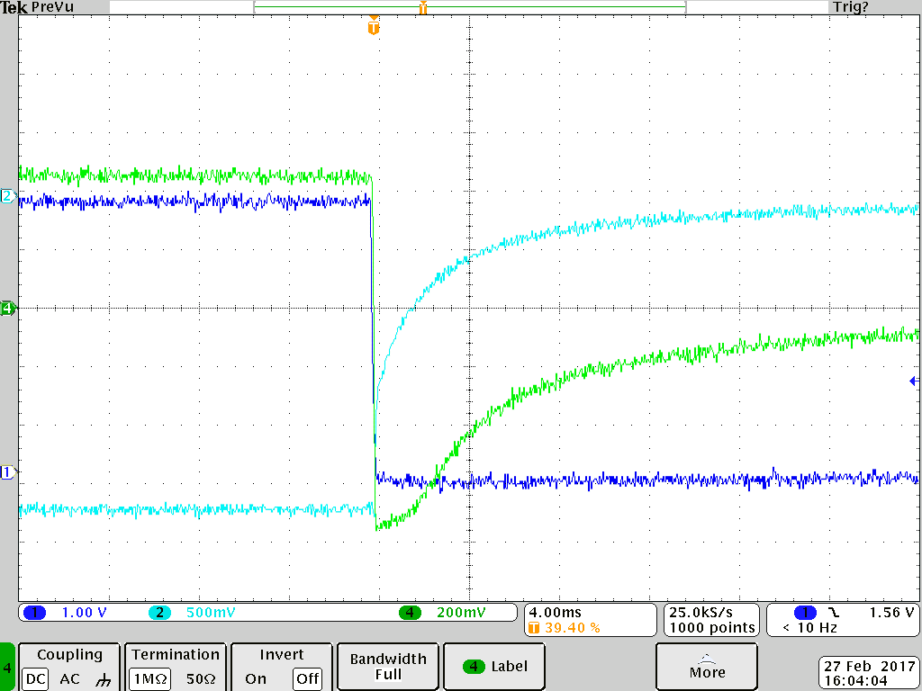

The amplifier output goes up to -0.6V while the spec of the ADC tolerates -0.3V

The signal on the (defect) ADC channel is even smaller.
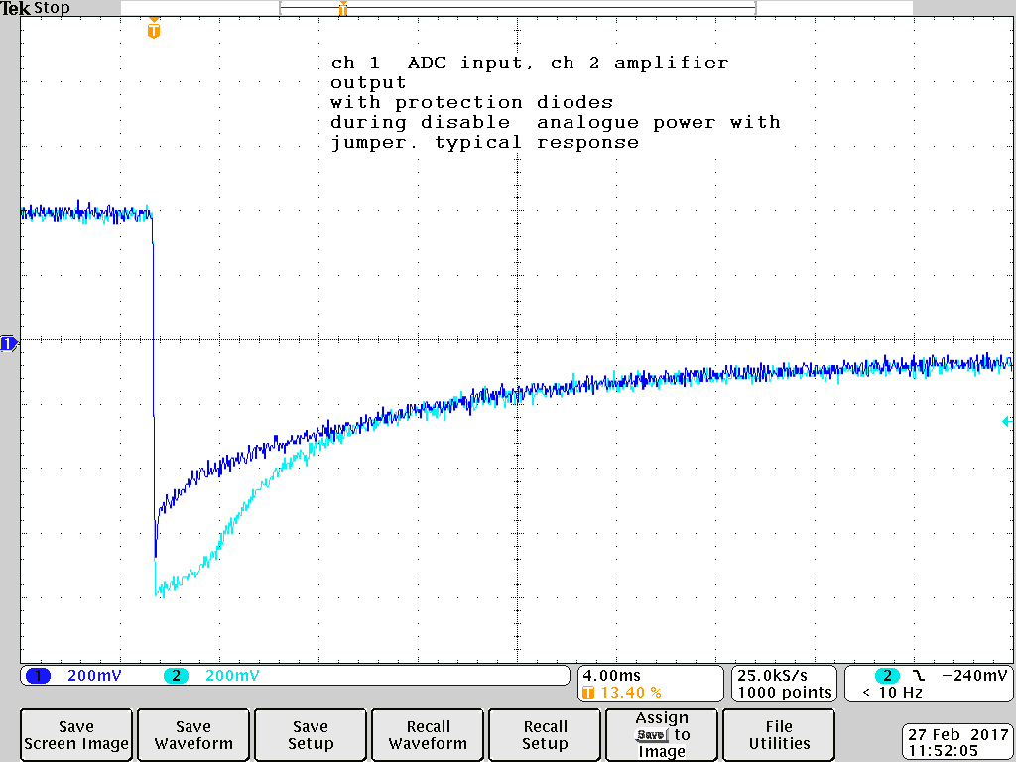
This is obtained with the D1213A-01W-7 protection diode from Diode inc.
The advantage of these diodes are the very small capacitance ~ 4 pF and can withstand high ESD voltages ( discharges) . But the later one is not where we not concern about. We have not to protect the output of the amlifiers.

Schottky dyodes have much higher capacitance ~ 11 pF for the small reverse voltage we apply. In addition the reverse voltage is not for all diodes the same so one get different capacitances ( ~ +/- 2 pF) and varies with the signal ( non linearities)

The effect of capacitance schottly diodes can be seen but is not dominant. So also the effect of capacitance differences would be small ( and on the none linearities). In this part of the circuit we are not sensitive for pickup so also the common mode rejection should be not effected.

Below the simulation, The V(adc2) is the curve with the schottky diodes capacitance set to 2x10pF
( In the schematics are not all the correct values but the relative influence of the capacitance should be the same)
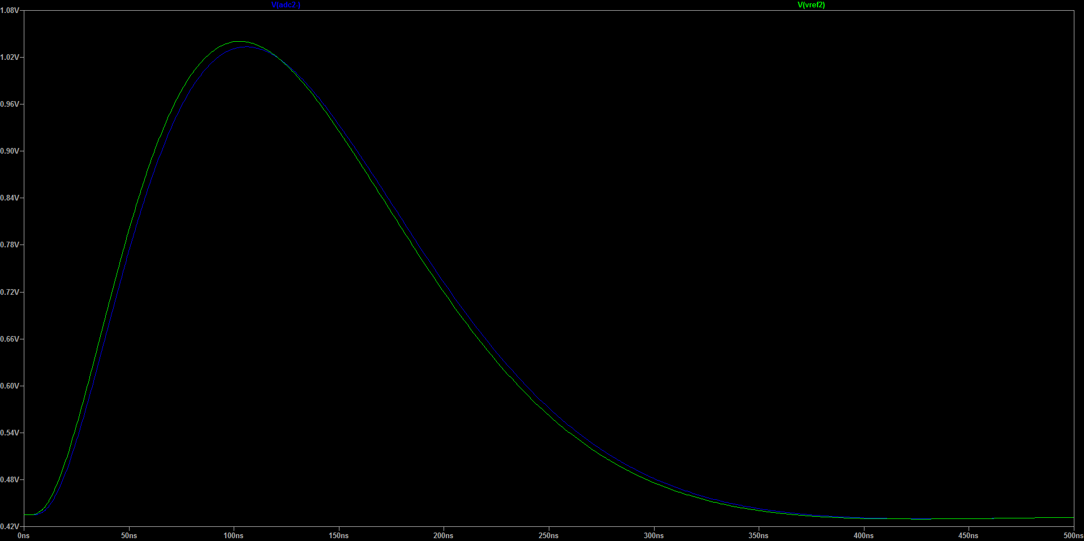

I selected at the moment the DB3S308F dual Shottky diode . Vf ( @ If =10mA) 0.3V ( while we expect less then 10mA) recovery time 10ns.

I suggest to have the current 32 chan board equipped with these Schottky diodes to protect the ADC .

Schottky diodes measurements
In the scope pictures there can be an DC offset that is not displayed in the status page of the ADC. There where important the levels are marked with cursors that includes the offset .

Switching on / off disabling power supplies

Measurements on output when disable power supplies . Clamping at -200mV .
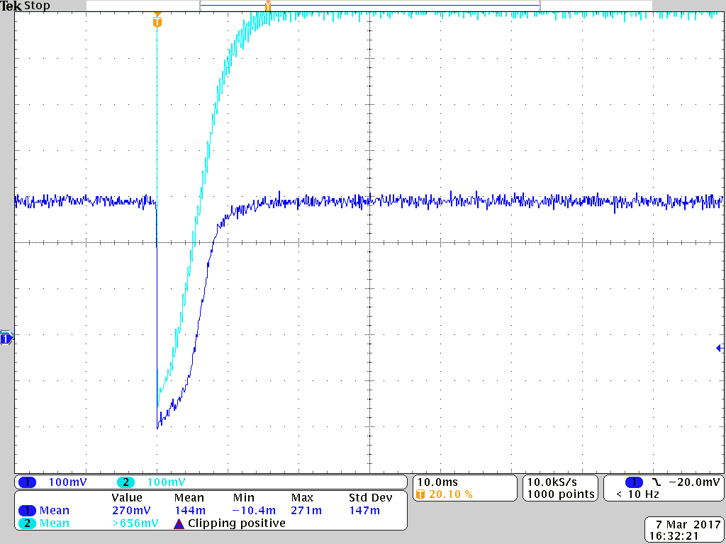
Time zoom
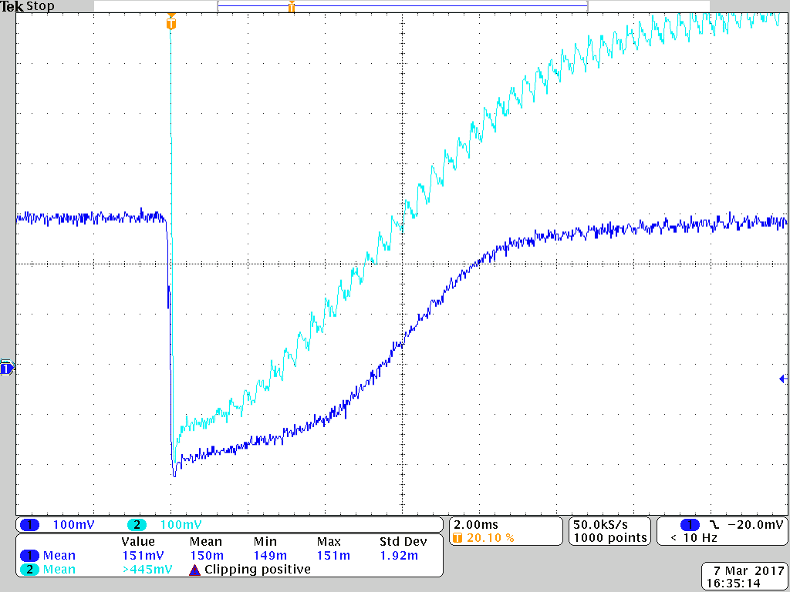

Loozing the 5 V
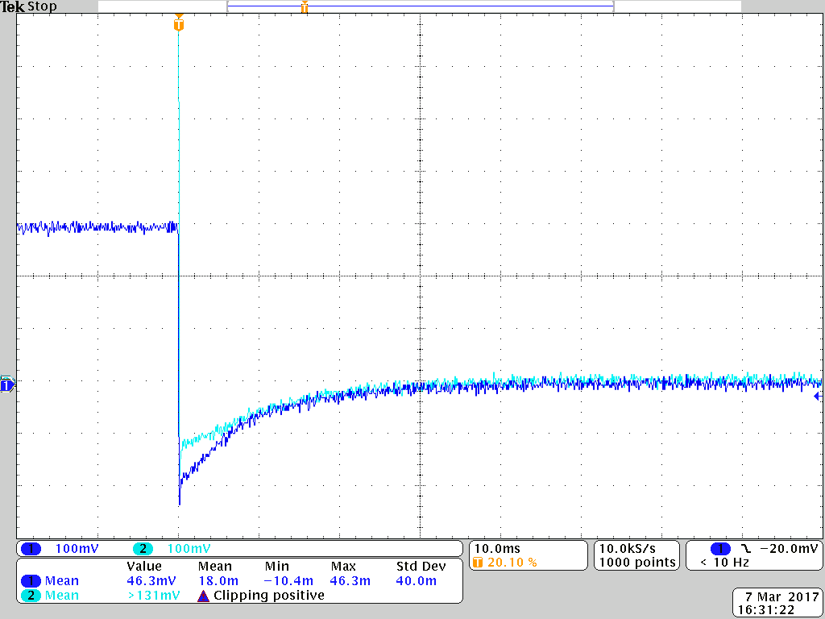
Loozing the 5 V timezoom
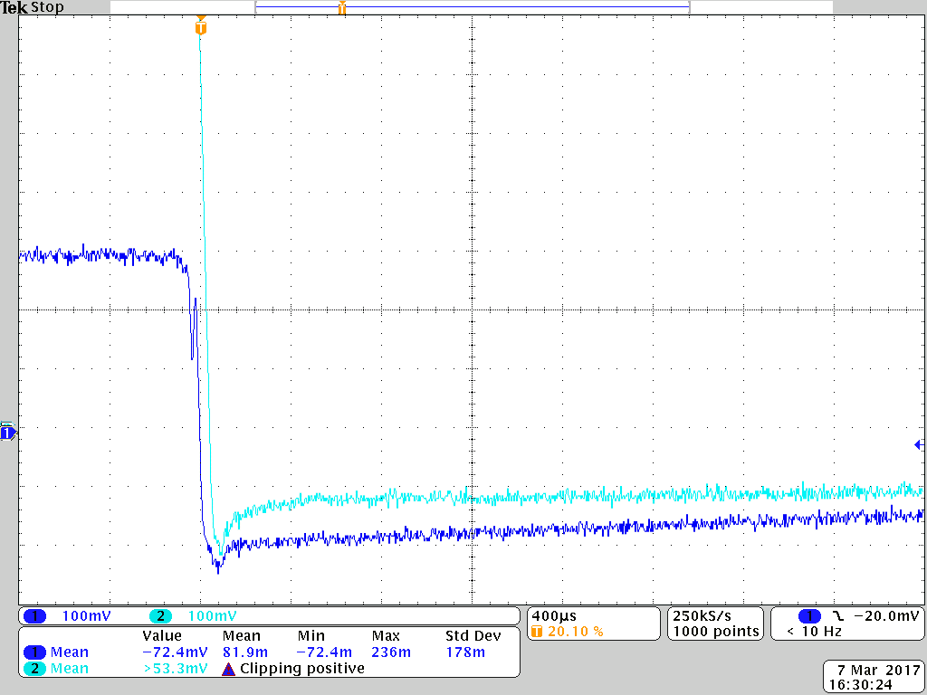

Clamping @ +2 V . Not seen :
Triggered on a 1.9 level . Scope didn't fire:
- disabling the power supply
- removing the -3V
- removing the +5 V

Effect on signal
signal without schottky diodes
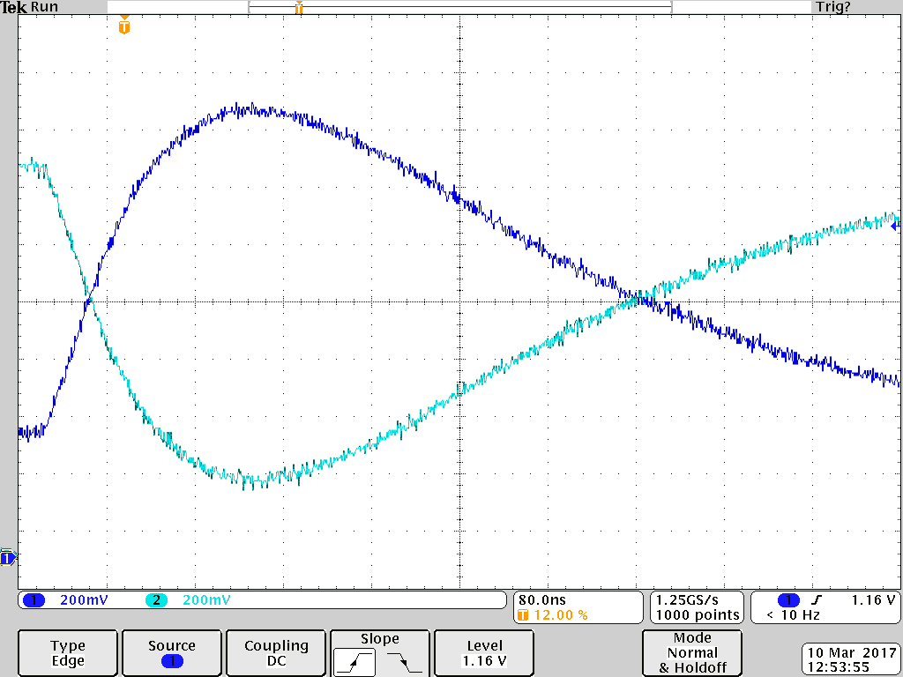
signal with schottky diodes
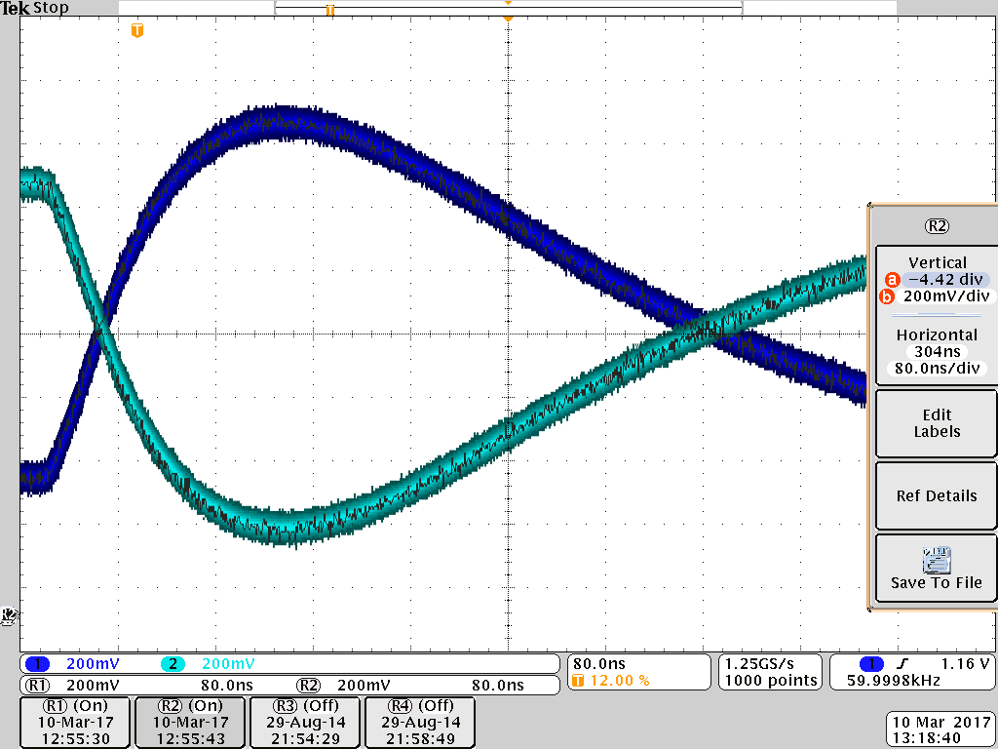
Thicker line is effect of the oscilloscope. In black the signal without Schottky diodes. So no difference .
Scope probes are parallel to the schottky diodes!! 8pF so near the same value as the Schottky diodes.

ADC connected
( defect ADC but should have no effect. Mainly the capacity in front of the ADC ) .
Signal clamping

For the following measurements a square wave with a big amplitude is used ( passed via a capacitor)
The positive edge of the square wave is defined for a positive signal.

Positive signal clamping

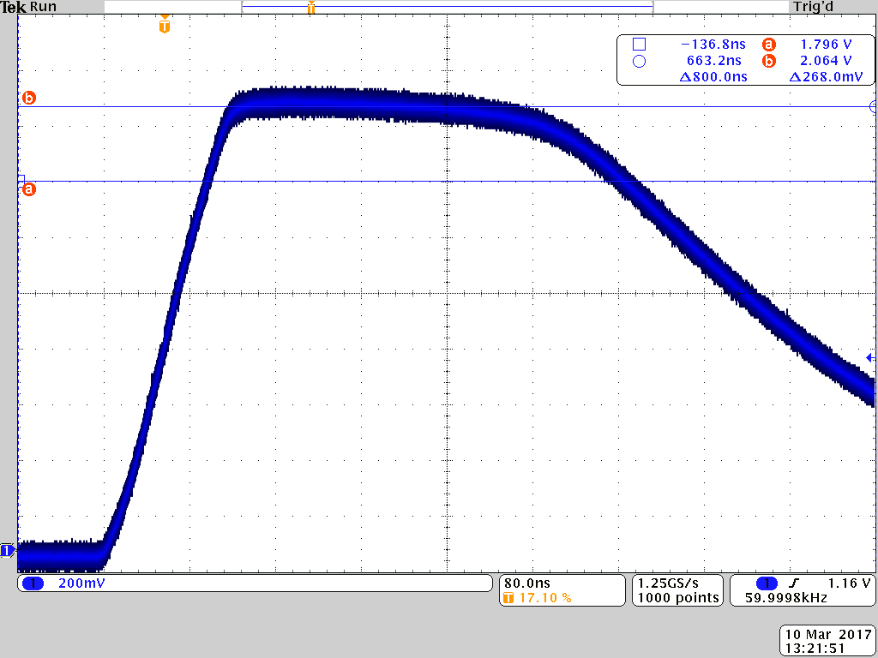
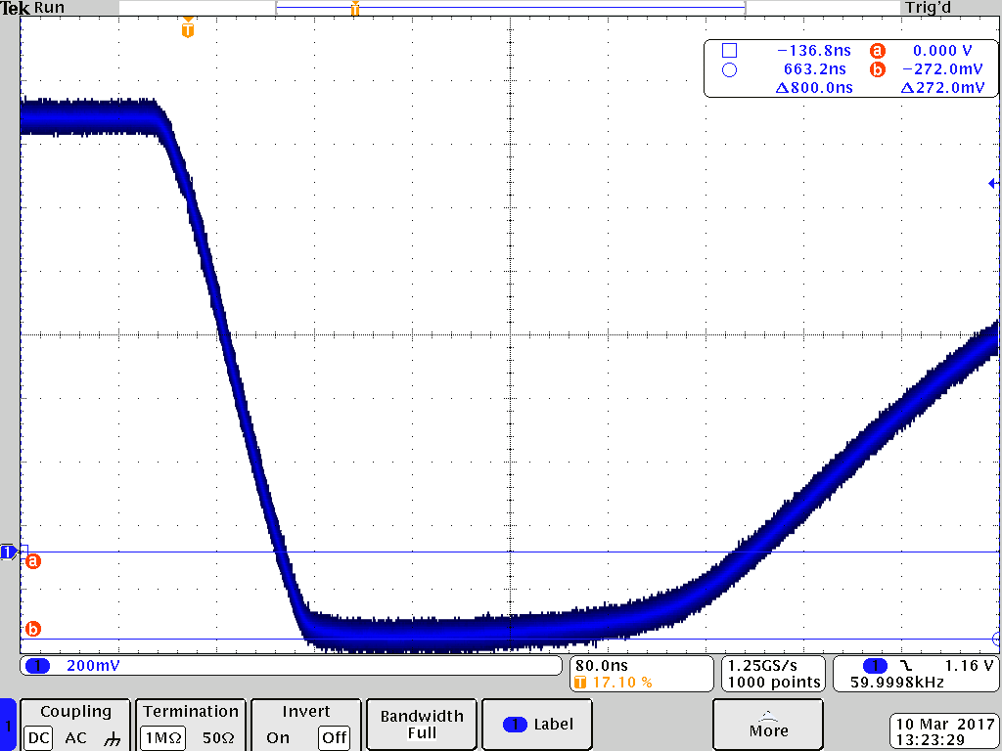
Negative input signal clamping
Inject square . Check on the negative edge. Under normal operation should not happen but can also not be excluded.
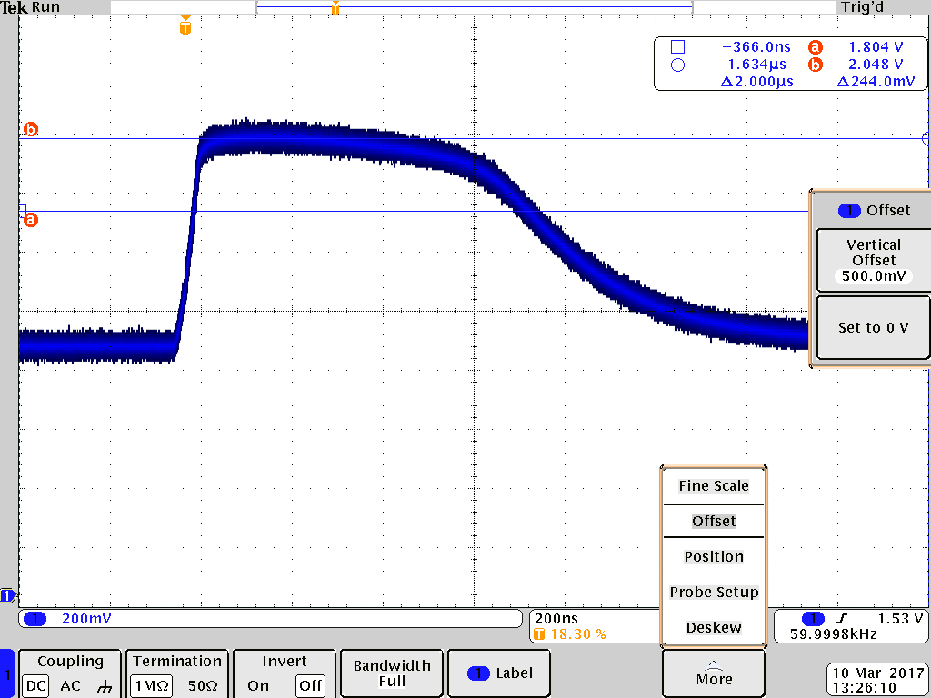

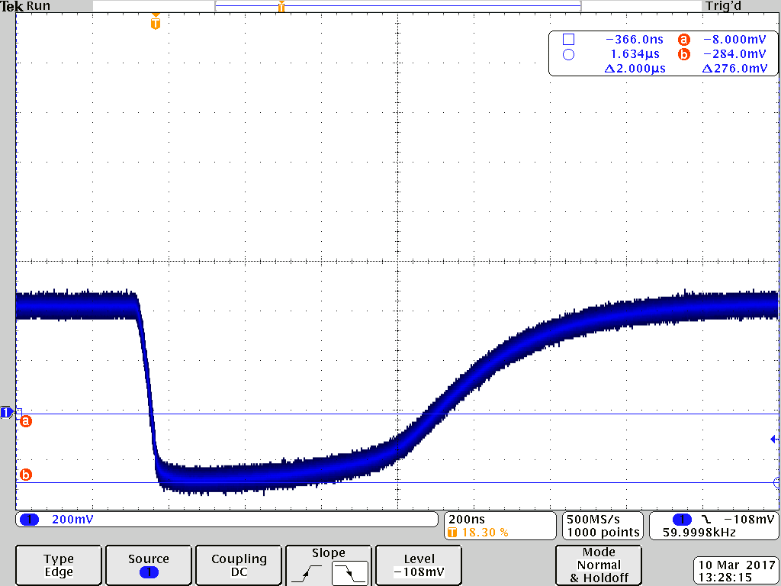

Comparison 8 ch pulse
Input is a sharp saw wave form via a capacitor. Both circuits ( 8 ch ,32 ch ) have the same source. Only there is a short extra cable for the 32ch for the connector adaptation.
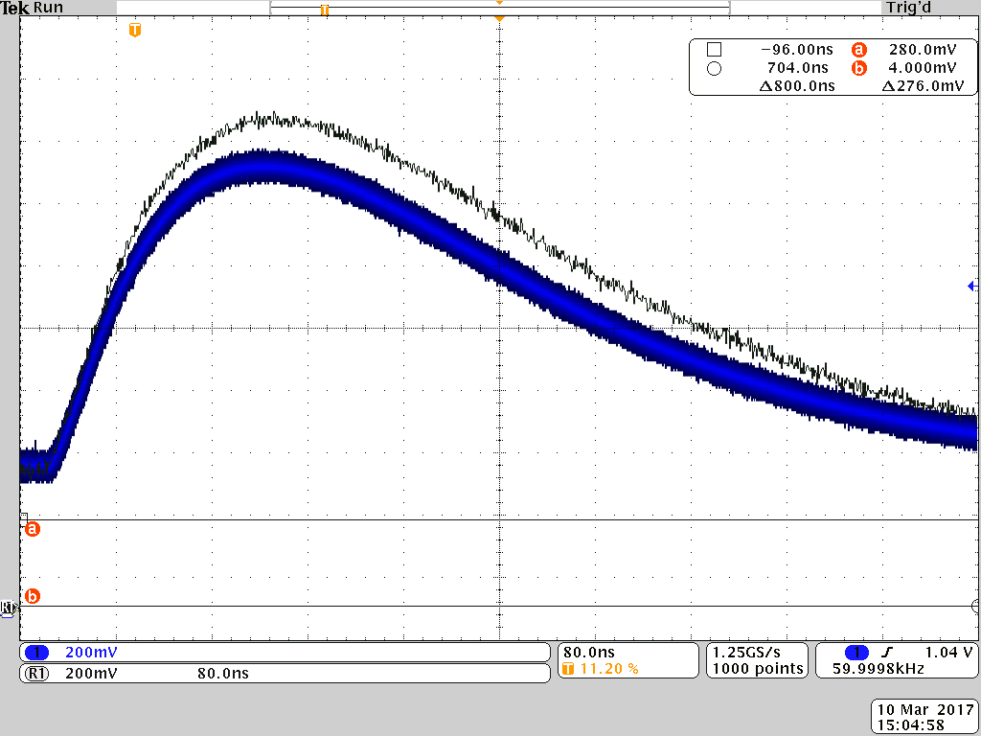
Black line 32 ch , blue 8ch . ( the blue line is thicker as effect of the oscilloscope ).
So the 32 ch version has more gain.
Same as above . Only the vertical scale for the blue is adjusted to the amplitude of the black line. So it is easier to compare the pulse response.
