Solder side patches :
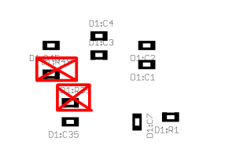
Remove all Dxx:R39 and Dxx:R49

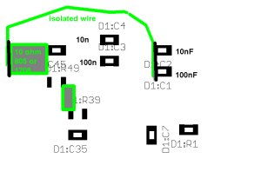
Place a 10ohm resistor packag 603 ( or 402 if not available) between Dxx:R39 and Dxx:R49

Solder a 10ohm resitor packag 805 or 1206
to the side of Dxx:C45 , at the side of the pad of
Dxx:R39 , Pad of R39 can be touch as it is electrical the same signal.

Solder a small isolated wire to the other side of the 10 ohm resistor.
Solder the other end of the wire to Dxx:C1 and Dxx:C2 as indicated. ( same signal)
If C1 .. C4 is missing place them ( lower priority)

