DC coupling from the analogue amplifier to the ADC .

version 1.0

General remarks
( number below are proposals, to be agreed)
The DC level of the signal is suppose to be at 15% of the full range
( V+ == Vcmm -.43 , V- =Vcmm+.43), If Vcmm =0.9V : V+ =.47V , V-=1.33 V)
The initial error can be +/- 5 % of this value
The drift +/- 5 % . << 1% / 60 s

For version 1.0 it are principles. Values are not final

resistor network :
- inject "current" ( positive, negative) at the input to get an offset
- Change the CMM level by the Vocm to .8V

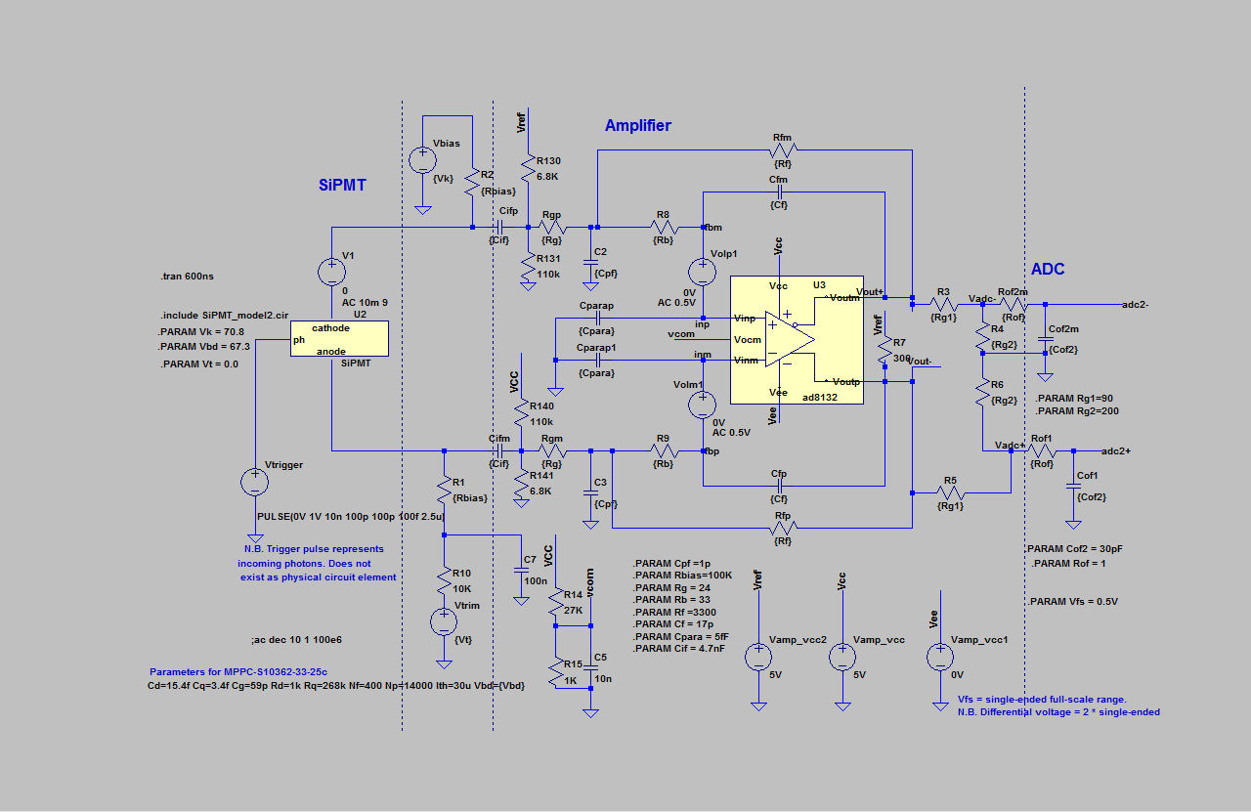
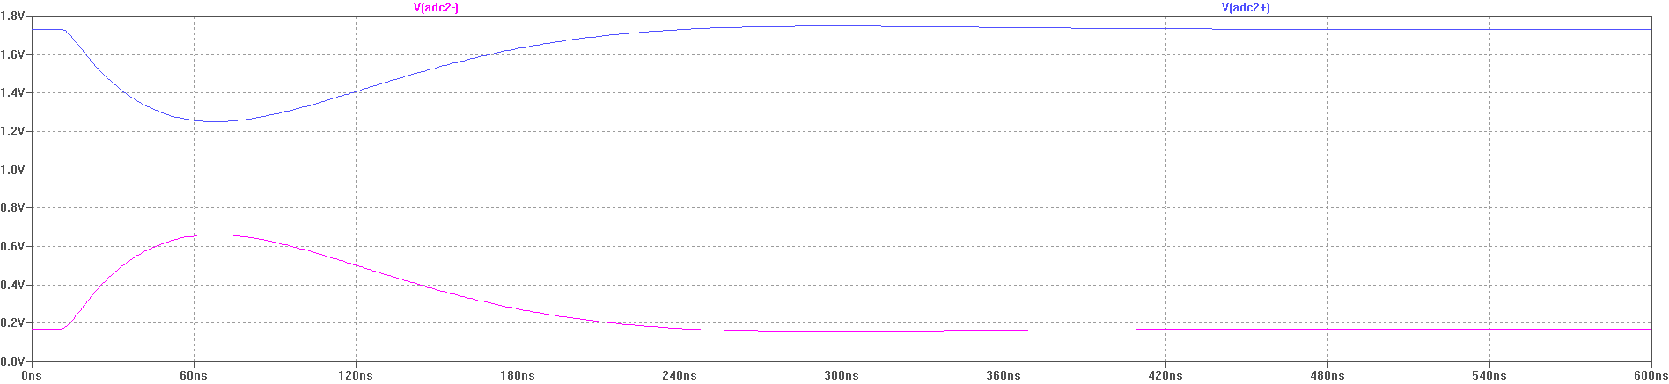
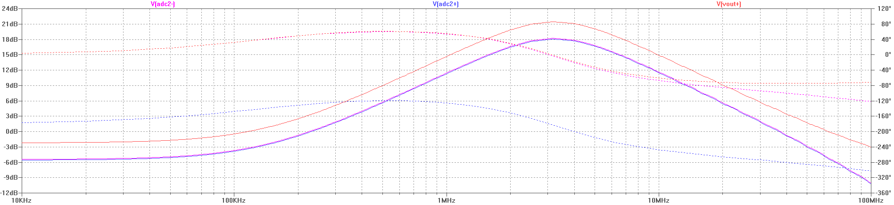
The voltage drop is made over the feed back resistors ( Rfm)
The impedance on the input nodes is kept the same.
Due to the lower Vcom the currents are not equal.
Therefore R7 is used to have the output currents of the amplifier roughly the same .

According the data base it should be able to change Vocm between 0.3 and 3 V.
But in the simulation vcom doesn't go below 1.4 V.
With the evaluation board I can bring down vcom to 0.9V but when vcom goes below 1.1 V the gain start to drop and is ( almost?) zero when vcom =0.9 V. ( need answer from Analog devices to understand the range).
Vcom of the ADC could also be set to 1.2 V ( David comments :)
So in this simulation I used a voltage divider to bring the common mode further down to 0.9V.
The divider is roughly 2/3 time the signal.
The divider has to be placed close to the ADC to have a noise filter together with Cof ( = ~25pF + 2pF ADC input). The bandwidth of the ADC input circuit is 187 MHz. To limit the current Rg1 and Rg2 could be increased and Cof2 could be smaller. ( David can you comment on this ).
To get the gain correct the Rfm and Cfp where change to get a higher gain, not calculated in detail.

The power supply current increase with ~ 8mA ( 40mW * 32 = 1.3 W )

Vref:
Not clear if this can be ( filtered ) Vcc. Current for 32 channels is to high for a standard 4.7V ref .
options :
- Vref with output amplifiers
- Accept some shifts in Vcc. As all are analogue and buffered there are no big load changes so only small drifts are to be expected
- have one dedicated regulator for the Vref .
Always need filters on the Vref inputs to avoid cross-talk between the channels.

One of the concerns is the CMMR because the amplifier has different output currents.
Also the AC impedance to ground at the input is different.

other amplifiers

LT6220 no rely stable.

TSH74 to low bandwidth in addition high supply current (10mA / amplifier)
Also high input current , 10uA , offset 5 uA.
But cheap 0.5 -- 07 Euro for 4 amplifiers . 2 amplifiers package is more expensive.
same pulse response as shown for LM6152A
Also seems to be stable without Cfb=0 .
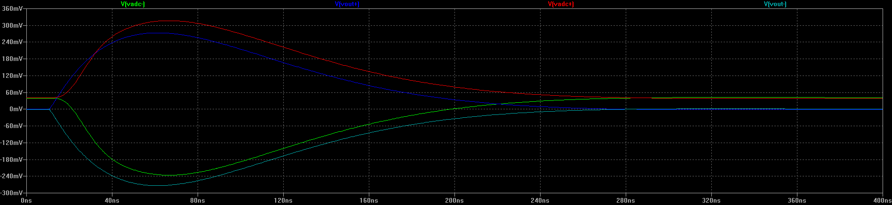
(farnell comes with with alternative TEXAS INSTRUMENTS OPA4353UA Operational Amplifier, QUAD, 44 MHz, 4, 22 V/µs, 2.7V to 5.5V, SOIC, 14 , 3.22 Euro )

simulated with Vee=0 and Vcc =5 V. Voff 2.94, 2.06

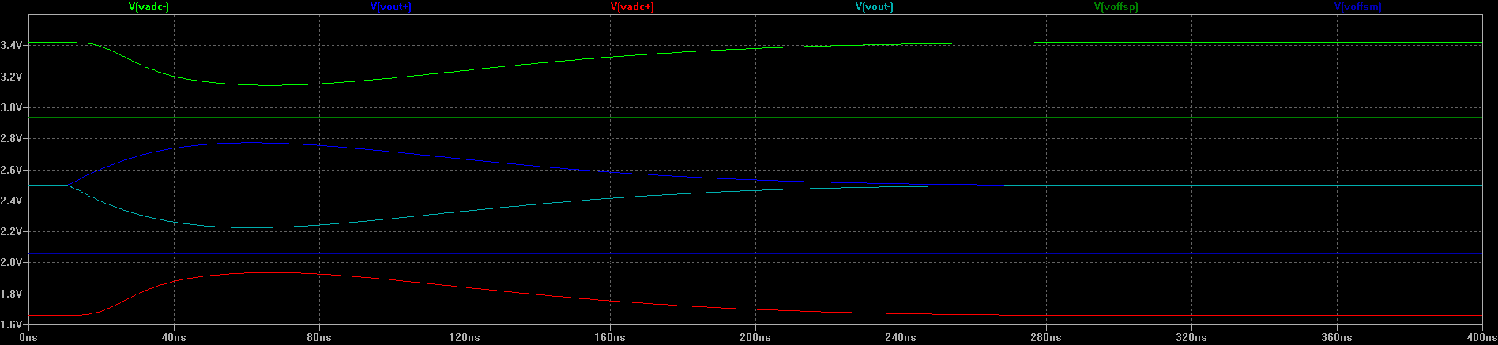

LT1805 LT1810 look good but expensive

MCP661 also looks reasonable from price , not clear if it is stable at gain = -1, it doesn't simulate.

LM6152A :

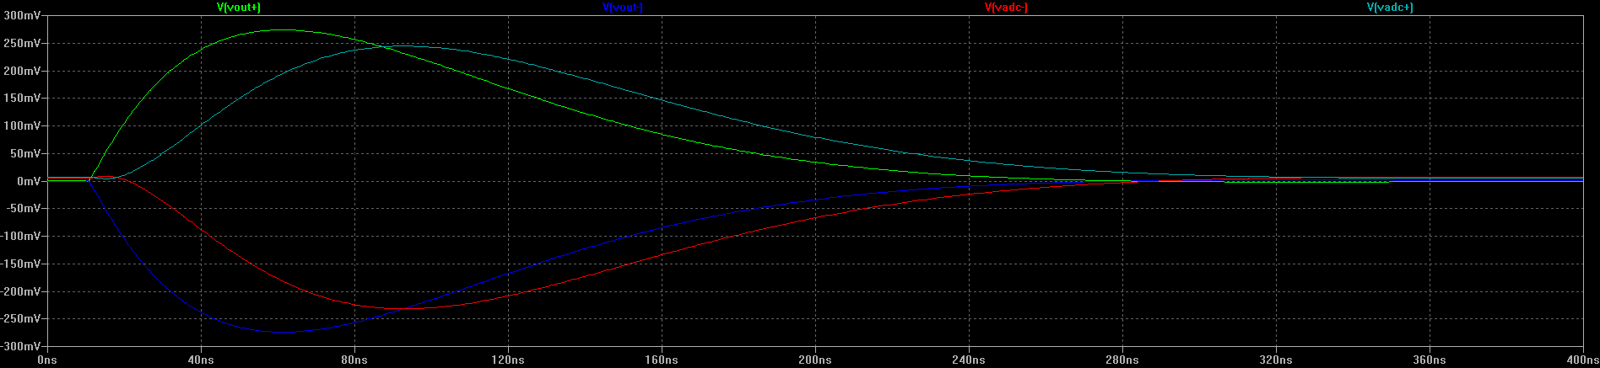
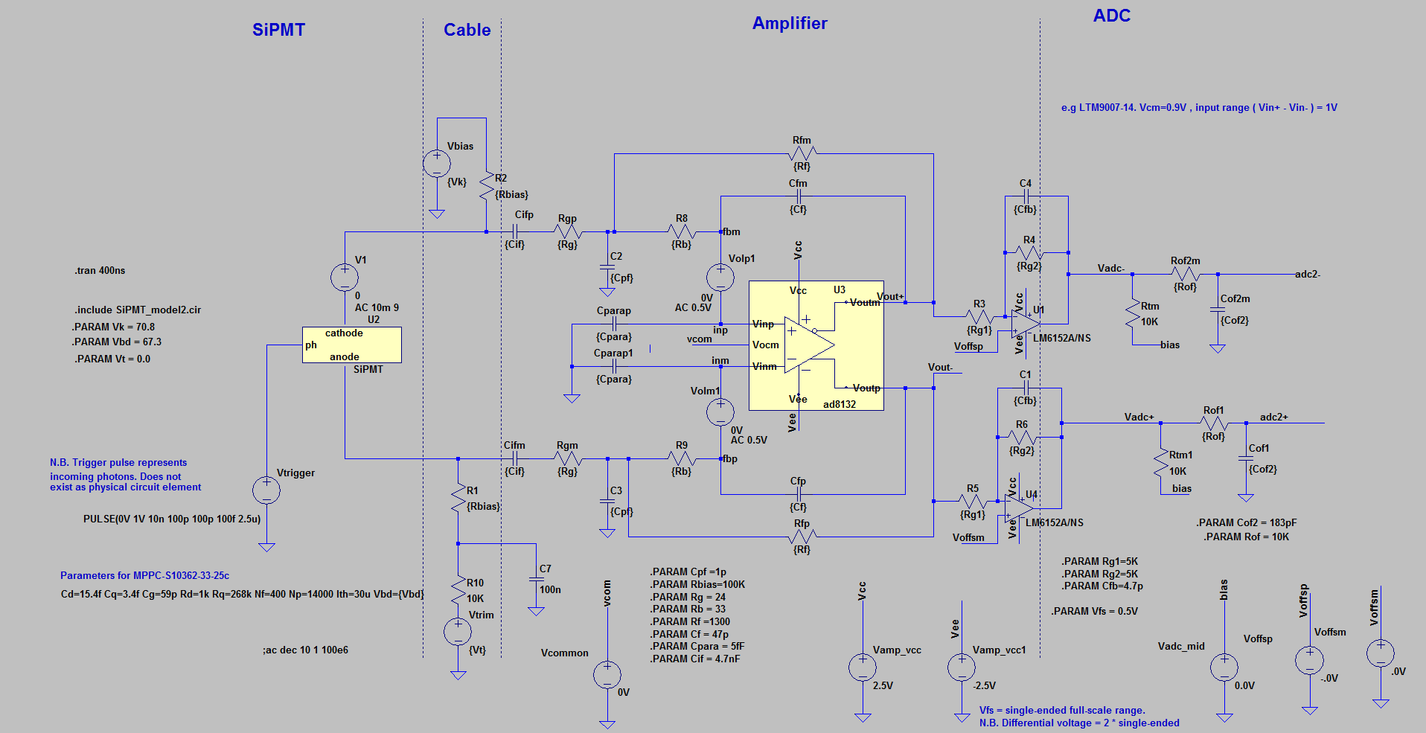
remarks :
C4 , C1 added to have a more passive component determent pulse shape then by the amplifier.
To get some faster response Rg2 , Rg1 are 5k instead of 10k, Cfb needed for stability ?
Extra pool so left out C3, C2 , have to see effect on cmmr.

gain is -1. Offset will depend on gain ( Rg2/Rg1) but is fixed.
LM6152BCMX/NOPB cost ~ 1.5 Euro , 2 opamps == 1 channel

LM6154BCMX/NOPB cost ~ 3 Eurp , 4 opamps = 2 Ch so no big price advantage , more complex routing , cross talk

done with 10 K output load

Amplifier solution
This is not yet defined in detail
This is the principle circuit.
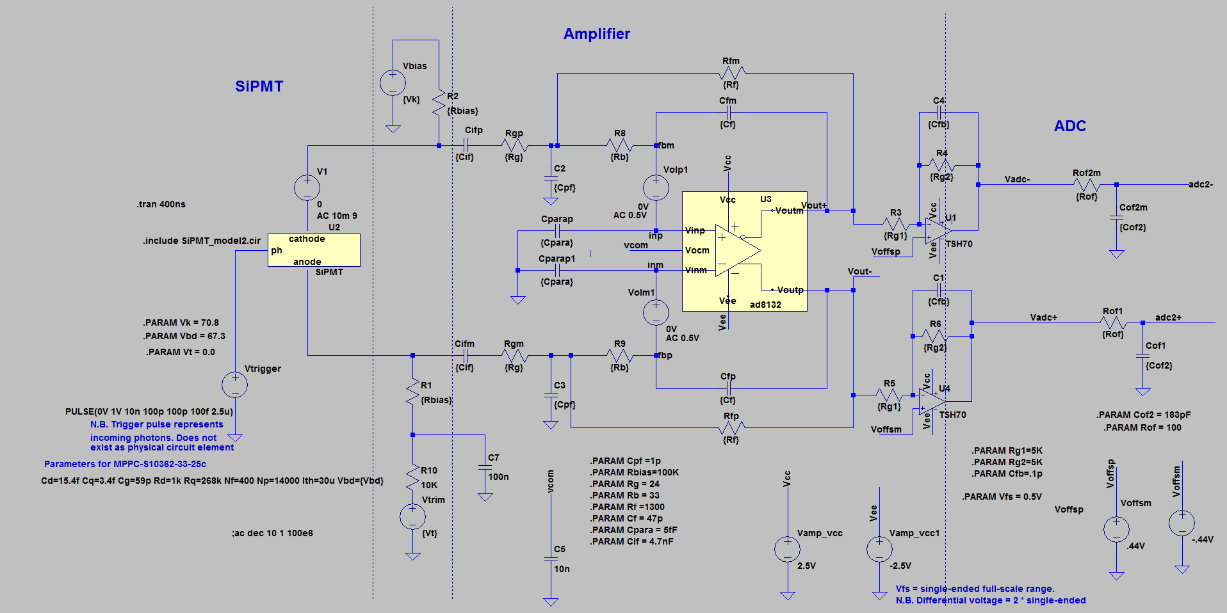
The (dual) amplifiers (rail to rail) are relative expensive more then 1.5 Euro / ch. ( supply < 3mA)
The TSH70 is a cheap on ( < 0.5 Euro /channel ) but needs 10 mA .
Offset will be corrected partially by changing vcom

Concern will be the linearity near the 0V ( how good is rail to rail output ?).
Eventual do the same trick as with the resistor network and use a network divider to bring down further the Vcmm

