no serial nr ( orignal manual populated board)
Send to Bristol

srnr 1 :
made all the changes as defined in version 2.1.4 3 May 2016.
DC check , bias check and MPPC pulse response done
I2C devices checked, no precise check of the DAC output voltages done.

I2C addresses :

MCP 4725
MCP 4728 ( ch 0 .. 3 )
MCP 4728 ( ch 4 .. 7)
MCP9808

srnr 2 :
during applying patches , ground pad below pin of amp D4:U1 broken. No decoupling on this VEE.

Measurements at brd 3

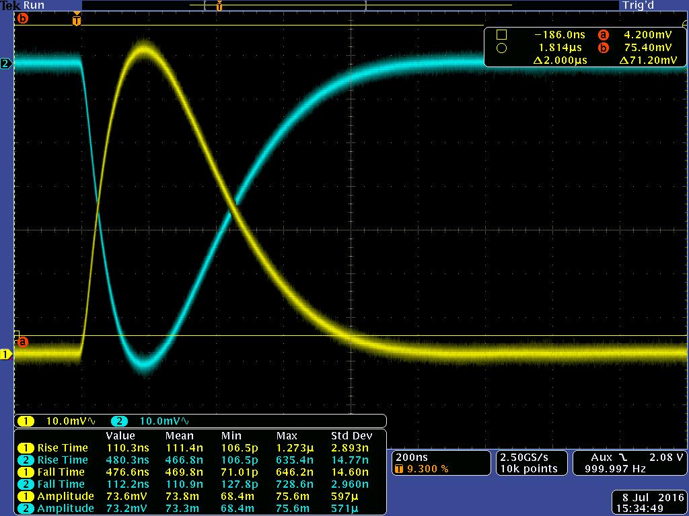Illustration 1: pulse response measured with probe no load
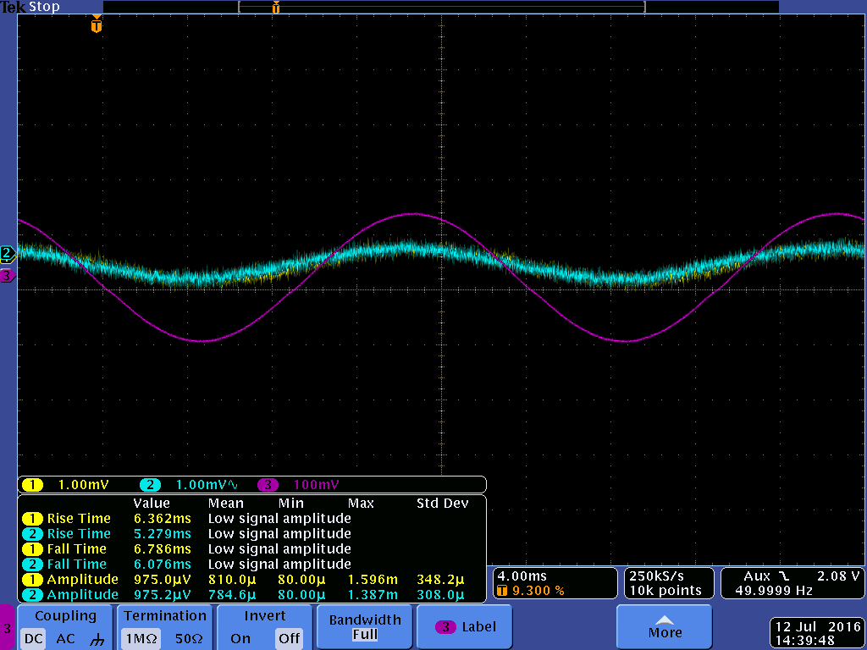Illustration 2: sine cmm 50 Hz in ~ 140 mVOutput is in phase . Signals average to see the effect. Here ch 1 is in DC mode with offset correction.
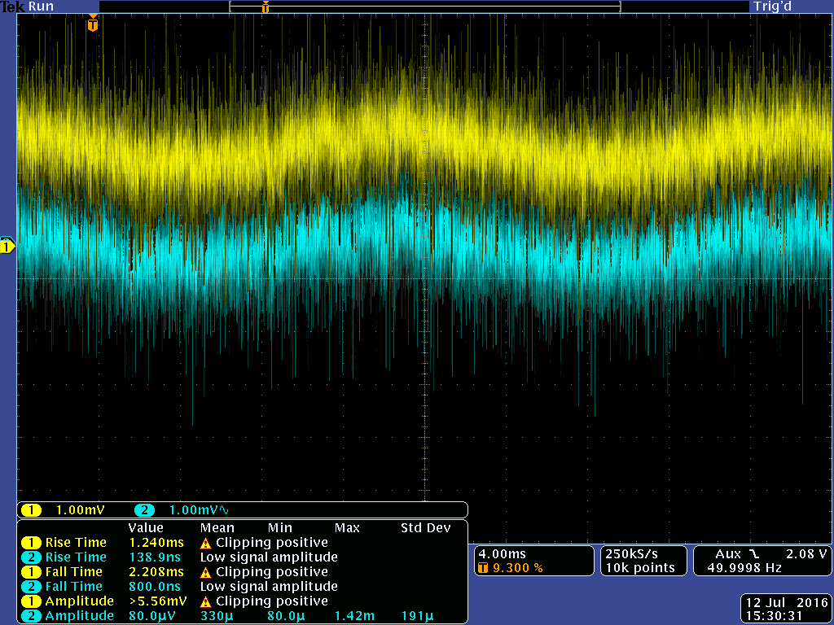Illustration 3: same as previous but now no average .
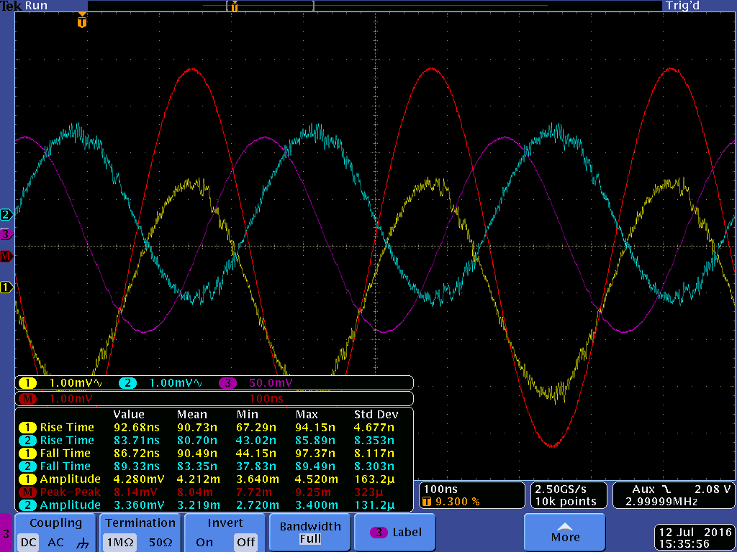Illustration 4: in 3 MHz cmm. ch red is difference signal. ( math)
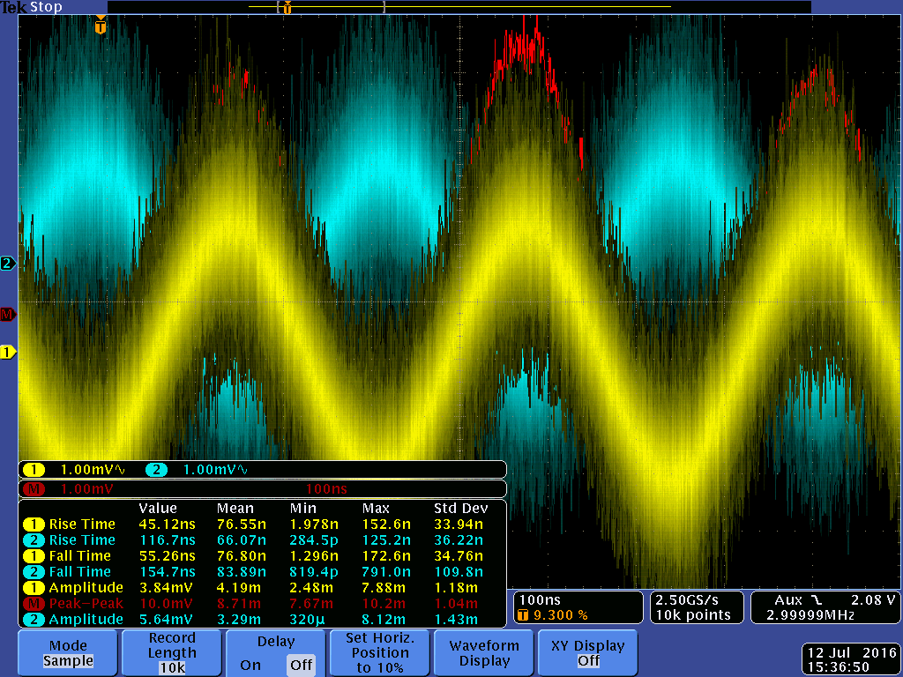Illustration 5: same without average

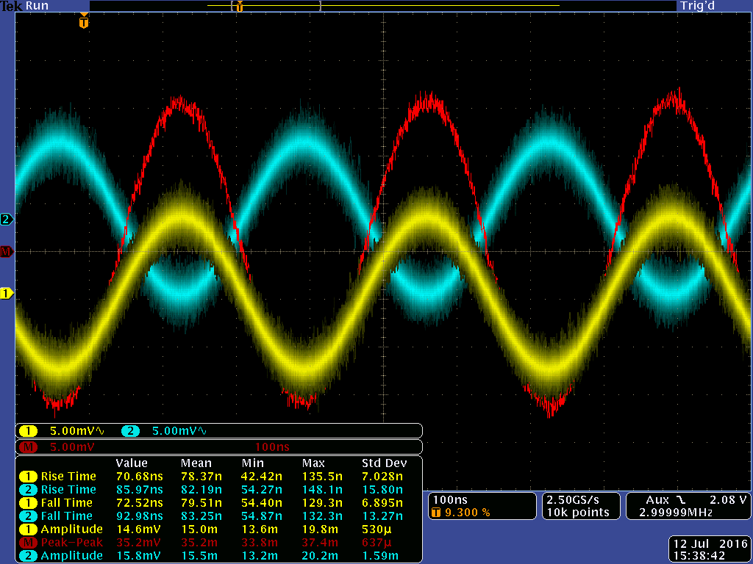Illustration 6: in 3 MHz single ended. in respect to previous measurment input is 1:100
input signal to small to show ( with probe)
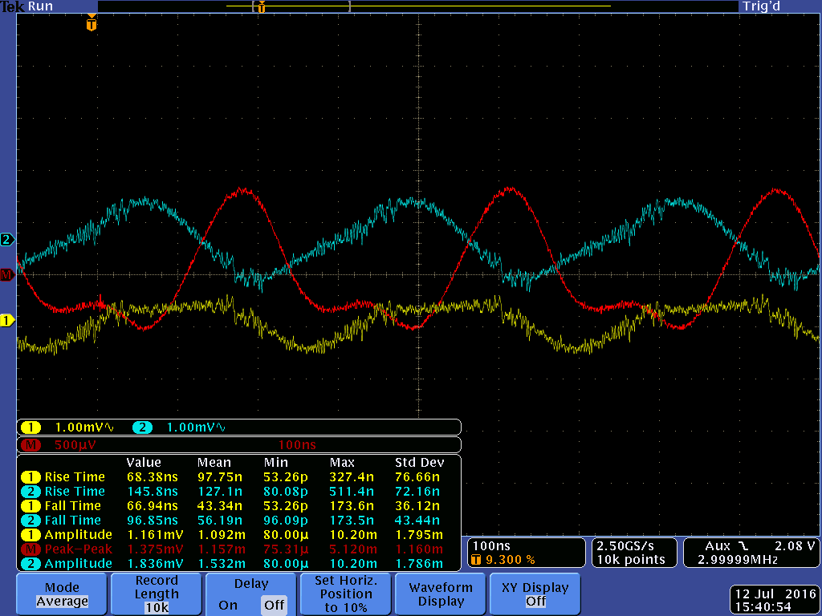Illustration 7: crosstalk to the next channel input signal see next .
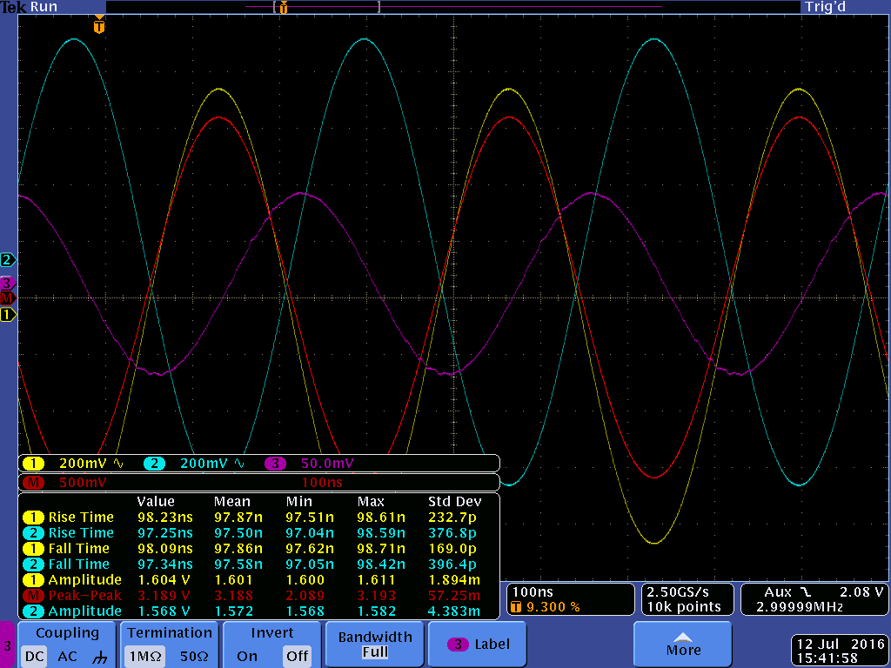Illustration 8: in 3 MHz single ended. ( purple) signal amplitude as used for
cmm and cross talk

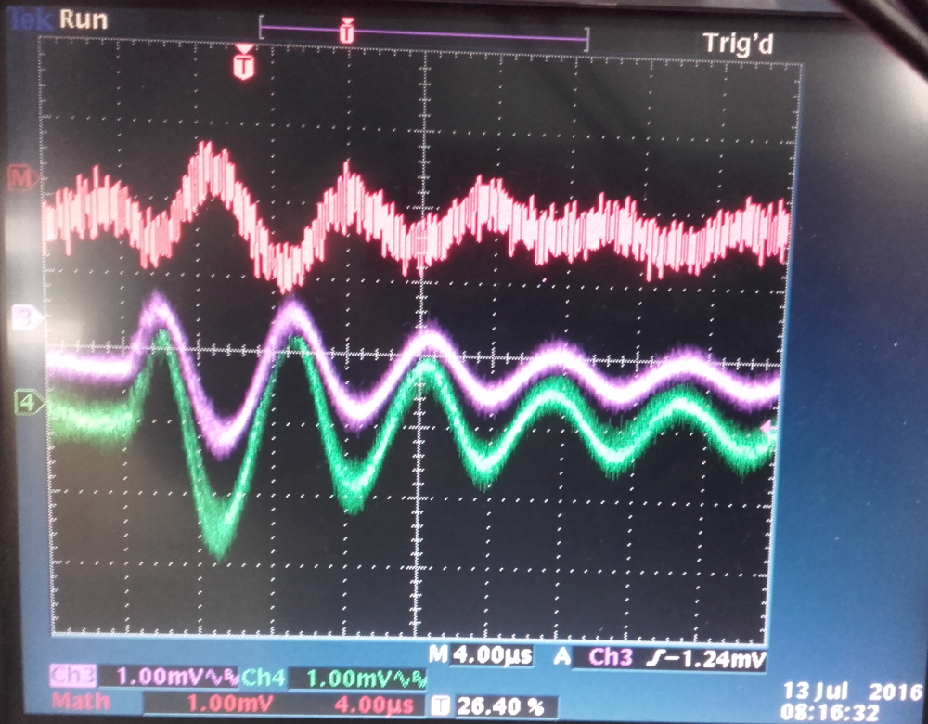Illustration 9: effect of a switched power supply. scale 1mV !! red is the diff signal. Bandwith applied 20MHz. so ~ 3 lsb but not optimal filters !! Vee still lineair

