Components of SoLiD Readout
- The solid readout system consists of 64 channel readout boxes (one per fame).
  - Each readout box contains:
    - One ADC+FPGA board ( 64 channels )
      - Each ADC+FPGA board has one Trenz TE0712 module mounted
    - Two Amplifier boards ( 32 channels each )
    - One I2C pass-through board ( connects I2C signals generated on ADC+FPGA board and connects to frame)
    - One power filter board ( Connects to single power cable from services box. Has three cables inside electronics enclosure. Two supply amplifier boards. One supplies ADC+FPGA board
- Ten readout modules in a detector module are synchronized and controlled by a single services box.
  - Each services box contains:
    - Power supplies for readout modules. 48V input
    - Clock and syncronization fanout. ( Takes a single set of clock and synchronization signals and fans out to the 10 readout boxes in a module.
      - Each clock and synchronization fanout consists of
        - One clock/sync main board
        - … connected by a VHDCI cable to ...
        - One clock/sync interface FMC , which plugs onto ….
        - One Enclustra FPGA module
          - Each Enclustra FPGA module consists of
            - One PM3 base board
            - One Mars AX3 FPGA module
      - JTAG fanout ( can program the ten FPGAs in a module from a single RJ45 Ethernet connection )
        - Each JTAG fanout consists of
          - One JTAG fanout board ( this is a single PCB split in two with the pieces arranged side by side )
          - … connected by a USB-A → USB micro-B cable to ….
          - One Minnow Board Turbot single board computer
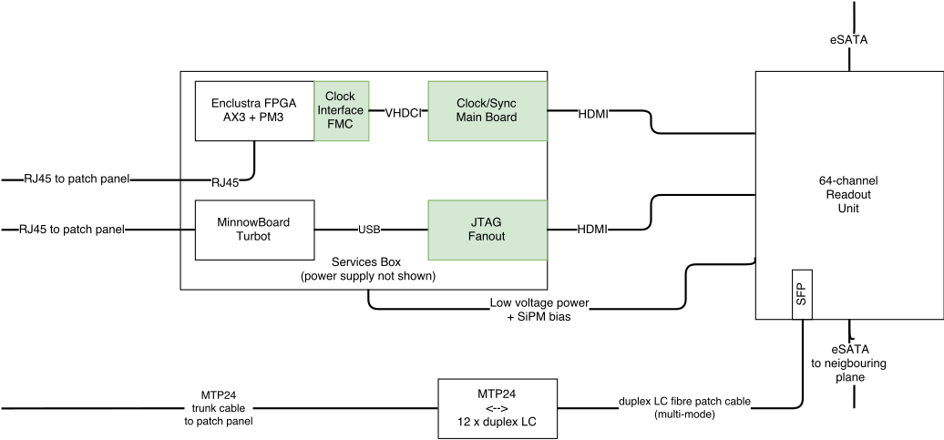Illustration 1: Block diagram of a services box. One readout box is also shown
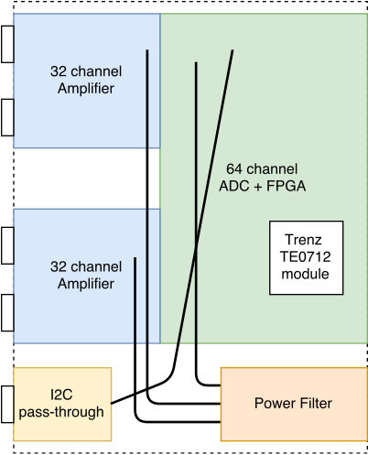Illustration 2: Block diagram of a single 64-channel readout box
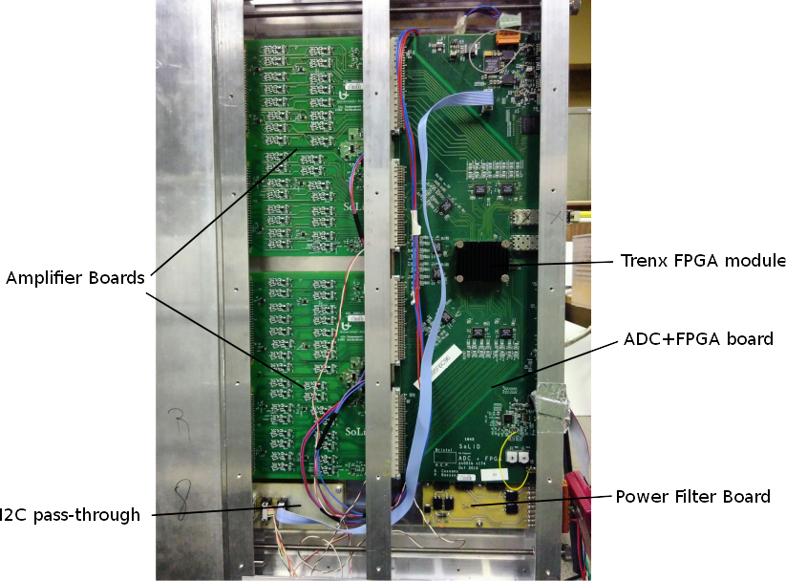Illustration 3: Annotated photograph of a prototype readout box (connected to Calypso)

