Flooding of the Okavango Delta influences Connectivity for Dispersing African Wild Dogs

David D. Hofmann1,2,§

Dominik M. Behr1,2

John W. McNutt2

Arpat Ozgul1

Gabriele Cozzi1,2

Climate change is expected to profoundly impact vital rates of wild living animal populations. While the impact of climate change on the demographics of local subpopulations has been studied repeatedly, little is known about the consequences of environmental change on dispersal and connectivity between such subpopulations.

Here, we capitalize on natural, flood-pulse driven environmental change across the Okavando Delta in northern Botswana to investigate the impact of changing environmental conditions on the dispersal ability of the endangered African wild dog (*Lycaon pictus*). For this, we utilize a previously parametrized dispersal model and apply it to simulate dispersal under two extreme environmental scenarios; one assuming a minimal flood extent, one assuming a maximum flood extent.

Our results show that the flood extent of the Okavango delta substantially impacts the dispersal prospects of African wild dogs. During maximum flood, large parts of the landscape become inaccessible to dispersers, resulting in lower connectivity and increased dispersal durations between distinct habitat patches. Conversely, the delta reveals vital dispersal routes during times of low flood, promoting geneflow between remaining subpopulations. Climate change is expected to critically impact the flood-pulsing cycles of the Okavango delta and may therefore critically alter landscape connectivity in this area. Besides a better understanding of the conservation needs for the African wild dog, our study also presents a first step towards incorporating environmental changes due to seasonality or climate change in dispersal and connectivity analyses. Finally, our analysis demonstrates the usefulness of individual-based dispersal simulations as a pertinent conservation tool to study impacts of environmental change in a spatially realistic way.

1 Department of Evolutionary Biology and Environmental Studies, University of Zurich, Winterthurerstarsse 190, 8057 Zurich, Switzerland.

2 Botswana Predator Conservation Program, Private Bag 13, Maun, Botswana.

§ Corresponding author (david.hofmann2@uzh.ch)

**Running Title:** None

**Keywords:** Seasonal Flooding of the Okavango Delta and its Consequences for African Wild Dog Connectivity

# Introduction

## Climate Change

Climate change is expected to profoundly impact ecosystems worldwide, with far-reaching consequences for species living therein (cite IPCC) (Radchuk et al. 2019). Importantly, the impacts of climate change are not uniformly distributed across the planet, but particularly pronounced at high latitudes and in arid ecosystems (IPCC) (Maestre, Salguero-Gómez, and Quero 2012; Midgley and Bond 2015). For instance, (Engelbrecht et al. 2015) predicted an increase between 4 and 6C in temperature over southern Africa by the end of the century. The ability of species to persist under these changing conditions depends on the amplitude and speed of environmental change and species’ demographic responses to such changes. However, as (Paniw et al. 2021) show, empirical information on species’ demographic responses to climate change remains scarce, especially for regions most vulnerable to altered conditions.

## Dispersal

The lack of knowledge in terms of species demographic responses to climate change is further compounded by a lack of information of dispersal under changing environmental conditions (Travis et al. 2013). By bringing individuals away from their natal location, dispersal profoundly impacts population dynamics. It enables genetic exchange, the colonization of empty habitats, and the reinforcement of extant or empty habitat patches. Dispersal also serves to track suitable habitat, and may thus mediate demographic consequences of environmental change (Travis et al. 2013). It is also inextricably linked to landscape connectivity, which is generally understood as the degree by which the landscape facilitates or ...

Besides its importance in determining population dynamics and landscape connectivity, our understanding of dispersal and and its implications under changing environmental conditions is limited. This is mainly owed to the difficulty of obtaining data collected on dispersing animals at the appropriate temporal and spatial scale (Graves et al. 2014; Vasudev et al. 2015) and our inability to project dispersal prospects under changing environmental conditions.

As previously by (Travis et al. 2013), climate may affect dispersal directly, by altering the propensity of individuals to disperse, or indirectly, through changes in the biophysical environment. Here, we will focus on the latter and study dispersal prospects under changing environmental conditions.

It is, in fact, presumed that humanity has already transgressed the planetary boundary for climate change, therefore triggering irreversible feedbacks in the biosphere (**???**).

Cite IPCC, Planetary boundaries, Tucker (step length). Phenological shifts. Cite Robynne, Arpat, Megan, Dominik, Rabaiotti etc.

## Connectivity

Dispersal is an important, if not the important, driver of landscape connectivity and therefore of major interest to conservation authorities.

## Okavango Delta and African Wild Dogs

The Okavango delta in Southern Africa poses a unique opportunity to study the impacts of environmetal change on species dispersal ability and connectivity in large scale natural experiment setup. According to projections by the IPCC, Botswana and its surroundings are among the most vulnerable to climate change.

# Materials and Methods

We conducted all analyses using the programming language R. Any spatial data manipulation was completed using the terra and spatstat packages. Several helper functions for the simulation algorithm were written in C++ and imported to R using the Rcpp package. Figures were generated using ggplot2, igraph, and ggnetwork. All R-scripts used to conduct our analyses are provided through an online repository.

## Study Area

The study area for this analysis was focused on the Okavango delta (OD) and its surroundings in Southern Africa, comprising parts of Angola, Namibia, Botswana, Zimbabwe, and Zambia (). The OD is the world’s largest inland delta and the main driver of seasonal environmental change in the region. While our primary focus lied on the immediate surroundings of the Okavango Delta, we considered a large rectangular extent stretching from 20’ E to 26E. (totaling to an area of 300’000 km2) to accommodate for the long distance dispersal events commonly observed in African wild dogs (e.g. (**???**; Masenga et al. 2016; Cozzi et al. 2020)). The flood-pulsing rhythm of the OD is mainly dictated by precipitation in the catchment areas of the Angolian highlands, where rainwater is collected and channeled into the OD through the Okavango River. Although precipitation in Angola peaks between December and March, water only slowly descends through the Okavango river and its distributaries, reaching the distal ends of the delta in July or August, where the water percolates at the Thamalakane and Kunyere Faults. At minimum extent, the flood covers an area of 3’600 km2, during maximum flood more than 9’000 km2. Vegetation in the study area is dominated by mopane forest, mixed acacia woodland, and grassland. Human influence is low and mainly concentrated around small villages at the western periphery of the delta as well as the city of Maun at the south-eastern tip of the OD. Large portions of land are dedicated national parks, game reserves or forest reserves. The study area is also part of the world’s largest transboundary conservation initiative, the Kavango-Zambezi Transfrontier Conservation Area, which aims to restore connectivity between protected areas in Southern Africa.

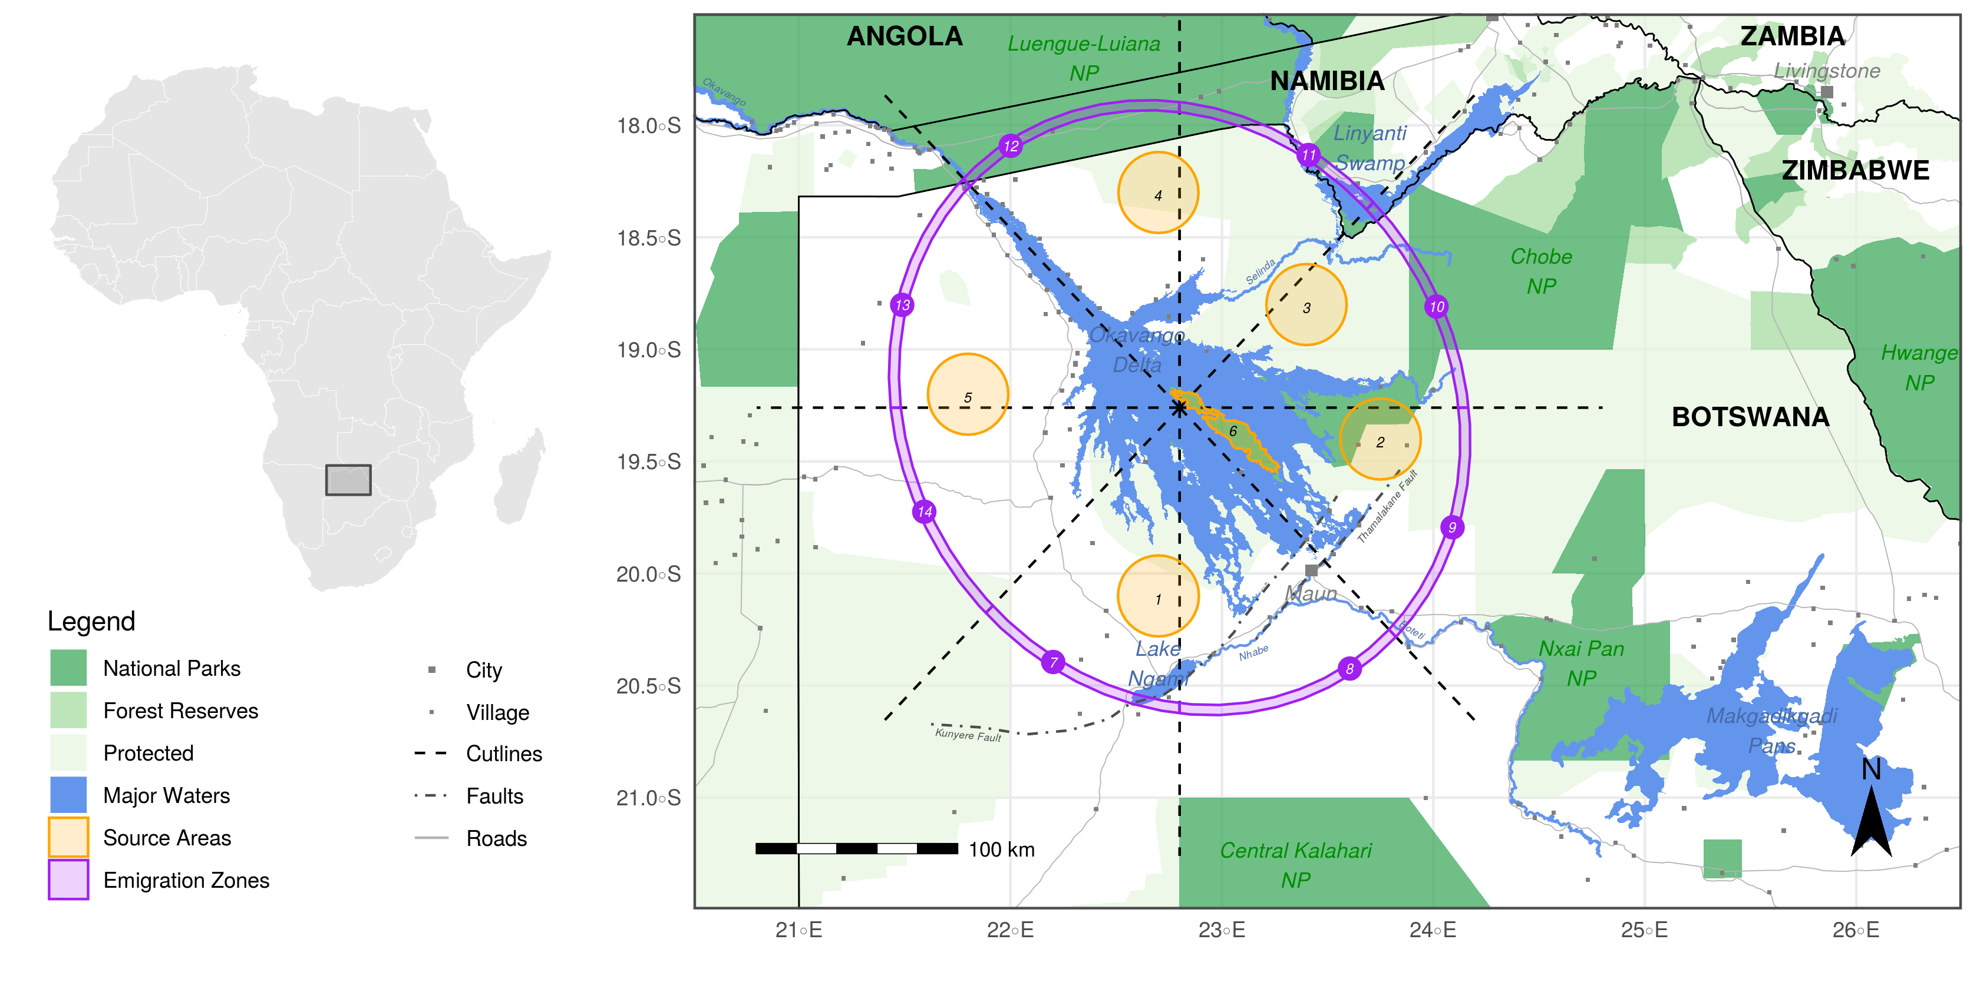

Study area across which we simulated dispersal. Simulated dispersers were released at random locations within the orange source areas distributed across the delta. Emigration zones (purple) served as checkpoints and enabled us to identify if and where simulated dispersers left the close surroundings of the Okavango delta. These zones were generated using a set of cutlines originating from the center of the delta and roughly cutting an elliptical buffer zone into sections of equal size.

## Spatial Habitat Layers

We represented the physical landscape through which dispersers could move by a set of spatially referenced habitat layers, each resolved at 250m x 250m. The set of layers included water-cover, distance-to-water, tree-cover, shrub/grassland-cover, and a human influence layer depicting anthropogenic influences through villages, roads, and agriculture. A detailed description of the different habitat layers is provided in . Importantly, the water-cover and derived distance-to water layers were generated using MODIS Terra MCD43A4 satellite imagery that was classified using a “floodmapping” algorithm developed by (**???**) and available through the R-package floodmapr. The algorithm allowed us to generate almost weekly updated “floodmaps”, thus providing detailed information about the flood-extent at any given point in time. In total, we generated 700 floodmaps between the years 2000 and 2019. Based on these maps, we generated a minimal and maximum flood scenario. To create the minimum flood scenario, we averaged the 50 floodmaps with smallest flood extent and generated a binary image using areas that were inundated in at least 50% of the maps. Similarly, we created an average image for high flood using the 50 most flooded maps. The final maps are depicted in .

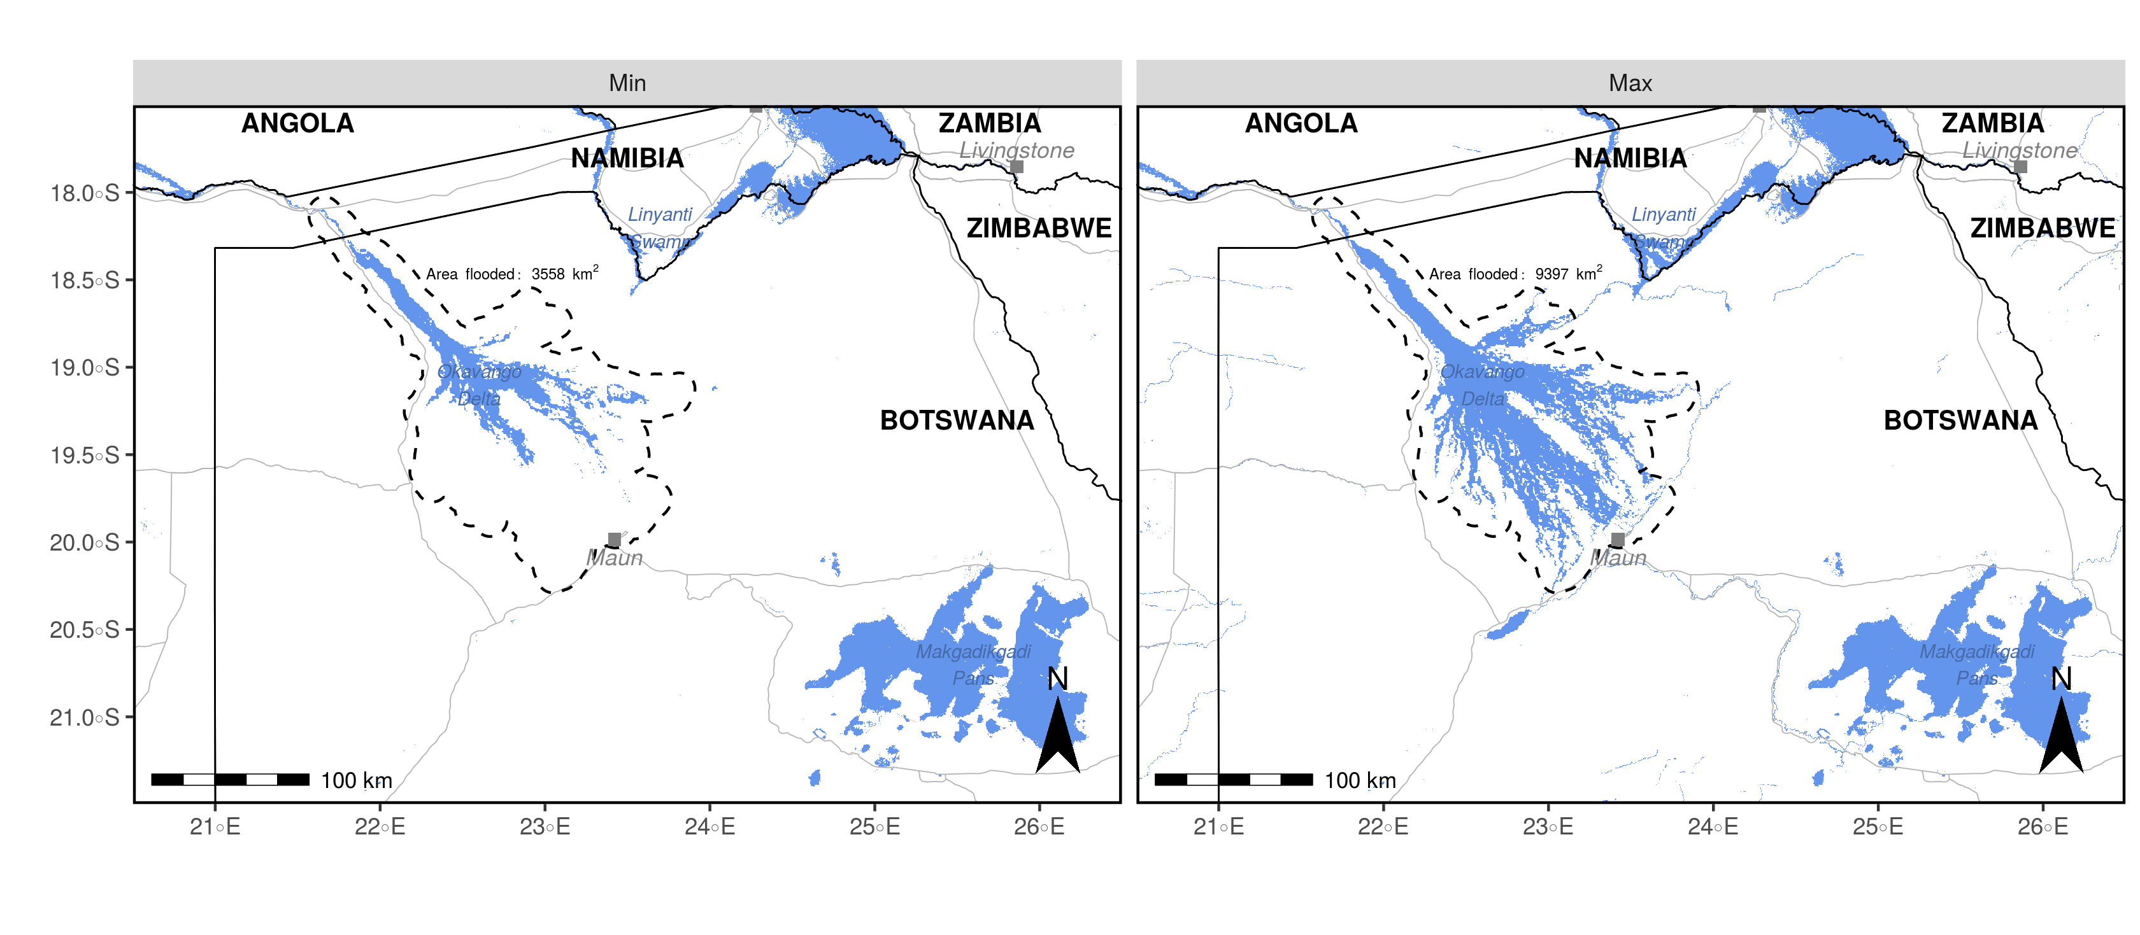

Flood extent in the two scenarios considered. In the left panel, the flood is at an extremely low level, stretching across 3’558 km2, whereas in the right panel the flood is at an extremely high level and covers 9’397 km2. The two maps were generated using 700 remote sensed MODIS MCD43A4 satellite images spanning the years 2000 to 2019.

## Dispersal Model

Our dispersal model was based on a previously parametrized and validated integrated step-selection function (iSSF, (Avgar et al. 2016)) fitted to GPS data of dispersing AWDs (Hofmann et al. 2021). In step selection functions (SSFs, (Fortin et al. 2005)), observed GPS locations are converted into steps (the straight-line traveled between two GPS recordings (**???**)) and compared to a set of *random* steps in a (mixed effects) conditional logistic regression framework (Fortin et al. 2005; Thurfjell, Ciuti, and Boyce 2014; Muff, Signer, and Fieberg 2020; **???**). The model presented in (Hofmann et al. 2021) used dispersal data of 16 dispersing African wild dogs from a free-ranging wild dog population in northern Botswana. GPS data during dispersal was collected at 4-hourly intervals and translated into steps of similar duration. Observed steps were then paired step with 24 random steps that were generated using a uniform distribution for turning angles () and step lengths from a gamma distribution fitted to observed steps (scale = 6’308 and shape = 0.37). It was then assumed that animals assigned to each observed and random step a selection score of the form (Fortin et al. 2005):

Where () represent the covariate values along each of the steps and the () are the animal’s relative selection strengths (Avgar et al. 2017) towards these covariates. The benefit of *integrated* SSFs over regular SSFs is that they provide a means to render two complementary “kernels”. A movement kernel that describes general movement behavior of dispersing AWDs and a habitat kernel that describes preferences of AWDs with regards to environmental conditions (**???**). iSSFs also allow interactions among the two kernels and are thus suitable to render that movement behavior may change depending on habitat conditions. A brief summary of the fitted dispersal model is provided in Appendix xx.

## Source Areas and Emigration Zones

We simulated dispersing AWDs originating from six distinct source areas located in the vicinity of the Okavango delta (). For areas one to six we selected locations at the delta’s periphery that remained dry in both scenarios. At those locations, we generated circular buffers with a radius of 20 km. For source area six, we isolated a polygon covering Chief’s Island, a peninsula located at the OD’s center. Besides source areas, we also generated “zones of emigration” that we used as checkpoints to determine if and where simulated individuals left the delta’s vicinity (). We generated emigration zones by first overlaying the OD with an elliptic buffer zone that we dissected using a set of cutlines that originated from the ODs center and spread according to cardinal points ().

## Dispersal Simulation

For each source area we simulated 1’000 individuals, once assuming a minimum flood, once assuming a maximum flood. This resulted in the simulation of 6’000 individuals for each environmental scenario, hence 12’000 individuals in total. The simulation algorithm was based on the algorithm described in and works as follows. A random location within the source area is chosen as a starting point. Originating from the starting point, a set of 25 random steps is generated by sampling step lengths from a gamma distribution fitted to observed steps (what is a step?) (shape = , scale = ) and turning angles from a uniform distibution (). Along each random step the underlying spatial covariates are extracted and relevant movement metrics are computed (i.e. log(sl), cos(ta), ta). The parametrized dispersal model is used to predict the probability of each step for being chosen given the steps covariate values. One of the steps is sampled based on assigned probabilities and the location of the animal is updated. The procedure is then repated until the desired number of steps is realized. Here, we simulated each individual for 2’000 steps, which correspons to the longest dispersal duration recorded in our data. The original model was trained using 4-hourly steps, thus a simulated step also resembled the movement conducted within four hours. Trajectories resulting from such a simulation can be understood as correlated random walks that take into account both habitat and movement preferences of dispersing individuals.

## Dispersal Prospects and Connectivity

Based on simulated dispersal trajectories in the two scenarios we quantified dispersal sucess and connectivity using three complementary connectivity metrics as outlined in (**???**). First, we generated heatmaps depicting the frequency at which different areas in the landscape were visited by simulated dispersers. Such heatmaps serve to detect dispersal hotspots and areas of intense use. However, they are less suitable for detecting pinchpoints and bottlenecks that are critical in linking distinct patches. Hence, we also computed spatially explicit betweenness scores which are useful to highlight exactly such pinchpoints (**???**; **???**). To compute betweenness, we overlayed the study area with a regular grid with 2.5 km x 2.5 km grid cells and determined how often simulated individuals transitioned from one grid-cell to another. Note that in case the same individual repeatedly realized the same cell-transition (e.g. repeatedly moved between A-B-A-B...), we only counted a single transition to avoid emphasis on regions where individuals moved in circles. With on the so generated transitions, we generated a network using the centers of all grid-cells as nodes and cell-transitions as weighted connections between the nodes. Based on this network we computed weighted betweenness scores using the R-package igraph. As a final connectivity metric and metric of dispersal success, we calculated the number of successful dispersal events between the different source areas as well as towards the emigration zones. We coin this type of connectivity “inter-patch connectivity” as it relates to the movement between distinct patches. Dispersal between two areas was said to be successful whenever a trajectory leaving one area intersected with the target area. To gauge the dispersal duration needed to move between patches (be consistent with “patches”, “source-areas” etc.), we also recorded the minimum number of steps that individuals moved before arriving at the respective patch.

# Results

## Heatmaps

Heatmaps produced from simulated dispersal trajectories reveal that the OD acts as a major dispersal barrier during periods of high flood, but reveals viable dispersal corridors during periods of low flood (). During minimum flood, the area north-west of Maun appears to serve as vital dispersal habitat. The same area is entirely avoided during maximum flood. Besides striking differences in connectivity for the close vicinity of the delta, the remainder of the study area shows only marginal differences in connectivity between the two scenarios. For instance, in both scenarios the area south of the Linyanti swamp appears as frequently visited dispersal habitat. Additional heatmaps highlighting differences in connectivity for each source area separately are provided in Appendix SX.

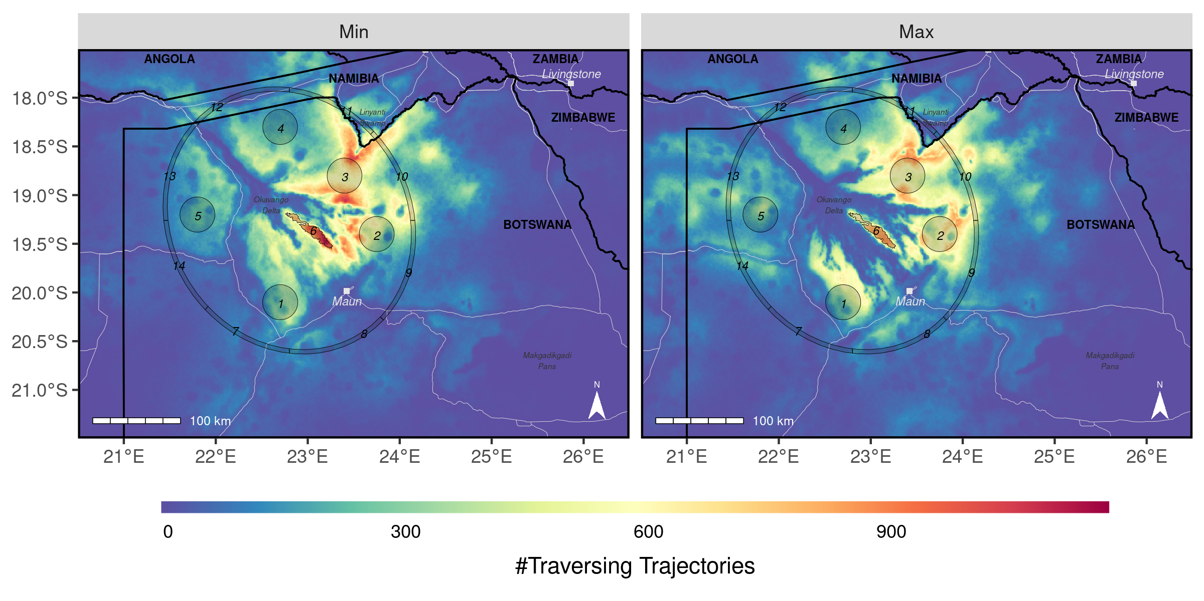

Heatmaps depicting the number of simulated dispersal trajectories traversing each grid-cell in the study area. The left panel shows results for the minimum flood scenario, whereas the right panel shows results for the maximum flood scenario. Source areas (numbered 1-6) from which dispresers were released, and emigration zones (numbered 7-14) are shaded in dark gray.

## Betweenness

The betweenness maps reveal a similar pattern in that connectivity through the OD is only pronounced during periods of low floods and vanishes entirely during maximum flood (). A set of four dispersal corridors meets on the central peninsula (source area 5, ) at minimum flood but the same corridors are absent when the flood reaches a maximum extent. Instead, a narrow corridor runs north west of Maun, connecting source areas one and two. Again, the remainder of the study area is only marginally affected by flooding patterns. Additional betweenness maps highlighting differences in connectivity for each source area separately are provided in Appendix SX.

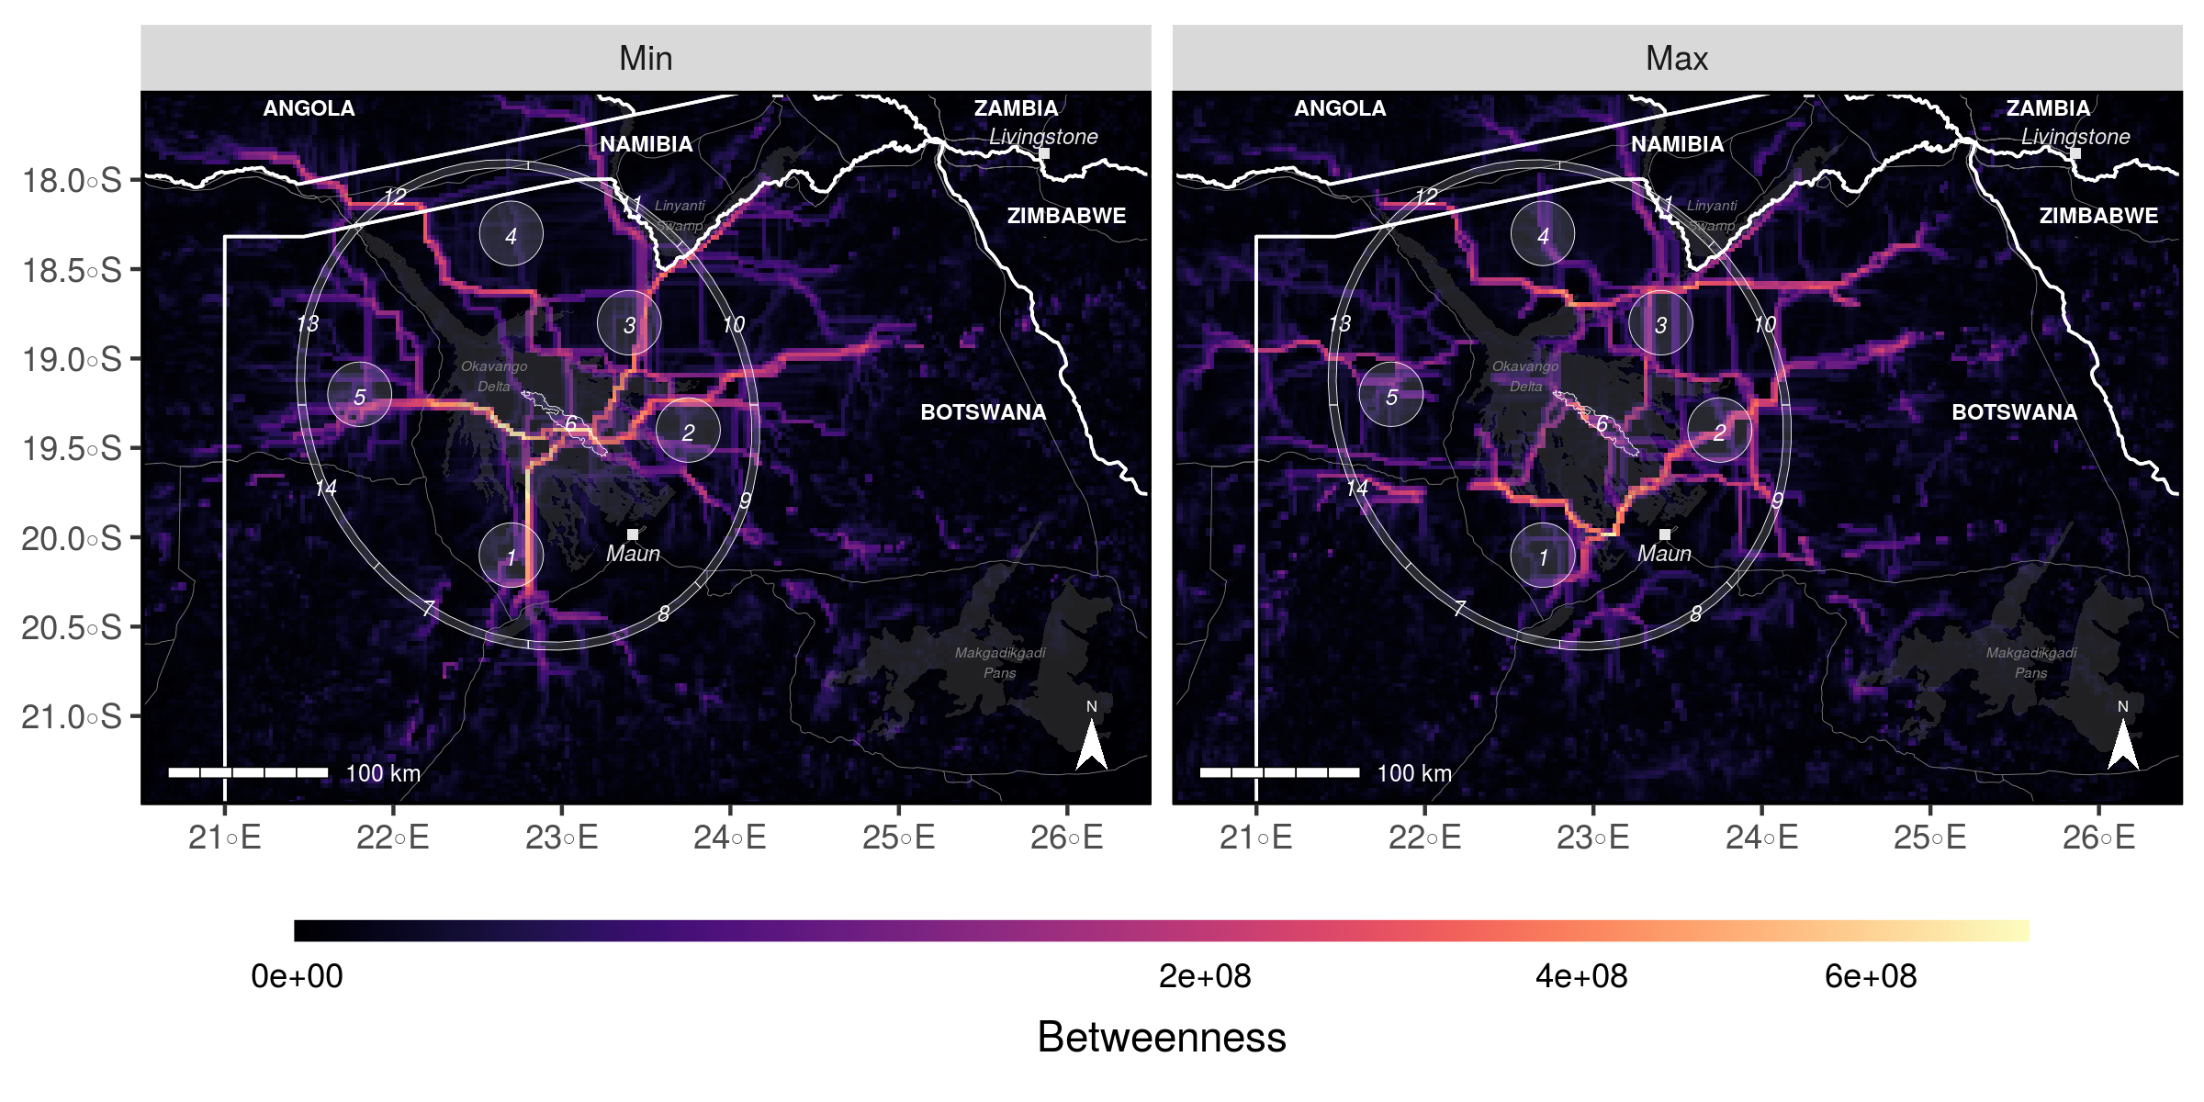

Betweenness scores highlighting potential dispersal corridors for both the minimum and maximum flood scenario. Areas with high betweenness scores (bright yellow) are used by many simulated individuals to move into adjacent regions and can thus be understood as critical pinch-points. Source areas (numbered 1-6) from which dispresers were released, and emigration zones (numbered 7-14) are shaded in light gray.

## Inter-Patch Connectivity

Our analysis of interpatch connectivity demonstrates notable differences in dispersal prospects and duration depending on the extent of the flood (). While $\input{99_NumberReachingOthersMinFlood.tex}$ simulated dispersers reach another source area during minimum extent, only $\input{99_NumberReachingOthersMaxFlood.tex}$ do so during maximum extent. The differences are particularly pronounced for individuals dispersing from or into the source area located at the OD’s center (). While the area is reached by $\input{99_NumberReachingArea6MinFlood.tex}$ simulated individuals during minimum flood, only $\input{99_NumberReachingArea6MaxFlood.tex}$ dispersers arrive there during maximum flood. Furthermore, the dispersal duration into source area six from any other source area increases from $\input{99_StepsToReachingArea6MinFlood.tex}$ to $\input{99_StepsToReachingArea6MaxFlood.tex}$. Across all simulations, the average dispersal duration before reaching another source area increases from xx to xx from the minimum to the maximum flood scenario. Nevertheless, connectivity into some areas increases during maximum flooding. Emigration increased slightly from xx to xx

For instance, while dispersers .. Additional maps highlighting differences in inter-patch connectivty for each source area separately are provided in Appendix SX.

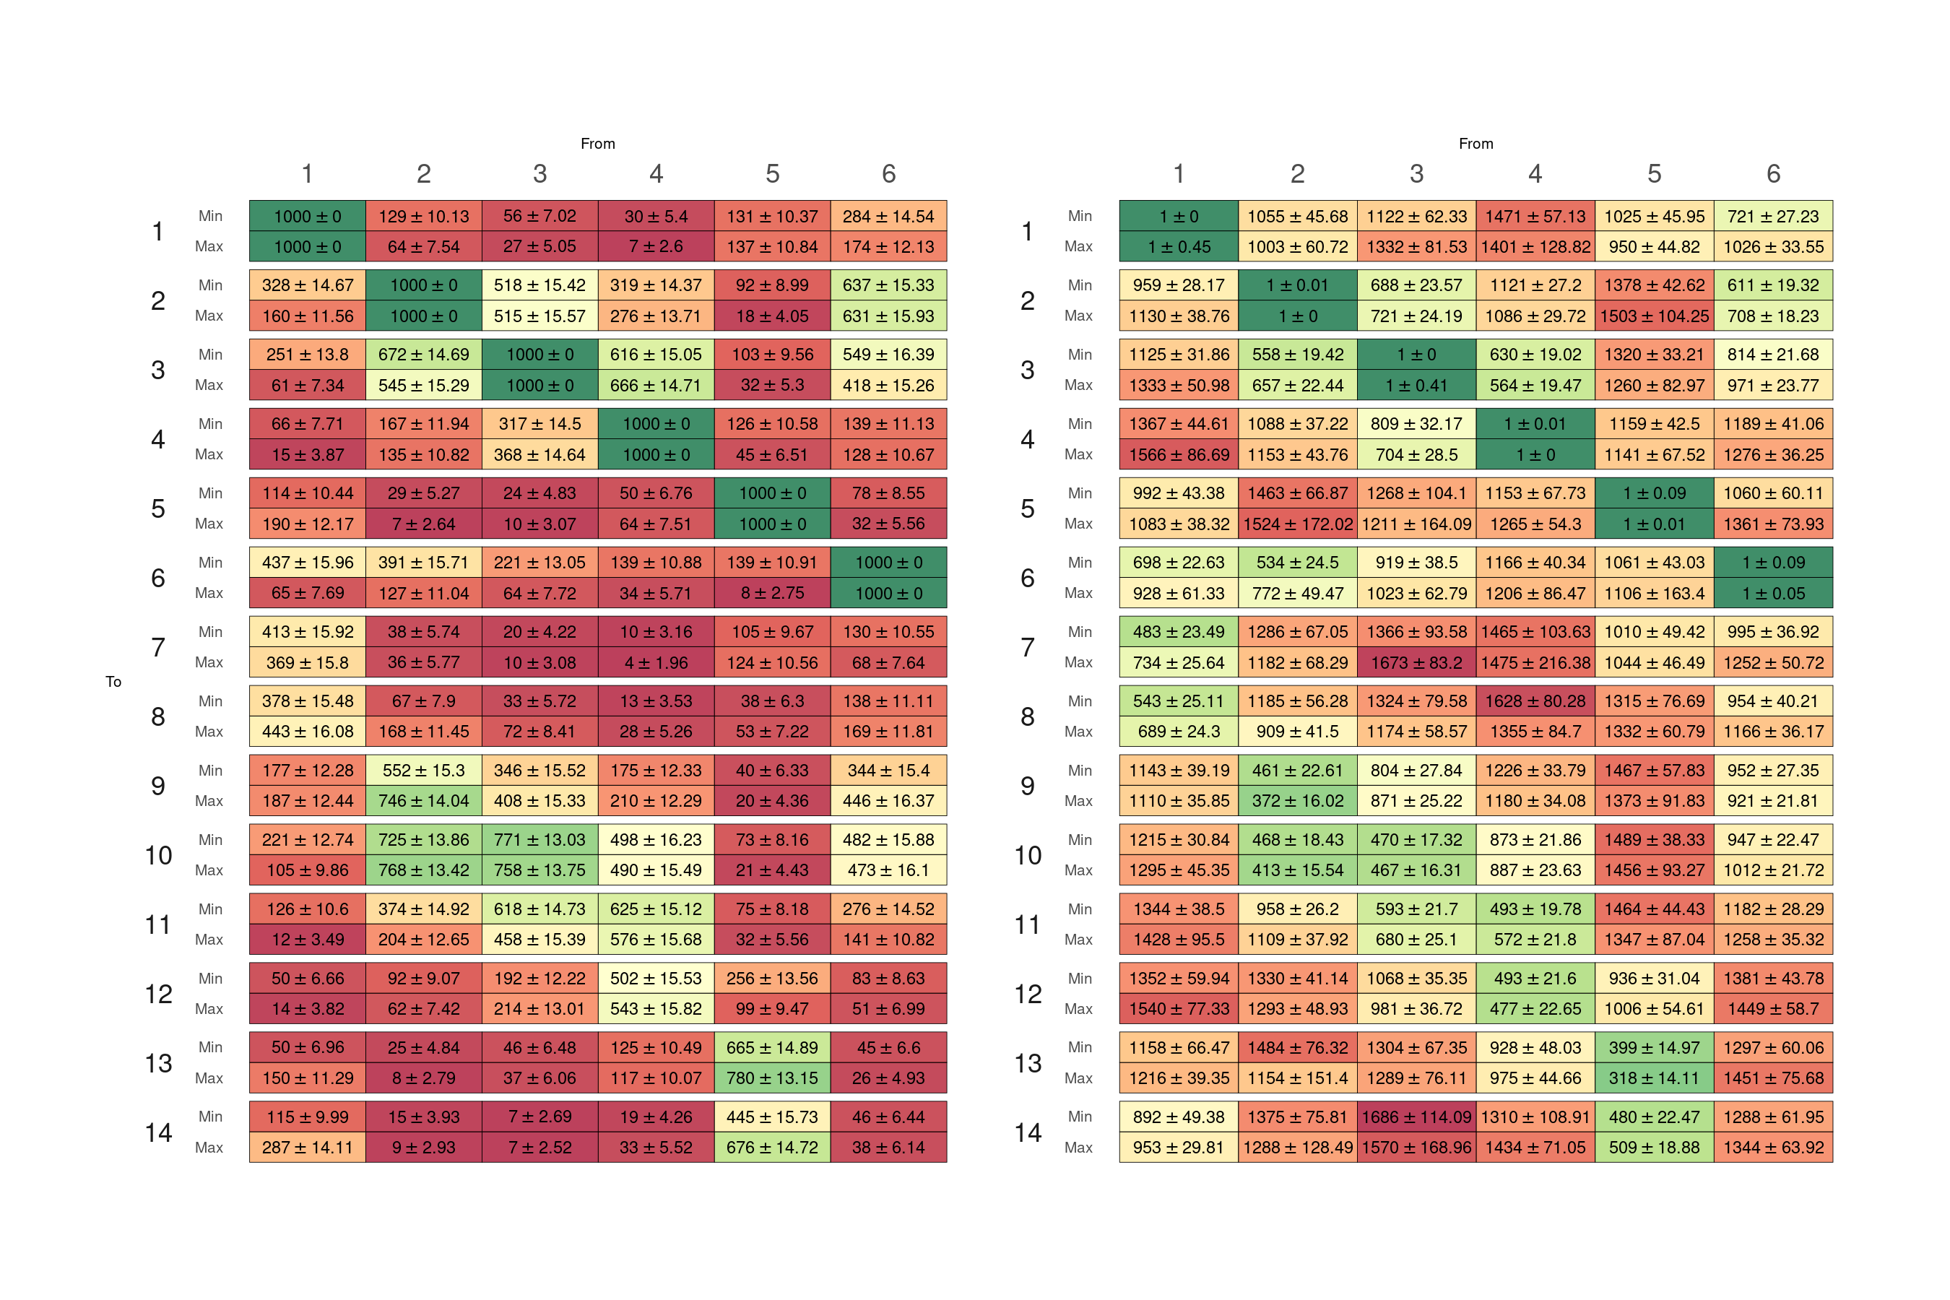

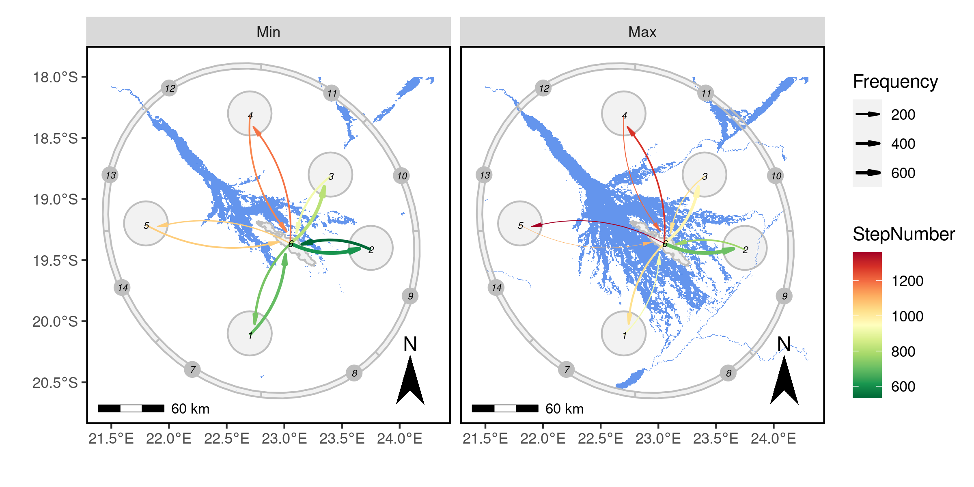

# Discussion

According to our simulations, the propensity to move between the eastern and western part of the delta is much lower during maximum extent. This is mainly due to the flood-waters and the city of Maun acting as dispersal barriers. During maximum extent, the floodwaters of the delta close a gap between the delta and Maun that otherwise would serve as dispersal corridor. Anecdotal evidence supports this hypothesis, for the only dispersing individuals recorded to move from the eastern to the western part of the delta moved at times of low flood. In line with this, it appears that a large flood extent pushes dispersing individuals to move closer to human inhabited areas such as the village of Maun.

Predicting how climate change will impact the dispersal ability of AWDs is challenging for multiple reasons. First of all, predicting the flooding patterns of the OD under climate change is merely impossible due to the complex feedbacks between surface-temperature, soil conditions, precipitation patterns and the associated changes in vegetation. Second, the delta is not only prone to changes in environmental conditions, but also to changes in anthropogenic use of the inflowing water. Finally, it is unclear how AWDs, in fact, how any species, will cope with environmental change due to global warming. Even though some studies predict that AWD populations are likely to decline under increasing temperatures, these studies fail to account for the behavioral plasticity of their focal species. AWDs respiratory system, for instance, has evolved as a perfect adaptation to high temperatures and AWDs may, in fact, profit from a comparative advantage (cite an economist) over their competitors and prey under rising temperatures. Although the theory of comparative advantages is a fundamental concept in economics, it has yet to find its way into ecological studies.

(**???**) predicted that increased temperatures, additional human abstractions, and reduced river flows might lead to a “Delta dying” and that the impact of climate will be much more pronounced than the impact of anthropogenic water use.

Although local rainfalls in Botswana are expected to increase in terms of intensity, simulations show that the length of the rainy season will decline, more than offsetting the incline in precipitation (Akinyemi 2019).

We assessed the implications of environmental change on the dispersal prospects, yet we did not consider how changing conditions alter dispersal propensity.

According to our simulations, dispersers are able to cover larger distances during periods of low flood. This finding is little surprising, considering that inundated areas act as dispersal barriers and force dispersers to detour and circumvent water-covered areas. However, it still leads to an interesting hypothesis. Previous studies have shown that the euclidean dispersal distance of female coalitions is larger than that of male coalitions. This has led to ... However, demographic analyses have also revealed that female offspring tend to emigrate from their pack at younger ages and earlier in the year, when floodwaters are still at a relatively low level (Behr). It is thus conceivable that the sex-differences in reported dispersal distances is mainly a consequence of environmental conditions during dispersal, rather than owed to physiological differences between sexes.

While our analysis marks an important step into incorporating environmental change into studies of connectivity, there are several critical additions that should be considered in the future. We studied dispersal and connectivity under two different environmental scenarios, yet our movement model assumed that dispersers had identical habitat and movement preferences in both scenarios. In reality, however, it can be expected that movement and habitat kernels of dispersers differ depending on the season considered (examples).

An additional complication arises when species movement is not solely driven by environmental conditions, but also affected by itra- and inter-specific factors. For instance, ... has shown that dispersers... Rendering such conditions alone is challenging, yet rendering the conditions under changing environmental conditions is merely impossible.

To address such differences, researchers could model habitat and movement preferences using season-dependent models, or, alternatively, by combining hidden markov models with step-selection functions. (cite papers that fieberg sent)

Only recently, it has been discovered that AWDs communicate using shared marking sites. The role of such marking sites for dispersing coalitions remains to be investigated, yet it is is likely that, akin to resident packs, use SMS as navigation waypoint and demarcation lines. Chemical analyses suggest that the compounds used for communication are highly volatile and may not persist in extreme climate conditions. In result, dispersers may lose their ability to effectively navigate across the landscape and locate potential mates with whom to settle. This would reduce pack-formation prospects and undermine...

Validating predictions from individual-based dispersal models is challenging and requires additional dispersal data, which is inherently scarce anyways. Sciticen science may help to fill this gap by augmenting observed GPS data with occasional sightings of uncollared dispersing coalitions. This is especially ciritical for species that disperse across borders and beyond confined study areas. The African carnivore wildbook offers ...

The OD is an important driver of species distribution and it has been found that an expanding flood limits available habitat, thus leading to more inter-specific competition, particularly between AWDs and lions.

## Conclusion

Our dispersal simulations across two extreme climatic scenarios reveal striking differences in dispersal prospects and landscape connectivity for dispersing AWDs. This implies that (1) climatic variation, be it due to seasonality or climate change, must be included in anlayses dealing with dispersal and (2) that projected climate change is likely to have profound impacts on landscape connectivity.

# Authors’ Contributions

D.D.H., D.M.B., A.O. and G.C. conceived the study and designed methodology; D.M.B., G.C., and J.W.M. collected the data; D.D.H. and D.M.B. analysed the data; G.C. and A.O. assisted with modeling; D.D.H., D.M.B., and G.C. wrote the first draft of the manuscript and all authors contributed to the drafts at several stages and gave final approval for publication.

# Data Availability

GPS movement data of dispersing wild dogs is available on dryad (**???**). Access to R-scripts that exemplify the application of the proposed approach using simulated data are provided through Github (<https://github.com/DavidDHofmann/DispersalSimulation>). In addition, all codes required to reproduce the African wild dog case study will be made available through an online repository at the time of publication.

# Acknowledgements

We thank the Ministry of Environment and Tourism of Botswana for granting permission to conduct this research. We thank C. Botes, I. Clavadetscher, and G. Camenisch for assisting with wild dog immobilizations. We also thank B. Abrahms for sharing her data of three dispersing wild dogs. Furthermore, we would like to thank Johannes Signer for assisting with the simulation algorithm. This study was funded by Albert-Heim Foundation, Basler Stiftung für Biologische Forschung, Claraz Foundation, Idea Wild, Jacot Foundation, National Geographic Society, Parrotia Stiftung, Stiftung Temperatio, Wilderness Wildlife Trust Foundation, Forschungkredit der Universität Zürich, and a Swiss National Science Foundation Grant (31003A_182286) to A. Ozgul.

Akinyemi, Felicia O. 2019. “Potential Impacts of Global Warming Levels 1.5 C and Above on Climate Extremes in Botswana.” *Climatic Change*, 14.

Avgar, Tal, Subhash R. Lele, Jonah L. Keim, and Mark S. Boyce. 2017. “Relative Selection Strength: Quantifying Effect Size in Habitat- and Step-Selection Inference.” *Ecology and Evolution* 7 (14): 5322–30. <https://doi.org/10.1002/ece3.3122>.

Avgar, Tal, Jonathan R. Potts, Mark A. Lewis, and Mark S. Boyce. 2016. “Integrated Step Selection Analysis: Bridging the Gap Between Resource Selection and Animal Movement.” Edited by Luca Börger. *Methods in Ecology and Evolution* 7 (5): 619–30. <https://doi.org/10.1111/2041-210X.12528>.

Cozzi, Gabriele, Dominik M. Behr, Hugh S. Webster, Megan Claase, Caleb M. Bryce, Boitshepho Modise, John W. Mcnutt, and Arpat Ozgul. 2020. “African Wild Dog Dispersal and Implications for Management.” *The Journal of Wildlife Management*, February, 614–21. <https://doi.org/10.1002/jwmg.21841>.

Engelbrecht, Francois, Jimmy Adegoke, Mary-Jane Bopape, Mogesh Naidoo, Rebecca Garland, Marcus Thatcher, John McGregor, et al. 2015. “Projections of Rapidly Rising Surface Temperatures over Africa Under Low Mitigation.” *Environmental Research Letters* 10 (8): 085004. <https://doi.org/10.1088/1748-9326/10/8/085004>.

Fortin, Daniel, Hawthorne L. Beyer, Mark S. Boyce, Douglas W. Smith, Thierry Duchesne, and Julie S. Mao. 2005. “Wolves Influence Elk Movements: Behavior Shapes a Trophic Cascade in Yellowstone National Park.” *Ecology* 86 (5): 1320–30. <https://doi.org/10.1890/04-0953>.

Graves, Tabitha, Richard B. Chandler, J. Andrew Royle, Paul Beier, and Katherine C. Kendall. 2014. “Estimating Landscape Resistance to Dispersal.” *Landscape Ecology* 29 (7): 1201–11. <https://doi.org/10.1007/s10980-014-0056-5>.

Hofmann, David D., Dominik M. Behr, John W. McNutt, Arpat Ozgul, and Gabriele Cozzi. 2021. “Bound Within Boundaries: Do Protected Areas Cover Movement Corridors of Their Most Mobile, Protected Species?” *Journal of Applied Ecology*.

Maestre, Fernando T., Roberto Salguero-Gómez, and José L. Quero. 2012. “It Is Getting Hotter in Here: Determining and Projecting the Impacts of Global Environmental Change on Drylands.” *Philosophical Transactions of the Royal Society B: Biological Sciences* 367 (1606): 3062–75. <https://doi.org/10.1098/rstb.2011.0323>.

Masenga, Emmanuel H., Craig R. Jackson, Ernest E. Mjingo, Andrew Jacobson, Jason Riggio, Richard D. Lyamuya, Robert D. Fyumagwa, Markus Borner, and Eivin Røskaft. 2016. “Insights into Long-Distance Dispersal by African Wild Dogs in East Africa.” *African Journal of Ecology* 54 (1): 95–98. <https://doi.org/10.1111/aje.12244>.

Midgley, Guy F., and William J. Bond. 2015. “Future of African Terrestrial Biodiversity and Ecosystems Under Anthropogenic Climate Change.” *Nature Climate Change* 5 (9): 823–29. <https://doi.org/10.1038/nclimate2753>.

Muff, Stefanie, Johannes Signer, and John Fieberg. 2020. “Accounting for Individual-Specific Variation in Habitat-Selection Studies: Efficient Estimation of Mixed-Effects Models Using Bayesian or Frequentist Computation.” *Journal of Animal Ecology* 89 (1): 80–92. <https://doi.org/10.1111/1365-2656.13087>.

Paniw, Maria, Tamora D. James, C. Ruth Archer, Gesa Römer, Sam Levin, Aldo Compagnoni, Judy Che-Castaldo, et al. 2021. “The Myriad of Complex Demographic Responses of Terrestrial Mammals to Climate Change and Gaps of Knowledge: A Global Analysis.” *Journal of Animal Ecology* 90 (6): 1398–1407. <https://doi.org/10.1111/1365-2656.13467>.

Radchuk, Viktoriia, Thomas Reed, Céline Teplitsky, Martijn van de Pol, Anne Charmantier, Christopher Hassall, Peter Adamík, et al. 2019. “Adaptive Responses of Animals to Climate Change Are Most Likely Insufficient.” *Nature Communications* 10 (1): 3109. <https://doi.org/10.1038/s41467-019-10924-4>.

Thurfjell, Henrik, Simone Ciuti, and Mark S. Boyce. 2014. “Applications of Step-Selection Functions in Ecology and Conservation.” *Movement Ecology* 2 (4). <https://doi.org/10.1186/2051-3933-2-4>.

Travis, Justin M. J., Maria Delgado, Greta Bocedi, Michel Baguette, Kamil Bartoń, Dries Bonte, Isabelle Boulangeat, et al. 2013. “Dispersal and Species’ Responses to Climate Change.” *Oikos* 122 (11): 1532–40. <https://doi.org/10.1111/j.1600-0706.2013.00399.x>.

Vasudev, Divya, Robert J. Fletcher, Varun R. Goswami, and Meghna Krishnadas. 2015. “From Dispersal Constraints to Landscape Connectivity: Lessons from Species Distribution Modeling.” *Ecography* 38 (10): 967–78. <https://doi.org/10.1111/ecog.01306>.