Simulating Dispersal across Seasonal Landscapes to Assess Dynamic Connectivity for an Endangered Large Carnivore

David D. Hofmann1,2,§ Dominik M. Behr1,2 John W. McNutt2

Arpat Ozgul1, 2 Gabriele Cozzi1,2

July 24, 2023

1. Department of Evolutionary Biology and Environmental Studies, University of Zurich,

Winterthurerstrasse 190, 8057 Zurich, Switzerland.

1. Botswana Predator Conservation Program, Wild Entrust, Private Bag 13, Maun,

Botswana.

§ Corresponding author (david.hofmann2@uzh.ch)

**Running Title:** Seasonality and Landscape Connectivity: Understanding Nature’s

Changing Pathways

**Keywords:** Seasonality, dispersal, connectivity, individual-based, Lycaon pictus,

Okavango Delta

**Abstract**

Many ecosystems experience changes in environmental conditions due to seasonality. While such seasonal changes may drastically alter connectivity for endangered species, most studies represent their study system by a static set of spatial layers, thus ignoring seasonal variation. Here, we utilize natural environmental fluctuations across the Okavango Delta in Botswana to address this shortcoming and investigate seasonal connectivity patterns emerging for dispersing African wild dogs (*Lycaon pictus*). For this, we parameterize a seasonal individual-based dispersal model using frequently updated spatial layers and multi-seasonal GPS data collected on dispersing individuals. Using the parametrized model, we simulate dispersal across different seasons and investigate emerging patterns of connectivity. Despite a better understanding of the conservation needs for African wild dogs, our study also provides evidence that incorporating seasonality in studies of connectivity is imperative to more accurately predict the dispersal ability of endangered species.

**Contents**

**1 Introduction** **1**

**2 Methods** **3**

2.1 Study Area 4

2.2 GPS Data 4

2.3 Spatial Habitat Layers 5

2.3.1 Landscape Characteristics 6

2.3.2 Climate Descriptors 7

2.3.3 Anthropogenic Features 7

2.4 Step Selection Function 8

**3 Results** **9**

**4 Discussion** **9**

**5 Authors’ Contributions** **10**

**6 Data Availability** **11**

**7 Acknowledgements** **11**

# Introduction

Landscape connectivity, i.e. the degree to which a landscape facilitates or impedes movement among habitat patches (Taylor et al., 1993), plays a central role in maintaining biodiversity (Fahrig, 2003) and is one of the most frequently recommended strategies to promote resilience against changing environmental conditions (Rudnick et al., 2012). Studies of landscape connectivity typically combine information on habitats with knowledge about species’ preferences towards to those habitats to delineate critical movement corridors (Beier et al., 2008; Diniz et al., 2019). However, while seasonality is a fundamental characteristic of most ecosystems, it only rarely enters connectivity models in an explicit manner. Ignoring seasonality in the landscape or species’ habitat preferences may result in biased connectivity estimates and thus a misallocation of scarce conservation funds (Osipova et al., 2019; Zeller et al., 2020).

In light of the continued degradation, fragmentation, and destruction of valuable habitats worldwide (Fahrig, 2003; Haddad et al., 2015), preserving and reestablishing connectivity between remaining habitat patches has become a task of utmost importance (Heller and Zavaleta, 2009; Rudnick et al., 2012). The ultimate goal of promoting connectivity is to facilitate dispersal (Doerr et al., 2011; Baguette et al., 2013), i.e. the movement of individuals away from their natal location to the site of first reproduction (Clobert et al., 2012). Dispersal, in turn, promotes genetic exchange (Perrin and Mazalov, 2000; Frankham et al., 2002) and the colonization of empty habitats (Hanski, 1999; MacArthur and Wilson, 2001). Two popular approaches to estimate functional connectivity are least-cost path analysis (Adriaensen et al., 2003) and circuit theory (McRae et al., 2008), both graph-based methods that quantify conductance of the landscape based on a resistance surface (Zeller et al., 2012; Diniz et al., 2019). More recently, individual-based movement models (IBMMs), where dispersal is explicitly simulated according to a set of movement rules, have also gained some momentum (Kanagaraj et al., 2013; Allen et al., 2016; Hauenstein et al., 2019; Diniz et al., 2019; Zeller et al., 2020; Unnithan Kumar et al., 2022a,b; Hofmann et al., 2023). All methods have in common that they rely on information on landscape characteristics and how these affect the dispersal movements of the focal species to infer critical movement corridors and dispersal bottlenecks (Diniz et al., 2019). Irrespective of the chosen method, researchers only rarely account for seasonal changes in landscape characteristics or habitat preferences, thus providing an incomplete view on connectivity across seasons.

Thanks to recent advancements in remote sensing technologies and facilitated access to petabytes of landscape data at unprecedented spatial and temporal scales, new opportunities for the study of seasonality and its impacts on connectivity have emerged (Toth and J´o´zk´ow, 2016). Google Earth Engine, for instance, is an online catalogue and cloud-based analysis platform that enables a fully reproducable and standardized workflow to access and manipulate a broad range of satellite products that readily capture seasonal changes across the globe (Zhao et al., 2021). Simultaneously, the downsizing of GPS tracking devices and the extension of their battery life have led to an increase in the availability of high-quality and multi-seasonal movement data (Cagnacci et al., 2010; Kays et al., 2015) that can be used to derive seasonal habitat preferences (Fortin et al., 2005; Manly et al., 2007; Cushman and Lewis, 2010) and inform connectivity models (Diniz et al., 2019). In this regard, dispersal data are particularly valuable, as they readily capture the primary process by which connectivity is established (Elliot et al., 2014; Vasudev et al., 2015, but see Fattebert et al., 2015).

Seasonality may impact dispersal and connectivity through two channels (Mui et al., 2017). Firstly, through seasonal changes in the landscape configuration and its associated impact on *structural* connectivity. In ecosystems that experience alternating dry and wet seasons, for instance, the onset of the rainy season results in distinct “green-up” waves that affect the distribution of food resources that are tracked by herbivores (Merkle et al., 2016). Secondly, seasonality could impact how a species reacts to prevailing environmental conditions through the species’ phenology, thus impacting *functional* connectivity. For example, most amphibians require both aquatic and terrestrial habitat, yet their preference towards aquatic or terrestrial environments depends on season and breeding status (Baldwin et al., 2006). Using graph-based connectivity models, seasonal landscapes and seasonal habitat preferences can be incorporated by generating seasonal resitance surfaces and repeatedly running the connectivity analysis on the difference surfaces (e.g. Chetkiewicz and Boyce, 2009; Cushman and Lewis, 2010; Osipova et al., 2019; Zeller et al., 2020; Kaszta et al., 2021; Ciudad et al., 2021). IBMMs, on the other hand, provide the benefit that landscape characteristics and habitat preferences can be updated “as simulated individuals move”, thus providing seasonal connectivity estimates from a single analysis (Zeller et al., 2020).

The African wild dog (AWD, *Lycaon pictus*) is a keystone predator and umbrella species for conservation efforts in southern Africa (Dalerum et al., 2008). While once present across the entire Sub-Saharan continent, the species has disappeared from the majority of its historic range, largely due to human persecution, deadly diseases, and habitat destruction (Woodroffe and Sillero-Zubiri, 2020). With fewer than 2’000 adult individuals remaining in the wild, the species is listed as endangered by the IUCN red list. The biggest remaining wild-living population resides in the Okavango Delta in northern Botswana (McNutt, 1996; Woodroffe and Sillero-Zubiri, 2020), a highly seasonal and flood-pulse driven ecosystem (Wolski et al., 2017). AWDs typically reside in packs comprising up to 40 individuals, where a single dominant pair monopolizes the majority of reproduction (Frame et al., 1979; Malcolm and Marten, 1982). Upon reaching sexual maturity, individuals born into the pack emigrate and disperse in single-sex coalitions in an attempt to find suitable mates and to establish their own pack (McNutt, 1996). Timing of dispersal appears to be seasonal, with female dispersal peaking prior to the mating season, and male dispersal peaking at the onset of the wet season (Behr et al., 2020). Previous research revealed that dispersal coalitions can cross several hundred kilometers within only few days (Davies–Mostert et al., 2012; Masenga et al., 2016; Cozzi et al., 2020). Dispersers prefer moving along water-bodies and across open grass or shrubland but avoid areas dominated by humans or densely covered by forests (O’Neill et al., 2020; Hofmann et al., 2021a). Despite the importance of seasonality in this study system, a seasonal take on connectivity is still lacking for this species.

In this paper we aim to explore seasonal connectivity patterns for the endangered African wild dog in northern Botswana. To estimate connectivity, we first combine multi-seasonal GPS movement data of dispersing AWDs with dynamically updated habitat layers and parameterize a two-season dispersal model. This model is based on an integrated stepselection function (iSSF, Avgar et al., 2016), which produces unbiased estimates for habitat and movement preferences and results in a mechanistic dispersal model (Avgar et al., 2016; Signer et al., 2017). We use the model to simulate dispersal from distinct habitat patches while dynamically updating habitat preferences and underlying environmental conditions as the simulated dispersers move. This results in xx-thousands simulated dispersal trajectories that we use to quantify seasonal connectivity the chosen habitat patches in the landscape (sensu Hofmann et al., 2023).

# Methods

We used the R programming language (R Core Team, 2022) for all data preparation and analyses. Spatial data manipulation was performed using the terra (Hijmans et al., 2023) and spatstat (Baddeley et al., 2015) packages. We generated figures using ggplot2 (Wickham, 2016). To ensure reproducibility, all R-scripts will be made available through an online repository.

## Study Area

The study area for this project was focussed on northern Botswana (centered at 24 30’E

20 42’S at an elevation of approx. 950 m) but also encompassed parts of Namibia and Zimbabwe, and stretched across a rectangular extent of 160’000 km2 (Figure 1). The main physographical feature within the study area is the Okavango Delta, a flood-pulse driven mosaic of patchy woodlands, permanent swamps, and seasonally flooded grasslands that lie within the otherwise dry and sandy Kalahari Basin (Wilson and Dincer, 1976; Ramberg et al., 2006). Precipitation across the study area varies considerably between seasons, ranging from 0 mm during peak dry season (dry season from 15 May to 15 October) to 140 mm during peak wet season (wet season from 15 October to 15 May), totalling to 600 mm across an average year (Figure 2a). Daily maximum above-ground temperature fluctuates between 7 during winter (i.e. dry season) to 38 C during winter (i.e. wet season, Figure 2b). Vegetation in the study area is mainly composed of mopane forest (*Colophospermum mopane*), acacia-dominated woodland (*Acacia spp.*), and grassland. Green-up after the dry season is typically initiated after the first rains of the wet season, which stimulate plant growth and leaf production. The normalized difference vegetation index (NDVI) therefore depicts a lagged and smoothed response to the precipitation patterns across the study area (Figure 2c). The yearly flood-cycle of the delta is predominantly driven by rainfalls in the Angolan highlands, where water is collected and channeled through the Okavango River into the Okavango Delta (McCarthy et al., 2003; Gumbricht et al., 2004). Because water only slowly descends from the catchment areas in Angola into the delta’s tributaries, the flood is out of sync with local rainfalls and typically reaches its maximum extent during August-September, i.e. during peak dry season (Wolski et al., 2017, Figure 2d). While the extent of large-bodied rivers and floodplains is driven by precipitation in Angola, local precipitation during the wet season lead to the emergence of small water-filled pans. 62% of the landscapes in the study area form part of a national park or some other type of protected area, such that human impact remains low and is largely limited to settlements along the western part of the delta and the city of Maun at the delta’s southern tip. Landscapes outsite protected areas in Zimbabwe, however, are heavily dominated by humans, largely due to agricultural fields and human

settlements.

## GPS Data

Between the years 2015 and 2022, we collected GPS data of 30 dispersing AWD coalitions (15 female coalitions, 15 male coalitions) from a free-ranging population in northern Botswana.

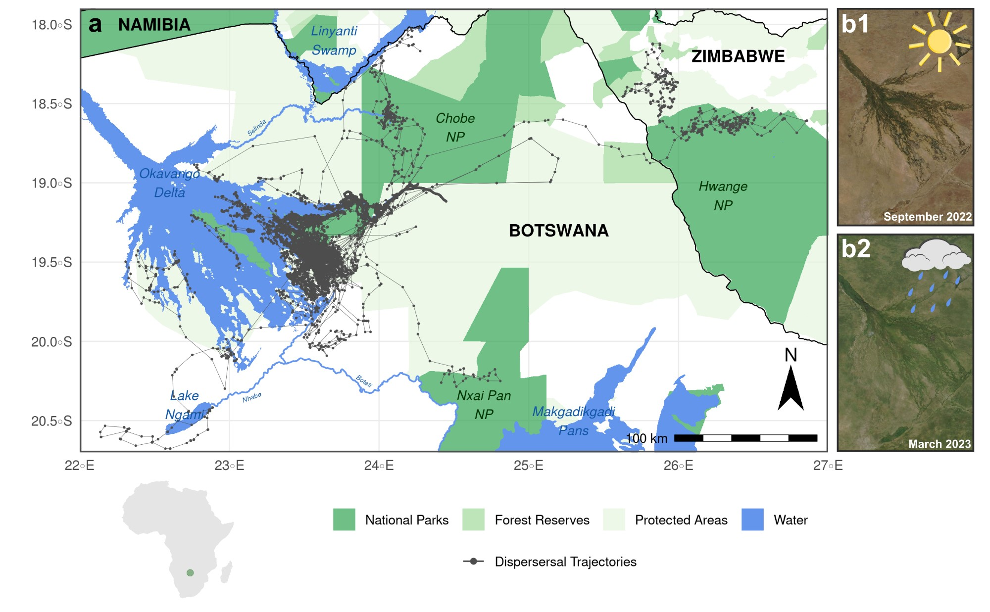

**Figure 1:** (a) Study area from which data on dispersing AWDs was collected. Dispersal trajectories are plotted in dark gray. The study area encompassed parts of the Okavango Delta, a highly dynamic, flood-pulse-driven ecosystem. The entire study area undergoes substantial seasonal changes, as can be seen from two satellite images taken during peak dry season (b1) and peak rainy season (b2). Notably, the flood of the Okavango Delta reaches its maximum extent during peak dry season.

Details on the GPS collar fitting procedure and how we distinguished between dispersal and resident movements can be found in Cozzi et al. (2020) and Hofmann et al. (2021a). During dispersal, we programmed GPS satellite collars to record a GPS fix at a predetermined 4hourly schedule. The collars regularly transmitted the data to a base station, which allowed us to track dispersing individuals, even if they moved outside the main study area. In total, we successfully collected 5’940 fixes during dispersal, with an average of 198 ± 239 fixes per coalition. Occasionally, the acquisition of a GPS location failed (success rate = 93 ± 8%), resulting in irregular durations between some subsequent fixes.

## Spatial Habitat Layers

We represented the physical landscape through which dispersers could move by a series of spatial layers that we believed whould influence wild dog movements during dispersal. The layers can be broadly categorized into descriptors of (1) landscape characteristics, (2) climatic conditions, and (3) anthropogenic factors (Table 1). To appropriately render seasonal dynamicity in each of these layers, we downloaded spatial data at the highest temporal resolution available. That is, whenever possible, we represented covariates by a series of raster layers that spanned the entire range of dates for which we collected data of dispersing

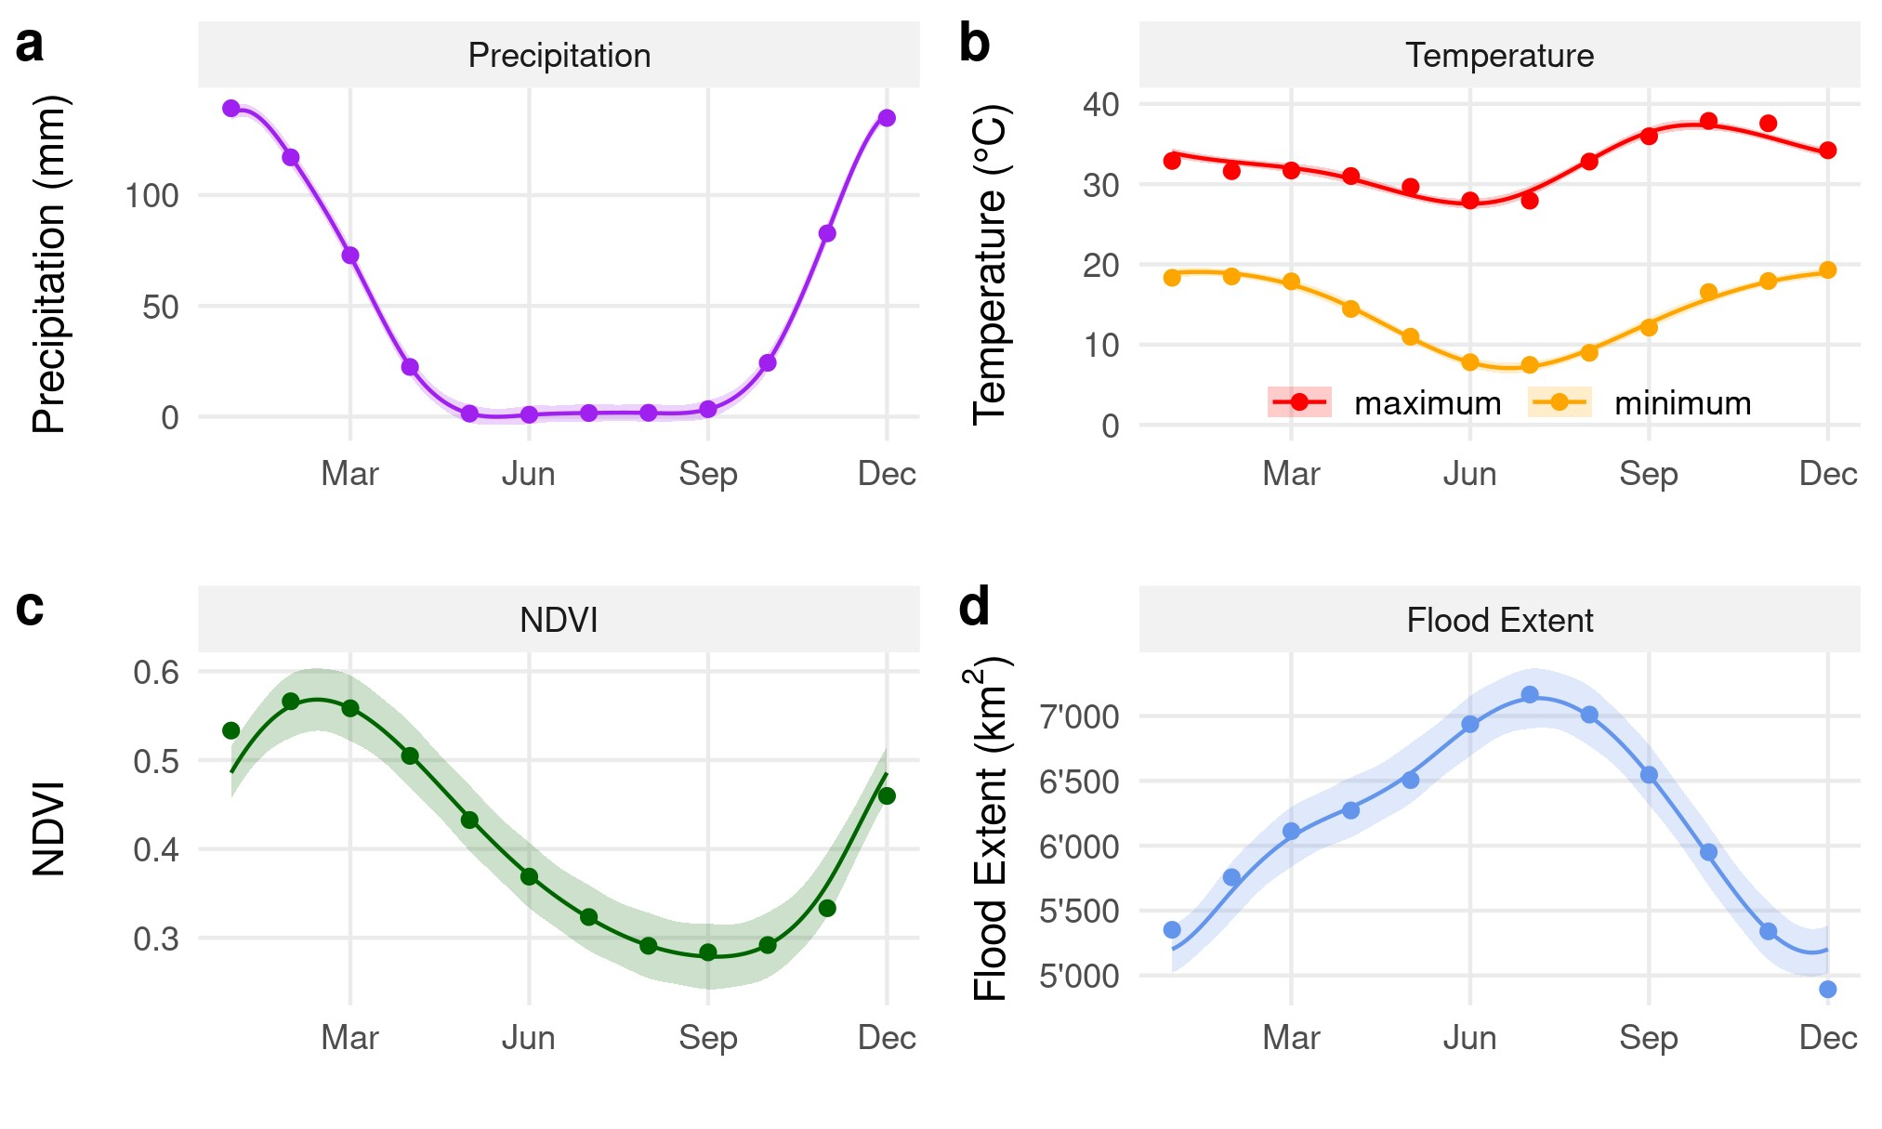

**Figure 2:** Illustration of how some of the covariates considered in this study vary across seasons. Data for the graphs was obtained from the (a) Global Satellite Mapping of Precipitation dataset, (b) ERA5 dataset, (c) MODIS MOD13Q1 dataset, and (d) remote sensed MOD43A4 satellite images. Values were extracted across the study area and averaged by months. The smoothing curves were fitted using simple GAM models in the mgcv package (Wood, 2011).

AWDs. We downloaded each product at the highest spatial resolution available (Table 1).

### Landscape Characteristics

We used data from the MODIS Vegetation Continuous Fields dataset (MOD44B V061, DiMiceli et al., 2022) to represent vegetation across the study area. The MOD44B dataset comprises three continuous layers, depicting the percentage cover of woodland, shrubs/grassland, and bareland, respectively. Because the layers add up to 100%, we only considered the two layers woodland and shrubs/grassland, thus preventing issues of perfect multicollinearity. This specific product is updated on day 65 of each year and so we used the R-package RGISTools (P´erez-Goya et al., 2020) to download yearly updated layers for the years for which GPS data was at our disposal. We also downloaded information on the normalized vegetation difference index (NDVI) from the MODIS MOD13Q1 dataset (Didan, 2015). This product is updated every 16 days and we accessed the respective layers through Google Earth Engine (Gorelick et al., 2017) using the r-package rgee (Aybar, 2023). We depicted open water sources using the Globeland30 dataset, from which we only retained the landcover class water. To dynamically update the distribution of floodwater across the extent of the Okavango Delta, we combined the Globeland30 water-cover layer with weekly updated floodmaps derived from remote sensed MODIS MOD43A4 satellite images. The algorithm

**Table 1:** Spatial covariates used in this study.

|  |  |  |  |  |  |
| --- | --- | --- | --- | --- | --- |
| Variable Description | | Temporal Resolution | Spatial Resolution | Source | Download  Method |
| **Landscape Characteristics**  Trees Percentage tree cover | | 1 year | 250 m | MODIS MOD44B | RGISTools |
| Shrubs / grassland | Percentage non-tree vegetation | 1 year | 250 m | MODIS MOD44B | RGISTools |
| NDVI | Normalized difference in vegetation index | 16 days | 250 m | MODIS MOD13Q1 | rgee |
| Permanent water | Presence of water bodies | static | 30 m | Globeland30 | website |
| Pan-water | Presence of pans | 5/10 days | 10 m | Sentinel 2 | sen2r |
| Flood-water | Presence of flood water | 8 days | 500 m | MOD34A4 | floodmapr |
| Distance to water | Distance to nearest source of water (m) | - | - | - | - |
| Rivers | Presence of rivers | static | 90 m | MERIT Hydro | website |
| **Climate Descriptors**  Temperature 2-m above-ground temperature (Celsius) | | 1 hour | 10 km | ERA5 | rgee |
| Precipitation Accumulated precipitation (mm/h)  **Anthropogenic Features** | | 1 hour | 10 km | JAXA GSMaP | rgee |
| Human density | Estimated human density (inh / sq-km) | static | 30 m | Facebook | website |
| Agriculture | Presence of agriculture | static | 30 m | Globeland30 / Cropland | website |
| Roads | Presence of roads | static | vectorized | Open Street Map | website |
| Protection status | Protection status of the area | static | vectorized | Peace Parks | website |

*Note:*

Layers highlighted in gray were combined into a single proxy for human-influence.

1 Test

upon which the separation between floodwater and dryland is based is described in detail in Wolski et al. (2017) and Hofmann et al. (2021a) and is implemented in the floodmapr package (available on GitHub; [https://github.com/DavidDHofmann/floodmapr)](https://github.com/DavidDHofmann/floodmapr). Because this algorithm has been developed to remote sense large-scale bodies of floodwater, it is unsuitable for the detection of smaller waterbodies, such as those represented by pans. As such, we parametrized a classifier that was specifically focused on detecting surface water from small-scale pans using Sentinel 2 satellite imagery (European Space Agency, 2018). This allowed us to obtain updated maps for the distribution of pan-water at an interval of 5 to 10 days.

### Climate Descriptors

We downloaded hourly updated information on above-ground temperature and precipitation through Google Earth Engine (Gorelick et al., 2017) using the rgee package (Aybar, 2023). We obtained temperature data from the ERA5-Land dataset (Mun˜oz-Sabater et al., 2021), whereas we utilized the Global Satellite Mapping of Precipitation dataset to access precipitation data (Kubota et al., 2020). To match hourly values from the temperature and precipitation data with the 4-hour fixes from the GPS data collection, we computed average precipitation and temperature values across four hours.

### Anthropogenic Features

We combined anthropogenic pressures arising from the presence of humans, agriculture, and roads into a single proxy for human influence. We obtained information on human density from Facebook’s high resolution human density dataset (Tiecke et al., 2017) which we downloaded from the humdata website ([www.data.humdata.org/)](http://www.data.humdata.org/). We also downloaded rasterized information on the presence of agricultural fields from the Globeland30 (Chen et al., 2015) and Cropland (Xiong et al., 2017) datasets. Vectorized data on main tar roads was downloaded from OpenStreetMaps (OpenStreetMap contributors, 2017). How the individual layers were merged and combined into a single layer is described in detail in Hofmann et al. (2021a). Finally, we also derived vector data on the distribution of national parks, wildlife management areas and other protected areas from the Peace Parks Foundation ([www.maps.ppf.org.za/)](http://www.maps.ppf.org.za/).

## Step Selection Function

We estimated seasonal habitat and movement preferences of dispersing individuals using an integrated step-selection function (iSSF, Fortin et al., 2005; Avgar et al., 2016). In iSSFs, *observed* steps (i.e. the straight line between two consequtive GPS locations (Turchin, 1998)) are compared to *random* steps in a conditional logistic regression framework (Fortin et al., 2005; Thurfjell et al., 2014; Muff et al., 2020; Fieberg et al., 2021). We thus converted subsequent GPS locations during dispersal into bursts of steps with equal duration. For this, we first identified bursts of consecutive GPS fixes where the duration between two GPS fixes did not exceed 4 hours (± 15 minutes). Within each burst, we computed step lengths (sl) and relative turning angles (ta) associated with each observed step. 26 dispersing coalitions (12 female coalitions, 14 male coalitions) remained in the final dataset. This yielded a total of 5’310 steps (204 ± 225 per coalition). We partitioned the resulting steps into wet and dry season. 59% of the GPS data fell into the dry season, 41% into the wet-season.

We paired each observed step with a set of 25 random steps, generated by sampling turning angles from a uniform distribution U(−*π,*+*π*) and step lengths from a gamma distribution fitted to observed steps (scale *θ* = valuefromtex and shape *k* = valuefromtex) using the fitdistrplus package (Delignette-Muller and Dutang, 2015). Together, an observed step and its 25 associated random steps formed a stratum that received a unique identifier. Along each step, we extracted covariate values from the underlying spatial habitat layers (Table 1). For continuous covariates, we computed average values along each step, for categorical covariates the percentage cover of each category along the step. To facilitate model convergence, we standardized extracted values using a z-score transformation.

We then assumed that each animal assigned a score *w*(*x*) of the following exponential form to each realized and random step (Fortin et al., 2005):

**Table 2:** Test

FixedEffects

RandomEffects

|  |  |  |  |  |  |  |  |  |
| --- | --- | --- | --- | --- | --- | --- | --- | --- |
| Season | Covariate | Coefficient | SE | z-value | p-value | Significance | Variance | SD |
|  | cos ta | 0.166 | 0.049 | 3.348 | 0.001 | *** | 0.010 | 0.102 |
| Wet | sl  log sl | -0.007  0.006 | 0.020  0.018 | -0.371  0.342 | 0.711  0.733 |  | 0.005  0.002 | 0.069  0.048 |
|  | Water | -0.089 | 0.093 | -0.959 | 0.338 |  | 0.016 | 0.126 |
|  | cos ta | 0.168 | 0.044 | 3.826 | 0.000 | *** | 0.008 | 0.087 |
| Dry | sl  log sl | -0.005  0.027 | 0.016  0.009 | -0.317  2.879 | 0.751  0.004 | *** | 0.003  0.000 | 0.056  0.000 |
|  | Water | -0.051 | 0.068 | -0.753 | 0.452 |  | 0.000 | 0.000 |

*w*(*x*) = *exp*(*β*1*x*1 + *β*2*x*2 + *...* + *βnxn*) (Equation 1)

Here, (*x*1*,x*2*,...,xn*) represent the covariate values along the respective step and (*β*1*,β*2*,...,βn*) are the animal’s relative selection strengths (Avgar et al., 2017) towards these covariates. To estimate relative selection strengths (i.e. the *β*’s), we used the mixed effects conditional logistic regression model as proposed by Muff et al. (2020). We implemented their method using the R-package *glmmTMB* (Brooks et al., 2017) and used dispersing coalition ID to model random slopes. The approach also requires the inclusion of a random intercept with an arbitrarily fixed variance of 106.

To establish whether the number of random steps sufficed to reliably estimate model parameters, we ran a series univariate models where we only included single predictors and estimated model coefficients considering 1, 5, 10, 50, and 100 random steps, respectively (sensu Fieberg et al., 2021). We replicated each model run 100 times and randomly resampled the necessary number of random steps. This allowed us to investigate the minimum number of random steps that were required before estimates for habitat and movement preferences converged towards a stationary estimate.

# Results

# Discussion

Dynamic connectivity increases our understanding of temporal changes in connectivity (Martensen et al., 2017).

Martensen et al. (2017) showed that dynamic connectivity was higher than static connectivity because of stepping stones that emerged and disappeared again.

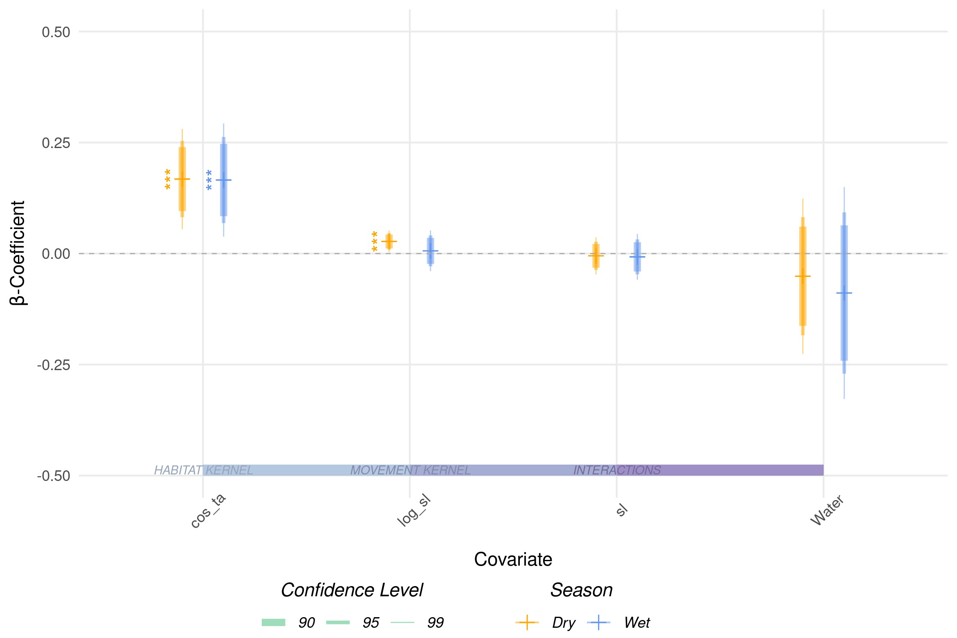

**Figure 3:** This is a caption

Osipova et al. (2019) in contrast find that connectivity is both over and underestimated, depending on the season.

Benz et al. (2016) showed that habitat selection of moose changes depending on the season and used a combination of RSFs and SSFs to study habitat selection across seasons.

Badly designed corridors can result in population sinks and wasted financial resources (Simberloff et al., 1992).

Could talk a bit about the following papers: (Chetkiewicz and Boyce, 2009; Benz et al.,

2016; Mui et al., 2017; Osipova et al., 2019; Kaszta et al., 2021)

# Authors’ Contributions

D.D.H. and G.C. conceived the study and designed methodology; D.D.H., G.C., D.M.B, and J.W.M. collected the data; D.D.H. analysed the data; G.C. assisted with modeling; D.D.H. and G.C. wrote the first draft of the manuscript and all authors contributed to the drafts at several stages and gave final approval for publication.

# Data Availability

GPS movement data of dispersing wild dogs is available on dryad (Hofmann et al., 2021b). Access to R-scripts that exemplify the application of the proposed approach using simulated data are provided through Github ([https://github.com/DavidDHofmann/DispersalSimulation)](https://github.com/DavidDHofmann/DispersalSimulation). In addition, all codes required to reproduce the African wild dog case study will be made available through an online repository at the time of publication.

# Acknowledgements

We thank the Ministry of Environment and Tourism of Botswana for granting permission to conduct this research. We thank C. Botes, I. Clavadetscher, and G. Camenisch for assisting with wild dog immobilizations. We also thank B. Abrahms for sharing her data of three dispersing wild dogs. Furthermore, we would like to thank Johannes Signer for assisting with the simulation algorithm. This study was funded by Albert-Heim Foundation, Basler Stiftung fu¨r Biologische Forschung, Claraz Foundation, Idea Wild, Jacot Foundation,

National Geographic Society, Parrotia Stiftung, Stiftung Temperatio, Wilderness Wildlife

Trust Foundation, Forschungkredit der Universit¨at Zu¨rich, and a Swiss National Science

Foundation Grant (31003A 182286) to A. Ozgul.

**References**

Adriaensen, F., Chardon, J., De Blust, G., Swinnen, E., Villalba, S., Gulinck, H., and Matthysen, E. (2003). The Application of ‘Least-Cost’ Modelling as a Functional Landscape Model. *Landscape and Urban Planning*, 64(4):233–247.

Allen, C. H., Parrott, L., and Kyle, C. (2016). An Individual-Based Modelling Approach to Estimate Landscape Connectivity for Bighorn Sheep (Ovis canadensis). *PeerJ*, 4:e2001.

Avgar, T., Lele, S. R., Keim, J. L., and Boyce, M. S. (2017). Relative Selection Strength: Quantifying Effect Size in Habitat- and Step-Selection Inference. *Ecology and Evolution*, 7(14):5322–5330.

Avgar, T., Potts, J. R., Lewis, M. A., and Boyce, M. S. (2016). Integrated Step Selection Analysis: Bridging the Gap Between Resource Selection and Animal Movement. *Methods in Ecology and Evolution*, 7(5):619–630.

Aybar, C. (2023). Rgee: R Bindings for Calling the ’Earth Engine’ Api.

Baddeley, A., Rubak, E., and Turner, R. (2015). *Spatial Point Patterns: Methodology and Applications with R*. Chapman and Hall/CRC Press, London.

Baguette, M., Blanchet, S., Legrand, D., Stevens, V. M., and Turlure, C. (2013). Individual Dispersal, Landscape Connectivity and Ecological Networks: Dispersal, Connectivity and Networks. *Biological Reviews*, 88(2):310–326.

Baldwin, R. F., Calhoun, A. J. K., and deMaynadier, P. G. (2006). Conservation Planning for Amphibian Species with Complex Habitat Requirements: A Case Study Using Movements and Habitat Selection of the Wood Frog Rana Sylvatica. *Journal of Herpetology*, 40(4):442–453.

Behr, D. M., McNutt, J. W., Ozgul, A., and Cozzi, G. (2020). When to Stay and When to Leave? Proximate Causes of Dispersal in an Endangered Social Carnivore. *Journal of Animal Ecology*, pages 1365–2656.13300.

Beier, P., Majka, D. R., and Spencer, W. D. (2008). Forks in the Road: Choices in Procedures for Designing Wildland Linkages. *Conservation Biology*, 22(4):836–851.

Benz, R. A., Boyce, M. S., Thurfjell, H., Paton, D. G., Musiani, M., Dormann, C. F., and Ciuti, S. (2016). Dispersal Ecology Informs Design of Large-Scale Wildlife Corridors. *PLoS ONE*, 11(9):e0162989.

Brooks, M. E., Kristensen, K., van Benthem, K. J., Magnusson, A., Berg, C. W., Nielsen,

A., Skaug, H. J., Maechler, M., and Bolker, B. M. (2017). glmmTMB Balances Speed and Flexibility Among Packages for Zero-Inflated Generalized Linear Mixed Modeling. *The R Journal*, 9(2):378–400.

Cagnacci, F., Boitani, L., Powell, R. A., and Boyce, M. S. (2010). Animal Ecology Meets GPS-Based Radiotelemetry: A Perfect Storm of Opportunities and Challenges. *Philosophical Transactions of the Royal Society B: Biological Sciences*, 365(1550):2157–2162.

Chen, J., Chen, J., Liao, A., Cao, X., Chen, L., Chen, X., He, C., Han, G., Peng, S., and Lu, M. (2015). Global Land Cover Mapping at 30 m Resolution: A POK-Based Operational Approach. *ISPRS Journal of Photogrammetry and Remote Sensing*, 103:7–27.

Chetkiewicz, C.-L. B. and Boyce, M. S. (2009). Use of Resource Selection Functions to Identify Conservation Corridors. *Journal of Applied Ecology*, 46(5):1036–1047.

Ciudad, C., Mateo-S´anchez, M. C., Gast´on, A., Blazquez-Cabrera, S., and Saura, S. (2021). Landscape Connectivity Estimates Are Affected by Spatial Resolution, Habitat Seasonality and Population Trends. *Biodiversity and Conservation*, 30(5):1395–1413.

Clobert, J., Baguette, M., Benton, T. G., and Bullock, J. M. (2012). *Dispersal Ecology and Evolution*. Oxford University Press, Oxford.

Cozzi, G., Behr, D. M., Webster, H. S., Claase, M., Bryce, C. M., Modise, B., Mcnutt, J. W., and Ozgul, A. (2020). African Wild Dog Dispersal and Implications for Management. *The Journal of Wildlife Management*, pages 614–621.

Cushman, S. A. and Lewis, J. S. (2010). Movement Behavior Explains Genetic Differentiation in American Black Bears. *Landscape Ecology*, 25(10):1613–1625.

Dalerum, F., Somers, M. J., Kunkel, K. E., and Cameron, E. Z. (2008). The Potential for Large Carnivores to Act as Biodiversity Surrogates in Southern Africa. *Biodiversity and Conservation*, 17(12):2939–2949.

Davies–Mostert, H. T., Kamler, J. F., Mills, M. G. L., Jackson, C. R., Rasmussen, G. S. A., Groom, R. J., and Macdonald, D. W. (2012). Long–Distance Transboundary Dispersal of African Wild Dogs Among Protected Areas in Southern Africa. *African Journal of Ecology*, 50(4):500–506.

Delignette-Muller, M. L. and Dutang, C. (2015). fitdistrplus: An R package for fitting distributions. *Journal of Statistical Software*, 64(4):1–34.

Didan, K. (2015). MOD13Q1 Modis/Terra Vegetation Indices 16-Day L3 Global 250m Sin Grid V006.

DiMiceli, C., Sohlberg, R., and Townshend, J. (2022). MODIS/Terra Vegetation Continuous Fields Yearly L3 Global 250m SIN Grid V061.

Diniz, M. F., Cushman, S. A., Machado, R. B., and De Marco Ju´nior, P. (2019). Landscape Connectivity Modeling from the Perspective of Animal Dispersal. *Landscape Ecology*, 35:41–58.

Doerr, V. A. J., Barrett, T., and Doerr, E. D. (2011). Connectivity, Dispersal Behaviour and Conservation Under Climate Change: A Response to Hodgson et al.: Connectivity and Dispersal Behaviour. *Journal of Applied Ecology*, 48(1):143–147.

Elliot, N. B., Cushman, S. A., Macdonald, D. W., and Loveridge, A. J. (2014). The Devil Is in the Dispersers: Predictions of Landscape Connectivity Change with Demography. *Journal of Applied Ecology*, 51(5):1169–1178.

European Space Agency (2018). Sentinel-2 MSI Level-2A BOA Reflectance.

Fahrig, L. (2003). Effects of Habitat Fragmentation on Biodiversity. *Annual Review of Ecology, Evolution, and Systematics*, 34(1):487–515.

Fattebert, J., Robinson, H. S., Balme, G., Slotow, R., and Hunter, L. (2015). Structural Habitat Predicts Functional Dispersal Habitat of a Large Carnivore: How Leopards Change Spots. *Ecological Applications*, 25(7):1911–1921.

Fieberg, J., Signer, J., Smith, B., and Avgar, T. (2021). A ‘How to’ Guide for Interpreting Parameters in Habitat-Selection Analyses. *Journal of Animal Ecology*, 90(5):1027–1043.

Fortin, D., Beyer, H. L., Boyce, M. S., Smith, D. W., Duchesne, T., and Mao, J. S. (2005). Wolves Influence Elk Movements: Behavior Shapes a Trophic Cascade in Yellowstone National Park. *Ecology*, 86(5):1320–1330.

Frame, L. H., Malcolm, J. R., Frame, G. W., and Van Lawick, H. (1979). Social Organization of African Wild Dogs (Lycaon pictus) on the Serengeti Plains, Tanzania 1967–1978 1. *Zeitschrift fu¨r Tierpsychologie*, 50(3):225–249.

Frankham, R., Ballou, J. D., Briscoe, D. A., and McInnes, K. H. (2002). *Introduction to Conservation Genetics*. Cambridge University Press, 1 edition.

Gorelick, N., Hancher, M., Dixon, M., Ilyushchenko, S., Thau, D., and Moore, R. (2017). Google Earth Engine: Planetary-Scale Geospatial Analysis for Everyone. *Remote Sensing of Environment*.

Gumbricht, T., Wolski, P., Frost, P., and McCarthy, T. (2004). Forecasting the Spatial Extent of the Annual Flood in the Okavango Delta, Botswana. *Journal of Hydrology*, 290(3-4):178–191.

Haddad, N. M., Brudvig, L. A., Clobert, J., Davies, K. F., Gonzalez, A., Holt, R. D., Lovejoy, T. E., Sexton, J. O., Austin, M. P., Collins, C. D., Cook, W. M., Damschen, E. I., Ewers, R. M., Foster, B. L., Jenkins, C. N., King, A. J., Laurance, W. F., Levey, D. J., Margules, C. R., Melbourne, B. A., Nicholls, A. O., Orrock, J. L., Song, D.-X., and Townshend, J. R. (2015). Habitat Fragmentation and Its Lasting Impact on Earth’s Ecosystems. *Science Advances*, 1(2):e1500052.

Hanski, I. (1999). Habitat Connectivity, Habitat Continuity, and Metapopulations in Dynamic Landscapes. *Oikos*, 87(2):209.

Hauenstein, S., Fattebert, J., Gru¨ebler, M. U., Naef-Daenzer, B., Pe’er, G., and Hartig, F. (2019). Calibrating an Individual-Based Movement Model to Predict Functional Connectivity for Little Owls. *Ecological Applications*, 29(4):e01873.

Heller, N. E. and Zavaleta, E. S. (2009). Biodiversity Management in the Face of Climate Change: A Review of 22 Years of Recommendations. *Biological Conservation*, 142(1):14– 32.

Hijmans, R. J., Bivand, R., Pebesma, E., and Sumner, M. D. (2023). Terra: Spatial Data Analysis.

Hofmann, D. D., Behr, D. M., McNutt, J. W., Ozgul, A., and Cozzi, G. (2021a). Bound Within Boundaries: Do Protected Areas Cover Movement Corridors of Their Most Mobile, Protected Species? *Journal of Applied Ecology*, 58(6):1133–1144.

Hofmann, D. D., Behr, D. M., McNutt, J. W., Ozgul, A., and Cozzi, G. (2021b). Bound within boundaries: How well do protected areas match movement corridors of their most mobile protected species?

Hofmann, D. D., Cozzi, G., McNutt, J. W., Ozgul, A., and Behr, D. M. (2023). A ThreeStep Approach for Assessing Landscape Connectivity Via Simulated Dispersal: African Wild Dog Case Study. *Landscape Ecology*.

Kanagaraj, R., Wiegand, T., Kramer-Schadt, S., and Goyal, S. P. (2013). Using IndividualBased Movement Models to Assess Inter-Patch Connectivity for Large Carnivores in Fragmented Landscapes. *Biological Conservation*, 167:298–309.

Kaszta, Z., Cushman, S. A., and Slotow, R. (2021). Temporal Non-Stationarity of Path-˙ Selection Movement Models and Connectivity: An Example of African Elephants in Kruger National Park. *Frontiers in Ecology and Evolution*, 9:553263.

Kays, R., Crofoot, M. C., Jetz, W., and Wikelski, M. (2015). Terrestrial Animal Tracking as an Eye on Life and Planet. *Science*, 348(6240):aaa2478–aaa2478.

Kubota, T., Aonashi, K., Ushio, T., Shige, S., Takayabu, Y. N., Kachi, M., Arai, Y., Tashima, T., Masaki, T., Kawamoto, N., Mega, T., Yamamoto, M. K., Hamada, A., Yamaji, M., Liu, G., and Oki, R. (2020). Global Satellite Mapping of Precipitation (GSMaP) Products in the GPM Era. In Levizzani, V., Kidd, C., Kirschbaum, D. B., Kummerow, C. D., Nakamura, K., and Turk, F. J., editors, *Satellite Precipitation Measurement: Volume 1*, Advances in Global Change Research, pages 355–373. Springer International Publishing, Cham.

MacArthur, R. H. and Wilson, E. O. (2001). *The Theory of Island Biogeography*. Princeton University Press.

Malcolm, J. R. and Marten, K. (1982). Natural Selection and the Communal Rearing of Pups in African Wild Dogs (Lycaon pictus). *Behavioral Ecology and Sociobiology*, 10(1):1–13.

Manly, B. F., McDonald, L., Thomas, D. L., McDonald, T. L., and Erickson, W. P. (2007). *Resource Selection by Animals: Statistical Design and Analysis for Field Studies*. Springer Science & Business Media.

Martensen, A. C., Saura, S., and Fortin, M.-J. (2017). Spatio-Temporal Connectivity: Assessing the Amount of Reachable Habitat in Dynamic Landscapes. *Methods in Ecology and Evolution*, 8(10):1253–1264.

Masenga, E. H., Jackson, C. R., Mjingo, E. E., Jacobson, A., Riggio, J., Lyamuya, R. D., Fyumagwa, R. D., Borner, M., and Røskaft, E. (2016). Insights into Long-Distance Dispersal by African Wild Dogs in East Africa. *African Journal of Ecology*, 54(1):95–98.

McCarthy, J. M., Gumbricht, T., McCarthy, T., Frost, P., Wessels, K., and Seidel, F. (2003). Flooding Patterns of the Okavango Wetland in Botswana between 1972 and 2000. *AMBIO: A Journal of the Human Environment*, 32(7):453–457.

McNutt, J. (1996). Sex-Biased Dispersal in African Wild Dogs, Lycaon pictus. *Animal Behaviour*, 52(6):1067–1077.

McRae, B. H., Dickson, B. G., Keitt, T. H., and Shah, V. B. (2008). Using Circuit Theory to Model Connectivity in Ecology, Evolution, and Conservation. *Ecology*, 89(10):2712–2724.

Merkle, J. A., Monteith, K. L., Aikens, E. O., Hayes, M. M., Hersey, K. R., Middleton, A. D., Oates, B. A., Sawyer, H., Scurlock, B. M., and Kauffman, M. J. (2016). Large Herbivores Surf Waves of Green-up During Spring. *Proceedings of the Royal Society B: Biological Sciences*, 283(1833):20160456.

Mun˜oz-Sabater, J., Dutra, E., Agust´ı-Panareda, A., Albergel, C., Arduini, G., Balsamo, G., Boussetta, S., Choulga, M., Harrigan, S., and Hersbach, H. (2021). ERA5-Land: A state-of-the-art global reanalysis dataset for land applications. *Earth System Science Data*, 13(9):4349–4383.

Muff, S., Signer, J., and Fieberg, J. (2020). Accounting for Individual-Specific Variation in Habitat-Selection Studies: Efficient Estimation of Mixed-Effects Models Using Bayesian or Frequentist Computation. *Journal of Animal Ecology*, 89(1):80–92.

Mui, A. B., Caverhill, B., Johnson, B., Fortin, M.-J., and He, Y. (2017). Using Multiple Metrics to Estimate Seasonal Landscape Connectivity for Blanding’s Turtles (Emydoidea blandingii) in a Fragmented Landscape. *Landscape Ecology*, 32(3):531–546.

O’Neill, H. M. K., Durant, S. M., and Woodroffe, R. (2020). What Wild Dogs Want: Habitat Selection Differs Across Life Stages and Orders of Selection in a Wide-Ranging Carnivore. *BMC Zoology*, 5(1).

OpenStreetMap contributors (2017). Planet dump retrieved from https://planet.osm.org.

Osipova, L., Okello, M. M., Njumbi, S. J., Ngene, S., Western, D., Hayward, M. W., and Balkenhol, N. (2019). Using Step-Selection Functions to Model Landscape Connectivity for African Elephants: Accounting for Variability Across Individuals and Seasons. *Animal Conservation*, 22(1):35–48.

P´erez-Goya, U., Montesino-SanMartin, M., Militino, A. F., and Ugarte, M. D. (2020). RGISTools: Downloading, Customizing, and Processing Time Series of Remote Sensing Data in R.

Perrin, N. and Mazalov, V. (2000). Local Competition, Inbreeding, and the Evolution of Sex-Biased Dispersal. *The American Naturalist*, 155(1):116–127.

R Core Team (2022). *R: A Language and Environment for Statistical Computing*. R Foundation for Statistical Computing, Vienna, Austria.

Ramberg, L., Hancock, P., Lindholm, M., Meyer, T., Ringrose, S., Sliva, J., Van As, J., and Vander Post, C. (2006). Species Diversity of the Okavango Delta, Botswana. *Aquatic Sciences*, 68(3):310–337.

Rudnick, D. A., Ryan, S. J., Beier, P., Cushman, S. A., Dieffenbach, F., Epps, C. W., Gerber, L. R., Hartter, J., Jenness, J. S., Kintsch, J., Merenlender, A. M., Perkl, R. M., Preziosi, D. V., and Trombulak, S. C. (2012). The Role of Landscape Connectivity in Planning and Implementing Conservation and Restoration Priorities. *Issues in Ecology*, (16):1–23.

Signer, J., Fieberg, J., and Avgar, T. (2017). Estimating Utilization Distributions from Fitted Step-Selection Functions. *Ecosphere*, 8(4):e01771.

Simberloff, D., Farr, J. A., Cox, J., and Mehlman, D. W. (1992). Movement Corridors: Conservation Bargains or Poor Investments? *Conservation Biology*, 6(4):493–504.

Taylor, P. D., Fahrig, L., Henein, K., and Merriam, G. (1993). Connectivity Is a Vital Element of Landscape Structure. *Oikos*, 68(3):571–573.

Thurfjell, H., Ciuti, S., and Boyce, M. S. (2014). Applications of Step-Selection Functions in Ecology and Conservation. *Movement Ecology*, 2(4).

Tiecke, T. G., Liu, X., Zhang, A., Gros, A., Li, N., Yetman, G., Kilic, T., Murray, S., Blankespoor, B., Prydz, E. B., and Dang, H.-A. H. (2017). Mapping the World Population One Building at a Time.

Toth, C. and J´o´zk´ow, G. (2016). Remote Sensing Platforms and Sensors: A Survey. *ISPRS Journal of Photogrammetry and Remote Sensing*, 115:22–36.

Turchin, P. (1998). *Quantitative Analysis of Movement: Measuring and Modeling Population Redistribution in Animals and Plants*. Sinauer Associates, Sunderland, Mass.

Unnithan Kumar, S., Kaszta, Z., and Cushman, S. A. (2022a).˙ Pathwalker: A New Individual-Based Movement Model for Conservation Science and Connectivity Modelling. *ISPRS International Journal of Geo-Information*, 11(6):329.

Unnithan Kumar, S., Turnbull, J., Hartman Davies, O., Hodgetts, T., and Cushman, S. A. (2022b). Moving Beyond Landscape Resistance: Considerations for the Future of Connectivity Modelling and Conservation Science. *Landscape Ecology*, 37(10):2465–2480.

Vasudev, D., Fletcher, R. J., Goswami, V. R., and Krishnadas, M. (2015). From Dispersal Constraints to Landscape Connectivity: Lessons from Species Distribution Modeling. *Ecography*, 38(10):967–978.

Wickham, H. (2016). *Ggplot2: Elegant Graphics for Data Analysis*. Springer-Verlag New York.

Wilson, B. H. and Dincer, T. (1976). An Introduction to the Hydrology and Hydrography of the Okavango Delta. Presented at the Symposium on the Okavango Delta and Its Future Utilization; Gaborone (Botswana); 30 Aug 1976. In *Proceedings of the Symposium on the Okavango Delta and Its Future Utilization, Barone, Botswana*.

Wolski, P., Murray-Hudson, M., Thito, K., and Cassidy, L. (2017). Keeping It Simple: Monitoring Flood Extent in Large Data-Poor Wetlands Using MODIS SWIR Data. *International Journal of Applied Earth Observation and Geoinformation*, 57:224–234.

Wood, S. N. (2011). Fast Stable Restricted Maximum Likelihood and Marginal Likelihood Estimation of Semiparametric Generalized Linear Models. *Journal of the Royal Statistical Society Series B: Statistical Methodology*, 73(1):3–36.

Woodroffe, R. and Sillero-Zubiri, C. (2020). Lycaon pictus (amended version of 2012 assessment). *The IUCN Red List of Threatened Species*, 2020.

Xiong, J., Thenkabail, P., Tilton, J., Gumma, M., Teluguntla, P., Oliphant, A., Congalton, R., Yadav, K., and Gorelick, N. (2017). Nominal 30-m Cropland Extent Map of Continental Africa by Integrating Pixel-Based and Object-Based Algorithms Using Sentinel-2 and Landsat-8 Data on Google Earth Engine. *Remote Sensing*, 9(10):1065.

Zeller, K. A., McGarigal, K., and Whiteley, A. R. (2012). Estimating Landscape Resistance to Movement: A Review. *Landscape Ecology*, 27(6):777–797.

Zeller, K. A., Wattles, D. W., Bauder, J. M., and DeStefano, S. (2020). Forecasting Seasonal Habitat Connectivity in a Developing Landscape. *Land*, 9(7):233.

Zhao, Q., Yu, L., Li, X., Peng, D., Zhang, Y., and Gong, P. (2021). Progress and Trends in the Application of Google Earth and Google Earth Engine. *Remote Sensing*, 13(18):3778.