Seasonal Dynamism OR MODEL REALISM: What DRIVES BETTER PREDICTIONS OF Landscape Connectivity?

  - David D. Hofmann^{1,2,§}, Dominik M. Behr^{1,2}, John W. McNutt², Arpat Ozgul^{1, 2}, Gabriele Cozzi ^{1,2}
¹ Department of Evolutionary Biology and Environmental Studies, University of Zurich, Winterthurerstrasse 190, 8057 Zurich, Switzerland.
² Botswana Predator Conservation Program, Wild Entrust, Private Bag 13, Maun, Botswana.
§ Corresponding author: david.hofmann2@uzh.ch

Running Title: Connectivity in Seasonal Landscapes
Keywords: African wild dog, Connectivity, Dispersal, Dynamism, Individual-based, Lycaon pictus, Okavango Delta, Seasonality, Integrated Step-Selection Functions, Mechanistic Models
Data Statement: Due to the endangered status of the African wild dog (Lycaon pictus), individual-level GPS tracking data are not publicly available but can be shared upon reasonable request and subject to approval by Botswana Predator Conservation. All covariate data and analysis code will be archived in Zenodo upon publication. In the meantime, the code is available for peer review via GitHub: https://github.com/DavidDHofmann/SeasonalityModelRealism
Abstract
Connectivity modeling is central to conservation science, yet most studies assume static landscapes and fixed species-habitat preferences, thus overlooking seasonal dynamics. Additionally, many rely on simplistic species-habitat associations rather than realistic movement models that mechanistically capture animal behavior. These limitations risk masking key ecological processes, leading to poor agreement between predicted and observed movements.
We propose and employ a conceptual framework illustrating that seasonality can be incorporated at three stages of the connectivity modeling pipeline: (1) when extracting spatial covariates for model fitting, (2) when specifying the selection model, and (3) when making predictions. This yields several model configurations varying in seasonal dynamism. Further, we compare the performance of alternative models that vary in their degree of biological realism, ranging from simplistic habitat-based models to realistic formulations that consider both environmental and behavioral drivers of movement.
Using GPS data from dispersing African wild dogs (Lycaon pictus) in the seasonally dynamic Okavango Delta, we assess whether accounting for seasonality improves predictions of dispersal trajectories and connectivity. We fit integrated step-selection functions and predict connectivity using individual-based dispersal simulations while explicitly considering seasonal dynamism in both environmental covariates and the species’ habitat and movement preferences. Furthermore, predictions from a simplistic habitat-based model are contrasted with those from a more mechanistic and biologically realistic model enabled by individual-based simulations.
We evaluate predictive performance through cross-validation across seasonal configurations and levels of model realism. We hypothesized that incorporating seasonality and using a realistic movement model would improve predictions. Contrary to expectations, seasonality modestly improved predictions when using a simplistic model, but had no added benefit when using the realistic model, which already performed well.
Our findings offer a framework for integrating seasonality into connectivity studies and highlight the greater value of realistic movement models over simplistic ones. While seasonal dynamics are important, their benefits may be limited when biologically informed models are already in place. Connectivity studies should therefore prioritize mechanistic approaches to better capture species movement and landscape use.

Introduction
Landscape connectivity is defined as the degree to which the landscape facilitates or impedes movement among habitat patches (Taylor et al., 1993) and is a central prerequisite for maintaining biodiversity (Fahrig, 2003). Improved connectivity facilitates dispersal (Baguette et al., 2013; Doerr et al., 2011), which in turn promotes genetic diversity (Frankham et al., 2002; Perrin & Mazalov, 2000) and the colonization of vacant habitats (Hanski, 1999; MacArthur & Wilson, 2001). Due to its beneficial impacts on metapopulation dynamics, restoring connectivity is among the most frequently recommended strategies to conserve biodiversity and to promote resilience against climate change (Heller & Zavaleta, 2009; Rudnick et al., 2012). Quantifying connectivity and identifying critical dispersal corridors have therefore become crucial tasks in conservation science (Heller & Zavaleta, 2009; Hofmann et al., 2021; Keeley et al., 2019; Rudnick et al., 2012). Reliable estimation of connectivity is thus paramount for a targeted allocation of scarce conservation funds. Two often-overlooked factors that can hinder our ability to predict connectivity are the neglect of seasonal changes in landscape characteristics and the use of simplistic models that fail to capture the behavioral nuances of movement (Hofmann et al., 2023; Osipova et al., 2019; Zeller, Wattles, et al., 2020).
Seasonality can impact functional connectivity both through spatio-temporal variation in the landscape itself, or through temporal variation in species’ preferences towards prevailing conditions (Forrest et al., 2024; Mui et al., 2017; Simpkins & Perry, 2017; Zeller, Wattles, et al., 2020). In ecosystems that experience alternations between wet and dry seasons, for example, the onset of the rainy season initiates distinct “green-up” waves, which affect the availability of food resources for herbivores and, subsequently, shape their movements (Merkle et al., 2016). The variation in environmental conditions, for instance, drives herbivore migrations across massive spatial scales, resulting in short-lived movement corridors between otherwise disconnected habitats (Naidoo et al., 2016; Serneels & Lambin, 2001). Alternatively, seasonality can affect functional connectivity via temporal changes in a species’ habitat preferences. Amphibians, for example, require both aquatic and terrestrial habitats, but their preference for one habitat over the other heavily depends on the season (Baldwin et al., 2006). Although such seasonal intricacies are likely to play a fundamental role in many ecosystems, they are only rarely considered in connectivity studies in an explicit manner. In fact, most connectivity studies represent their study system by a static set of environmental layers and assume their focal species to exhibit a fixed set of preferences (e.g., Elliot et al., 2014; Abrahms et al., 2017; but see Forrest et al., 2024; Mui et al., 2017). Overcoming these limitations requires viewing connectivity as a dynamic process and modeling it accordingly (Zeller, Lewison, et al., 2020; Zeller, Wattles, et al., 2020).
A second major challenge in accurately predicting connectivity arises from the use of simplistic models that fail to capture the complexity of animal movement. Traditional approaches to study functional connectivity generally follow a three-step pipeline: (1) compiling presence or movement data for the focal species, alongside spatial covariate layers that influence connectivity, (2) fitting a selection model to estimate species preferences for environmental features and (3) generating a resistance (or permeability) surface based on inferred preferences, which is then used as input to a connectivity model (Diniz et al., 2019; Zeller et al., 2012). One downside to such resistance-based approaches is that models are limited to variables that can be represented as spatial layers. This prevents scientists from including biologically relevant, yet non-spatial effects, such as, for example, the effect of time of day on movement and habitat preferences. More recently, an increasingly popular alternative has been to bypass the resistance surface and simulate individual movement directly from the selection model, thus inferring connectivity from emergent movement patterns (Allen et al., 2016; Hauenstein et al., 2019; Hofmann et al., 2023; Kanagaraj et al., 2013; Unnithan Kumar et al., 2022, 2022; Zeller, Wattles, et al., 2020). This paradigm shift has been accelerated by the rise of integrated step-selection functions (iSSFs), which allow jointly modeling an animal’s movement kernel and habitat selection (Avgar et al., 2016; Fieberg et al., 2021) and permit simulating movement directly from a fitted model (Avgar et al., 2016; Signer et al., 2017). Unlike resistance-based approaches, iSSF-based simulations are not limited to variables that can be represented as raster layers, rather iSSFs offer greater realism by capturing non-spatial, dynamic factors—such as directional persistence, circadian rhythms, and interactions between movement behavior and environmental variables (Forrest et al., 2024; Hofmann et al., 2023; Potts & Börger, 2023; Signer et al., 2024).
Accounting for seasonality in connectivity analyses is non-trivial, as it can enter the modeling pipeline at three distinct stages (Figure 1a). (1) When compiling spatial covariates (e.g., vegetation, water cover), researchers can either use a single layer per covariate (representing a static or averaged snapshot) or a series of layers that capture seasonal variation (Figure 1a, Stage 1). Historically, static representations have been the norm (e.g., Brennan et al., 2020; Elliot et al., 2014). However, advances in remote sensing and increased access to petabytes of landscape data (Rumiano et al., 2020; Toth & Jóźków, 2016) have made high-resolution spatiotemporal layers more accessible, enabling more dynamic representations of study systems (Forrest et al., 2024; Kaszta et al., 2021; Osipova et al., 2019). (2) When fitting a selection model, species’ habitat preferences can either be assumed constant by pooling all data or modeled separately by season to account for seasonal preferences (Figure 1a, Stage 2; e.g., Cushman and Lewis 2010; Fortin et al. 2005; Manly et al. 2007; Zeller, Wattles, et al. 2020). For instance, Chetkiewicz and Boyce (2009) partitioned their data by season to estimate seasonal habitat preferences for pumas (Puma concolor) and grizzly bears (Ursus arctos). (3) Finally, one must decide whether to predict connectivity for “average” environmental conditions or for distinct seasons (Figure 1a, Stage 3). Using resistance-based models, the latter approach requires repeatedly applying connectivity models to seasonally updated resistance surfaces (e.g., Kaszta et al., 2021; Osipova et al., 2019; Zeller, Wattles, et al., 2020). This is demonstrated ad extremum by Kaszta et al. (2021), who predicted dynamic connectivity for African elephants based on monthly updated resistance surfaces (Loxodonta africana). Simulations from iSSFs allow to more elegantly incorporate seasonality, as simulations eliminate the need for seasonally updated resistance surfaces. Instead, one can directly incorporate seasonality by adjusting both the environmental features and the species’ habitat preferences as simulated individuals move. However, such an approach has not yet been employed. Regardless of the method used, integrating seasonality into connectivity analyses remains analytically and computationally demanding (Bishop-Taylor et al., 2018), raising the question of when, if, and to what extent it should be prioritized.

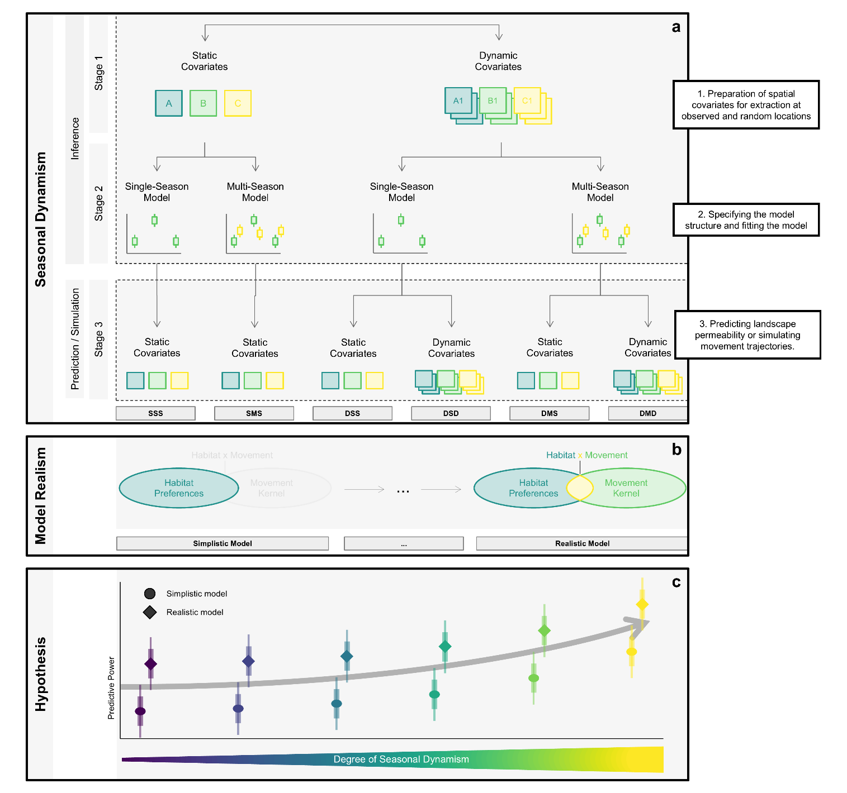
Figure 1: Graphical abstract to illustrate how seasonal dynamism and model realism enters connectivity studies. Subfigure (a) highlights the different stages at which seasonality can be incorporated in studies of dispersal and landscape connectivity. Stage 1: During model fitting, one needs to decide whether to represent the environment by a static set of covariate layers, thus ignoring seasonality, or to obtain a dynamic set covariate layers that allow capturing how the landscape changes over time. One also needs to decide whether to parameterize a single-season model, assuming fixed species preferences across the year, or to engage in a multi-season model that accounts for seasonal differences in habitat and movement preferences. Stage 2: When utilizing the fitted model to predict connectivity, one can either assume a static set of environmental covariates or again attempt a seasonal take that renders how connectivity differs depending on the season. Stage 3: Depending on these decisions, six different combinations that differ in terms of the degree of seasonality they encapsulate emerge. (b) We additionally examined the importance of moving from simplistic models (akin to those used in resistance-based connectivity models) to mechanistic realistic models (akin to those used with individual-based simulations). (c) Our hypothesis was that increasing the degree of seasonal dynamism and moving from a simplistic to a mechanistic realistic model when predicting dispersal and connectivity would lead to improved predictions.
To study the importance of seasonal dynamism and a more realistic representation of movement when predicting connectivity, we use data from a free-living population of the endangered African wild dog (Lycaon pictus) inhabiting the Okavango Delta ecosystem in northern Botswana (McNutt, 1996). The system is well suited to address our objectives, for the Okavango Delta ecosystem experiences significant seasonal variation. African wild dogs are pack-living carnivores that are primarily active during the cooler morning and evening hours (Rasmussen & Macdonald, 2012), as well as during moonlit nights (Cozzi et al., 2012). Their nocturnal activity is strongly mediated by light availability, as wild dogs lack the highly developed night vision typical of felids. Elevated ambient temperatures are associated with shorter activity periods, as wild dogs typically rest during the hottest parts of the day (Rabaiotti & Woodroffe, 2019). Upon reaching sexual maturity, individuals born into a pack disperse in same-sex coalitions to find mates and a territory to settle (McNutt, 1996). In Botswana, the timing of dispersal is seasonal, with female dispersal peaking prior to the mating season in March, and male dispersal peaking at the onset of the rainy season in December (Behr et al., 2020). Euclidean distances moved by dispersers range from a few dozen to 500 km, with some coalitions covering several hundred kilometers within only a few days (Cozzi et al., 2020, 2023; Davies–Mostert et al., 2012; Masenga et al., 2016; Sandoval‐Seres et al., 2022). Studies of habitat-selection show that dispersing wild dogs avoid venturing into large water bodies, prefer moving along it, prefer moving across open grassland or shrubs, yet avoid areas dominated by humans and densely covered by forests (Hofmann et al., 2021; O’Neill et al., 2020).
Our aims are to (1) elaborate a framework for incorporating seasonality into connectivity analyses, (2) evaluate whether including seasonality improves the predictive performance of dispersal models, and (3) assess the value of more realistic representations of movement when predicting connectivity. To achieve this, we compare the predictive performance of six seasonal configurations (Figure 1a) and two movement models – one simplistic and one realistic (Figure 1b). We compile an extensive set of remote sensing data that accurately represent seasonal landscape changes across the Okavango Delta ecosystem and combine these data with dispersal GPS data from 30 dispersing wild dog coalitions in northern Botswana. We then apply k-fold cross-validation for case-control studies to assess predictive efficacy under each configuration and model type. Lastly, we use iSSF-based simulations to estimate connectivity under different degrees of dynamism and under both a simplistic and realistic model. We hypothesize that habitat selection and movement behavior of dispersing wild dogs differ between seasons and that increasing seasonal dynamism improves the predictive efficacy of the simulation model (Figure 1c). We also anticipate that a realistic movement model yields markedly better predictions than a simplistic one.

Methods
We used the R programming language (R Core Team, 2023) for all data preparation and analyses. We performed spatial data manipulation using the terra (Hijmans et al., 2024) and spatstat (Baddeley et al., 2015) packages. We generated figures using the ggplot2 (Wickham et al., 2024) and ggpubr (Kassambara, 2024) packages. We provide access to our R-scripts through an online repository.

Study Area
The study area comprised the Okavango Delta ecosystem in northern Botswana (centered at 24°30’E and 20°42’S at an elevation of approx. 950 m) and extended to parts of eastern Namibia and western Zimbabwe, encompassing an extent of 160,000 km² (Figure 2). The Okavango Delta is a flood-pulse driven mosaic of patchy woodlands, permanent swamps, and seasonally flooded grasslands that lie within the otherwise dry and sandy Kalahari Basin (Mendelsohn et al., 2010; Ramberg et al., 2006; Wilson & Dincer, 1976). Precipitation across the study area varies considerably between seasons, ranging from 0 mm/month during the dry season (from 15 April to 15 October) to 140 mm/month during the wet season (from 15 October to 15 April), totaling to 600 mm across an average year (Figure 3a). Daily maximum above-ground temperature fluctuates between 7°C during the dry winter months and 38°C during the wet summer months (Figure 3b). The vegetation in the study area is mainly composed of mopane (Colophospermum mopane) forest, mixed woodland acacia-dominated (Acacia spp.), and grassland. Substantial vegetation green-up (e.g., plant and shoots growth, leaf production, and grass greening) starts with a delay of some weeks after the onset of the first rains in the wet season. The normalized difference vegetation index (NDVI) therefore depicts a smoothed and lagged response to precipitation patterns across the study area (Figure 3c). The yearly flood-cycle of the Okavango Delta is predominantly driven by rainfalls in the Angolan highlands, where water is collected and channeled through the Cubango and Cuito rivers into the Okavango Delta (Gumbricht et al., 2004; McCarthy et al., 2003; Mendelsohn et al., 2010). Because water only slowly descends from the catchment areas in Angola into the Delta’s tributaries, the flood is out of sync with local rainfalls and reaches its maximum extent between August and September, i.e. during peak dry season (Wolski et al. 2017; Figure 3d). While the extent of large-bodied rivers and floodplains is determined by precipitation in Angola, the emergence of smaller, ephemeral water-bodies (i.e., pans) is driven by local precipitation during the wet season. 62% of the landscape in the study area form part of formally protected areas (i.e., National Parks, Game Reserves, and Wildlife Management Areas), such that human impact is low and largely limited to settlements along the western part of the Okavango Delta and the city of Maun at the Delta’s southern tip (Figure 2). Landscapes outside protected areas in Zimbabwe, however, are more heavily influenced by humans, mainly through agricultural fields and human settlements.
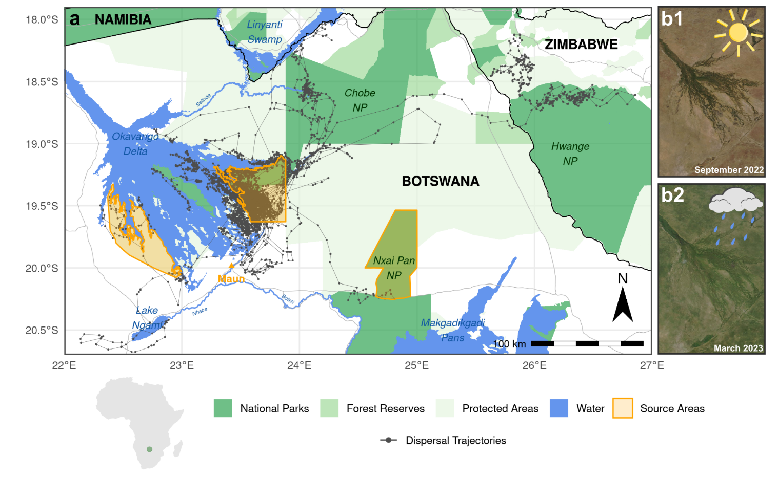
Figure 2: (a) Study area within which GPS data on dispersing African wild dogs were collected. Dispersal trajectories are displayed in dark gray. The study area encompassed parts of the Okavango Delta in northern Botswana, a highly dynamic, flood-pulse-driven ecosystem. The entire study area undergoes substantial seasonal changes, as can be seen from two satellite images taken during peak dry season (b1) and peak rainy season (b2). Notably, the flood of the Okavango Delta reaches its maximum extent during peak dry season between August and September. Source areas from which dispersers were simulated are highlighted in orange. Satellite images in panels b1 and b2 are from the MODIS Terra sensor and were provided through NASA Worldview Snapshots. Sun and cloud icons are original artwork created by the authors in Inkscape.

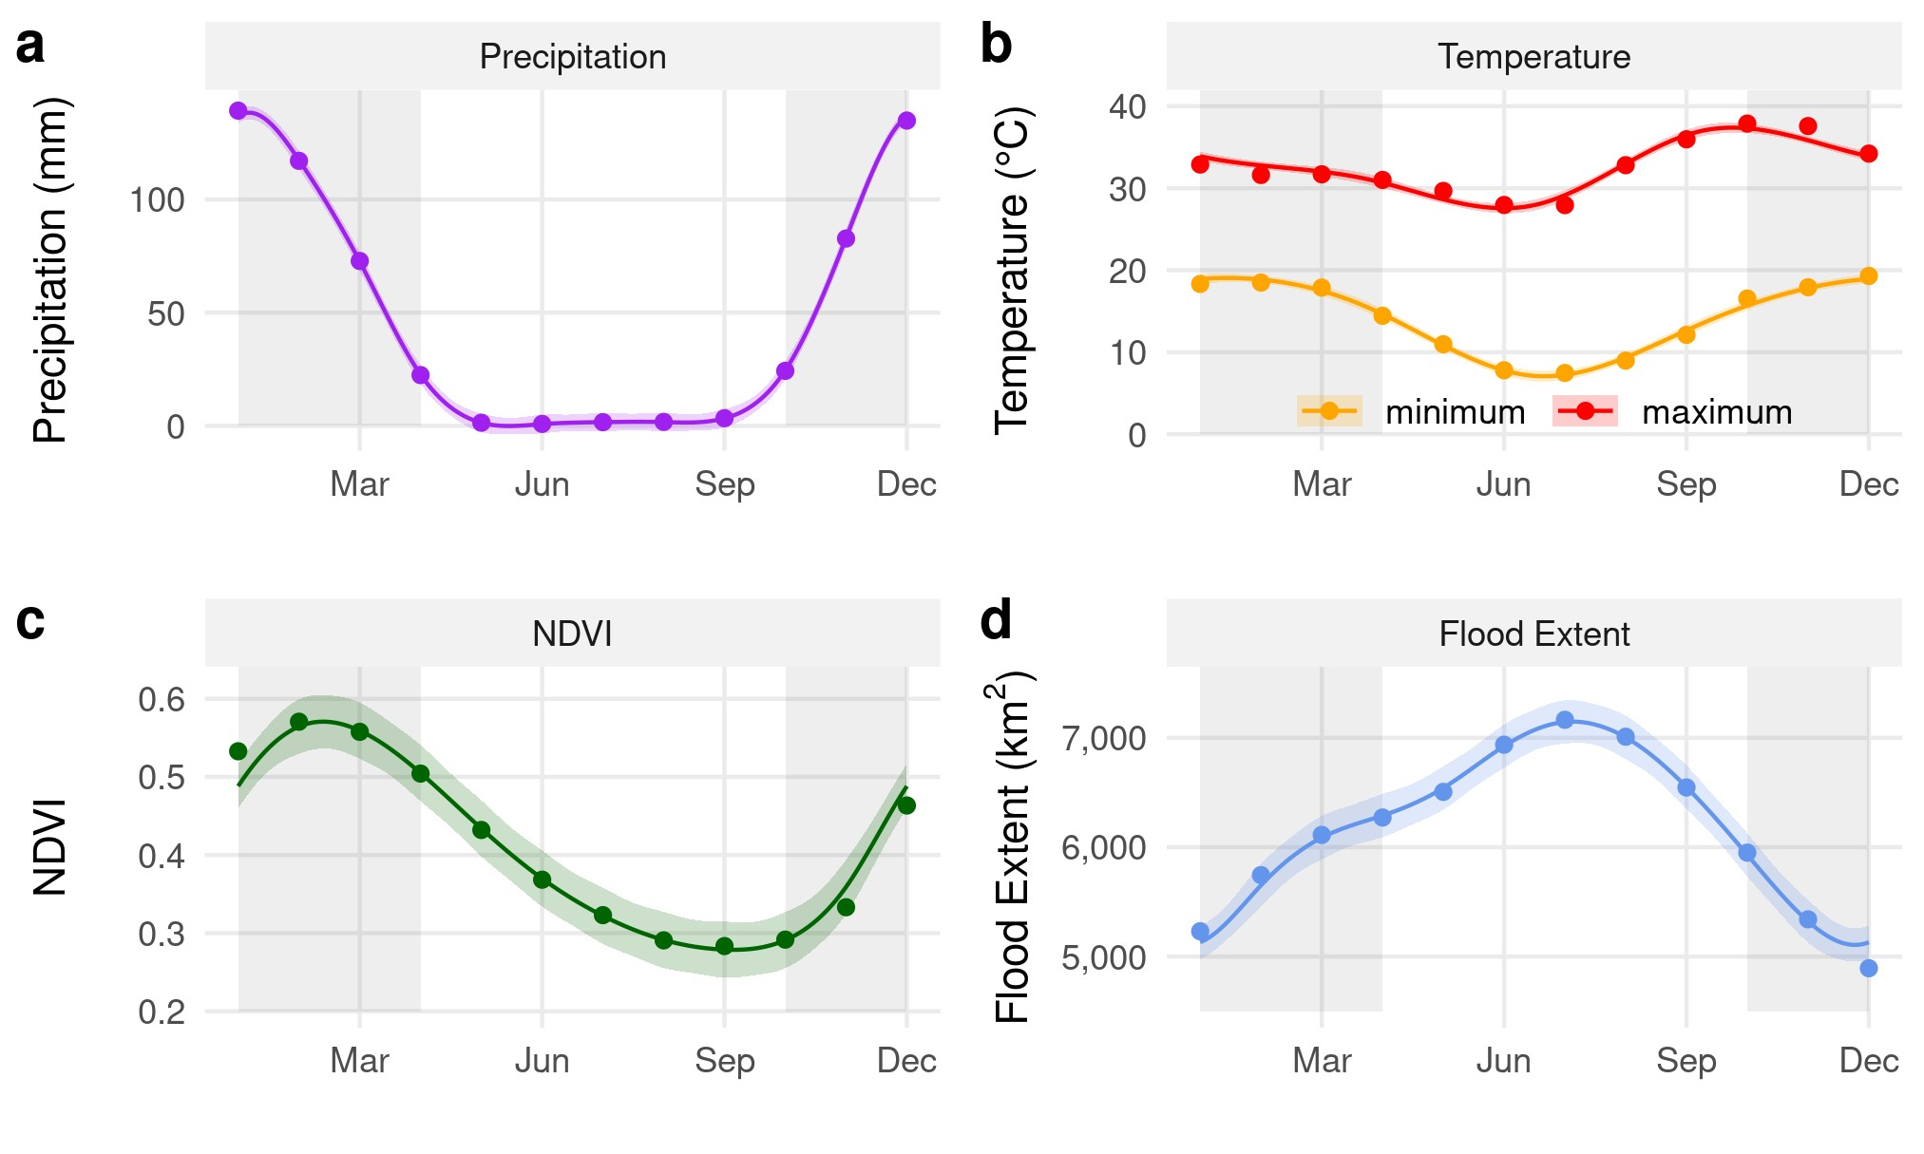
Figure 3: Illustration of how some of the covariates considered in this study vary across seasons. The wet season spans mid-October to mid-April (shaded in gray), the remainder is considered as dry season. Data for the graphs were obtained from (a) JAXA GSMaP, (b) ERA5, (c) MODIS MOD13Q1, and (d) remote sensed MOD43A4 satellite images. Smoothing curves were fitted using GAMs as implemented in the mgcv R-package (Wood, 2011).

GPS Data
Between 2015 and 2022, we collected GPS data on 30 dispersing wild dog coalitions (15 female coalitions, 15 male coalitions; Figure 2b). We programmed GPS satellite collars to record GPS locations at 01:00, 05:00, 09:00, 17:00, and 21:00. The eight-hour window between 09:00 and 17:00 can be considered comparable to a four-hour window during the rest of the day, as wild dogs generally rest between 11:00 and 15:00 (Cozzi et al., 2012; Hayward & Slotow, 2009), leaving approximately four hours of activity. The collected GPS data were regularly transmitted to a base-station via Iridium satellite, thereby allowing dispersing individuals to be monitored, even if they ventured across national borders. In total, we obtained 5,940 locations during dispersal, with an average of 198 ± 239 locations per coalition. Occasionally, the acquisition of a GPS location failed (success rate = 93 ± 8%), resulting in slight deviations from the aspired four-hourly schedule. Further details on the GPS collar fitting procedure and how we distinguished between dispersal and resident movements can be found in Cozzi et al. (2020) and Hofmann et al. (2021).

Covariates
We represented the physical landscape through which dispersers moved by a suite of spatial covariates known to influence wild dog movements during dispersal. We broadly categorized these into descriptors of (1) landscape characteristics, (2) climatic conditions, and (3) anthropogenic features (Table 1; see Hofmann et al. 2021; 2023). Besides spatial covariates, we also prepared a series of covariates relating to (4) light intensity (Table 1; see Cozzi et al. 2012) to appropriately render seasonality in each of the spatial covariates (1–3), we downloaded them at the highest spatial and temporal resolutions available. That is, for each spatial covariate, we obtained a stack of raster layers spanning the entire range of dates for which GPS data on dispersing wild dogs were available. Depending on the covariate, this resulted in differing spatial and temporal resolutions (Table 1). Additionally, for each spatial covariate, we also generated a static layer, representing “average” conditions across the entire duration of the study. For this, we flattened each covariate stack into a single layer, thus removing seasonal and yearly variation from the spatial data entirely. For continuous covariates, we achieved this by averaging conditions across all collected layers, whereas for categorical (binary) layers, we identified areas that were covered by the respective category in at least 50% of all layers. Using the same aggregation techniques, we computed covariate stacks representative of a typical year. That is, instead of removing seasonality by flattening across the entire range of dates, we flattened stacks across years, thereby eliminating year-specific effects while retaining seasonal variation. For example, the floodmap for day one of the typical year was computed by averaging all floodmaps collected on day one across different years. These latter layers were ultimately used in the dispersal simulation, where we needed spatial layers that depicted seasonal dynamism across a typical year. In summary, we prepared each covariate statically, dynamically for the entire range of dates considered, and dynamically for an average year. Further details on the covariate preparation are provided in Appendix A1 and by Hofmann et al. (2021).
Table 1: Covariates that were used in this study, including information on their temporal and spatial resolutions, as well as on the avenue through which the respective data were accessed or downloaded. Download methods printed in typewriter font indicate the use of an R-package that is available through CRAN or GitHub.
Category | Variable | Type | Description | Temporal Resolution | Spatial Resolution (m) | Source | Download Method
Landscape Characteristics | Trees | C | Percentage tree cover | 1 Year | 250 | MODIS MOD44B | RGISTools
 | Shrubs / grassland | C | Percentage non-tree vegetation | 1 Year | 250 | MODIS MOD44B | RGISTools
 | NDVI | C | Normalized difference in vegetation index | 16 Days | 250 | MODIS MOD13Q1 | rgee
 | Rivers | B | Presence of rivers | Static | 90 | MERIT Hydro | website
 | Permanent water | B | Presence of permanent water bodies | Static | 30 | Globeland30 | Website
 | Floodwater | B | Presence of seasonal flood water | 8 Days | 500 | MOD34A4 | floodmapr
 | Distance to water | C | Distance to nearest source of flood or permanent water (m) | 8 Days | 500 | MOD43A4 | floodmapr
 | Pans | C | Presence of (water-filled) pans | 5/10 Days | 10 | Sentinel 2 | sen2r
 | Distance to pans | C | Distance to nearest (water-filled) pan-water (m) | 5/10 Days | 10 | Sentinel 2 | sen2r
Climate | Temperature | C | 2-m above-ground temperature (Celsius) | 4 Hours | 1,000 | ERA5 | rgee
 | Precipitation | C | Accumulated precipitation (mm/h) | 4 Hours | 1,000 | JAXA GSMaP | Rgee
Anthropogenic | Human density | C | Estimated human density (inh / sq-km) | Static | 30 | Facebook | website
 | Agriculture | B | Presence of agriculture | Static | 30 | Globeland30 / Cropland | website
 | Roads | B | Presence of roads | Static | vectorized | Open Street Map | website
Light Intensity | Night | B | Binary variable (0 = day, 1 = night) | 4 Hours | - | - | moonlit
 | Moon illumination | C | Estimated moonlight illumination (lux) | 4 Hours | - | - | moonlit
Note: The covariates in gray were combined into single layers for water, human influence, and light intensity, respectively. Layers were either of the continuous type (C) or binary (B). Further details on covariate preparation and aggregation are provided in Appendix A1 and by Hofmann et al. (2021).

Step-Selection Models
We modeled dispersers’ movement kernels and habitat selection using integrated step-selection functions (iSSFs; Fortin et al. 2005; Avgar et al. 2016), following the procedures described by Fieberg et al. (2021) and Muff et al. (2020). For this, we identified bursts of subsequent GPS locations where the duration between two locations did not exceed 4 hours (± 15 minutes) or 8 hours (± 30 minutes, for data recorded between 09:00 and 17:00). Within each burst, we converted locations into steps, where a step represented the straight line segment between two consecutive locations (Turchin, 1998). For each step, we computed the associated step length (sl, in meters) and relative turning angle (ta, in radians). During this pre-processing, four coalitions dropped due to temporally irregular data, leaving a total of 26 dispersing coalitions (12 female coalitions, 14 male coalitions) for further analyses. The final dataset comprised 5,310 steps (204 ± 225 per coalition), which we further categorized into steps collected during the wet season (15 October to 15 April) and steps collected during the dry season (15 April to 15 October), yielding 3,124 steps (59%) during the dry season and 2,186 steps (41%) during the wet season.
We paired each observed step with a set of 100 random steps, generated by sampling turning angles from a uniform distribution U(−π,+π) and step lengths from a gamma distribution fitted to observed steps (scale θ = 6341.96 and shape k = 0.39). Together, an observed step and its associated 100 random steps formed a stratum that received a unique identifier. Along each step, we extracted covariate values from the underlying spatial layers and determined light conditions (Table 1). We opted for covariate extraction along steps rather than at their endpoints, as we believed that environmental conditions along steps were relevant in determining wild dog movement during dispersal (sensu Hofmann et al., 2023). For continuous covariates, we computed average values along each step, for categorical covariates the percentage cover of each category along the step. To model a decreasing marginal impact of “distance-to-feature” variables, we included their square-root as predictors in the final models. To facilitate model convergence, we normalized extracted values to a range between zero and one.
To estimate movement and habitat parameters of interest, we applied the maximum likelihood procedure proposed by Muff, Signer, and Fieberg (2020), using the glmmTMB package (Brooks et al., 2017). To examine whether the effect of accounting for seasonality was modulated by the model structure, we employed two models informed by previous studies on wild dog dispersal (Hofmann et al., 2021, 2023). In the simplistic model, we exclusively included covariates relating to spatial features, alongside the movement descriptors (sl, log(sl), cos(ta)) that are mandatory to fit an iSSF (Avgar et al., 2016; Fieberg et al., 2021). This formula is akin to the models that are used with resistance-based approaches, which, however, preclude a mechanistic understanding of movement. In the realistic model, by contrast, we considered additional interactions between step descriptors, landscape characteristics, climate descriptors and light intensity, to account for the fact that wild dog movement during dispersal may be affected by such interactions too. In both models, we also included a stratum-specific intercept with a large, fixed variance (10⁶; Muff, Signer, and Fieberg 2020) and used dispersing coalition ID to model random slopes for all main effects. To ensure comparability across the six configurations of seasonal dynamism (Figure 1), we applied the same model structures but varied the data used for model fitting (Figure 1a). In configuration SSS, we used static environmental data and pooled movement data across seasons. In configuration SMS, we used static environmental data, but we split the movement data by season. In configurations DSS and DSD, we used dynamic covariates but pooled movement data. In configurations DMS and DMD, we used dynamic covariates and split movement data by season. For each configuration, we fit both a simplistic and realistic model. To quantify how many random steps were necessary before model estimates stabilized (sensu Fieberg et al., 2021), we fitted each model with 5, 10, 25, 50, 75, and 100 random steps.

Validation
We compared the predictive efficacy of each of the six configurations presented in Figure 1b using k-fold cross-validation for case-control studies (Fortin et al., 2009). For this, we split movement data into training and validation sets using an 80:20 ratio and fit the iSSF models described above. We then used the obtained β-estimates to predict the probability of each random and observed step in the validation set for being chosen. Depending on the configuration, we predicted step-probabilities using static or dynamic covariates. Within each stratum, we assigned ranks 1-101 to each step based on predicted probabilities and recorded the number of times the observed step was assigned each rank. Finally, we computed Spearman’s rank correlation between ranks and associated frequencies $r_{s, realized}$. The better a model’s predictive ability, the more negative $r_{s, realized}$ should be (i.e., the less often the observed step should be assigned a low rank). For reference, we also computed Spearman’s rank correlation for randomized preferences ($r_{s, random}$), which we achieved by removing the observed step from each stratum and identifying the rank of a randomly chosen step. We replicated this validation procedure 100 times and employed ANOVA to compare the predictive efficacy of different configurations.

Simulations
To assess differences in predicted connectivity upon increasing seasonal dynamism and model realism, we ran dispersal simulations under the two most distinct configurations, i.e. the fully static (SSS, Figure 1) and fully dynamic (DMD, Figure 1) configurations, once using the simplistic model, once using the realistic model. We simulated individuals starting from three distinct regions known to host viable wild dog populations (Figure 2). The definition of these areas was somewhat arbitrary, albeit we deliberately selected areas in the west and east of the Okavango Delta to examine potential influences of flooding on connectivity (sensu Hofmann et al., 2024). We also selected a more independent location (Nxai Pan National Park; Figure 2) that remained unaffected by the Okavango Delta’s flood extent. To initiate simulated dispersal trajectories, we randomly placed 1,000 starting points within each of these source area, with starting dates that were equally distributed across the year. To simulate dispersal and obtain connectivity maps under both configurations, we applied the simulation algorithm for iSSFs described by Signer, Fieberg, and Avgar (2017) and employed by Hofmann et al. (2023). We applied the simulation algorithm as follows. Originating from the starting point, we generated a set of 25 random steps by sampling step lengths from the fitted gamma distribution and turning angles from a uniform distribution. Along each random step, we extracted spatial covariates, computed relevant movement metrics (sl, log(sl), cos(ta)), and assigned light conditions. We then employed the fitted iSSF model to predict the probability of each step for being chosen, thus generating a “redistribution kernel” around the current location of the simulated individual (Signer et al., 2017, 2024). Based on this kernel, we probabilistically sampled one of the steps and updated the simulated individual’s position and time. We repeated the procedure until a total of 2,000 steps were realized (∼ 400 dispersal days).
Depending on the configuration, we employed different spatial covariates and preferences during the simulation. For the SSS configuration, we omitted any seasonality and predicted connectivity using the static set of covariates and fixed preferences (i.e., β-estimates). For the DMD configuration, on the other hand, we updated covariates and preferences dynamically as the simulation progressed. That is, after every simulated step, we generated a new covariate stack comprising spatial layers that best represented environmental conditions at that particular point in time (Figure 4). For the purpose of this comparison, we employed the set of covariates representing an average year. Similarly, we predicted the redistribution kernel using β-estimates from the appropriate season. Finally, following Hofmann et al. (2023) we obtained heatmaps under each configuration and computed difference maps to highlight differences in resulting connectivity patterns.
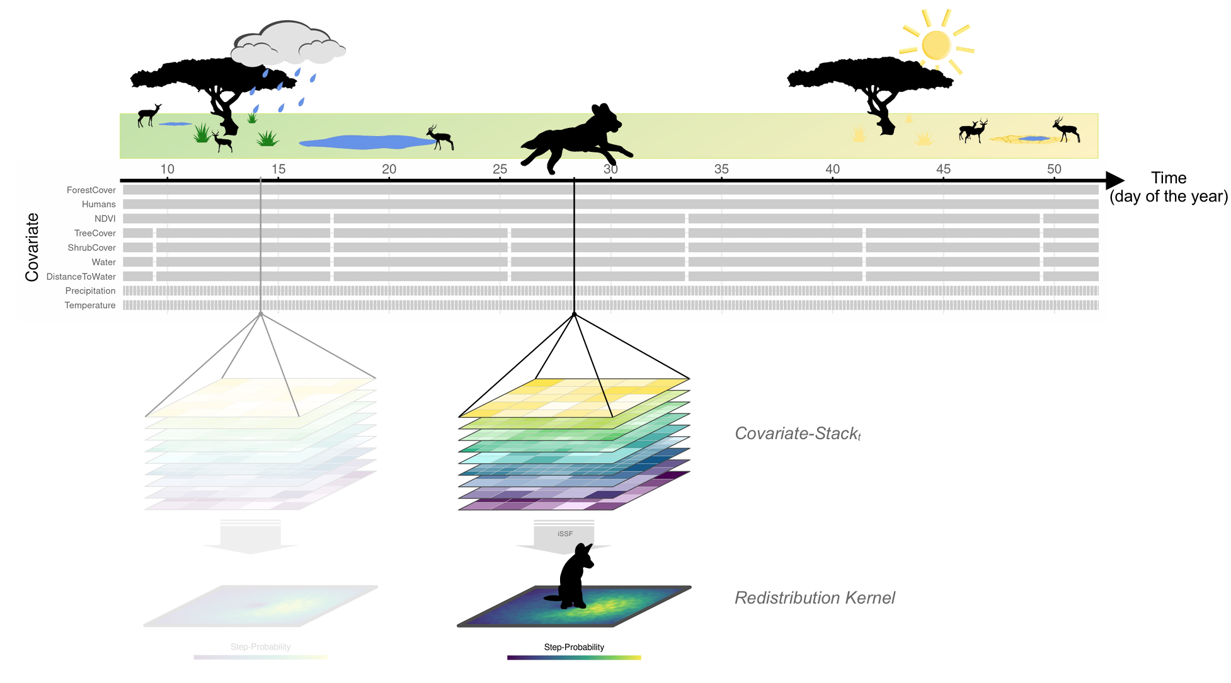
Figure 4: Schematic illustration of our dispersal simulation with dynamic covariates. As the simulation proceeded, the underlying spatial covariates (symbolized by the stack of layers) were updated. Depending on the covariate, the update frequency varied from a few hours (e.g., temperature) to multiple months (e.g., shrub cover). Each gray block represents a single layer and the duration for which it was “active”. Originating from the current position of the simulated animal, a redistribution kernel was derived, indicating potential steps and their predicted probability. We generated redistribution kernels by proposing a set of 25 random steps and applying the parametrized step-selection model to predict the probability of each step for being chosen. Based on this kernel, one location was probabilistically sampled and the animal’s position and time were updated. This procedure was then repeated until 2,000 steps (∼ 400 dispersal days) were simulated. All icons and silhouettes are original artwork created by the authors in Inkscape and Microsoft Powerpoint.

Results
Model performance was generally robust across all considered configurations. Nonetheless, due to convergence issues, we removed the covariates NDVI, precipitation, and distance to pans from all analyses. While this improved overall model convergence, some minor convergence issues remained, as our validation procedure failed in 59 (i.e., 3%) out of 1,800 validation attempts. Since convergence issues occurred randomly across different configurations, we deemed their exclusion of no concern.

Step-Selection Models
Patterns of habitat selection and movement behavior were qualitatively similar, irrespective of whether models were fit using static or dynamic covariates (Figure 5, Tables S3-S6) and irrespective of the number of random steps considered (Figure S9). The most notable quantitative difference when using static vs. dynamic covariates was that models fitted using dynamic covariates resulted in narrower confidence intervals (Figure 5). Furthermore, effect sizes (i.e., β-estimates) of models fit using static covariates were more pronounced than effect sizes from models that were fit using dynamic covariates (Figure 5). Differences were most marked for β_{DistanceToWater}, which was estimated ≈−0.8 using static covariates, but ≈−0.3 when using dynamic covariates. Differences in β-estimates between seasons were moderate and most pronounced when models were fit using static covariates. For instance, when models were fit using static covariates, β_{Water} was ≈−0.9 during the dry season but ≈ 0.2 during the wet season. This indicates avoidance of water during the dry season, yet selection for water during the wet season. When dynamic covariates were used, by contrast, β_{Water} was ≈−0.6 and ≈−0.3, respectively, indicating avoidance of water, irrespective of the season. Regardless of the type of covariates used, β_{sl:Dark} was markedly lower during the wet season (≈−0.9) than during dry season (≈−0.1). This implies that dispersers generally avoided long steps during dark nights, with this tendency being more pronounced in the wet season. Plots that aid with the interpretation of the models are provided in Figure S10.
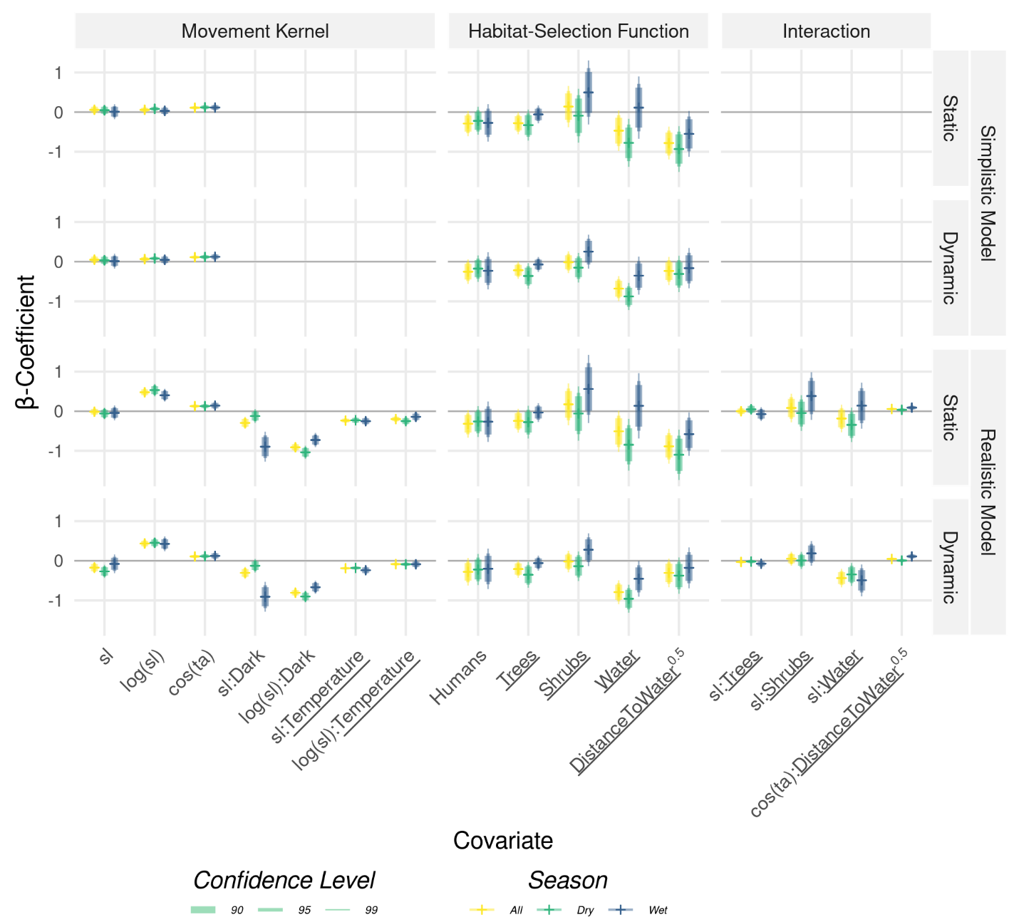
Figure 5: β−estimates from the integrated step-selection models, grouped by movement kernel, habitat-selection function, and their interaction. We either fit models using a simplistic model (without interactions) or a realistic model that comprised several interaction terms that rendered how movement behavior depended on environmental conditions. Furthermore, we distinguished between models fit using static and dynamic covariates. However, only the underlined covariates differed between the static and dynamic configurations, as covariates were either represented as a single layer (static), or a stack of layers (dynamic). Furthermore, data were either pooled across seasons (yellow bars) or split into dry (green bars) and wet (blue bars) season. Results are shown for replicates that used 25 random steps, as all associated models converged. The number of random steps did not appear to influence model estimates (Figure S9). The horizontal ticks indicate the point estimates, and the vertical segments represent the 90%, 95%, and 99% confidence-intervals of the respective 𝛽-coefficients.

Validation
Spearman’s rank correlation coefficients (r) obtained from the validation procedure revealed that predictions from the realistic model performed markedly better than those from the simplistic model ${\overline{r}}_{simplistic}$ = −0.5, ${\overline{r}}_{realistic}$= −0.9, Figure 6). Irrespective of the employed model, Spearman’s rank correlation differed significantly depending on the amount of dynamism considered (ANOVA_{simplistic}: F(5, 593) = 26.45, p < 0.001, ANOVA_{realistic}: F(5, 594) = 7.14, p < 0.001), albeit with moderate effect sizes. Using the simplistic model, moving from a fully static (SSS) to a fully dynamic (DMD) configuration decreased Spearmans’s rank correlation (i.e., increased the predictive performance) by 0.15 from -0.41 to -0.56. With the realistic model, conversely, moving from a fully static (SSS) to a fully dynamic (DMD) configuration entailed a minor increase in $r$ (i.e., a decrease in the predictive performance) by 0.01 from -0.89 to -0.88. Our hypothesis that accounting for seasonal dynamism results in better predictive performance only held when using the simplistic model (Figure 6a), but not when employing the realistic model (Figure 6b).

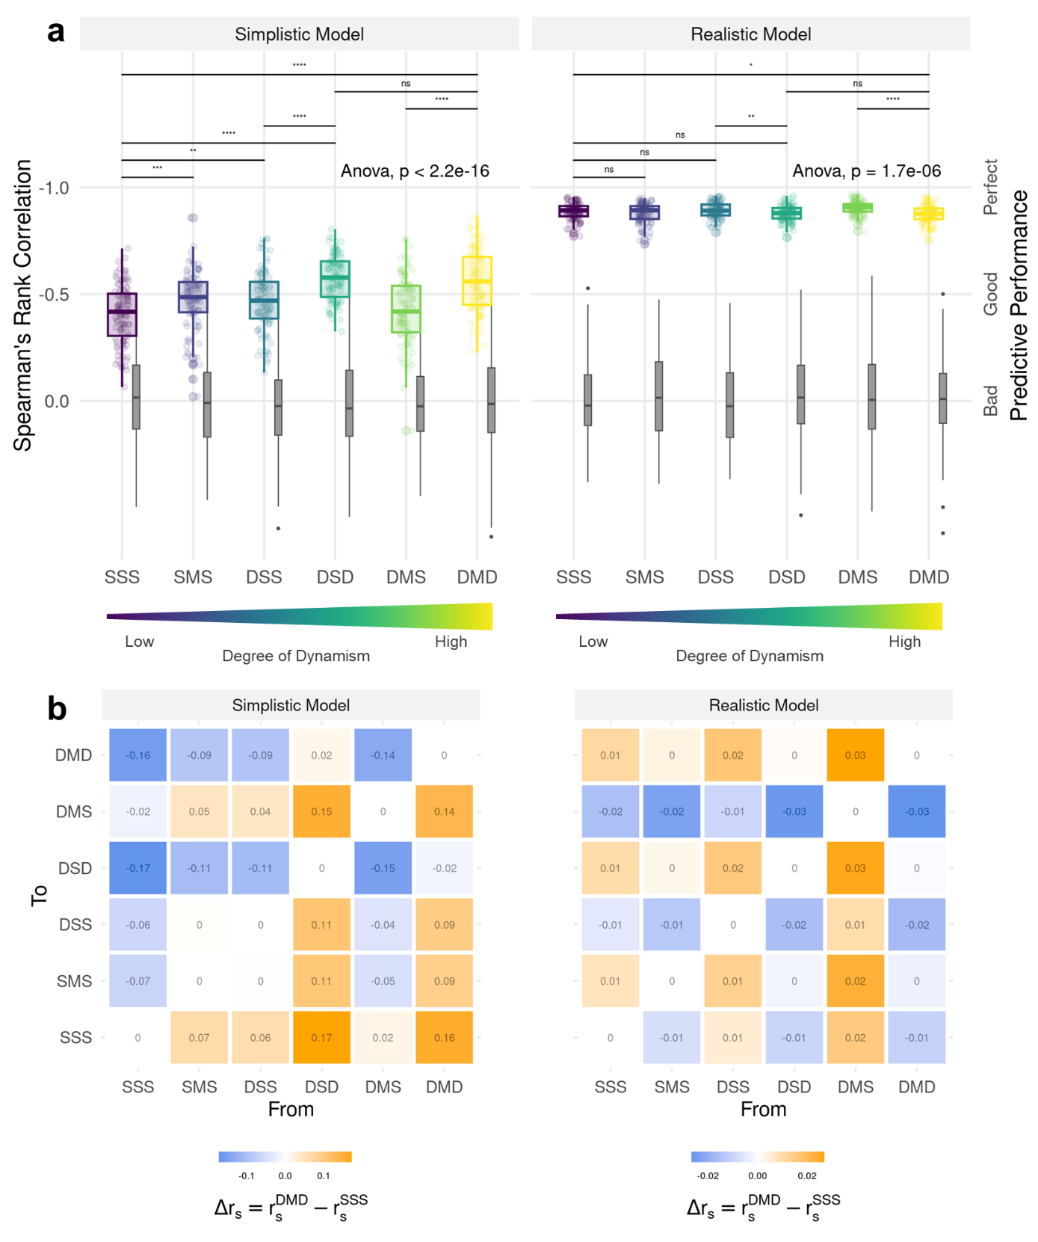
Figure 6: (a) Boxplots of Spearman’s rank correlation across different configurations of dynamism that range from entirely static (SSS) to fully dynamic (DMD). The more negative Spearman’s rank correlation, the better is the predictive performance under the respective configuration. Correlations were computed for 100 replicates. Note that the y-axis is inverted to match our expectation of increasing performance as dynamism increases. The boxplots in light gray represent Spearman’s rank correlation coefficients under a null model and serve for comparison. (b) Difference in Spearman’s rank correlation when moving from one configuration to another. Values < 0 (blue) indicate an increase in predictive performance, whereas values > 0 (orange) indicate a decrease in predictive performance.

Simulations
Simulations under the most static (SSS) and dynamic (DMD) configurations revealed different connectivity patterns (Figure 7). In the static configuration, simulated trajectories were more concentrated, suggesting frequent movement across a few key habitats. In the dynamic configuration, by contrast, simulated trajectories were more homogeneously distributed, suggesting that movement was less restricted. When comparing the heatmaps generated under the simplistic and realistic models, differences in predicted connectivity are imperceptible (Figure 7).
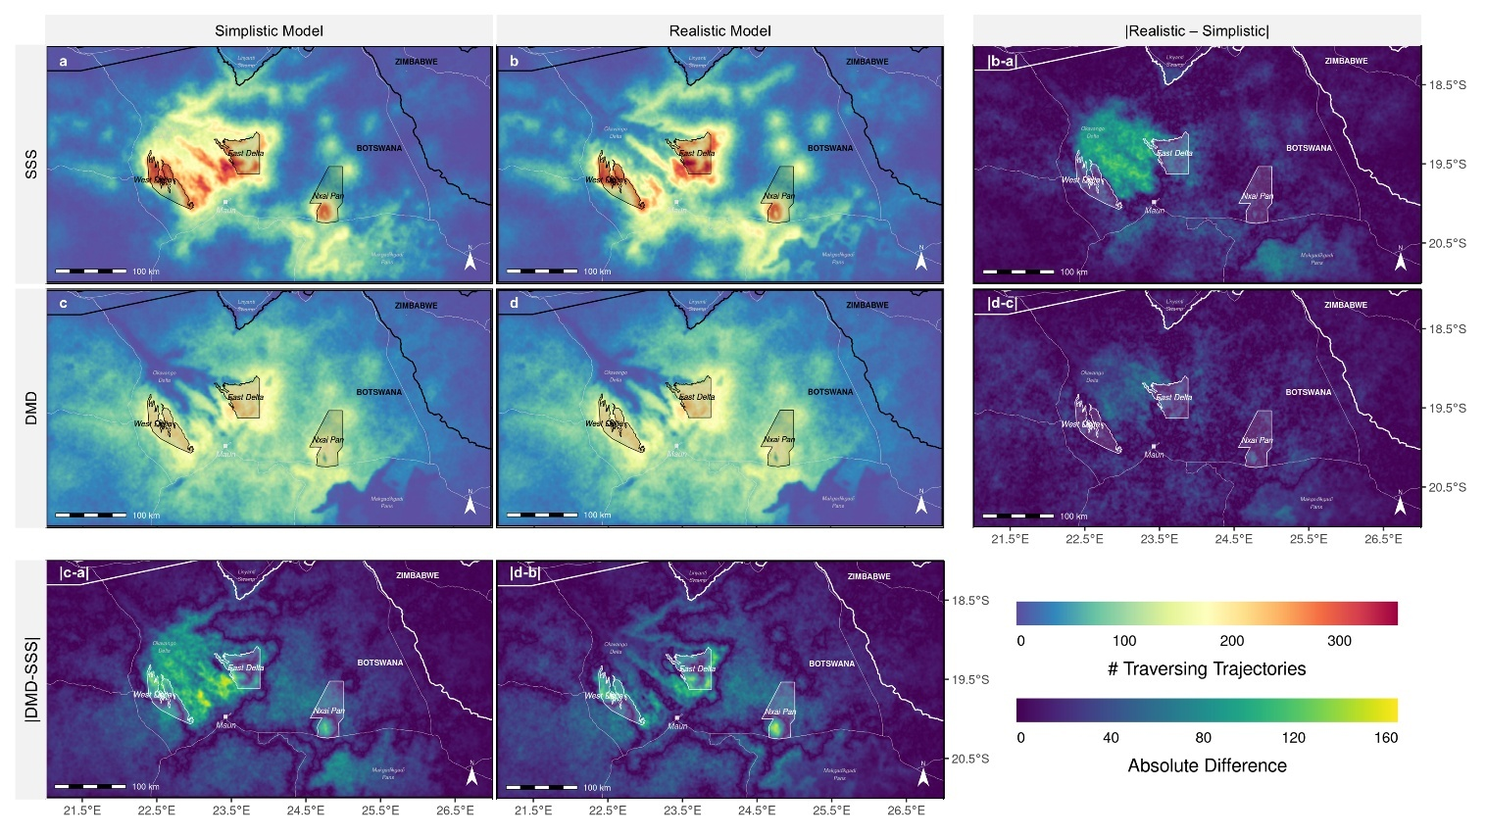
Figure 7: (a-d) Heatmaps generated under the most static (SSS) and most dynamic (DMD) configurations, using both a simplistic and a realistic model, as well as difference maps highlight discrepancies between these modeling approaches.

Discussion
We developed and tested a conceptual framework for incorporating seasonality into connectivity analysis at three stages: (1) when extracting spatial covariates for fitting the selection model, (2) when specifying the selection model, and (3) when predicting from the fitted model. Using movement data from dispersing African wild dogs, we compared the predictive performance of six resulting configurations that varied in seasonal dynamism and biological realism. While seasonality had limited influence on estimated patterns of habitat selection and movement behavior, and only marginally improved predictive performance overall, the realistic model alone achieved such high predictive efficacy that increasing seasonal dynamism only marginally improved predictions. Despite this, our simulations showed that seasonal dynamism can lead to contrasting connectivity patterns: Static configurations produced clumped connectivity around a few hot spots, whereas dynamic configurations yielded more homogeneously distributed connectivity across the landscape.
Our validation procedure revealed only moderate improvements in our ability to predict dispersal movements when increasing the degree of seasonal dynamism. Given the system’s extreme seasonal variability, this was somewhat surprising. We suspect that the absence of a pronounced improvement can be traced back to multiple factors. Firstly, we focused our analysis on dispersing individuals, which cover large distances in search of potential mates and a suitable territory (Cozzi et al., 2020; McNutt, 1996). In our case, the average 4-hourly step length was 2.5 km, implying that dispersers cross and sample a large variety of habitats within short time. The spatial scale of the dispersal process may thus misalign with the spatial scale at which seasonality affects connectivity. A second explanation could emerge from the fact that dispersers prioritize finding unoccupied territories and areas with low competition, which are unlikely to represent optimal habitat conditions, over selecting specific habitat types (e.g., Creel, 2001; Creel & Creel, 1996). Dispersers’ habitat selection may therefore be more strongly influenced by the spatial organization of territorial, resident conspecifics and only little affected by the landscape (Cozzi et al., 2018) and its seasonally changing characteristics. This would also explain the relatively weak selection or avoidance of environmental characteristics exhibited in Figure 5. Finally, the African wild dog is a generalist species that occupies a broad variety of habitats (Woodroffe, 2011). A certain tolerance towards changing environmental conditions can therefore be expected and may explain why seasonal differences were faint. This holds particularly true for dispersers, which are usually more tolerant towards unfavorable habitat conditions as they spend little time within the same area (Elliot et al., 2014; O’Neill et al., 2020).
Even though incorporating seasonality provided little benefit in terms of predictive performance in our system, we stress that adopting our conceptual framework will facilitate greater clarity and rigor in connectivity studies overall. By explicitly defining where and how seasonality enters the modeling pipeline, our framework forces researchers to be more specific about the type of seasonal variation their study accounts for, reducing ambiguity in how seasonal effects are represented. Additionally, it prompts a more deliberate consideration of the pathways through which seasonality can influence connectivity, helping to identify whether its effects primarily stem from environmental variability, shifts in species behavior, or both. Our approach not only enhances transparency and comparability across studies but also fosters a more realistic and mechanistic understanding of movement, ultimately improving the ecological relevance of connectivity analyses.
Compared to the improvements achieved by increasing seasonal dynamism, moving from the simplistic to a realistic model more significantly benefited predictions. Through the realistic model, we could represent several important aspects of African wild dog behavior, such as reduced movement during dark nights (Cozzi, 2013; Cozzi et al., 2012) and during times of high ambient temperature (Rabaiotti & Woodroffe, 2019). We could also model that dispersers’ movement behavior depended on habitat conditions, as evidenced by shorter steps in areas covered by water (Hofmann et al., 2023). The ability of encapsulating and replicating dispersal movements in such realistic manner is unique to iSSF-based simulations and cannot be achieved using resistance-based models. This is also a testimony to step-selection functions as a powerful means of conducting both inference and prediction of movement and connectivity (Forrest et al., 2024; Hofmann et al., 2023). While many of the additionally encapsulated processes are not directly linked to landscape connectivity, incorporating them helps control for key behavioral and environmental influences that might otherwise obscure critical movement patterns. In our case, this versatility elevated the predictive power of our dispersal model to a level where the added benefit of considering seasonal dynamism was negligible.
Comparisons of connectivity under the most static (SSS) and most dynamic (DMD) configurations, revealed that connectivity was concentrated on a few major dispersal hotspots under the most static configuration, but uniformly distributed across the entire landscape under the most dynamic configuration. This corroborates previous research showing that static connectivity analyses tend to underestimate connectivity, as seasonal stepping stones or corridors are missed (Martensen et al., 2017). Seasonally available dispersal habitats periodically allow dispersers to access areas that would otherwise remain inaccessible. In our case, such stepping stones emerged in two ways: through changes in the landscape that reshaped the distribution of preferred habitats, and through seasonal shifts in the dispersers’ habitat preferences. For instance, the pulse-like flood dynamics of the Okavango Delta seasonally reveal vital dispersal habitats through which individuals access otherwise inundated regions. Similarly, seasonal differences in the species willingness to move far distances at night modulate the likelihood of dispersal between adjacent protected areas. Jointly, seasonal landscapes and changing preferences resulted in a more balanced mosaic of connectivity. Note, however, that the fact that connectivity was more evenly distributed across the year does not exclude the possibility of certain areas experiencing lower connectivity seasonally. As already shown by Osipova et al. (2019), a static representation may result in both an over- and under-estimation of short-term connectivity, depending on the area and season. For conservation planning, this implies the need to protect landscapes more broadly, as areas that provide little connectivity during some season may be critical during others. A dynamic take at connectivity therefore improves our understanding of ecological processes in dynamic landscapes and may help to identify otherwise overlooked dispersal hotspots (Zeller, Lewison, et al., 2020).
Our results showed only marginal improvements in predictive efficacy with increased seasonal dynamism, yet they revealed vastly different connectivity patterns. While this may seem contradictory, it likely arises from our validation approach, which was constrained to the step level due to a fundamental limitation in validating seasonal connectivity from an iSSF. In dynamic landscapes with shifting preferences, connectivity varies both spatially and temporally, requiring validation at each timestamp in the dataset. Since our landscape changed every four hours (i.e., with each step), a new connectivity map would need to be generated around each validation step, effectively reducing validation to the step level. Given this constraint, we deemed the application of k-fold cross-validation using Spearman’s rank correlation at the step level appropriate. Note, however, that Spearman’s rank correlation is influenced by the number of steps per stratum, making it unsuitable for comparing predictive efficacy across studies (Figure S11). For static connectivity analyses, alternative validation techniques exist, which typically compare connectivity at observed vs. random locations (Brennan et al., 2020; Finerty et al., 2023; McClure et al., 2016; Zeller et al., 2018). Developing similar validation approaches beyond the step level for dynamic connectivity analyses remains a challenge for future research.
Increasing seasonal dynamism to model dynamic connectivity comes at significant costs, both in terms of data requirements and computational challenges. To represent seasonal changes across the landscape, spatial layers need to be downloaded and processed at an appropriate seasonal interval. This is time-consuming and implies a substantial increase in the data-volume to be handled. Seasonal products are less commonly available, potentially necessitating custom remote-sensing analyses (e.g., Appendix A2). Moreover, seasonal layers are often plagued by noise and missing data, especially during seasons with extensive cloud cover. Extracting covariates from seasonal layers poses a further challenge, as covariate data can no longer be extracted from single layers but need to be extracted from those layers that best represent environmental conditions at the time of the observed movement. This applies to the extraction of covariates for both model fitting (Figure 1, stage 1) and prediction (Figure 1, stage 3). Finally, splitting species data by season to model seasonal preferences reduces the amount of data remaining per season, potentially causing convergence issues. In our case, the moderate improvement in predictive ability did not justify these additional efforts and complications. The trade-offs between increased realism and practical applicability must therefore be carefully considered, as greater complexity does not always lead to better insights and may even obscure key ecological patterns (Puy & Saltelli, 2022). Whether incorporating seasonal dynamism improves connectivity predictions likely depends on several key factors. Species traits play a central role: habitat specialists may respond more strongly to seasonal environmental changes than generalists, whose broader tolerances buffer them against such variability. Similarly, animals with limited mobility may be more sensitive to fine-scale seasonal changes than long-distance dispersers, for whom connectivity patterns are shaped by broader-scale landscape structure. Landscape characteristics also matter: dynamic connectivity may be more relevant in heterogeneous, mosaic-like environments where seasonal shifts significantly alter movement corridors, compared to more homogeneous landscapes.
In conclusion, we provided a conceptual framework to integrate seasonality into connectivity analyses and investigated the role of seasonal dynamism in modeling dispersal and connectivity. While increasing the level of dynamism led to only moderate improvements in predictive performance, it had a substantial impact on inferred connectivity patterns, resulting in more evenly distributed connectivity when seasonality was considered. This suggests that seasonal fluctuations can shape connectivity in ways that may not be immediately evident from overall predictive accuracy alone. However, the added effort of incorporating seasonal landscapes and seasonal species preferences must be carefully weighed against its practical benefits. Beyond the effects of seasonal dynamism, our findings highlight that model structure plays a more crucial role in shaping movement predictions. In our case, a biologically realistic and mechanistic model, which explicitly accounted for species-specific movement constraints, outperformed a simplistic model, akin of those typically used with resistance-based approaches. In fact, a realistic model obliterated any improvement of accounting for seasonality by elevating predictive efficacy to a very high level. While this result may be specific to our study system, it underscores the broader importance of selecting an appropriate movement model when studying connectivity and it attributes a large potential to iSSF-based simulations for studying connectivity.

Authors’ Contributions
D.D.H. and G.C. conceived the study and designed methodology; D.D.H., G.C., D.M.B, and J.W.M. collected the data; D.D.H. analysed the data; G.C. assisted with the modeling framework; A.O. contributed to conceptual discussions and provided feedback during the development of the study; D.D.H. and G.C. wrote the first draft of the manuscript and all authors contributed to the drafts at several stages and gave final approval for publication.

Data Availability
Access to R-scripts to replicate our analyses will be provided through an online repository at the time of publication.

Acknowledgments & Funding
We thank the Ministry of Environment and Tourism and the Department of Wildlife and National Parks of Botswana for granting permission to conduct this study under research permit EWT 8/36/4 XXXVI (33). D.D.H. was funded by a Swiss National Science Foundation Grant No. 310030_204478 awarded to G.C.

Bibliography
Abrahms, B., Sawyer, S. C., Jordan, N. R., McNutt, J. W., Wilson, A. M., & Brashares, J. S. (2017). Does Wildlife Resource Selection Accurately Inform Corridor Conservation? Journal of Applied Ecology, 54(2), 412–422. https://doi.org/10.1111/1365-2664.12714
Allen, C. H., Parrott, L., & Kyle, C. (2016). An Individual-Based Modelling Approach to Estimate Landscape Connectivity for Bighorn Sheep (Ovis canadensis). PeerJ, 4, e2001. https://doi.org/10.7717/peerj.2001
Avgar, T., Potts, J. R., Lewis, M. A., & Boyce, M. S. (2016). Integrated Step Selection Analysis: Bridging the Gap Between Resource Selection and Animal Movement. Methods in Ecology and Evolution, 7(5), 619–630. https://doi.org/10.1111/2041-210X.12528
Baddeley, A., Rubak, E., & Turner, R. (2015). Spatial Point Patterns: Methodology and Applications with R. Chapman and Hall/CRC Press.
Baguette, M., Blanchet, S., Legrand, D., Stevens, V. M., & Turlure, C. (2013). Individual Dispersal, Landscape Connectivity and Ecological Networks. Biological Reviews, 88(2), 310–326. https://doi.org/10.1111/brv.12000
Baldwin, R. F., Calhoun, A. J. K., & deMaynadier, P. G. (2006). Conservation Planning for Amphibian Species with Complex Habitat Requirements: A Case Study Using Movements and Habitat Selection of the Wood Frog Rana Sylvatica. Journal of Herpetology, 40(4), 442–453. https://doi.org/10.1670/0022-1511(2006)40[442:CPFASW]2.0.CO;2
Behr, D. M., McNutt, J. W., Ozgul, A., & Cozzi, G. (2020). When to Stay and When to Leave? Proximate Causes of Dispersal in an Endangered Social Carnivore. Journal of Animal Ecology, 89(10), 2356–2366. https://doi.org/10.1111/1365-2656.13300
Bishop-Taylor, R., Tulbure, M. G., & Broich, M. (2018). Evaluating Static and Dynamic Landscape Connectivity Modelling Using a 25-Year Remote Sensing Time Series. Landscape Ecology, 33(4), 625–640. https://doi.org/10.1007/s10980-018-0624-1
Brennan, A., Beytell, P., Aschenborn, O., Du Preez, P., Funston, P. J., Hanssen, L., Kilian, J. W., Stuart‐Hill, G., Taylor, R. D., & Naidoo, R. (2020). Characterizing Multispecies Connectivity Across a Transfrontier Conservation Landscape. Journal of Applied Ecology, 57(9), 1700–1710. https://doi.org/10.1111/1365-2664.13716
Brooks, M. E., Kristensen, K., van Benthem, K. J., Magnusson, A., Berg, C. W., Nielsen, A., Skaug, H. J., Maechler, M., & Bolker, B. M. (2017). glmmTMB Balances Speed and Flexibility Among Packages for Zero-Inflated Generalized Linear Mixed Modeling. The R Journal, 9(2), 378–400. https://doi.org/10.32614/RJ-2017-066
Cozzi, G. (2013). Patterns of Habitat Use and Segregation Among African Large Carnivores [PhD Thesis, University of Zurich]. https://doi.org/10.5167/UZH-93646
Cozzi, G., Behr, D. M., Webster, H. S., Claase, M. J., Bryce, C. M., Modise, B., McNutt, J. W., & Ozgul, A. (2020). African Wild Dog Dispersal and Implications for Management. The Journal of Wildlife Management, 84(4), 614–621. https://doi.org/10.1002/jwmg.21841
Cozzi, G., Broekhuis, F., McNutt, J. W., Turnbull, L. A., Macdonald, D. W., & Schmid, B. (2012). Fear of the Dark or Dinner by Moonlight? Reduced Temporal Partitioning Among Africa’s Large Carnivores. Ecology, 93(12), 2590–2599. https://doi.org/10.1890/12-0017.1
Cozzi, G., Maag, N., Börger, L., Clutton-Brock, T. H., & Ozgul, A. (2018). Socially Informed Dispersal in a Territorial Cooperative Breeder. Journal of Animal Ecology, 87(3), 838–849. https://doi.org/10.1111/1365-2656.12795
Cozzi, G., Reilly, M., Abegg, D., Behr, D. M., Brack, P., Claase, M. J., Holmberg, J., Hofmann, D. D., Kalil, P., Ndlovu, S., Neelo, J., & McNutt, J. W. (2023). An AI‐Based Platform to Investigate African Large Carnivore Dispersal and Demography Across Broad Landscapes: A Case Study and Future Directions Using African Wild Dogs. African Journal of Ecology, 62(1), e13227. https://doi.org/10.1111/aje.13227
Creel, S. (2001). Four Factors Modifying the Effect of Competition on Carnivore Population Dynamics as Illustrated by African Wild Dogs. Conservation Biology, 15(1), 271–274. https://doi.org/10.1111/j.1523-1739.2001.99534.x
Creel, S., & Creel, N. M. (1996). Limitation of African Wild Dogs by Competition with Larger Carnivores. Conservation Biology, 10(2), 526–538. https://doi.org/10.1046/j.1523-1739.1996.10020526.x
Cushman, S. A., & Lewis, J. S. (2010). Movement Behavior Explains Genetic Differentiation in American Black Bears. Landscape Ecology, 25(10), 1613–1625. https://doi.org/10.1007/s10980-010-9534-6
Davies–Mostert, H. T., Kamler, J. F., Mills, M. G. L., Jackson, C. R., Rasmussen, G. S. A., Groom, R. J., & Macdonald, D. W. (2012). Long–Distance Transboundary Dispersal of African Wild Dogs Among Protected Areas in Southern Africa. African Journal of Ecology, 50(4), 500–506. https://doi.org/10.1111/j.1365-2028.2012.01335.x
Diniz, M. F., Cushman, S. A., Machado, R. B., & De Marco Júnior, P. (2019). Landscape Connectivity Modeling from the Perspective of Animal Dispersal. Landscape Ecology, 35, 41–58. https://doi.org/10.1007/s10980-019-00935-3
Doerr, V. A. J., Barrett, T., & Doerr, E. D. (2011). Connectivity, Dispersal Behaviour and Conservation Under Climate Change: A Response to Hodgson et al.: Connectivity and Dispersal Behaviour. Journal of Applied Ecology, 48(1), 143–147. https://doi.org/10.1111/j.1365-2664.2010.01899.x
Elliot, N. B., Cushman, S. A., Macdonald, D. W., & Loveridge, A. J. (2014). The Devil Is in the Dispersers: Predictions of Landscape Connectivity Change with Demography. Journal of Applied Ecology, 51(5), 1169–1178. https://doi.org/10.1111/1365-2664.12282
Fahrig, L. (2003). Effects of Habitat Fragmentation on Biodiversity. Annual Review of Ecology, Evolution, and Systematics, 34(1), 487–515. https://doi.org/10.1146/annurev.ecolsys.34.011802.132419
Fieberg, J., Signer, J., Smith, B., & Avgar, T. (2021). A ‘How to’ Guide for Interpreting Parameters in Habitat-Selection Analyses. Journal of Animal Ecology, 90(5), 1027–1043. https://doi.org/10.1111/1365-2656.13441
Finerty, G. E., Cushman, S. A., Bauer, D. T., Elliot, N. B., Kesch, M. K., Macdonald, D. W., & Loveridge, A. J. (2023). Evaluating Connectivity Models for Conservation: Insights from African Lion Dispersal Patterns. Landscape Ecology, 38(12), 3205–3219. https://doi.org/10.1007/s10980-023-01782-z
Forrest, S. W., Pagendam, D., Bode, M., Drovandi, C., Potts, J. R., Perry, J., Vanderduys, E., & Hoskins, A. J. (2024). Predicting fine‐scale distributions and emergent spatiotemporal patterns from temporally dynamic step selection simulations. Ecography, e07421. https://doi.org/10.1111/ecog.07421
Fortin, D., Beyer, H. L., Boyce, M. S., Smith, D. W., Duchesne, T., & Mao, J. S. (2005). Wolves Influence Elk Movements: Behavior Shapes a Trophic Cascade in Yellowstone National Park. Ecology, 86(5), 1320–1330. https://doi.org/10.1890/04-0953
Fortin, D., Fortin, M.-E., Beyer, H. L., Duchesne, T., Courant, S., & Dancose, K. (2009). Group-Size-Mediated Habitat Selection and Group Fusion–Fission Dynamics of Bison Under Predation Risk. Ecology, 90(9), 2480–2490. https://doi.org/10.1890/08-0345.1
Frankham, R., Ballou, J. D., Briscoe, D. A., & McInnes, K. H. (2002). Introduction to Conservation Genetics. Cambridge University Press. https://doi.org/10.1017/CBO9780511808999
Gumbricht, T., Wolski, P., Frost, P., & McCarthy, T. S. (2004). Forecasting the Spatial Extent of the Annual Flood in the Okavango Delta, Botswana. Journal of Hydrology, 290(3–4), 178–191. https://doi.org/10.1016/j.jhydrol.2003.11.010
Hanski, I. (1999). Habitat Connectivity, Habitat Continuity, and Metapopulations in Dynamic Landscapes. Oikos, 87(2), 209–219. https://doi.org/10.2307/3546736
Hauenstein, S., Fattebert, J., Grüebler, M. U., Naef‐Daenzer, B., Pe’er, G., & Hartig, F. (2019). Calibrating an Individual‐Based Movement Model to Predict Functional Connectivity for Little Owls. Ecological Applications, 29(4), e01873. https://doi.org/10.1002/eap.1873
Hayward, M. W., & Slotow, R. (2009). Temporal Partitioning of Activity in Large African Carnivores: Tests of Multiple Hypotheses. South African Journal of Wildlife Research, 39(2), 109–125. https://doi.org/10.3957/056.039.0207
Heller, N. E., & Zavaleta, E. S. (2009). Biodiversity Management in the Face of Climate Change: A Review of 22 Years of Recommendations. Biological Conservation, 142(1), 14–32. https://doi.org/10.1016/j.biocon.2008.10.006
Hijmans, R. J., Bivand, R., Pebesma, E., & Sumner, M. D. (2024). terra: Spatial Data Analysis (Version 1.7-38) [Computer software]. https://cran.r-project.org/web/packages/terra/index.html
Hofmann, D. D., Behr, D. M., McNutt, J. W., Ozgul, A., & Cozzi, G. (2021). Bound Within Boundaries: Do Protected Areas Cover Movement Corridors of Their Most Mobile, Protected Species? Journal of Applied Ecology, 58(6), 1133–1144. https://doi.org/10.1111/1365-2664.13868
Hofmann, D. D., Behr, D. M., McNutt, J. W., Ozgul, A., & Cozzi, G. (2024). Dispersal and Connectivity in Increasingly Extreme Climatic Conditions. Global Change Biology, 30(5), e17299. https://doi.org/10.1111/gcb.17299
Hofmann, D. D., Cozzi, G., McNutt, J. W., Ozgul, A., & Behr, D. M. (2023). A Three-Step Approach for Assessing Landscape Connectivity Via Simulated Dispersal: African Wild Dog Case Study. Landscape Ecology, 38(4), 981–998. https://doi.org/10.1007/s10980-023-01602-4
Kanagaraj, R., Wiegand, T., Kramer-Schadt, S., & Goyal, S. P. (2013). Using Individual-Based Movement Models to Assess Inter-Patch Connectivity for Large Carnivores in Fragmented Landscapes. Biological Conservation, 167, 298–309. https://doi.org/10.1016/j.biocon.2013.08.030
Kassambara, A. (2024). ggpubr: “ggplot2” Based Publication Ready Plots (Version 0.6.0) [Computer software]. https://cran.r-project.org/web/packages/ggpubr/index.html
Kaszta, Ż., Cushman, S. A., & Slotow, R. (2021). Temporal Non-Stationarity of Path-Selection Movement Models and Connectivity: An Example of African Elephants in Kruger National Park. Frontiers in Ecology and Evolution, 9, 553263. https://doi.org/10.3389/fevo.2021.553263
Keeley, A. T. H., Beier, P., Creech, T., Jones, K., Jongman, R. H., Stonecipher, G., & Tabor, G. M. (2019). Thirty Years of Connectivity Conservation Planning: An Assessment of Factors Influencing Plan Implementation. Environmental Research Letters, 14(10), 103001. https://doi.org/10.1088/1748-9326/ab3234
MacArthur, R. H., & Wilson, E. O. (2001). The Theory of Island Biogeography. Princeton University Press. https://doi.org/10.1515/9781400881376
Manly, B. F., McDonald, L., Thomas, D. L., McDonald, T. L., & Erickson, W. P. (2007). Resource Selection by Animals: Statistical Design and Analysis for Field Studies. Springer Science & Business Media.
Martensen, A. C., Saura, S., & Fortin, M. (2017). Spatio‐Temporal Connectivity: Assessing the Amount of Reachable Habitat in Dynamic Landscapes. Methods in Ecology and Evolution, 8(10), 1253–1264. https://doi.org/10.1111/2041-210X.12799
Masenga, E. H., Jackson, C. R., Mjingo, E. E., Jacobson, A., Riggio, J., Lyamuya, R. D., Fyumagwa, R. D., Borner, M., & Røskaft, E. (2016). Insights into Long-Distance Dispersal by African Wild Dogs in East Africa. African Journal of Ecology, 54(1), 95–98. https://doi.org/10.1111/aje.12244
McCarthy, J. M., Gumbricht, T., McCarthy, T., Frost, P., Wessels, K., & Seidel, F. (2003). Flooding Patterns of the Okavango Wetland in Botswana between 1972 and 2000. AMBIO: A Journal of the Human Environment, 32(7), 453–457. https://doi.org/10.1579/0044-7447-32.7.453
McClure, M. L., Hansen, A. J., & Inman, R. M. (2016). Connecting Models to Movements: Testing Connectivity Model Predictions Against Empirical Migration and Dispersal Data. Landscape Ecology, 31(7), 1419–1432. https://doi.org/10.1007/s10980-016-0347-0
McNutt, J. W. (1996). Sex-Biased Dispersal in African Wild Dogs, Lycaon pictus. Animal Behaviour, 52(6), 1067–1077. https://doi.org/10.1006/anbe.1996.0254
Mendelsohn, J. M., Vander Post, C., Ramberg, L., Murray-Hudson, M., Wolski, P., & Mosepele, K. (2010). Okavango Delta: Floods of Life. RAISON.
Merkle, J. A., Monteith, K. L., Aikens, E. O., Hayes, M. M., Hersey, K. R., Middleton, A. D., Oates, B. A., Sawyer, H., Scurlock, B. M., & Kauffman, M. J. (2016). Large Herbivores Surf Waves of Green-up During Spring. Proceedings of the Royal Society B: Biological Sciences, 283(1833), 20160456. https://doi.org/10.1098/rspb.2016.0456
Muff, S., Signer, J., & Fieberg, J. (2020). Accounting for Individual-Specific Variation in Habitat-Selection Studies: Efficient Estimation of Mixed-Effects Models Using Bayesian or Frequentist Computation. Journal of Animal Ecology, 89(1), 80–92. https://doi.org/10.1111/1365-2656.13087
Mui, A. B., Caverhill, B., Johnson, B., Fortin, M.-J., & He, Y. (2017). Using Multiple Metrics to Estimate Seasonal Landscape Connectivity for Blanding’s Turtles (Emydoidea blandingii) in a Fragmented Landscape. Landscape Ecology, 32(3), 531–546. https://doi.org/10.1007/s10980-016-0456-9
Naidoo, R., Chase, M. J., Beytell, P., Du Preez, P., Landen, K., Stuart-Hill, G., & Taylor, R. (2016). A Newly Discovered Wildlife Migration in Namibia and Botswana Is the Longest in Africa. Oryx, 50(1), 138–146. https://doi.org/10.1017/S0030605314000222
O’Neill, H. M. K., Durant, S. M., & Woodroffe, R. (2020). What Wild Dogs Want: Habitat Selection Differs Across Life Stages and Orders of Selection in a Wide-Ranging Carnivore. BMC Zoology, 5(1). https://doi.org/10.1186/s40850-019-0050-0
Osipova, L., Okello, M. M., Njumbi, S. J., Ngene, S., Western, D., Hayward, M. W., & Balkenhol, N. (2019). Using Step‐Selection Functions to Model Landscape Connectivity for African Elephants: Accounting for Variability Across Individuals and Seasons. Animal Conservation, 22(1), 35–48. https://doi.org/10.1111/acv.12432
Perrin, N., & Mazalov, V. (2000). Local Competition, Inbreeding, and the Evolution of Sex‐Biased Dispersal. The American Naturalist, 155(1), 116–127. https://doi.org/10.1086/303296
Potts, J. R., & Börger, L. (2023). How to Scale up from Animal Movement Decisions to Spatiotemporal Patterns: An Approach Via Step Selection. Journal of Animal Ecology, 92(1), 16–29. https://doi.org/10.1111/1365-2656.13832
Puy, A., & Saltelli, A. (2022). Mind the Hubris: Complexity Can Misfire (No. arXiv:2207.12230). arXiv. http://arxiv.org/abs/2207.12230
R Core Team. (2023). R: A Language and Environment for Statistical Computing [Manual]. https://www.R-project.org/
Rabaiotti, D., & Woodroffe, R. (2019). Coping with Climate Change: Limited Behavioral Responses to Hot Weather in a Tropical Carnivore. Oecologia, 189(3), 587–599. https://doi.org/10.1007/s00442-018-04329-1
Ramberg, L., Hancock, P., Lindholm, M., Meyer, T., Ringrose, S., Sliva, J., Van As, J., & Vander Post, C. (2006). Species Diversity of the Okavango Delta, Botswana. Aquatic Sciences, 68(3), 310–337. https://doi.org/10.1007/s00027-006-0857-y
Rasmussen, G. S. A., & Macdonald, D. W. (2012). Masking of the Zeitgeber: African Wild Dogs Mitigate Persecution by Balancing Time. Journal of Zoology, 286(3), 232–242. https://doi.org/10.1111/j.1469-7998.2011.00874.x
Rudnick, D. A., Ryan, S. J., Beier, P., Cushman, S. A., Dieffenbach, F., Epps, C. W., Gerber, L. R., Hartter, J., Jenness, J. S., Kintsch, J., Merenlender, A. M., Perkl, R. M., Preziosi, D. V., & Trombulak, S. C. (2012). The Role of Landscape Connectivity in Planning and Implementing Conservation and Restoration Priorities. In Issues in Ecology (Issue 16, pp. 1–23).
Rumiano, F., Wielgus, E., Miguel, E., Chamaillé-Jammes, S., Valls-Fox, H., Cornélis, D., Garine-Wichatitsky, M. D., Fritz, H., Caron, A., & Tran, A. (2020). Remote Sensing of Environmental Drivers Influencing the Movement Ecology of Sympatric Wild and Domestic Ungulates in Semi-Arid Savannas, a Review. Remote Sensing, 12(19), 3218. https://doi.org/10.3390/rs12193218
Sandoval‐Seres, E., Moyo, W., Madhlamoto, D., Madzikanda, H., Blinston, P., Kotze, R., Van Der Meer, E., & Loveridge, A. (2022). Long‐Distance African Wild Dog Dispersal Within the Kavango-Zambezi Transfrontier Conservation Area. African Journal of Ecology, 60(4), 1262–1266. https://doi.org/10.1111/aje.13065
Serneels, S., & Lambin, E. F. (2001). Impact of Land-Use Changes on the Wildebeest Migration in the Northern Part of the Serengeti–Mara Ecosystem. Journal of Biogeography, 28(3), 391–407. https://doi.org/10.1046/j.1365-2699.2001.00557.x
Signer, J., Fieberg, J., & Avgar, T. (2017). Estimating Utilization Distributions from Fitted Step-Selection Functions. Ecosphere, 8(4), e01771. https://doi.org/10.1002/ecs2.1771
Signer, J., Fieberg, J., Reineking, B., Schlägel, U. E., Smith, B. J., Balkenhol, N., & Avgar, T. (2024). Simulating Animal Space Use from Fitted Integrated Step-Selection Functions. Methods in Ecology and Evolution, 15(1), 43–50. https://doi.org/10.1111/2041-210X.14263
Simpkins, C. E., & Perry, G. L. W. (2017). Understanding the Impacts of Temporal Variability on Estimates of Landscape Connectivity. Ecological Indicators, 83, 243–248. https://doi.org/10.1016/j.ecolind.2017.08.008
Taylor, P. D., Fahrig, L., Henein, K., & Merriam, G. (1993). Connectivity Is a Vital Element of Landscape Structure. Oikos, 68(3), 571–573. JSTOR. https://doi.org/10.2307/3544927
Toth, C., & Jóźków, G. (2016). Remote Sensing Platforms and Sensors: A Survey. ISPRS Journal of Photogrammetry and Remote Sensing, 115, 22–36. https://doi.org/10.1016/j.isprsjprs.2015.10.004
Turchin, P. (1998). Quantitative Analysis of Movement: Measuring and Modeling Population Redistribution in Animals and Plants. Sinauer Associates.
Unnithan Kumar, S., Kaszta, Ż., & Cushman, S. A. (2022). Pathwalker: A New Individual-Based Movement Model for Conservation Science and Connectivity Modelling. ISPRS International Journal of Geo-Information, 11(6), 329. https://doi.org/10.3390/ijgi11060329
Wickham, H., Chang, W., Henry, L., Pedersen, T. L., Takahashi, K., Wilke, C., Woo, K., Yutani, H., Dunnington, D., Posit, & PBC. (2024). ggplot2: Create Elegant Data Visualisations Using the Grammar of Graphics (Version 3.4.3) [Computer software]. https://cran.r-project.org/web/packages/ggplot2/index.html
Wilson, B. H., & Dincer, T. (1976). An Introduction to the Hydrology and Hydrography of the Okavango Delta. Presented at the Symposium on the Okavango Delta and Its Future Utilization; Gaborone (Botswana); 30 Aug 1976. Proceedings of the Symposium on the Okavango Delta and Its Future Utilization, Barone, Botswana.
Wolski, P., Murray-Hudson, M., Thito, K., & Cassidy, L. (2017). Keeping It Simple: Monitoring Flood Extent in Large Data-Poor Wetlands Using MODIS SWIR Data. International Journal of Applied Earth Observation and Geoinformation, 57, 224–234. https://doi.org/10.1016/j.jag.2017.01.005
Woodroffe, R. (2011). Ranging Behaviour of African Wild Dog Packs in a Human-Dominated Landscape: Ranging Behaviour of African Wild Dogs. Journal of Zoology, 283(2), 88–97. https://doi.org/10.1111/j.1469-7998.2010.00747.x
Zeller, K. A., Jennings, M. K., Vickers, T. W., Ernest, H. B., Cushman, S. A., & Boyce, W. M. (2018). Are All Data Types and Connectivity Models Created Equal? Validating Common Connectivity Approaches with Dispersal Data. Diversity and Distributions, 24(7), 868–879. https://doi.org/10.1111/ddi.12742
Zeller, K. A., Lewison, R., Fletcher, R., Tulbure, M., & Jennings, M. (2020). Understanding the Importance of Dynamic Landscape Connectivity. Land, 9(9), 303. https://doi.org/10.3390/land9090303
Zeller, K. A., McGarigal, K., & Whiteley, A. R. (2012). Estimating Landscape Resistance to Movement: A Review. Landscape Ecology, 27(6), 777–797. https://doi.org/10.1007%2Fs10980-012-9737-0
Zeller, K. A., Wattles, D. W., Bauder, J. M., & DeStefano, S. (2020). Forecasting Seasonal Habitat Connectivity in a Developing Landscape. Land, 9(7), 233. https://doi.org/10.3390/land9070233

