EDUC 641 Assignment 03 Key

1. Dataset

1.1. Review the codebook above and transform any variable into its correct type (format), as needed. **(1 point)**

1.2. Write your own code to view the structure of the dataset and write 3-4 sentences about the structure of the data. How many rows/observations are there? How many variables are there? What type is each variable (after converting types)? What does each variable represent? **(1 point)**

There are four variables in the dataset: *tchid, treat, coursework* and *vocabulary*. *tchid* is the teacher’s unique identification number; *treat* indicates participation in the consultancy PD, and is coded as 1 for teachers in the treatment, 0 otherwise; *coursework* is a continuous measure of how many PD sessions the teacher participated in; and *vocabulary* is the average score of the teachers’ students on a vocabulary assessment. The dataset contains 126 teacher-level observations. All variables are in continuous interval levels of measurement. However, *treat* is a binary (categorical) ordinal variable and should be converted as such. *tchid* is in numeric format and can be converted into a factor as well.

#### 2. Descriptive statistics of the outcome variable

2.1 What are the mean and median of vocabulary? In 2 sentences, interpret the meaning of these measures. **(1 point)**

The mean of *vocabulary* is 88.12, which means that the average student score for the sampled teachers is 88.12. The median of *vocabulary* is 88.35, which means that half of the teachers have an average student vocabulary score above 88.35, and the other half of teachers have an average student vocabulary score below 88.35.

2.2 What are the mean and median of coursework? You will find that the mean is a smaller value than the median. In 1-2 sentences, explain why this is the case. **(1 point)**

The mean of *coursework* is 11.70 and the median is 13. This means that the average amount of coursework completed by teachers was 11.7 hours; however, half of teachers completed more than 13 hours and the other half less than 13 hours. This implies that there was a longer (or fatter) tail in the distribution of teachers who completed fewer hours of coursework than the median, as compared to those who completed more hours.

2.3. Create a plot to show the distribution of vocabulary and make sure to label the x- and y-axes. In 2-4 sentences, describe the distribution, referencing your plot as appropriate. Make sure to use the following terms: tail(s), skew, kurtosis, mound/modal. **(2 points)**

**We present the distribution of teachers’ students’ mean vocabulary scores in Figure 1. It is a uni-modal distribution and relatively symmetrically shaped. Neither tail of the distribution is particularly fat or long. The symmetric and minimally skewed distribution is evident in the nearly identical mean and median values labelled in Figure 1. There is, perhaps, some evidence of a very slight left- (negative-) skew with a few teachers who have a lower average student score than the mean, as compared to teachers’ student scores above the mean. There is little evidence of kurtosis or excessive “peaked-ness” in the distribution.**

**Figure 1**

***Kernel density plot of teacher-level student vocabulary scores***

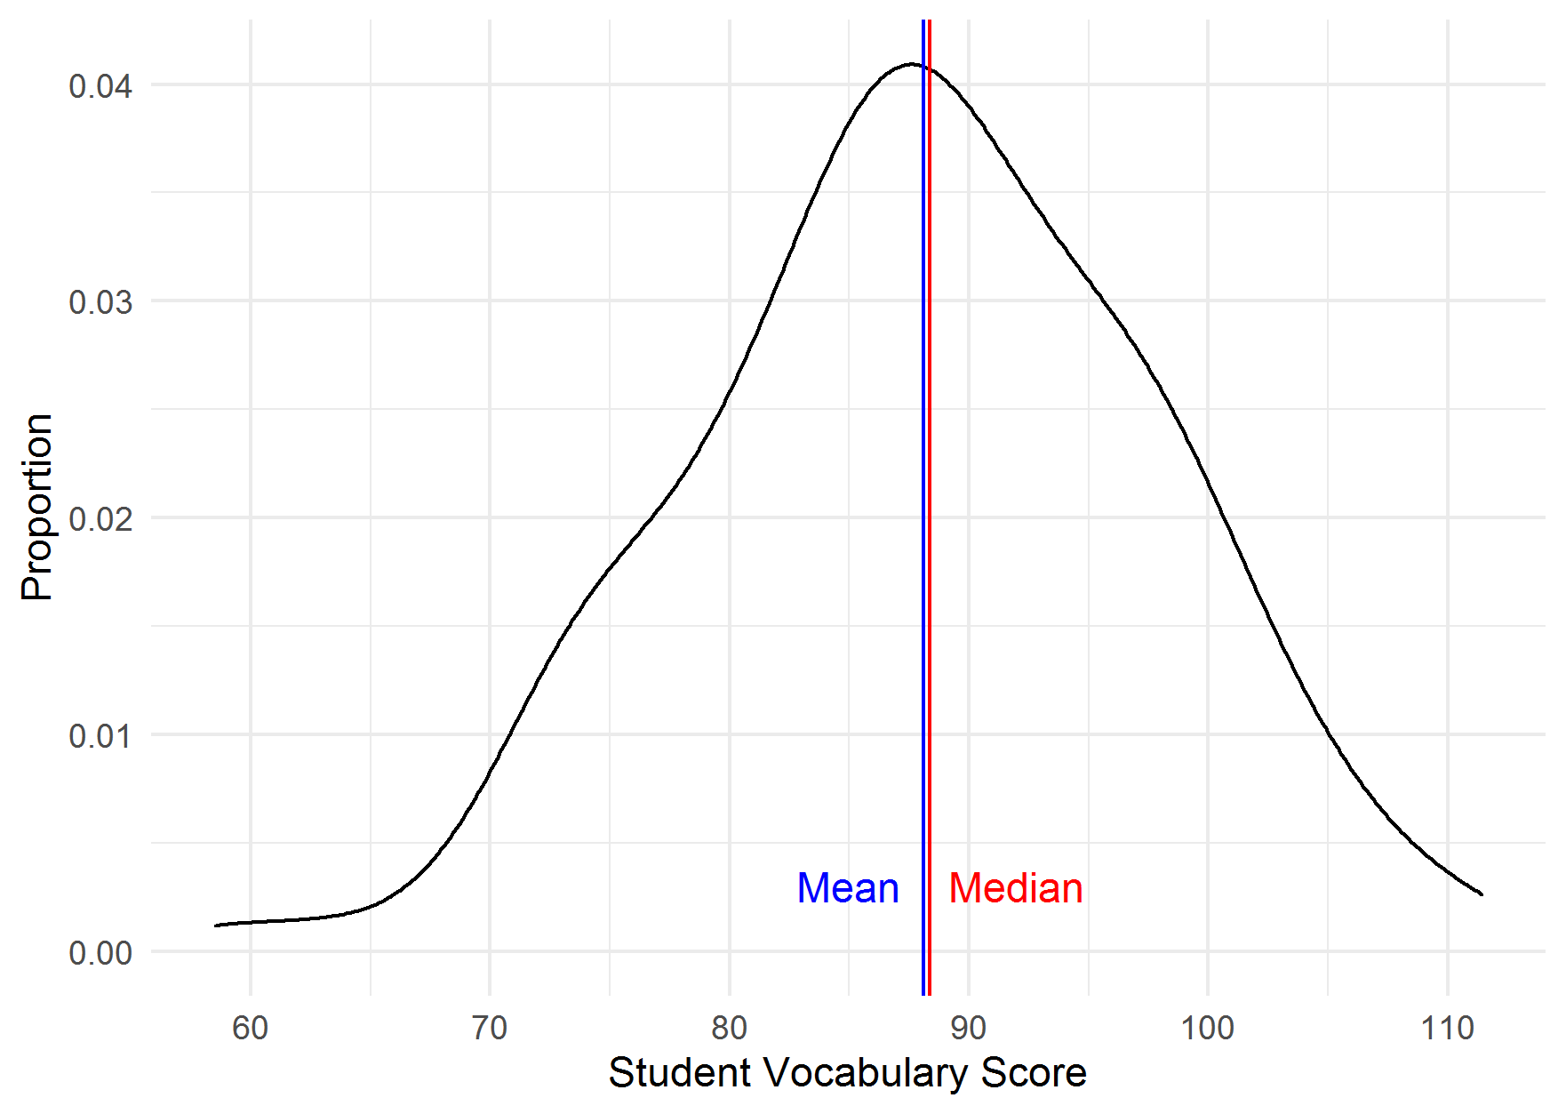

* 1. What are the range and inter-quartile range of vocabulary (provide both the upper/lower limits as well as the ranges themselves). **(1 points)**

**The range and inter-quartile range of *vocabulary* are 52.94 and 13.24, respectively. The upper- and lower-limits (minimum/maximum) of the range are 58.50 and 111.44. The upper- and lower-limits of the IQR (25th and 75th percentiles) are 81.51 and 94.74, respectively.**

* 1. What are the variance and standard deviation of vocabulary? In 1 sentence, interpret the statistical meaning of these measures. **(1 point)**

The variance of *vocabulary* is 92.78, and the standard deviation is 9.63. The variance represents the average squared deviation of each observation from the mean, and the standard deviation is the square root of this number, or the average distance that each number is from the mean.

3. Transformations

3.1. Standardize the variables *coursework* **and** *vocabulary* to have a mean of 0 and standard deviation of 1. You do not need to include this part of the response in your memo; only in your code. **(1 point)**

3.2. Let’s examine one particular teacher: Teacher 1832 (*tchid*==1832). This teacher did not participate in much coursework, nor did their students perform particularly well on their vocabulary test. For which variable (*coursework* or *vocabulary*) was this teacher observation more extreme, given the distribution of these particular variables in our sample? Explain and interpret in 1-2 sentences **(1 point)**

Teacher #1832 participated in coursework at 3.37 standard deviations below the mean, compared to other students in our sample; in comparison, their average student performance on a vocabulary test was 1.44 standard deviations below the mean. Thus, this teacher was lower in the distribution of coursework participation than vocabulary scores, in this sample of teachers.

#### 4. Compare observed mean of vocabulary to population mean

* 1. In one sentence, state your null-hypothesis. **(1 point)**

On average, the mean value of teacher-level student vocabulary scores is not different from the population mean of 87.

4.2 Conduct a one-sample *t*-test. State the results of your test, including the alpha-threshold you have set and whether you have conducted a one- or two-tailed test and why. **(2 points)**

Assuming a population mean of 87, the proportion of random samples that would return a sample mean equal to or more extreme than 88.12 is 0.19 (*t*(125) = 1.31, *p* = 0.194). Per convention, we set an alpha threshold of 0.05, and we conduct a two-tailed *t*-test because it is possible that our sample mean is higher or lower than our known population mean. Because our *p*-value of 0.19 is greater than our alpha-threshold of 0.05, we fail to reject the null hypothesis.

4.3. Write 2-3 sentences to interpret the results of your test in the preceding question. **(2 points)**

In our sample of 126 teachers, their students’ average vocabulary scores were 88.12. When we test whether these were different from a defined population mean of 87, we fail to reject the null hypothesis and conclude that the mean of vocabulary in our sample is not significantly different from the population mean 87, on average.