EDUC 641 Lab: Applied Statistics in Education and Human Services I
Lab 5: 10/28 and 10/29

Focus on describing and summarizing one continuous variable and recall filter() to look at individual observations.
Goals:
- Describe summary statistics of one continuous variable using the functions: mean, median, range, IQR, variance, standard deviation, summary
- Visualize the distribution of one continuous variable: using geom_histogram() and geom_density()
- Recall using filter() function to look at an individual observation (e.g., one teacher)

What’s NEW?!
Summary functions:
mean(), median(), range(), IQR(), sd(), var(), summary()

Distribution functions using ggplot():
geom_histogram() and geom_density() to create visualizations of the distribution of our data.

Missing variables:
You can set the na.rm parameter to TRUE (to remove any missing values if they exist)

Example:
‘ na.rm = T ‘

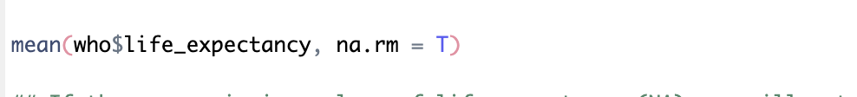

Worksheet
Don’t forget to load packages: library(tidyverse)

Measures of Central Tendency
- Suppose you want to know the average or measures of central tendency of your variable.
  - Use the mean() function to find the average
mean(your_data$variable_name, na.rm = T
  - Use the median() function as another measure for central tendency
median(your_data$variable_name, na.rm = T)

Measures of Variation
- If you want to know how much your variable ranges, try:
  - range(your_data$variable_name, na.rm = T)
  - IQR(your_data$variable_name, na.rm = T)

Measures of Spread
  - var(your_data$variable_name, na.rm = T)
  - sd(your_data$variable_name, na.rm = T)
  - summary(your_data$variable_name)
**The summary function returns a bunch of summary statistics of one continuous variable including, minimum value, maximum value, mean, median, first quartile, third quartile, and the number of NAs.

Try yourself: Summarize the descriptive statistics of the life_expectancy variable from the who dataset.

Distribution
- To visualize the distribution of your data:
  - ‘ geom_histogram() ‘

ggplot(your_data, aes(x = your_variable)) +
geom_histogram() +
labs(title = “Your title distribution of variable_name”,
x = “Title of x-axis”,
y = “Frequency or Count”)

  - ‘ geom_density() ‘

ggplot(your_data, aes(x = your_variable)) +
geom_density() +
labs(title = “Your title distribution of variable_name”,
x = “Title of x-axis”,
y = “Density”)
Try yourself: Represent the distribution of the life_expectancy variable using geom_histogram() and geom_density() from the who dataset.

- Suppose you want to look at the data relevant to only one individual teacher
  - subset_teacher1 <- filter(your_data, teacher_variable == "individual_teacher")

Try yourself: Filter the who dataset to look at only Canada. What is the life_expectancy in Canada?

