EDUC 641 Lab: Applied Statistics in Education and Human Services I
Lab 3: 10/21 and 10/22

Focus on Assignment 2, chi-square tests, and using the filter() function to create new datasets
Goals:
- Chi-square goodness-of-fit test of categorical association
- Sub-sample comparison using filter() function

What’s NEW?!

Using the filter() function in R.
The filter() function in R is used to subset or filter rows from a dataframe based on specific conditions or selected variable criteria. It's a fundamental function for data manipulation and is commonly used in data analysis and data wrangling tasks. Here's how it works:

Code:

subset_data <- filter(your_data, your_data$varaible == “variable specification/condition”)

- your_data: This is your dataframe (i.e., what you name cat.csv using ‘<-’ ).
- Variable specification/condition: This is a logical condition (meaning it has to be in quotes) that specifies which rows you want to keep. Rows that satisfy this logical condition will be included in the filtered result.
  - This is where you select the aspects, or levels, of a variable(s) you want to keep
- The newly created subset_data dataframe will contain only the rows that meet the specified conditions (male or female, etc.).

Example
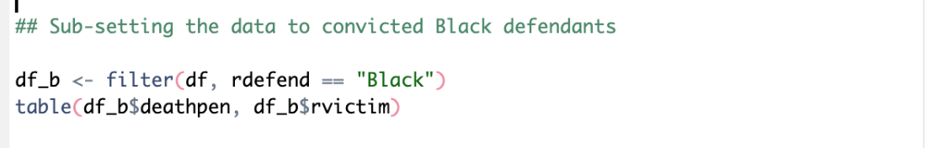

Notice: the ' == ’ sign to specify the condition or the criteria that the variable must meet to be
included in the newly subset data. AND that in generating a new table() when calling to your variables using ‘ $ ‘ make sure you’re using your new subset_data dataframe.
Help sheet

Don’t forget to install packages (install.packages() if you haven’t already) then load:
library(tidyverse)

- Start a new R script for assignment 2 (educ641_assmt2.R). Copy from assignment one or read in data and assign to object/dataframe name
  - your_data <- read.csv(here("data/your_data.csv")) # just like assignment one
# make sure categorical variables are factored appropriately
  - factor data accordingly using code from assmt 1.

- Create tables and figures to observe the variables
  - Two ways to create tables
    - your_table <- table(your_data$variable1, your_data$variable2)
addmargins(your_table) # new function here that adds a Sum column
# OR (same thing, just another way to do it)
    - your_table2 <- xtabs(formula = ~ variable1 + variable2, data = your_data)
addmargins(your_table2) # again, addmargins() function adds Sums to
# rows and columns

  - Using proportion table to display percent
    - Round(prop.table(table(your_data$variable1, your_data$variable2), margin= 2) *100, 2)
Note: The ` margin ` argument determines which total is used as the denominator when calculating proportions.
- margin = 1: Each row adds to 100%. Use this when comparing the distribution of column categories within each row category.
- margin = 2: Each column adds to 100%. Use this when comparing the distribution of row categories within each column category.
- No margin specified: All cells together add to 100%, representing the distribution of the entire sample.
Important: Choose the margin based on your research question and which groups you want to compare. For example, if you want to compare the percentage of chronically absent students within each treatment group, use margin = 2 when treatment groups are displayed in the columns.
  - Create one figure representing variable1 and variable2
Observe categorical variables using code from last week’s lab:
ggplot(your_data, aes(x = variable1, fill = variable2)) +
geom_bar(position = "dodge") + # importance of function shown below
labs(title = "Title of Graph", x = "x-axis title", y = "Counts") +
theme_minimal()

Example geom_bar(position = "dodge"):
NO (position = “dodge”) example
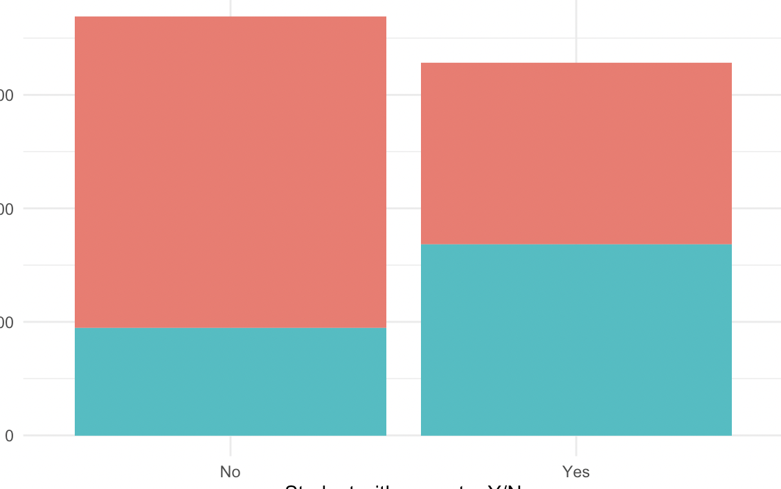
YES (position= “dodge”)
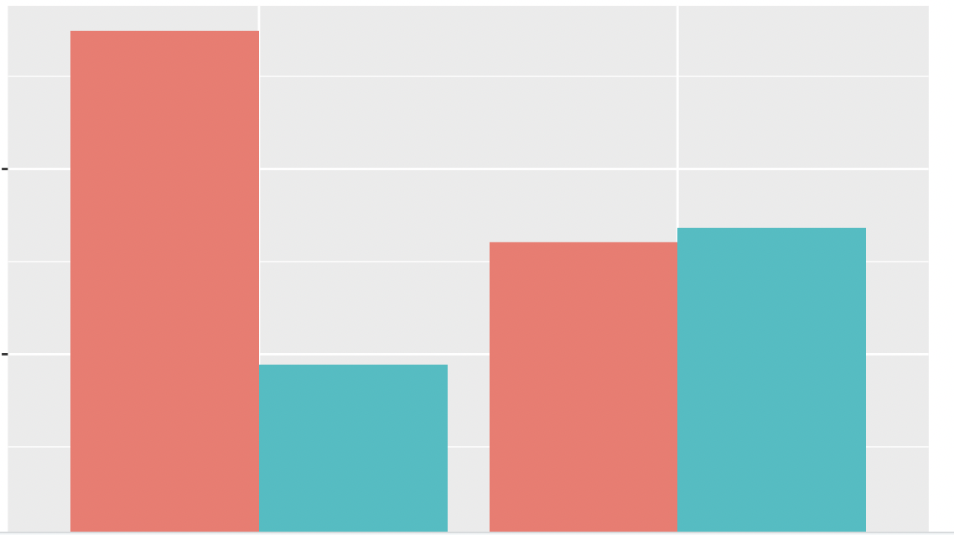
Note. Plots with bars plotted side by side are more readily interpretable to the viewer and are the preferred visualization.

- Run Chi-Square tests AFTER you state your hypothesis question(s)
  - chi_df <- chisq.test(your_data $variable1, your_data $variable2)
chi_df # code for 3.3
  - chi_df$expected # for 3.2
  - chi_df$observed
## Display just the chi^2 statistic:
  - chi_b$statistic
## Display the p-value
  - chi_b$p.value
# or rounded to 10 decimal places...
  - round(chi_b$p.value, 10)

- Subsetting data using filter() [see example on page one for what filter is/does]
  - subset_data <- filter(your_data, variable3 == "variable3 condition")
# variable 3: the other categorical variable you’re subsetting, i.e., cgender

  - Use the chi-square test function chisq.test() to analyze your variables using this new subset_data
e.g.
chisq.test(subset_data$variable1, subset_data2$variable2)

