EDUC 641 Lab: Applied Statistics in Education and Human Services I
Lab 2: 10/7 and 10/8

Importing data, exploring categorical variables, and exporting results
Goals:
- Data types in R
- Import data
- Identify the main features of a dataset
- Describe categorical variables of your dataset (tables and plots)
Note:
- Work in groups and discuss with your peers as you go. Write down your questions as they arise.
- **Everything inside the single quotes (‘) symbol and gray area is code. When typing the code in R, skip the quotes sign and type whatever is inside.
- Run code through R Script line-by-line. To run a code, go anywhere on the line where you wrote the code and either click ‘Run’ using the mouse or press Ctr/Command + Enter on your keyboard. The output will be printed on the console.
Foundational Concept—What does R store?
Data types in R: integer, character, numerical/double, and logical. Data types tell R what kind of information a value contains. Some common types are:
- integer: whole numbers
- double: numeric values
- character: text
- logical: TRUE or FALSE
Important: R data types are not the same thing as levels of measurement (nominal, ordinal, interval, ratio). Data type describes how R stores information; level of measurement describes what the variable means and what kinds of statistical operations are appropriate.
Objects: In R, we can save information by assigning it a name. This creates an object that we can use again later.

Objects are things we create and save in R. Objects can contain different kinds of information. Some common R objects are vectors, matrices, and data frames. Most of the datasets we analyze in this course will be stored as data frames.

Examples of ‘Objects’ in R:
R
integer_eg <- 2L
character_eg <- “hi”
logical_eg <- FALSE
double_eg <- 2
**What do you think ‘ <- ’ is doing in each line?**

What if we need to group numbers or characters?
R
group_of_numbers <- c(1,3,6,9) # vector
group_of_letters <- c(“a”, “b”, “c”, “d”) # vector
arrange_numbers <- matrix(data = c(0,10,13,0,51,5,8,3,0), # matrix
nrow = 3,
ncol = 3,
byrow = TRUE)
data_eg <- mtcars # data frame

To obtain information about objects, we can use the ‘str()’ ‘class()’ and ‘typeof()’ functions.
R
str()
class()
typeof()

Today’s Lab
- Import dataset in R:
- First, download the dataset from the class website and save it inside the data folder of your R-project

- Open the R-project and the R-script you created in the labs folder last time. You can copy and paste this code “template” into your R script and edit it to match your data file name (i.e., cat.csv).

R
cat_df <- read.csv(“data/name_of_dataset.csv”) # typing out the file path here to your desktop data

You should see this in your environment here:
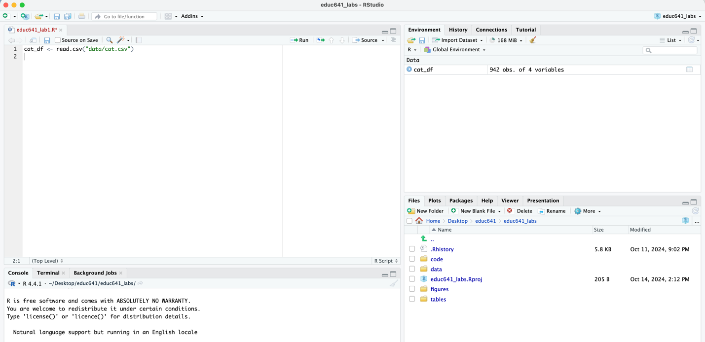

- Identify the key features of the dataset by asking R what you imported
- We can click the name of the dataset object (cat_df) in Environment to open the dataset in a new tab. Use these functions to obtain information about the dataset:
- str()
- dim()
- colnames()
- rownames()
- head()
*Based on your output from the above ‘ functions() ,’ how many rows and columns are in the dataset?*
**What variables are there?**

- To access specific columns (or one variable) of the dataset, we do the following: Hint the name of your data you made in 1.b. it’s, ` cat_df `
R
your_data$your_column
# use ‘class()’ function to see what R thinks that variable is
class(your_data$your_variable)

- How does R understand our variables?

R can represent categorical variables using factors. A factor tells R that the values represent categories rather than ordinary numerical values. In this course, we will often convert categorical variables to factors before analyzing them so that R can see the substantive categories those numbers represent.

Example:
R

data_df$school_type <- factor(
data_df$school_type,
levels = c(1, 2, 3),
labels = c( “Elementary”, “Middle” , “High”) # Quotes are needed for character labels
) # Always close out all parentheses

- First, you need to know how data is coded (levels) that appear in the column and what they actually mean (labels) based on the information you have on your dataset from your codebook.
R
your_data$your_categorical_column <- factor(your_data$your_categorical_column,
levels = c(...), #write the levels as they appear in the data object
labels = c(...) #write the labels, i.e., what they represent as characters
)
# verify
class(your_data$variable_name)
levels(your_data$variable)

**What are the categories R now recognizes for this variable? Do these match the codebook?**

- What does our categorical variable look like?
  - Counts and Proportion
R
table(your_data$your_categorical_column) # to view counts of categorical variable
counts <- table(your_data$your_categorical_column) # can store these counts in ‘ object ‘ to use in ‘ function ’
counts # to view counts of categorical variable, run
prop_table <- prop.table(table(your_data$your_categorical_column))
# or simply use ‘ counts ’ from stored earlier
prop_table <- prop.table(counts) # this is doing the same as the line above; the data is just stored in object
prop_table
**Which category occurs most frequently? What proportion of observations are in this category?**
  - Proportion bar chart
R

prop.table(table(your_data$variable_name))

barplot(prop_table) # explicitly displays ‘proportions’

**INTERPRET PLOT**
  - Bar chart
R
library(tidyverse)
#If you don't have tidyverse installed, do install.packages("tidyverse") first, we will cover this later
ggplot(your_data) + # explicitly displays ‘count’ data
geom_bar(aes(x = your_categorical_column), fill = "choose_a_color_of_your_choice")+
labs(
x = "Give a descriptive x-axis label",
y = "Give a descriptive y-axis label",
title = "Give a descriptive title"
) +
theme_minimal()
**INTERPRET PLOT**
**What does the y-axis represent in each graph? Do the two graphs tell the same substantive story?** Why?

BONUS
Exporting tables and figures: For assignment 1, you can either take a screenshot of your output, type out the tables, or export your results. Below are some ways to save your results.

- First, save the tables and plots into a named object, like this,
R
# creating object to export count data nicely as a data frame
counts_df <- as.data.frame(table(your_data$cat_variable))

# creating object to export barplot nicely as a PNG
barplot_save <- ggplot(your_data) +
geom_bar(aes(x = your_categorical_column), fill = "color_of_your_choice") +
labs(
x = "Give a meaningful x-axis label",
y = "Give a meaningful y-axis label",
title = "Give a meaningful title"
) +
theme_minimal()

- To export, use the following code. The files will be saved in the path you specify.
R
write.csv(counts_df, "tables/counts_df.csv", row.names = FALSE)
ggsave(filename = "figures/barplot.jpeg",
plot = barplot_save) #uses default width and height, which can be changed
Summarize for yourself. Write all the functions you learned today to help yourself with the assignment!

