EDUC 643 Assignment 04 Key

1. Does the relationship between school spending and school poverty rates differ across school grade-band levels?

1.1 State your null hypothesis regarding the above research question. (1 point)

**In the population of Oregon public schools, the relationship between school family-poverty rates and per-pupil expenditure does not differ across school grade-band levels (early education, elementary, middle and high school). Formally:**

**H0 = *βearlyedXfrpl* = *βelemXfrpl* = *βmiddleXfrpl* = *βhighXfrpl* = 0**

1.2 Test your null hypothesis and present a table displaying the results of this test. Construct a fitted equation for each school level in order to interpret the results of your analysis. (2 points)

We reject our null hypothesis and conclude that the relationship between the proportion of students receiving free- and reduced-price lunch (*FRPL*) in a school and the school’s per-pupil expenditure (*PPE*) differs across grade levels. We present the results of our test in Table 1. In Model 1, we assess the bivariate relationship between *FRPL* and *PPE* and estimate that schools that differ in their enrolled FRPL populations by 10 percentage points, on average, spend $263.43 more per child. In our test of the main effects of school level (Model 2), we find meaningful differences in spending across grade-bands. In Model 3, we reject the null hypothesis (alpha=0.05) and conclude that there exist statistical differences in the relationship between *FRPL* and *PPE* by school level.

In particular, the magnitude of the relationship between FRPL and PPE is more than twice as big at the middle- and high-school levels than it is at the elementary levels. Elementary schools that differ in their enrolled FRPL proportions by 10 percentage points will, on average, spend roughly $130 more per student; whereas, our models predict that middle and high schools that differ in their FRPL populations by the same amount have per-pupil expenditures that differ by roughly $400 or $470, respectively. We refrain from interpreting the coefficients on early education settings because there are only six such schools in our data.

**Fitted equations:**

$${\hat{PPE}}_{elem}=12748.86+1290.05*FRPL$$

$${\hat{PPE}}_{earlyed}=12748.86+1290.05*FRPL-12162.36+16981.72*FRPL$$

$$=586.50+18271.77*FRPL$$

$${\hat{PPE}}_{middle}=12748.86+1290.05*FRPL-2230.96+2682.47*FRPL$$

$$=10517.90+3972.52*FRPL$$

$${\hat{PPE}}_{high}=12748.86+1290.05*FRPL-7.15+3424.38*FRPL$$

$$=12741.71+4714.43*FRPL$$

**Table 1**

**Ordinary Least Squares estimates of the relationship between schooling level and per-pupil expenditure, by schooling level in Oregon public schools, 2018-19**

|  | (1) | (2) | (3) |
| --- | --- | --- | --- |
| (Intercept) | 12226.90*** | 13532.67*** | 12748.86*** |
|  | (271.68) | (110.58) | (276.26) |
| FRPL | 2634.33*** |  | 1290.05*** |
|  | (427.86) |  | (377.57) |
| Early Education |  | -1959.04 | -12162.36* |
|  |  | (2219.01) | (5369.70) |
| High School |  | 1669.35*** | -7.15 |
|  |  | (378.42) | (805.88) |
| Middle School |  | -1014.89*** | -2230.96*** |
|  |  | (243.41) | (549.41) |
| FRPL x Early Ed |  |  | 16981.72** |
|  |  |  | (6469.01) |
| FRPL x High |  |  | 3424.38* |
|  |  |  | (1482.83) |
| FRPL x Middle |  |  | 2682.47** |
|  |  |  | (877.41) |
| Num.Obs. | 1193 | 1193 | 1193 |
| R2 | 0.034 | 0.053 | 0.102 |
| *Notes*: + p < 0.1, * p < 0.05, ** p < 0.01, *** p < 0.001. Cells report coefficients and heteroscedastic-robust standard errors in parentheses. Reference category is Elementary schools. Each observation is one school. | | | |

1.3 Construct a plot of the (potentially) differing relationship between *ppe* and *frpl* by school-grade-band level. Include confidence intervals on the plot. Interpret the plot. (3 points)

In Figure 1, we plot the fitted relationship between the proportion of students receiving FRPL in a school and the school’s per-pupil expenditure, by grade level. Again, we restrict our analyses to elementary, middle and high schools due to the very few early education schools in our sample. As Figure 1 highlights, the relationship between *PPE* and *FRPL* differs meaningfully by grade level. Elementary schools have a much more uniform level of spending, irrespective of their low-family-income composition. The magnitude of the relationship between *FRPL* and *PPE* is much larger for middle and high schools, as compared to elementary schools.

**Figure 1**

*Relationship between rate of school-level free-and reduced-price lunch (FRPL) receipt and predicted per-pupil expenditure (PPE) at different grade levels of schooling for Oregon public schools, 2018-19*

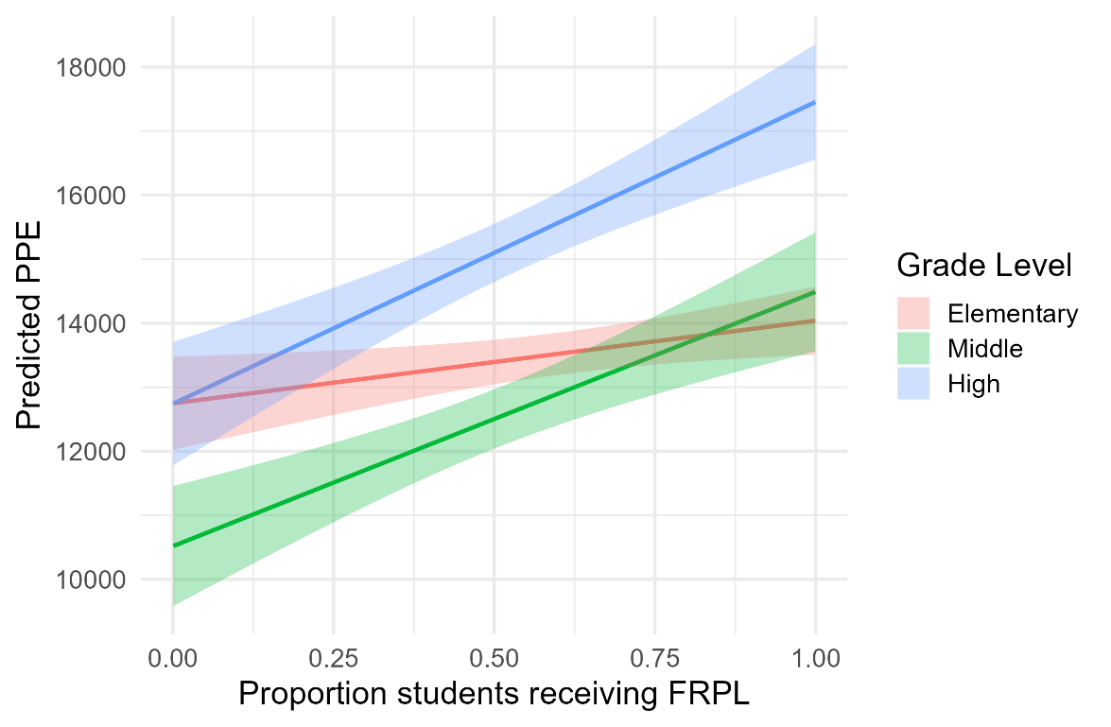

1.4 Describe how the results of your analysis in these questions differ from your analysis in Questions 2.1 - 2.4 on your previous assignment. **(1 point)**

Whereas our prior analysis in Assignment 3 examined whether spending levels differed, on average, by the level of the school, the analysis in this assignment examines whether the relationship between the proportion of students receiving FRPL and per-pupil expenditures differs by the grade-level of the school. In formal terms, our prior assignments tested the main effects of grade-level and FRPL, whereas in this assignment, we are testing an interaction model between grade-level and FRPL.

2. Does the relationship between school spending and school poverty rates differ by school size (enrollment)?

2.1 State your null hypothesis regarding the above research question. (1 point)

**In the population of Oregon public schools, the relationship between school family-poverty rates and per-pupil expenditure does not differ by school size (total enrollment). Formally:**

**H0: *βfrplXenroll* = 0**

2.2 Test your null hypothesis, present a table displaying the results of this test, and interpret those results **(2 points)**

**In order to test our null hypothesis that the relationship between per-pupil expenditure and free- and reduced-price lunch receipt is equivalent across school enrollments, we employ an Ordinary Least Squares estimation strategy. We begin in Table 2 with re-estimating the main effect of *FRPL* on *PPE* (repeating Model 1 from Table 1). We then estimate the main effect of enrollment on PPE, and we find that schools with larger total enrollments spend less per student (-$0.94 per one additional student). Model 3 is a formal test of our null hypothesis. While the main effect of enrollment remains positive, the cross-product term is strongly negative, suggesting that larger schools that also have more students receiving FRPL do not receive as much more additional funding as smaller schools that have larger proportions of students receiving FRPL.**

**Table 2**

**Ordinary Least Squares estimates of the relationship between schooling level and per-pupil expenditure in Oregon public schools, 2018-19**

|  | (1) | (2) | (3) |
| --- | --- | --- | --- |
| (Intercept) | 12226.90*** | 14138.54*** | 11744.05*** |
|  | (271.68) | (265.75) | (544.49) |
| FRPL | 2634.33*** |  | 4283.29*** |
|  | (427.86) |  | (947.57) |
| Total enrollment |  | -0.94* | 1.27+ |
|  |  | (0.37) | (0.72) |
| FRPL x Enrollment |  |  | -4.18** |
|  |  |  | (1.53) |
| Num.Obs. | 1193 | 1193 | 1193 |
| R2 | 0.034 | 0.006 | 0.045 |
| *Notes*: + p < 0.1, * p < 0.05, ** p < 0.01, *** p < 0.001. Cells report coefficients and heteroscedastic-robust standard errors in parentheses. Reference category is Elementary schools. Each observation is one school. | | | |

2.3 Select (and justify) some prototypical values of school size for which to display the (potentially) differing relationship between *ppe* and *frpl*. Construct and interpret a plot of these prototypical values**(3 points)**

Larger schools in Oregon have a much weaker gradient in the relationship between school poverty levels and per-pupil spending than comparatively smaller schools. In Figure 2, we present prototypical plots describing this phenomenon generated from Model 3 in Table 2. We select round enrollment values at roughly the 10th, 50th and 90th percentiles of the school size distribution to visualize these differing relationships: 140 students, 400 students and 800 students, respectively. We can observe in Figure 2 that the interactions are ordinal (i.e., that all three slopes are positive); however, the magnitude of the relationship between FRPL and PPE is much larger for small and mid-sized schools than it is for large schools. As a result, we estimate that schools of all different sizes will, on average, spend roughly equivalent amounts (~$13,000/student) when their student bodies are around one-third low-income. However, in schools in which 90 percent of students receive FRPL, small schools spend roughly $15,250/student and mid-size schools spend $14,600.

**Figure 2**

*Relationship between rate of school-level free-and reduced-price lunch (FRPL) receipt and predicted per-pupil expenditure (PPE) at different levels of schooling, adjusting for other school and community factors.*

