Title: | Cluster of Instruments

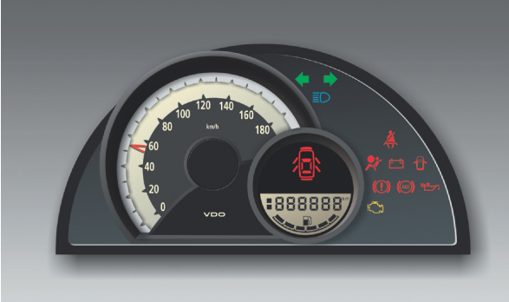

Maturity: | Draft
Authors: | Francisco Javier Quirarte Pelayo
Authors: | David Antonio Diaz Ramirez
VERSION: | Public
Security Classification: | None

History
Issue status  (Index) | Maturity/Date  (draft/invalid/valid)  (dd-mmm-yyyy) | Author  Department | Check/Release  Department | Description
1.0 | Draft  26-nov-15 | Francisco Quirarte | Francisco Quirarte y David Díaz | Creation of the document.
History
Issue status  (Index) | Maturity/Date  (draft/invalid/valid)  (dd-mmm-yyyy) | Author  Department | Check/Release  Department | Description
2.0 | Draft  27-nov-15 | David Díaz | Francisco Quirarte | Added: Purpose, Definitions and abbreviations.
History
Issue status  (Index) | Maturity/Date  (draft/invalid/valid)  (dd-mmm-yyyy) | Author  Department | Check/Release  Department | Description
3.0 | Draft  28-Nov-15 | Francisco Quirarte y  David Díaz | Francisco Quirarte | Added: Realization constraints and targets.
History
Issue status  (Index) | Maturity/Date  (draft/invalid/valid)  (dd-mmm-yyyy) | Author  Department | Check/Release  Department | Description
4.0 | Draft  29- Nov -15 | Francisco Quirarte y  David Díaz | Oswaldo Garcia | Added: SW Conceptual design.

History
Issue status  (Index) | Maturity/Date  (draft/invalid/valid)  (dd-mmm-yyyy) | Author  Department | Check/Release  Department | Description
6.0 | Draft  30-nov-15 | Francisco Quirarte y  David Díaz | Luis Alvarez | Review of SW Component internal breakdown and added general corrections.  General corrections at traceability matrix

History
Issue status  (Index) | Maturity/Date  (draft/invalid/valid)  (dd-mmm-yyyy) | Author  Department | Check/Release  Department | Description
7.0 | Release  30-Nov-15 | Francisco Quirarte y  David Díaz | Oswaldo Garcia e  Isamar Gálvez | Review of SW Conceptual design and added general corrections.  Review of the test plan.

Table of Contents
1 Introduction 5
2 Purpose 6
3 Comparison chart protocols 7
4 LIN Protocol Concepts 8
5 Chart Concepts 9
6 Definitions and abbreviations 11
7 LIN Software Driver Services 13
8 The ISO/OSI reference model and LIN 14
8.1 Figure 10: reference model ISO/OSI LIN 14
9 Software Layers 15
9.1 Figure 11: Layers 15
9.2 Layer descriptions 15
9.3 Functional Blocks Descriptions 16
10 Requeriments 17
11 Realization constraints and targets 19
11.1 Network Graphical Description 21
11.1.1 Figure 11: Deployment Diagram (A) 21
11.2 Use Case Diagram 22
11.2.1 Figure 12: Use Case Diagram 22
11.3 Component diagram request & response (A/D) 23
11.3.1 Figure 3: Component diagram (A/D). 23
11.3.2 Figure: Components Descriptions 23
11.3.3 Component diagram SW 24
11.4 Activity Diagram (R) 25
11.5 SEQUENCE 26
11.6 Response Sequence Diagram 27
11.7 State machine diagram 28
11.7.1 Slave 2 28
11.7.2 Lin manager 29
11.7.3 LIN Handler 31
11.7.4 Master node transmission handler 32
11.7.5 LED Handler 34
12 Application Program Interface Specification ver. 2.2a 35
12.1 CORE API 35

Introduction: The CAN bus

The CAN bus is a broadcast type of bus. This means that all nodes can “hear” all transmissions. There is no way to send a message to just a specific node; all nodes will invariably pick up all traffic. The CAN hardware, however, provides local filtering so that each node may react only on the interesting messages.
The bus uses Non-Return to Zero (NRZ) with bit-stuffing. The modules are connected to the bus in a wired-and fashion: if just one node is driving the bus to a logical 0, then the whole bus is in that state regardless of the number of nodes transmitting a logical 1.
The CAN standard defines four different message types. The messages uses a clever scheme of bit-wise arbitration to control access to the bus, and each message is tagged with a priority.
The CAN standard also defines an elaborate scheme for error handling and confinement, “CAN Error Handling”.
Bit timing and clock synchronization is discussed in Page 8 of this Tutorial. Here’s a bit timing calculator you can use to calculate the CAN bus parameters and register settings.
CAN may be implemented using different physical layers, some of which are described here, and there are also a fair number of connector types in use. We also provide a number of oscilloscope pictures for those interested in the details of a message.

CAN Messages
The CAN bus is a broadcast type of bus. This means that all nodes can “hear” all transmissions. There is no way to send a message to just a specific node; all nodes will invariably pick up all traffic. The CAN hardware, however, provides local filtering so that each node may react only on the interesting messages.
CAN uses short messages – the maximum utility load is 94 bits. There is no explicit address in the messages; instead, the messages can be said to be contents-addressed, that is, their contents implicitly determines their address.

Message Types
There are four different message types (or “frames”) on a CAN bus:
- The Data Frame,
- The Remote Frame,
- The Error Frame, and
- The Overload Frame.

The Data Frame
The Data Frame is the most common message type. It comprises the following major parts (a few details are omitted for the sake of brevity):
- The Arbitration Field, which determines the priority of the message when two or more nodes are contending for the bus. The Arbitration Field contains:
  - For CAN 2.0A, an 11-bit Identifier and one bit, the RTR bit, which is dominant for data frames.
  - For CAN 2.0B, a 29-bit Identifier (which also contains two recessive bits: SRR and IDE) and the RTR bit.
- The Data Field, which contains zero to eight bytes of data.
- The CRC Field, which contains a 15-bit checksum calculated on most parts of the message. This checksum is used for error detection.
- An Acknowledgement Slot; any CAN controller that has been able to correctly receive the message sends an Acknowledgement bit at the end of each message. The transmitter checks for the presence of the Acknowledge bit and retransmits the message if no acknowledge was detected.

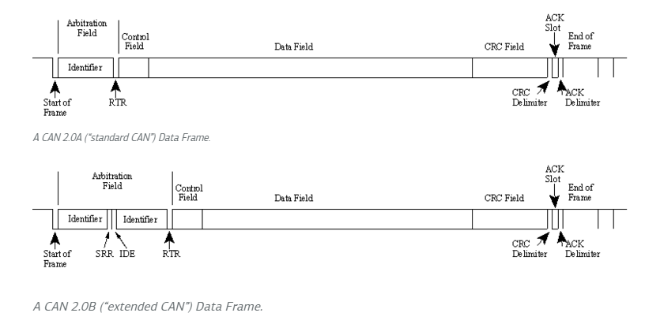

The Remote Frame
The Remote Frame is just like the Data Frame, with two important differences:
- it is explicitly marked as a Remote Frame (the RTR bit in the Arbitration Field is recessive), and
- There is no Data Field.

The intended purpose of the Remote Frame is to solicit the transmission of the corresponding Data Frame. If, say, node A transmits a Remote Frame with the Arbitration Field set to 234, then node B, if properly initialized, might respond with a Data Frame with the Arbitration Field also set to 234.
Remote Frames can be used to implement a type of request-response type of bus traffic management. In practice, however, the Remote Frame is little used. It is also worth noting that the CAN standard does not prescribe the behaviour outlined here. Most CAN controllers can be programmed either to automatically respond to a Remote Frame, or to notify the local CPU instead.
Remote Frames can be used to implement a type of request-response type of bus traffic management. In practice, however, the Remote Frame is little used. It is also worth noting that the CAN standard does not prescribe the behaviour outlined here. Most CAN controllers can be programmed either to automatically respond to a Remote Frame, or to notify the local CPU instead.
There’s one catch with the Remote Frame: the Data Length Code must be set to the length of the expected response message. Otherwise the arbitration will not work.
Sometimes it is claimed that the node responding to the Remote Frame is starting its transmission as soon as the identifier is recognized, thereby “filling up” the empty Remote Frame.

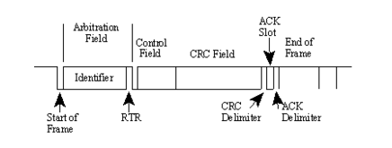

The Error Frame
Simply put, the Error Frame is a special message that violates the framing rules of a CAN message. It is transmitted when a node detects a fault and will cause all other nodes to detect a fault – so they will send Error Frames, too. The transmitter will then automatically try to retransmit the message. There is an elaborate scheme of error counters that ensures that a node can’t destroy the bus traffic by repeatedly transmitting Error Frames.
The Error Frame consists of an Error Flag, which is 6 bits of the same value (thus violating the bit-stuffing rule) and an Error Delimiter, which is 8 recessive bits. The Error Delimiter provides some space in which the other nodes on the bus can send their Error Flags when they detect the first Error Flag.
Here’s the Error Frame:
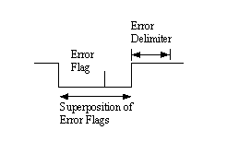

The Overload Frame
The Overload Frame is mentioned here just for completeness. It is very similar to the Error Frame with regard to the format and it is transmitted by a node that becomes too busy. The Overload Frame is not used very often, as today’s CAN controllers are clever enough not to use it. In fact, the only controller that will generate Overload Frames is the now obsolete 82526.

Standard vs. Extended CAN
Originally, the CAN standard defined the length of the Identifier in the Arbitration Field to eleven (11) bits. Later on, customer demand forced an extension of the standard. The new format is often called Extended CAN and allows no less than twenty-nine (29) bits in the Identifier. To differentiate between the two frame types, a reserved bit in the Control Field was used.
The standards are formally called
- 2.0A, with 11-bit Identifiers only,
- 2.0B, extended version with the full 29-bit Identifiers (or the 11-bit, you can mix them.) A 2.0B node can be
  - “2.0B active”, i.e. it can transmit and receive extended frames, or
  - “2.0B passive”, i.e. it will silently discard received extended frames (but see below.)
- 1. refers to the original specification and its revisions.
New CAN controllers today are usually of the 2.0B type. A 1.x or 2.0A type controller will get very upset if it receives messages with 29 arbitration bits. A 2.0B passive type controller will tolerate them, acknowledge them if they are correct and then – discard them; a 2.0B active type controller can both transmit and receive them.
Controllers implementing 2.0B and 2.0A (and 1.x) are compatible – and may be used on the same bus – as long as the controllers implementing 2.0B refrain from sending extended frames!

Basic CAN vs. Full CAN
The terms “Basic CAN” and “Full CAN” originate from the childhood of CAN. Once upon a time there was the Intel 82526 CAN controller which provided a DPRAM-style interface to the programmer. Then came along Philips with the 82C200 which used a FIFO- (queue-) oriented programming model and limited filtering abilities. To distinguish between the two programming models, people for some reason termed the Intel way as “Full CAN” and the Philips way as “Basic CAN”. Today, most CAN controllers allow for both programming models, so there is no reason to use the terms “Full CAN” and “Basic CAN” – in fact, these terms can cause confusion and should be avoided.

Bus Arbitration and Message Priority
The message arbitration (the process in which two or more CAN controllers agree on who is to use the bus) is of great importance for the really available bandwidth for data transmission.
Any CAN controller may start a transmission when it has detected an idle bus. This may result in two or more controllers starting a message (almost) at the same time. The conflict is resolved in the following way. The transmitting nodes monitor the bus while they are sending. If a node detects a dominant level when it is sending a recessive level itself, it will immediately quit the arbitration process and become a receiver instead. The arbitration is performed over the whole Arbitration Field and when that field has been sent, exactly one transmitter is left on the bus. This node continues the transmission as if nothing had happened. The other potential transmitters will try to retransmit their messages when the bus becomes available next time. No time is lost in the arbitration process.
An important condition for this bit-wise arbitration to succeed is that no two nodes may transmit the same Arbitration Field. There is one exception to this rule: if the message contains no data, then any node may transmit that message.
Since the bus is wired-and and a Dominant bit is logically 0, it follows that the message with the numerically lowest Arbitration Field will win the arbitration.
Q: What happens if a node is alone on the bus and tries to transmit?
A: The node will, of course, win the arbitration and happily proceeds with the message transmission. But when the time comes for acknowledging… no node will send a dominant bit during the ACK slot, so the transmitter will sense an ACK error, send an error flag, increase its transmit error counter by 8 and start a retransmission. This will happen 16 times; then the transmitter will go error passive. By a special rule in the error confinement algorithm, the transmit error counter is not further increased if the node is error passive and the error is an ACK error. So the node will continue to transmit forever, at least until someone acknowledges the message.

Message Addressing And Identification
It is worth noting once again that there is no explicit address in the CAN messages. Each CAN controller will pick up all traffic on the bus, and using a combination of hardware filters and software, determine if the message is “interesting” or not.
In fact, there is no notion of message addresses in CAN. Instead, the contents of the messages is identified by an identifier which is present somewhere in the message. CAN messages are said to be “contents-addressed”.
A conventional message address would be used like “Here’s a message for node X”. A contents-addressed message is like “Here’s a message containing data labeled X”. The difference between these two concepts is small but significant.
The contents of the Arbitration Field is, per the Standard, used to determine the message’s priority on the bus. All CAN controllers will also use the whole (some will use just a part) of the Arbitration Field as a key in the hardware filtration process.
The Standard does not say that the Arbitration Field must be used as a message identifier. It’s nevertheless a very common usage.

The Layout of a Bit
Each bit on the CAN bus is, for timing purposes, divided into at least 4 quanta. The quanta are logically divided into four groups or segments -
- the Synchronization Segment
- the Propagation Segment
- the Phase Segment 1
- the Phase Segment 2
Here is a picture of a CAN data bit:
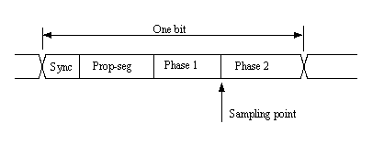

Clock Synchronization
In order to adjust the on-chip bus clock, the CAN controller may shorten or prolong the length of a bit by an integral number of quanta. The maximum value of these bit time adjustments are termed the Synchronization Jump Width, SJW.
Hard synchronization occurs on the recessive-to-dominant transition of the start bit. The bit time is restarted from that edge.
Resynchronization occurs when a bit edge doesn’t occur within the Synchronization Segment in a message. One of the Phase Segments are shortened or lengthened with an amount that depends on the phase error in the signal; the maximum amount that may be used is determined by the Synchronization Jump Width parameter.

How CAN Handles Errors
Error handling is built into in the CAN protocol and is of great importance for the performance of a CAN system. The error handling aims at detecting errors in messages appearing on the CAN bus, so that the transmitter can retransmit an erroneous message. Every CAN controller along a bus will try to detect errors within a message. If an error is found, the discovering node will transmit an Error Flag, thus destroying the bus traffic. The other nodes will detect the error caused by the Error Flag (if they haven’t already detected the original error) and take appropriate action, i.e. discard the current message.
Each node maintains two error counters: the Transmit Error Counter and the Receive Error Counter. There are several rules governing how these counters are incremented and/or decremented. In essence, a transmitter detecting a fault increments its Transmit Error Counter faster than the listening nodes will increment their Receive Error Counter. This is because there is a good chance that it is the transmitter who is at fault! When any Error Counter raises over a certain value, the node will first become “error passive”, that is, it will not actively destroy the bus traffic when it detects an error, and then “bus off”, which means that the node doesn’t participate in the bus traffic at all.

Error Detection Mechanisms
The CAN protocol defines no less than five different ways of detecting errors. Two of these works at the bit level, and the other three at the message level.
- Bit Monitoring.
- Bit Stuffing.
- Frame Check.
- Acknowledgement Check.
- Cyclic Redundancy Check.

1. Bit Monitoring
Each transmitter on the CAN bus monitors (i.e. reads back) the transmitted signal level. If the bit level actually read differs from the one transmitted, a Bit Error is signaled. (No bit error is raised during the arbitration process.)

2. Bit Stuffing
When five consecutive bits of the same level have been transmitted by a node, it will add a sixth bit of the opposite level to the outgoing bit stream. The receivers will remove this extra bit. This is done to avoid excessive DC components on the bus, but it also gives the receivers an extra opportunity to detect errors: if more than five consecutive bits of the same level occurs on the bus, a Stuff Error is signaled.

3. Frame check
Some parts of the CAN message have a fixed format, i.e. the standard defines exactly what levels must occur and when. (Those parts are the CRC Delimiter, ACK Delimiter, End of Frame, and also the Intermission, but there are some extra special error checking rules for that.) If a CAN controller detects an invalid value in one of these fixed fields, a Form Error is signaled.

4. Acknowledgement Check
All nodes on the bus that correctly receives a message (regardless of their being “interested” of its contents or not) are expected to send a dominant level in the so-called Acknowledgement Slot in the message. The transmitter will transmit a recessive level here. If the transmitter can’t detect a dominant level in the ACK slot, an Acknowledgement Error is signaled.

5. Cyclic Redundancy Check
Each message features a 15-bit Cyclic Redundancy Checksum (CRC), and any node that detects a different CRC in the message than what it has calculated itself will signal an CRC Error.

Purpose

The purpose of this document is to design the software that will be responsible for controlling the car cluster.
Represent the behavior of a standard instrument panel for an automobile. This panel consists of a series of elements that display information to the user in order to report some of the most important parameters of the car.
The instrument panel proposed for this practice will consist of:
1. Speedometer
2. Odometer
3. Fuel Gauge
4. Visual Indicators

- Speedometer the purpose is to inform the driver of the vehicle the precise rate.
- The odometer on the display should display the value of the total distance traveled by the car in units of kilometers.
- By this gauge is controlled at will the level Fuel tank to show the user.
- The purpose of the door ajar indicator is to alert the driver while the vehicle is running.

Definitions and abbreviations
Definitions

LIN 2.2A | Serial network protocol used for communication between components in vehicles
Master (node) | Node chosen to control all communications. Bus arbiter.
Slave (node) | Node that responds to the master in three possible ways: Receive data, transmit data or ignore data.

Abbreviations

LIN | Local Interconnect Network
RX | Reception
TX | Transmission
MSTR | Master
SLV | Slave
MSG | Message
HAL | Hardware Abstraction Layer
LIN | Local Interconnect Network
CAN | Controller Area Network
ECU | Electronic Control Unit
API | Application User Interface
IDE | Integrated Development Enviroment
UART | Universal Asynchronous Receiver Transmitter
ASC | Async/Synchronous Serial Interface
ID | Identifier
EMI | Electro Magnetic Isolation
t_slv_stat | Signal to display slave node status.

References

N° | Document name
1 | Traceability Matrix Template.xlsx
2 | MPC5604B/C Microcontroller Reference Manual.pdf
3 | Test_template.xls
4 | http://www.freescale.com/products/power-architecture-processors/mpc5xxx-5xxx-32-bit-mcus/mpc56xx-mcus/mpc5606b-startertrak-development-kit:TRK-MPC5606B
5 | SW_C_Code_Review_Template.docx
6 | CAN-PowertrainSW.ppt
7 | Final_Project_cluster_Instrument.doc

The ISO/OSI Layer Structure

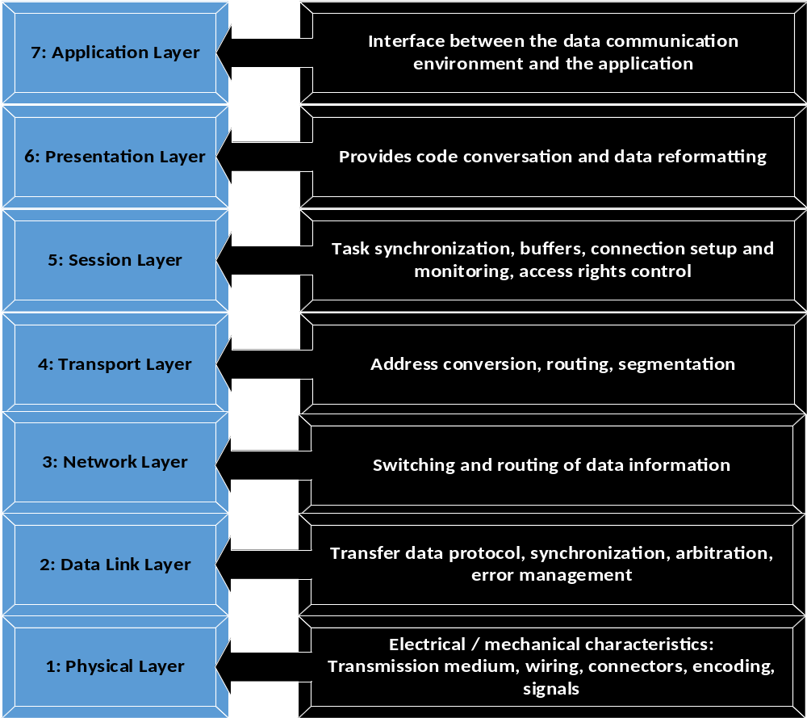

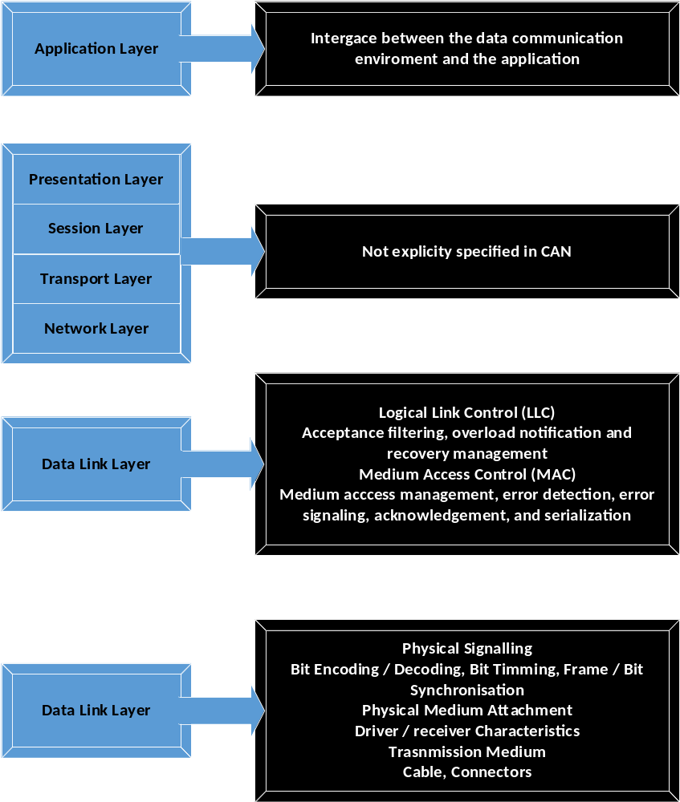

Requirements

Command Name | ID | Number of parameters | Name / Description  parameter | Range /  Resolution
Vel | 0x01 | 2 | ACTENG_LOW  ACTENG_HIGH | 0-655.35/ 0.01
Odo | 0x02 | 1 | INCREASE  ACKNOWLEDGE | 0.1 Km
Tnk | 0x03 | 2 | TNK Low part,  TNK High part | 0-500 / 0.1 L
Ind | 0x04 | 2 | DOOR  SEAT_BELT  GAS  HIGH_BEAMS  BRAKE | ON  OFF
.

AEP CAN database

Message | Transmitter | Receiver | ID | DLC | B0
Eng_RPM | ECM | ACU | 0x100 | 2 | RPM_MSB
Eng_Speed | ECM | SIM/AVT | 0x101 | 7 | DutyCycle_MSB
Eng_DTC | ECM | ID | 0x102 | 3 | DTC_HB
Veh_Speed | SIM/AVT | ID/ACU | 0x201 | 2 | ACTENG_MSB
Odometer | SIM/AVT | ID/ACU | 0x202 | 2 | Increase_ACK
Fuel_Tank | SIM/AVT | ID | 0x203 | 2 | TNK_MSB
Indication | BCM | ID/ACU | 0x204 | 5 | Door_Status
SeatBeltIndicator | ACU | ID | 0x601 | 7 | Driver_Indication
Chime_Request | ACU | ID | 0x602 | 6 | Sound_Tone
LIGHT_CTRL_MSG | SIM/AVT | BCM | 0x05A | 6 | LightCmd
Ignition_status | SIM/AVT | ID | 0x302 | 1 | Ign_Status
Control_Shift | SIM/AVT | ID | 0x307 | 1 | Gearbox_Status

B1 | B2 | B3 | B4 | B5
RPM_LSB | Engine_Active_Status
DutyCycle | DutyCycle_LSB | Period_MSB | Period_LSB | Current_MSB
DTC_MB | DTC_LB | DTC_Status
ACTENG_LSB
Odometer_Value
TNK_LSB | GAS_Status
High_Beams_Status | Brake_Status
Driver_Ind_Duty | Driver_Ind_Period | Passenger_Indication | Passenger_Ind_Duty | Passenger_Ind_Period
Sound_Cadence_  Period | Repetitions | Duty Cycle | SoundLocation_Driver | SoundLocation_  Passenger
LightCmdNParams | LightCmdParam0 | LightCmdParam1 | LightCmdParam2 | LightCmdChksum

B6 | B7 | SendType | Cycle
 |  | Periodic | 10 ms
Current_LSB |  | Event
 |  | Event
 |  | Periodic | 50 ms
 |  | Periodic | 100 ms
 |  | Periodic | 100 ms
 |  | Periodic | 100 ms
Driver_Auxiliary_Request |  | Periodic | 200ms
 |  | Periodic | 200ms
 |  | Periodic | 100 ms
 |  | Periodic | 100 ms
 |  | Periodic | 100 ms

Figure 11: Deployment Diagram (A)

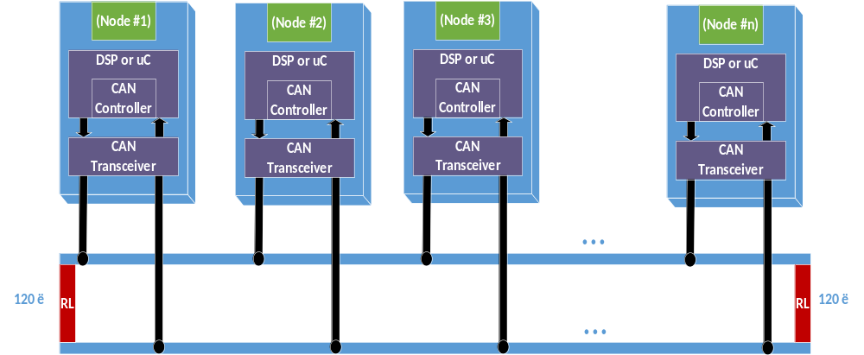

Use Case Diagram
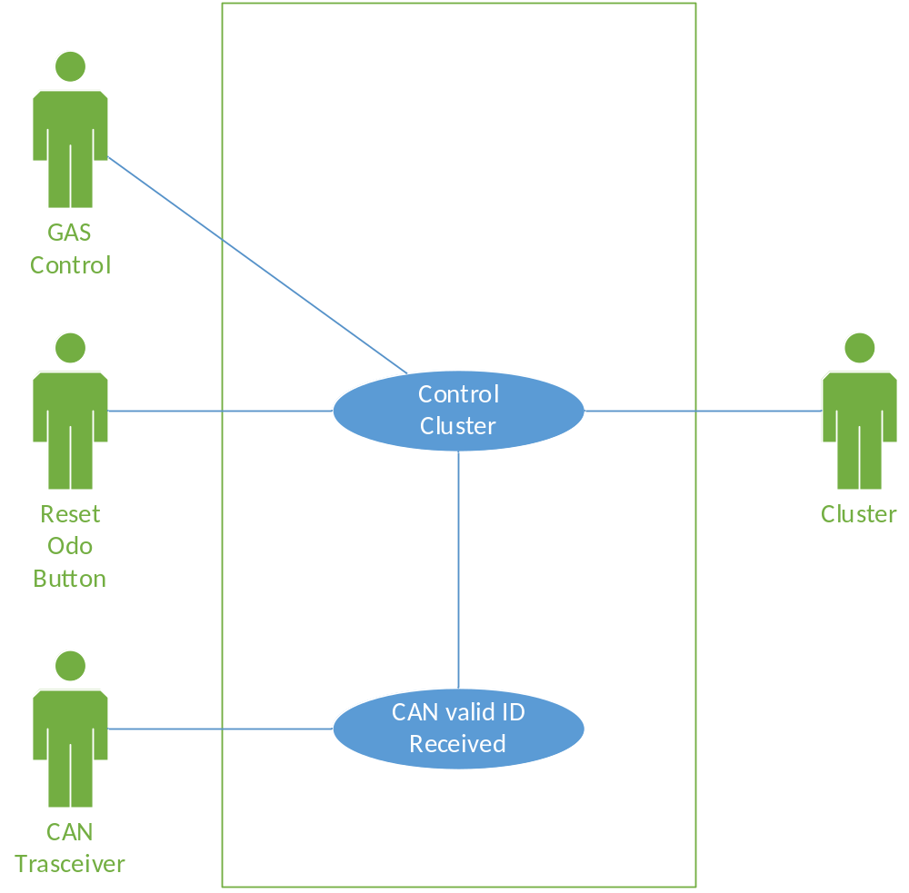

Component diagram request & response (A/D)

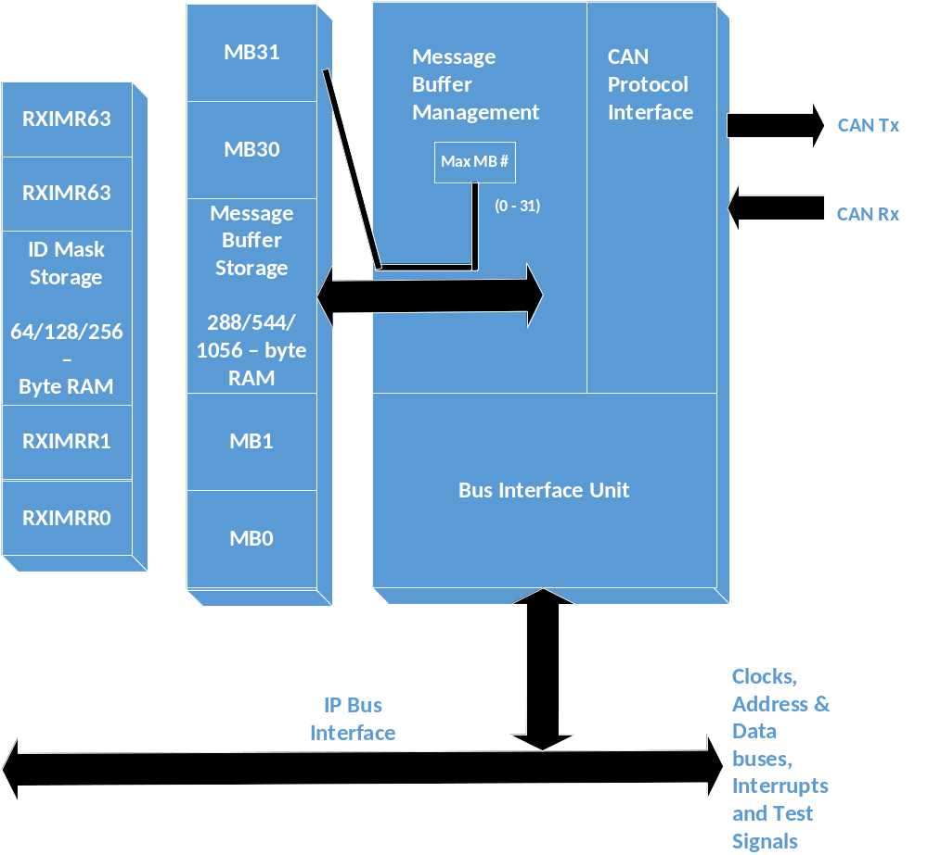

Layers Map

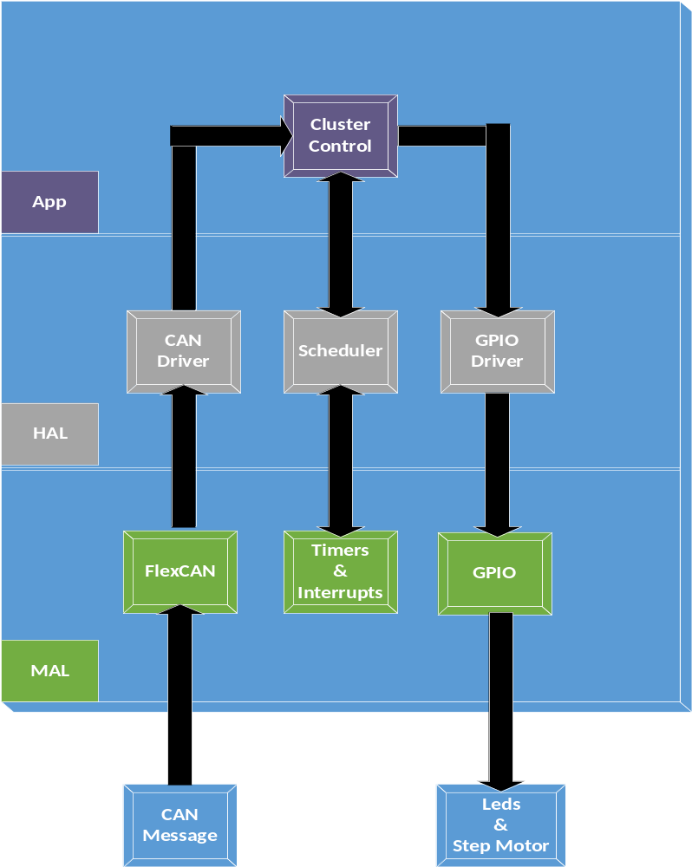

SEQUENCE

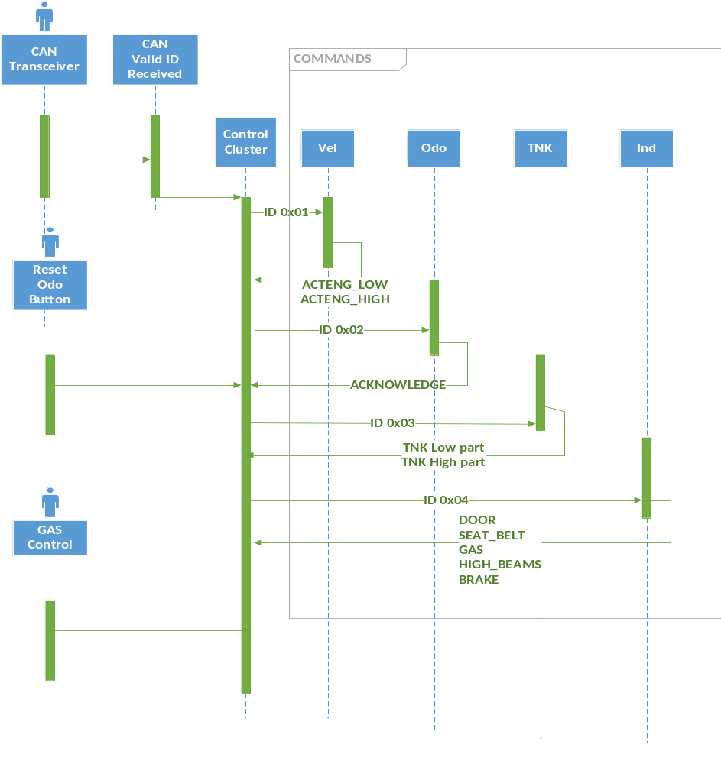

Response Sequence Diagram

State machine diagram

Lin manager

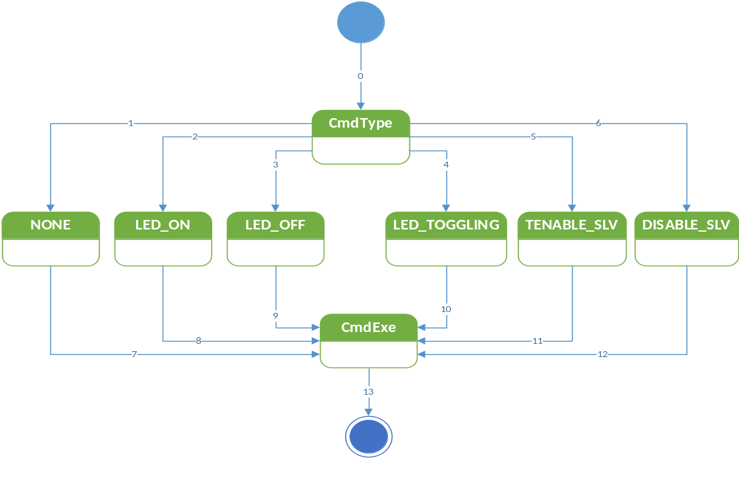

TRANSITION | CONDITION | ACTION
0 | Signal Msg == MASTER_CMD | Initialize CmdType
1 | t_cmdType==cmd_NONE | Initialize none.
2 | t_cmdType==cmd_LED_on | Initialize LED_ON
3 | t_cmdType==cmd_LED_off | Initialize LED_OFF
4 | t_cmdType==cmd_LED_toggling | Initialize LED_TOGGLING
5 | t_cmdType==cmd_enable_slv | Initialize ENABLE_SLV
6 | t_cmdType==cmd_disable_slv | Initialize DISABLE_SLV
7 | Command variable updated to None. | Go to CmdExe
8 | Command variable updated to LED on. | Go to CmdExe
9 | Command variable updated to LED off. | Go to CmdExe
10 | Command variable updated to LED toggling. | Go to CmdExe
11 | Command variable updated to Enable. | Go to CmdExe
12 | Command variable updated to Disable. | Go to CmdExe
13 | Cmd==executed. | Exit state machine.

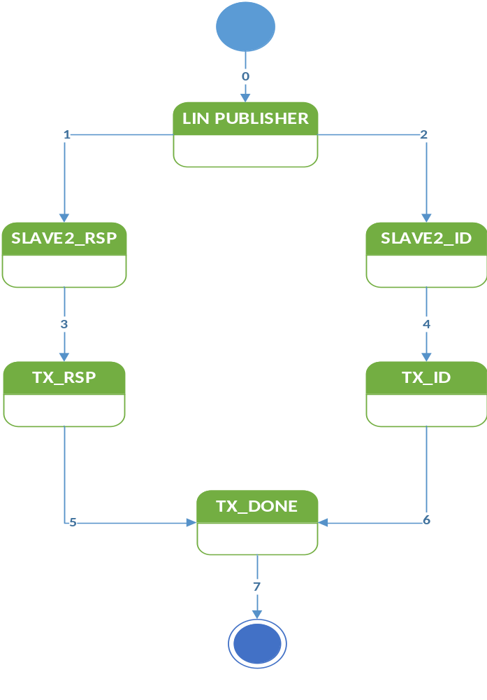

TRANSITION | CONDITION | ACTION
0 | (Signal Msg == SLAVE2_RSP)II(Signal Msg==SLAVE2_ID) | Initialize LIN Publisher.
1 | If Signal Msg == SLAVE2_RSP | Initialize SLAVE2_RSP.
2 | If Signal Msg == SLAVE2_ID | Initialize SLAVE2_ID.
3 | (ID field==valid)&&(Header==sent) | Initialize TX_RSP.
4 | (ID field==valid)&&(Header==sent) | Initialize TX_ID.
5 | Data TX_RSP==transmitted | Go to TX_Done.
6 | Data Tx_ID==transmitted | Go to TX_Done.
7 | Transmission completed. | Exit state machine.

LIN Handler

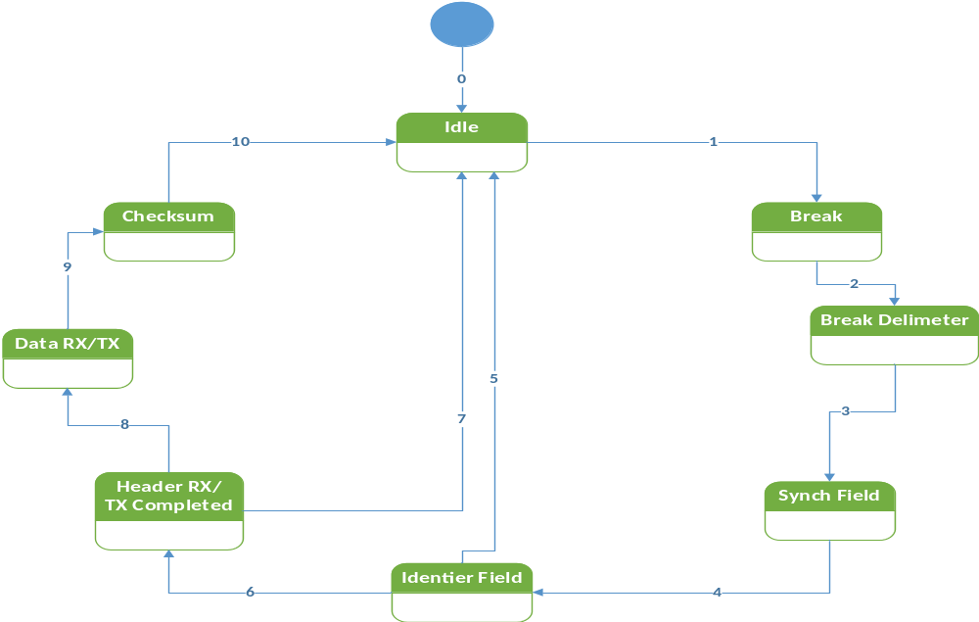

TRANSITION | ACTION
0 | Initialize Idle
1 | Go to break.
2 | Enter Break Delimiter.
3 | Enter Synch Field.
4 | Initialize Identifier Field.
5 | Return to Idle.
6 | Enter Header Rx/ Tx compl.
7 | Return to Idle.
8 | Go to Data Rx/Tx.
9 | Enter Checksum.
10 | Return to Idle.

Master node transmission handler

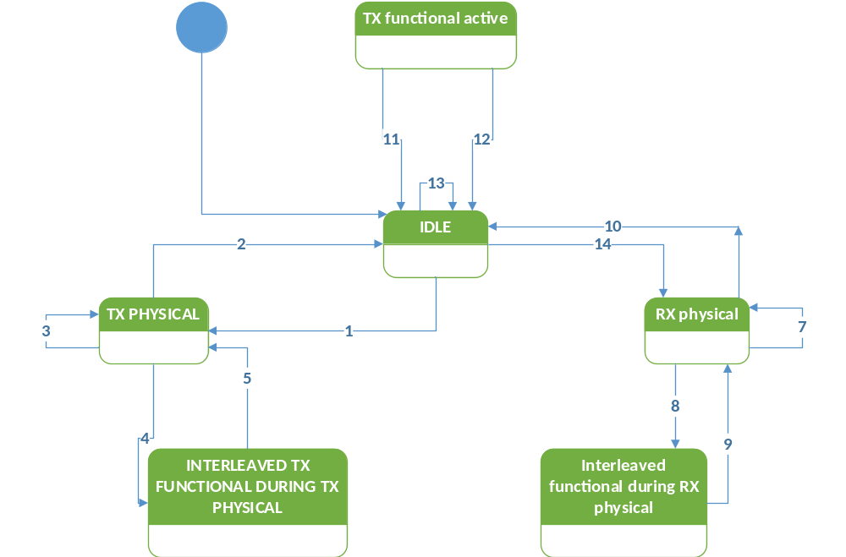

1.- IDLE STATE | Tx physical active state  Trigger:  Start of a physical transmission from the back-bone bus to a slave node.  Effect:  Start executing diagnostic master request frame schedule tables and handle the transport protocol.
2.- Tx physical active state | Idle state  Condition: routing of the physical transmission from the back-bone bus to the cluster has finshed or a transport protocol transmission error  Action: stop executing master request frame schedule tables.
3.- Tx physical active state | Tx physical active state  Condition: routing of the physical transmission from the back-bone bus to the slave node has not finished  Action: continue executing master request schedule table and handle transport protocol on LIN
4.- Tx physical active state | Interleaved functional during Tx physical state  Condition: functional addressed request from the back-bonebus has been received.  Action: interrupt the physical transmission to the slave node and execute a single master request frame schedule to transmit the functional addred request onto the cluster.
5.- interleaved functional during Tx physical state | Tx physical active state  Condition: functional addressed request has been routed onto the cluster.  Action: continue the interrupted physical transmission to the slave node.
6.- Tx physical active state | Rx physical active state  Condition: functional transmission to the slave node has been successfully completed (according to the transport layer specification).  Action: stop executing master request frame schedule tables, start executing slave response frame schedule tables and handle the incoming response from the previously addressed slave node.
7.- interleaved functional during Rx physical state | Rx physical active state  Condition: functional addressed request has been routed onto the cluster.  Action: restart executing slave response frame schedules and continue the interrupted reception from the slave node.

LED Handler

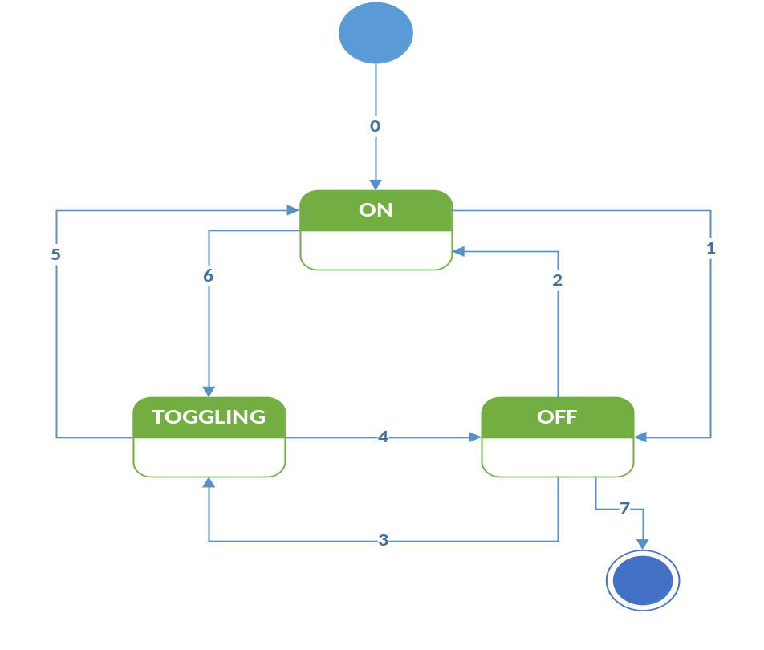

TRANSITION | CONDITION | ACTION
0 | Initialize MCU | Default state is ON
1 |  | Go to OFF
2 |  | Return to ON.
3 |  | Set to TOGGLING
4 |  | Go to OFF.
5 |  | Go to ON.
6 |  | Go to TOGGLING.
7 |  | Exit the state machine.

Application Program Interface Specification ver. 2.2a

CORE API
The LIN core API has a set of functions all based on the idea to give the API a separate name space, in order to minimize the RISK of conflicts with existing software. All functions and types will have the prefix “l_” (lowercase L followed by an undercore).

The LIN core shall define the following types:
- L_bool - 0 is false, and non- zero (>0) is true
- L_ioctl_op - implementation dependent
- L_irqmask - implementation dependent
- L_u8 - unsigned 8 bit integer
- L_u16 - unsigned 16 bit integer

Name | Prototype | Description
L_sys_init | L_bool l_sys_init (void); | Performs the initialization of the LIN core. The scope of the initialization is the physical node.  The call to the l_sys_init is the first call a user must use in the LIN core before using any other API function.  The function returns:  Zero if the initialization succeded  Non-zero if the initialization failed
Static Prototype |  | Dynamic Prototype
None |  | None

Name | Prototype | Description
Scalar signal read | None | Reads and returns the current value of the signal
Static Prototype |  | Dynamic Prototype
L_bool l_bool_rd_read (void);  L_u8 l_u8_rd_read (void);  L_u16 l_u16_rd_read (void); |  | L_bool l_bool_rd (l_signal_handle read);  L_u8 l_u8_rd (l_signal_handle read);  L_u16 l_u16_rd (l_signal_handle read);

Name | Prototype | Description
Scalar signal write | None | Sets the current value of the signal to v.
Static Prototype |  | Dynamic Prototype
Void l_nool_wr_write (l_bool v);  Void l_u8_wr_write (l_u8 v);  Void l_u16_wr_write (l_u16 v); |  | Void l_bool_wr (l_signal_handle write, l_bool v);  Void l_u8_wr (l_signal_handle write, l_u8 v);  Void l]_u16_wr (l_signal_handle write, l_u16 v);

Name | Prototype | Description
Byte array read | none | Reads and returns the current values of the selected bytes in the signal.  The sum of start and count shall never be greater than the length of the byte array.
Static Prototype |  | Dynamic Prototype
Void l_bytes_rd_data_read (l_u8 start,  L_u8 count,  L_u8* const data); |  | Void l_bytes_rd (l_signal_handle data_read,  L_u8 start, /*first byte to read from*/  L_u8 count, /*number of bytes to read*/  L_u16 const data); /*where data will be written*/

Name | Prototype | Description
Byte array write | none | Sets the current value of the selected bytes in the signal specified by the name write data to the value specified.
Static Prototype |  | Dynamic Prototype
Void l_bytes_wr_write_data (l_u8 start,  L_u8 count,  Const l_u8* const data); |  | Void l_bytes_wr (l_signal_handle write_data,  L_u8 start,  L_u8 count,  Const l_u8* const data);

Name | Prototype | Description
L_flg_tst | none | Returns a C boolean indicaing the current state of the flag specifified by the name flag_state, returns zero if the flag is cleared, non-zero otherwise
Static Prototype |  | Dynamic Prototype
L_bool l_flg_tst_flag_state (void); |  | L_bool l_flg_tst (l_flag_handle flag_state);

Name | Prototype | Description
L_flg_clr | none | Sets the current value of the flag specified by the name clear_flag to zero
Static Prototype |  | Dynamic Prototype
Void l_flg_clr_clear_flag (void); |  | Void l_flg_clr (l_flag_handle clear_flag);

Name | Prototype | Description
L_flg_tick | none | The l_sch_tick function follows a schedule. When a frame becomes due, its transmission is initiated. When the end of the current schedule is reached, l_sch_tick starts again at the beginning of the schedule.
Static Prototype |  | Dynamic Prototype
L_u8 l_sch_tick_tickflg |  | L_u8 l_sch_tick (l_ifc_handle tickflg);

Name | Prototype | Description
L_sch_set | none | Sets up the next schedule to be followed by the l_sch_tick function for a certain interface tickflg. The new schedule will be activated as soon as the current schedule reaches its next schedule entry point.
Static Prototype |  | Dynamic Prototype
Void l_sch_set_tickflg (l_schedule_handle schedule, l_u8 entry); |  | Void l_sch_set (l_ifc_handle tickflg,  L_schedule_handle schedule,  L_u8 entry);

Name | Prototype | Description
L_ifc_goto_sleep | none | This call request slave nodes on the cluster connected to the interface to enter bus sleep mode by issuing one go to sleep command,.  The go to sleep command will be scheduled latest when the next schedule entry is due.
Static Prototype |  | Dynamic Prototype
Void l_ifc_goto_sleep (l_ifc_handle gsleep); |  | Void l_ifc_goto_sleep_gsleep (void);

Name | Prototype | Description
L_ifc_wake_up | none | The function will transmit one wake up signal. The wake up signal will be transmitted directly when this function is called. It is the responsibility of the application to retransmit the wake up signal according to the wake up sequence defined
Static Prototype |  | Dynamic Prototype
Void l_ifc_wake_up_wup (void); |  | Void l_ifc_wake_up (l_ifc_handle wup);

