1. Download [EV3Files.zip](https://docs.google.com/file/d/0BywTvTErJT3hRmdqVFFvNnVmbWM/edit?usp=sharing)
2. Install CSLITE (run CSLITE.exe):
   1. 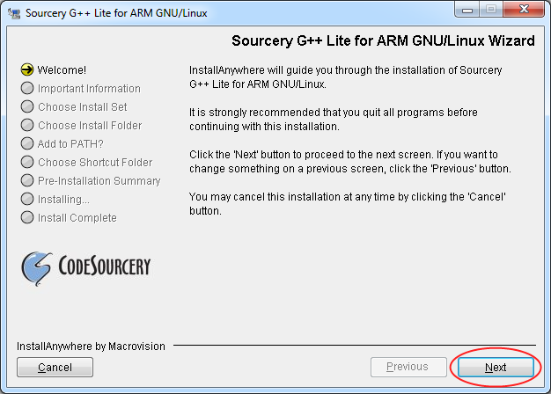
   2. 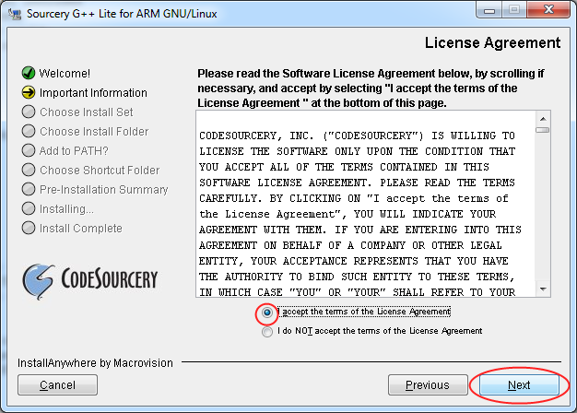
   3. 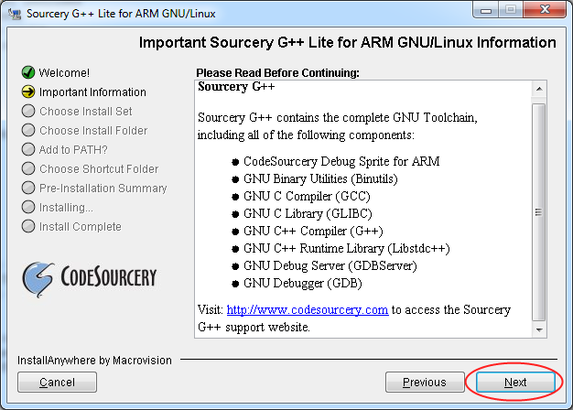
   4. 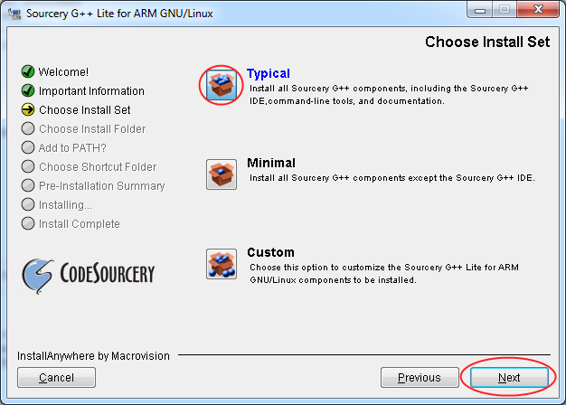
   5. 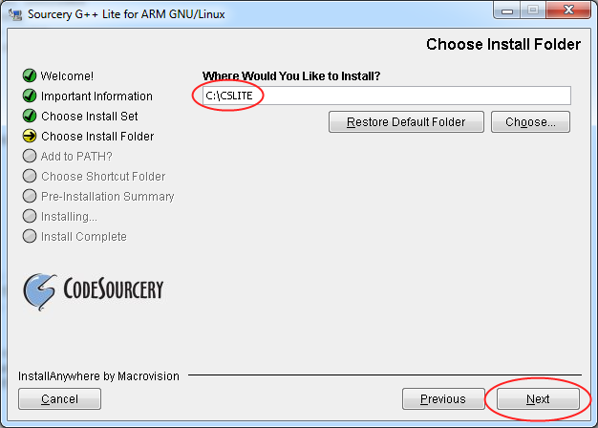
   6. 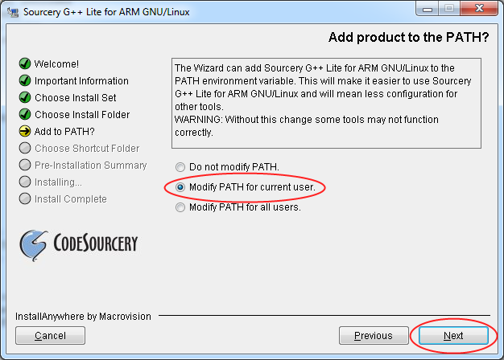
   7. 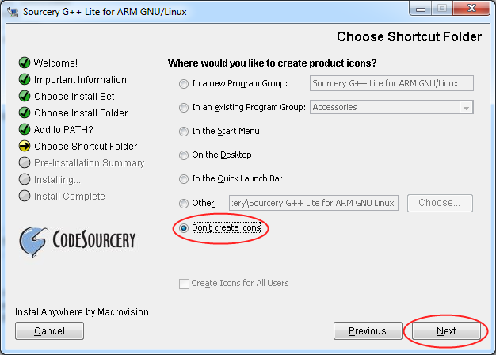
   8. 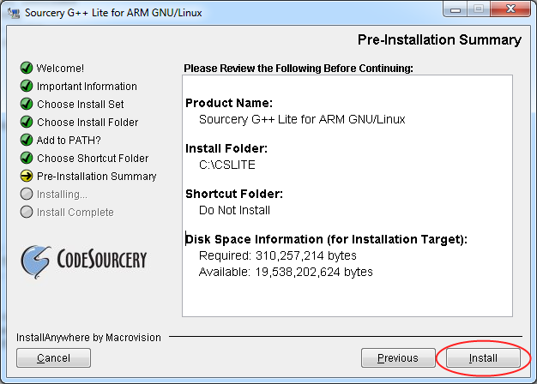
   9. Installation shall proceed, wait until it is complete.
   10. 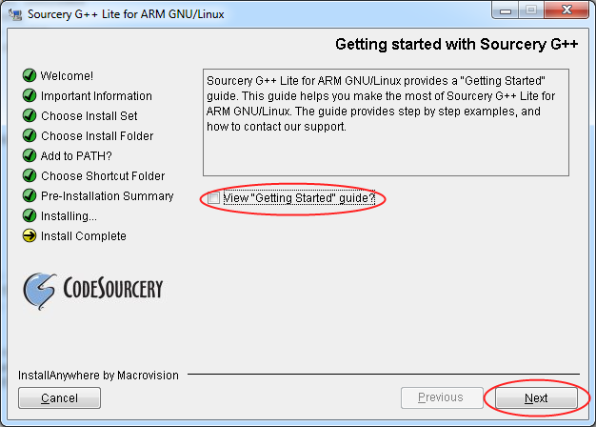
   11. 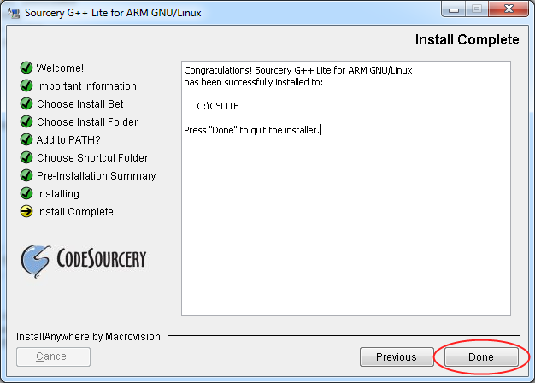

2. Copy files make.exe and rm.exe to C:\CSLITE\bin\

3.Install BricxCC (run BricxCC.exe. you can use Alt-Tab to go between windows)

1. 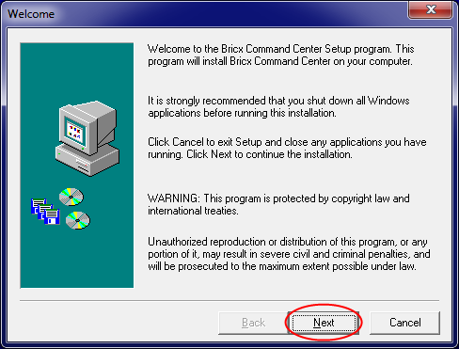
2. 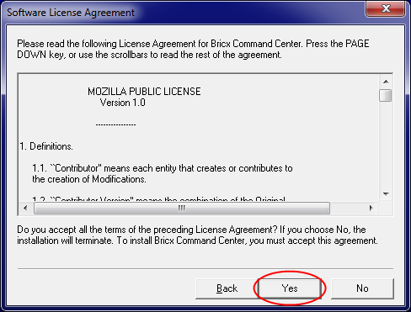
3. 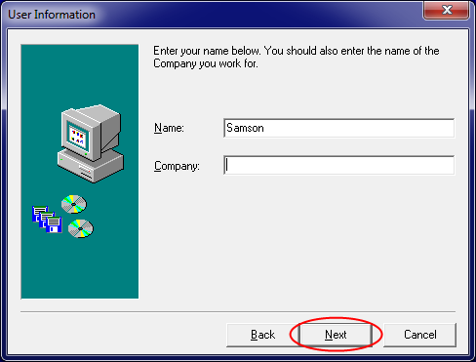
   1. 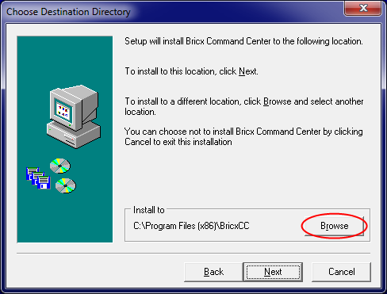
   2. 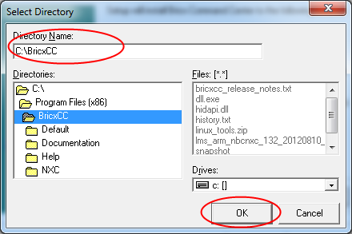
   3. 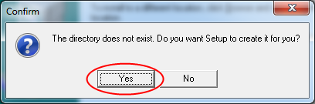
   4. 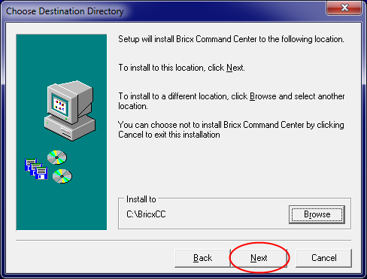
4. 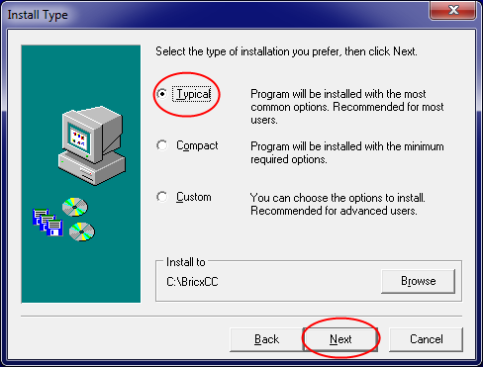
5. 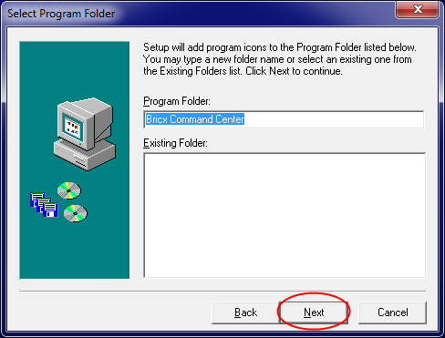
6. 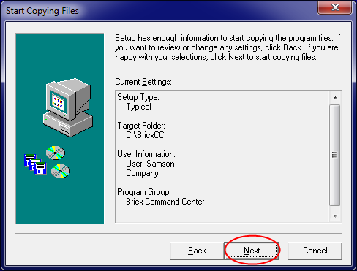
7. Wait for install to complete. When it is finished, the window will automatically close.

4. Update BricxCC:

1. Open BricxCCUpdate Folder
2. Select everything, then right-click and choose ‘copy’
3. Open C:\BricxCC
4. Right-Click and choose ‘paste’
5. For folder conflicts: Select Yes (Merge) and select ‘Do this for all items’
6. For file conflicts: Select ‘Copy and Replace’ and select ‘do this for all items’
7. Attach EV3 Brick to computer and turn on. Wait until EV3 Brick shows main menu.

6. Launch Bricx Command Center. Choose following options on startup:

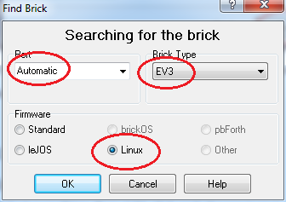

7. Update EV3 firmware to latest version

1. **MAKE SURE BRICK IS PLUGGED IN AND CHARGING!**
2. Select Tools -> Download Firmware.
3. Navigate to where you unzipped EV3Files.zip and select EV3 Firmware V1.03H.bin (downloading firmware takes a while! )
4. ***IMPORTANT***: If the downloading firmware bar disappears, **RESTART THE FIRMWARE DOWNLOAD IMMEDIATELY.**
5. When complete, EV3 Brick will restart. On the screen, navigate to the Wrench on the far-right and choose Brick Info. It should look like this (ID will vary brick to brick):
   1. 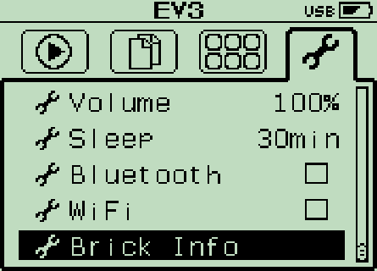
   2. 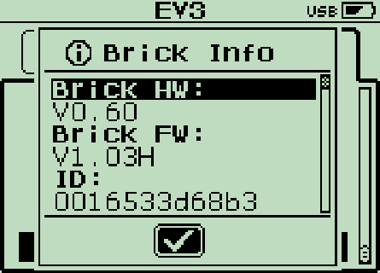

8. Test that everything went well:

1. In BricxCC, choose File->Open…
2. Navigate to where you unzipped EV3Files.zip
3. Select the file Test.c
4. Select View-> Project Manager
5. In the white box that appears, right click and choose add…
6. Navigate to where you unzipped EV3Files.zip and open the folder lmsapi.
7. Select the files named ev3_lcd.c, ev3_timer.c, and ev3_command.c
8. Your window should look like this:
   1. 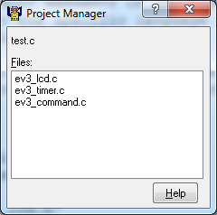
9. Select Compile->Compile.
   1. If you get an error, press F12 to see the compiler output window.
   2. Common errors and solutions:
      1. “make: *** No rule to make target `ev3_lcd.o', needed by `all'. Stop.”

See Step 9

1. Select Compile->Download and Run. If there are no errors, the EV3 screen should display:
   1. 