Vision and Scope Document

for

DuoLegend Project

**Version 1.0 approved**

**Prepared by Group 1**

**SWR 302 - SU21**

**May 21, 2021**

**Table of Contents**

Table of Contents ii

Revision History ii

1. Business Requirements 1

1.1. Background 1

1.2. Business Opportunity 1

1.3. Business Objectives 1

1.4. Success Metrics 1

1.5. Vision Statement 1

1.6. Business Risks 1

1.7. Business Assumptions and Dependencies 2

2. Scope and Limitations 2

2.1. Major Features 2

2.2. Scope of Initial Release 2

2.3. Scope of Subsequent Releases 2

2.4. Limitations and Exclusions 2

3. Business Context 2

3.1. Stakeholder Profiles 2

3.2. Project Priorities 3

3.3. Deployment Considerations 4

**Revision History**

|  |  |  |  |
| --- | --- | --- | --- |
| **Name** | **Date** | **Reason For Changes** | **Version** |
| Group 1 | 21/5/2021 | initial draft | 1.0 |
| Group 1 | 23-5-2021 | approved | 1.0 approved |

# Business Requirements

## Background

After hours of work, people need to have time to unwind. One of the most popular activities is playing games, especially League of Legends (This game has over 115 million monthly players and According to statistics released by Riot Games, the average League of Legends player spends 832 hours on the game). However, playing League of Legends may bring more stress due to the toxicity of the teammate who is auto-matched by the system. The toxic behavior can be (verbal abuse-harassment and offensive language, hate speech-including: racism, sexism, homophobia,...). 72% of people claim that they have experimented with one or more of the following behavior.

## Business Opportunity

Many players are playing alone and have to use the automatic finding match system in the game to find teammates. This system has many disadvantages so many of them have a desire to have a website for them to find suitable partners to play with. Finding partners through this website can help them avoid playing with toxic players and suffering stress. There are some existing websites with the same function but they do not support users to chat with each other through the website before deciding to play and users using these websites can not determine whether other users can use voice chatting when playing.

## Business Objectives

BO-1: Reduce the time of finding a match by 20%.

If a user found 1 other player to collaborate with, the time of finding a match would be reduced by 20%.

If a user found 2 other players to collaborate with, the time of finding a match would be reduced by 30%.

If a user found 3 other players to collaborate with, the time of finding a match would be reduced by 40%.

If a user found 3 other players to collaborate with, the time of finding a match would be reduced by 50%.

BO-2: Increase winning rate by 5%.

BO-3: Reduce chance to unexpectedly play with toxic players by 70%.

## Success Metrics

SM-1: After 6 months of release, the website will have 500 accessors per week.

SM-2: 10% of user success in finding their teammate.

## Vision Statement

For players who want to find partners from League of Legend to play, the DuoLegend is a web application that helps to look for and connect players from all over the world. Unlike some connecting websites (duo.lol….), DuoLegend provides a way to communicate with other players by chatting, rating features.

## Business Risks

RI-1: Too few users might use the website, resulting in the lack of revenue for the cost of system development and marketing fee.

RI-2: Many users might use other player’s in-game which would make other users feel confused and inconvenient.

RI-3: Chat feature might become a play for bad users to send spam and unsafe messages.

## Business Assumptions and Dependencies

AS-1: With our website, LOL players will be able to find duo partners based on their need.

AS-2: LOL players will have a great time playing together thanks to our DuoLegend.

DE-1: Our website depends on Riot API in order to get information from LOL clients.

# Scope and Limitations

## Major Features

FE-1: Create, login, update, verify user account.

FE-2: Displaying a list of users for other users to see.

FE-3: Search player by play style.

FE-4: Rating and following system for users.

FE-5: Chat system.

FE-6: Site moderation capabilities for administrator.

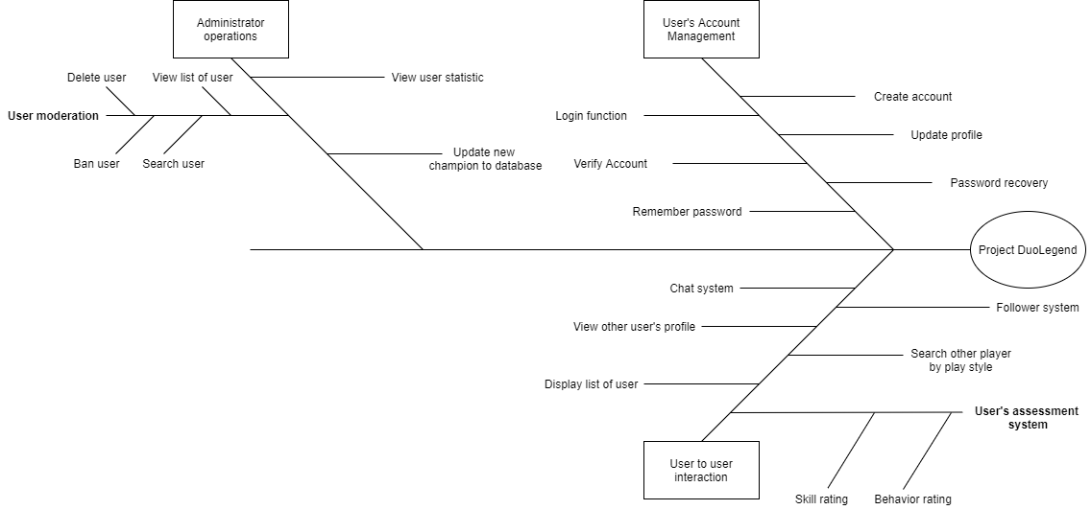

## Scope of Initial Release

|  |  |
| --- | --- |
| Feature | Release 1 |
| FE-1: Create, login, update, verify user account | Create, login, update profile will be implemented |
| FE-2: Displaying a list of users for other users to see | Not implemented |
| FE-3: Search player by play style | Not implemented |
| FE-4: Rating and following system for user | Not implemented |
| FE-5: Chat system | Not implemented |
| FE-6: Site moderation capabilities for administrator | Not implemented |

## Scope of Subsequent Releases MINH HỒ

|  |  |  |
| --- | --- | --- |
| **Feature** | **Release 2** | **Release 3** |
| FE-1: Create, login, update, verify user account |  | Login using Facebook account |
| FE-2: Displaying a list of users for other users to see | Display random list of user | Display list of user sort by rank |
| FE-3: Search player by play style | Let user choose their playstyle |  |
| FE-4: Rating and following system for user | Rating user’s skill | Rating user’s behaviour |
| FE-5: Chat system | Send messages between users |  |
| FE-6: Site moderation capabilities for administrator | User account’s management |  |

## Limitations and Exclusions

LI-1: Server SEA is not allowed to get ingame information from LOL client.

LI-2: Sometime the website can be procrastinated due to the instability of the third-party API server.

# Business Context

## Stakeholder Profiles

|  |  |  |  |  |
| --- | --- | --- | --- | --- |
| ***Stakeholder*** | ***Major Value*** | ***Attitudes*** | ***Major Interests*** | ***Constraints*** |
| *LOL players (users)* | *Higher player satisfaction when experiencing LOL games.* | *Desire to find suitable partner in games/* | *Have a great time with a duo partner.* | *Gamer playing League of Legend.* |
| *Developer* | *Attaining intermediate C#, .Net, and web programing experiences* | *Want to provide a way to connect LOL players, building a friendly gaming community.* | *Building a complete website based on user feedback.* | *Lack of experience* |
| *Riot* | *Provide API to get information from players.* | *None identified* | *None identified* | *Inability to provide API of SEA server.* |
| *Instructor* | *No benefit.* | *Strong enthusiasm, has high expectation for the project* | *The success of the project* | *None identified* |

## Project Priorities

|  |  |  |  |
| --- | --- | --- | --- |
| ***Dimension*** | ***Driver (state objective)*** | ***Constraint (state limits)*** | ***Degree of Freedom (state allowable range)*** |
| *Schedule* | *release 1.0 to be available by 10/1, release 1.1 by 12/1*  release 1.0 to be available by 18/07. |  |  |
| *Features* |  |  | *70-80% of high priority features must be included in release 1.0.* |
| *Quality* | 90-95% of user acceptance tests must pass for release 1.0, |  |  |
| *Staff* | maximum team size is 1 PM 1BA, 2 developer,1 tester. |  |  |
| *Cost* |  |  | *budget overrun up to 15% acceptable without sponsor review.* |

## Deployment Considerations

There are many web servers that can be used to deploy this product but for the cross-platform purpose, we should use Apache for our web server. According to the documentation of Microsoft, the product should be deployed to a folder on the hosting server and setting up a process manager to automatically start and restart the app when a request arrives or after it crashes.