Hey David!
I’m currently an LMFT-S and accepting supervision inquiries. For Phase 1 of the website (now through August), the site should be supervision-first because I’m still in my full-time role, and supervision is my primary offering during this window.
After I resign in August and transition into my private practice launch plan, I’ll update the website to balance visibility across the three services (Supervision, Therapy, Consulting) rather than primarily featuring supervision.
Summary:
- Now (Phase 1): Supervision is the main call to action and primary funnel on the Home page.
- Later (post-August): We’ll revise the Home page and navigation so supervision, therapy, and consulting are presented more evenly
Below are images of what I have so far, and I’m open to suggestions on how to improve the website’s appearance and layout. Let me know if you think anything needs adjusting or looks off. Thank you very much for offering your time, talent, and skills to help me complete this!

Website: (Integrated Relational Dynamics, PLLC). The key point: the top navigation items Services / About / Contact should function as scroll-to-section anchors on the Home page, while the service items within the Services section should link to their individual pages (I still need to add text to some sections).
PHASE 1 PRIORITY (now → August)
- Site is supervision-first until I resign from my full-time job in August.
- Keep the tone “quiet authority” (clean, structured, minimal, no hype).
- Email inquiries only for now (no phone number).
HOME PAGE TOP NAV (scroll anchors)
Please set these as in-page scroll links (not separate pages):
- Services → scroll to the Home page “Services” section (Section 4)
- About → scroll to the Home page “About” section (create/position as needed)
- Contact → scroll to the Home page “Contact / Boundaries & Logistics” section (footer area)
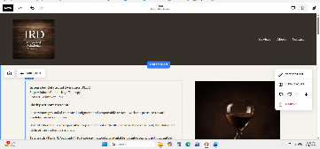
- Nav links should point to: /#services, /#about, /#contact
HOME PAGE — REQUIRED Call-To-Action ROUTING
I want Supervision to be the primary conversion path. Please include a Supervision CTA button in three sections::
- Section 1 (Main): Button → /supervision (image above for
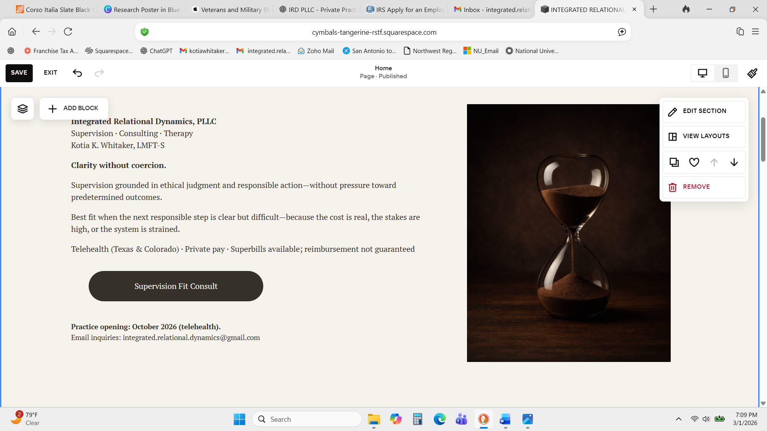
- Section 2 (no links) –“What This Helps With”
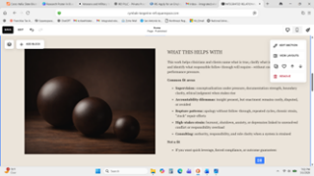
- Section 3 (Start Here: Supervision Fit Consult): Button → /supervision
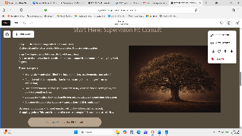

- Section 4 (Services): Button → /supervision
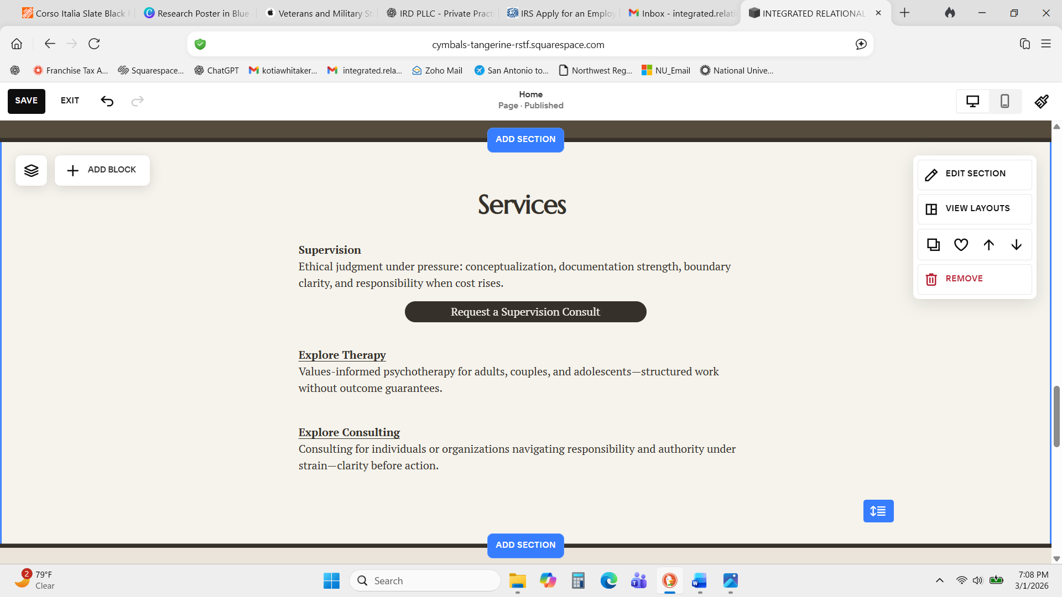
SERVICES SECTION (Section 4) — LINKS TO INDIVIDUAL PAGES
Within the Services section, please include these as clickable links:
- Supervision → /supervision (primary; can also be a button)
- Explore Therapy → /therapy
- Explore Consulting → /consulting
PAGES TO CREATE (separate pages)
These should be separate pages (not anchors):
- /supervision (primary service page; includes CTA to contact/email)
- /therapy
- /consulting
- /resources (optional to link in footer)
- /contact page is NOT needed for Phase 1 if the Contact nav item scrolls to the footer section, but we can create /contact later if needed.
EMAIL LINKS (inquiries)
Please make my email clickable everywhere it appears:
- integrated.relational.dynamics@gmail.com (mailto link)
Section 5 (no links/button required)
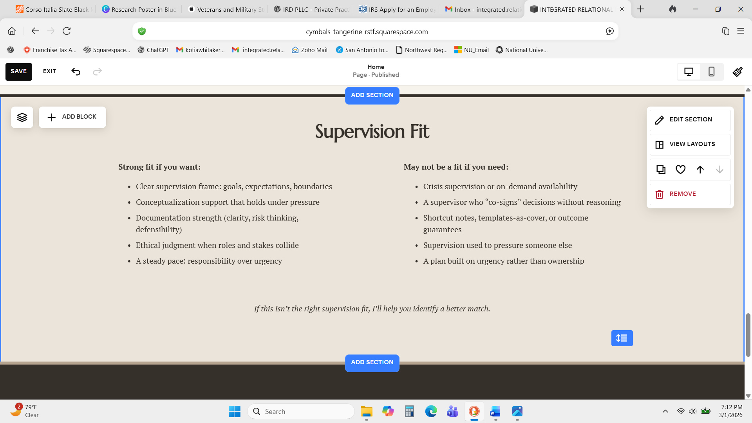
Section 6 (Boundaries and Logistics
- Needs footer utility links (as available): Policies · Fees · Resources · Contact (I can send the resources to post- 2 diagrams/ tables)

I still need to add text to these sections
1) Button: Request a Supervision Fit Consult
Goal: convert supervision leads with clarity + boundaries.
Page sections:
- Header (repeat identity)
- Integrated Relational Dynamics, PLLC · Kotia K. Whitaker, LMFT-S
- “Supervision Fit Consult”
- What this is
- 2–3 lines: structured fit + frame-setting; not supervision; no case consultation.
- What we’ll cover
- 5 bullets (tight): goals/setting, conceptualization habits, documentation strength, boundaries/ethics under pressure, cadence/expectations.
- What to bring (simple checklist)
- Setting + population
- License status / requirements (if applicable)
- 1–2 short examples of the kinds of cases/situations you want help conceptualizing (no identifiers)
- Documentation questions you’re stuck on
- Boundary/ethics scenarios you want to think through
- Logistics
- Duration (45–60 min) + telehealth
- Private pay (price if you’re ready; if not, “fee provided by email”)
- Email-only inquiries
- Cancellation/reschedule boundary (simple)
- Stopping points / not a fit
- Crisis coverage not provided
- No outcome guarantees
- No supervision used as leverage
- “If not a fit, I’ll help you find a better match.”
- CTA block
- Big heading: “Request a Supervision Fit Consult”
- Embedded Squarespace form OR mailto link
  - Name
  - Email
  - State
  - Current role (associate/intern/fully licensed)
  - What you want from supervision (short)
  - Any documentation/boundary focus (short)

2) Link: Explore Supervision???
Goal: inform + qualify (the “why you” page).
Page sections:
- Supervision focus statement (1 paragraph)
- Core emphasis bullets (conceptualization, documentation, boundaries, ethics under pressure)
- How supervision works (cadence, what sessions look like, expectations)
- Documentation & defensibility (what notes must do; no templates-as-cover posture)
- Fit / Not fit (short)
- CTA: button to Request a Supervision Fit Consult
Therapy
At Integrated Relational Dynamics, therapy is clarity without coercion—structured, steady work that supports responsible action without pressure toward predetermined outcomes. Insight is treated as meaningful yet insufficient on its own. The aim is not quick relief or forced resolution, but durable clarity that can be carried into real-life follow-through.

Who this is for
This practice serves adults, couples, and adolescents navigating relational strain, high-stakes decisions, and the pressure of responsibility. Telehealth-only.

Common fit areas
- Repeated conflict cycles, shutdown, or repair that doesn’t hold
- Decision points where every option carries real cost
- Boundary confusion, role strain, or responsibility overload
- Anxiety, depression, burnout, or numbness linked to unresolved conflict
- Dating/premarital discernment: expectations, authority, and commitment clarity
- Family-of-origin patterns that meaningfully shape present-day dynamics (context, not excuse)

How therapy works here
Therapy is paced for clarity and ethical containment. Sessions emphasize:
- Naming what is true (without performance or persuasion)
- Clarifying what is yours to carry—and what is not
- Identifying the next responsible step when cost rises
- Building follow-through that is voluntary and sustainable
- Holding boundaries that protect dignity, safety, and agency
This work does not rush reconciliation or certainty, and it does not use therapy as leverage in relational conflict.

Rates, payment, and superbills
Sessions are provided via secure telehealth and are offered on a private-pay basis. Superbills are available upon request; reimbursement is determined by your insurer and is not guaranteed.

Request a brief screening (email)
If you’d like to explore fit, send an email with:
- Your state (Texas or Colorado, if applicable)
- Whether you’re seeking individual, couple, or adolescent services
- A brief description of what you want help clarifying (no PHI details)
- Your general availability
Email: integrated.relational.dynamics@gmail.com
[Button] Request a Brief Screening

CONSULTING

What consulting is
Consulting at Integrated Relational Dynamics is clarity before action for individuals, leaders, and organizations navigating authority, role strain, and responsibility under cost. The focus is helping you name what is true, clarify what is yours to carry, and identify the next responsible step—without coercion, performance pressure, or outcome guarantees.

Common scenarios
- Role confusion or blurred authority (who decides, who owns what, who is accountable)
- Decision bottlenecks when every option carries loss or tradeoffs
- Conflict escalation, misalignment, or chronic tension inside a team/system
- Accountability breakdowns (repeated promises, stalled follow-through, symbolic responsibility)
- Boundary problems that create instability (overreach, avoidance, or unmanaged exposure)
- Transitions that strain responsibility (growth, restructure, leadership change, crisis aftermath)

Engagement options
- Single Consulting Consult (60–90 minutes): clarify the situation, map constraints, identify the next responsible step
- Short Series (3–6 sessions): sustained clarity work for complex/unclear dynamics, role strain, or decision pressure
- Documentation / deliverables (optional): brief written summary of decisions, boundaries, roles, and next steps (available upon request)

Boundaries
- Consulting is not psychotherapy and is not crisis response.
- Consulting is not legal advice, clinical supervision, or HR adjudication.
- Work is structured for clarity and responsibility—no outcome guarantees and no use of consulting as leverage over others.

Request a consulting inquiry
If you’d like to explore fit, send an email including:
- Your state and your role (individual / leader / organization)
- The situation in 4–6 sentences (no sensitive details)
- What decision or responsibility question you need clarity on
- Timeline and general availability
Email: integrated.relational.dynamics@gmail.com
[Button] Request a Consulting Inquiry

5) Footer links
Policies
- Communication boundaries (email response window)
- Crisis/emergency disclaimer
- Telehealth boundaries
- Cancellation/reschedule
- Confidentiality basics (minimal; don’t over-legalize)
Fees
- Supervision fit consult fee + ongoing supervision fee (or “provided upon inquiry”)
- Payment method
- Superbills language (if therapy)
- No insurance / reimbursement not guaranteed
Contact
- Simple form + email
- What to include in inquiry (state, service requested, availability)
- “No PHI via email” line
Resources
- “Doctoral research overview” (short paragraph)
- “Working manuscripts (unpublished drafts available on request)”
- “Tools” page links (Accountability Map / Repair-Labor Audit / Refusal Viability Check) with guardrails

