Development of Grid Corrections to Mixing Parameterizations with Application to Arctic Climate Change

Richard T. McNider,ª Arastoo Pour-Biazar,^{a,}
ª Earth Systems Science Center, University of Alabama in Huntsville, Huntsville, Alabama

Corresponding author: Richard T. McNider, mcnider@nsstc.uah.edu

Submitted to Journal of Applied Meteorology and Climate

ABSTRACT
The response of the Earth’s climate system to GHG forcing has been largest in the Arctic, both in observations and models. However, in multi-model evaluations (CMIP3 through CMIP6), most models continue to underestimate the amount of warming. Here, we examine the role of parameterizations of the stable boundary layer (SBL) in impacting the magnitude of warming and the spread in model responses. Turbulent parameterization of the SBL has long been a challenge in models. Forms used in high-resolution research boundary layer models often do not work well in coarser grid operational or climate models. GCM resolution often deteriorates to a few layers in the SBL and 500m or more in deeper stable layers (SL). This resolution may not capture well the correct strength/depth of the Arctic inversion, the entrainment warming as the SBL is destabilized by GHG forcing, or the correct energy budgets. It seems likely that the large spread in GCM Arctic simulations is in part due to the differences and misapplications of these grid-dependent parametrizations. In this investigation, we plan a new approach to the SBL parameterization problem by explicitly incorporating grid resolution in the parameterization. This will be carried out by analytically and numerically recovering a stability correction function dependent on grid spacing. Initial tests of an analytically recovered correction function indicate that the correction function provides longer-tailed stability functions for coarse grid models. Applying this correction to a simplified Arctic profile made coarser grid models agree better with fine-scale results.

- Introduction
Here we provide background on Arctic warming and how it is related to turbulence parameterizations, which are problematic in coarse vertical grid climate models. We also present a preliminary analysis of a path to make stable boundary layer (SBL) and deeper stable layer (SL) modeling less dependent on grid spacing. Our analytical approach utilizes the discretized form for stability functions, which is how they are used in the model. This shows that the stability functions can be a direct function of grid spacing. We focus on the possible roles the SBL and SL might have in climate simulations of the high-latitude environment because vertical grid spacing in global climate models (GCMs) is large.
Background is provided on previous studies of Arctic warming on how mixing processes are important to energy budgets in climate change scenarios. These imply that finding solutions to mixing in the SL in coarse resolution models is critical to understanding climate change at high latitudes.
A prime tenet of climate change theory is that warming in the Arctic will be much larger than over the rest of the globe – this is referred to as Arctic Amplification (AA). This has been verified both in observations and models testing the response of the climate system to GHG forcing (Boe et al. 2009; Swanson 2013, Davy and Outten, 2020). However, in model evaluations (CMIP3 through CMIP5), most models continue to underestimate the amount of warming (Swanson 2013) compared to observations. CMIP6 models appear to have similar issues (Davy and Outten, 2020). Moreover, model inter-comparisons show the greatest spread in performance and warming occurs in the high latitudes of the Arctic and Antarctic. Warming in the Arctic is complex, involving albedo feedback, sea ice modeling, heat transport aloft from lower latitudes, and cloudiness (Pithan et al. 2016). Here, we examine the role of boundary layer parameterizations of the SBL in impacting the amount of warming and the spread in model response.
In terms of energy budgets, we explicitly acknowledge, a perhaps under-appreciated positive climate feedback process, the redistribution of heat to the surface as the boundary layer destabilizes from enhanced downward IR from greenhouse gases (GHG) (see McNider et al. 2012, Walters et al. 2007). As discussed in mid-latitude studies, the amount of this positive feedback depends on the particular SBL parameterization employed and the strength of the surface inversion.
Turbulent parameterization of the SBL has long been a challenge in the boundary layer community (Mahrt 1996; Steeneveld et al. 2006; Esau and Byrkjedal 2007; Mahrt 1999). Modeling the SBL is further complicated by the fact that parameterizations employed in weather and climate models can provide different results for different model vertical grid resolutions (Esau and Byrkjedal 2007; Byrkjedal et al. 2008; Tjernström et al. 2005). Vignon et al. (2017) discussed the need to increase resolution in examining the SBL in the Antarctic. For the Arctic specifically, Byrkjedal et al. (2008) noted that model performance deteriorated with coarser model resolution (see also Cassano, 2001; Zilitinkevich and Esau, 2003). Thus, SBL parameterizations that appear to work in high-resolution research models may not work in coarser resolution operational forecast models or climate models (Viterbo, 1999; Esau and Byrkjedal 2007; Savijarvi, 2009; Beljaars et al., 2012; Vignon et al 2017). More recently, Davy and Outten (2020) and Audouin et al (2021) also mentioned model physics and resolution as an issue in model performance.
In this investigation, we approach the SBL parameterization problem by attempting to explicitly incorporate grid resolution in the parameterization. This will be carried out by analytically defining a stability correction function dependent on grid spacing. While such an approach may be useful in modeling the SBL for other purposes (e.g. weather prediction or air quality), it has particular importance for climate models trying to capture warming rates in the Arctic because of GCMs’ coarse resolution. The new correction function is tested in idealized Arctic environments (GABLS1- see Cuxart et al., 2006). Key evaluation metrics for the corrected SBL parameterization are impacts on wind and temperature profiles for different resolutions. An additional important metric, whether the model can realistically transition from a highly stable state to a weakly stable state (Vignon et al. 2017; Acevedo et al. 2021) was not available for testing in the GABLS-1 protocol.
In the summary, we indicate that further understanding, refinements, and testing of our approach are needed to reduce grid dependence in model performance. Testing should be done in more realistic Arctic domains and in terms of response to GHG forcing (as carried out in McNider et al. 2012). However, we think others may benefit from our initial analytical approach to examining grid dependence in SL modeling and may build upon this to find other pathways to correct and test the SL parametrizations.

- Background on Arctic Amplification and Role of Boundary Layer Processes
Arctic Amplification (AA) has long been considered a signature of greenhouse gas warming, as articulated by Manabe and Wetherald (1975) and Bindoff et al. (2013). In early studies (Manabe and Stouffer, 1994; Hall, 2004), the primary process for enhanced high-latitude warming was snow/ice albedo feedback. In a warming world, snow/ice cover would be reduced, decreasing surface albedo and leading to further warming. However, as discussed by Boe et al. (2009) and others, since most of the warming in the Arctic is in winter, in both models and observations, the albedo feedback must be indirect, since little short-wave is available at polar latitudes in winter. Rather, carried forward, reduced ice cover from summer and fall (and perhaps previous warmer winters) is then manifested in increased surface oceanic heat flux in the winter. Furthermore, as discussed by Graversen and Wang (2009), polar amplification can occur without changes in surface albedo. Other processes may also contribute to polar amplification (e.g. Taylor et al., 2013; Pithan and Mauritsen, 2014), including confining long-wave heating to a smaller depth. Lower surface temperatures at high latitudes would require a greater increase in warming for an equivalent LW loss. Sea ice loss can change not only the albedo but also surface fluxes and heat budgets (Boe et al., 2009; Bintanja et al., 2012). Finally, high latitude warming is affected by meridional heat transport and large-scale patterns such as the amplitude/phase of the Atlantic Meridional Overturning Circulation (AMOC) (Rugenstein et al., 2013). This can create deeper stable layers due to the warm air advection above the surface-based inversion. Thus, many complex factors impact AA. Here, we will limit the inquiry to turbulent processes that can amplify warming and the difficulty of coarse-resolution climate models to capture such processes.
  - Positive Feedback from Inversion Entrainment
Studies have included the Arctic inversion as a mechanism for surface warming and AA (Boe et al., 2009). For example, Davy and Esau (2014) and Bintanja et al. (2012) discussed that the strong Arctic inversion confined CO2 downward LW to a shallow surface layer, thereby amplifying its impact. However, there does not seem to have been explicit consideration of the role turbulent entrainment has in amplifying surface warming beyond simply confining the warming to a shallow layer. Figure 1 from McNider et al. 2012 (hereafter MCN12, a mid-latitude study) shows an examination of a stable profile subjected to enhanced greenhouse gas forcing of approximately 4 Wm⁻². The top figure shows that the forcing has destabilized the inversion. The lower figure shows that the destabilization increases the surface temperature but cools the layers aloft. Over the 12-hour simulation, approximately 207,000 J of warming was found in the lower part of the profile. However, in examining the atmospheric and surface budgets, only about 14,000 J of this warming was added to the atmosphere from the GHG forcing. As shown in MCN12 most of the warming seen at the surface was due to the entrainment of heat from aloft (the cooling at the top of the profile in 1b.) In fact, MCN12 showed over 10 times more heat in the near surface atmosphere is due to this entrainment than the direct greenhouse gas energy. MCN12 computed the atmosphere and surface budgets and showed that the GHG entrainment warming increases outgoing radiation and sensible flux into the ground.
In the Arctic, this would warm the ocean/melt ice. Models with sufficient resolution should capture this process, and part of the surface warming discussed in Davy and Esau (2014) and Bintanja et al. (2012) is undoubtedly due to entrainment. This GHG entrainment amplification is perhaps an under-appreciated positive climate feedback. Entrainment amplification depends on the strength of the inversion and resolution in the model. As discussed below, the amount of this entrainment warming is highly dependent on the particular stable boundary layer parametrization employed. Those stable boundary layer parameterizations with less mixing (stronger initial inversions) would be more sensitive to extra GHG forcing due to greater entrainment. On the other hand, GCMs that have too much mixing in the base state (before enhanced GHG forcing) would underestimate the entrainment warming and AA. This is also consistent with Bintanja et al. 2012 (see discussion below).

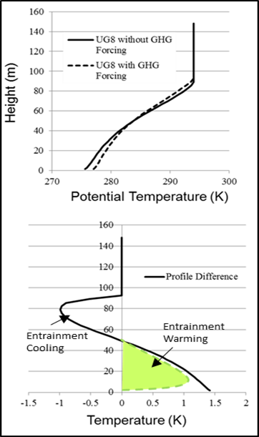
Fig. 1. (top) The impact on potential temperature profile between the case of added GHG energy and base case for a geostrophic wind of 8 ms⁻¹. (bottom) Expanded view of profile difference. Colored green area shows the approximate warming due to entrainment which is much larger than the direct CO2 warming (the remaining white area). From McNider et al. 2012.

  - Uncertainty in Stable Boundary Layer Parameterizations
The SBL and deeper strong Arctic inversions are ubiquitous features of high latitudes because of a mean negative balance in the surface energy budget and warm air advection aloft due to the direct Hadley cell. The potential impact of the stable layer (SL) and interaction with other amplification processes is dependent on the SL parameterization used in the GCM. Unfortunately, at present, confidence in SL parameterizations as implemented in both weather forecast models and GCMs is low. As discussed by Mahrt (1989), ReVelle (1993), McNider et al (1995), Acevedo et al. 2001 and Van de Wiel et al. (2002a), the stable boundary layer is a sensitive non-linear dynamical system. Here, temperature stability and shear compete in determining whether the system will go to a warm/windy solution or a cold/calm solution at the surface (see Vignon et al. 2017b and Acevedo et al. 2021). The sensitive dependence of this system on model parameters (McNider et al. 1995) and model vertical resolution (Shir and Bornstein, 1977) has been a continuing problem in both weather forecast models (Viterbo and Beljaars,1995) and global climate models (Holtslag and Boville 1993; Esau and Byrkjedal 2007; Vignon et al. 2017; Davy and Outten 2020; and Audouin et al 2021). The global energy and water cycle experiment (GEWEX) atmospheric boundary-layer study (GABLS) has carried out studies of parameterizations of the stable boundary and model inter-comparisons (Holtslag 2006; Holtslag et al. 2013). One of the inter-comparison studies of the SBL under GABLS (Bosveld et al. 2014) compared 19 models from 11 different institutes. The results of the inter-comparison showed that the spread in model performance in the nighttime SBL was much larger than the spread during the day.
  - Uncertainties in GCM Performance and Warming Sensitivity at High Latitudes
There have been several assessments of model inter-comparisons of AA under both the CMIP3 and CMIP5 programs (e.g., Holland and Bitz 2003; Taylor et al. 2013; Pithan and Mauritsen 2014). Figure 2 shows the comparison of CMIP3 and CMIP5 trends and the comparison by Swanson (2013). It shows that model spread is largest at high latitudes in both hemispheres, with the spread being largest in the Arctic. It also shows that the mean warming in the CMIP3 and CMIP5 models is larger than observations (ERA Interim and HadCRUT4). Note also that the CMIP5 improvements perhaps come at the expense of overwarming at lower northern latitudes.
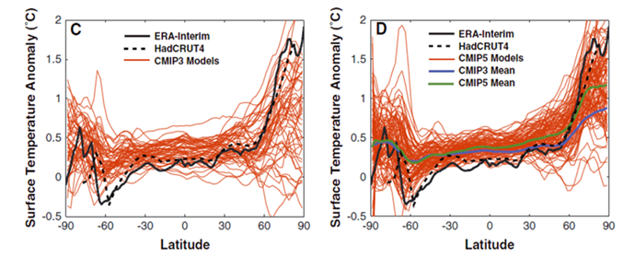
Fig. 2. (Adapted from Swanson 2013) Panel C shows the surface air temperature anomalies as a function of latitude for the CMIP3 simulations (red curves), as well as the ERA-Interim reanalysis (heavy black curve). The anomalies in his paper are the change in near-surface air temperatures for the 2002–2011 decade relative to the 1979–2001 mean. Panel D is the same, but for CMIP5. Note ERA Interim and HadCRUT4 are observational data sets.

Multiple studies to date have also evaluated the performance of CMIP5 models in simulating AA (Shindell, 2007; Screen et al., 2012). Franzke et al. (2017) examined a set of 10 CMIP5 models for the correlation between surface air temperature (SAT) and surface fluxes. The exhibited differences may be due to differences in the parameterization of SBL processes.
Bintanja et al. (2012) recognized the critical role of the inversion strength in confining downward LW to a shallow layer, increasing temperature warming. They showed that in climate models, the strength of the inversion was dependent on mixing. Moreover, they carried out a more controlled experiment, changing mixing in a single model. Figure 3 from Bintanja et al. (2012) shows that in a GCM, the AA is tied to the amount of turbulent mixing in the high-latitude SBL. Less mixing produces a larger amplitude response in the AA. Bintanja et al. (2012) recognized the critical role of the inversion strength in confining downward LW to a shallow layer, increasing temperature warming. They showed how differences due to uncertainty in SBL can impact AA in climate models (Figure 3).
As discussed below, model SBL and SL mixing are dependent on resolution. Unlike in previous developments of SL parameterizations, we will explicitly incorporate model vertical resolution in the parameterizations. This may provide more robust parameterizations in climate and coarse-resolution operational weather forecast models. It may also help provide greater confidence in model performance for AA by providing a path for reducing the spread of modeled AA responses.
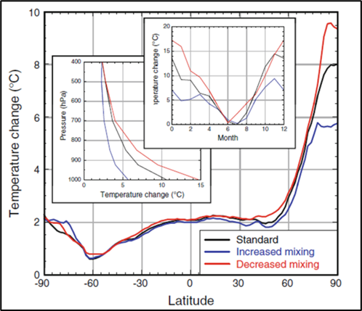
Fig. 3. Zonal and annual mean surface air temperature change for three mixing cases (doubled CO2)). Inserts show the vertical profile of annual mean temperature change (averaged over 70–90_N), the seasonal variation of surface air temperature change (averaged over 70–90_N), and the seasonal variation of surface air temperature change (averaged over 70–90_N). (Source Bintanja et al. 2012).

  - Modeling Difficulties for SBL Regimes
In the 1980’s, models began using local mixing schemes (e.g. Blackadar 1979; Mellor and Yamada 1982) for the stable boundary layer and employing turbulent kinetic energy models or stability function closures based on fundamental Monin-Obukhov similarity functions (Businger 1973). As a result, models began to have a problem of becoming too stable, with surface conditions becoming too cold and calm (Derbyshire 1999). Mixing of heat and momentum to the surface was too weak (Louis 1979; Beljaars and Holtslag 1991; Viterbo et al.1999; Beljaars et al.2012; Audouin et al 2021). In these coarse grid operational models, it appeared that additional mixing was needed (Savijarvi 2009; Viterbo et al. 1999). Thus, mixing formulations that had more mixing were employed, such as longer-tailed stability functions – see below. Bintanja et al. (2012) also discussed the bias in the ECMWF IFS model and referenced the adjustments made by Viterbo et al. (1999) to add mixing for operational forecast purposes. But, they noted that such adjustments may not be appropriate in climate models in that too much mixing can impact the sensitivity of the climate model to GHG forcing.
In K closure models in the stable layer, such as those used in GCMs and weather forecast models (Esau and Byrkjedal 2007), the vertical mixing coefficient is often parameterized (Blackadar 1979; McNider et al. 1981; Savijarvi 2009) by
(1)
Here , are the mixing coefficients for momentum and heat. The symbols , are referred to as the stability functions with Ri, the Richardson Number, given by
) / .
The symbol l is a mixing length, s is the local shear, and Pr is the Prandtl Number. Here, we will refer to generically as then can be recovered using the Prandtl Number (see Pleim 2007). Esau and Byrkjedal (2007) provide an excellent overview of the first-order closure /recovery of and from LES databases. Note that this stability function closure is basically a TKE model with the advection of turbulence ignored.
Originally, Blackadar (1979) and others based the stability function on boundary layer observations in which turbulence was suppressed beyond an Ri ~ 0.25. Fig. 4 shows the typical stability functions used in the SBL in the past. The England-McNider and Duynkerke would be short-tailed forms, more consistent with turbulent theory and LES results, while the Beljaars-Holtslag and Louis forms would be considered longer-tailed forms having enhanced mixing at larger Ri. As discussed by Savijarvi (2009), the added mixing needed by operational models was often implemented by using the longer-tailed stability functions (Beljaars and Holtslag 1991; Viterbo et al. 1999).
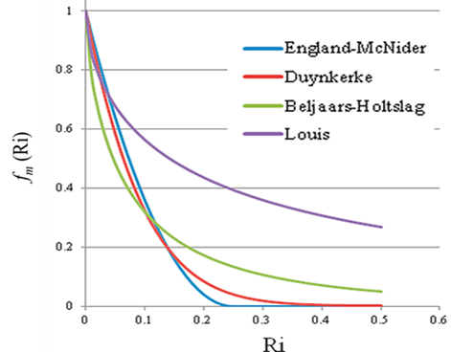
Fig. 4. Typical stability functions used in modeling the SBL. Ri is the gradient Richardson number. See England and McNider (1995), Duynkerke (1991), Beljaars and Holtslag (1991) and Louis 1979). The Duynkerke, Beljaars and Holtslag, and Louis represent curve fits to the original parameterization. See also Van de Wiel et al. 2002a.

Early on, as local turbulent closures were being implemented, investigators (e.g., Blackadar 1979; Shir and Bornstein 1977; McNider and Pielke 1981) argued for the need for additional mixing in coarse grid models beyond the cutoff at a critical Richardson Number (Ri_{c}) of ~0.25. The physical argument was based on the existence of unresolved fine-scale shear and temperature gradients in the real atmosphere that contributed to mixing. It was also argued that neglect of unresolved mesoscale terrain required more mixing in models (Mahrt 1996; Steeneveld et al 2008b). However, as shown below, perhaps part of the reason is how the discretized form of Ri is defined, which is explicitly dependent on grid spacing and not just missing unresolved structure. This is the focus of the present investigation.
Besides the longer-tailed stability functions, other mixing adjustments, such as making Ri_{c} an ad hoc function of grid spacing (McNider and Pielke 1981) or setting minimum diffusivities (Pleim 2007), were employed to add mixing and to keep the model from being too cold. Today, however, it appears that with increased vertical resolution and/or improved radiation schemes, some operational forecast models are now making the opposite error with these adjustments, having too much mixing (Steeneveld et al 2008a; Savijarvi 2009; MCN12). This leads to an environment in the model that is too warm and windy at the surface, especially over oceans and homogeneous settings such as the Arctic (see Savijarvi 2009, and Esau and Byrkjedal 2007). Vignon et al. (2017a,b) indicated that such added mixing can be detrimental to modeling the SBL. This is especially true in regards to maintaining a very stable state. In particular, Vignon et al. 2017 in a moderate resolution model (79 levels), showed that the default long-tail forms (similar to the Louis form) lead to a too smooth transition and too weak near-surface inversion. Thus, the spread in temperature in the GABLS and GCM Arctic Amplification as discussed by Bintanja et al. (2012) is likely in part a result of historical variations in the issue of parameterizing mixing in SBL.

  - Impact of Different Mixing Parameterizations on Arctic Profiles and Energy Budgets
Different SBL parameterizations can greatly impact profiles of temperature. Figure 5 shows the development of an idealized Arctic stable boundary layer for several different mixing parameterizations using a single column model for a GABLS1 boundary layer test case. It employs the UAH single column model – see McNider et al. 2012 for a description. See Cuxart et al. (2006) for a description of the test case.
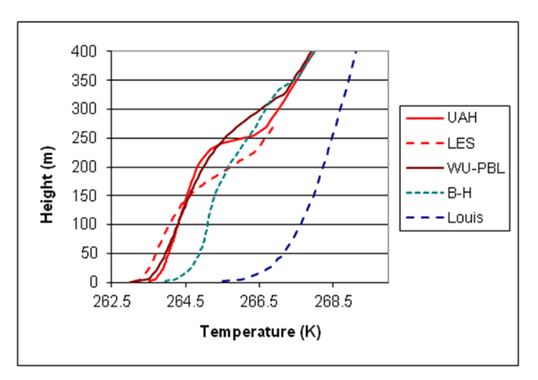
Fig. 5. Comparison of the short-tail EM (UAH) against the GABLS1 single column model Arctic inter-comparison case [see Cuxart et al., 2006]. LES came from the LES ensemble reported by Cuxart et al. [2006], WU-PBL is the Wageningen model [see Steeneveld et al., 2006]. The B-H and Louis curves are runs with the UAH model using the Beljaars-Holtslag stability function and the Louis function. (from McNider et al. 2012). Note also that the longer-tailed forms were employed in the high resolution UAH model, not in the coarser grids for which they were developed.

In this GABLS1 test case, surface fluxes are specified rather than coming from a land surface model as in a later GABLS study (Bosveld et al 2014). It shows that the shorter tail stability functions produce a stronger inversion and colder SAT. The shorter-tailed cases - UAH using the England-McNider stability function and the Wagenengen model using the Duynkerke stability function - are more consistent with the LES simulations, which have even less mixing. Note that these shorter-tailed forms are also more consistent with Monin-Obukhov observationally similarity profiles (see Businger 1973; England and McNider 1995) and LES modeling (Esau and Byrkjedal 2007). The Beljaars-Holtslag (B-H) and Louis stability functions were developed to add mixing needed in coarse-resolution weather forecasting and climate models. The performance of these longer-tailed profiles in their original coarse resolution setting would be different than the UAH model with high vertical resolution (2m). But this does show the sensitivity of the SBL to parameterizations and the important role of model resolution.
The Arctic - Models with Less Mixing: Boe et al. (2009) and Bintanja et al. (2012), for the Arctic, showed that models with less mixing (stronger inversions) had a larger surface air temperature (SAT) warming from GHG energy. This is likely due to greater entrainment warming at the surface (seen in Figure 1 above) and the confinement of the added GHG energy to a shallower boundary layer (Davy and Esau 2014). Thus, in terms of the first metric (SAT change), models with less mixing would have a greater SAT response. This is consistent with the dynamical system analyses carried out by Walters et al. (2007).
MCN12, looking at the sensitivity of the SBL to GHG forcing, showed that models with limited mixing have a greater SAT response. They also showed that models with less mixing may reduce the sensible heat fluxes of the added GHG energy to the atmosphere. Models with reduced mixing failed to lift the added GHG heating off the land surface to the atmosphere. MCN12 carried out detailed energy budget analyses of a mid-latitude nighttime SBL. These showed that different stability functions totally changed the components in the surface/atmosphere energy budget. The shorter tail forms, EM (England-McNider) and B-H (Beljaars- Holtslag), added less sensible heating to the atmosphere than the long-tailed (Louis) form. For the reduced mixing cases, the land surface warmed more, leading to greater radiative losses to space (Plank effect discussed by Pithan and Mauritsen 2014) and greater losses into the land substrate than the larger mixing cases (BH-Beljaars-Holtslag and Louis). The energy budgets for the Arctic SBL may likely behave similarly; however, future studies specifically for the Arctic will have to verify this assertion.
The Arctic - Models with Greater Mixing: If the baseline (pre-industrial period) case has too much mixing, the sensitivity to enhanced GHG downward radiation will be understated, producing less relative warming. This is because the initial strength of the Arctic inversion will be too weak, so that the downward mixing of heat from entrainment due to destabilization (Fig. 2) will be too small (see MCN12). This is evidently the case discussed by Bintanja et al. (2012) and Boe (2009). As noted by Bintanja et al. (2012), warming in the Arctic will decrease the strength of the inversion, decreasing the future sensitivity to forcing.
Importance of Correct Transition Between Strongly and Weakly Stable States: Recent studies of the SBL have shown the importance of correctly capturing the transition between weak and strong stability states as a function of external parameters (Van de Wiel et al 2012; Van de Wiel et al. 2017; Acevedo et al 2021). This is because the transition between the two states has a large impact on average SAT, surface heat flux, and temperature profiles. Vignon et al (2017) concluded that correctly capturing the transition was critical to establishing and maintaining the pervasive inversion in the Antarctic. They further showed that this transition was both a function of turbulent parametrizations and model vertical grid resolution.
Vignon et al. (2017) also used several stability functions. They employed a long-tail form between the Louis and Beljaars, and the Holtslag form seen in Figure 4. This form is referred to as L82 in their paper. They also employed two shorter-tail forms, the first one similar to the Duynkerke form in Figure 4 – referred to as KO1. They also used the England and McNider form – referred to as the Cutoff form. Vignon et al 2017, through scatter plots, showed the transition to/from weakly/strongly stable conditions at the observation site at Dome C. These scatter plot forms are very close to the bifurcation diagrams in McNider et al. (1995) and Walters et al. (2007) that captured the transition in stability. The shape of the scatter describes the transition. It shows that higher resolution simulations and short-tailed stability functions agree best with the observations. In fact, they indicated that the Cutoff form (England McNider) worked best. It is also interesting that the near-vertical shape of the scatter plots, near 5m/s, shows a large difference in the strength of the inversion for small changes in wind speed. This is consistent with multiple solutions found by McNider et al. (1995), Wiel et al. (2002,2002b), and the lack of predictability posed by Lorenz (1963).
- Role of Model Vertical Resolution to Improve Understanding of Modeled AA
As discussed above, the SBL is sensitively dependent on model resolution. Under the present project, we will attempt to develop improved SBL parameterizations within the context of equation (1) by creating a correction to the short-tailed stability function ) dependent on model resolution. Within the SBL community, the role of model resolution has been discussed as a fundamental issue with general SBL parameterizations going back to Shir and Bornstein (1977), Blackadar (1979), and McNider and Pielke (1981). More recently, Esau and Byrkjedal (2007) provided an excellent review of the resolution issue, providing several examples of the sensitivity error to model resolution. Byrkjedal et al. (2008) showed GCM performance in the Arctic deteriorated with coarser resolution. Thus, resolution is a critical issue in global climate modeling, in that the coarse resolution in GCMs may not capture the correct strength/depth of the Arctic inversion, the entrainment warming discussed above, or the correct energy budgets (MCN12). In particular, Vignon et al. (2017) showed that while the shorter-tailed (EM) form performs best in higher resolution models, they couldn’t recommend these for GCM resolutions since they produced runaway cooling over the Antarctic Plateau.
- Development of Grid-Dependent Correction Function
The improvement of parameterization within the context of (1) will be carried out by developing a grid resolution correction to the stability function ). Within the SBL community, the role of model resolution has long been discussed as a fundamental issue with general SBL parameterizations going back to Shir and Bornstein (1977) and Blackadar (1979). As noted above, the most fundamental theoretical forms for the stability functions in the stable boundary layer are the short–tailed forms in Fig. 4 (such as England and McNider and Duynkerke), which are derived from the Monin-Obukhov surface profiles (Businger 1973).
We believe that examining the discretized form of (1), which is how it is used in numerical models, may be a somewhat fresh approach to this long-running SBL issue. For analytical simplicity, all the stability function forms in Fig. 4 can be well approximated by an exponential function
, (2)
where large γ yields a shorter-tailed form. A value of =3.2 approximates the shorter tail England McNider form seen in Figure 4 and was used in the present study. While research models with high vertical resolution perform well using the more fundamental short-tail forms, coarse resolution weather forecasting and climate models using the same forms appeared not to have enough mixing. As noted above, mixing was added, often in an ad hoc manner, to improve model performance. Ideally, the results of parameterizations should not depend on the grid spacing. Thus, to preserve the integrity of the simulation in coarse grid models, (Ri) may need to be a function of vertical grid spacing . This was discussed early on by Blackadar (1979), Shir and Bornstein (1977), McNider and Pielke (1981), and more recently by Walters et al (2007), though no general forms were proposed. Thus, we desire to find a correction function such that
(3)

We assume that the short-tailed form works well for a small and call this small reference grid spacing . Next, use the finite difference or discretized form of Ri (mentioned by Walters et al. 2007)
) = (4)
Here, note the dependence of Ri on Δz, with larger Δz giving a larger Ri for a given constant . A larger Ri would reduce the amount of mixing. As background, the observational community has long used a discretized form of Ri and called it a bulk Ri number when the spacing of observations can be large. See Stull 1988. This, Stull noted, then requires a larger critical Ri to maintain mixing. Fernando and Weil 2010 also have shown a near-linear increase in Ri as the vertical spacing in measurements increases (their Fig. 2). This is consistent with the extensive discussion above of the need for more mixing in models at larger Δz. However, there is a caveat. If is an inverse linear function of Δz (i.e. = a /Δz), then this behavior goes away (the implications of this are discussed below).
Here, we take a new approach to the potential increase of Ri and the corresponding reduction in mixing. Using (4) in (3), we obtain the ODE as an initial value problem as departs from . The initial condition is = (i.e. no correction).
(5)
It is instructive to examine the form of the ODE. If = a /Δz, then the Δz cancels out in the first expression, implying there is no dependence on Δz. In this case, the expression is a constant and ODE is identically zero and thus is ill-posed. This result is, perhaps, intuitive since if the gradients are linear, then the discretization would be perfect and there would be no need for a correction. This is perhaps where curvature in comes into play (suggested by Beljaars 2020), which will be discussed later.
We can solve this ordinary differential equation (ODE) analytically with a specific assumption about the functional dependence of on . Assume that is a constant. Then the ODE (5) can be solved analytically to find f_{c} . Let v = , dv = d, =v +, then

By expanding the derivative and separating, we arrive at
.
Next, integrating with a constant, the solution is
.
Using the initial condition from above, then C=0. So that
(6)

However, note that from (3) above = Ri. Therefore, we can substitute this definition in to write the solution in terms of Ri
(7)
But, with the caution that the form of this solution is based on being a constant, or equivalently, Ri a constant. However, we can plot the solution for different values of this constant ( ) or Ri. Thus, while this form shows what the solution might look like for different Ri, the form of the solution might be different if the variation of Ri with z had been included in the solution of the ODE. Since the solution is not exact for the general case (i.e. Ri not a constant) to partially account for this uncertainty, we add a variable (D) to explore the sensitivity of the correction function
(8)
Since is a correction function applied to , we now look at the product
(9)
This can be further simplified to a form invariant with grid spacing
(10)
Which conveys the weighted averaging of and , being normalized by (where
). This form also conveys the dependence on D. For D=0, the fraction is 1 (no correction to the short-tail stability function), and for D=1, the exponent is adjusted by , yielding a long-tailed stability function for larger grid spacing. Thus, this form represents a weighted combination of short- and long-tail functions, with D controlling the relative contribution of each.
Figure 6 shows the behavior of f_{s}*f_{c} for three different values of D. While the assumption of being a constant is a simplification and not likely to occur in general, it is interesting that the form of the analytical recovery reflects the need for longer-tailed forms at larger grid spacing. This is consistent with added mixing discussed by Savijarvi (2009) and Beljaars and Holtslag (1991), such as the Beljaars-Holtslag and Louis forms in Figure 4 that have been used in operational and coarse models. Also, it is consistent with the approach to increase Ri_{c} to add more mixing (McNider and Pielke 1981) in coarse grid settings in models or bulk Ri in observations (Stull 1988).
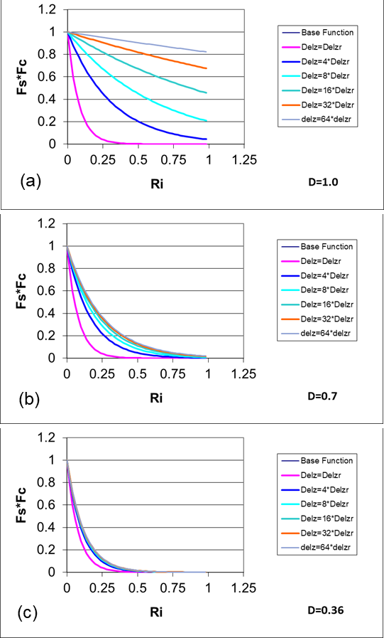
Fig. 6. Behavior of the correction function (actually fs*fc) from (8) as a function of Ri for different values of D. Note that for smaller the correction yields a short tail form, and for larger yields a longer tail form with greater mixing. Note that the base function is covered by delZr case. The behavior of (8) is consistent with Ri_{c} (McNider and Pielke 1981).

- Preliminary Tests of the Analytically Derived Correction Function
In order to test the correction function in (8) we carry out a series of numerical simulations for the Arctic using the UAH single column model (see Figure 5) discussed in McN12. Note that the UAH model uses an explicit diffusion scheme to avoid numerical diffusion (see MCN12) rather than a semi-implicit scheme used in many operational models. We employ the GABLS1 single-column model inter-comparison framework (see Cuxart et al., 2006), which is based on an idealized Arctic stable boundary layer (Kosovic and Curry, 2000). The initial components of the wind are set equal to those of the geostrophic wind (u=ug, v=vg). The potential temperature (θ) equals 265 K up to 100 m, then it increases at a rate of 0.01 K/m until the domain top (400 m), where a value of 268K is reached. The surface temperature is set to 265 K initially, decreasing at a constant rate of 0.25 K/h. The value of the aerodynamic roughness length (z₀) is set to 0.1 m. Note, this is a very idealized case. Actual Arctic boundary layers may have fine-scale features with more complex and deeper stable atmospheric structure.
Here we explore the sensitivity of the solutions to grid spacing and then examine whether we can use the correction function in (8) to make the solution more independent of grid resolution. Figure 7 shows the model simulation of potential temperature after 10 hours of simulation for different grid spacings with no correction. (Case 1). Note that the mixing in the coarser grids is less than the values for the 2 m grid. This is consistent with our original formulation for Ri (see (4) above), in that Ri would be larger, indicating a reduction in f_{s}(Ri) (since Ri would be shifted to the right as in Figure 4). The coarser grid also shows the mixing increasing with height, but near the 250 m level, it has slightly less mixing than the finer grids. While the differences in mixing are small, the behavior of the temperature profile is quite different. Showing the sensitive non-linear behavior of the SBL (McNider et al. 1995 and Van de Wiel et al. 2002a,b).
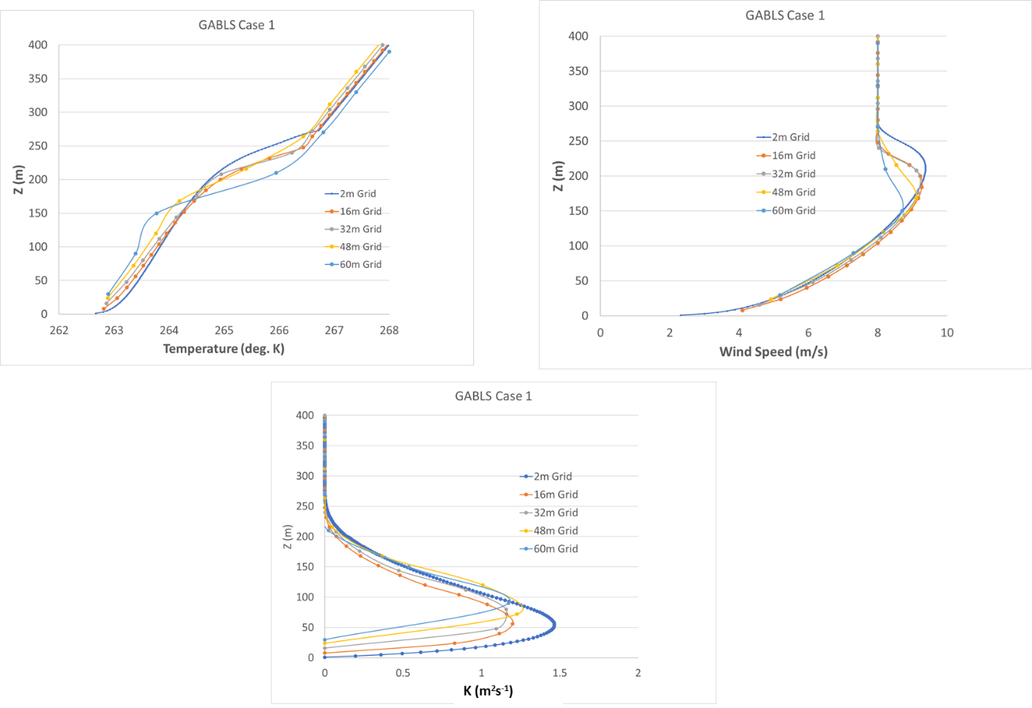
Figure 7 Case for No Correction. (top left) Potential temperature profile after 10 hrs of simulation for different grid spacings. (top right) wind speed profile (m s⁻¹) after 10 hours of simulation for different grid spacings. (bottom) average mixing values over the length of the integration for different grid spacings K (m²s⁻¹). Grid spacings are given in figures.

Here, the differences for different grid spacing may not seem large, but in this idealized limited height case, the largest grid was only 60 meters. In real Artic profiles, which may go up to 10-15 km, the GCM grid spacing may be 200 - 500 m or more (Esau and Byrkjedal 2007). As will be discussed later, the GABLS1 case, utilized here, is an extremely idealized barotropic case with no shear in the upper atmosphere, which would exist in real baroclinic cases. The GABLS1 framework, which is well known in the SBL community, is only used as initial proof of concept for our approach. Real cases may show much greater differences as you go to larger grid spacing and more complex profiles. There is also the large non-linearity in the SBL, in that small changes in mixing can lead to large changes in the SBL structure (see Mahrt 1989; Derbyshire 1999; McNider et al. 1995; Van de Wiel et al. 2002a,b).
We next employ the grid correction function (8). In interpreting the figures, we are looking for corrections that make the larger grid results more like the 2m or reference grid. We first tried using D=1, but it produced too much mixing (similar to the Louis profile in Figure 5). Next, we tried smaller values of D. Figure 7 shows the impact of using f_{c} with D = 0.7 (Case 2). It corrects the lower part of the profile but puts too much mixing at the top of the profile. This indicates that D may need to be variable as discussed below. Note that the mixing coefficients are too large over most of the domain compared to the 2 m reference case.
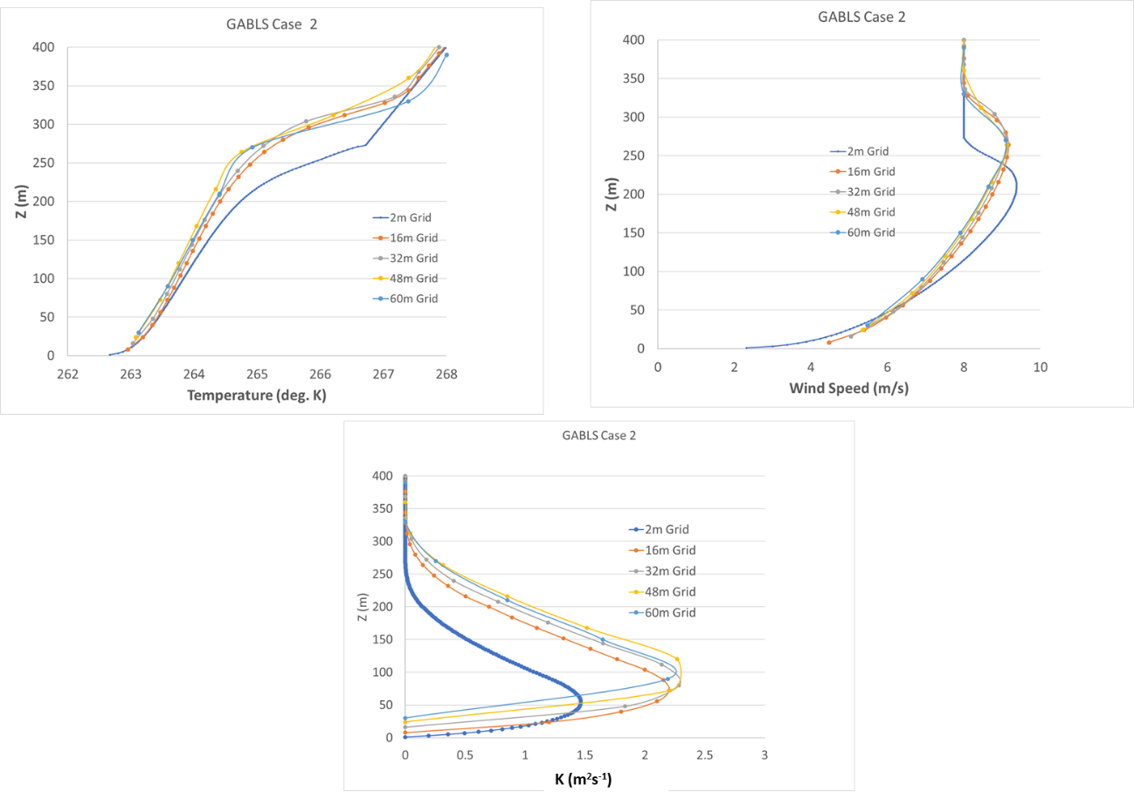
Figure 8 Case for Correction with D= 0.7 (top left) Potential temperature profile after 10 hrs of simulation for different grid spacing. (top right) Wind speed profile (m s ⁻¹ ) after 10 hrs of simulation for different grid spacing. (bottom) Average mixing values over the length of the integration for different grid spacings K (m²s⁻¹). Grid spacings are given in figures.

Figure 9 shows the result with D = 0.36 (Case 3). It shows that the different grids can be corrected to have a solution mostly like the 2m reference case. However, the lower part of the profile correction is not as improved as the D = 0.7 case in figure 11. Note also in figure 9 (right) that the mixing coefficients have been corrected to be more in line with the 2m reference case.

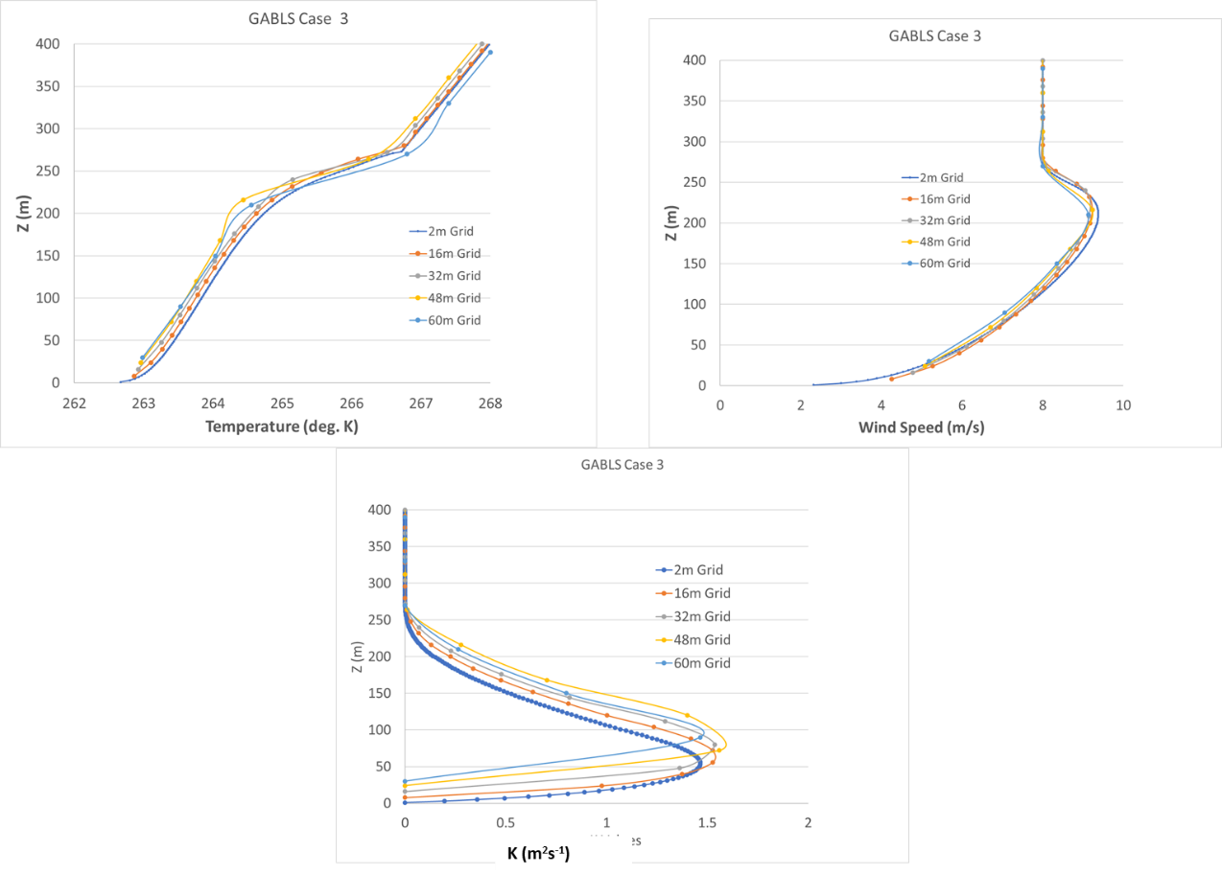
Figure 9 Case for Correction with D= 0.36. (top left) Potential temperature profile after 10 hrs of simulation for different grid spacing. (top right) Wind speed profile (m s⁻¹) after 10 hrs of simulation for different grid spacing. (bottom) Average mixing values over the length of the integration for different grid spacings K (m²s⁻¹). Grid spacings are given in figures.
- Improved Specifications to the Parameter “D” in the Analytical Solution ( 8)
The analytical correction in equation (8) is appealing because of its structure and computational efficiency. It only takes two additional lines of code - one line to compute f_{c} (8) and one to compute the product f_{s}*f_{c}. The correction, which effectively yields longer tailed stability functions for larger grids is based on being a constant, which in effect is for Ri being constant. This is not in general true. The examples in figures 8 and 9 show that the correction functions can make model predictions less grid dependent. However, it also shows that different values of D can impact the correction. Given the fact that the ODE is ill-posed for linear gradients, it seems that one path might be to make D a function of the curvature in or equivalently Ri (Beljaars 2020). Here we explore D as a function of curvature in Ri, i.e. D (d² (/dz²). Under this proposed framework, D becomes smaller as gradients in Ri becomes linear (i.e. no need for correction).

Figure 10 shows a plot of Ri for the case of “No Correction” given in Figure 7. Note this is the average value of Ri over the length of the integration (10 hours), consistent with the average K values in figures 7-9. Visually, the average curvature (concave upward) is largest below about 40 m, and between 40 m and 90 m, there is less curvature. Near 75 m, the curvature changes sign (concave down). Above 100 m, the curvature becomes less but remains concave downward. Note also that the curvature is smaller in the larger grids.
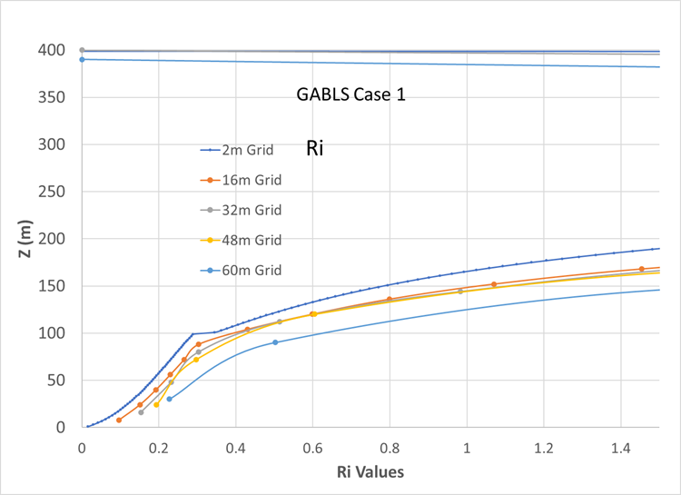
Figure 10 Plot of Ri for the Case of No Correction given in figure 7. These are the average values of Ri over the length of the run (ten hours). Note that curvature (concave upward) is largest below about 40 m. Between 40 m and 90 m there is less curvature. Near 75 m, the curvature changes sign (concave down). Above 100 m the curvature becomes less but remains concave downward. Note also that the curvature is smaller in the larger grids.

As noted above D=0.36 proves a correction which makes the coarser grids look more like the finer grid solution. In adding curvature, we explored D being a linear function of curvature. We used a linear function
D = D₀ + M* |(d² (/dz²|
where D₀ is the intercept (minimum value) and M is the slope. For curvature, d² (/dz², we employ the absolute value of the curvature since the sign of the curvature should not be relevant. Since a value of D=0.36 as seen in Figure 9, provides an improvement, but a value of D = 0.7, as seen in Figure 8, provides too much mixing, we tried linear functions that bracket these values. Specifically, we chose through trials that D₀ = 0.3 and M= 300 so that
D = 0.3 +300 * |(d² (/dz²| with D < 0.7 (8)
provided the best results.
Figure 11 shows the results of this curvature-dependent correction. It shows that the curvature-dependent correction for D (8), is an improvement over D=0.36. The curvature correction improves the upper part of the temperature profile, bringing it in line with the 2m grid case. Near the bottom of the profile, there seems to be a need for further correction. However, in looking at the curvature, as seen in Figure 10, it can be seen that the coarser grids do not capture the amount of curvature as seen in the smaller grids. In these simulations, we used similarity theory (England and McNider 1995) to specify heat and momentum from the surface up to the first model layer. As discussed below, a refinement in the technique in the future could utilize the curvature from surface similarity in terms of Ri rather than the grid calculated curvature employed here.
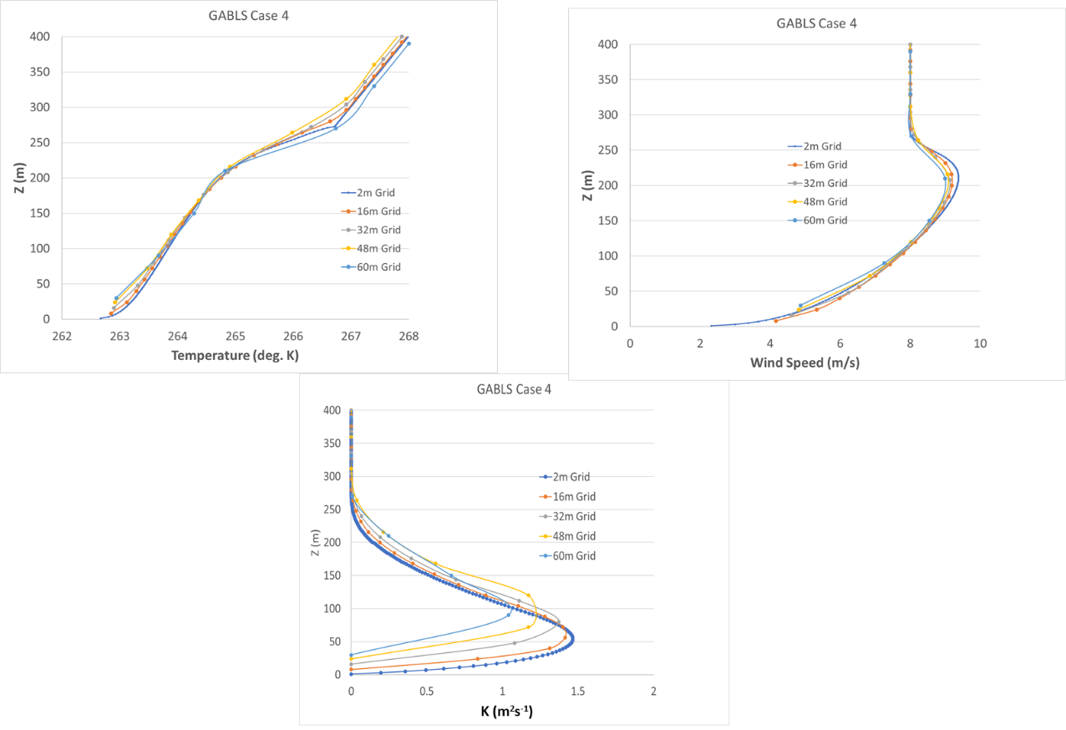
Figure 11 Case for D function of curvature ( 8). (top left) Potential temperature profile after 10 hrs of simulation for different grid spacing. (top right) Wind speed profile (m s⁻¹ ) after 10 hrs of simulation for different grid spacing. (bottom) Average mixing values over the length of the integration for different grid spacings K (m²s⁻¹). Grid spacings are given in figures.
- Future Work and Summary
The background on Arctic Amplification (AA) and the modeling of the SBL in coarse grid climate models suggests that treatments of the SBL and deeper SL in GCMs may be partly responsible for the spread seen in GCM predictions in high latitudes. This may also be a part of the reason models have underestimated the strength of AA. As discussed in section 2.5, if models have too much mixing in the base-state, they may not have the sensitivity to enhance GHG energy as models with less mixing. Also, given the difficulties with handling the SBL and SL in coarse grid settings, GCMs may have other fixes that add mixing and underestimate the sensitivity to GHG energy.
We believe the development of a grid correction and the initial tests presented here show promise in improving the problem of grid dependence in modeling the SBL and SL. This may provide a path to allow coarse grid models to make improved climate predictions in the Arctic. However, the initial results show that further improvements are needed in making the analytical adjustment perform better. Also, the simple Arctic simulation carried out here with such a limited vertical domain needs to be expanded to more realistic settings where grid spacing in models may be much greater. The present paper and its grid correction function provide a potential path for making model performance better in the future. As a final caveat, we note that the approach presented here only addresses the explicit dependence of Ri on (4). It does not address issues of unresolved structure (Blackadar, 1979) or mesoscale energy (Mahrt 1996; Steeneveld et al 2008b), which may add mixing.
We hope to carry out some future model experiments to look at specifying better correction functions and more realistic settings. However, because of our team’s lack of experience with full climate models, we feel publishing these preliminary results can perhaps allow other investigators to make progress in making the modeling SL in Arctic environments less grid-dependent. We outline some paths for improvement below.
- Metrics for evaluating model performance
In testing the derived f_{c} to determine the best value for variable D, we largely used a visual test for model improvement. For future, more complex recovery of D or numerical recovery of f_{c} (see below), we believe two basic metrics should be considered.

(1) Quantification of improvements in the wind and temperature profile compared to the high-resolution model (i.e., model run at the spacing) and to data sets (LES and observational). This can be accomplished by developing statistical estimates of the functional form that provides the best fit (RMSE, BIAS) in correcting the coarser grid profiles to agree with the 2m or () reference grid. This is similar to the approach throughout the history of boundary layer similarity and modeling.

(2) Assess whether the model with the grid corrected stability function can preserve the transition from weak/strong stability. Vignon et al. (2017) and Acevedo et al (2021) have transition postulated as a critical element in SBL parametrizations. McNider et al. (1995) and Van de Wiel et al. (2002a,b) showed that the SBL is a non-linear dynamical system with the transition from/to strong/weak stability sensitively dependent on external parameters. Vignon et al. (2017) showed that the transition over the Antarctic was also highly dependent on the form of the stability function and was at the heart of capturing the SBL in the Antarctic. Vignon et al. used scatter plots of low-level temperature gradients versus 9 m wind speed to capture the transition. It showed that short-tailed forms best captured the transition between strongly/weakly stable conditions as found in the observations. One could use similar measures to see whether the grid corrected stability function maintains the transition for larger grids. One could also follow Acevedo et al. (2021) in calculating the windspeed, V_{R}, where the SBL transitions from weakly to strongly stable occurs. The V_{R} could be calculated in both the fine grid and in grid corrected runs to see if they are invariant. One might use the GABLS1 and possibly Dome C framework with varying geostrophic winds to calculate the V_{R} for different grid spacings to see whether the V_{R} in the fine (2m) resolution is maintained in the corrected coarser grid runs.

Numerical Solutions to Find Correction (f_{c})
The analytical solution derived and tested here (8) is appealing due to its framework for providing corrected stability functions, f_{s}, which are longer-tailed (see figure 6). Previous investigators have shown that longer-tailed forms are necessary to provide additional mixing in coarser grids (Beljaars and Holtslag 1991), Louis 1979), Savijarvi (2009). While this paper lays out a framework for correction, its assumption of a constant , or equivalently Ri, does not generally hold. As one moves to more complex and deeper test cases, a different approach may be required (if finding a variable D as described above is not sufficient). Another approach, would be to carry out an “on- the–fly” numerical solution of the ODE given in (5). Here, an ODE solver could be used to solve for . Because of the suspected dependence on curvature in , the stencil in the ODE solver will have to capture the curvature. The ODE might initially be solved at each time step in the model simulation. However, it might be solved less often, such as for how radiation is not called every time step in some models. The correction function, as calculated numerically, would be used to calculate the corrected stability function fs*fc. While solving the ODE will add computational cost, it should be far less than running a model at a very high vertical resolution. Similar metrics as described above would be used to test the numerical fc.

Additional SL Model Frameworks
The present work on a grid corrected stability function has used the diffusion coefficient (K) approach. Some models may have a TKE formulation for local mixing in the stable layers (Mellor and Yamada 1982; Kantha and Clayson 1994; Basu et al 1999) that may be more robust modeling approaches. But they have similar issues with resolution and with the stability function forms. Two well-known TKE closures are the MYJ formulation (Janjic, 2001) and the QNSE (Sukoriansky et al., 2005), in which
(10)
Where α is a non-dimensional coefficient, S is the inverse of a stability function, l is a turbulence length scale, and TKE is the turbulence kinetic energy. As discussed by Tastula et al. (2015), a difference between MYJ and QNSE is the form of the stability function. The MYJ has a shorter-tail form with K’s shutting off at small Ri, while the QNSE form has a longer-tail with K’s being maintained well beyond an Ri of 1. While there is added complexity with the TKE systems, this may be a path for others to address grid dependence in TKE forms.

Changes in Atmospheric Energy Budgets with Grid Corrections
A key factor in Arctic Amplification is how energy budgets behave in models as GHG energy is added. MCN12 showed energy budgets were sensitive to the stability functions employed. The above tests showed a path for making model profiles more invariant with grid spacings. In Arctic climate change simulations, the real test is how the atmospheric and surface energy budgets change with the grid corrections. McNider et al. 2012, for a mid-latitude case, examined energy budgets as GHG energy was added for different stability functions. The GABLS1 protocol used here does not have a surface model; all surface values are specified. For more realistic Arctic cases, changes in energy budgets could be similarly calculated as in McNider et al. (2012) as the grid is changed and grid corrections (are implemented.

Tests of the Corrections Functions in Deeper More Complex Arctic Profiles
The modeling activities presented here are intended to evaluate and validate new grid-dependent stability functions discussed above. We focused on the Arctic because of the uncertainty in predicted climate simulations and because of the coarse resolution in climate models, where our approach may be most needed. However, the GABLS1 Arctic case used here is very idealized and shallow, with simple initial conditions (constant temperature profile and barotropic wind profiles).
In the GCM and weather forecasting worlds, model domains are much deeper, extending through the troposphere. The limited domain of GABLS1 made it impossible for us to look at larger grid spacings beyond 60 m. The GABLS cases have also emphasized near-surface SBL behavior. However, weather forecast models and GCMs must deal with stable layers throughout the troposphere. Figure 12 shows the deep stable layers in Arctic profiles at the Department of Energy ARM Site near Barrow, Alaska. Part of the development of deep stable layers is due to the advection of warm air aloft as part of the direct Hadley cell. Cai and Lu 2007 noted that the enhanced poleward heat transport aloft under climate change, as they called it “a greenhouse-plus" amplification, enhances the Arctic inversion, amplifying high-latitude warming. In models at these larger heights, grid spacings may be 200-500 m or larger. Future tests of the grid correction should be conducted in these deeper, more complex settings.
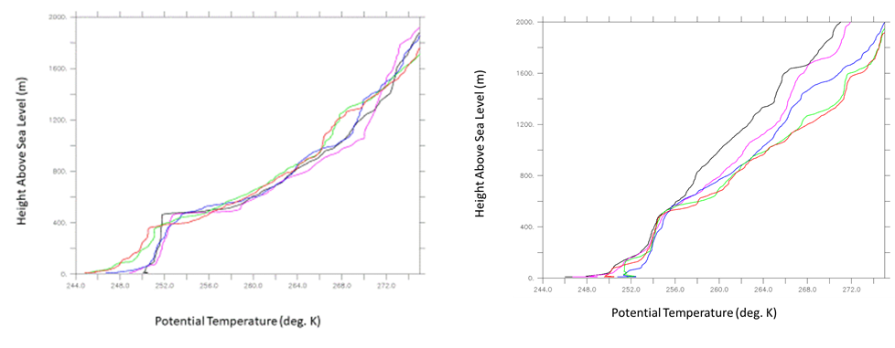
Figure 12 Winter potential temperature profiles over ARM’s North Slope Alaska site. (left) Dec. 30, 2020, (right) Jan. 06, 2021. 5:30 (BLACK), 11:00 (PURPLE), 17:30 (BLUE), 21:30 (GREEN), and 23:00 (RED)

- Summary
The present study provides a quantitative approach to correcting model performance with different grids in predicting local turbulent levels in stable environments. As discussed in Section 2, this has long been a problem for models using local closures (Shir and Bornstein 1977; Blackadar 1979), in that coarser grid operational models had too little mixing. Modelers such as Louis 1979, McNider and Pielke 1981, Beljaars and Holtslag 1991, and Viterbo and Beljaars 1995 added additional mixing through either longer-tailed stability functions (f_{s}) or larger critical Richardson numbers. Observationalists also had the same issue determining turbulence levels with bulk Richardson numbers in coarse observations. However, these corrections were also somewhat ad hoc, but they improved performance in specific grids.

The present study provides an analytical framework for defining a correction function (f_{c}) for the stability functions such that . This ODE was solved analytically under certain assumptions to recover . These correction functions were tested in a simplified Arctic simulation framework GABLS1 (Cuxart et al. 2006) and found to make the solutions less grid dependent. However, more work and testing are needed. We believe publishing this preliminary work now may lead others to provide improvements, insights and critiques. In terms of Arctic Amplification, it is an extraordinarily complex system involving albedo, sea ice and clouds. However, we believe it will be better to evaluate these issues in a system where turbulence and grid dependence, which are also important, were handled more correctly. It is hoped that this preliminary study can spur ideas and approaches by others.

Acknowledgments.
This work was sponsored by the Department of Energy grant #DE-SC0023332 with partial support by the Alabama Office of State Climatologist. The article does not necessarily represent views of DOE.

Data Availability Statement.
Paste your data availability statement here. The model runs and code for the simulations by the UAH model (McNider et al. 2012) can be found on the UAH public server at ESSC.
Arastoo can you add the link. I will send you the runs and the code. .

REFERENCES
Acevedo, O. C. and D. R. Fitzjarrarld, 2001: The early evening surface layer transition: Temporal and spatial variability. J. Atmos. Sci., 58, 2650-2667, https://doi.org/10.1175/1520-0469(2001)058<2650:TEESLT>2.0.CO;2.
Acevedo, O.C., Costa, F.D., Maroneze, R., Carvalho, A.D., Puhales, F.S. and Oliveira, P.E., 2021: External controls on the transition between stable boundary‐layer turbulence regimes. Quarterly Journal of the Royal Meteorological Society, 147(737), 2335-2351, https://doi.org/10.1002/qj.4027.
Audouin, O., Roehrig, R., Couvreux, F. and Williamson, D., 2021: Modeling the GABLS4 Strongly‐Stable Boundary Layer With a GCM Turbulence Parameterization: Parametric Sensitivity or Intrinsic Limits? Journal of Advances in Modeling Earth Systems, 13(3), e2020MS002269, https://doi.org/10.1029/2020MS002269.
Basu, S., Raman, S., Mohanty, U.C. and Rajagopal, E.N., 1999: Influence of the planetary boundary layer physics on medium-range prediction of monsoon over India. pure and applied geophysics, 155, pp.33-55, https://doi.org/10.1007/s000240050253.
Beljaars, A.C.M. and Holtslag, A.A.M., 1991: Flux parameterization over land surfaces for atmospheric models. Journal of Applied Meteorology, 30(3), 327-341, https://doi.org/10.1175/1520-0450(1991)030<0327:FPOLSF>2.0.CO;2.
Beljaars, A.C.M. , 2020: Personal Communication.
Beljaars, A. C. M., and Coauthors, 2012: The stable boundary layer in the ECMWF model. Proc. ECMWF Workshop on Diurnal Cycles and the Stable Boundary Layer, Reading, England, ECMWF/WCRP, 1-10, https://www.ecmwf.int/sites/default/files/elibrary/2012/8029-stable-boundary-layer-ecmwf-model.pdf
Bindoff, N.L., Stott, P.A., AchutaRao, K.M., Allen, M.R., Gillett, N., Gutzler, D., Hansingo, K., Hegerl, G., Hu, Y., Jain, S. and Sebbari, R., 2014: Detection and attribution of climate change: from global to regional. Climate change 2013: the physical science basis,
Bintanja, R., Van der Linden, E.C. and Hazeleger, W., 2012: Boundary layer stability and Arctic climate change: A feedback study using EC-Earth. Climate dynamics, 39(11), 2659-2673, https://doi.org/10.1007/s00382-011-1272-1.
Blackadar, A.K., 1979: High resolution models of the planetary boundary layer. Advances in Environmental Science and Engineering, 1(1), 50-85.
Boe, J., Hall, A. and Qu, X., 2009: Current GCMs’ unrealistic negative feedback in the Arctic. Journal of Climate, 22(17), 4682-4695, https://doi.org/10.1175/2009JCLI2885.1.
Bosveld, F.C., Baas, P., Steeneveld, G.J., Holtslag, A.A., Angevine, W.M., Bazile, E., de Bruijn, E.I., Deacu, D., Edwards, J.M., Ek, M. and Larson, V.E., 2014: The third GABLS intercomparison case for evaluation studies of boundary-layer models. Part B: results and process understanding. Boundary-layer meteorology, 152(2), 157-187, https://doi.org/10.1007/s10546-014-9919-1.
Businger JA, 1973: Turbulent transfer in the atmospheric surface layer. In Workshop on Micrometeorology, 67-100, Am. Met. Soc.
Byrkjedal, Ø., Esau, I. and Kvamstø, N.G., 2008: Sensitivity of simulated wintertime Arctic atmosphere to vertical resolution in the ARPEGE/IFS model. Climate dynamics, 30(7-8), 687-701, https://doi.org/10.1007/s00382-007-0316-z.
Cai, M., and J. H. Lu, 2007: Dynamical greenhouse-plus feedback and polar warming amplification. Part II: Meridional and vertical asymmetries of the global warming. Climate Dyn., 29, 375–391, https://doi.org/10.1007/s00382-007-0238-9.
Cassano, J. J., Parish, T. R. and King, J. C., 2001: Evaluation of Turbulent Surface Flux Parameterizations for the Stable Surface Layer over Halley, Antarctica. Mon. Wea. Rev., 129, 26-46, https://doi.org/10.1175/1520-0493(2001)129<0026:EOTSFP>2.0.CO;2.
Cuxart, J., Holtslag, A. A. M., Beare, R. J., Bazile, E., Beljaars, A., Cheng, A., Conangla, L., Freedman, M. Ek, F. , Hamdi, R., Kerstein, A., Kitagawa, H., Lenderink, G., Lewellen, D., Mailhot, J., Mauritsen, T., Perov, V., Schayes, G., Steeneveld, G. J. Svensson, G., Taylor, P., Weng, W., Wunsch, S. and Xu, K.-M., 2006: Single Column Model Intercomparison for the Stably Stratified Atmospheric Boundary Layer, Boundary-Layer Meteorol., 118(2), 273-303, https://doi.org/0.1007/s10546-005-3780-1.
Davy, R. and Esau, I., 2014: Global climate models’ bias in surface temperature trends and variability. Environmental Research Letters, 9(11), 114024, https://doi.org/10.1088/1748-9326/9/11/114024.
Davy, R. and Outten, S., 2020: The Arctic surface climate in CMIP6: status and developments since CMIP5. Journal of Climate, 33(18), 8047-8068, https://doi.org/10.1175/JCLI-D-19-0990.1.
Derbyshire, S.H., 1999: Boundary-layer decoupling over cold surfaces as a physical boundary-instability. Boundary-Layer Meteorology, 90(2), 297-325.
Duynkerke, P.G., 1991: Radiation fog: A comparison of model simulation with detailed observations. Monthly Weather Review, 119(2), 324-341, https://doi.org/10.1175/1520-0493(1991)119<0324:RFACOM>2.0.CO;2.
England, D.E. and McNider, R.T., 1995: Stability functions based upon shear functions. Boundary-Layer Meteorology, 74(1-2), 113-130.
Esau, I.N. and Byrkjedal, Ø., 2007: Application of a large-eddy simulation database to optimisation of first-order closures for neutral and stably stratified boundary layers. Boundary-layer meteorology, 125(2), 207-225.
Fernando, H.J.S. and Weil, J.C., 2010: Whither the stable boundary layer? A shift in the research agenda. Bulletin of the American Meteorological Society, 91(11), 1475-1484.
Franzke, C.L., Lee, S. and Feldstein, S.B., 2017: Evaluating Arctic warming mechanisms in CMIP5 models. Climate Dynamics, 48, 3247-3260.
Graversen, R.G. and Wang, M., 2009: Polar amplification in a coupled climate model with locked albedo. Climate Dynamics, 33, 629-643.
Hall, A., 2004: The role of surface albedo feedback in climate. Journal of Climate, 17(7), 1550-1568.
Holland, M.M. and Bitz, C.M., 2003: Polar amplification of climate change in coupled models. Climate Dynamics, 21(3-4), 221-232.
Holtslag, A.A.M. and Boville, B.A., 1993: Local versus nonlocal boundary-layer diffusion in a global climate model. Journal of Climate, 6(10), 1825-1842.
Holtslag, A.A.M., Svensson, G., Baas, P., Basu, S., Beare, B., Beljaars, A.C.M., Bosveld, F.C., Cuxart, J., Lindvall, J., Steeneveld, G.J. and Tjernström, M., 2013: Stable atmospheric boundary layers and diurnal cycles: challenges for weather and climate models. Bulletin of the American Meteorological Society, 94(11), 1691-1706.
Holtslag, B., 2006: Preface: GEWEX atmospheric boundary-layer study (GABLS) on stable boundary layers. Boundary-Layer Meteorology, 118(2), 243-246.
Janjic ZI. 2001: Nonsingular implementation of the Mellor-Yamada Level 2.5 scheme in the NCEP Meso Model, NOAA/NWS/NCEP Office Note 437.
Kantha, L.H. and Clayson, C.A., 1994: An improved mixed layer model for geophysical applications. Journal of Geophysical Research: Oceans, 99(C12), 25235-25266.
Kosović, B. and Curry, J.A., 2000: A large eddy simulation study of a quasi-steady, stably stratified atmospheric boundary layer. Journal of the atmospheric sciences, 57(8), 1052-1068
Lorenz, E.N., 1963: Deterministic nonperiodic flow. Journal of atmospheric sciences, 20(2), 130-141.
Louis, J.F., 1979: A parametric model of vertical eddy fluxes in the atmosphere. Boundary-Layer Meteorology, 17(2), 187-202.
Mahrt, L., 1989: Limit cycle mixing. Journal of Atmospheric Sciences, 46(8), 1061-1075.
Mahrt, L., 1996: The bulk aerodynamic formulation over heterogeneous surfaces. Boundary-Layer Meteorology, 78(1), 87-119.
Mahrt, L., 1999: Stratified atmospheric boundary layers, Bound-layer Meteor., 90, 375-396.
Manabe, S. and Stouffer, R.J., 1994: Multiple-century response of a coupled ocean-atmosphere model to an increase of atmospheric carbon dioxide. Journal of climate, 7(1), 5-23.
Manabe, S. and Wetherald, R.T., 1975: The effects of doubling the CO2 concentration on the climate of a general circulation model. Journal of Atmospheric Sciences, 32(1), 3-15.
McNider, R.T. and Pielke, R.A., 1981: Diurnal boundary-layer development over sloping terrain. Journal of Atmospheric Sciences, 38(10), 2198-2212.
McNider, R.T., England, D.E., Friedman, M.J. and Shi, X., 1995: Predictability of the stable atmospheric boundary layer. Journal of the Atmospheric Sciences, 52(10), 1602-1614.
McNider, R.T., Pour-Biazar, A., Doty, K., White, A., Wu, Y., Qin, M., Hu, Y., Odman, T., Cleary, P., Knipping, E. and Dornblaser, B., 2018: Examination of the physical atmosphere in the Great Lakes region and its potential impact on air quality—Overwater stability and satellite assimilation. Journal of Applied Meteorology and Climatology, 57(12), 2789-2816.
McNider, R.T., Steeneveld, G.J., Holtslag, A.A.M., Pielke, R.A., Mackaro, S., Pour‐Biazar, A., Walters, J., Nair, U. and Christy, J., 2012: Response and sensitivity of the nocturnal boundary layer over land to added longwave radiative forcing. Journal of Geophysical Research: Atmospheres, 117(D14).
Mellor, G.L. and Yamada, T., 1982: Development of a turbulence closure model for geophysical fluid problems. Reviews of Geophysics, 20(4), 851-875.
Pithan, F. and Mauritsen, T., 2014: Arctic amplification dominated by temperature feedbacks in contemporary climate models. Nature Geoscience, 7(3), 181.
Pithan, F., Ackerman, A., Angevine, W.M., Hartung, K., Ickes, L., Kelley, M., Medeiros, B., Sandu, I., Steeneveld, G.J., Sterk, H.A. and Svensson, G., 2016: Select strengths and biases of models in representing the Arctic winter boundary layer over sea ice: the Larcform 1 single column model intercomparison. Journal of advances in modeling earth systems, 8(3), 1345-1357.
Pleim, J.E., 2007: A combined local and nonlocal closure model for the atmospheric boundary layer. Part I: Model description and testing. Journal of Applied Meteorology and Climatology, 46(9), 1383-1395.
ReVelle D. O., 1993: Chaos and “bursting” in the planetary boundary layer, J. Appl. Meteor., 32, 1169-1180.
Rugenstein, M.A., Winton, M., Stouffer, R.J., Griffies, S.M. and Hallberg, R., 2013: Northern high-latitude heat budget decomposition and transient warming. Journal of Climate, 26(2), 609-621.
Savijärvi, H., 2009: Stable boundary layer: Parametrizations for local and larger scales. Quarterly Journal of the Royal Meteorological Society, 135(641), 914-921.
Screen, J.A., Deser, C. and Simmonds, I., 2012: Local and remote controls on observed Arctic warming. Geophysical Research Letters, 39(10).
Shindell, D., 2007: Local and remote contributions to Arctic warming. Geophysical research letters, 34(14).
Shir, C.C. and Bornstein, R.D., 1977: Eddy exchange coefficients in numerical models of the planetary boundary layer. Boundary-Layer Meteorology, 11(2), 171-185.
Steeneveld, G.J., Holtslag, A.A.M., Nappo, C.J., Van de Wiel, B.J.H. and Mahrt, L., 2008b: Exploring the possible role of small-scale terrain drag on stable boundary layers over land. Journal of applied meteorology and climatology, 47(10), 2518-2530.
Steeneveld, G.J., Mauritsen, T., De Bruijn, E.I.F., Vilà-Guerau de Arellano, J., Svensson, G. and Holtslag, A.A.M., 2008a: Evaluation of limited-area models for the representation of the diurnal cycle and contrasting nights in CASES-99. Journal of Applied Meteorology and Climatology, 47(3), 869-887.
Steeneveld, G.J., Van de Wiel, B.J.H. and Holtslag, A.A.M., 2006: Modeling the evolution of the atmospheric boundary layer coupled to the land surface for three contrasting nights in CASES-99. Journal of the atmospheric sciences, 63(3), 920-935.
Stull, R.B., 1988: Mean boundary layer characteristics. In An introduction to boundary layer meteorology (pp. 1-27). Dordrecht: Springer Netherlands.
Sukoriansky, S., Galperin, B. and Staroselsky, I., 2005: A quasinormal scale elimination model of turbulent flows with stable stratification. Physics of fluids, 17(8), 085107.
Swanson, K.L., 2013: Emerging selection bias in large‐scale climate change simulations. Geophysical Research Letters, 40(12), 3184-3188.
Tastula, E.M., Galperin, B., Dudhia, J., LeMone, M.A., Sukoriansky, S. and Vihma, T., 2015: Methodical assessment of the differences between the QNSE and MYJ PBL schemes for stable conditions. Quarterly Journal of the Royal Meteorological Society, 141(691), 2077-2089.
Taylor, P.C., Cai, M., Hu, A., Meehl, J., Washington, W. and Zhang, G.J., 2013: A decomposition of feedback contributions to polar warming amplification. Journal of Climate, 26(18), 7023-7043.
Tjernstrom, M., Zagar, M., Svensson, G., Cassano, J. J., Pfeifer, S., Rinke, A., Wyser, K., Dethloff, K., Jones, C., Semmler, T., Shaw, M.: 2005: Modelling the Arctic Boundary Layer: An Evaluation of Six ARCMIP Regional-Scale Models with Data from the SHEBA Project, Boundary-Layer Meteorol., 117, 337-381.
Van de Wiel, B. J. H., A. F. Moene, R.J. Ronda H. A. R. De Bruin, and A. A. M. Holtslag, 2002b: Intermittent turbulence and oscillations in the stable boundary layer over land. Part II. A system dynamics approach., J. Atmos. Sci., 59, 2567-2581.
van de Wiel, B. J. H., Moene, A. F., Jonker, H. J. J., Baas, P., Basu, S., Donda, J. M. M., . . . Holtslag, A. A. M., 2012: The minimum wind speed for sustainable turbulence in the nocturnal boundary layer. Journal of Atmospheric Science, 69, 3097–3115, https://doi.org/10.1175/JASD-12-064.1.
van de Wiel, B. J. H., Vignon, E., Baas, P., van Hooijdonk, I. G. S., van der Linden, S. J. A., van Hooft, J. A., . . . Genthon, C., 2017: Regime transitionin near-surface temperature inversions: A conceptual model. Journal of Atmospheric Sciences, 74, 1057–1073, https://doi.org/10.1175/JAS-D-16-0180.1.
Van de Wiel, B.J.H., Ronda, R.J., Moene, A.F., De Bruin, H.A.R. and Holtslag, A.A.M., 2002: Intermittent turbulence and oscillations in the stable boundary layer over land. Part I: A bulk model. Journal of the Atmospheric Sciences, 59(5), 942-958.
Vignon, E., Hourdin, F., Genthon, C., Gallée, H., Bazile, E., Lefebvre, M.P., Madeleine, J.B. and Van de Wiel, B.J., 2017a: Antarctic boundary layer parametrization in a general circulation model: 1‐D simulations facing summer observations at Dome C. Journal of Geophysical Research: Atmospheres, 122(13), 6818-6843.
Vignon, E., van de Wiel, B.J., van Hooijdonk, I.G., Genthon, C., van der Linden, S.J., van Hooft, J.A., Baas, P., Maurel, W., Traullé, O. and Casasanta, G., 2017b: Stable boundary‐layer regimes at Dome C, Antarctica: observation and analysis. Quarterly Journal of the Royal Meteorological Society, 143(704), 1241-1253.
Viterbo, P. and Beljaars, A.C., 1995: An improved land surface parameterization scheme in the ECMWF model and its validation. Journal of climate, 8(11), 2716-2748.
Viterbo, P., Beljaars, A., Mahfouf, J.F. and Teixeira, J., 1999: The representation of soil moisture freezing and its impact on the stable boundary layer. Quarterly Journal of the Royal Meteorological Society, 125(559), 2401-2426.
Walters, J. T., R. T. McNider, X. Shi, and W. B. Norris, 2007: Positive surface temperature feedback in the stable nocturnal boundary layer. Geophys. Res. Let., 34(12), https://doi.org/10.1029/2007GL029505.
Zilitinkevich, S.S. and Esau, I.N., 2003: The effect of baroclinicity on the equilibrium depth of neutral and stable planetary boundary layers. Quarterly Journal of the Royal Meteorological Society, 129(595), 3339-3356, https://doi.org/10.1256/qj.02.94.

