STABILITY FUNCTIONS BASED UPON SHEAR FUNCTIONS
DAVID E. ENGLAND AND RICHARD T. MCNIDER
Mathematical Sciences Department, University of Alabama in Huntsville, Huntsville, Alabama
Abstract. The stability functions for momentum and heat under a Richardson number formulation are derived from the nondimensional shear functions under a Monin-Obukhov formulation. The Prandtl number is also derived as a function of the Richardson number. Previously, this has been done only in a limited sense. Because the Richardson number formulation is expressed in closed form, iterative techniques are no longer needed in numerical models that use Monin-Obukhov similarity theory. This time-saving approach is made possible by deriving expressions for the friction velocity and temperature in terms of the Richardson number dependent stability functions. In addition, the Richardson number approximation in the lowest layer is made to depend explicitly upon the surface roughness.

1. Introduction
Under first-order closure the exchange coefficients for momentum (Km) and heat (Kh) depend upon the stability of the atmosphere, height above the surface (mixing length) and vertical wind shear. Similarity theory yields shear functions, which depend upon the dimensionless Monin-Obukhov height (z) for incorporating stability. The use of shear functions is widespread among boundary layer analysts, and numerous field programs have been conducted to determine these functions (see e.g., Dyer and Hicks, 1970; Webb, 1970; Businger et al., 1971; Carl et al., 1973; Dyer, 1974; Hicks, 1976; Dyer and Bradley, 1982; Hšgstršm, 1985).
The existence of limit-cycle mixing is known to depend upon the turbulent Prandtl number Pr (Mahrt, 1989), which can be expressed in terms of shear functions. Bendixson’s criterion can be applied to a two-layer, K-closure model to determine the possible existence of limit-cycles (see England and McNider, 1994). However, the derivatives needed in Bendixson’s criterion cannot be resolved analytically, because z depends upon the shear functions. Such a circular definition also requires numerical boundary-layer models to use iterative solution procedures. A closed-form method for incorporating stability dependence into the exchange coefficients would therefore be desirable. The use of stability functions depending on the Richardson number (Ri) provides such a method. Relationships between the shear and stability functions, as well as z and Ri, are known (see e.g., Dyer, 1974; Paulson, 1970; Blackadar, 1979; Garratt, 1992). To date, little work has been done in expressing Pr as a function of Ri. The main goal of this study is to use Monin-Obukhov similarity theory to derive both the stability functions and Pr in terms of Ri.
Prevalent choices for the shear functions have different forms for the stable boundary layer (SBL) and the unstable boundary layer (UBL). Hence, derivations for the different regimes must be carried out separately. The friction velocity and temperature will also be expressed in terms of stability functions and Ri, with explicit dependence upon surface roughness obtained through a logarithmic transformation. In addition, it will be shown that if Pr = 1 in the SBL, the stability functions are the same and have a quadratic form rather than the linear form introduced by Blackadar (1979). This result is important because more modern and accurate experiments indicate that Pr does not significantly deviate from 1.00 in the SBL (see Yaglom, 1977; Hšgstršm, 1988; Kaimal and Finnigan, 1994). The quadratic stability function has the advantage of having a continuous derivative in the SBL, which should provide smoother solutions of first-order closure models. Finally, some mesoscale models diminish smoothness in the vertical direction by using a time-consuming, iterative z formulation near the surface and an inconsistent Ri formulation for the upper levels. The inconsistency can be eliminated by using the results outlined in this work.

2. Exchange Coefficients
The shear- and stability-function techniques for expressing the exchange coefficients differ only in whether atmospheric stability is parameterized by z or Ri. The shear functions are based upon similarity theory, but, certain constants must be determined from experiments. Similarity theory is used extensively in numerical models, especially near the ground, because a fine grid resolution is needed to resolve flux quantities. A drawback of this formulation, from which the Ri formulation does not suffer, is that z must be found by an iterative procedure. These two formulations are compared and contrasted in the following discussion.

2.1. MONIN-OBUKHOV FORMULATION
The exchange coefficients for momentum and heat expressed in terms of shear functions are
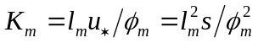 (1a)
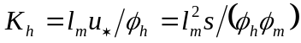, (1b)
where the friction velocity is given by
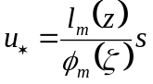, (2)
the vertical wind shear by
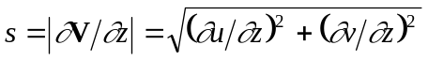, (3)
and the mixing length in the surface layer by
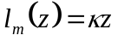, (4)
where k is von K‡rm‡n’s constant, and z is height above the surface. This investigation is restricted to shear functions of the following forms
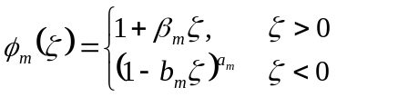 (5a)
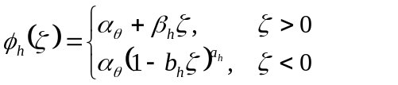 (5b)
where the constants 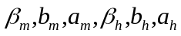, and 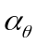 are determined empirically (see Table I). The results obtained by Businger et al. (1971) were for a von K‡rm‡n’s constant of k = 0.35. The functions (5) are also referred to as flux profile relationships. There has been controversy concerning the value of von K‡rm‡n’s constant and whether 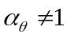 (see Dyer, 1974; Yaglom, 1977; Hšgstršm, 1985; Telford and Businger, 1986; Hšgstršm, 1986; Hšgstršm, 1988; Kaimal and Finnigan, 1994). Results from more precise instrumentation than that used by Businger et al. (1971) indicate that k = 0.40 and = 1.00. Nevertheless, the functions in (5) will be taken to be ‘known’ in this work because of their generality. The Ri-based stability functions will be derived from the functions in (5). A consistent set of values can then be used (such as from Table I) to provide first-order closure. The authors are not advocating that = 0.74, although this value will be used later on for comparison of results with those of Businger et al., (1971). The Businger et al. (1971) results are considered in order to gauge the extent of the deviation of Pr from 1.00 in the SBL. The derivation of the Ri-based stability functions from the flux profile relationship (5) is kept general with , bm , bh , bm , and bh unspecified. However, for the sake of brevity, the stability functions are derived only for the momentum and heat exponents of am = -1/4 and ah = -1/2, respectively. The momentum exponent am = -1/3 for the very unstable regime (Carl et al., 1973) is not considered. Changes in the functional form of the shear functions (such as the changes in equations (5) at z = 0) can introduce unwanted noise in numerical solutions in both space and time, because higer-order derivatives are not continuous. It will be shown that the stability functions also change form slightly when the Pr = 1.0 in the SBL
The dimensionless Monin-Obukhov height is , where is the Monin-Obukhov length and is the buoyancy parameter, and q0 a scaling temperature. The friction temperature,
, (6)
is analogous to the friction velocity in (2), where q is potential temperature. The definition of the friction parameters (2) and (6) is circular (not closed-form) because they are expressed in terms of the shear functions (5), which depend upon z, which in turn depends on the friction parameters. In numerical computations an iterative scheme is usually required to solve (2) and (6). Furthermore, such a circular formulation does not easily lend itself to the application of Bendixson’s criterion, which addresses the existence of limit cycles in a two-dimensional dynamical system, because derivatives cannot be resolved analytically (see England and McNider, 1994).

2.2. RICHARDSON NUMBER FORMULATION
The Richardson number is defined by
. (7)
Using (2), (6) and (7), a well-known relationship can be derived that expresses Ri as a function of z, i.e.,
(8)
An analogous expression for z as a function of Ri will be derived after the stability functions have been discussed.
Monin-Obukhov theory holds for all values of z. However, a Ri formulation breaks down past a critical value. The critical Richardson number (Ric), which corresponds to an infinite z, is found by taking the following limit
. (9)
The critical value is usually taken to be between 1/5 and 1/4.
Substitution of the profiles (5) for the SBL into (8) results in a quadratic equation,
, (10)
which can be solved to yield
, . (11)
The negative root has been taken because z(0) = 0. Also, when , the relationship (11) is simply
, (12)
a form used by Paulson (1970) and Blackadar (1979) among others. Repeating the procedure used to obtain (10) for the SBL results in the cubic equation
(13)
for the UBL. The algebraic solution of (13) is given in the Appendix.

3. Stability Functions
In the Ri formulation, the exchange coefficients are
(14a)
, (14b)
where and are stability functions for momentum and heat. Comparison of (1) and (14) yields
(15a)
. (15b)
The stability functions are now known implicity, because for a given Ri, (11), (12) or (13) can be used to solve for z, which in turn can be used in (5) and then (15) to give the corresponding values of the stability functions. However, one of the goals of this work is to obtain an explicit functional form of the stability functions so that they can be physically analyzed. This goal is only partially achieved because of the cubic equation (13) for the UBL. A systematic approach is outlined that may seem to be mathematically excessive but is followed because of its generality, i.e., the same approach can be used to derive expressions for the stability functions for different exponent values such as am = -1/3. In fact, the approach may also work for shear functions that do not have the form of (5). Also, in a numerical setting the Ri approximation in the lower level(s) has not been made to depend explicity upon the surface roughness as is customary for z.
The relationships (2), (6) and (15) give a friction velocity and temperature
(16a)
, (16b)
which are expressed in terms of stability functions and Ri. Equations (16), along with , can be used to relate z to Ri, i.e.,
. (17)
Equation (17) can be considered to be the dual of (8) and will be instrumental in deriving the stability functions from (5) and (15). To the authors’ knowledge this relationship has not appeared previously in the literature, although Paulson (1970) did present a relationship similar to (17) based upon the KEYPS equation
. (18)

3.1. STABLE BOUNDARY LAYER
Before deriving the stability functions in the SBL, it is necessary to discuss the (turbulent) Prandtl number, because the functional form of the stability functions will depend upon it. The Prandtl number, defined by
(19)
(see e.g., Garratt, 1992) is a ratio that expresses the relative efficiency of the mixing of heat and momentum. In general, it depends upon atmospheric stability, i.e.,
. (20)
In the SBL a z formulation for (20) is
. (21)

3.1.1. Pr ¹ 1
If , then . Hence, Pr increases asymptotically from for a neutral atmosphere to as stability increases, i.e., . The small variation of Pr is justification for assuming it to be constant in the SBL. The assumption may not be a valid for the UBL.
The stability functions for the SBL based upon the profiles (5) will be derived before considering the more diffcult UBL regime. From Table I, it can be seen that in the SBL. In the subsequent analysis, therefore, we set . The analysis can be carried out without this assumption, but the authors feel that it is unwarranted. From (5), (15) and (17) we have
(22a)
. (22b)
Equation (22a) can be manipulated to yield
. (23)
Substitution of (23) into (22b) gives the following quadratic equation in , i.e.,
, (24)
which can be solved to yield
. (25)
The negative root has been taken because (15a) implies that . The stability function for momentum is then simply
. (26)
The solution (25) is not valid for (24) if . This case will later be shown to coincide with the assumption that Pr = 1 in the SBL. Now that the stability function for momentum is known, the one for heat can be found from (23). Comparison of equations (20) and (23) gives Pr as a function of Ri in the SBL, i.e.,
(27)
Using the fact that , (26) can be divided by (27) to give
(28)
The graphs of the stability functions and Pr are given in Fig. 1, based upon the profiles (5).

3.1.2. Pr =1
In this section, we consider the stability functions for a Prandtl number identically equal to one in the SBL, i.e.,
. (29)
The above assumption, which is supported by the data, implies that we must have and . In this case substituting (12) into (15a) or solving (24) gives
(30)
or
(31)
since . For comparison with Fig. 1, the functions and are shown in Fig. 4. Notice that the quadratic form (31) for is smoother than the linear form proposed by Blackadar (1979), i.e.,
(32)
The stability function (31) is preferrable over (32) for two reasons. First, it is derived from the flux profile relationships under the assumption of Pr = 1 in the SBL, which are determined from data. Second, (31) is smoother than (32), i.e., (31) has a continuous derivative in the SBL, while the derivative of (32) has a discontinuity at the critical Richardson number. The advantages of this additional degree of smoothness are discussed later. Also, numerical models that employ (32) can be modified to (31) by the addition of a single line of code where the stability function is merely squared in the SBL.

3.2. UNSTABLE BOUNDARY LAYER
The analysis in this section will only be carried out for the exponents given by Businger et al. (1971). Just as for the SBL, (5) and (15) can be used to solve for the stability functions in the UBL, i.e.,
(33a)
. (33b)
Solving equation (33a) for the heat stability function yields
, (34)
which gives
. (35)
Substitution of (34) in (33b) gives a cubic equation in , i.e.,
. (36)
Equation (36) could be solved by algebraic methods, but the algebraic functional form is cumbersome and is therefore not presented explicity. We take the equivalent approach of using the solution of (13) for a given (negative) Ri and then using (15) to calculate the values of the stability functions. The stability functions and Pr obtained by this procedure are shown in Fig. 2.

3.3. PROFILE APPROXIMATIONS
The desired solution of (36) is almost a straight line as can be seen by reconsidering (8) for the UBL, i.e.,
, (37)
for , or , where . For , and , , i.e., z is five percent larger in magnitude than Ri in the UBL. This result agrees quite well with the factor of four percent based upon the Kansas wheat-field data analyzed by Businger et al. (1971). Using (37) in (15a) and squaring produces , which is approximately linear. Thus, the approximate momentum stability function is
, (38)
which agrees well with previously obtained results (Blackadar, 1979). The corresponding heat stability function is
(39)
giving
. (40)
These approximate functions are shown in Fig. 3. For smaller values equation (37) gives the approximation , i.e., in the near-neutral regime @ 1.33.
To test the validity of the approximate stability function (38), a relationship will be derived, which the induced shear functions would have to satisfy. Substitution of (8) into (38) and using (15a), implies that
, (41)
where . The process could be repeated for (39) to obtain a higher-order multinomial, which is not presented. Note that if in (41), then the KEYPS equation (18) is obtained. For the profiles (5), equation (41) would be exactly satisfied in the UBL if and . This indicates that the KEYPS equation may be valid only in the near-neutral regime where Pr @ 1.

4. Smoothness
Smoother stability functions (continuous functions having continuous derivatives) can be obtained from smoother shear functions (5). Smoother exchange coefficients are more desirable because they should produce smoother solutions. For example, in the SBL for Pr = 1, the quadratic form (31) for is smoother than the linear form (31), because the derivative of (31), i.e.,
(42)
is continuous at Ric. This smoothness is important in carrying out dynamical analyses of boundary layer systems (England and McNider, 1994; McNider et al., 1994). It is also expected that numerical solutions using these forms will have less noise in time and space.
Similarly, an added degree of smoothness can be obtained in the near-neutral regime if the following conditions are met:
(43a)
(43b)
From Table I, it can be seen that these conditions are almost met.
The conditions of (43) also provide a means of extrapolating parameter values for the SBL. Specifically, the further assumption of produces . For the exponent values of , (43b) reduces to . For the other parameters are , values which are close to those usually cited. These results indicate that the derivatives of the shear (stability) functions are continuous at atmospheric neutrality. This assertion is further supported by the data (see e.g. Businger et al., 1971), which indicate that the shear functions are very smooth. To address the question of smoothness, the optimal values for the constants in (5) would have to be re-estimated with the imposed constraints (43), perhaps by more robust nonlinear estimations techniques.
Ideally, a single, smooth shear (stability) function, one each for momentum and heat, would be best because the change in functional form of the functions from the UBL to the SBL necessitates the use of conditional statements in the source codes of numerical models and hinders the optimization of the code.
Some numerical modelers introduce discontinuities in vertical derivatives by using a z formulation for the lower level(s) and a Ri formulation for the upper levels that are inconsistent. This problem can be overcome by using the approximations in the next section.

5. Contrast of Formulations
From the preceeding discussion, it was seen that the Ri formulation is equivalent to a z formulation. However, in finite-difference models, the lowest level is usually treated differently. Equations (1), (2), (4) and (6) can be combined to produce the following relations
(44a)
, (44b)
(44c)
where . The friction parameters in the lowest level are approximately
, (45a)
, (45b)
where is the height of the lowest level (see Panofsky, 1963). Note that the lower limit of integration of (45a) should be , but the approximation is usually made. The mathematical evaluation of the integrals in (45) are straightforward in the SBL because the shear functions are linear. The process is more difficult in the UBL (see Paulson, 1970; Nickerson and Smiley, 1975; or Benoit, 1977). It should be pointed out that there is a minor difference between the ground temperature, qg = q(0), and the temperature at the roughness height, . In fact, Blyth et al. (1993) indicates that the assumption of equal roughness heights for momentum and heat is a poor one. However, for heat, there is not a “nice” definition for the roughness height such as = 0 for momentum. The roughness height for heat would be the lowest height for which similarity theory is valid for the thermal boundary layer. Also, the ground temperature, qg = q(0), is not easily determined because actual ground is a “fuzzy” boundary. The difficulties encountered by these ambiguities are different depending upon whether one is working with observations or performing numerical simulations. In the case of observations, the heat roughness height is usually taken to be the lowest height that the temperature can be accurately measured. In the numerical case, temperature is parameterized by equations such as Blackadar’s (1979) slab model.
In practice, calculating the friction parameters from (45) requires an iterative procedure because the upper limit of integration also depends upon the friction parameters. This time-comsuming procedure can be circumvented in a Richardson number formulation. However, a forward difference approximation to the lowest-layer Ri produces the bulk Richardson number,
, (46)
which does not depend directly upon (although it should), but does depend upon the ambiguous ground temperature. Recall that the z formulation incorporated the dependence by means of a logarithmic transformation and the chain rule in the form of
. (47)
Thus, equations (16a) and (16b) in centered finite-difference approximation form are
(48a)
. (48b)
Logically, Ri must also go through the same transformation. Under a logarithmic transformation
, (49)
so that the approximation to Ri is
, (50)
where , or . Thus the new, effective, average depth for Ri is . The transformation can be performed without assuming equal roughness heights for heat and momentum, yielding a more involved result than (50). Finally, the closed-form Ri formulation should now be fully equivalent to the z formulation. The relations (48) can be manipulated to yield
(51a)
, (51b)
which can then be used in conjunction with (44) to approximate the momentum and heat fluxes.

6. Conclusion
This paper outlines a consistent, closed-form, Richardson-number approach for a smooth, first-order, K-closure, boundary-layer, numerical model that does not require iterative procedures for a constant surface roughness. On the whole, the mathematical results of this paper agree well with the observations and theoretical results of other researchers. However, the stability function (31) for the SBL is preferrable over (32) for two reasons. First, it was derived from the flux profile relationships (5) for Pr = 1.0 in the SBL. Second, both the function and its derivative are continuous, which should produce smoother results. Shear or stability functions that do not change form from the SBL to the UBL would add an additonal degree of smoothness. Also allowing numerical models based upon first-order K-closure to be greatly optimized. Such functions must be based upon observations. Additional work is required to generalize the Ri parameterized fluxes to include evaporation as well as sensible heat transfer.

Acknowledgments
The authors would like to thank M. P. Singh for a very astute observation and William B. Norris for his review of the manuscript. This work was supported in part by the Division of Atmospheric Sciences, National Science Foundation under Grant ATM-9120321.

Appendix
To solve (13), define the following quanities:
(A1)
. (A2)
There are two negative Richardson numbers a and b such that . These points are given by
(A3)
(A4)
For the profiles (5) the values are approximately . The nondimensional height for a given Richardson number in the unstable boundary layer based upon (5) is given by
, (A5)
where (w in radians).

References
Antonia, R. A., Danh, H. Q., and Prabhu, A.: 1977, ‘Response of a Turbulent Boundary Layer to a Step Change in Surface Heat Flux’, J. Fluid. Mech. 80, 153-177.
Benoit, R.: 1977, ‘On the Integral of the Surface Layer Profile-Gradient Functions’, J. Appl. Meteorol. 16, 859-860.
Blackadar, A. K.: 1979, ‘High Resolution Models of the Planetary Boundary Layer’, Adv. Environ. Sci. Eng. 1, 50-85.
Blyth, E. M., Dolman, A. J., and Wood, N.: 1993, ‘Effective Resistance to Sensible- and Latent-Heat Flux in Heterogeneous Terrain’, Quart. J. Roy. Meterol. Soc. 119, 423-442.
Businger, J. A., Wyngarrd, J. C., Izumi, Y., and Bradley, E. F.: 1971, ‘Flux-Profile Relationships in the Atmospheric Surface Layer’, J. Atm. Sci., 28, 181-189.
Carl, D. M., Tarbell, T. C., and Panofsky, H. A.: 1973, ‘Profiles of Wind and Temperature from Towers Over Homogeneous Terrain’, J. Atm. Sci., 30, 788-794.
Dyer, A. J., and Bradley, E. F.: 1982, ‘An Alternative Analysis of Flux-Gradient Relationships at the the 1976 ITCE’, Boundary-Layer Meteorol., 22, 3-19.
Dyer, A. J., and Hicks, B. B.: 1970, ‘Flux-Gradient Relationships in the Constant Flux Layer’, Quart. J. Roy. Meteorol. Soc. 96, 715-721.
Dyer, A. J.: 1974, ‘A Review of Flux-Profile Relationships’, Boundary-Layer Meteorol., 7, 363-372.
England, D. E., and McNider, R. T.: 1994, ‘Absence of Limit Cycles in a Two Layer Nocturnal Slope Flow Model’ (in preparation, to be submitted to Nonlinear World)
Garrat, J. R.: 1992, The Atmospheric Boundary Layer, Cambridge University Press, 316 pp.
Hicks, B. B.: 1971, ‘Wind Profile Relationships from the Wangara Experiment’, Quart. J. Roy. Meteorol. Soc. 102, 535-551.
Hšgstršm, U.: 1985, ‘Von Karman’s Constant in Atmospheric Boundary Layer Flow: Re-evaluated’, J. Atm. Sci., 42, 263-270.
Hšgstršm, U.: 1986, ‘Reply’, J. Atm. Sci., 43, 2131-2134.
Kaimal, J. C., and Finnigan, J. J.: 1994, Atmospheric Boundary Layers Flows: Their Structure and Measurment, Oxford University Press, New York, 289 pp.
Mahrt, L.: 1989, ‘Limit Cycle Mixing’, J. Atm. Sci. 46, 1061-1075.
McNider, R. T., England, D. E., Friedman, M. J., and Shi, X.: 1994, ‘On the Predictability of the Stable Boundary Layer’, (accepted byJ. Atm. Sci.,)
Nickerson, E. C., and Smiley, V. E.: 1975, ‘Surface Layer and Energy Budget Parameterizations for Mesoscale Models’, J. Appl. Meteorol., 14, 297-300.
Panofsky, H. A.: 1963, ‘Determinations of Stress from Wind and Temperature Measurements’, Quart. J. Roy. Meteorol. Soc., 89, 67-90.
Paulson, C. A.: 1970, ‘The Mathematical Representation of Wind Speed and Temperature Profiles in the Unstable Atmospheric Surface Layer’, J Appl. Meteorol. 9, 85-94.
Telford, J. W., and Businger, J. A.: 1986, ‘Comments on “Von Karman’s” Constant in Atmospheric Boundary Layer Flow: Re-Evaluated’, J. Atm. Sci., 43, 2127-2130.
Webb, E. K.: 1970, ‘Profile Relationships: The Log-Linear Range and Extensions to Strong Stability’, Quart. J. Roy. Meteorol. Soc., 96, 67-90.
Yaglom, A. M.: 1977, ‘Comments on Wind and Temperature Flux-Profile Relationships’, Boundary-Layer Meteorol. 11, 89-102.
TABLE I
Some estimated values for the unknown constants in the shear functions (5).

Author | Constants |  |  |  |  |  |  |  |  |  |  |  |  |  |  |  | Range of z
 | k
Dyer and Hicks (1970) | 0.41 | 1.00 | -1/4 | 16 | -1/2 | 16 |  |  | -1.0; 0.0
Webb (1970) | 0.41 | 1.00 |  |  |  |  | 5.2 | 5.2 | -0.03; 1.0
Businger et al. (1971) | 0.35 | 0.74 | -1/4 | 15 | -1/2 | 9 |  |  | -1.0; 0.0
 |  |  |  |  |  |  | 4.7 | 4.7 | 0.0; 2.0
Carl et al. (1973) | 0.41 | 1.00 | -1/3 | 16 |  |  |  |  | -10.0; -2.0
 | 0.41 | 1.00 | -1/4 | 16 |  |  |  |  | -2.0; 0.0
Dyer (1974) | 0.41 | 1.00 | -1/4 | 16 | -1/2 | 16 | 5.0 | 5.0
Hicks (1976) |  |  |  |  |  |  | 5.0 | 5.0 | 0.02; 1.0
Dyer and Bradley (1982) | 0.40 | 1.00 | -1/4 | 28 | -1/2 | 14

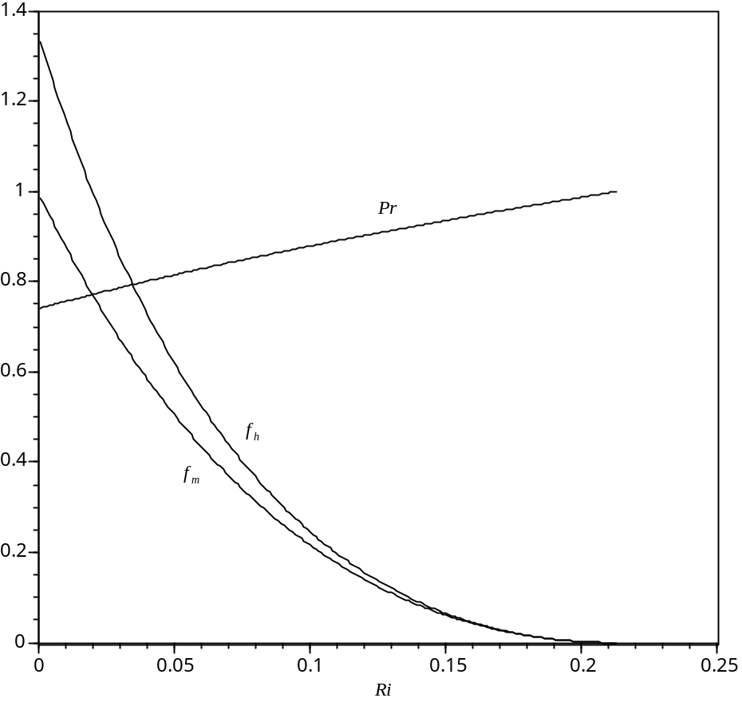
Fig. 1. Stability functions for the stable boundary based upon the profiles (5).

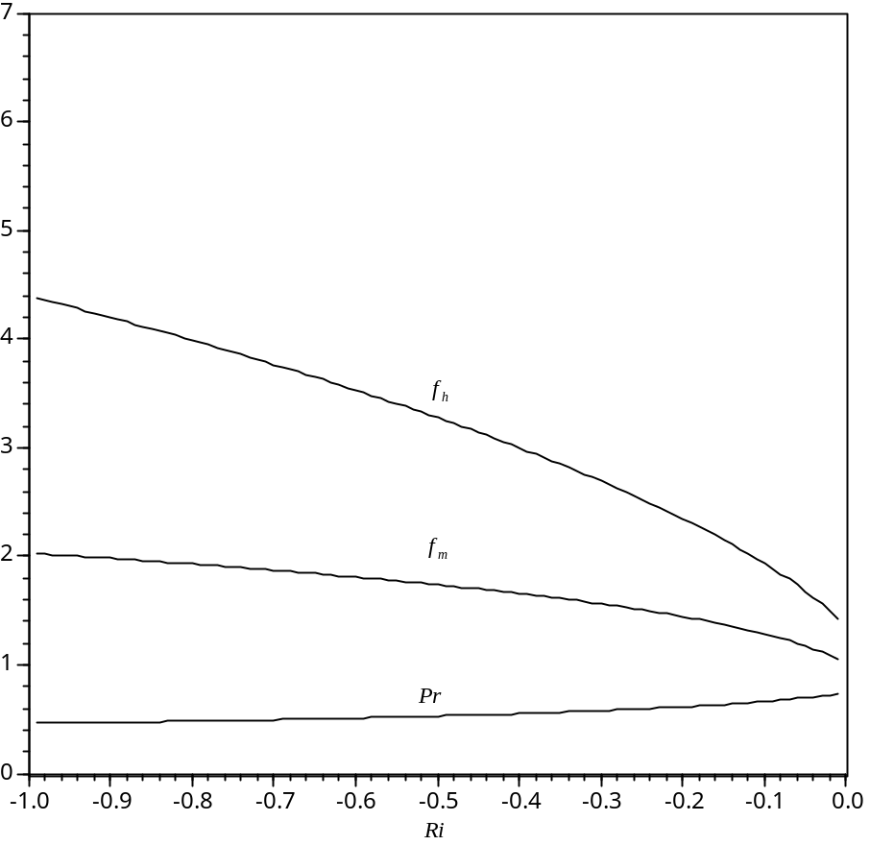
Fig. 2. Stability functions for the unstable boundary based upon the profiles (5).

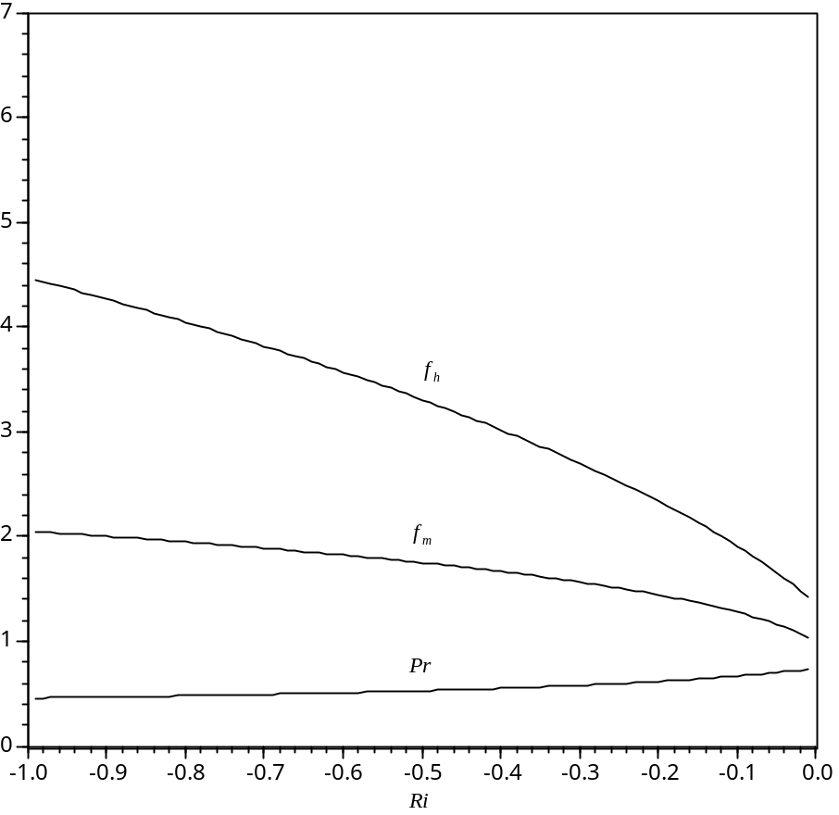
Fig. 3. Approximate stability functions for the unstable boundary.

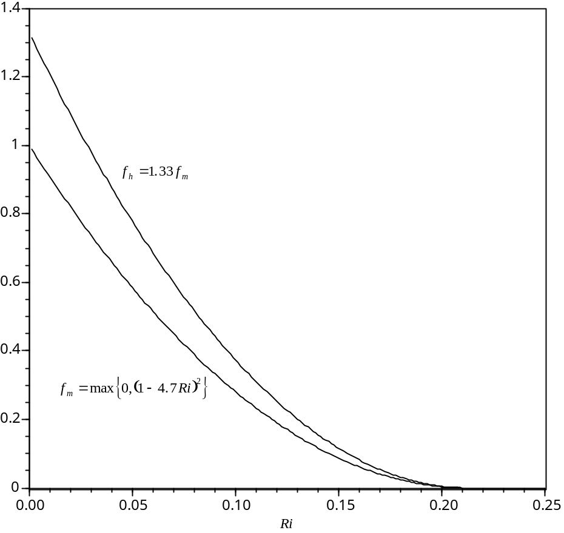
Fig. 4. Approximate stability functions for the stable boundary layer.

