Software Engineering Group Project
Title
Author: | David
Config Ref: | SE_05_xxx_xx
Date: | 2015-10-17
Version: | x.x
Status: | Release/Draft/Review
Department of Computer Science
Aberystwyth University
Aberystwyth
Ceredigion
SY23 3DB
Copyright © Aberystwyth University 2015

CONTENTS
CONTENTS 2
1. Introduction 2
2. Purpose of this Document 2
2.2 Objectives 2
3. BODY OF DOCUMENT 2
REFERENCES 2
DOCUMENT HISTORY 2

Introduction
Clear, consistently followed, document standards are essential in software engineering.
Add your own intro here stating why this document exists

Purpose of this Document
This document is to describe an MS Word template.
Add what this document will describe

Scope
This supports the standards laid down for CS22120 Group Projects [1].
Add what context this should be taken in, is it “To assist in the deployment of Java” or limited to “The standard of code used in java…”

Objectives
The objective of this document is to both carry the template and explain a little of how it works.
These should be like outcomes such as at the end of this document the reader should understand how a foo fits into a bar. The more measurable to objective is the better it is.

BODY OF DOCUMENT
Front material is stored in document properties. These are not the correctly named properties but their use permits automation of running header update. Editing the front material will make changes throughout the document.
Titles, headings, body, bibliography entries, captions and table of content entries are defined as shown in Figure 1

Select the text then the style it should be – the styles are self-descriptive. If you are not sure get somebody else to double check your documents and explain it to you.
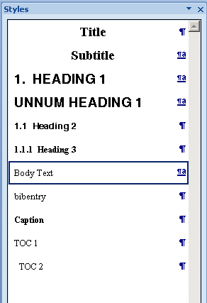
Figure 1: Recommended styles

REFERENCES
DON’T forget to reference anything you are paraphrasing or quoting…etc. Including QA documents!
[1] Software Engineering Group Projects: General Documentation Standards. C. J. Price, N. W. Hardy, B.P. Tiddeman. SE.QA.03. 1.8 Release

DOCUMENT HISTORY
Version | CCF No. | Date | Changes made to document | Changed by
1.0 | N/A | 12/09/08 | N/A - original version | CJP
1.1 | N/A | 2010-10-12 | Updated to Office 2007; key field automation increased; paragraph styles updated | NWH
1.2 | N/A | 2011-10-10 | Typos | NWH
1.3 | N/A | 2015-10-16 | Update for Office 2013 | NWH

