**Exercícios Unidade00i:**

1)

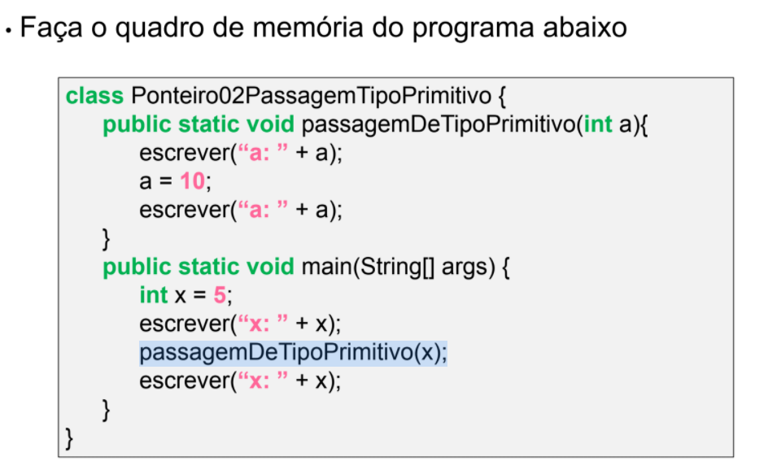

**Resposta:**

|  |  |  |  |
| --- | --- | --- | --- |
| Memoria |  |  | Tela |
| x: 5 | 75h |  | x: 5 |
| a: 5 => 10 | 76h |  | a: 5 |
|  | 78h |  | a: 10 |
|  | 7Ah |  | x: 5 |

2)

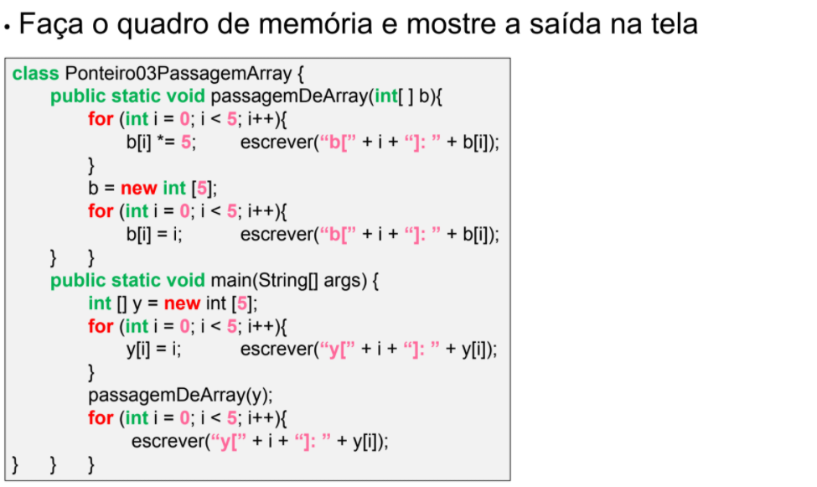

**Resposta:**

|  |  |  |  |
| --- | --- | --- | --- |
| Memoria |  |  | Tela |
| Y: 7Eh | 75h |  | Y[0]: 0 |
| B: 7Eh => 78h | 76h |  | Y[1]: 1 |
|  | 77h |  | Y[2]: 2 |
| 0 | 78h |  | Y[3]: 3 |
| 1 | 79h |  | Y[4]: 4 |
| 2 | 7Ah |  | B[0]: 0 |
| 3 | 7Bh |  | B[1]: 5 |
| 4 | 7Ch |  | B[2]: 10 |
|  | 7Dh |  | B[3]: 15 |
| 0 | 7Eh |  | B[4]: 20 |
| 1 => 5 | 7Fh |  | B[0]: 0 |
| 2 =>10 | 80h |  | B[1]: 1 |
| 3 =>15 | 81h |  | B[2]: 2 |
| 4 =>20 | 82h |  | B[3]: 3 |
|  |  |  | B[4]: 4 |
|  |  |  | y[0]: 0 |
|  |  |  | y[1]: 5 |
|  |  |  | y[2]: 10 |
|  |  |  | y[3]: 15 |
|  |  |  | y[4]: 20 |

3)

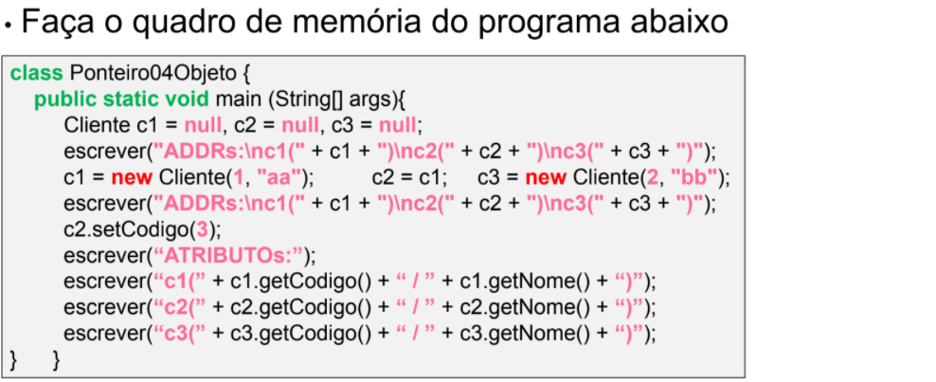

**Resposta:**

|  |  |  |  |
| --- | --- | --- | --- |
| Memoria |  |  | Tela |
| C1: null => 79h | 75h |  | ADDRs: |
| C2: null => 79h | 76h |  | C1: null |
| C3: null => 7Ah | 77h |  | C2: null |
|  | 78h |  | C3: null |
| |  |  | | --- | --- | | 1 => 3 | “aa” | | 79h |  | ADDRS: |
| |  |  | | --- | --- | | 2 | “bb” | | 7Ah |  | C1: 79h |
|  | 7Bh |  | C2: 79h |
|  | 7Ch |  | C3: 7Ah |
|  | 7Dh |  | ATRIBUTOs: |
|  | 7Eh |  | C1(3 / aa) |
|  | 7Fh |  | C2(3 / aa) |
|  | 80h |  | C3(2 / bb) |

**4)**

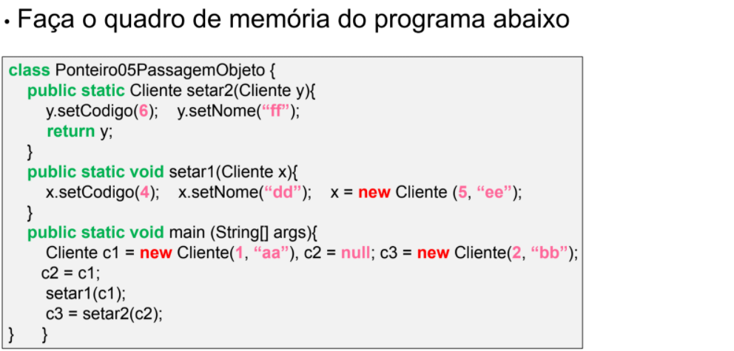

**Resposta:**

|  |  |
| --- | --- |
| Memoria |  |
| C1: 79h | 75h |
| C2: null => 79h | 76h |
| C3: 7Ah => 79h | 77h |
|  | 78h |
| |  |  |  | | --- | --- | --- | | 1 | aa | | | 4 | dd | | | 6 | | ff | | 79h |
| |  |  | | --- | --- | | 2 | bb | | 7Ah |
| |  |  | | --- | --- | | 5 | ee | | 7Bh |
|  | 7Ch |
| X: 79h => 7Bh | 7Dh |
| Y: 79h | 7Eh |
|  | 7Fh |
|  | 80h |

**5)**

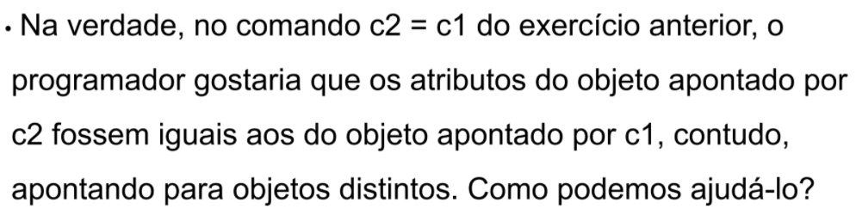

**Resposta:**

O programador poderia utilizar um método para copiar o conteúdo de c1 para c2

|  |
| --- |
| public static Cliente copia(){  Cliente copia = new Cliete();  copia.codigo = this.codigo;  copia.nome = this.nome;  return copia;  } |

6)

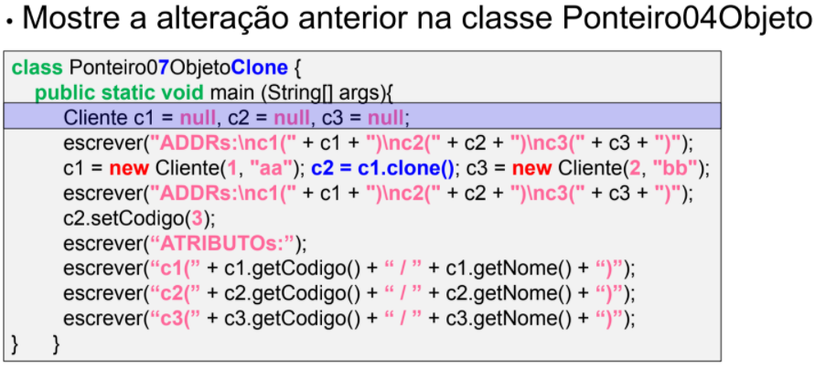

**Resposta:**

|  |  |  |  |
| --- | --- | --- | --- |
| Memoria |  |  | Tela |
| C1: null => 79h | 75h |  | ADDRs: |
| C2: null => 7Bh | 76h |  | C1: null |
| C3: null => 7Ah | 77h |  | C2: null |
|  | 78h |  | C3: null |
| |  |  | | --- | --- | | 1 => 3 | “aa” | | 79h |  | ADDRS: |
| |  |  | | --- | --- | | 2 | “bb” | | 7Ah |  | C1: 79h |
| |  |  | | --- | --- | | 1 => 3 | “aa” | | 7Bh |  | C2: 79h |
|  | 7Ch |  | C3: 7Ah |
|  | 7Dh |  | ATRIBUTOs: |
|  | 7Eh |  | C1(3 / aa) |
|  | 7Fh |  | C2(3 / aa) |
|  | 80h |  | C3(2 / bb) |

7)

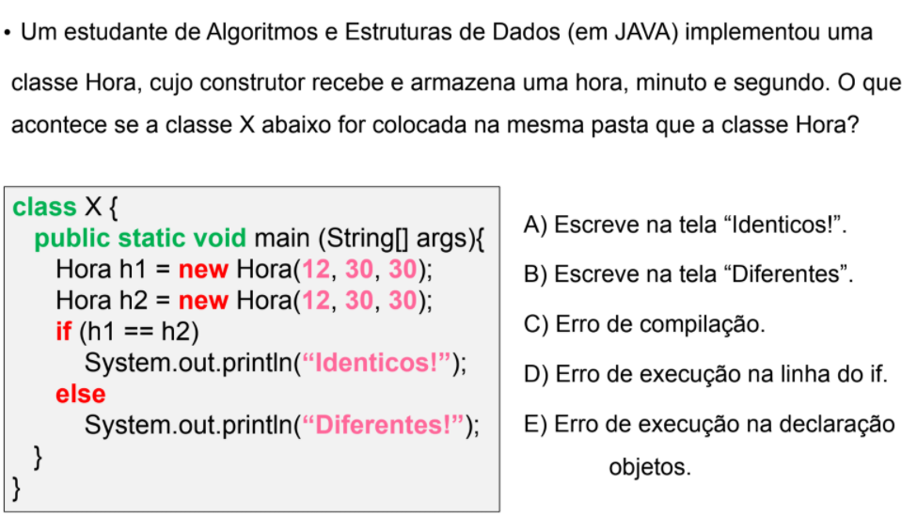

**Resposta:**

* B) Escreve na tela “Diferentes”.

**8)**

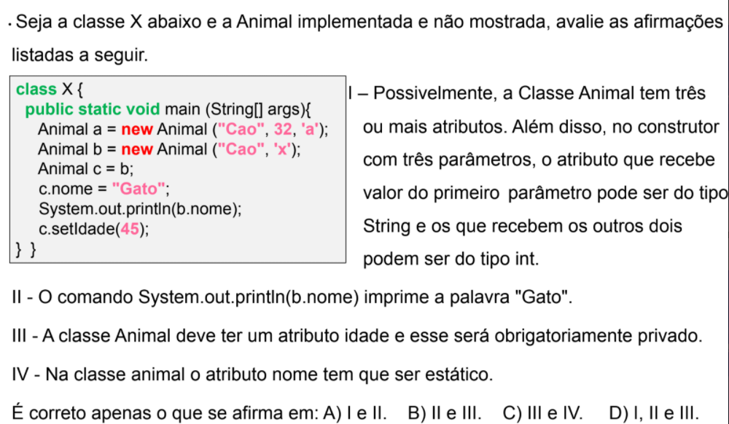

**Resposta:**

* A) I e II.