The Great Wealth Transfer
An Agent-Based Modelling Approach for France, Germany, and Italy
Arnstein Aassve, Letizia Mencarini, Elisa Del Frari, David Feitzinger, Luca Neroni

Chapter 1 — Introduction
"There are basically two ways to become rich: either through one's own work or through inheritance." — Thomas Piketty (2011)

Within the next two to three decades, the advanced economies will witness the largest intergenerational transfer of private wealth in recorded history. Global estimates place the volume of inheritances and inter-vivos gifts changing hands over the coming twenty to twenty-five years at more than €64 trillion (UBS, 2025). Over a fifty-year horizon, this report estimates that intergenerational transfers in France, Germany, and Italy — the three largest economies of the European Union — will exceed €7 trillion. This is not a single event but a gradual process, one whose scale is without historical parallel even though its unfolding might largely go unnoticed.
The origins of a transfer of this magnitude can be well grasped in generational terms. At its center stands the Baby Boomer generation, born approximately between 1946 and 1964 and constituting the largest birth cohort in modern European history. Having entered the labour market during decades of sustained growth, acquired residential property at prices that now appear exceptionally low, and lived through four decades of near-continuous asset-price appreciation, this cohort has come to hold a historically high concentration of wealth. Most of this wealth is expected to be transferred to members of Generation X (born 1965–1980) and the Millennials (born 1981–1996), whereas Generation Z (born 1997–2012) will benefit only more distantly, since by the time wealth descends to it much of that capital will already have been reshaped by the financial decisions of the recipients preceding it.
Three structural forces have converged to produce such a transfer, each carrying distinct implications for the identity of its beneficiaries and the magnitude of those benefits.
The first is rising longevity. Over the past half-century, life expectancy in Europe has increased by approximately a decade, and the Boomer generation has been its principal beneficiary. Living longer, its members have accumulated more, and they will bequeath their wealth to heirs who are themselves already close to, or already in, retirement.
The second force is declining fertility. Throughout most of the twentieth century, European fertility rates were sufficient to sustain relatively balanced population pyramids; from the late 1970s onward, however, this ceased to be the case. Fertility fell below the replacement level of 2.1 children per woman, standing in 2025 at 1.56 in France, 1.32 in Germany, and 1.14 in Italy. The cumulative effects of more than four decades of sub-replacement fertility, particularly pronounced in Italy, have given rise to a demographic trap: progressively smaller birth cohorts resulting not only from persistently low fertility but also from the shrinking number of potential parents, themselves members of the smaller generations born roughly three decades earlier. Combined with increasing life expectancy, this process is driving the population pyramid toward inversion, whereby the cohorts positioned to inherit are not only smaller than those positioned to bequeath wealth but also, on average, older at the time of inheritance than previous generations. This demographic transformation has concentrated wealth within the Baby Boomer generation, a large and long-lived cohort supported by an increasingly narrow base of younger successors. As a consequence, each heir stands to inherit a proportionally larger share of accumulated wealth, simply because there are fewer beneficiaries among whom it must be divided.
The third force is the concentration of wealth, both between and within generations. In France, Germany, and Italy, households headed by individuals aged 65 and over account for around 35% of total household wealth. Moreover, the richest 10% of households own roughly 55% of household wealth in the euro area, and the top 1% receives approximately 15% of all inheritances (Morelli et al., 2025). Thus, the largest inheritances are likely to accrue to those already at the top of the wealth distribution, making the forthcoming transfer highly unequal.
These forces are mutually reinforcing. Longer lives postpones inheritance. At the same time, smaller cohorts of heirs translate into larger inheritances per recipient, while high levels of wealth concentration ensure that these larger transfers accrue disproportionately to those who are already the wealthiest. The combined effect is a transfer structurally tilted toward the already affluent and arriving late in the life cycle of recipients.
This report examines the way this process will unfold across France, Germany, and Italy over the period 2021–2075. Three questions structure the analysis: 1) over what time horizon the transfer will unfold; 2) who the future heirs are, and what demographic and wealth profile they present; and 3) how much heirs will receive, and how these amounts vary across the wealth distribution.
To address these questions, an Agent-Based Model (ABM) was developed to simulate the life trajectories of nine thousand households from France, Germany and Italy on an annual basis from 2021 to 2075. The initial population comprises households whose head is aged 57 or above, drawn from the 2021 wave of the Household Finance and Consumption Survey (HFCS) coordinated by the European Central Bank. This ensures that the simulations are anchored on the observed demographic and wealth distribution of each country. The model reproduces three interdependent processes jointly: demographic cycle, in which individuals age and die according to mortality risks drawn from Eurostat projections; wealth dynamics, in which household wealth evolves along empirically estimated age–wealth profiles that vary by wealth quartile; and intergenerational transmission, in which the death of the parent(s) heading the household passes accumulated wealth to children, gross of country-specific inheritance taxes. Taken together, these mechanisms enable a year-by-year account of how much wealth changes hands, who receives it, and how the distribution of wealth is thereby altered.
The report proceeds as follows. Chapter 2 sets out the demographic and economic background to the transfer, tracing the forces — longevity, fertility decline, and wealth concentration — that have brought Europe to its present juncture. Chapter 3 turns to the projections generated by the model: the timing and scale of transfer flows, the profile of future heirs, and the distributional consequences of receiving an inheritance at different points in the wealth and age distributions. Chapter 4 draws out the implications of these findings for three constituencies — citizens, policymakers, and financial institutions.

Chapter 2 — The Great Wealth Transfer: Demographic and Economic Background
Europe stands on the threshold of a wealth transfer without modern precedent. This report estimates that more than €7 trillion will pass between generations across France, Germany, and Italy over the next five decades. Three structural forces have converged to produce the transfer: rising longevity, a pronounced fertility decline, and the historic concentration of wealth within the Boomer generation. These forces do not operate in isolation, and it is their interaction that renders the forthcoming transfer at once so large, so skewed, and so resistant to reversal. This chapter highlights the extent to which demographic trends shape the timing, magnitude, and distribution of the upcoming intergenerational wealth transfer.

2.1 Longevity: longer lives, wealthier decedents, older heirs
Over the past fifty years, life expectancy at birth in Europe has risen by approximately a decade, comfortably exceeding eighty years across most of Western Europe. However considerable an achievement this represents in its own right, it carries consequences for the intergenerational distribution of wealth that are only now becoming fully apparent.
The most direct of these consequences is that wealth-holders die at older ages. In Italy, life expectancy at age 65 stood at 21.3 years in 2020 and is projected by Eurostat to reach 25.6 years by 2070. The share of the very old — those aged 85 and above, among them a rapidly expanding population of centenarians — is rising across all three countries and is projected to continue doing so through mid-century. Within the over-65 population, moreover, growth is increasingly concentrated toward the upper ages: the proportion of the “younger old” (65–74) is falling, while that of the “old” (75–84) and the “very old” (85+) is rising in both absolute and relative terms.
Because people live longer, wealth is transferred to heirs at progressively older ages. Inheritance now commonly arrives after the recipient has already passed the age of fifty, and increasingly while the recipient is already retired.

2.2 Fertility: sub-replacement and smaller cohorts of heirs
In addition to longevity, long-term changes in fertility constitute an important demographic determinant of the scale of the forthcoming transfer.
Throughout most of the postwar period, European fertility rates sufficed to sustain broadly balanced population structures. France maintained rates close to or above replacement well into the 1970s, sustained by a long tradition of family policy, while Germany and Italy both recorded rates comfortably above 2.0 through the 1960s. The subsequent decline, particularly in Southern Europe, has proved both deep and durable. Italy's total fertility rate fell from approximately 2.4 in 1960 to below replacement by the mid-1970s and has since continued to fall, reaching 1.14 in 2025— the lowest in its history and among the lowest rates recorded anywhere in the developed world. Germany has followed a broadly comparable trajectory, standing in 2025 at 1.32, whereas France, though more resilient, has also declined sharply in recent years, to 1.56.

Country | 1960 | 2025
France | 2.85 | 1.56
Germany | 2.37 | 1.32
Italy | 2.40 | 1.14
Table 1: Total fertility rates: historical and current. Source: Eurostat, Worldbank.org
The cumulative consequence of more than four decades of sub-replacement — and, in Italy, ultra-low — fertility is not simply that fewer children are being born, but that the population pyramid has been progressively hollowed from below. The Italian age pyramids in Figure 1 illustrate this. In 1960 the shape was a classic pyramid, broad at the base (24.7% of the population under 15) and narrow at the top (9.3% aged 65+, median age 31). By 2024 that shape has inverted into a top-heavy column — the under-15 share has roughly halved to 12.2% while the 65+ share has more than doubled to 24.3% (7.7% are now 80+, versus just 1.3% in 1960), pushing the median age to 48. In other words, the cohorts now positioned to inherit are structurally smaller than those positioned to bequeath. By 2050, Italy is projected to approach a dependency ratio of nearly one age-dependent person—either under 20 or over 65—for every working-age adult, equivalent to approximately 98 dependents per 100 working-age individuals, the highest ratio in Europe. Germany and France are expected to reach ratios of approximately 84 and 94, respectively.
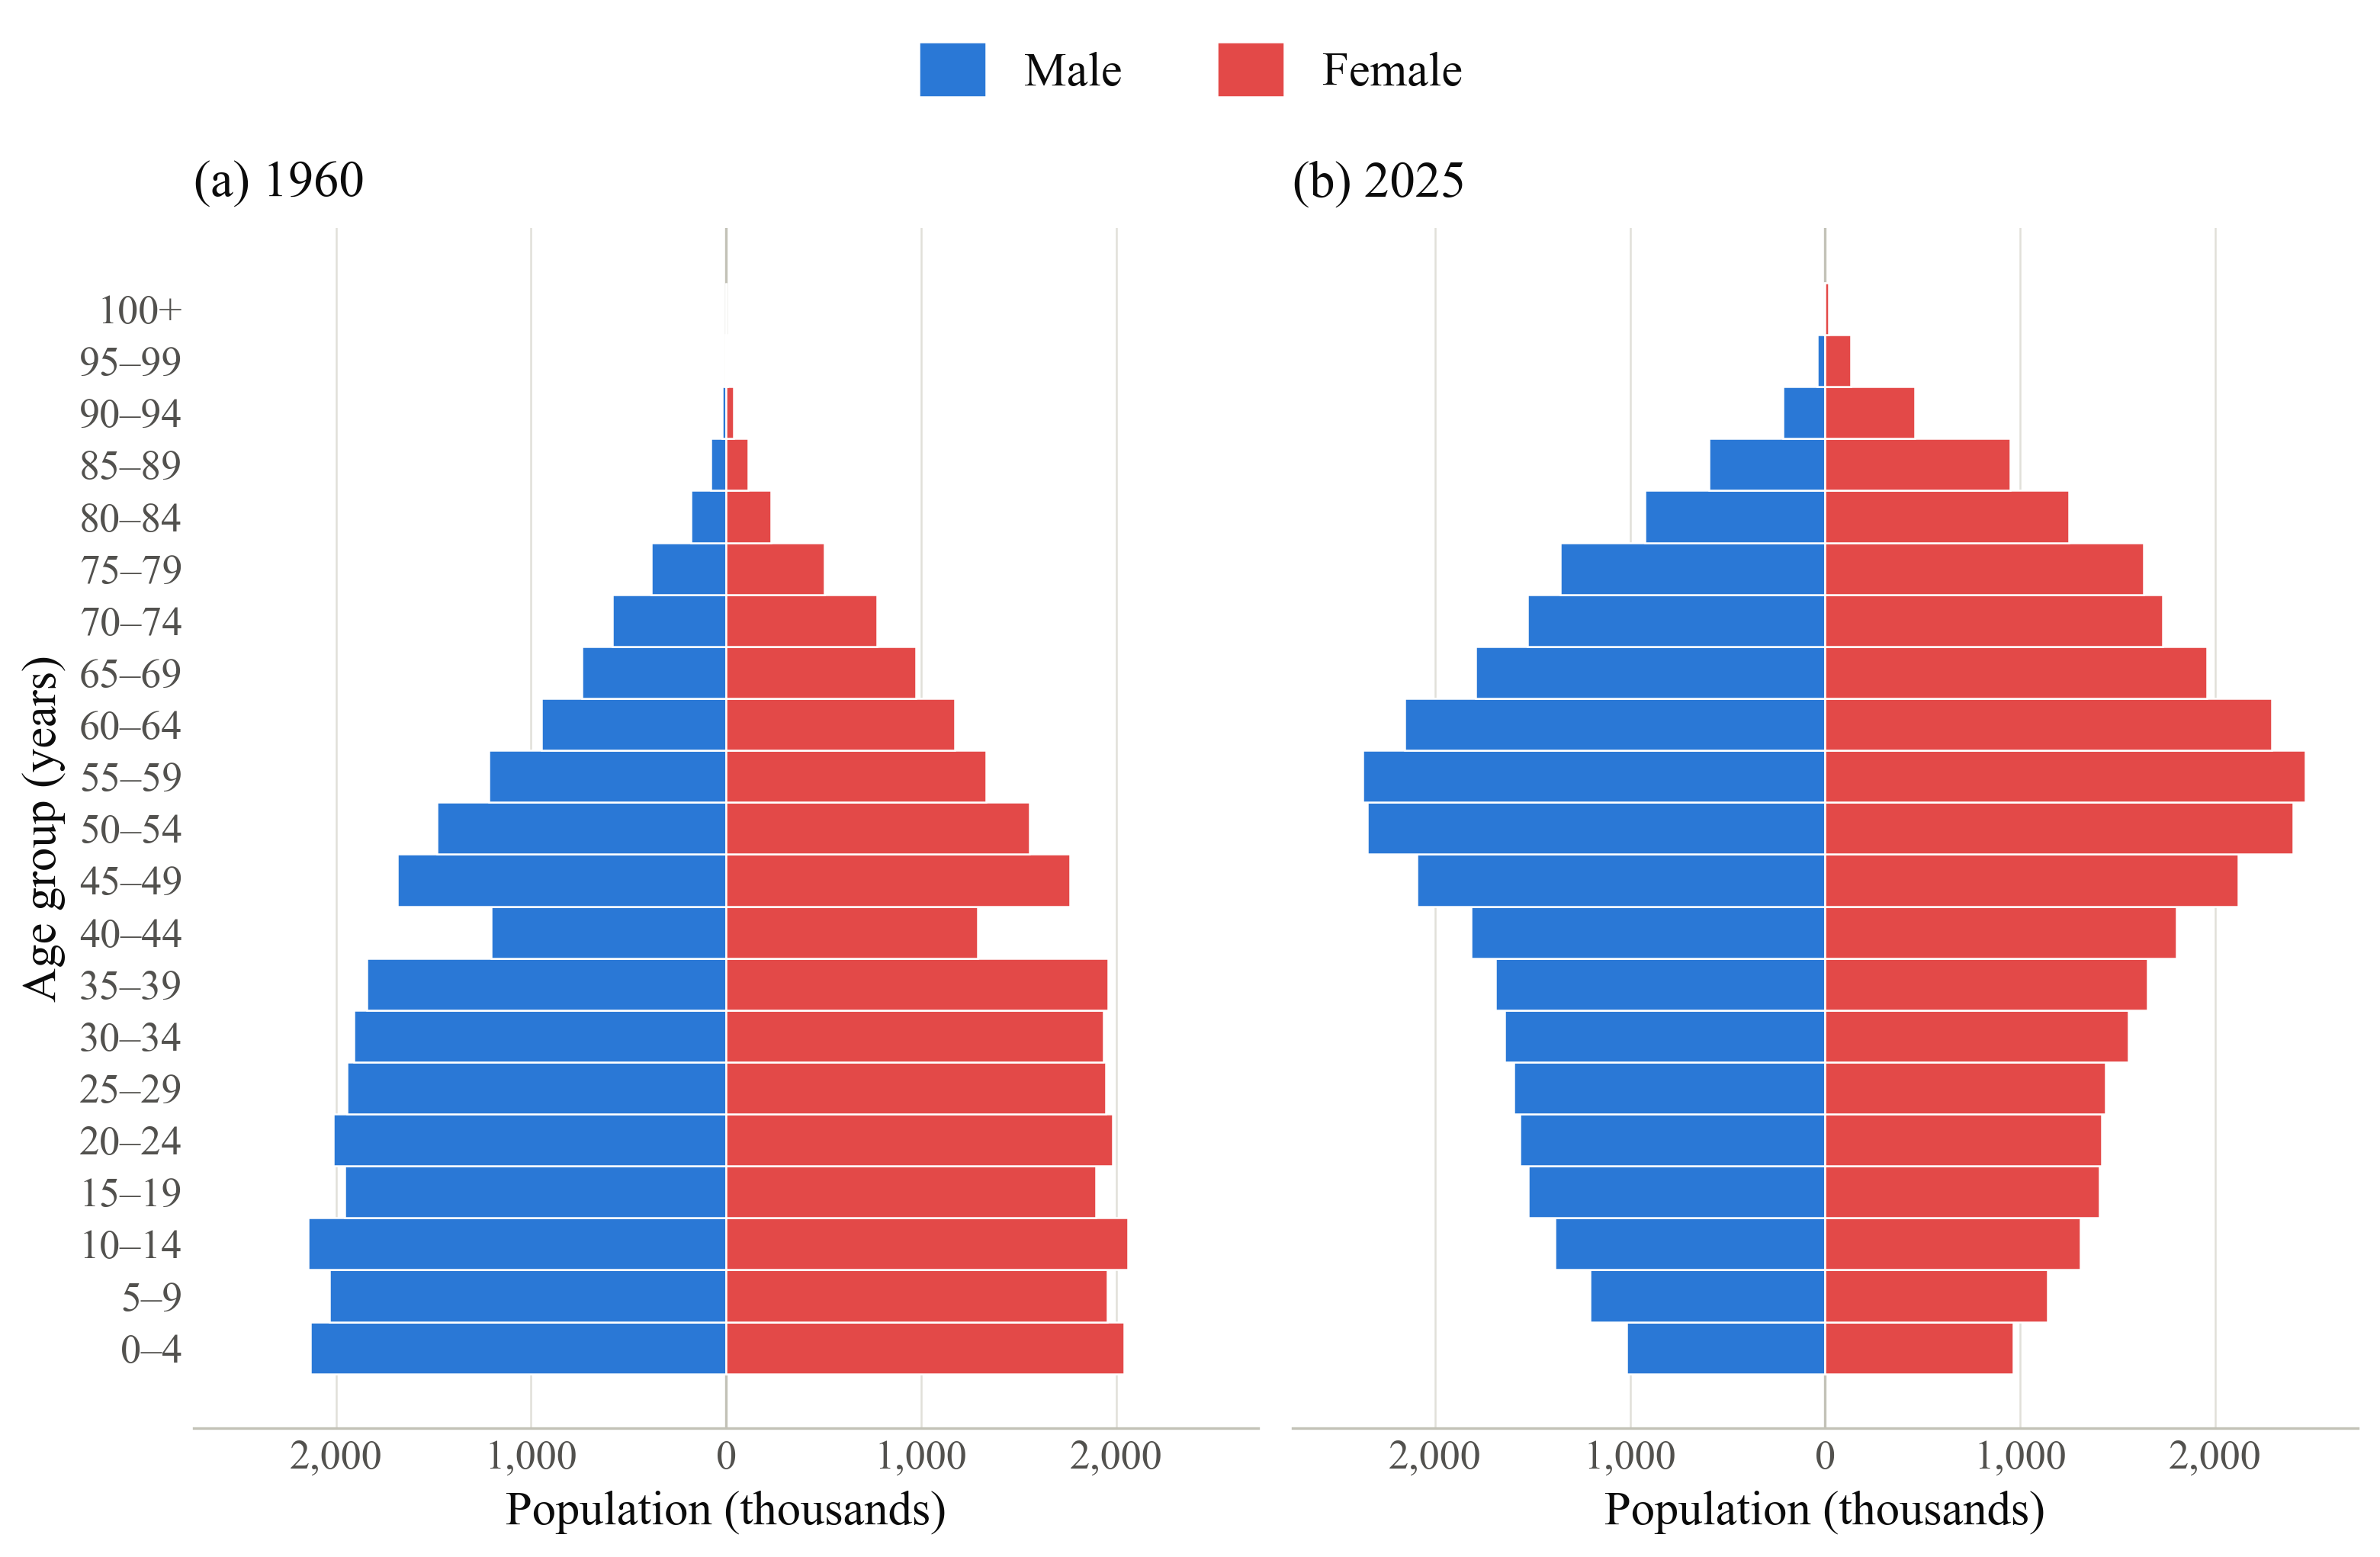
Figure 1: Age structure of the Italian population in 1960 and 2025 (source: ISTAT)

The implication for the Great Wealth Transfer is straightforward: smaller cohorts of heirs come to divide larger pools of inherited wealth. Since each household headed by Boomers leaves fewer descendants than its own parents did, per-heir transfers rise mechanically, independently of any change in asset prices or accumulation behaviour. This constitutes the fertility dividend of the transfer, and it operates entirely in the direction of greater concentration.

2.3 Wealth concentration: the precondition
The demographic forces described above would generate a substantial transfer even if wealth were distributed evenly, which it is not. Wealth in Europe is, in fact, highly concentrated, and this concentration constitutes the third structural force governing the scale and distribution of the forthcoming transfer.
According to own calculations from ECB's Household Finance and Consumption Survey, households headed by individuals aged 65 and over in France, Germany, and Italy account for around 35% of total household wealth. Moreover, ownership remains highly unequal even within this group. The top 10% of households in the euro area own approximately 55% of total household wealth, while the bottom 40% hold around 2.5%. Financial wealth is more skewed still than real estate, the top 20% of households owning nearly 80% of all financial assets; and among older households the disparity is sharper again, the net wealth of the top 20% exceeding that of the bottom 20% by a factor of nearly seven.
The receipt of inheritances closely tracks this inequality. Across France, Germany, Italy, Spain, and the United Kingdom, roughly one third of households reported having received an inheritance or substantial gift in 2010 (Morelli, Nolan, Palomino, & Van Kerm, 2025); yet both the probability of receipt and the sums involved diverge sharply across the wealth distribution. Among the wealthiest 20% of households across the OECD, between 39% (Canada) and 66% (Finland) report receiving a transfer, a share that falls to between 3% (Italy) and 26% (Finland) among the poorest 20% (OECD, 2021). The value of transfers received by the top 20% is, on average, close to fifty times that received by the bottom 25%, and the top 1% of households absorb roughly 15% of all inheritances received, rising to 18% in the United Kingdom and the United States (Morelli et al., 2025).
The underlying mechanism is dynastic: because wealth is strongly correlated across generations, wealthier parents are more likely to pass on larger estates to their heirs, who in turn tend to be wealthier themselves. The forthcoming transfer therefore constitutes not a broad redistribution but, in significant measure, a reinforcement of existing advantage, as large transfers flow to heirs already well positioned to receive them.

2.4 The interplay: how demography drives wealth concentration

2.4.1 Putting demography at the center
The three forces examined above - longer lives, the fertility decline, and the concentration of wealth - are mutually reinforcing. Before examining the nature of that reinforcement, however, it is worth considering a proposition that is insufficiently emphasized in the existing literature: that demographic forces account for more of the observed dynamics than is commonly appreciated.
Most analyses of the Great Wealth Transfer treat it principally as a matter of wealth accumulation. On this account, older cohorts are wealthy because they saved diligently, could buy property early, and benefited from decades of rising asset prices, and the transfer is large because a great deal of wealth has come to rest at the summit of the age pyramid. This framing is not mistaken, but it is incomplete. The missing element is the age structure of the population. Its significance may be illustrated by means of a counterfactual thought experiment in which every age group is assumed to hold precisely the same average wealth. Even under this assumption, the forthcoming transfer would remain substantial, for the straightforward reason that an exceptionally large generation is now entering ages of elevated mortality while the generations succeeding it are structurally smaller. It is thus the relative size and timing of these cohorts, rather than their wealth alone, that drives the transfer.
Figure 2 renders this precise by decomposing the observed age–wealth concentration in France, Germany, and Italy into two distinct channels. The first is a wealth-accumulation effect: the extent to which concentration among older age groups reflects the greater wealth those households have accumulated over their lifetimes through saving, property ownership, and investment returns. The second is a demographic-composition effect: the extent to which concentration reflects the sheer size of the older cohorts relative to younger ones, independently of any individual household's saving.

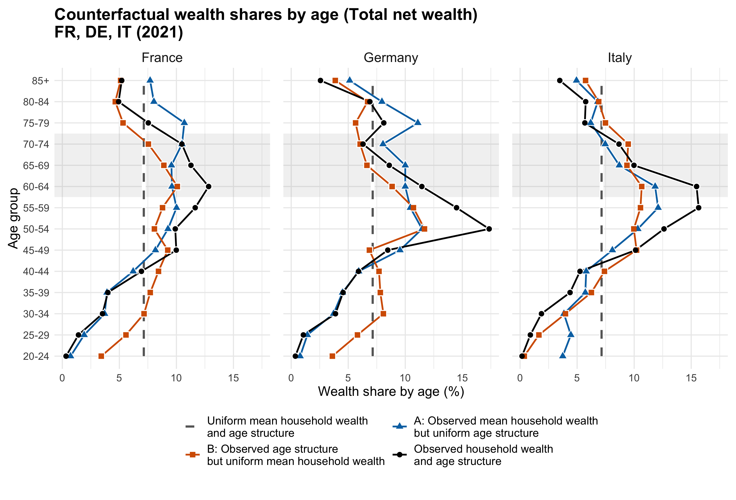
Figure 2: Counterfactual shares of total net wealth by age for France, Germany and Italy
(source: 2021 HFCS survey wave)

The two effects are most readily interpreted as counterfactuals. The accumulation counterfactual (blue line) asks what the age–wealth distribution would resemble if the population was perfectly uniform in age structure, meaning that every age group was of equal size. Any concentration remaining under this condition would be attributable purely to differential wealth accumulation across the life course. The demographic counterfactual (red line) poses the converse question, asking what the distribution would resemble were every age group to hold identical average wealth, so that concentration arose solely from the unequal sizes of successive cohorts. The distance between these two counterfactuals, together with the position of the observed distribution relative to them, indicates which channel predominates.
The results vary across countries. In France and Germany, the accumulation channel predominates, as indicated by the blue line lying above the black line representing the status quo. Households with heads above sixty hold mean wealth substantially above the national average, and this differential is the principal driver of age–wealth concentration; the age structure amplifies this effect but does not originate it, for even under a uniform population French and German wealth would remain heavily concentrated among older cohorts. On the other hand, in Italy the two channels contributing in roughly equal measure, as both the blue and red lines lie above the black line. This configuration reflects its particularly inverted age structure — the cumulative consequence of decades of ultra-low fertility — in combination with high average wealth among older cohorts built primarily upon housing.
The principal finding, however, lies not in this cross-country variation but in the growing weight of the demographic channel, especially in Italy. As persistently low-fertility cohorts age into the prime wealth-holding years, the population share of the 50–70 age group will remain elevated relative to younger cohorts for at least two further decades; and even were per-household wealth profiles to remain entirely flat, the age-structural tilt of the European population would continue to concentrate aggregate wealth among older households, thereby continuing to generate substantial transfer flows as mortality has its incidence.
This carries a practical implication of deserving emphasis: the Great Wealth Transfer is, to a significant degree, locked in by demography. Financial markets may fluctuate, asset prices may correct, and saving behaviour may shift, yet none of these developments can undo the age structure of the European population, whose arithmetic is already determined. The transfer is, in consequence, more predictable and more amenable to anticipation than a purely wealth-driven account would imply.

2.4.2 The Fortunate Generation: Boomers and the asset boom
While demography explains one dimension of the concentration, the other stems from the exceptional wealth accumulation of the Boomer generation.
Born approximately between 1946 and 1964, the Baby Boomers entered the labour market during a period of strong post-war economic growth and relatively favourable employment conditions, acquired residential property when prices were substantially lower than those prevailing today, and accumulated wealth during several decades of substantial asset-price appreciation. European property markets provide a striking illustration: in France, per capita household wealth nearly tripled between 1995 and 2019 — against cumulative consumer-price inflation of roughly 40% over 1996–2019 — while it more than doubled in several other OECD economies over the same period (OECD, 2021). German residential real estate, long regarded as the European exception on account of its post-war price stability, underwent a pronounced revaluation after 2010: nominal house prices roughly doubled between 2010 and mid-2022 (Deutsche Bundesbank, 2023), against cumulative consumer-price inflation of between 18% and 28% over the same period. Equity markets reinforced these gains, with major European markets generating substantial long-run returns despite episodes of severe volatility, while the prolonged low-interest-rate environment of the 2010s supported higher valuations across both financial and real assets.
The cumulative result is that households headed by persons over 65 in France, Germany, and Italy today hold a share of national wealth — typically around 35% — that is without modern precedent.
The primary recipients of the first wave of Boomer bequests will be members of Generation X and the Millennials. Yet they will do so late, many being in their late fifties or early sixties at the moment of receipt. Some among them have themselves benefited materially from rising asset markets, particularly during the property boom of the late 1990s and 2000s, so that for a considerable number the inheritance will arrive not as a transformative windfall but as a comfortable addition to already-established wealth. This has important implications for what the transfer can and cannot achieve with respect to opportunity and social mobility.

2.4.3 The current landscape: low growth, high returns on capital, and the return of inheritance
The macroeconomic environment in which the Great Wealth Transfer is unfolding is not neutral in its effects; on the contrary, it actively amplifies the demographic and accumulation forces already described. When the return on capital persistently exceeds the rate of economic growth, accumulated wealth can grow faster than income, reinforcing wealth concentration (Piketty, 2014). As inherited wealth becomes increasingly important relative to labour income as a source of economic advantage, these dynamics can further strengthen the intergenerational transmission of economic inequality (Piketty, 2011).
This is broadly the environment that has prevailed across much of Europe since the 2010s. Economic and productivity growth have been relatively subdued, while real wage growth has often been weak and, in many countries, has failed to keep pace with productivity gains. At the same time, asset owners have benefited from substantial increases in the value of residential property and financial assets. The consequence is a widening of the gap between those who own assets and those who depend upon wages, and a corresponding increase in the economic advantage conferred by inherited capital, or by the prospect of inheriting it.
Population ageing amplifies this dynamic further still. As the share of the population in retirement rises and that in active employment falls, the aggregate weight of capital income relative to labour income increases, and older households — already the wealthiest — benefit disproportionately from returns on capital. The wealth they transmit has therefore grown not through a lifetime of accumulation alone but through a retirement phase of continued appreciation.
Taken together, these forces compose a coherent and somewhat sobering picture. Older Europeans hold an unusually large share of national wealth — because they have accumulated more across longer working lives, because asset prices have appreciated substantially over their lifetimes, and because their cohorts are large relative to the generations below them. They are now starting to transmit this wealth. The Great Wealth Transfer is thus not a discrete occurrence but the visible expression of slow-moving demographic and economic forces that have been gathering for decades.

Chapter 3 — The Great Wealth Transfer in Numbers:
Scale, Timing, and Distribution
Whereas the preceding chapter established the structural forces underlying the Great Wealth Transfer, the present chapter turns to their quantitative expression. Drawing upon the agent-based simulation model, it addresses three questions in sequence: the magnitude of the transfer and the timing of its peak (Section 3.1); the identity of the heirs and the point in their own lives at which they receive (Section 3.2); and the effect that receiving an inheritance exerts upon a household's wealth position, together with the question of for whom that effect is greatest (Section 3.3).

3.1 The scale and timing of the transfer

3.1.1 The demographic signature of the transfer
An Agent-Based Model (ABM) is used to simulate the prospective wealth trajectories of nine thousand households from France, Germany and Italy, whose head is aged 57 or above in 2021, drawing on wealth and household characteristics from the Household Finance and Consumption Survey (HFCS). Each household is assigned descendants based on information from the Survey of Health, Ageing and Retirement in Europe (SHARE), enabling the model to capture the intergenerational transmission of wealth as parents die and their assets are inherited by their descendants. For simplicity, the model abstracts from migration and new family formation. The simulation therefore follows the wealth trajectories of Baby Boomers and older cohorts and of their children from 2021 until 2075, while modelling the timing and distribution of inheritances among their descendants.
Figure 3 shows the pattern of inheritance events. The left-hand panel reports parent-death inheritance events, counting the number of parental households that die and transmit wealth in a given year and treating a couple's estate as a single event irrespective of the number of heirs among whom it is ultimately divided. The right-hand panel reports individual inheritance counts, assigning one observation to each heir, so that, for instance, an estate divided between two siblings generates two counts of inheritance. The two panels are best read in conjunction, since they illuminate distinct aspects of the process — the former reflecting mortality patterns among the wealth-holding generation, the latter the manner in which estates are divided among the receiving generation.
Both measures share a common shape: a pronounced inverted-U that rises sharply from 2021, peaks around 2030, and declines gradually toward zero by the late 2060s. The number of bequest-generating deaths rises as older cohorts enter ages of elevated mortality and falls rapidly once those cohorts have largely passed. This profile constitutes the “demographic signature” of the transfer: the greater part of this process will unfold within a concentrated window of approximately thirty-forty years centered around the 2030s.
The cross-country differences discernible within this shared pattern are themselves instructive. Germany consistently records the highest and earliest inheritance flows under both measures, its parent-death events peaking at approximately 365,000 around 2033 — a pattern that reflects both its larger population base and the comparatively earlier ageing of its population.
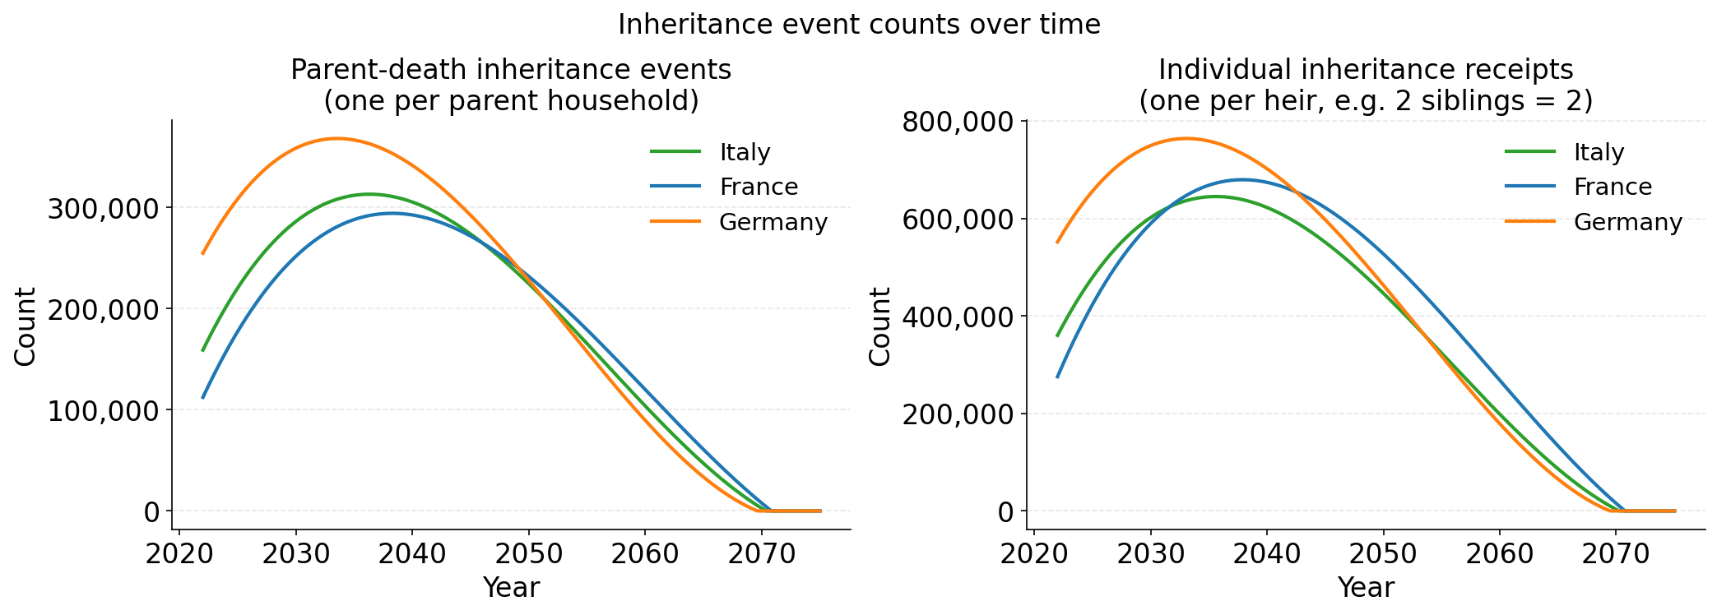Figure 3: Simulated counts of inheritance events in France, Germany and Italy from 2021 to 2075
The comparison between Italy and France is more revealing still. Measured by parent-death events, the two tracks similarly, both peaking in the late-2030s at around 300,000 events, though Italy records marginally higher values through the 2040s before the series almost converge around mid-century. Measured by individual receipts, however, France overtakes Italy decisively from the early 2030s onward, attaining a peak of roughly 675,000 receipts against approximately 640,000 in Italy. This divergence is attributable entirely to fertility: France's historically higher fertility ensures that each parental estate is divided among a greater number of children, so that a comparable number of deaths generates a greater number of receipts, whereas Italy's persistently ultra-low fertility yields fewer children per decedent and therefore fewer recipients per estate — a concrete illustration of the manner in which the fertility transition described in Chapter 2 reshapes not merely the magnitude of the transfer but its structure.
The practical implication is unambiguous: the window within which the transfer's consequences may be shaped is the present decade. The transfer is not approaching but already in motion, and the decisions taken over the coming years by governments, financial institutions, and households will determine how its consequences are distributed and managed.

3.1.2 Trillions in motion
If the demographic timing of the transfer establishes when wealth moves, its economic significance is a function of the size of transfers.
Figure 4 reports the total value of wealth transferred in each country by decade to 2075. The aggregate profile mirrors the hump-shaped pattern of transfer events, combined flows across the three countries rising from the current decade to a peak in the 2030s before tapering gradually. Over the full fifty-year horizon, the three economies will together transfer wealth on the order of €7 trillion from the present older cohorts to younger generations — a macroeconomic flow of sufficient magnitude to reshape household balance sheets, alter patterns of saving and consumption, and shift the composition of private wealth across the distribution.
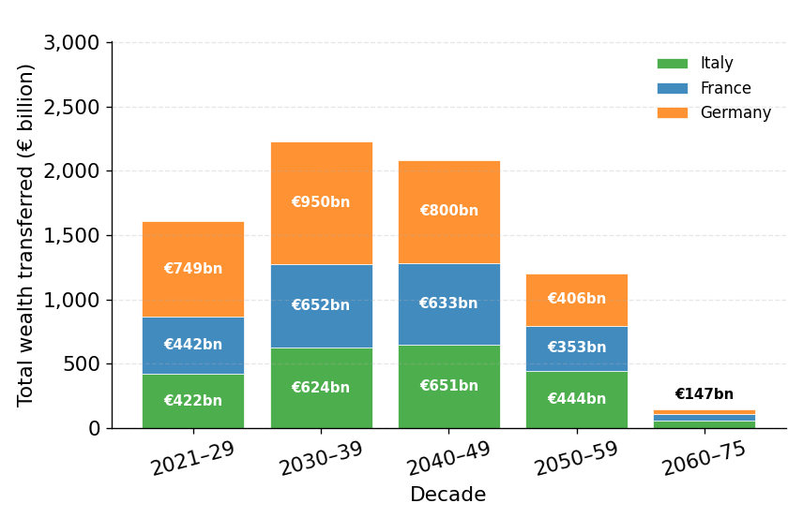
Figure 4: Simulated aggregate wealth transferred per decade in France, Germany and Italy from 2021 to 2075
The national profiles nonetheless differ in both scale and timing. France and Germany reach their respective peaks in the 2030s, at around €652 billion and €950 billion, whereas Italy peaks approximately a decade later, in the 2040s, at €651 billion.
This difference in timing reflects underlying differences in the way household wealth varies across age cohorts. Italy holds the largest share of its money with its youngest segment of the 57+ population: the share of total wealth held by households under 65 is 43.7%, contrary to 35.9% in France and 40.2% in Germany. This more concentrated share of wealth among relatively younger households implies that a larger proportion of Italy’s wealth is held by cohorts whose transfers are likely to occur further into the future.
In practical terms, these figures indicate that inheritances will constitute a substantial and sustained macroeconomic flow across all three countries for the next three decades.
For the financial sector, this represents not a background trend but a structural shift in the origin and distribution of private wealth — one that will progressively render inherited capital, rather than accumulated saving, a key driver of household balance-sheet growth for an increasing share of clients.

3.2 The profile of future heirs

3.2.1 Inheritance arrives late
Knowledge of when wealth is transferred and how much moves constitutes only part of the analysis; of equal importance are the identity of the recipients and the point in their own lives at which they receive. On these questions, the simulation yields a clear and consistent finding across all three countries: the typical heir receives an inheritance well into middle age or beyond.
Figure 5 plots the age distribution of heirs at the moment of inheritance in France, Germany, and Italy. All three distributions are broadly bell-shaped with a mild rightward skew and center upon broadly the same point, the mean age at inheritance being 62.4 years in France, 60.9 in Germany, and 62.1 in Italy. The spread of inheritance ages is also very similar across countries. In France, Germany, and Italy, most heirs inherit in their late fifties to late sixties, with the highest concentration of inheritances occurring between ages 62 and 66. France's distribution is marginally the oldest and Germany's marginally the youngest, a difference that reflects the timing of mortality across the three countries.
This constitutes a structural shift relative to earlier generations, and its consequences are considerable. Inheritance has historically discharged an important economic function, furnishing younger households with capital at the moment of greatest need — for the purchase of a first home, the funding of education, to mitigate early-career income instability, the establishment of a business, or the raising of children — events that cluster in the twenties and thirties. A bequest received at 62 can serve none of these purposes; at best it supplements a retirement portfolio the heir has already assembled without it, arriving at a point in the life cycle at which its marginal economic impact is considerably lower than it would have been three decades earlier.
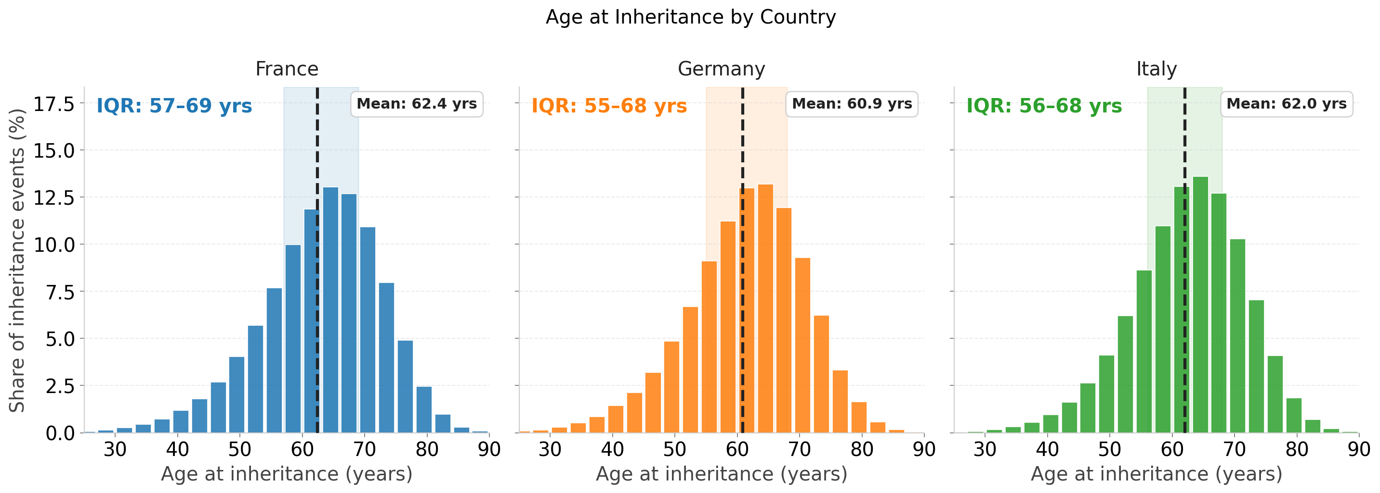Figure 5: Simulated distributions of age at inheritance in France, Germany and Italy

This timing is not incidental, but the direct arithmetical consequence of rising longevity. As parents now routinely survive into their eighties and nineties, retaining their assets throughout an ever-lengthening retirement, their children are themselves approaching or already in retirement by the time they die. The wealth concentration described in Chapter 2 is therefore not transmitted downward through the age pyramid so much as sideways, from one retirement-age cohort to another only marginally younger.
There exists, however, an alternative reading of this timing, one of particular relevance to the financial institutions that serve this market. Heirs receiving wealth in their sixties are not passive recipients winding down their financial affairs, but active, healthy, and financially engaged individuals, frequently working longer than previous generations, travelling, pursuing new interests, and supporting their own children and grandchildren. Inherited wealth arriving at this stage becomes the financial foundation of what may be termed a second adulthood — a novel and economically significant phase of life around which the Silver Economy is increasingly organized.

3.2.2 The young tend to inherit more
That most inheritance arrives late is by now established; whether it also arrives smaller for the few who receive it early — deepening their disadvantage or relieving it — is the question Figure 6 answers. The figure plots the median inheritance received by heirs in four age groups — under 40, 40–55, 55–70, and 70 and over — for each country.
In Germany and Italy, median amounts decline as the heir's age rises, though the gradient varies considerably in steepness. The descent is sharpest in Germany, where the median falls from approximately €63,000 among heirs under 40 to some €34,500 among those over 70 — very nearly a halving across the range. Italy traces a shallower decline, from around €45,000 among the under-40s to roughly €29,000 among the oldest. On the other hand, France's trend is more hump-shaped: from about €40,000 among the under-40s, €47,000 at 40–55, and €46,000 at 55–70, to around €38,000 among heirs over 70.
The different French profile reflects the later concentration of wealth over the life cycle. Median net wealth in France peaks at approximately €314,000 among individuals aged 67–69, compared with around €233,000 at ages 61–63 in Italy and approximately €332,000 at ages 64–66 in Germany. As a result, French decedents who die at older ages are more likely to remain near the peak of their wealth accumulation than their Italian or German counterparts. Germany's slightly higher mortality at older ages further reinforces the tendency for inheritances to occur earlier, when wealth levels remain comparatively elevated.
Overall, younger heirs are disproportionately the beneficiaries of parents who died relatively early, whereas older heirs are more likely to inherit from parents who survived into their nineties. And because household wealth follows a hump-shaped trajectory over the life cycle—rising through the working years before being gradually drawn down in retirement—those inheriting later tend to receive inheritances that have already been partially depleted by consumption, healthcare costs, and longevity. Consequently, later inheritances are associated not only with a shorter remaining investment horizon for recipients but also, in many cases, with smaller inheritances in absolute terms.
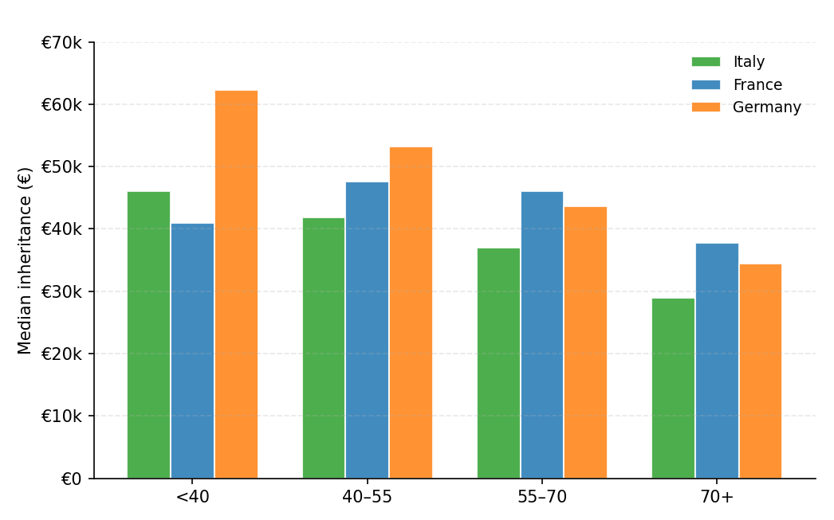
Figure 6: Simulated median inheritance amounts by age group in France, Germany and Italy

The paradox is therefore clear. Inheritance exerts its greatest influence when it is received earliest, before households have had time to accumulate substantial wealth of their own. Yet, this is also the point in the life course at which inheritances are least likely to occur. As shown in the previous section, the typical heir inherits only around the age of 60, by which stage the transfer has been partially depleted.

3.3 The impact of inheritance across the wealth distribution

3.3.1 Inheritance reshapes wealth — but unevenly
The size of an inheritance conveys only part of its significance, which depends in equal measure upon the financial position of its recipient: a transfer of €50,000 is transformative for a household possessing net wealth of €20,000, yet negligible for one possessing €2 million. This section accordingly examines the way the impact of inheritance varies across the wealth distribution, and in doing so introduces a finding of considerable importance both for the distributional consequences of the transfer and for the behavioural responses it is likely to elicit.
Figure 7 plots median net wealth immediately before (circles) and immediately after (triangles) the receipt of an inheritance, with heirs grouped by both their pre-inheritance wealth bracket and their age; the vertical distance between the two markers represents the direct effect of the inheritance upon a typical recipient's wealth position.
One dominant pattern proves remarkably consistent across all three countries: the wealthier the recipient prior to inheriting, the larger the bequest received. This regularity reflects two reinforcing mechanisms: the persistence of wealth across generations and the greater bequests associated with higher parental wealth.
The gradient is pronounced. Among individuals with negative pre-inheritance wealth (below €0), the increase in median wealth is minimal — typically just a few thousand euros, essentially flat in Germany (~€3,000 across all age groups shown) and reaching at most about €15,000–€19,000 for some age groups in France and Italy; no 70+ individuals fall into this bracket in any country, so no comparison is possible there. Among those holding between €0 and €500,000, gains are larger though still contained, ranging from roughly €22,000 (Italy, 70+) to about €66,000 (Germany, under-40s) depending on country and age group. Among those in the €500,000–€1 million bracket, median gains rise steeply, from around €367,000 in Italy to about €538,000 in France. Among those whose pre-inheritance wealth exceeds €1 million, gains become both larger and more heterogeneous, spanning from around €411,000 for the oldest Italian heirs to about €725,000 for French heirs aged 40–55 — whose median net wealth rises from roughly €1.17 million to €1.89 million.
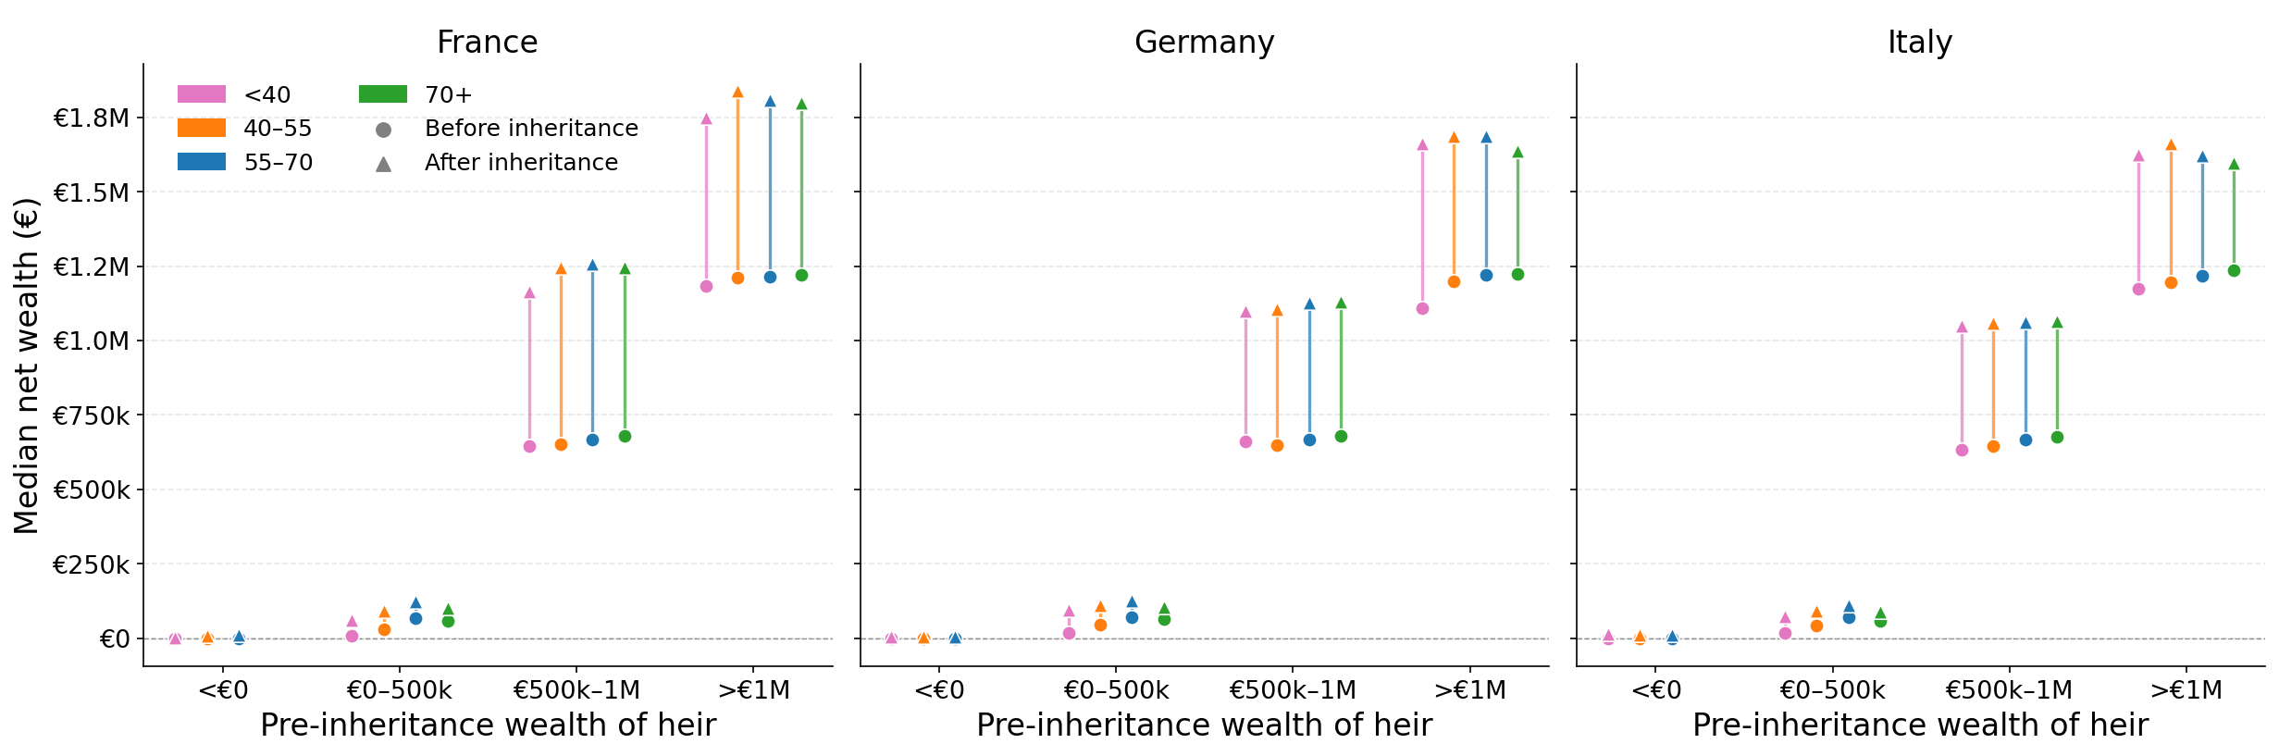
Figure 7: Simulated median wealth positions before (circle) and after (triangle) inheritance by pre-inheritance wealth bracket and age group in France, Germany and Italy.

The age dimension introduces a further layer of heterogeneity, whose shape changes across the distribution. In the €0–500,000 bracket, the youngest heirs secure among the largest increases in all three countries — clearly so in Germany (€66,000) and Italy (€45,000), narrowly edged out by the 40–55 group in France (€51,000 vs. €42,000) — while the oldest heirs (70+) consistently gain the least everywhere (€22,000–€25,000). That pattern does not carry over uniformly. In Italy, the youngest heirs continue to gain the most all the way up the distribution: €399,000 in the €500,000–€1 million bracket and €496,000 above €1 million, both among the largest gains in their bracket, with gains still declining fairly steadily by age (70+ trailing at €367,000 and €411,000 respectively). In France, by contrast, the reversal starts one bracket earlier than the top: already in the €500,000–€1 million bracket the under-40s record the smallest gain of the four groups (€479,000, versus €538,000 for the 40–55 group), and this holds in the >€1 million bracket too (€639,000, the lowest of the four, versus €725,000 for the 40–55 group, wealth rising from €1.17 million to €1.89 million) — the age gradient in France is inverted relative to Italy across both of the top two brackets, not just the highest one. Germany sits in between: gains in the €500,000–€1 million bracket are close together across ages (€411,000–€428,000, with the under-40s marginally the lowest), before the under-40s pull back into the lead in the >€1 million bracket (€594,000, versus €469,000 for the 70+ group) — so the German reversal, unlike France's, is confined to the middle bracket rather than persisting at the top.
On balance, then, although inheritance raises wealth across the entire distribution, it confers the largest absolute gains upon those who were already wealthy. Rather than diminishing wealth disparities, it therefore reinforces existing inequalities by amplifying the advantages of those situated at the top of the distribution.

3.3.2 Proportional impact falls as wealth rises
The analysis of Section 3.3.1 establishes that larger transfers accrue to wealthier heirs. The question most pertinent to the distributional consequences of the transfer, however, concerns not the absolute magnitude of receipts but their magnitude relative to the wealth recipients already hold.
Figure 8 reports the inheritance received as a share of the recipient's pre-inheritance wealth, distinguishing three brackets — below €500,000, €500,000–€1 million, and above €1 million — and reveals that relative impact is smallest among the wealthiest heirs in each of the three countries, those holding more than €1 million gaining proportionally least from what they inherit.
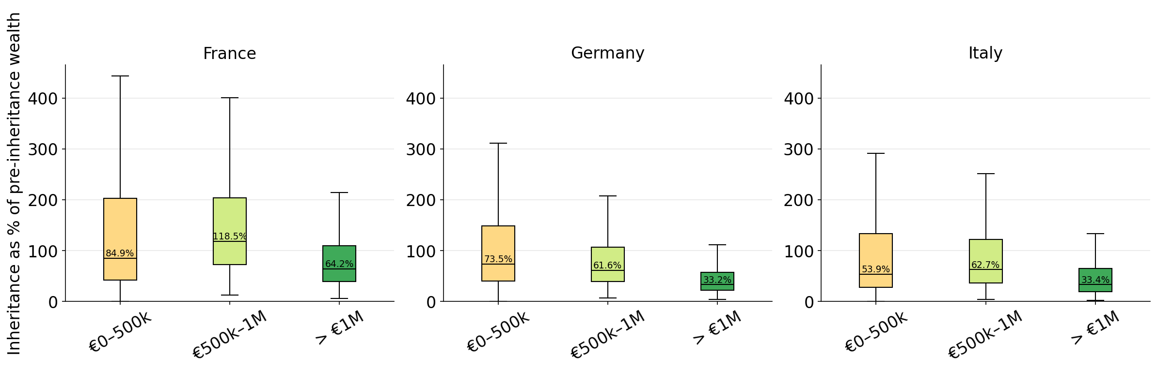Figure 8. Simulated relative impact of inheritance by pre-inheritance wealth bracket in France, Germany and Ital
Among heirs already holding more than €1 million, the median inheritance amounts to 64.2% in France, 33.2% in Germany, and 33.4% of prior wealth in Italy: a meaningful addition, yet one that settles upon an already-substantial position.
The distribution is tightly compressed, its upper whiskers reaching only around 115–215%, so that few heirs in this bracket receive a transfer approaching a doubling of their wealth. Although wealthier children tend to inherit larger amounts, in keeping with the positive parent–child wealth correlation embedded in the model, the increase in the size of the inheritance is not proportional to the far larger stock of wealth recipients already possess, and the inheritance-to-wealth ratio consequently remains low.
At the lower end of the distribution the picture differs markedly. Among heirs holding less than €500,000 in prior wealth, the median inheritance amounts to 84.9% in France, 73.5% in Germany, and 53.9% of prior wealth in Italy, with a long upper tail extending to roughly 290–445% across all three countries. For individuals of limited accumulated wealth, even a moderate inheritance represents a large proportion of pre-inheritance holdings, such that for these households an inheritance constitutes not a supplement but a transformation.
The headline finding is therefore clear: inheritance accomplishes proportionally more for those who possess less. The transfer thus exerts a degree of mechanical equalization within the receiving generation — a force, however, substantially offset by the absolute-size gradient documented in Section 3.3.1, according to which those with less receive less in absolute terms to begin with.
A full account of the distributional impact of inheritance must, moreover, consider the uses to which transfers are put, since the relative importance of an inheritance depends also upon whether it is consumed, invested, or applied to other expenditures.
Heirs in the lower wealth brackets, for whom the inheritance represents a large proportional addition to modest holdings, are more likely to consume or actively deploy it — in the repayment of debt, the funding of housing, or investment in their children's education — whereas heirs in the upper brackets are more likely to absorb it into an already-established portfolio, reinvesting it in financial assets or property. Should this be so, the distributional consequences of the transfer will depend not only upon who receives how much but upon what recipients do with it — a behavioral dimension that shapes inequality, aggregate saving, and the composition of demand within the Silver Economy.
3.3.3 Relative impact declines steeply with age
The final component of the analysis draws together the size of the inheritance and the recipient's prior wealth at successive points in the life cycle, in order to establish the age at which the receipt of an inheritance exerts its greatest proportional effect.
Figure 9 plots the median inheritance as a share of the recipient's pre-inheritance wealth by age band for each country. Its dominant feature is a steep and monotonic decline with age across all three countries: the older the recipient, the smaller the inheritance relative to existing wealth.
For the youngest heirs, those under 40, an inheritance is transformative in proportional terms, amounting to roughly 250% of prior wealth in France, 235% in Germany and 200% in Italy—more than a doubling of a typical recipient's holdings.
By the 40–55, band the ratio has already fallen to around 100% in France and Germany and 76% in Italy; by 55–70 it sits near 50–70% across all three countries; and for those over 70 it settles just slightly lower. The curves converge as age advances; the large cross-country differences visible among the under-40s having all but disappeared by the time heirs are over 70, at which point all three countries settle at around half of prior wealth.

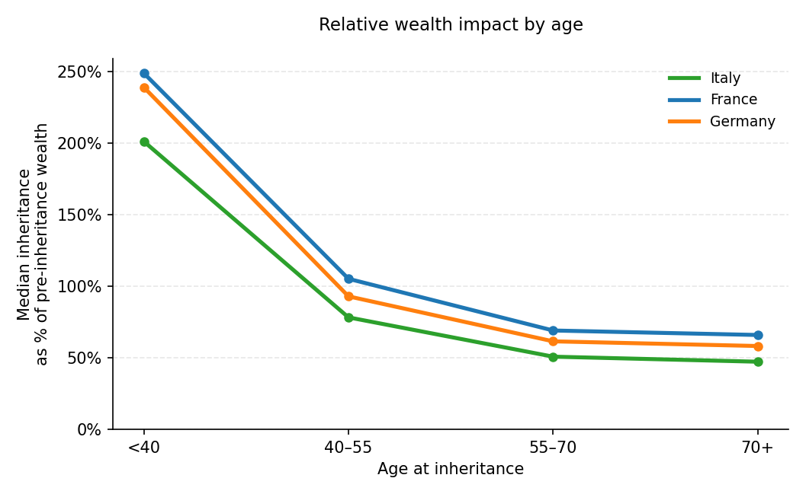
Figure 9: Simulated relative impact of inheritance on pre-inheritance net wealth by age group in France, Germany and Italy
Two cross-country patterns merit attention. France and Germany track one another closely throughout, while Italy lies consistently below both, the gap being widest among the young, where the Italian ratio is barely half its Franco-German counterpart.
These patterns are best understood by examining the two components of the ratio separately. The numerator, being the value of the inheritance, varies among age groups: as seen in Section 3.2.2, younger heirs tend to receive larger inheritances than older inheritors. The denominator, being the heir's wealth immediately prior to inheritance, increases monotonically with age until the late sixties, in accordance with the life-cycle dynamics embedded in the model, whereby individuals accumulate wealth through labor income and saving; inheritances consequently account for a progressively smaller share of total wealth among older recipients.
The implications of this age gradient are direct. Inheritance has its greatest capacity to reshape a household's financial trajectory in the under-40 band — yet, as Section 3.2.1 showed, this is precisely the band that almost no one occupies. Most heirs receive their inheritance around age 60, when it represents only half of prior wealth and reinforces an already-established position rather than founding a new one. Inheritance's redistributive potential is real. Under prevailing demographic conditions, however, it remains largely unrealized.

Chapter 4 — Implications and Opportunities

The preceding chapters have established three principal findings.
First, the Great Wealth Transfer is of exceptional scale: on the order of €7 trillion will pass between generations across France, Germany, and Italy over the fifty years to 2075, in a wave that rises from the current decade, peaks in the 2030s — a decade later in Italy — and recedes within the projection horizon.
Second, it is, to a strong degree, determined by demography. Financial markets may fluctuate, and asset prices may correct, but the age structure of the European population is, by contrast, fixed. This renders the transfer more predictable, and more amenable to advance preparation than a purely wealth-driven account would suggest.
Third, and most consequentially for the discussion that follows, it is misaligned with the life cycle: the typical heir receives an inheritance at around the age of sixty, well into middle age and frequently after retirement, while the greatest proportional impact of a bequest — its capacity to alter a financial trajectory — is concentrated at younger age bands, when relatively few inheritances are received.
This chapter considers the implications of these findings for the three constituencies with the greatest stake in the transfer: citizens planning their own financial futures, policymakers addressing its equity and revenue dimensions, and insurers and financial institutions operating in a market whose foundations are changing. A single observation runs through all three. Because inherited wealth now arrives towards the end of working life rather than at its beginning, the governing question has changed: it is no longer how to grow the sum received, since the recipient rarely has the time horizon to do so, but how to deploy it to secure a longer, and considerably more expensive, later life. This transfer, moreover, is foreseeable in both its timing and its scale — and each of these actors is accordingly in a position to prepare for it in advance.

4.1 For Citizens: Reframing the Windfall
For individuals, the single most important implication of the analysis concerns timing. Inherited wealth, where it is received at all, will most probably arrive late: the mean age at inheritance is close to sixty in all three countries, and the middle half of heirs receive theirs between their mid-fifties and late sixties. A bequest arriving at that stage cannot perform the functions inheritance has traditionally served: it comes decades too late to fund a first home, an education, a business, or the raising of a family, expenditures that cluster in early adulthood. It is capital for the later stages of adult life, not its beginning. The first task for the individual is therefore to reframe expectations accordingly.
For the substantial group who reach later life without having been able to provide adequately for their own retirement (the households that pension reforms, by tightening the link between contributions and benefits, have left most exposed), a late inheritance represents a rare opportunity to reinforce later-life security. With only a few years remaining before retirement, the objective is not accumulation but conversion: there is little time to compound returns or to recover from market volatility, so the priority becomes transforming a lump sum into guaranteed lifetime income and protection against the risks that dominate old age. Entering a private pension scheme close to retirement is, in this respect, less an exercise in growing capital than the purchase of a life annuity that hedges longevity risk and insures against the possibility of outliving one's savings.
Health and long-term care, moreover, constitute the largest and most uncertain expenses of later life, and public provision in all three countries is only partial. A late-life inheritance may therefore best be allocated, in whole or in part, to financing care needs and supplementary health insurance, rather than being consumed immediately or left uninvested.
For those who are already financially comfortable when they inherit, by contrast, the relevant considerations are optimization and succession. Integrated wealth-and-health planning, tax-efficient giving, and estate arrangements all assume greater importance at this level. Yet, the most significant instrument available to this group addresses the mistiming that this report documents directly, and it is one that only households themselves can employ. Those who have no need for the inheritance are in a position to interrupt the cycle by transferring wealth earlier. Wealth retained until death perpetuates the existing pattern, since one's own children will, in turn, inherit at around sixty. Deliberate transfers made during life, to children and grandchildren at the ages when capital is most transformative, whether for a housing deposit, a course of study, or a business venture, constitute the single most effective private response to the developmental function that inheritance has lost.
Across both groups, the common requirement is a change of approach: from windfall to plan, from growth to security, and, for those in a position to do so, from bequest to earlier gift.

4.2 For Policymakers: Unlocking Europe’s Hidden Capital
For policymakers, the defining feature of the transfer is its timing in relation to the public finances. It reaches its peak at precisely the moment the fiscal costs of ageing are greatest: public expenditure on pensions, health, and long-term care across the European Union is projected to rise over the coming decades, while dependency ratios are deteriorating sharply, approaching, in Italy, nearly one dependent for every working-age adult by mid-century.
The same demographic change that places these systems under strain, however, simultaneously transfers an extraordinary pool of private capital into households: more than €7 trillion across France, Germany, and Italy over the projection horizon. The central question for policy design is therefore whether that wealth is put to productive use. In the absence of intervention, a substantial proportion of it will not be.
The explanation lies in the mistiming documented in this report. Because inheritance now arrives late, and disproportionately to recipients who are already comfortable and have no pressing need of it, a large share is at risk of remaining dormant, absorbed into an existing portfolio, neither spent nor productively invested, and generating no wider economic benefit. It is here that policy has its most valuable role to play.
Targeted incentives — most obviously, favourable tax treatment for inheritances channelled into funded retirement provision, life annuities, long-term-care cover, or long-horizon productive investment — can convert dormant capital into active capital.
The rationale is twofold. First, such measures relieve pressure on the public finances: every household that draws on an inheritance to fund part of its own longevity and care needs is one that depends less heavily on strained public pension and health systems.
Second, they mutualise what would otherwise remain a purely private windfall, since idle inherited wealth generates no spillover, whereas capital directed into pension insurance, productive investment, and the real economy contributes to narrowing Europe's structural investment gap. Mobilising even a modest share of the transfer in this manner would materially strengthen the financing of later life across all three countries.
A further class of incentive addresses the mistiming at source. Because the developmental value of inherited capital is greatest when it reaches recipients at a young age — at the stages of home purchase, education, and family formation — favourable treatment for transfers made during life, and particularly to younger recipients, can encourage families to pass wealth down earlier rather than retaining it until death. Such measures direct capital towards the moments at which it is most transformative and, in doing so, activate it within the economy decades sooner.
A policy framework designed to encourage the productive redeployment of inherited wealth, rather than to permit it to remain inert, is one in which the insurance sector constitutes the natural instrument of delivery. The vehicles through which an inheritance is put to productive use — funded pensions, annuities that hedge longevity risk, and long-term-care and health cover — are precisely the products that insurers provide. In this sense, the public interest in a more resilient and self-financing old age and the commercial opportunity set out in the following section are aligned.

4.3 For Insurers: New Markets to Build
For insurers and financial institutions, the Great Wealth Transfer represents a strategic opportunity of the first order. As this report has demonstrated, several trillion euros will pass between generations across the three countries over the coming half-century.
This trajectory is, moreover, sufficiently predictable to afford insurers a rare opportunity to prepare in advance of demand — by developing appropriate product portfolios and cultivating the client relationships that will prove most valuable over time.
The analysis identifies two distinct customer groups, each requiring a different proposition. The first is the modest inheritor — the "mass segment" of the Silver Economy — who receives a relatively small lump sum at around the age of sixty. Because the sum arrives so close to retirement, the appropriate response is protection rather than accumulation: the conversion of the lump sum into guaranteed lifetime income, and insurance against the two dominant risks of a long old age, namely longevity and morbidity — the danger of outliving one's savings and the cost of declining health. For heirs who were unable to save sufficiently during their working lives, this late and frequently unexpected sum provides the basis for a more secure retirement, and it corresponds closely to the products designed for that purpose, from private pensions and annuities that hedge longevity risk to supplementary health and long-term-care cover, despite the latter being technically challenging to design and price.
The second is the wealthy inheritor, who receives a large transfer that is added to an already-substantial position: for heirs holding more than €1 million, the median bequest represents only around a third to a half of prior wealth. For this group, the inheritance is not a necessity but a supplement to a position that is already secure. Their requirements extend to tailored wealth management, integrated wealth-and-health propositions, long-term-care and concierge health services, and succession and estate planning — including, in particular, advice on the tax-efficient and earlier transmission of wealth to their own children or to productive investment. This constitutes the high-value "premium segment", willing to pay for bespoke advice and for the seamless integration of financial, health, and lifestyle management.
What the two customer groups have in common is that both consist of heirs in their sixties. Inherited wealth arriving at this stage provides the financial foundation for a second adulthood, and it requires products calibrated to a longer active horizon than traditional retirement planning has assumed.
Two operational imperatives warrant particular emphasis. The first is retention through the transfer itself. The point at which wealth passes between generations is one of high asset attrition, at which heirs frequently move inherited assets away from the incumbent institution. Engaging the receiving generation in advance of the transfer — through intergenerational advice encompassing both the bequeathing and the inheriting household — is the means by which an institution retains those assets under management throughout the transfer, rather than surrendering them at the point at which it occurs.
The second is liquidity, a consideration most acute in Italy. A large share of Boomers’ wealth is held in owner-occupied property — Italy's wealth base is the most heavily concentrated in housing of the three — which is illiquid and difficult both to draw upon in retirement and to transfer early. Equity-release and lifetime-mortgage products, which enable older owners to release property wealth in order to fund a longer retirement, to finance care, or to make earlier transfers to their children at the ages at which they matter most, represent a natural and currently under-served market that also helps to address the mistiming at the level of the individual household.
These differences imply that no single European product suite will serve all three markets. Germany records the highest and earliest flows — its parent-death events peak around 2033 — and, uniquely, transfers larger amounts to younger heirs, so that it presents both a broader base of substantial inheritors and an earlier imperative to act. France's higher fertility divides estates among a greater number of children, producing a larger number of clients receiving smaller per-heir sums. Italy's ultra-low fertility concentrates estates into fewer transfers, which arrive latest and rest on the least liquid and most property-bound wealth, rendering liquidity and equity-release solutions especially valuable in that market.
Across both clienteles and all three countries, however, the core advisory proposition is the same, and it mirrors the conclusions reached for citizens and policymakers alike: a shift from growing wealth to preserving it, and from returns to protection against the risks of a long life. The institution that recognizes the transfer for what it is — predictable, sharply segmented, and constrained by liquidity — and that establishes the relationships and develops the products in advance of the 2030s peak, stands to convert a demographic certainty into a lasting commercial advantage.
Taken together, the three perspectives converge on a single conclusion. The Great Wealth Transfer is large, unequal, and — because it is inscribed in the age structure of the population — effectively inevitable in its scale and timing. What is not inevitable is its effect.
Citizens can plan for a late transfer and, where they are able, give earlier; policymakers can design incentives to encourage the productive use of this capital; and insurers can develop the products and relationships that convert inherited capital into protection against the risks of longer lives. The transfer will reshape the wealth of these nations over the coming half-century. Whether it does so to their benefit is a question not of demography, which is already settled, but of the choices made — by all three actors — while the wave is still rising.

Chapter 5 — Conclusions

The Great Wealth Transfer represents the largest intergenerational transfer of private wealth in recorded history, and this report has sought to establish how it will unfold across France, Germany, and Italy over the coming half-century. During this period, 7 trillions of euros of private wealth will pass between generations, reshaping the financial position of millions of households. Yet, the significance of this process lies not only in its unprecedented scale, but also in its timing, its distribution, and the age at which inheritance is received. Understanding these dimensions is essential to assess the economic consequences of population ageing and identify appropriate responses from households, policymakers, and the financial sector.

5.1 The Defining Features of the Great Wealth Transfer
The Great Wealth Transfer is characterized by three defining features: it is received by older generations than is often assumed, it unfolds over a finite demographic window, and its distribution reinforces existing wealth differences even as it provides relatively larger gains to less wealthy households.
The recipients of the transfer are predominantly members of Generation X and Millennials, and they are, in the main, not young. The mean age at inheritance is 62.4 years in France, 60.9 in Germany, and 62 in Italy, with the middle half of heirs receiving between their mid-fifties and late sixties. Wealth therefore moves less down the age pyramid than sideways, from one retirement-age cohort to another only marginally younger. At the same time, decades of sub-replacement fertility mean that estates are divided among fewer children than in previous generations.
These transfers are also concentrated within a well-defined period. Inheritance receipts follow a pronounced inverted-U trajectory, rising from 2021, peaking during the 2030s, and declining towards negligible levels by the mid-2060s.
Germany experiences the earliest and largest wave of bequests, which peak at approximately 365,000 around 2033. France and Italy peak later, in the late 2030s, at around 300,000 each. The value of annual transfers broadly tracks this demographic profile in France and Germany, which both reach their maximum in the 2030s at approximately €652 billion and €950 billion respectively. Italy is the exception: although its number of bequests peak in the late 2030s, the value of transfers continues to rise and reaches its maximum only in the 2040s, at around €651 billion. This lag arises because Italian wealth is concentrated in slightly younger cohorts, whose deaths fall later in the projection horizon. The Great Wealth Transfer is therefore not an open-ended process but a demographic wave with a clearly identifiable beginning, peak, and end.
Across this period, the three economies are projected to transfer more than €7 trillion of wealth. The aggregate scale, however, conceals an uneven distribution. In absolute terms, inheritances increase monotonically with recipients' existing wealth, from median receipts of roughly €5,000–9,000 among heirs with negative pre-inheritance wealth to around €300,000–600,000 among those already holding more than €1 million. In relative terms, however, the pattern is reversed. For heirs holding less than €500,000 before inheritance, the median transfer is equivalent to 54–85% of their existing wealth, whereas for those already holding more than €1 million, it represents only 33–64%. Inheritance therefore has its greatest proportional effect on less wealthy households while delivering its largest absolute gains to those who are already affluent. The equalizing potential of the former is consequently offset, at least in part, by the concentration of wealth in the latter.

5.2 Economic and Policy Implications
Because inherited capital now arrives towards the end of working life rather than at its beginning, the question it poses is no longer how the sum received might be grown—the recipient seldom possessing the investment horizon in which to do so—but how it might be deployed to finance a longer and considerably more expensive later life. For households, the immediate consequence is a shift in purpose. A bequest received in the 60s can no longer perform the traditional functions of inheritance, such as financing education, home ownership, or business formation. Instead, the central task becomes one of conversion rather than accumulation: transforming a lump sum into secure lifetime income and protection against the longevity, health, and long-term-care risks that increasingly dominate old age, risks for which public provision in France, Germany, and Italy remains only partial. For wealthier households, the challenge is different. Where retirement financing is already secure, attention turns to portfolio optimization and succession planning. In particular, lifetime transfers emerge as the principal mechanism for directing wealth to younger generations at the stage of life when capital has its greatest economic impact, thereby mitigating the delayed timing of inheritance documented throughout this report.
The implications extend beyond households to public finances. Every household able to finance a greater share of its retirement, healthcare, or long-term care from inherited wealth is one that relies less heavily on already strained public systems. This coincidence is particularly significant because the Great Wealth Transfer reaches its peak precisely as the fiscal costs of population ageing intensify. The policy question is therefore not whether resources exist, but whether they are mobilized. Two complementary levers emerge from the analysis. The first is to encourage inherited wealth to be channeled into funded retirement provision, annuities, health and long-term-care insurance, and other long-term investment vehicles. The second is to facilitate lifetime transfers, addressing the mistiming of inheritance at its source by allowing wealth to reach beneficiaries when it can have the greatest economic effect.
The private sector—and insurers in particular—occupies a central position in this transition. The analysis identifies two distinct client segments. The first consists of households receiving relatively modest inheritances close to retirement, for whom the priority is protection rather than further wealth accumulation. Here, demand is likely to center on annuities, supplementary health insurance, and long-term-care products, all of which remain comparatively underdeveloped across the three markets. The second comprises affluent households receiving substantial inheritances into already secure financial positions. Their needs extend beyond investment management to integrated wealth and health planning, succession strategies, and advice on earlier intergenerational transfers. Across both segments, two operational challenges stand out. The first is asset retention, as inheritance remains a moment of heightened attrition in assets under management; engaging families before wealth changes hands is therefore critical. The second is liquidity, particularly in Italy, where the concentration of Boomer wealth in owner-occupied housing makes equity-release products a natural complement to retirement planning. At the same time, important cross-country differences remain. Germany experiences the earliest transfer wave and channels larger inheritances to relatively younger heirs; France divides wealth among more numerous beneficiaries; and Italy combines the latest transfer profile with the least liquid household balance sheets. These structural differences suggest that no single European strategy is likely to be effective across all three markets.

Appendix: Description of the Simulation Model
1. Overview
To study how the Great Wealth Transfer will unfold in France, Germany and Italy over the coming decades, an agent-based model (ABM) was developed using Python programming language. An agent-based model is a computer simulation in which thousands of individual “agents” — in this case, people and households — act and interact according to simple rules. By running the simulation forward year by year, it is possible to observe how outcomes at the level of the whole population (such as total inheritances passed on) emerge from the life events of individuals.
The model captures three intertwined processes that shape the inheritance landscape:
- Demography (people age, are assigned a number of children, and eventually die)
- Wealth dynamics (household wealth grows or shrinks over the life cycle)
- Intergenerational transfers (when a household head dies, their wealth is passed on to their children). The strength of an ABM is precisely that these three processes can be combined transparently within the same framework, so that the wealth received by a child is mechanically the wealth of his or her parents at the moment of death.
The simulation starts in 2021 with a representative sample of nine thousand French, German and Italian households whose household’s head is aged 57 or over, taken from the Household Finance and Consumption Survey (HFCS), coordinated by the European Central Bank, and is then advanced one year at a time until 2075. At each step, every agent goes through a sequence of life events: getting older, possibly dying, possibly inheriting. The model records what happens, so that at the end of the simulation we can reconstruct the full distribution of wealth and its evolution year after year.
2. Data pre-processing
The raw ECB Household Finance and Consumption Survey (HFCS) 2021-wave microdata are processed through a five-stage pipeline:
- Raw data loading;
- Variables recoding, country split, geographic grouping;
- Data merging, birth cohort derivation, sample-level filtering;
- Implausible deposit values correction.
2.1 Raw data loading
The HFCS 2021 wave is released as five separate, complete datasets (“implicates”), each with missing values filled in by a different stochastic multiple-imputation draw. For each implicate, we load two file types:
File | Content | Key variables used
p1–p5.dta | Person-level records | relationship to reference person, gender, age, marital status, education, employment status
d1–d5.dta | Household-level derived variables | net wealth, financial wealth, deposits, gross income, debt flags, household type, region, household weight

2.2 Recoding, country split, geographical grouping
2.2.1 Categorical recoding
Applied to every implicate of the 2021-wave person- and household-level files:
Raw field | Recoded to | Mapping
dhhtype | household_type | Numeric HFCS household-type codes (51, 52, 6–13) → descriptive labels, e.g. “Two adults, at least one aged 65+”, “Single parent with dependent children”.
ra0200 | gender | 1 → Male, 2 → Female.
pa0100 | marital_status | 1–5 → Single/never married, Married, Consensual union (legal), Widowed, Divorced.
pa0200 | education_level | Codes 1 & 2 → Low, 3 → Medium, 5 → High.
ra0100 | relationship_to_ref | Codes 1–10 → Reference person, Partner, Son/daughter, Parent, Parent in law, Grandparent, Grandchild, Brother/sister, Another relative, Other non-relative.
pe0100a | employment_status | Codes 1–9 → Employed/self-employed, On leave, Unemployed, Student, Retired, Permanently disabled, Military/social service, Domestic tasks, Other not working for pay.
dhregion | household_region | NUTS-style region codes → named regions (Italian regioni, French bassins, German Bundesländer groupings).

2.2.2 Country split
Each recoded dataframe is split into Italy, France and Germany using the sa0100 country code (IT / FR / DE). France and Italy only vary in their derived-variable file across implicates in a negligible way, so the pipeline keeps a single implicate (implicate 1) for them going forward. Germany shows meaningfully more cross-implicate variation (see 3.4), so all five German implicates are carried forward in parallel as separate dataframes (germany1…germany5).
2.2.3 Geographical grouping
Each country's detailed region is mapped to a small number of macro-areas, and a country label column is added:

Country | Macro-areas
Italy | North, Center, South (grouped from the 20 Italian regions)
France | Île-de-France, North, East, South-West, Mediterranean, Overseas
Germany | North-West, West, East, South-West (grouped from the 4 German HFCS region codes)

2.3 Data merging, birth cohort derivation, sample-level filtering
2.3.1 Variable selection and merge
A fixed set of person-level columns (id, household id, relationship to reference person, gender, age, marital status, education, employment status) is merged (left join, on household id) with a fixed set of household-level columns (household id, household type, net wealth, financial wealth, deposits, gross income, credit-card / mortgage debt flags, region, household weight, macro-area, country). One merged dataframe is produced per country (Italy, France) or per implicate (Germany 1–5). Wealth values are averaged across the five German implicates to obtain a single wealth value per household.
2.3.2. Birth cohort computation
HFCS records only age at interview, with no year-of-birth field. Birth cohort is therefore computed as 2021 (the nominal HFCS wave year) minus age — an approximation, not a value read directly from the source data.
2.3.3. Sample filter: exclude divorced individuals
Divorced individuals are removed from every country/implicate dataframe at this point, before any age-based filtering.
2.3.4. Drop households without a reference person
A household is kept only if at least one of its member rows is coded relationship_to_ref == “Reference person”; households that fail this check (e.g. due to missing/miscoded relationship data) are dropped entirely, and the dropped count is printed per country.
2.3.4. Keep only households whose head is above 57
A household is retained only if the household head is aged 57 or older, capturing the Baby Boomer generation and earlier cohorts.
2.4 Implausible deposit values correction
HFCS deposit values are known to be understated for some households (survey underreporting of liquid assets). Implausibly low deposits are detected and corrected using four rules:
- Income rule: flags households whose deposits are below 10% of monthly income, excluding households with annual income under €10,000 or with credit-card debt. Among the flagged households, those with deposits below 1% of monthly income are treated as outliers and their deposits are replaced with the household-weighted average deposits of households with comparable income (±€2,500) that are NOT themselves outliers;
- Net wealth rule: Same logic applied to the ratio of deposits to net wealth instead of income: households with deposits below 1% of net wealth are flagged, excluding those with mortgage or credit-card debt (a plausible sign of genuine liquidity constraints). Outliers are replaced with the weighted average deposits of income-comparable, non-outlier households;
- Self-employed rule: self-employed households are compared to employed households with similar income (±€2,500). If a self-employed household's deposits fall below that peer group's weighted average, its deposits are raised to the peer average — correcting known underreporting of liquid assets among the self-employed.
Because the three rules above can each propose a different corrected value, only the largest of the three candidate corrections (or the original value, if none apply) is kept per household — i.e. deposits can only be revised upward, never downward. The resulting adjustment are propagated into both net wealth and financial wealth, so wealth totals stay internally consistent with the corrected deposit figure.
3. The two types of agents
The model contains two kinds of agents: individuals (people) and households. Households are containers in which individuals live; wealth is held at the household level, while life events such as ageing and death happen at the individual level.
3.1 Individuals
Each individual carries a small set of personal characteristics: age, gender, level of education, marital status, and the role they play in their household (reference person that responded to the survey, partner of the survey respondent, or child). These characteristics influence what the individual can do during the simulation. For instance, education affects the age at which a woman is most likely to have her first child, while age and gender determine the probability of dying in any given year.
3.2 Households
There are two types of households in the model:
- Parents households: these are the households observed in the starting data in 2021. Each one comes with a real net wealth, a geographical area, a number of children, and one or two adult members (a reference person and possibly a partner).
- Child households: these are generated at the beginning of the simulation. Whenever a parent household has children, each child is placed in his or her own newly formed household, which will eventually receive part of the parents’ wealth as an inheritance. Child households start with their own initial wealth (more on this in paragraph 4.2) and evolve independently from then on.
Splitting the population into parent and child households is what allows to capture the intergenerational dimension of the Great Wealth Transfer: wealth physically moves from one household to another only at the moment of inheritance.
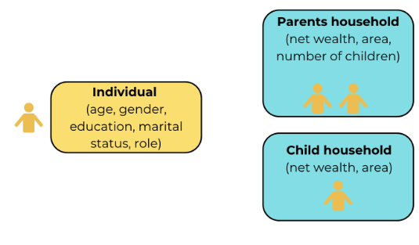
Figure A1: Individual and household object structure in the model
4. Building the starting population (year 2021)
The simulation does not start from an artificial population: it starts from a sample of nine thousand real French, German and Italian households, taken from the Household Finance and Consumption Survey (HFCS), coordinated by the European Central Bank. This survey provides detailed information on the assets, debts, and demographic composition of a representative sample of European households.
From this dataset we extract, for each household: household identifier, country and geographical area, the net wealth (assets minus debts), a sampling weight (which tells the model how many real households this single observation represents). For each member of the household that is either the main respondent or the partner, we extract age, gender, education, relationship to the reference person, and marital status. These households form the parents’ households.
Once all parent households and their members have been created in the simulation, the model assigns each household to a wealth quartile (Q1 = poorest 25%, Q2, Q3, Q4 = richest 25%). The thresholds are computed once, at the start of the simulation, and remain fixed throughout. This means that when we later say a household is in “quartile 3”, we mean it relative to the wealth distribution as it looked in 2021.

Country | France | Germany | Italy
Number of households | 3,708 | 2,001 | 3,333
Number of individuals | 6,077 | 3,414 | 5,520
Table A1: number of households and individuals per country at the beginning of the simulation
5. Generating the children
5.1 Assigning a number of children
The HFCS does not record the number of children a household has. Therefore, these are estimated based on data from the Survey of Health, Ageing and Retirement in Europe (SHARE). Specifically, country-specific distributions of the number of children conditional on female and male educational attainment (separately) were constructed and subsequently used to impute household fertility characteristics.
Households containing a male adult (either the household head or partner) were assigned a number of children by randomly sampling from the country-specific distribution conditional on male educational attainment. In households without a male adult, the number of children was sampled from the corresponding distribution conditional on female educational attainment.
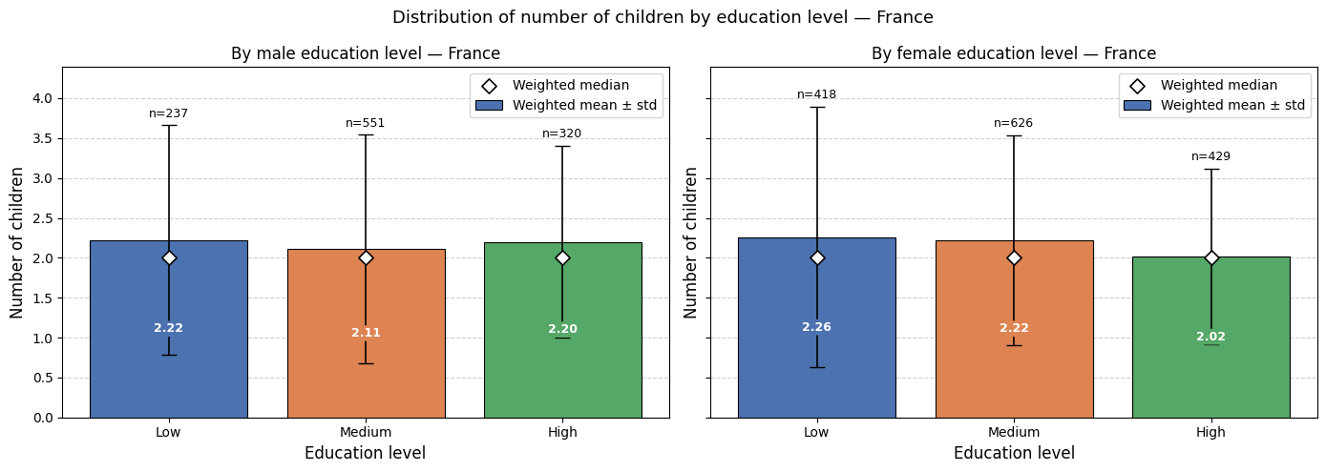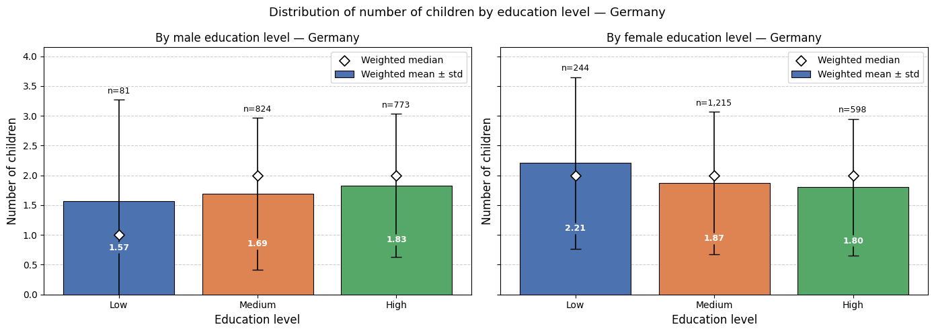
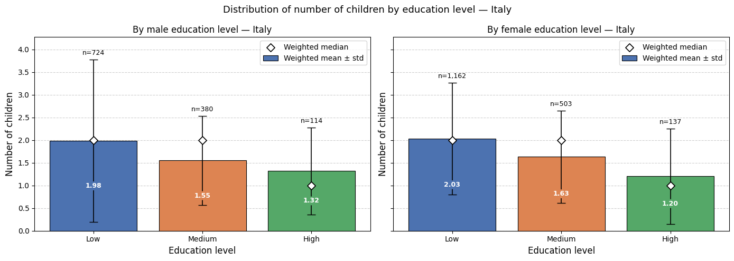
Figure A2: Number of children by education level and gender in France, Germany and Italy

5.2 Reconstructing children demographics
Thus, in the model every parent household can generate a set of child households, who will be the beneficiaries of the inheritance when the parents die. Children are created at the very beginning of the simulation, before time starts running.
5.2.1 Child's age
For each parent household, the model first looks at how many children the household reports having. If the household has children, the model identifies the woman in the couple and uses her age and education to reconstruct each child’s current age through the following steps:
- The mother’s age at first birth is drawn from an empirical distribution estimated on SHARE data and conditioned on her education level. Subtracting this age from her current age gives the age of the first child. Distributions are smoothed using Gaussian smoothing.
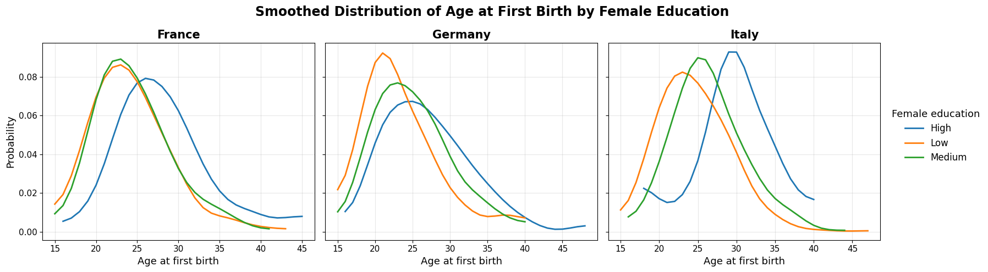Figure A3: Smoothed distributions of age at first birth by female education in France, Germany and Italy

- For each subsequent child, a birth spacing interval is drawn from a separate empirical distribution estimated on SHARE data — one distribution for the gap between the first and second child, and another for the gap between the second and third (which is then also applied to all higher-order births). Each interval is subtracted from the preceding sibling’s age to yield the next child’s current age. Distributions are smoothed using Gaussian smoothing.
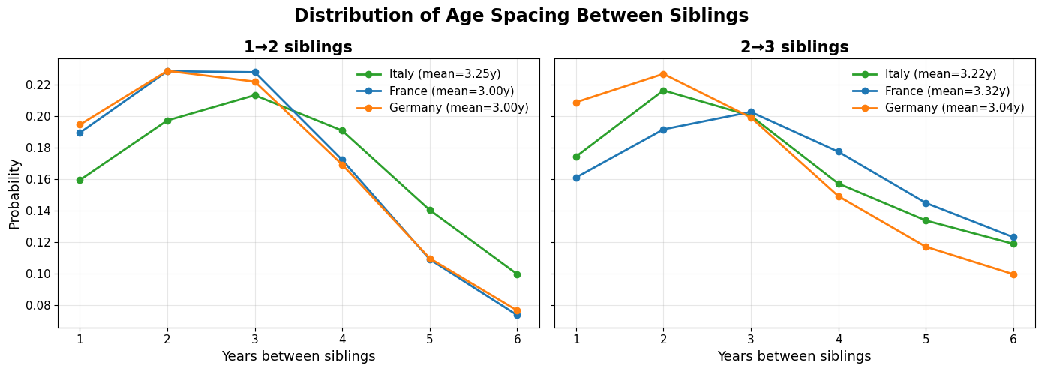Figure A4: Distribution of age spacing between siblings in France, Germany and Italy

Adding these intervals to the last sibling created gives the present-day age of each child. Each child is then placed in his or her own newly created child household, becoming the head of that household. The child household keeps a link to its parent household, so that when the parents die, the model knows where to send the inheritance.
5.2.2 Child's gender
Gender is randomly assigned such that individuals have an equal probability of being female or male.
5.2.3 Child's geographical area
The child inherits the same country and geographical area attributes as the parental household.
5.3 Assigning initial wealth
Each child household is also given an initial wealth. This is drawn from wealth trajectories estimated on HFCS data, conditional on the child’s age and wealth quartile. The wealth quartile is inherited from the parents’ wealth quartile.
The wealth trajectories for children’s households were computed using the following steps:
- Trajectories estimation: Children wealth trajectories are estimated from HFCS data until age 65.
The result are five nested shaded layers around each quartile's center (median) line, showing the spread of individual households within that age-quartile cell: the middle 20%, 40%, 60%, 80%, and 90% of households (respectively the 40th to 60th percentile, the 30th to 70th, 20th to 80t, the 10t to 90 and 5th to 95th percentile).
Children's wealth trajectories are estimated using longitudinal HFCS data from the 2010, 2014, 2017 and 2021 survey waves. The sample is restricted to individuals aged 18–65 with valid net wealth observations, excluding observations affected by inheritance receipts, which are modelled separately, and implausibly large wealth changes. Households are classified into four wealth quartiles based on their first observed net wealth, relative to households in the same five-year age group. Age-specific wealth profiles are then estimated through regressions of net wealth on age indicators interacted with wealth quartiles, controlling for household and survey-wave fixed effects. The resulting predicted wealth profiles are averaged by age and quartile and smoothed to reduce sampling noise.
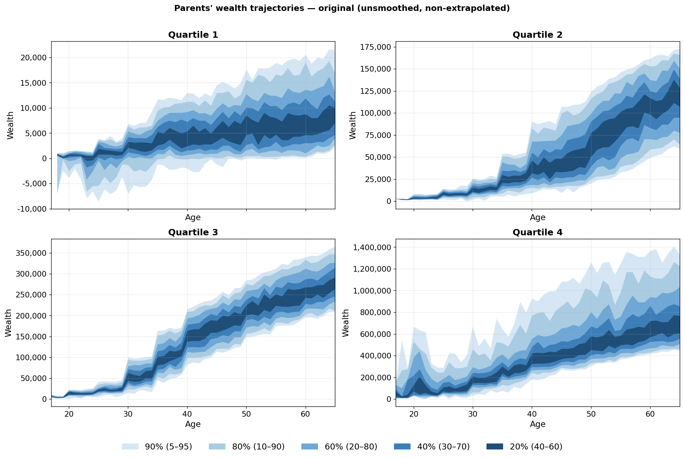Figure A5: Children’s wealth trajectories, unprocessed (unsmoothed and non-extrapolated)
- Trajectories extrapolation: Trajectories are extrapolated from age 65 to age 100 using the information contained in the parents' wealth trajectories. Specifically, for each subsequent age after 65, the year-over-year change observed in the parents' curve at the same age is applied to the child's trajectory. Estimation of parents’ wealth trajectories is explained in paragraph 5.2.
The change is propagated multiplicatively (i.e. as a proportional growth factor) where doing so is well-defined: when the parent's anchor at age 65 is safely non-zero and shares the same sign as the child's age-65 value. This preserves the parents' rate of decumulation.
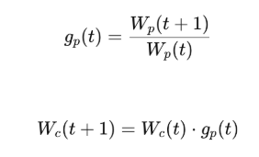
When those conditions are not met — typically in the bottom quartile, where wealth is near zero and lower percentiles legitimately turn negative — the multiplicative rule becomes unstable (small or sign-flipping denominators produce spurious blow-ups), so the change is propagated additively instead, i.e. by transferring the absolute year-over-year increment from the parents' curve onto the child's trajectory.
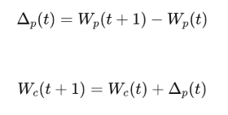
The following plot shows the extrapolated trajectories:
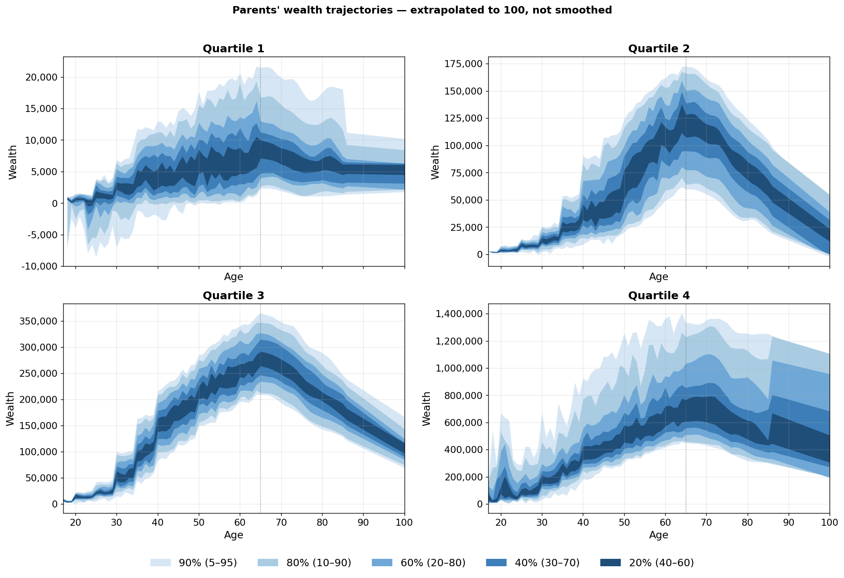
Figure A6: Children’s wealth trajectories, extrapolated until age 100

- Trajectories smoothing: LOWESS (Locally Weighted Scatterplot Smoothing) was applied to every trajectory independently. For each age, LOWESS fits a weighted linear regression on its local neighborhood (about 15% of the data points), weighted by distance with closer ages counting more. The fitted value at the center becomes the smoothed point.

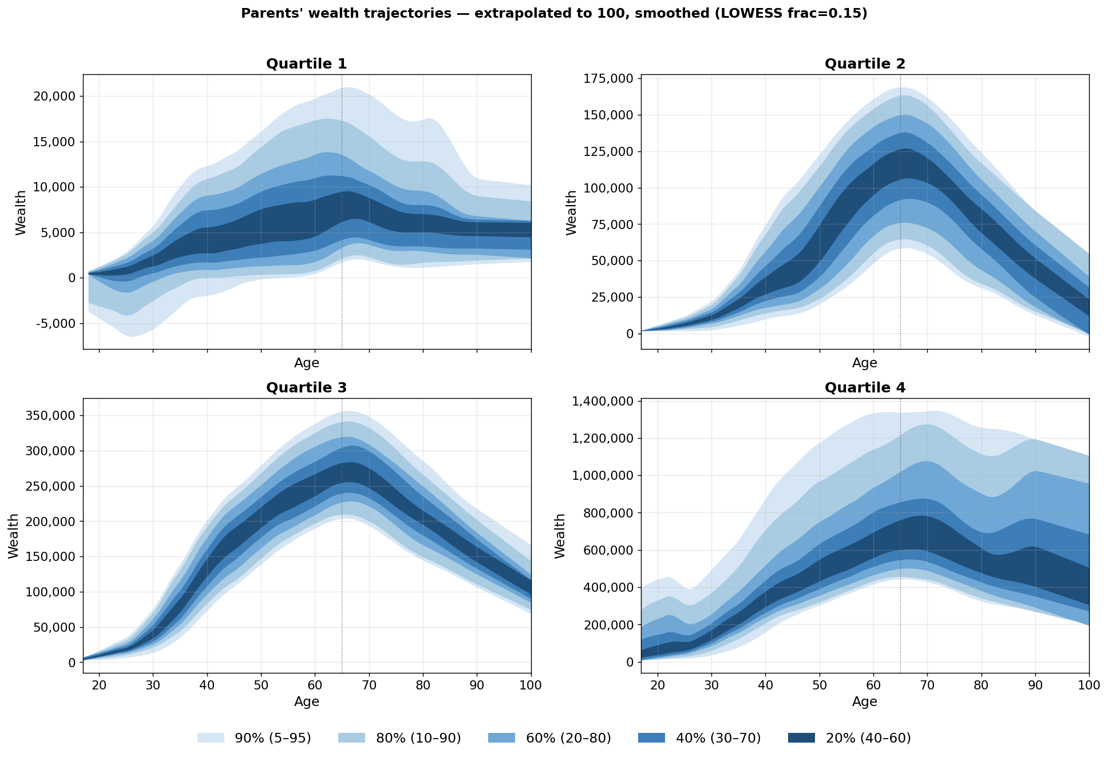
Figure A7: Children’s wealth trajectories, extrapolated until age 100, smoothed

The final wealth level draw is assigned using an inverse-transform two-step process:
- Each agent is assigned a percentile rank u~U(0,1) representing its position within its wealth quartile.
- The rank is mapped to a wealth level through a piecewise-linear quantile function defined by ten anchor points per age and quartile combination (the p5, p10, p20, p30, p40, p60, p70, p80, p90, p95 percentiles); anchors are interpolated linearly between adjacent ages to keep trajectories smooth. Below p5, the quantile function is extended linearly. Above p95, a lognormal tail fitted to the p90/p95 anchors is used to better represent the concentration of wealth at the top.
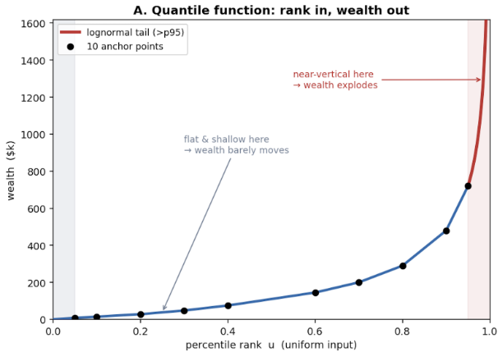
Figure A8: Inverse-transform process to draw a wealth level

Table A2 summarizes the attributes of parents and children households in the model.
Attribute | Parent Household | Child Household
Origin | Observed in 2021 HFCS survey wave | Created by the model at initialization, one per child of each parent household
Household identifier | Unique ID inherited from the survey (hid) | Derived from the child’s person ID (HH-personal_id)
Country / region | Set from survey data | Inherited from the parent household
Net wealth | Observed value from the survey; updated each year via the age-wealth profile | Drawn at initialization from an empirical distribution; augmented by inheritance at parents’ death
Wealth quartile | Assigned at initialization from the 2021 wealth distribution (Q1–Q4) | Inherited from the parent household
Sampling weight | Assigned from HFCS survey weights | Inherited from the parent household
Members | Household head (reference person) and, where present, a partner | A single head (the child)
Number of children | Estimated from SHARE survey data | Not applicable (child households do not themselves have children)
Link to other generation | Holds a list of its associated child households | Holds a reference to its parent household
Removed from simulation | After all members have died and wealth has been transferred to children | After the household head has died
Table A2. Attributes of parent and child households in the simulation model.
6. What happens each year
Once the starting population is in place, the model advances in yearly steps. Each step represents one calendar year and entails several updates. Figure A3 gives an overview of the main processes happening at every simulation step.
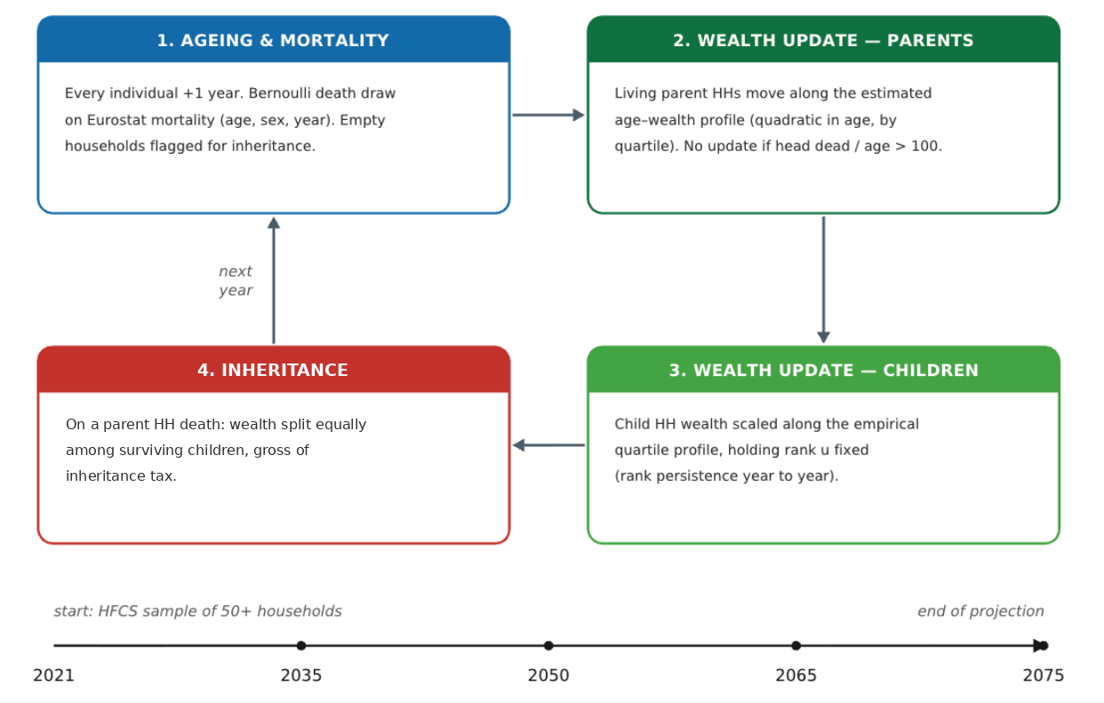
Figure A9: Overview of the model’s yearly update cycle

6.1 Ageing and mortality
Every individual ages by one year. After ageing, each individual is exposed to the risk of dying. The probability of dying in a given year depends on the person’s age, gender, and the calendar year, and is taken from official Eurostat projected mortality tables. A Bernoulli draw — parametrized by the agent-specific mortality rate — determines whether the individual survives or dies.
When an individual dies, they are removed from the household. If the household head dies and there is no other member left, the household becomes “empty” and is flagged for the inheritance step.
6.2 Wealth update for parents' households
All parents’ households still alive then update their wealth, which moves along an estimated age-wealth profile, a quadratic polynomial in age with full quartile interactions, estimated from HFCS data as described in the following steps.
The final parent wealth trajectory is created by first cleaning the parent wealth data and then estimating a smoothed age profile of net wealth separately for each parent wealth quartile. The method starts from the cleaned parent wealth trajectory dataset. The sample is restricted to parents aged 50 and above, since the figure is meant to capture wealth accumulation and decumulation later in life.
Before estimating the trajectories, extreme wealth observations are trimmed within each age. For every age, the 1st and 99th percentiles of net wealth are calculated. Observations below the age-specific 1st percentile or above the age-specific 99th percentile are set to missing for the graph variable. This limits the influence of extreme outliers while keeping the age structure of the data.
Next, the data is collapsed to the age by parent wealth-quartile level. For each combination of age and parent wealth quartile, the weighted mean of trimmed net wealth is calculated using household weights. This gives one average parent wealth value for each age and quartile.
The LOWESS method is then applied separately within each parent's wealth quartile. LOWESS smooths the relationship between age and average parent's net wealth without imposing a specific functional form, such as a linear or quadratic shape. Instead, it fits local regressions around each age point and produces a smooth trajectory. The resulting smoothed values form the central parent wealth trajectory line.
To create a distribution around this central line, the LOWESS trajectory is merged back to the individual-level parent data. For each observation, a residual is calculated as actual trimmed parent wealth minus the LOWESS-predicted wealth. These residuals measure how far individual parent households are above or below the smoothed average trajectory. To avoid extreme residuals driving the uncertainty bands, residuals are trimmed within each parent wealth quartile at the 5th and 95th percentiles.
The spread around the LOWESS line is then calculated using residual percentiles at each age and parent's wealth quartile. The 5th and 95th, 10th and 90th, 20th and 80th, 30th and 70th, and 40th and 60th percentile residuals are added back to the LOWESS line. This creates several shaded bands around the central trajectory. The widest band represents the middle 90% of the residual distribution, while the narrowest band represents the middle 20%.
For the extrapolated figure, the observed LOWESS line and all band boundaries are extended to age 100. This is done separately for each parent's wealth quartile by estimating a linear trend over the last 10 observed years of each series. The slope from this final age window is then used to project the LOWESS line and the percentile bands forward until age 100. In practice, the final trajectories combine these extrapolated predictions with manual adjustments, as the last 10 observed years do not always capture the peak of the wealth profile sufficiently. Observed parts of the trajectory are shown as solid lines, while extrapolated parts are shown as dashed lines.
Finally, one graph is produced for each parent wealth quartile. Each graph shows the LOWESS parent wealth trajectory as the central line and the residual-based percentile bands as shaded areas. The four quartile-specific graphs are then combined into a single two-by-two figure and exported as the final parent wealth trajectory figure.
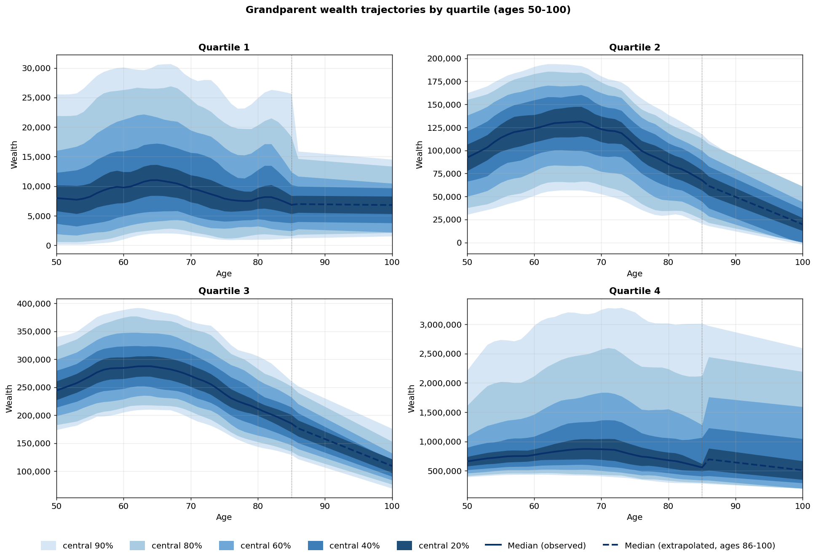Figure A10: Parents’ wealth trajectories by quartile

The year-to-year wealth update:
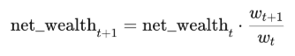
Where w_t and w_t+1 predicted wealth values at the parent’s current and next age. This applies a proportional growth (or shrinkage) that reflects how wealth in that quartile typically evolves with age. No update is applied if the household is empty or age is higher than 100.
6.3 Wealth update for children's households
Each year, the net wealth of children households is scaled by the ratio of the quantile function evaluated at age_t+1 versus age_t, holding u fixed:

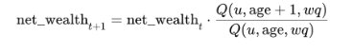

This ensures that the child's wealth follows the empirical age-wealth profile for their quartile while maintaining rank persistence: the child stays at the same relative position in the distribution year after year - until an inheritance event adds a lump sum on top. If the child's head is deceased or older than 100, no update is applied.
6.4 Inheritance
This is the core mechanism of the model. When a parents’ household has lost all of its members (because the head and any partner have died), its wealth is transferred to the children households associated with it. Concretely:
- The model first identifies the surviving children's households (those whose head is still alive). Children who have predeceased their parents do not inherit; if every child has died before the parents, the parents’ wealth is recorded as “lost”.
- The total wealth of the deceased household is then divided equally between the surviving children.
- The pre-tax inheritance amount is added to the net wealth of each child household.
After the transfer, the parent household has zero wealth and is removed from the simulation.
7. Assumptions and caveats
Like any simulation model, this framework relies on a set of simplifying assumptions that should be considered when interpreting its results. The main limitations are as follows.
- Closed population. The model follows the cohort of households whose heads were aged 57 or older in 2021, together with their direct descendants. It does not account for migration or the formation of entirely new family lineages outside this initial population.
- Limited representation of ultra-high-net-worth households. The Household Finance and Consumption Survey (HFCS) has limitations in capturing the wealthiest households, particularly millionaires and billionaires, consistently across countries. As a result, the model may not fully reflect the wealth concentration at the top of the distribution.
- Non-strategic household behaviour. Households do not adjust their saving, consumption, or labour supply decisions in response to evolving economic or demographic conditions. The model should therefore be interpreted as a mechanical projection of existing demographic and wealth dynamics, rather than as a general-equilibrium analysis that accounts for behavioural responses and feedback effects.
- Exclusion of inter vivos transfers. The current model captures only inheritances transferred upon death and does not account for gifts made during the donor's lifetime. These inter vivos transfers can represent a substantial channel of intergenerational wealth transmission and may affect both the timing and distribution of wealth transfers.
- Equal division of inheritances. Inherited wealth is assumed to be distributed equally among surviving children. This simplification abstracts from unequal bequests arising from wills or other arrangements that may result in different allocations across heirs.
Despite these simplifications, the model captures the essential mechanics of the Great Wealth Transfer: who has wealth, when they die, and who inherits. It is a transparent, reproducible tool to think quantitatively about the coming decades of intergenerational wealth flows.

BIBLIOGRAPHY

Börsch-Supan, A., Brandt, M., Hunkler, C., Kneip, T., Korbmacher, J., Malter, F., Schaan, B., Stuck, S., & Zuber, S. (2013). Data resource profile: The Survey of Health, Ageing and Retirement in Europe (SHARE). International Journal of Epidemiology, 42(4), 992–1001. https://doi.org/10.1093/ije/dyt088
Deutsche Bundesbank. (2023, May 24). Financial stability and monetary policy: From low-for-long to the new normal [Speech by C. Buch]. https://www.bundesbank.de/en/press/speeches/financial-stability-and-monetary-policy-from-low-for-long-to-the-new-normal-910300
Household Finance and Consumption Network. (2021). Eurosystem Household Finance and Consumption Survey, wave 2021. European Central Bank. https://www.ecb.europa.eu/stats/ecb_surveys/hfcs/html/index.en.html
Morelli, S., Nolan, B., Palomino, J. C., & Van Kerm, P. (2025). The influence of inheritances on wealth inequality in rich countries. Journal of Public Economics, 247, Article 105398. https://doi.org/10.1016/j.jpubeco.2025.105398
OECD. (2021). Inheritance taxation in OECD countries (OECD Tax Policy Studies, No. 28). OECD Publishing. https://doi.org/10.1787/e2879a7d-en
Piketty, T. (2011). On the long-run evolution of inheritance: France 1820–2050. The Quarterly Journal of Economics, 126(3), 1071–1131. https://doi.org/10.1093/qje/qjr020
Piketty, T. (2014). Capital in the twenty-first century (A. Goldhammer, Trans.). Belknap Press of Harvard University Press.
SHARE-ERIC. (2024). Survey of Health, Ageing and Retirement in Europe (SHARE) wave [N] (Release 9.0.0) [Data set]. SHARE-ERIC. https://doi.org/10.6103/SHARE.w**[N]**.900
UBS. (2025). Global wealth report 2025. https://www.ubs.com/global/en/wealthmanagement/insights/global-wealth-report.html

Results based on the authors' calculations using data from Eurosystem Household Finance and Consumption Survey
Results based on the authors' calculations using data from Eurosystem Household Finance and Consumption Survey
This paper uses data from the Eurosystem Household Finance and Consumption Survey. The results published and the related observations and analysis may not correspond to results or analysis of the data producers.
Wealth quartiles divide households into four equally sized groups based on their wealth, from the lowest 25% (first quartile) to the highest 25% (fourth quartile).
Because the harmonised HICP series begins in 1996, one year after the wealth observation window opens, the figure slightly understates cumulative inflation over the full 1995–2019 period. The omitted inflation amounts to approximately one year's price growth (around two percentage points, according to INSEE). Source: Eurostat (prc_hicp_ainr); author's calculations.
The range arises because the endpoint, mid-2022, lies between two annual observations: prices averaged some 18% above their 2010 level in 2021 and some 28% above it in 2022. Source: Eurostat (prc_hicp_ainr); author's calculations.
Results based on the authors' calculations using data from Eurosystem Household Finance and Consumption Survey
The SHARE target population consists of all persons aged 50 years and older at the time of sampling.
If there is no female agent in the couple, the man’s age is used as proxy for the missing female’s agent

