Overview. This section documents the procedural construction of a 3D space vehicle composed of geometric primitives. The model incorporates eleven components from four primitive types (cylinder, cone, box, sphere), employs translation, rotation, and non-uniform scaling, and positions components hierarchically. The vehicle is placed on Launchpad A at world coordinates (75, −1, 20).
Primitive Generation. Four mesh generators in primitive_shapes.cpp produce the geometric primitives: generate cylinder creates closed cylinders with outward-facing normals; generate_cone computes face normals via cross products; generate_box produces cuboids with per-face normals; generate_sphere uses latitude-longitude tessellation with normalised position vectors as normals. All generators output positions, normals, and indices in SimpleObjMesh
format.
Vehicle Composition. The vehicle comprises eleven interconnected parts generated by generate_space_vehicle():

Component | Primitive | Dimensions | Colour
Main body | Cylinder | r=0.8, h=8.0 | Light grey
Nose cone | Cone | r=0.6, h=3.0 | Red-orange
Engine nozzle | Cylinder | r=1.0, h=1.5 | Dark grey
Fins (×4) | Box | 0.15×2.5×1.0 | Blue
Window | Sphere | r=0.5, y-scaled 0.6 | Cyan
Antenna | Cylinder | r=0.1, h=1.5 | Yellow
Thruster pods (×2) | Cylinder | r=0.3, h=1.5 | Orange

The main fuselage serves as the structural reference. The nose cone sits atop at y=9.5, demonstrating relative placement. Four fins are distributed radially at 90 intervals via composed rotation-translation matrices. The window applies non-uniform y-axis scaling (60%) before translation. Thruster pods rotate π/2 about the z-axis before lateral positioning.
Transformations and Normals. The transform_mesh function applies 4×4 homogeneous matrices to vertex posi- tions. Normals are transformed using the inverse-transpose matrix, preserving perpendicularity under non-uniform scaling. This ensures correct Blinn-Phong shading response across all components.
Launchpad Placement. The vehicle is positioned on Launchpad A (sea platform from Task 1.4) with vertical offset y=0.2 so the engine base rests on the platform surface. Position stored in state.vehicleOriginalPos for animation support.
Screenshots.

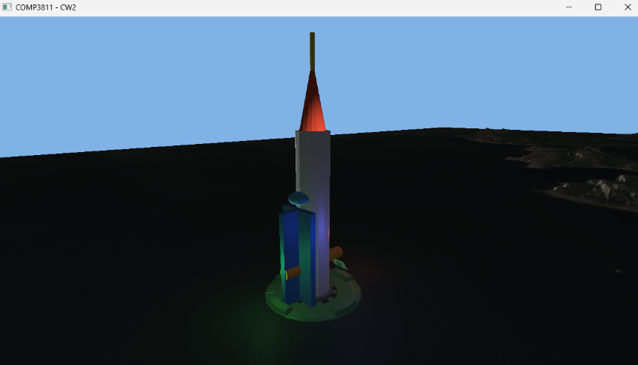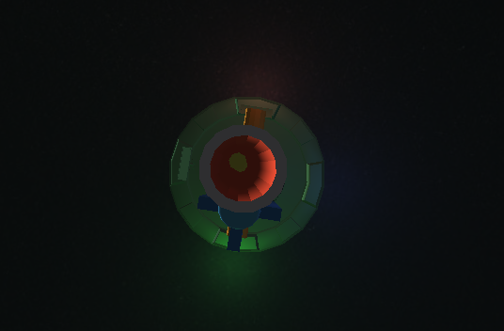

[Figure 5.1: Front-oblique view of the space vehicle on Launchpad A] [Figure 5.2: Elevated view showing radial fin arrangement and thruster pods]

Overview. This section documents the implementation of the full Blinn-Phong shading model for point lights with standard 1/r² distance attenuation. Three coloured point lights are positioned around the space vehicle, affecting all scene objects (terrain, launchpads, and vehicle). The directional light from Section 1.2 is preserved.
Blinn-Phong Shading Model. The fragment shaders (default.frag and material.frag) implement the complete Blinn-Phong reflection model. For each point light, the lighting contribution is computed as:
L = (k_{d} · max(N · L, 0) + k_{s} · max(N · H, 0)^{α}) · attenuation
where N is the surface normal, L is the light direction, H = normalize(L + V ) is the half-vector between light and view directions, and α is the shininess exponent. The diffuse term k_{d} provides base illumination, while the specular term k_{s} creates highlights on glossy surfaces.
Distance Attenuation. Point lights employ standard inverse-square distance attenuation:
attenuation = 1
1 + d2
where d is the distance from the light source to the fragment. The constant term prevents division by zero when
d ≈ 0. This physically-based falloff ensures realistic light intensity decay with distance.
Light Configuration. Three point lights with distinct colours are positioned around the space vehicle:

Light | Offset from Vehicle | Colour (RGB) | Purpose
Point Light 1 | (−3, 2, 0) | (2.0, 0.6, 0.6) Red | Left side accent
Point Light 2 | (+3, 2, 0) | (0.6, 2.0, 0.6) Green | Right side accent
Point Light 3 | (0, 3, −3) | (0.6, 0.6, 2.0) Blue | Rear/top accent

The lights are offset slightly from the geometry (2–3 units) to avoid numerical issues with the attenuation calcu- lation and to provide visible coloured illumination on vehicle surfaces. Light positions are stored as offsets from state.vehicleOriginalPos and updated dynamically during animation (Task 1.7).
Directional Light Preservation. The directional light from Section 1.2 remains active with direction (0, 1, −1) normalised and colour (1.0, 1.0, 1.0). This light uses the simplified ambient-plus-diffuse model (no specular) as specified in the original requirements, providing consistent base illumination across the entire scene independent of point light effects.
Shader Implementation. The blinnPhong() function in both fragment shaders computes per-light contributions. Uniforms include camera position (uCameraPosition) for view vector calculation, light properties (uPointLights[3]), and material shininess (uShininess). The helper function set_lighting_uniforms() in main.cpp uploads all lighting parameters to both shader programs, ensuring consistent illumination across textured terrain and material-coloured objects.
Global Application. All three point lights affect every rendered object: the terrain mesh (via default.frag), both launchpad instances, and the space vehicle (via material.frag). This unified lighting approach creates cohesive scene illumination with coloured highlights visible on nearby surfaces.
Screenshot.
[Figure 6.1: Space vehicle and launchpad illuminated by three coloured point lights]
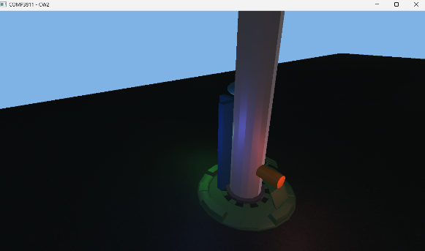

Overview. This section details the implementation of a procedural animation system for the space vehicle. The ani- mation simulates a rocket launch sequence with a curved trajectory, dynamic acceleration, and automatic orientation alignment. The system is interactive, allowing the user to control the playback state, and integrates seamlessly with the dynamic lighting system developed in Section 1.6.
Interaction Design. The animation state is managed through a state machine within the main application loop, controlled by user input via GLFW key callbacks:
- Start/Pause (F Key): Pressing F toggles the animation state. If the animation is inactive, it initializes the animationActive flag and resets the timer. If already active, it toggles the animationPaused flag, allowing users to freeze the vehicle mid-flight for inspection.
- Reset (R Key): Pressing R completely resets the simulation. The vehicle returns to its launch position (vehicleOriginalPos), the timer is zeroed, and the animation logic is disabled until the next start command.
Trajectory Generation. The vehicle’s flight path is defined procedurally using parametric equations based on the elapsed animation time t. To satisfy the requirement for a "curved path where it slowly accelerates from a standstill," the trajectory combines three distinct motion components:

- Vertical Ascent (Y ): The height is modeled to simulate a rapid initial climb that gradually levels off, mimicking a gravity turn. This is achieved using a quadratic damping function: y(t) = H · t · (1 − k · t), where H scales the maximum height.
- Forward Acceleration (Z): Forward movement follows a cubic function z(t) = −D · t³. This ensures the velocity starts at zero and increases non-linearly, providing the visual effect of the vehicle building up thrust and overcoming inertia.
- Horizontal Arc (X): To add complexity to the curve, a sine wave function x(t) = A· sin( ^{π} t) introduces a lateral
2
arc, resulting in a 3D corkscrew-like trajectory rather than a simple 2D parabola.

The system handles these phases using a normalized time parameter that transitions from an acceleration phase (quadratic interpolation) to a coasting phase (linear interpolation) after a fixed duration (3.0 seconds).
Orientation and Alignment. To ensure the vehicle always faces its direction of travel, the system calculates the instantaneous velocity vector v by computing the analytical derivatives of the position functions (dx/dt, dy/dt, dz/dt) with respect to time.
The orientation is derived by aligning the vehicle’s local up vector (up = (0, 1, 0)) with the normalized velocity vector
vˆ. This alignment is computed using the axis-angle rotation method:

- Rotation Axis: axis = up × vˆ
- Rotation Angle: θ = arccos(up · vˆ)
A rotation matrix is constructed from this axis and angle using Rodrigues’ rotation formula and applied to the vehicle’s model matrix. This ensures the rocket tilts naturally into the curve as it accelerates.
Dynamic Lighting Integration. The three point lights implemented in Section 1.6 are attached to the vehicle’s local coordinate system. In every frame of the animation, the light positions are updated by adding their constant local offsets to the vehicle’s current world position. These updated positions are passed to the shader uniforms, ensuring the coloured glow travels with the rocket, illuminating the launchpad during takeoff and the terrain during flight.
Visual Result.
[Figure 1.7.1: The space vehicle mid-flight, demonstrating the curved trajectory and orientation alignment. The coloured point lights can be seen traveling with the vehicle, illuminating the surrounding air.]

Overview. This section describes the implementation of an advanced camera system that allows users to switch between different viewing perspectives during the space vehicle simulation. To enhance the cinematic experience of the rocket launch, two automated tracking modes have been added alongside the standard free-roam camera: a "Follow" camera that chases the vehicle, and a "Ground" camera that acts as a fixed spectator viewpoint.
Camera State Management. The camera system is architected around a state machine implemented within the main application loop. An enumeration CameraMode defines three distinct states: Free, Follow, and Ground.
User interaction is handled via the C key. A cycling mechanism allows the user to transition sequentially through the modes:

Free Press C
Press C
Press C

−−−−→ Follow −−−−→ Ground −−−−→ Free
Crucially, when switching away from the Free camera mode, the current position and orientation of the user- controlled camera are saved to a temporary buffer (state.freeCamera). When the user cycles back to the Free mode, this state is restored, ensuring a seamless user experience where manual camera adjustments are pre- served.
Follow Camera (Chase View). The Follow camera is designed to maintain a fixed relative position behind and above the space vehicle, regardless of its orientation or position in world space. This requires transforming the camera’s position into the vehicle’s local coordinate system.
The algorithm calculates the camera position P_{cam} using the vehicle’s current position P_{veh}, its forward vector f , and its up vector u (extracted from the vehicle’s rotation matrix):
Pcam = Pveh − (f · dfollow ) + (u · hfollow )

where d_{follow} = 30.0 is the distance behind the vehicle and h_{follow} = 15.0 is the height above it.
Once positioned, the camera’s view matrix is updated using a look_at function targeting the vehicle’s center (P_{veh}). This ensures the vehicle remains perfectly centered in the frame while the background rotates dynamically, creating a sensation of speed and motion.
Ground Camera (Spectator View). The Ground camera simulates a fixed tracking station or a spectator standing near the launchpad. Unlike the Follow camera, its position is static in world space, fixed relative to the launchpad coordinates:
Pground = Plaunchpad + (20, 5, 20)
This places the camera slightly elevated (5 units up) and offset from the launch center.
While the position is fixed, the orientation is dynamic. In every frame, the camera re-calculates its view matrix to look directly at the current position of the vehicle (P_{veh}). As the rocket ascends and curves away, the camera rotates to track it, providing a stable frame of reference that emphasizes the vehicle’s altitude and trajectory.
Visual Results.
[Figure 1.8.1: The Follow camera mode, showing the vehicle from behind as it ascends.] [Figure 1.8.2: The Ground camera mode, looking up at the vehicle from the launch site.]

