A Depth-Aware, Physics-Based Data Augmentation Framework for Simulating Rain and Fog Distortions in Outdoor-RGB Images
Rongxuan Duan Pioneer Research Institute

Abstract

Introduction
Images used in computer vision are often distored. Distor-tion in computer vision refers to any signal that produces visual deviation in image/video from its original expectation. When the original iamge/video is unavailable, an observed visual comfort or simply annoying effect on the aesthetic vi-sual appearance is also considered as a distortion [1]. These distortions could be sorted as In-Capture Distortion, includ-ing blur, noise, uneven illumination, color shifts, haze, rain, snow, and other visibility changes; and Post-Capture Dis-tortion, such as transmission, impairments, enhancement artefacts, and adversarial distortion.
and reduce the reliability of machine learning models trained primarily on clean data [1]. Distortions affect the perfor-mances of high-level tasks, such as object classification, object detection, and scene understanding [1]. Therefore, distortion detection and removal are a possible preprocessing step for high-level tasks to decrease the impact on perfor-mance.
For machine learning, distortion is not only an image-quality issue but also is affected by dataset and training. Models usually learn from the distribution of inputs they are given, so a model trained only on clean images may have poor generalizability when working on the same object appearing under poor visibility, weather effects, or degraded contrast. Distortion-specified datasets are important because they make it possible to evaluate model robustness by type and severity, rather than reporting only a single clean-data accuracy score [1].

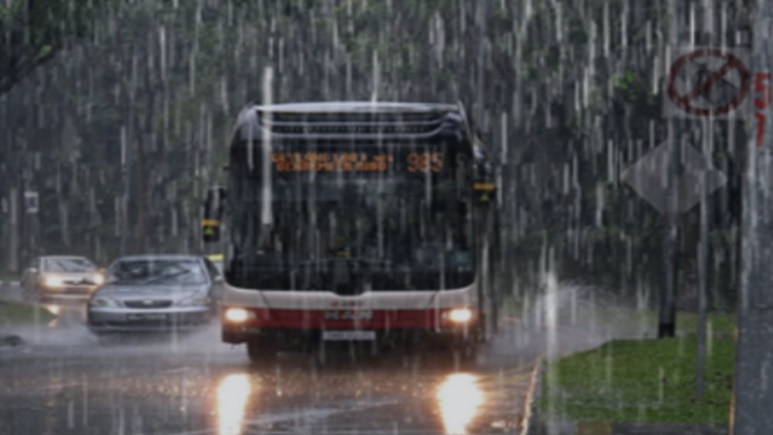
(a)
Image affected by rain
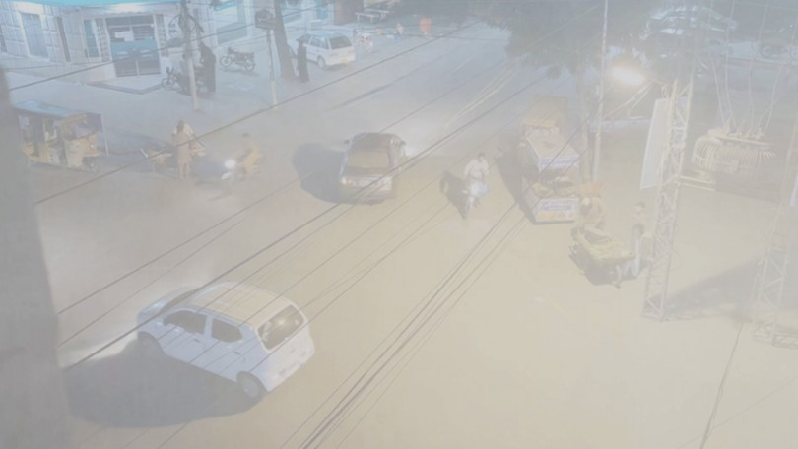
(d)
Haze effect on traffic road
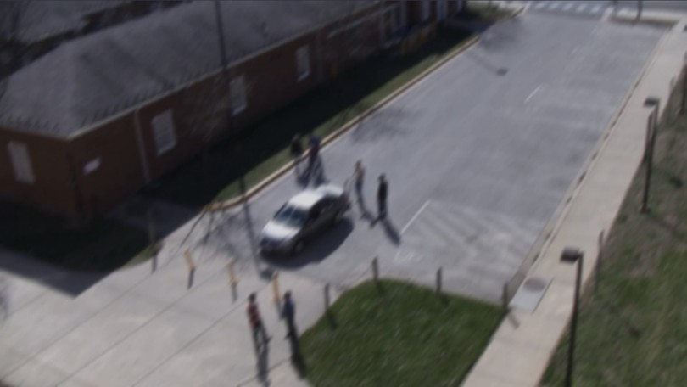
(g)
Human action recognition affected by motion blur
(b)
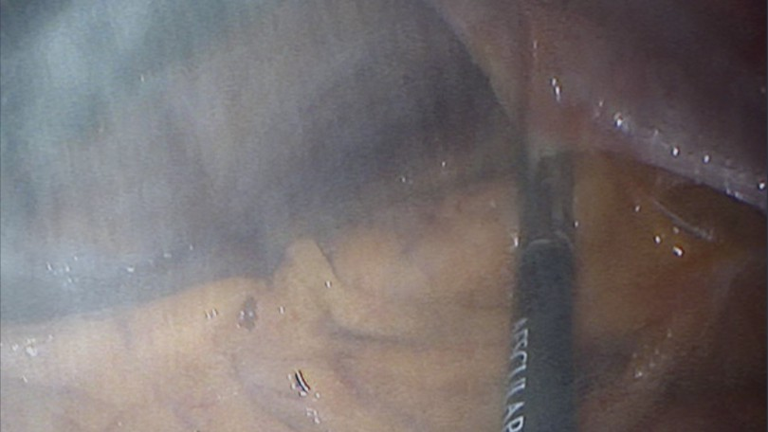
Surgery frame affected by smoke

(e)
Image affected by colour bleeding
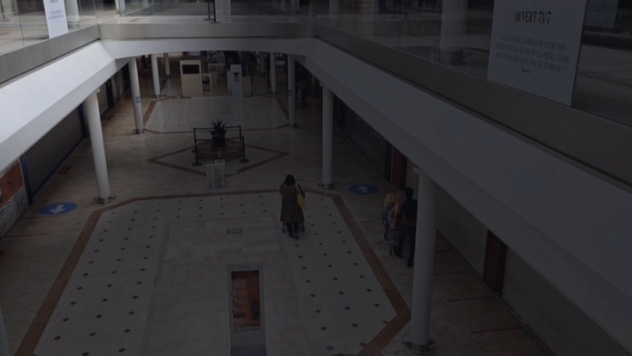
(h)
Visual tracking affected by uneven illumination
(c)
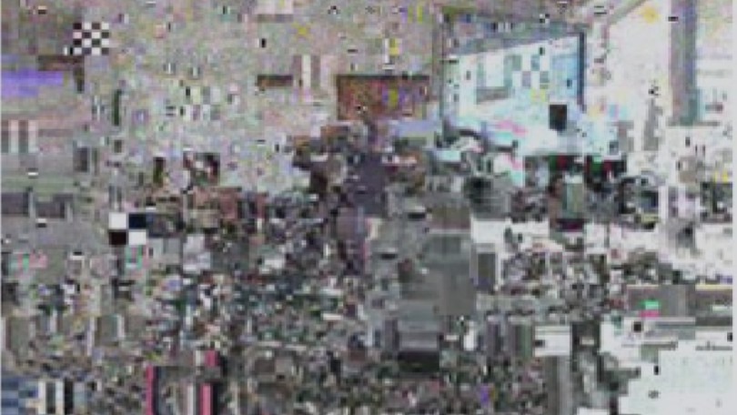
Packet loss in image transmission
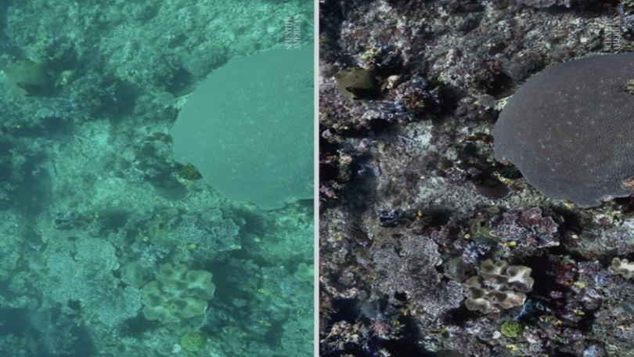
(f)
Colour loss in underwater imaging
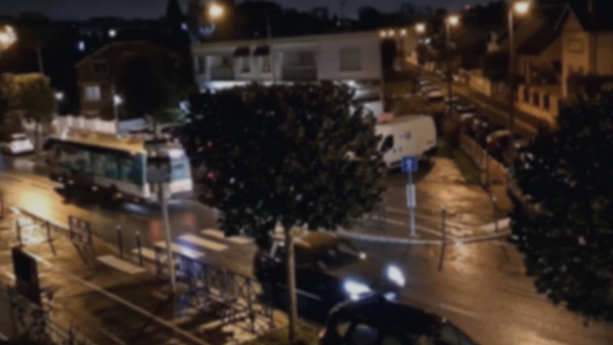

Auto-focus system failure in surveillance cameras
Current datasets of natural distortions have important limitations. Real rain, haze, fog, and snow images can be difficult to collect at scale, and the resulting data may be unbalanced across weather type, severity, scene category, and annotation quality. Many benchmark datasets also include distortions as broad corruptions rather than as physically meaningful, scene-dependent effects. This limits how well they can support controlled robustness studies or targeted training strategies. The need for environment-aware image formation is also visible in underwater computer vision, where more complicated distortions present due to an uneven refractive index of water, such as attenuation, scattering, color-shifting, halo effect, etc. [2].
Related work has explored both distortion recognition and natural-distortion simulation. Survey work on distor-

Figure 1: Examples of distortions encountered in computer vision and image/video analysis tasks, adapted from [1]

Although these effects may appear minor to human ob-servers, they can change the statistical structure of an image
tion classification emphasizes that multiple and natural dis-tortions remain difficult to categorize and model consis-tently [1]. In weather-focused vision, rain simulation has been used to render controlled rain effects for robustness evaluation, while haze and fog modeling often relies on at-

1

mospheric image-formation ideas such as scattering, attenu-ation, and reduced scene contrast. Work on adverse-weather perception, including foggy driving scenes, also shows that real weather can strongly affect downstream recognition and detection performance.
The model trains a distortion augmentation framework, which adds controlled rain and fog effects to existing base-line datasets such as BDD100K, ACDC and Cityscapes [3, 4, 5]. The framework is evaluated by comparing the performances of a downstream object detection model, YOLOv8n [6, 7], on the original dataset and the augmented dataset.

Cycle-GAN (Generative Adversarial Net-work)

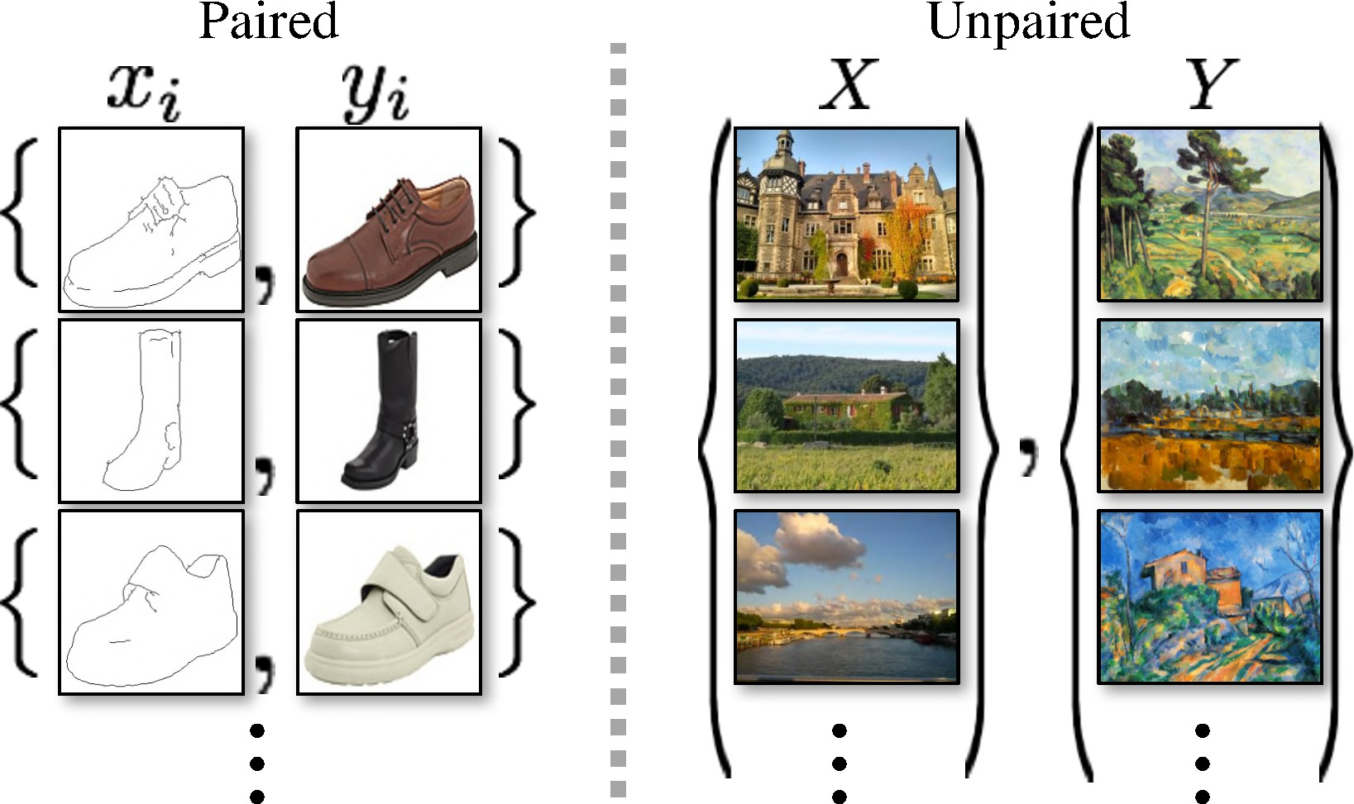

Figure 2: Paired training data (left) consists of training ex-amples {x_{i}, y_{i}}^{N} . Unpaired training data (right) consists
i=1

of a source set {x_{i}}^{N} (x_{i} ∈ X) and a target set {y_{i}}^{N}

Generative Adversarial Network (GAN) is a deep learning (
i=1
i=1

model that consists of two networks that c ompete against each other: a generator G and a discriminator D. The genera-tor G tries to generate realistic images from a target domain X, while the discriminator D tries to discriminate generated images from real images. That is, the generator learns a
mapping: G : X → Y . For example, in the context of our work, the generator G tries to create rainy or foggy looking
images from clear images, while the discriminator D tries to distinguish between real rainy or foggy images and gen-erated images. The generator and discriminator are trained in an adversarial manner, where the adversarial framework’s objective is to minimize the generator loss and maximize the discriminator loss. The loss function of GAN is given below, defined by Goodfellow et al[8].
y_{i} ∈ Y ). Unpaired training contains no correspondence from the source set X to the target set Y . Figure adapted
from [10].

Our work uses Cycle-GAN, which is a type of GAN that learns from unpaired training data. Cycle-GAN uses two generators and two discriminators. A generator G : X → Y transforms images from domain X to domain Y ; a reverse generator F : Y → X transforms images from domain
Y to domain X. The first discriminator D_{Y} distinguishes
between real images in domain Y and generated images from generator G; the second discriminator D_{X} distinguishes between real images in domain X and generated images from generator F . The Cycle-GAN framework uses a cycle-consistency loss to ensure that the generated images can

min max
Ex∼p
_{(x)}[log D(x)]
be transformed back to the original domain. The cycle-

G D data
+ E_{z∼p}z (z)[log(1 − D(G(z)))].
(1)
consistency loss is given below, defined by Zhu et al[10].

Traditional GANs use paired training data, which con-
sists of training examples {x , y }^{N} , where x is the input
L_{cyc}(G, F ) = E_{x∼p}data (x) [∥F (G(x)) − x∥₁]
+ E_{y∼p}data (y) [∥G(F (y)) − y∥₁] .
(2)

i i i=1 i

and y_{i} is the corresponding output. GAN is useful for image-to-image translation tasks, such as photo reconstruction from edge maps, colorization, photo synthesis fromlabel maps, etc[9]. However, in many cases, paired training data is not available. In the context of our work, it is difficult to collect paried training data of clear images and corresponding rainy or foggy images at same places. Existing datasets, such as BDD100K, cityscapes, or ACDC, are all unpaired datasets[3, 5, 4]. Figure 2 illustrates the difference between paired and unpaired training data.
The objective of Cycle-GAN is to minimize the adver-sarial loss, maximize the discriminator loss, and minimize the cycle-consistency loss. The key idea for Cycle-GAN is that if an image is transformed from doamin X to domain Y by G, and then it is transformed back to domain X by F, the resulting image should be similar to the original image. This cycle-consistency allows the model to not only produces an image that looks like it belongs to the target domain, but also preserves the content, or the structure of the original image[10].
In weather augmentation, cycle-GAN is useful because it generates realistic rainy or foggy images from clear images while it preserves the scene structures and it does not require paired training data. However, a limitation of Cycle-GAN, as well as other GANs, is that it is not controllable. It is impossible to control how much wetness, rain, or fog is gen-

erated, and it is impossible to control the depth-dependent effects of rain and fog[10, 11]. Therefore, our work uses Cycle-GAN to generate rainy and foggy images, but it also uses a physics-based, depth-aware renderer to generate rain with controllable appearance.

Related Work

Distortion Classification and Evaluation
Traditional distortion classification models and evaluation use blur indices, noise estimators, natural scene statistics, image quality metrics, Support Vector Machines (SVM), and K-Nearest Neighbours (KNN) to evaluate the impact of distortions. Recent distortion classification and detection models use Convolutional Neural Networks (CNN) and tem-poral models. Ahn, Kang, and Sohn train a Y-shaped CNN for joint distortion classification and localization. Other methods for distortion classification include feature pool, relating metrics with specific distortions, and Natural Scene Statistics (NSS). The method supports learned distortion fea-tures, yet most datasets focus on controlled distortions rather than natural weather [1, 12].
The quality of visual content in images and distortion severity are important factors that affect performance in high-level tasks, including object classification, object detection, and scene understanding. Using distortion classification and detection models could help researchers finetune models that are more resistant to distortions. However, our work helps finetuning models by presenting a data augmentation framework that increases models’ resilience to rain and fog distortions from training, which does not require distortion detection and distortion removal process.

Current Limitations of Distortion Datasets
Current distortion datasets give labels and severity levels, but many examples come from synthetic, single-type, quality-assessment settings. LIVE, TID2008, TID2013, CSIQ, Wa-terloo, KADID-10K, LIVEMD, and MDID help keep a con-trolled evaluation. However, they do not contain natural weather withprecise physical labels. Rain, haze, fog, and snow depend on lighting, exposure, particle density, scene depth, and occlusion. There is a lack of labeled, controlled multi-distortion datasets. Consequently, classification and localization of multiple distortions remains challenging due to lack of labeled, controlled datasets [1, 11]. Our work adds controlled, artificial distortions, which addresses lack of la-beled, controlled datasets, especially for outdoor datasets.

Traditional Rain Rendering
Garg and Nayar model rain streak photometry and spatio-temporal behavior. Their work links rain visibility to drop size, velocity, exposure time, scene radiance, camera settings, and drop shape oscillation. This result matters for render-ing because a transparent 2D texture ignores camera and scene factors. Traditional rain rendering lacks the effect of moisture on the scene, and it often appears to be unrealistic. For instance, traditional rain rendering lacks wet surfaces such as water on the ground, and it creates raindrops that are supposed to be hidden behind buildings [11]. Though, this framework supported rain detection, removal, rendering, and camera-based rain measurement [13].
Below examplifies three traditional rain rendering meth-ods: rain100H, rain800, and did-MDN [11].
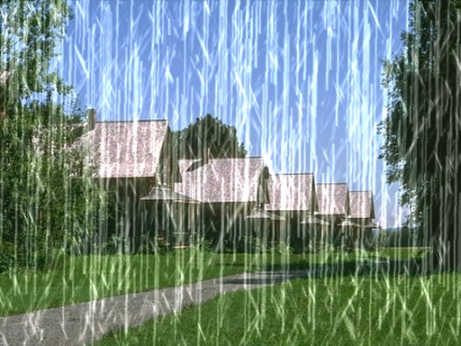
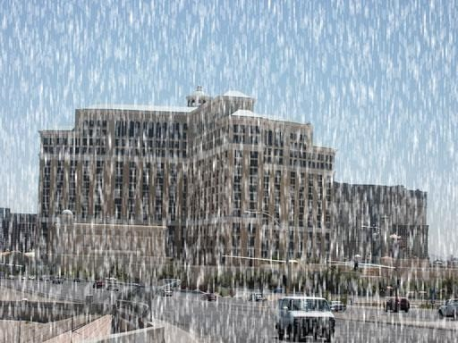
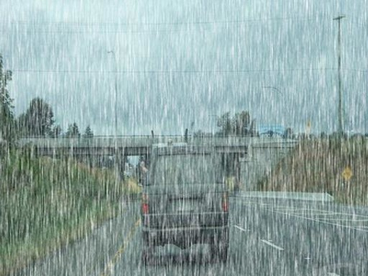
(a) Rain100H (b) Rain800 (c) DID-MDN
Figure 3: Three traditional rain rendering methods, adapted from [11]

Modern Rain Rendering
Modern rain rendering turns rain models into dataset aug-mentation for robustness tests. Halder, Lalonde, and de Charette combine a particle simulator, outdoor illumination estimation, and rain photometry to render rain and fog over clear driving images. The pipeline preserves labels from KITTI and Cityscapes while changing weather appearance. Detection and segmentation results then measure model sen-sitivity under controlled rain [14].
Tremblay, Halder, de Charette, and Lalonde compare three rendering routes: physics-based, data-driven, and hy-brid. They classify raindrops into rain particles and fog-like rain. Fog-like rain is a single pixel that contains multiple rain particles; it is located far away from the camera and appears as fog. The physics-based route combines fog-like rain, rain particles, and photometric modeling. The renderer estimates outdoor illumination because a raindrop receives light from a wider angular range (approximately 160 degrees) than the camera’s view (70 to 100 degrees). This design improves physical control over a flat overlay. The same design also depends on sky visibility, environmental symmetry about photometry, and compute cost [11, 15, 16].
The data-driven route uses a GAN-style image transla-tion model. A GAN trains two networks: a generator syn-thesizes target-domain images, and a discriminator judges whether each image looks real or generated. Adversarial

training on the generator outputs rainy-looking images. The output from the generator contains features such as dark sky, rainy environment, wet surfaces and dim lamination. How-ever, GAN is less controlled, which risks rain density, depth ordering, and scene consistency. GAN’s focus on global appearance also creates unrealistic features, such as fake water reflections [11, 9, 17].
Tremblay et al. render rain over KITTI, Cityscapes, and nuScenes. They evaluate object detection, semantic segmen-tation, and depth estimation under increasing degradation. The paper reports degrading performances as increasing rain intensity and more robust performances after finetuning us-ing rain-augmented datasets. The paper reports that outputs from GAN only are user-rated as the most realistic images; outputs from GAN plus PBR perform the best on data aug-mentation [11].
Our work is inspired from the framework from Tremblay et al. our work uses the traditional rain rendering framework with depth estimation to build rain streaks with controlled, depth-dependent rain streaks; our work also involves using a Cycle-GAN model that adds rainy and foggy visual effects.

Fog Rendering
Fog rendering often follows the atmospheric image forma-tion model. Scene radiance attenuates with distance, while airlight grows along the camera’s ray. Sakaridis, Dai, and Van Gool applies this model to clear Cityscapes images and produce Foggy Cityscapes. Depth makes fog stronger for far regions rather than uniform across the image. Training with synthetic fog improves semantic foggy scene understanding, but results depend on depth quality, density choices, and the synthetic-to-real gap [18].
Clear2Fog extends this direction with monocular depth estimation and atmospheric light estimation. Monocular depth estimation does not require 3D constructions such as LiDAR; rather, this paper uses Apple Depth Pro to produce an estimated depth map. The pipeline simulates fog on clear-weather driving datasets and tries to preserve camera-LiDAR consistency. Without relying on LiDAR, Clear2Fog remains stable under extreme conditions like fog, snow or haze. See-ing Through Fog Without Seeing Fog focuses on multimodal perception rather than rendering. The dataset and fusion model show different failure patterns across camera, LiDAR, radar, and gated near-infrared sensors [19, 20].

Depth Estimation and Application in Dis-tortion Rendering
Depth provides the geometry needed for natural distortion placement. In haze and fog, depth sets attenuation and airlight strength. In rain, depth helps determine the severity, intensity and placement of rain streaks. A renderer without
geometry often places plausible-looking weather in physi-cally inconsistent locations [18, 11].
Depth estimation models estimate distance from an im-age or complete sparse sensor depth. The output supplies an approximate geometry map when a dataset lacks dense ground truth. Jaritz et al. study sparse and dense depth completion for driving scenes. Depth Anything V2 offers a modern monocular option trained with synthetic images and pseudo-labeled real images. This makes Depth Anything V2 useful for RGB-only distortion rendering [21, 22].
Our work uses the depth-map output from Depth Any-thing V2 as the guiding parameter for transparency and ap-pearance of rain streaks and translucency and intensity of fog. The depth-map output from Depth Anything V2 is sta-ble and reliable, and it is a strong model for completing our computer vision tasks.

Datasets With Distortions
General distortion and corruption datasets support baselines, but natural weather rendering requires more geometry and scene context. The distortion survey lists LIVE, TID2008, TID2013, CSIQ, Waterloo, KADID-10K, LIVEMD, and
MDID as major image-quality or multi-distortion resources. ImageNet-C standardizes common corruption robustness for image classifiers. These resources help robustness framing. They do not model depth-aware rain, haze, or fog. [1].
eather-specific datasets match the project more closely. ACDC includes fog, nighttime, rain, and snow with dense driving-scene annotations and normal-condition correspondences for many scenes. Foggy Cityscapes and rain-augmented KITTI, Cityscapes, and nuScenes preserve existing labels while adding synthetic weather. The lim-itation of these datasets is the lack of controlled severity or intensity, depth-aware labels, and controlled natural distortions [4, 18, 11].

BDD100K
BDD100K serves as a baseline dataset for our work, because the data are large, diverse, and driving-focused. The dataset contains 100,000 driving videos and supports detection, seg-mentation, lane marking, drivable area, and related driving labels. BDD100K also includes geographic, environmen-tal, and weather variation. The limitation is missing paired clean/adverse views and controlled severity labels. A depth-aware rain and haze renderer would turn BDD100K into a controlled robustness testbed while keeping real driving diversity. [23].

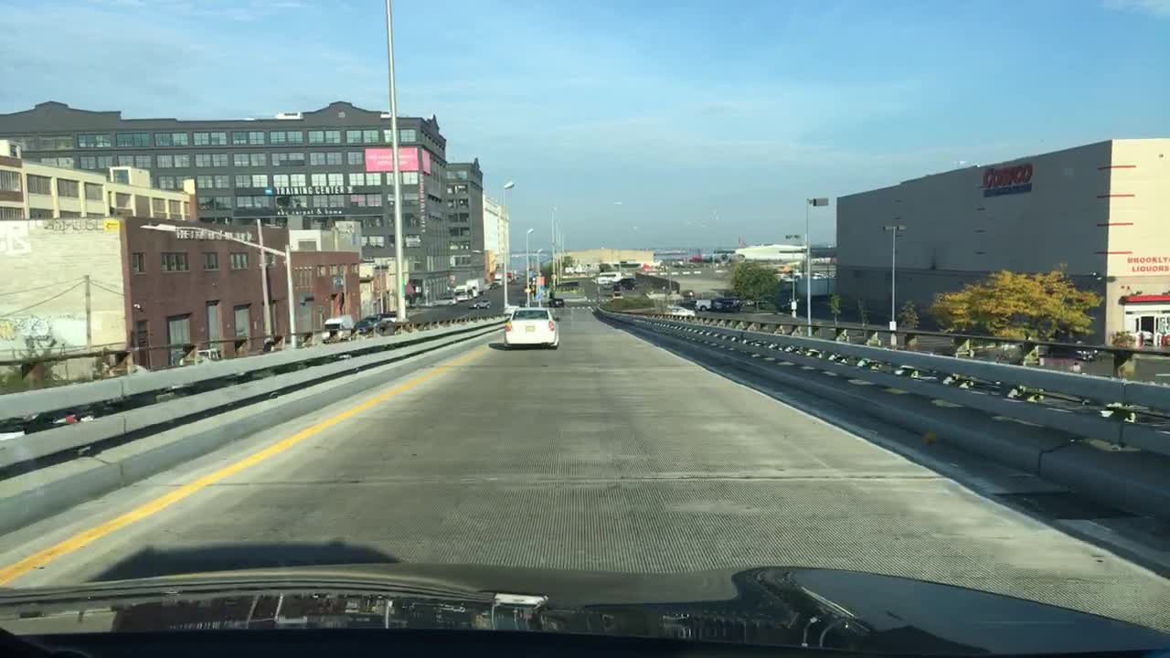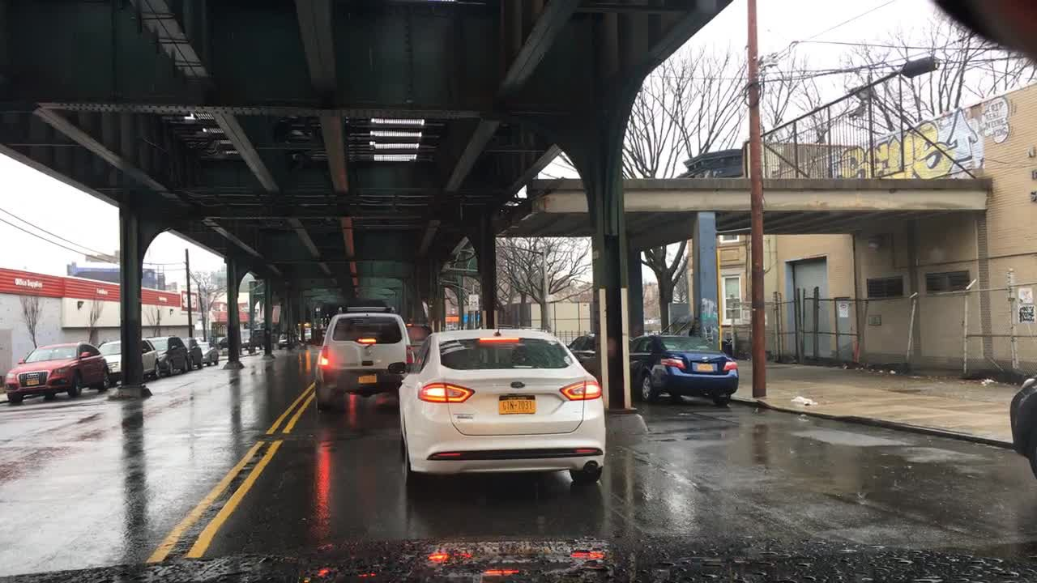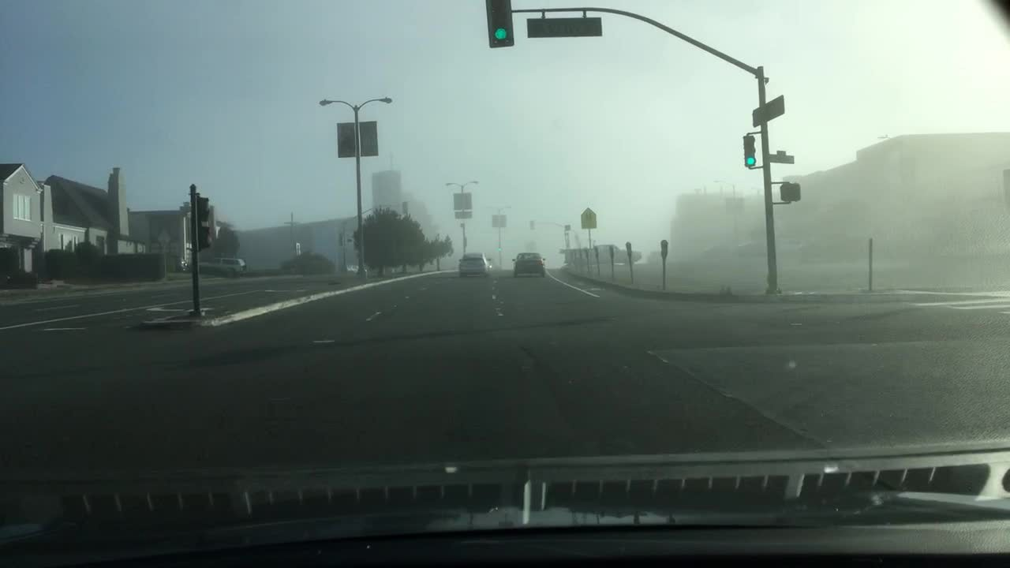
(a) Clear image from (b) Rainy image from (c) Foggy image from
where p₁ and p₉₉ are the 1st and 99th percentiles of the depth values used to exclude extreme values, and ϵ is a small constant to avoid division by zero. The normalized scene distance is then defined as d(x, y) = 1 − D_{n}(x, y), where
a d(x, y) = 0 represents foreground regions close to the

BDD100K
BDD100K
BDD100K
camera and d(x, y) = 1 represents distant scene regions.

Figure 4: Examples of clear, rainy, and foggy images from BDD100K [23]

Methodology
Data augmentation is a strategy for improving computer vi-sion models by artificially increasing the diversity of training images through transformations such as cropping, rotating, flipping and adding noise. These methods are especially useful when access to labeled image data is limited, because they expose a model to variations it may encounter in real-world visual tasks. In computer vision, data augmentation helps image classifiers learn features that are less dependent on a single viewpoint, orientation, or image style, reducing overfitting and improving generalization[26].
Data augmentation is the primary method to increase a dataset’s size and variety. In the context of this paper, it refers to adding rain and fog to images. As discussed in previous sections, collecting data with various natural distor-tions for an outdoor dataset is challenging. Therefore, using data augmentation to render natural distortions improves the performance for deep learning models. Our work focuses on rain and fog distortions in outdoor RGB images.

Rain Rendering
Rain appears as dynamic-looking particles and brings a rainy effect to the image. Inspired by Tremblay et al [11], our rain rendering method uses a physics-based rain rendering method that simulates raindrops and a Cycle-GAN model that creates rainy effect.

Physics-based Rendering (PRB)
To generate synthetic raindrop appearance, the physics-based rain rendering (PBR) method combines image-rspace rain streak synthesis, atmospheric scattering and linear-light com-positing, based on the monocular depth map produced by Depth Anything V2[22]. The objective of this renderer is to produce controllable raindrops while being consistent with scene geometry and depth.
Given an input RGB/BGR image I and an estimated depth map D, the raw depth values are first normaliszed into a relative distance map:
D = clip(D, p₁, p₉₉) − min(D) (3)
n
max(D) − min D) + ϵ
(
The renderer models rain as layered rain streaks. Four rain-depth layers are used: near, mid, far, and background. Each layer l has a fxed normalized depth z_{l}, a streak count N_{l}, strreak length L_{l}, streak width W_{l}, base opacity α_{l}, defocus blur, and angular jitter. For an image of height H, width W, minimum dimension m = min(H, W ), area scale A = HW/1000, and rain severity s. The layer parameters are defined as functions of severity. For example, the near layer uses:
N_{near} = A(0.025 + 0.13s)
L_{near} = m(0.025 + 0.080s)
W_{near} = 1.75 + 2.20s α_{near} = 0.020 + 0.055s
The mid, far, and background layers follow the same structure, with progressively smaller streak widths and lengthds but larger particle counts. This models the physical appearance of raindrops, which appear to be smaller and more numerous as they are positioned further from an observer. Nearby raindrops appear longer, thicker and more defocused, while distant raindrops appear denser and smaller.
Depth is used to determine whether rain in a given layer should be visible at each pixel. A rain layer is only visible when it lies in front of the visible scene surface. Raindrops from a given layer do not suddenly appear or disapper; rather, they fade in or out when their depth d(x, y) is at a depth-edge, where it is close to a layer’s fixed normalized depth z_{l}. The visibility is computed using a smooth transition function:

V_{l}(x, y) = smoothstep(−δ, δ, d(x, y) − z_{l}) (4)
where δ_{l} is the layer softness parameter that controls how rapidly the raindrops fade in or out. A smaller δ_{l} means a sharper transition, while a larger δ_{l} means a smoother transition. The near layer has the smallest δ_{l}, while the background layer has the largest δ_{l}. The smoothstep function is:
smoothstep(a, b, x) = t²(3 − 2t)
x − a
t = clip( , 0, 1)
b − a + ϵ
This prevenst distant rain from being visible in front of foreground objects. The smoothstep function and visibility

function prevents discontinuities in the rain appearance at a depth-edge. It also prevents halo spaces around object boundaries.
Individual rain streaks are genederated using a anisotropic motion kernal, which is a kernal that blurs differently in different directions, rather than hard lines. For a streak angle θ, each kernal pixel is projected into coordinates along and across the rain direction:
u = xcosθ + y sinθ v = −xsinθ + y cosθ
where u is distance along the rain streak and v is distance across the rain streak.
The streak intensity (how strong each pixel of a rain streak is inside the filter) is tapered along its length and Gaussian blurred along its width:
with the motion kernel, is added to the map. The optical thickness map is denoted as τ (x, y). Then, the renderer generates an opacity-weighted brightness map as:

τ ∆(x, y) = τ (x, y)∆_{i}
X
l
The final rain alpha is defined as:
αrain = clip(1 − e− clip(τ,0,3.5), 0, 0.62)
The final rain color delta map ∆_{rain} is the opacity-weighted average and clipped within the plausible range (−18, 145).
A light mist layer is applied before compositing the
streaks, based on the depth map. The mist intensity depends on layer, where a more distant layer has a higher intensity, a smoothstep function is applied, preventing abrupt change

K(u, v) =
_max
(0, 1 −
|u| \lp
· exp
− 1 ( v
\2!
in mist appearance between across layers. The mist map is denoted as I_{mist}, and it is then added with the slightly tinted

L/2

where p = 1.45 controls tapering and:
σ_{w} = max(0.35, 0.55W_{l})
2 σ_{w}
(5)
rain delta map ∆_{rain} to produce a weather augmentation mask, I_{target}.
The output image is then:
Iout = Imist(1 − αrain) + Itargetαrain (6)

The kernel is normalized so its peak value is one. By applying this kernel on point-like rain particle, it creates motional rain streaks that resembles real rain’s photometry rather than opaque white streaks.
For each sampled rain streak, the opacity α_{i} is defined by a log-nromal distribution and the layer opacity:
α_{i} = clip(α_{l} · LogNormal(0, 0.22), 0.001, 0.18)
The brightness level Y of a streak is made dependent on the local scene brightness. The local scene brightness is obtained from converting the image to linear light:
Y = 0.0722B + 0.7152G + 0.2126R
The rain streak contrast factor controls how visisble a rain streak should be depending on local brightness. It is stronger over dark regions and weaker over bright regions:
C = 0.34 + 1.05(1 − Y )^{0.72}
The pixel intensity delta for a rain streak is its change in brightness compared to the scene brightness Y :
∆_{i} = ϵ_{l}C − η_{l}Y ^{1.15} + N (0, 4 + 5α_{l})
where ϵ_{l} is the layer highlight strength constant and η_{l} is a shadow suppression constant. Delta is then clipped to a range clip(∆_{i}, −16, 135).
The renderer then accumulates rain as an optical thick-
ness map. Each raindrop’s pixel intensity ∆_{i}, convolved
Overall, the renderer combines depth estimation with physics-based optical accumulation. The depth-based layer visibility prevents rain from incorrectly appearing over fore-ground objects. the optical thickness map τ blends the opacities of rain streaks that are co-linear in a line from the observer, rather than overlaying rain streaks directly onto the input image, causing a local-unrealistic exposure. The brightness-aware streaks ensure the brightness to be adjustable depending on the background and depth.

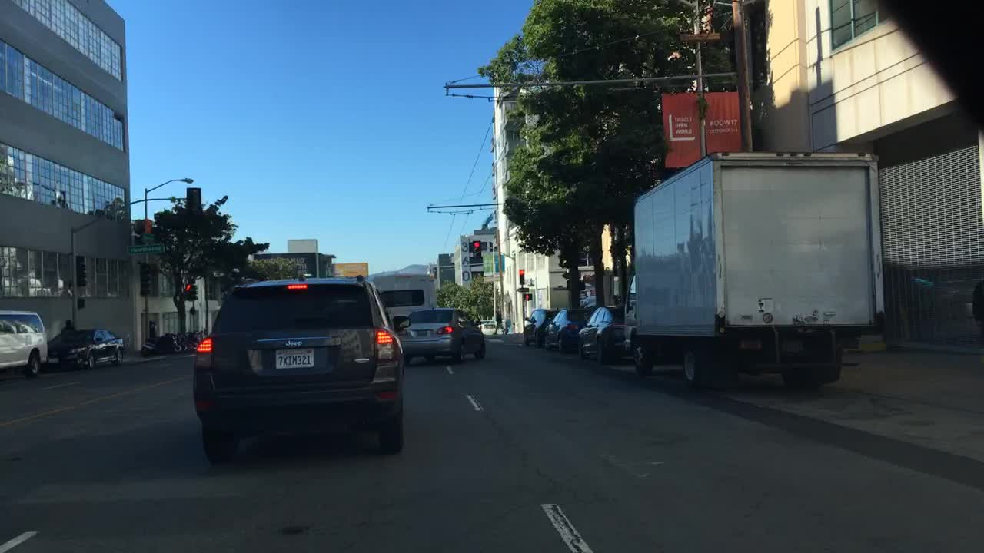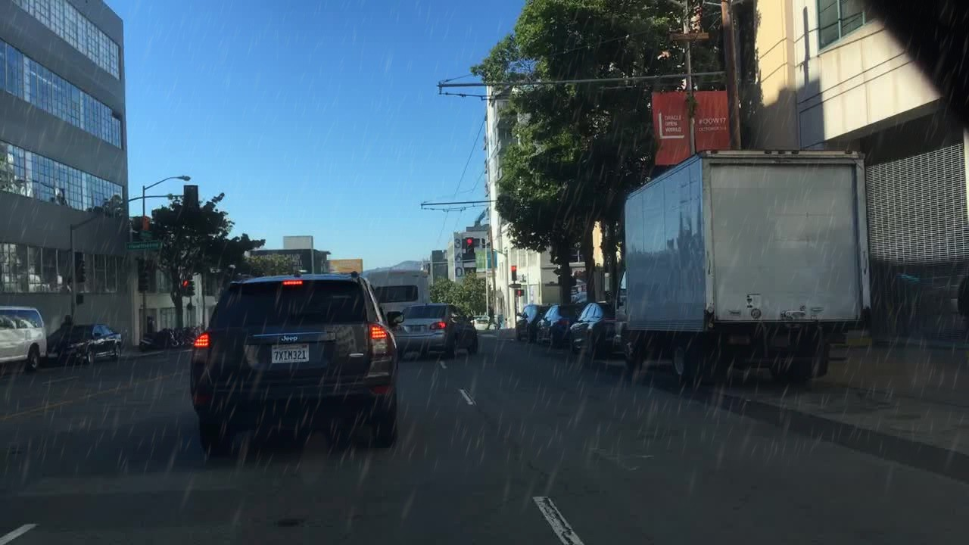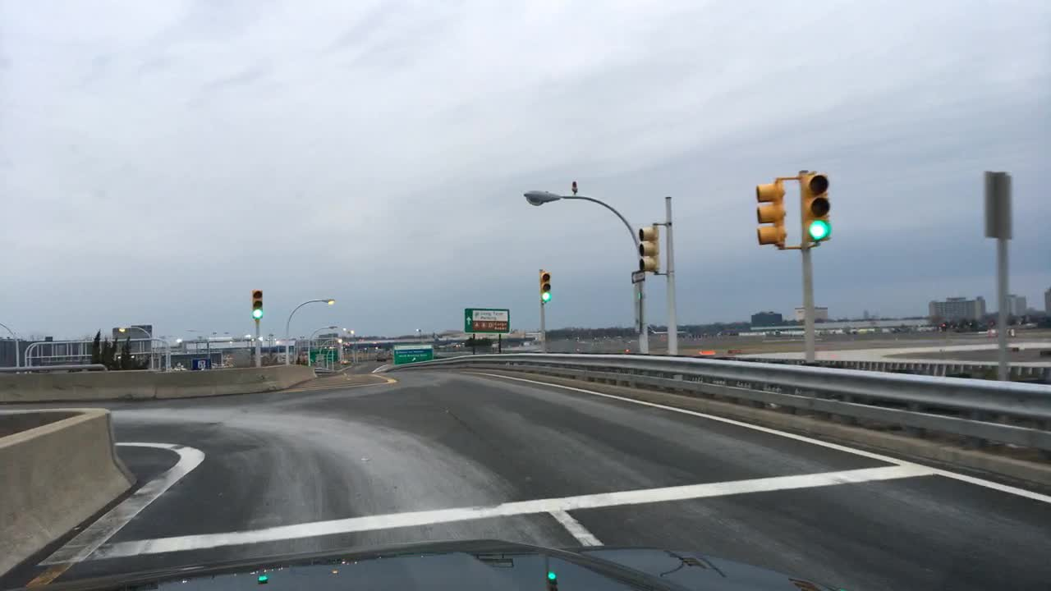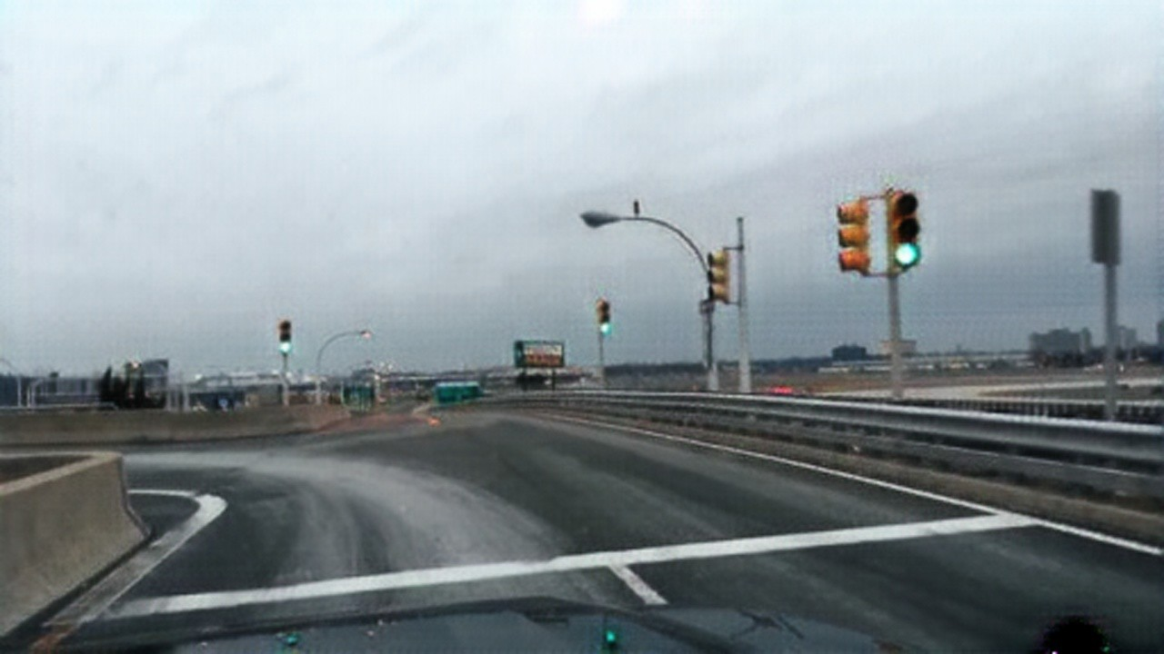

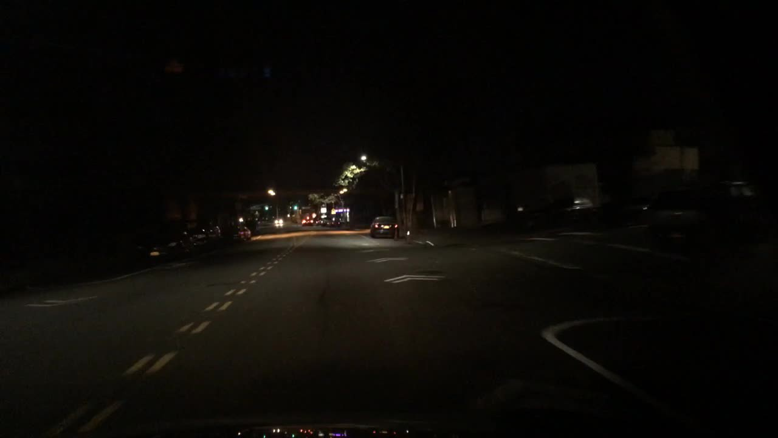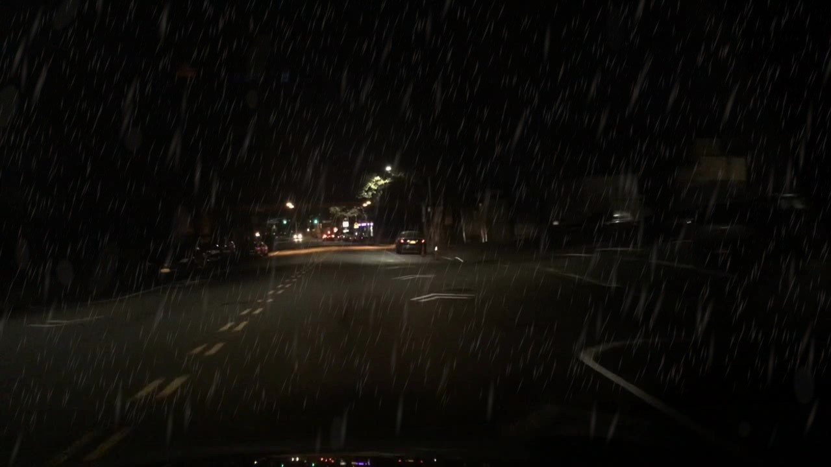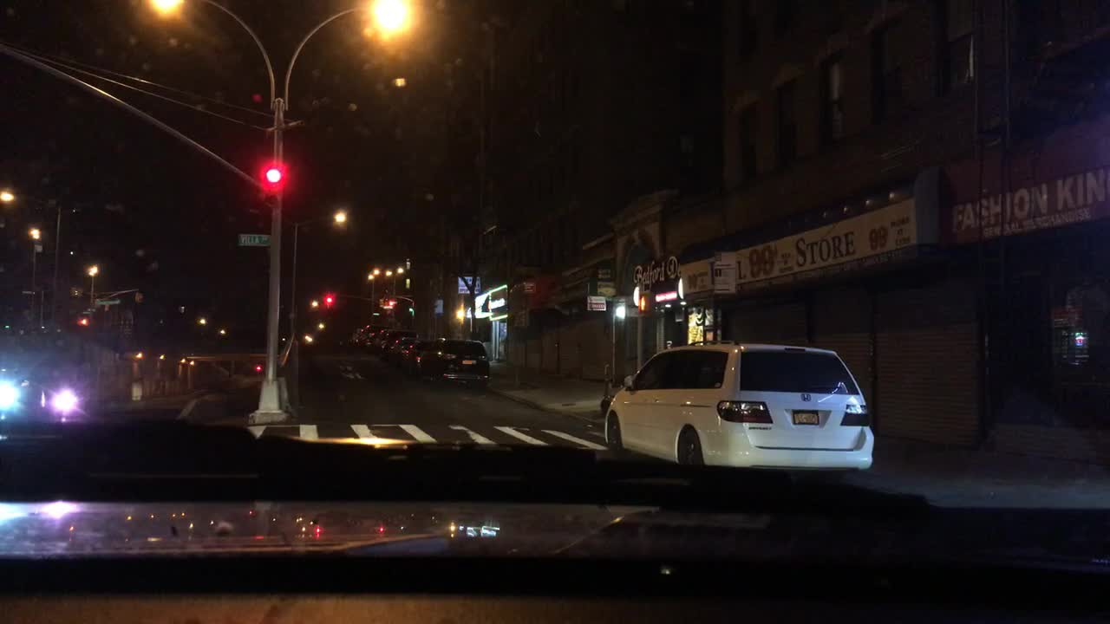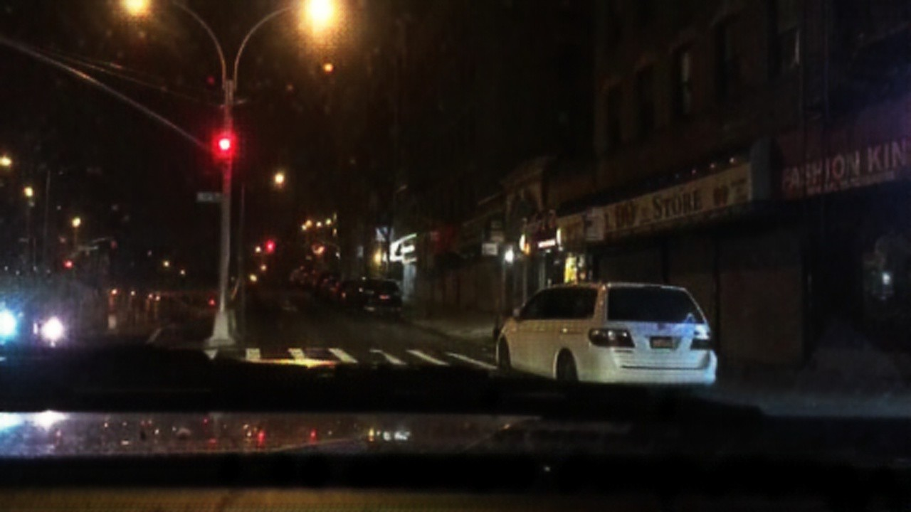

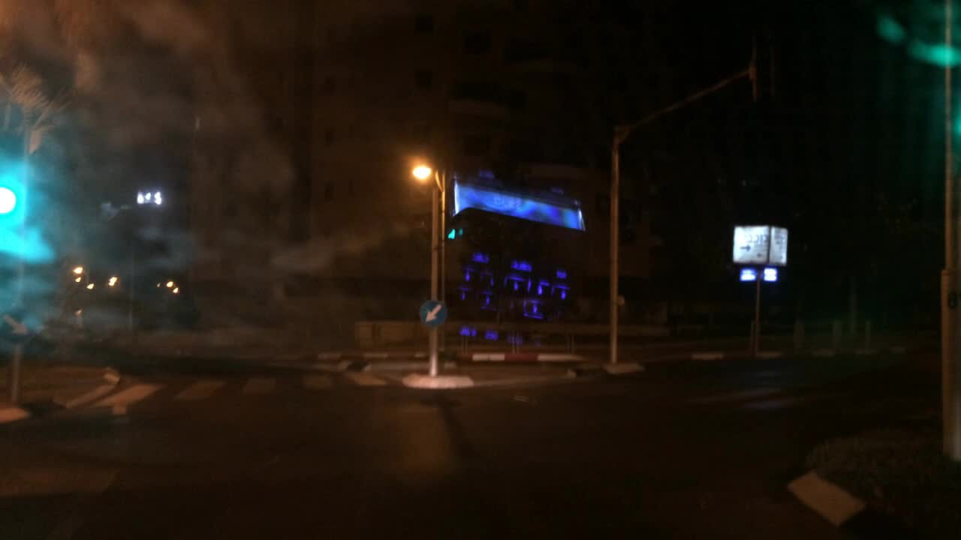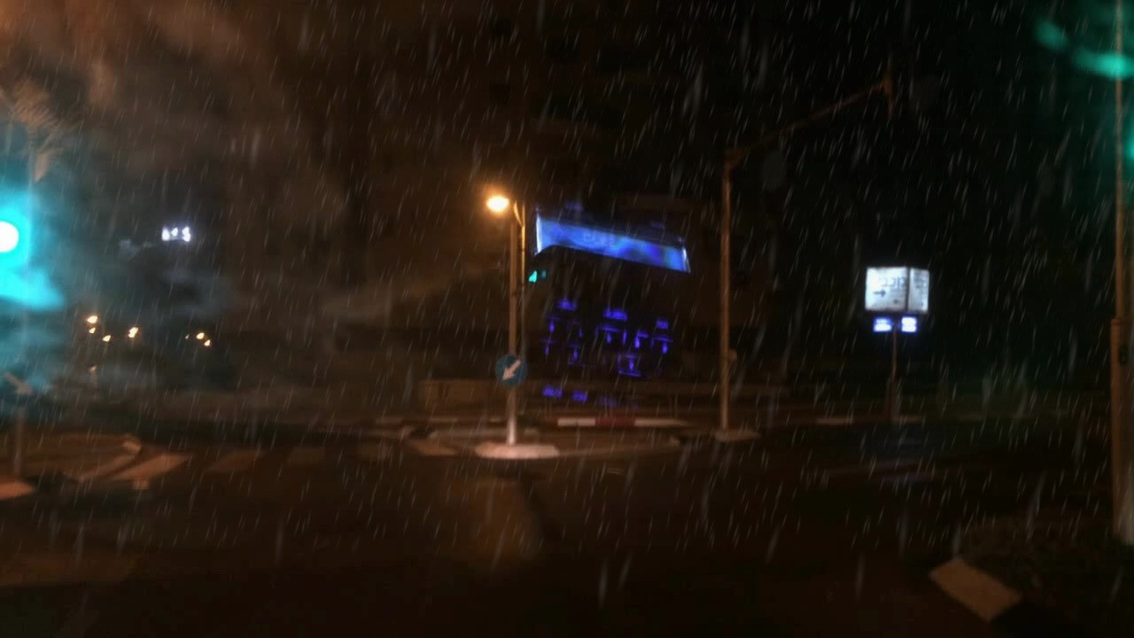
Clear weather input Depth-aware rain augmented output
Figure 5: Images in the left column are the clear-weather-labeled inputs from BDD100K dataset. Images in the right column are the corresponding depth-aware rain augmented output, severity parameter being set as ”medium”

Rain Cycle-GAN
While the physics-based renderer simulates raindrops and fine mist, it lacks rainy characteristics such as wetness, reflec-tions, sky and lighting. Scenes generated from the physics-based render may have realistic raindrops and mist, but they lack an overall rainy look. These characteristics are hard to generate through a controlled method, whereas Cycle-GAN can handle image-to-image translation tasks.
The dataset used for training is BDD100K. It contains seven labels: “clear”, “overcast”, “undefined”, “snowy”, “rainy”, “partly cloudy” and “foggy”. The corresponding numbers of images in train split are 37344, 8700, 8119, 5549,
5070, 5881, 130, respectively; the corresponding numbers
of images in validation split are 5346, 1239, 1157, 769, 738, 738, 13, respectively. Labels “clear” and “rainy” are used for training, which refer to clear weather and rainy weather, respectively.
For an unpaired Cycle-GAN training, the training pro-cess loads 3000 clear images and 3000 rainy images. Train-ing images are loaded as 512*512, then they are randomly cropped at 384*384. The model is optimized with 10 epochs and 10 decaying epochs, learning rate of 0.0001 and batch size of 1.
Clear weather input GAN augmented output
Figure 6: Images in the left column are the clear-weather-labeled inputs from BDD100K dataset. Images in the right column are the corresponding Rain Cycle=GAN augmented output.

The generated images have more foggy and desaturated skies and wet effects on the ground in common. However, some of them have random white noise. This issue is com-mon when the size of training images is too small, or the size of the train split is small. It could be fixed by increasing image resolution or using a bigger training dataset.
A large portion of the rainy images in BDD100K appear to have been captured after rainfall rather than during active rain. This may explain why the differences between the GAN-generated outputs and the input images are subtle and not always noticeable to the naked eye.

Framework Combining PBR and Rain Cycle-GAN
The final rain augmentation framework combines the Rain Cycle-GAN model and the depth-aware physics-based ren-derer into a hybrid pipeline. The purpose is to use the strengths of both methods. Rain Cycle-GAN generates the overall rainy appearance, while the physics-based rain ren-derer adds controllable rainfall, including rain streaks, fine mist, and depth-aware visibility.
The pipeline starts with a clear-weather image from BDD100K. First, the image is passed through the trained Rain Cycle-GAN generator to produce a rainy-looking out-put of the same scene. The output perserves structures such as road layout, vehicles, buildings, etc; it shifts the image to-ward the rainy domain. Depth Anything V2 also extismates a monocular depth map from the input image, which is used by the PBR renderer.
After the Cycle-GAN translation, the PBR renderer com-posites rain onto the GAN-generated image. The severity pa-rameter controls the number and appearance of rain streaks. Near rain layers contain larger and more visible streaks, while far layers contain smaller and denser streaks. The

depth map prevents inconsistent results, such as distant rain appearing in front of nearby cars or buildings.
The order is important. If the physics-based rain is added before Cycle-GAN, the generator may weaken or distort the synthetic rian streaks. By apply PBR after Cycle-GAN, the result may consistently keep the global rainy style while adding controllable rain.
Compared with Cycle-GAN alone, the hybrid framework provides direct control over rain intensity and depth place-ment. Compared with PBR alone, it produces a more com-plete rainy scene because it includes wetness and lighting changes. Therefore, the combined PBR and Rain Cycle-GAN framework assembles real rainy images better than PBR or GAN alone, and it can produce controlled rainy training data with smaller visual gap between synthetic rain and real rainy scenes.

References
- Muhammad Ali Qureshi et al. Distortion Classifi-cation in Computer Vision Applications: Current Progress, Challenges, and Perspectives — ACM Com-puting Surveys. https://dl.acm.org/doi/10.1145/3773023. (Visited on 06/10/2026).
- A Survey on Underwater Computer Vision — ACM
- Jun-Yan Zhu et al. Unpaired Image-to-Image Transla-tion Using Cycle-Consistent Adversarial Networks. Aug. 2020. DOI: 10 . 48550 / arXiv . 1703 .
10593. arXiv: 1703.10593 [cs.CV]. (Visited on 06/30/2026).
- Maxime Tremblay et al. “Rain Rendering for Eval-uating and Improving Robustness to Bad Weather”. In: International Journal of Computer Vision 129.2 (Feb. 2021), pp. 341–360. ISSN: 1573-1405. DOI: 10 . 1007 / s11263 - 020 - 01366 - 3. (Visited on 06/10/2026).
- Namhyuk Ahn, Byungkon Kang, and Kyung-Ah Sohn. “Image Distortion Detection Using Convolutional Neu-ral Network”. In: 2017 4th IAPR Asian Conference on Pattern Recognition (ACPR). Nanjing, China: IEEE, Nov. 2017, pp. 220–225. ISBN: 978-1-5386-3354-0. DOI: 10 . 1109 / ACPR . 2017 . 95. (Visited on 06/10/2026).
- Kshitiz Garg and Shree K. Nayar. “Vision and Rain”. In: International Journal of Computer Vision
75.1 (Oct. 2007), pp. 3–27. ISSN: 1573-1405. DOI:
10.1007/s11263- 006- 0028- 6. (Visited on
06/14/2026).
- Shirsendu Sukanta Halder, Jean-Franc¸ois Lalonde, and Raoul de Charette. Physics-Based Rendering

Computing Surveys. https://dl.acm.org/doi/10.1145/3578516.
(Visited on 06/10/2026).
- C. K. Wolfe. BDD100K: A Large-scale Diverse Driv-
for Improving Robustness to Rain. Aug. 2019. DOI: 10.48550/arXiv.1908.10335. arXiv: 1908.10335 [cs.CV]. (Visited on 06/14/2026).

ing Video Database. (Visited on 06/14/2026).
- Christos Sakaridis et al. ACDC: The Adverse Condi-tions Dataset with Correspondences for Robust Se-
- Yannick Hold-Geoffroy et al. Deep Outdoor Illumi-nation Estimation. Apr. 2018. DOI: 10 . 48550 / arXiv . 1611 . 06403. arXiv: 1611 . 06403

mantic Driving Scene Perception. https://arxiv.org/abs/2104.13395v[5c.s.CV]. (Visited on 06/14/2026).

Apr. 2021. (Visited on 06/24/2026).
- Marius Cordts et al. The Cityscapes Dataset for Se-mantic Urban Scene Understanding. Apr. 2016. DOI: 10.48550/arXiv.1604.01685. arXiv: 1604.
01685 [cs.CV]. (Visited on 07/02/2026).
- What Is YOLOv8: An In-Depth Exploration of the Internal Features of the Next-Generation Object De-tector. https://arxiv.org/html/2408.15857v1. (Visited on 07/03/2026).
- Jinsong Zhang et al. All-Weather Deep Outdoor Lighting Estimation. June 2019. DOI: 10.48550/ arXiv . 1906 . 04909. arXiv: 1906 . 04909
[cs.CV]. (Visited on 06/16/2026).
- Xun Huang et al. “Multimodal Unsupervised Image-to-Image Translation”. In: Computer Vision – ECCV 2018. Ed. by Vittorio Ferrari et al. Cham: Springer International Publishing, 2018, pp. 179–196. ISBN: 978-3-030-01219-9. DOI: 10.1007/978-3-030-

- Explore Ultralytics YOLOv8. https://docs.ultralytics.com/models/yo0l1o2v81.9-9_11.

Nov. 2023. (Visited on 07/03/2026).
- Ian J Goodfellow et al. “Generative Adversarial Nets”. In: ().
- Phillip Isola et al. Image-to-Image Translation with Conditional Adversarial Networks. Nov. 2018. DOI: 10.48550/arXiv.1611.07004. arXiv: 1611.
07004 [cs.CV]. (Visited on 06/16/2026).
- Christos Sakaridis, Dengxin Dai, and Luc Van Gool. “Semantic Foggy Scene Understanding with Synthetic Data”. In: International Journal of Computer Vision
126.9 (Sept. 2018), pp. 973–992. ISSN: 1573-1405. DOI: 10.1007/s11263-018-1072-8. (Visited on 06/14/2026).

- Mohamed Ahmed Mohamed and Xiaowei Huang. A Data Efficiency Study of Synthetic Fog for Object Detection Using the Clear2Fog Pipeline. May 2026. DOI: 10.48550/arXiv.2605.12608. arXiv: 2605.12608 [cs.CV]. (Visited on 06/18/2026).
- Mario Bijelic et al. “Seeing Through Fog Without See-ing Fog: Deep Multimodal Sensor Fusion in Unseen Adverse Weather”. In: Proceedings of the IEEE/CVF Conference on Computer Vision and Pattern Recog-nition (CVPR). June 2020, pp. 11682–11692. DOI: 10.1109/CVPR42600.2020.01170.
- Maximilian Jaritz et al. Sparse and Dense Data with CNNs: Depth Completion and Semantic Segmenta-tion. Aug. 2018. DOI: 10.48550/arXiv.1808.
00769. arXiv: 1808.00769 [cs.CV]. (Visited on 06/14/2026).
- Lihe Yang et al. Depth Anything V2. https://arxiv.org/abs/2406.09414v2. June 2024. (Visited on 06/24/2026).
- Fisher Yu et al. BDD100K: A Diverse Driving Dataset for Heterogeneous Multitask Learning. https://arxiv.org/abs/1805.04687v2. May 2018. (Visited on 06/24/2026).
- Md. Imtiyaz Anwar and Arun Khosla. “Vision Enhancement through Single Image Fog Removal”. In: Engineering Science and Technology, an Inter-national Journal 20.3 (June 2017), pp. 1075–1083. ISSN: 22150986. DOI: 10 . 1016 / j . jestch . 2016.11.015. (Visited on 06/18/2026).
- Mohamed Ahmed Mohamed and Xiaowei Huang. A Data Efficiency Study of Synthetic Fog for Ob-ject Detection Using the Clear2Fog Pipeline. https://arxiv.org/abs/2605.12608v1. May 2026. (Visited on 06/24/2026).
- Luis Perez and Jason Wang. The Effectiveness of Data Augmentation in Image Classification Using Deep Learning. Dec. 2017. DOI: 10 . 48550 / arXiv . 1712 . 04621. arXiv: 1712 . 04621 [cs.CV].
(Visited on 07/05/2026).

