


Technical Safety Concept Lane Assistance
Document Version: 1.0
Template Version 1.0, Released on 2017-06-21



Document history
[Instructions: Fill in the date, version and description fields. You can fill out the Editor field with your name if you want to do so. Keep track of your editing as if this were a real world project.

For example, if this were your first draft or first submission, you might say version 1.0. If this is a second submission attempt, then you'd add a second line with a new date and version 2.0]

Date | Version | Editor | Description
3/21/18 | 1.0 | David G | First draft

Table of Contents

[Instructions: We have provided a table of contents. If the table of contents is not showing up correctly in your word processor of choice, please update it. The table of contents should show each section of the document and page numbers or links. Most word processors can do this for you. In Google Docs, you can use headings for each section and then go to Insert > Table of Contents. Microsoft Word has similar capabilities]

Document history
Table of Contents
Purpose of the Technical Safety Concept
Inputs to the Technical Safety Concept
Functional Safety Requirements
Refined System Architecture from Functional Safety Concept
Functional overview of architecture elements
Technical Safety Concept
Technical Safety Requirements
Refinement of the System Architecture
Allocation of Technical Safety Requirements to Architecture Elements
Warning and Degradation Concept

Purpose of the Technical Safety Concept

A technical safety concept is a concrete evaluation of a system’s technology and specific technical safety requirements for that system. It also involves:

- Turning functional safety requirements into technical safety requirements
- Allocating technical safety requirements to the system architecture

Inputs to the Technical Safety Concept

Functional Safety Requirements

ID | Functional Safety Requirement | ASIL | Fault Tolerant Time Interval | Safe State
Functional  Safety  Requirement  01-01 | The lane keeping item shall ensure that the lane departure oscillating torque amplitude is below Max_Torque_Amplitude. | C | 50 ms | LDW function turned off.
Functional  Safety  Requirement  01-02 | The lane keeping item shall ensure that the lane departure oscillating torque frequency is below Max_Torque_Frequency. | C | 50 ms | LDW function turned off.
Functional  Safety  Requirement  02-01 | The electronic power steering ECU shall ensure that the lane keeping assistance torque is applied for only Max_Duration. | B | 500 ms | LKA function turned off.

Refined System Architecture from Functional Safety Concept
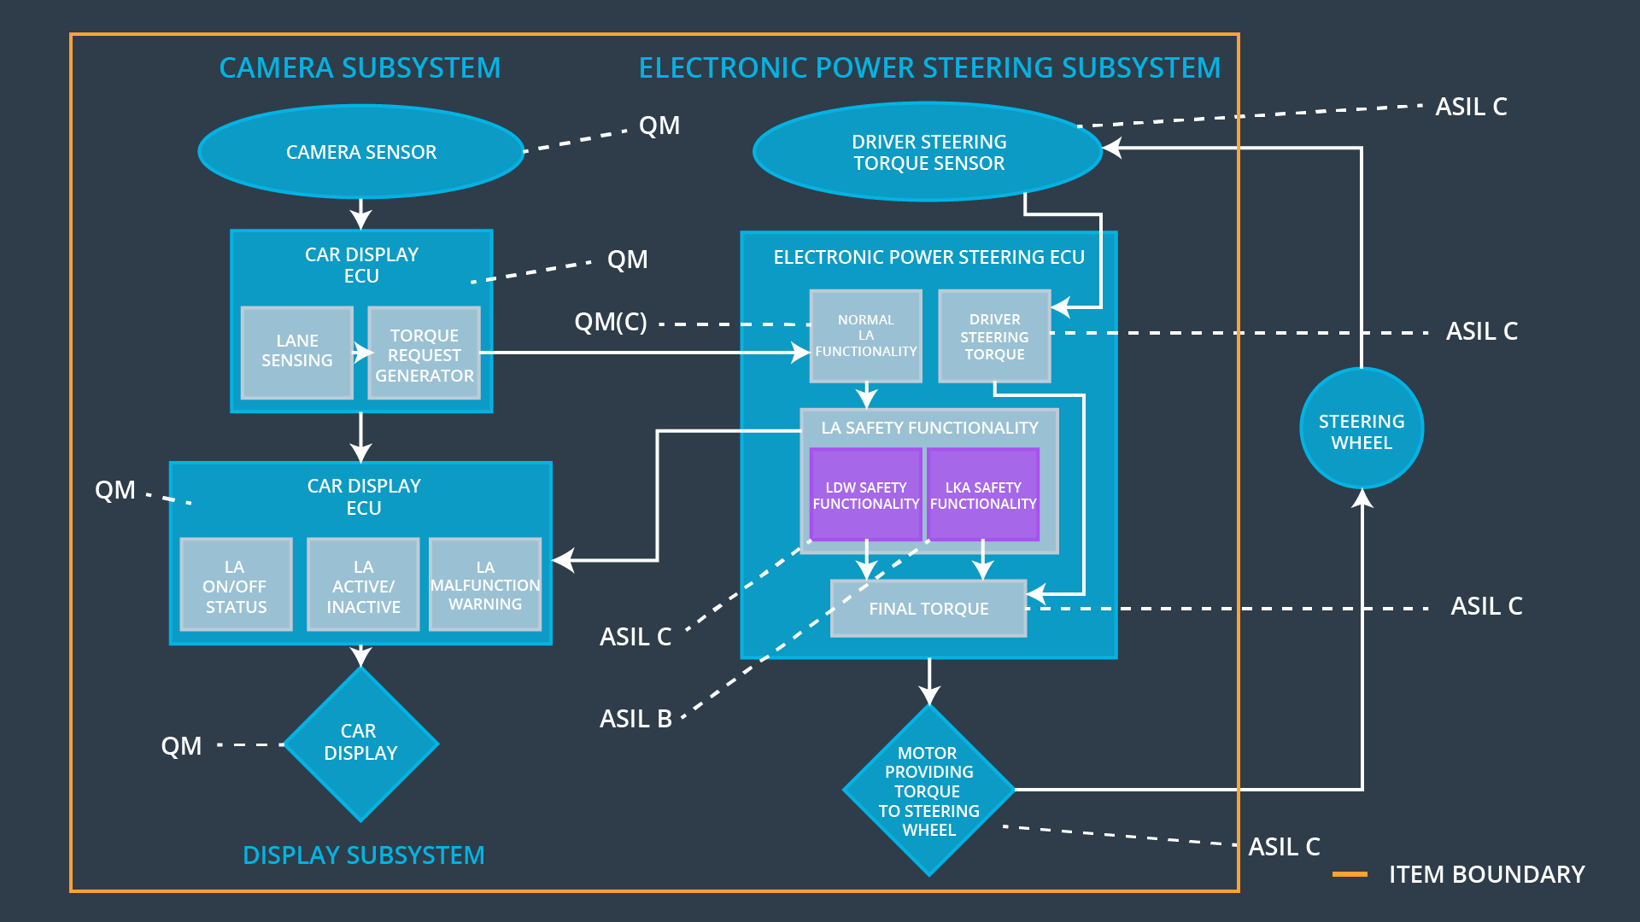

Functional overview of architecture elements

Element | Description
Camera Sensor | Visual observation of driving surface for lane detection. Signal sent to camera sensor ecu.
Camera Sensor ECU - Lane Sensing | Lane sensing functionality. Outputs data to torque request generator.
Camera Sensor ECU - Torque request generator | Sends torque request to electronic power steering ECU.
Car Display | Visual display to driver of LDW/LKA status recieved from car display ECU.
Car Display ECU - Lane Assistance On/Off Status | Determines if LA on/off. Sends to car display.
Car Display ECU - Lane Assistant Active/Inactive | Determines if LA active/inactive. Sends to car display.
Car Display ECU - Lane Assistance malfunction warning | Receives malfunction information from LA safety functionality. Sends to car display.
Driver Steering Torque Sensor | Measures driver torque input. Sends input to electronic power steering ECU driver toque element.
Electronic Power Steering (EPS) ECU - Driver Steering Torque | Recieves driver steering torque from torque sensor. Sends to final torque element in EPS ECU.
EPS ECU - Normal Lane Assistance Functionality | Standard LA functionality without safety implementations. Recieves driver torque request, sends to LA safety functionality.
EPS ECU - Lane Departure Warning Safety Functionality | Recieves torque request from normal LA functionality. Limits torque in regard to Functional Safety Requirement 01-01/01-02. Sends output to final torque.
EPS ECU - Lane Keeping Assistant Safety Functionality | Recieves torque request from normal LA functionality. Limits torque in regard to Functional Safety Requirement 02-01. Sends output to final torque.
EPS ECU - Final Torque | Recieves input from LA safety functionality and driver steering torque. Determines required torque to send to motor.
Motor | Receives required torque from final torque element and applies to steering wheel.

Technical Safety Concept

Technical Safety Requirements

Lane Departure Warning (LDW) Requirements:
Functional Safety Requirement 01-01 with its associated system elements
(derived in the functional safety concept)

ID | Functional Safety Requirement | Electronic Power Steering ECU | Camera ECU | Car Display ECU
Functional  Safety  Requirement  01-01 | The lane keeping item shall ensure that the lane departure oscillating torque amplitude is below Max_Torque_Amplitude | X

Technical Safety Requirements related to Functional Safety Requirement 01-01 are:
ID | Technical Safety Requirement | ASIL | Fault Tolerant Time Interval | Architecture Allocation | Safe State
Technical  Safety  Requirement  01 | The LDW safety component shall ensure that the amplitude of the 'LDW_Torque_Request' sent to the 'Final electronic power steering Torque' component is below 'Max_Torque_Amplitude. | C | 50 ms | LDW Safety | LDW function turned off.
Technical  Safety  Requirement  02 | As soon as the LDW function deactivates the LDW feature, the 'LDW Safety' software block shall send a signal to the car display ECU to turn on a warning light. | C | 50 ms | LDW Safety | LDW function turned off.
Technical  Safety  Requirement  03 | As soon as a failure is detected by the LDW function, it shall deactivate the LDW feature and the 'LDW_Torque_Request' shall be set to zero. | C | 50 ms | LDW Safety | LDW function turned off.
Technical  Safety  Requirement  04 | The validity and integrity of the data transmission for 'LDW_Torque_Request' signal shall be ensured. | C | 50 ms | Data Transmission Integrity Check | LDW function turned off.
Technical  Safety  Requirement  05 | Memory test shall be conducted at start up of the EPS ECU to check for any faults in memory. | A | Ignition cycle | Memory Test | LDW function turned off.

Functional Safety Requirement 01-2 with its associated system elements
(derived in the functional safety concept)
ID | Functional Safety Requirement | Electronic Power Steering ECU | Camera ECU | Car Display ECU
Functional  Safety  Requirement  01-02 | The lane keeping item shall ensure that the lane departure oscillating torque frequency is below Max_Torque_Frequency | X

Technical Safety Requirements related to Functional Safety Requirement 01-02 are:
ID | Technical Safety Requirement | ASIL | Fault Tolerant Time Interval | Architecture Allocation | Safe State
Technical  Safety  Requirement  01 | The LDW safety component shall ensure that the frequency of the 'LDW_Torque_Request' sent to the 'Final electronic power steering Torque' component is below 'Max_Torque_Frequency. | C | 50 ms | LDW Safety | LDW function turned off.
Technical  Safety  Requirement  02 | As soon as the LDW function deactivates the LDW feature, the 'LDW Safety' software block shall send a signal to the car display ECU to turn on a warning light. | C | 50 ms | LDW Safety | LDW function turned off.
Technical  Safety  Requirement  03 | As soon as a failure is detected by the LDW function, it shall deactivate the LDW feature and the 'LDW_Torque_Request' shall be set to zero. | C | 50 ms | LDW Safety | LDW function turned off.
Technical  Safety  Requirement  04 | The validity and integrity of the data transmission for 'LDW_Torque_Request' signal shall be ensured. | C | 50 ms | Data Transmission Integrity Check | LDW function turned off.
Technical  Safety  Requirement  05 | Memory test shall be conducted at start up of the EPS ECU to check for any faults in memory. | A | Ignition cycle | Memory Test | LDW function turned off.

Lane Keeping Assistance (LKA) Requirements:
Functional Safety Requirement 02-1 with its associated system elements
(derived in the functional safety concept)
ID | Functional Safety Requirement | Electronic Power Steering ECU | Camera ECU | Car Display ECU
Functional  Safety  Requirement  02-01 | The lane keeping item shall ensure that the lane keeping assistance torque is applied for only Max_Duration | X

Technical Safety Requirements related to Functional Safety Requirement 02-01 are:
ID | Technical Safety Requirement | ASIL | Fault Tolerant Time Interval | Allocation to Architecture | Safe State
Technical  Safety  Requirement  01 | The LKA safety component shall ensure that the duration of 'LKA_Torque_Request' sent to the 'Final electronic power steering Torque' component is below Max_Duration. | B | 500 ms | LKA Safety | LKA function turned off.
Technical  Safety  Requirement  02 | As soon as the LKA function deactivates the LKA feature, the 'LKA Safety' software block shall send a signal to the car display ECU to turn on a warning light. | B | 500 ms | LKA Safety | LKA function turned off.
Technical  Safety  Requirement  03 | As soon as a failure is detected by the LKA function, it shall deactivate the LKA feature and the 'LKA_Torque_Request' shall be set to zero. | B | 500 ms | LKA Safety | LKA function turned off.
Technical  Safety  Requirement  04 | The validity and integrity of the data transmission for 'LKA_Torque_Request' signal shall be ensured. | B | 500 ms | Data Transmission Integrity Check | LKA function turned off.
Technical  Safety  Requirement  05 | Memory test shall be conducted at start up of the EPS ECU to check for any faults in memory. | A | 500 ms | Memory Test | LKA function turned off.

Refinement of the System Architecture
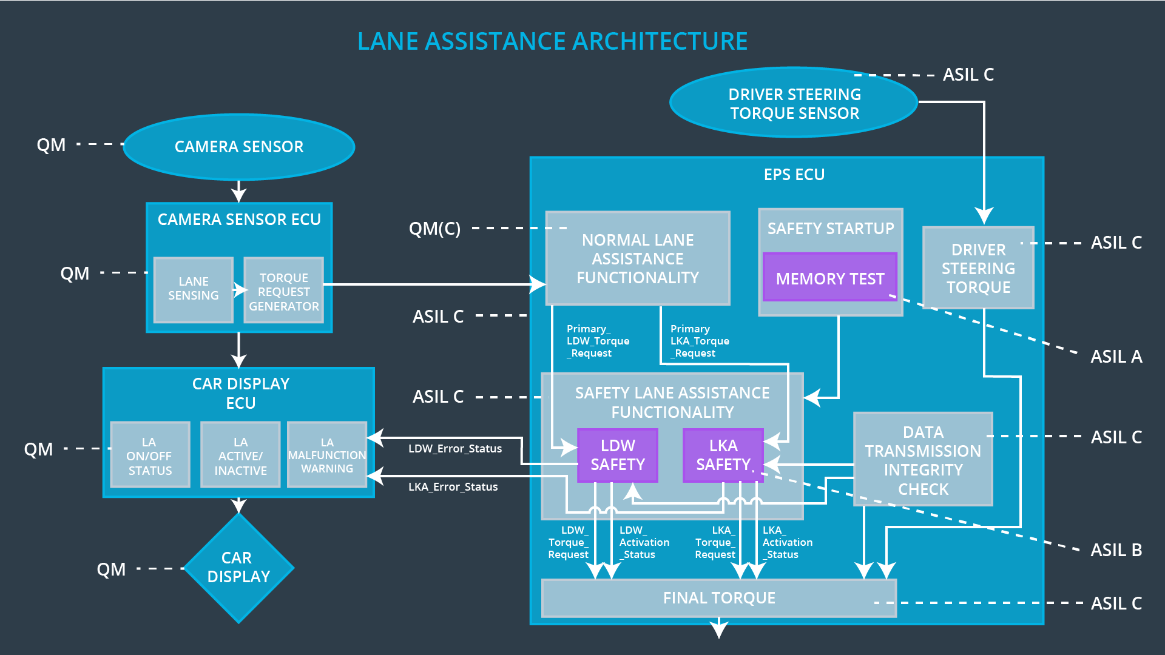

Allocation of Technical Safety Requirements to Architecture Elements

All technical safety requirements are allocated to the Electronic Power Steering ECU.

Warning and Degradation Concept

ID | Degradation Mode | Trigger for Degradation Mode | Safe State invoked? | Driver Warning
WDC-01 | Turn off LDW function. | Malfunction_01 / Malfunction_02 | Yes | Malfunction warning on Car Display.
WDC-02 | Turn off LKA function. | Malfunction_03 | Yes | Malfunction warning on Car Display.

