###### **Cairo University**

**Faculty of Computers and Information Information Systems Department Database Systems 1 – Spring 2017**

**SQL Booklet**

**Consider the following suppliers-parts-Projects-Shipments database (SPJ):** 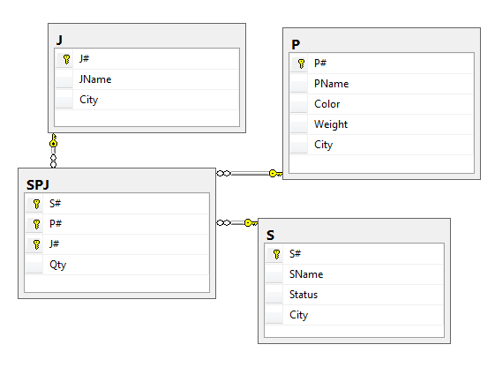

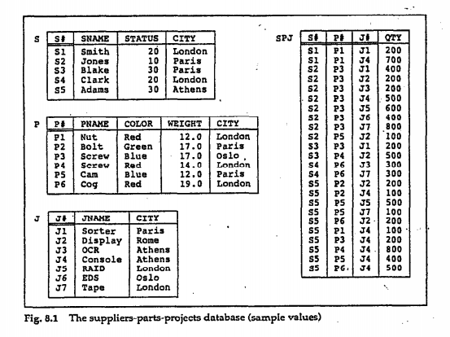

**Write SQL queries for the following:**

1. Get all supplier-number/part-number/project-number triples such that the indicated supplier, part, and project are all collocated.
2. Get all supplier-number/part-number/project-number triples such that the indicated supplier, part, and project are not all collocated.
3. Get all supplier-number/part-number/project-number triples such that no two of the indicated supplier, part, and project are collocated.
4. Get part numbers for parts supplied by a supplier in London.
5. Get part numbers for parts supplied by a supplier in London to a project in London.
6. Get all pairs of city names such that a supplier in the first city supplies a project city in the second city.
7. Get part numbers for parts supplied to any project by a supplier in the same city as that project.
8. Get project numbers for projects supplied by at least one supplier not in the same city.
9. Get all pairs of part numbers such that some supplier supplies both the indicated parts.
10. Get the total number of projects supplied by supplier *S1*.
11. Get the total quantity of part *P1* supplied by supplier *S1*.
12. For each part being supplied to a project, the project number, and the corresponding total quantity.
13. Get part numbers of parts supplied to some project in an average quantity of more than 320.
14. Get all shipments where the quantity is NOT NULL.
15. Get project numbers and cities where the city has an “O” as the second letter of its name.
16. Get project names for projects supplied by supplier *S1*.
17. Get color of parts supplied by supplier *S1*.
18. Get Part numbers for parts supplied to any project in London. – (Repeat your answer using exists)
19. Get project numbers for projects using at least one part available from supplier *S1*.(Repeat your answer using exists)
20. Get supplier numbers for suppliers supplying at least one part supplied by at least one supplier who supplies at least one red part.
21. Get supplier numbers for suppliers with status lower than that of supplier *S1*.
22. Get project numbers for projects supplied with part *P1* in an average quantity greater than the greatest quantity in which any part is supplied to project *J1*.
23. Get supplier numbers for suppliers supplying some project with part *P1* in a quantity greater than the average shipment quantity of part *P1* for that project.
24. Get project numbers for projects not supplied with any red part by any London supplier.
25. Get project numbers for projects supplied entirely by supplier *S1*.
26. Get part numbers for parts supplied to all projects in London.
27. Get supplier numbers for suppliers who supply the same parts to all projects.
28. Get project numbers for projects supplied with at least all parts available from supplier *S1*.
29. Construct an ordered list of all cities in which at least one supplier, part, or project is located.
30. Get supplier numbers for suppliers who are located in the same city as S1
31. Get supplier numbers for suppliers with status value less than the current maximum status value in the S table.
32. Get suppliers names for suppliers who supply parts p2(Use a sub-query)
33. Get supplier names for suppliers who do not supply part p2
34. Get supplier names for suppliers who supply all parts (Hence: there is no part that they do not supply!)
35. Get Supplier numbers for suppliers who supply at least all those parts supplied by supplier S2
36. Get part numbers for parts that either weigh more 16 pounds or are supplied by supplier s2 or both, make sure the duplicates are eliminated if any.
37. Get the project numbers for projects that use only parts that are available from supplier s1.
38. Get project number from projects that are supplied by supplier s1 with some of every part that supplier s1 supplies.
39. Get project numbers for projects such that at least some of every part they use is supplied to them by supplier s1.
40. Get project numbers for projects that are supplied by every supplier who supplies some red part.
41. (Update) Set the shipment quantity to zero for all suppliers in London
42. (Delete) Delete all shipments for suppliers in London.
43. (Multiple Record Insert) For each part supplied, get the part number and the total quantity supplied of that part, and save the result in the database.
44. Delete all projects for which there are no shipments
45. Delete all projects in Rome and all the corresponding shipments.
46. Construct a table containing a list of part numbers for parts that are supplied either by a London supplier or to a London Project.
47. Construct a table containing a list of project numbers for projects that are either located I London or are supplied by a London supplier.

# **Considering the Northwind Schema, Write the following queries in SQL:**

# 

1. Get all countries that contain customers in addition to the number of orders made in each country in case of more than 50 orders. Give suitable name(s) for any unnamed displayed column(s). Sort the result starting from the country with the highest number of orders.
2. Get the customer id, his/her total number of orders and the last order date for all customers with orders after 1996 and having at least 15 orders. Give suitable name(s) for any unnamed displayed column(s). Display the result starting from customers with the highest number of orders.
3. Get the product id, total number of orders related to that product in addition to the total price earned from selling orders of that product. Restrict the result to products with total price greater than 30,000 and number of orders more than 50 orders. Give suitable name(s) for any unnamed displayed column(s). Start by displaying products with the highest total price.
4. Get the supplier names (contact names) and the total number of supplied products for each supplier. Restrict the result to suppliers who supplied more than 4 products. Give suitable name(s) for any unnamed displayed column(s).
5. Display the customer name (contact name) and the number of orders made by this customer, for customers living in France. Restrict the result to orders less than 10. Arrange the result based on the number of orders from the greatest to the lowest.
6. Get the total quantity ordered for each displayed product name with unit price more than 20. Restrict the result for products having total ordered quantity between 100 and 300 units. Label any un-named column(s) with a meaningful name(s), and sort the result descendingly based on the total quantities.
7. For each displayed supplier name (contact name), show how many products were supplied by suppliers who have got a home page and supplied more than 3 products. Label any un-named column(s) by a meaningful name(s).
8. For each displayed country name, count the number of products supplied by suppliers who don’t have a fax number. Restrict the result for countries having more than six supplied products. Label any un-named column(s) by a meaningful name(s).
9. For countries alphabetically between Brazil and USA, display the country name in addition to the number of suppliers living in this country and don’t have a HomePage. Restrict the Result to countries having more than one supplier. Sort the result according to the highest number of suppliers first, and in case of a tie sort based on country name. Give a meaningful name(s) for any un-named column(s).
10. Get the product names and their unit prices for products having more than 40 units in stock, and unit prices greater than all Condiments. Include only products which were ordered at least once. Don’t repeat product names in the result.
11. Get the last name, job title, hiring date and date of birth of all employees who were born in the second half of the year and were hired before all employees working as Sales Managers and Inside Sales Coordinators.
12. Get the contact titles of customers, and their total number of orders if greater than the number of orders made in each country where at least one customer lives.
13. Get the Beverages product names and their total prices, if the total price is more than the total price of any product category in 1996. Label any un-named column(s) by a meaningful name(s).
14. Get the US shipping city names, and the total number of orders shipped from them if it is more than the total number of orders shipped from any country. Sort the result descendingly based on the total number of orders. Label any un-named column(s) by a meaningful name(s).
15. Get the country name and the number of orders made from this country if there is a customer living in France ordered more orders than this country. Label any un-named column(s) by a meaningful name(s).
16. Get the customer name (contact name) and the order dates for customers living in USA and made orders in December 1996. Fully optimize your query to minimize the cost of accessing any unneeded columns and/or rows from the relevant tables.
17. Get the supplier name (contact name) and the supplied product name for products having unit price less than 7. Fully optimize your query to minimize the cost of accessing any unneeded columns and/or rows from the relevant tables.
18. Get the product name, quantity per unit and the corresponding category name for seafood products having their quantities measured in jars. Fully optimize your query to minimize the cost of accessing any unneeded columns and/or rows from the relevant tables.

**Using Company Database Schema, write the below queries in SQL:**

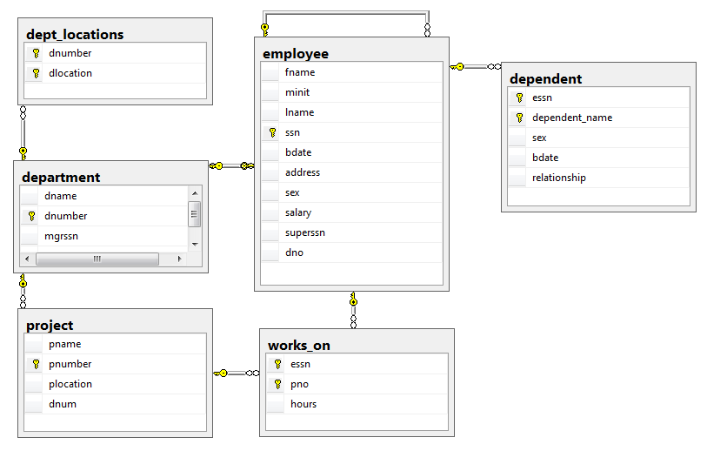

1. Retrieve the names of all employees in department 5 who work more than 10 hours per week on the ProductX project.
2. List the names of all employees who have a dependent with the same first name as themselves
3. Find the names of all employees who are directly supervised by ‘Franklin Wong’.
4. For each department whose average employee salary is more than $30,000, retrieve the department name and the number of employees working for that department.
5. Retrieve the names of all employees who work in the department that has the employee with the highest salary among all employees.
6. Retrieve the names of all employees whose supervisor’s supervisor has ‘888665555’ for SSN.
7. Retrieve the names of employees who make at least $10,000 more than the employee who is paid the least in the company.
8. For each employee get the numbers of hours that he/she worked on his/her projects. order by employee name descending .
9. Get the name of the projects which employees who work on this projects have more than one dependent. Remove Duplicates
10. Retrieve the name of each employee who works on all the projects controlled by department number 5
11. Retrieve the Social Security numbers of all employees who work on project numbers 1, 2, or 3.
12. Find the sum of the salaries of all employees, the maximum salary, the minimum salary, and the average salary.
13. Find the sum of the salaries of all employees of the ‘Research’ department, as well as the maximum salary, the minimum salary, and the average salary in this department.
14. For each department, retrieve the department number, the number of employees in the department, and their average salary.
15. For each project, retrieve the project number, the project name, and the number of employees who work on that project.
16. For each project on which more than two employees work, retrieve the project number, the project name, and the number of employees who work on the project.
17. For each project, retrieve the project number, the project name, and the number of employees from department 5 who work on the project.
18. Get the total number of employees whose salaries exceed $40,000 in each department.
19. For each department that has more than five employees, retrieve the department number and the number of its employees who are making more than $40,000.
20. Find the numbers of males and females Employees who work on each department. Group by department name.
21. Make a list of all project numbers for projects that involve an employee whose last name is ‘Smith’, either as a worker or as a manager of the department that controls the project.

**Considering Pubs (publishers) database Schema, Write the following SQL queries:**

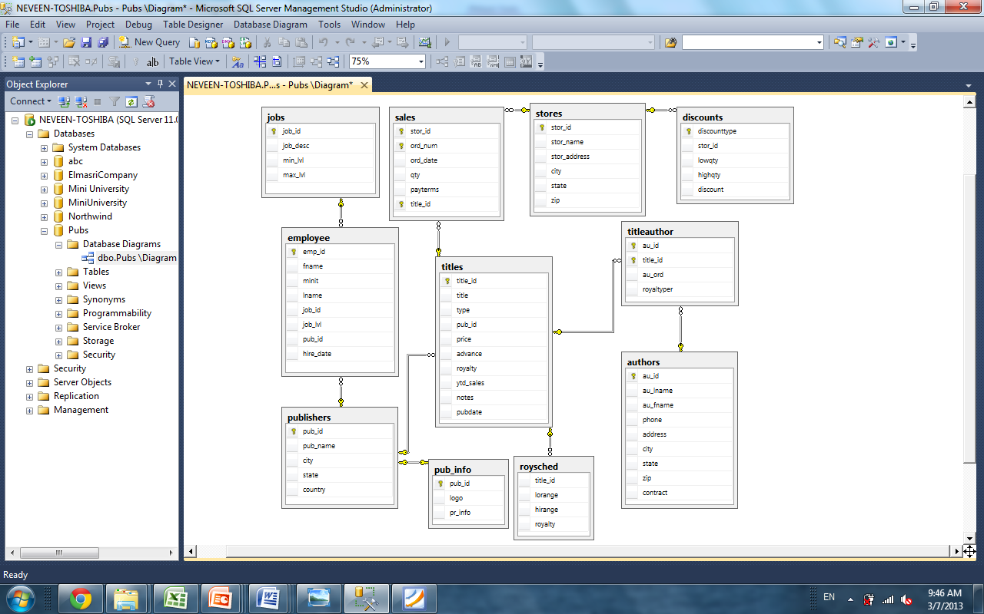

1. **Get the first, last names of authors who wrote books related to psychology or cooking and are first authors ( author-order =1) in these books, also display the titles and types of these books.**
2. **For books whose sales quantity exceed 20 in the period between May 1st, 1993 and September 30th, 1994, Get the titles of the books, their sales quantity, their order dates, the Store names and Cities, Display result only for the cities of ‘Tustin’, ‘portland’ and ‘Remulade’**
3. **Increase the price of all books that were written by ‘MacFeather’ , ’ Green’ or ‘Yokomoto’ by 10% of their prices only if their original prices was less than 20 but more than 10 $**
4. **Find the names of publishers who published titles of type business and have a known city. Show the results without any duplication and in ascending sorted order**
5. **Show the names of all publishers in USA country and the titles of the books they published. And Make sure to display all publishers even if they didn’t publish any books.**
6. **Find the names of authors who live in the same city with a publisher company.**
7. **Get all book titles having more than one author.**
8. **For each publisher name, get the total book sales.**
9. **Get the last names of the authors who co-authored in at least two books.**
10. Retrieve the store ID, title ID, order date, and quantity sold for all sales that occurred in the year 1994 from stores that either sold more than 20 copies of a single title or had a payment term of "Net 30" days.
11. Get the titles and types of books that the city of the author not the same of the city of the publisher.
12. For each book get the name of the author and the name of the publisher which the publisher state is MA or IL or the author city is Berkeley.
13. Display the type and average price for each type, for books whose type ends with the character string 'cook'.
14. Determine the number of days between the latest employee hire date and today
15. The title ID, title, and year-to-date sales for all books not sold in stores in California.
16. The title ID, title, and number of authors for all books that have exactly two authors.
17. The publisher ID, name and numbers of titles published for each publisher. Place the listing in descending order by the number of titles.