Contents

1. Introduction 1

2. Requirements 1

3. Procedure 2

3.1. MS1 feature extraction in Skyline 2

3.2. Contamination assessment using HowDirty 5

4. Creation of instrument-specific reference threshold files 7

5. References 8

Introduction

Objective: Assess the level of contamination of LC-MS results using the HowDirty workflow.

Input LC-MS raw files + Target List from publication (see instructions where to find it)

Output: HTML report with plots evaluating the normalized abundance of contaminants in the samples. Excel file compiling the results and summary statistics.

Summary: The presence of contaminants (e.g., PEG) and detergents (e.g., CHAPS, SDS) in samples analyzed by LC-MS can be severely detrimental to identifying peptides/proteins or other molecules. Skyline is used to extract MS1 features of many known contaminant masses from raw files (e.g., .raw and .d). The results are exported to a .csv file, then processed in R using HowDirty to generate an HTML interactive report that evaluates sample contamination risks.

# Requirements

* Raw LC-MS results to be evaluated
* Skyline version > 4 [1,2].  
  To install it, you can register online and download the latest version here:  
  <https://skyline.ms/project/home/software/Skyline/begin.view>.
* Skyline HowDirty template, including the Skyline molecular contaminant transition list [3] and reports configuration: <https://github.com/DavidGZ1/HowDirty/tree/main/tutorial>
* Alternatively, you can set up Skyline yourself (further instructions in the [Skyline tutorials](https://skyline.ms/wiki/home/software/Skyline/page.view?name=tutorials))
  + Download the original template with the molecular contaminant transition list [3] from [Panorama](https://panoramaweb.org/labkey/contaminants.url) and load it into Skyline: ***File /Open***
  + Create the PeakAreas_Contaminants report: containing the columns:
  + ***Settings / Document Settings / Reports / Add***, then enter the name “PeakAreas_Contaminants” and select the columns (Tip: click on the binoculars symbol to access the search):   
    "Proteins", "Peptides", "Replicate Name", "Peptide Retention Time", "Total Area MS1", "Total Ion Current Area"
  + Enable the report form by ticking the box next to its name, then click ***OK***
* R software for data analysis and the R packages Rmarkdown, knitr, and HowDirty  
  [HowDirty](https://github.com/DavidGZ1/HowDirty) can be installed by running the following code in R using a freshly open console window   
  (e.g., in R Studio):

if(!require(devtools)) install.packages("devtools")

devtools::install_github("kassambara/ggpubr")

devtools::install_github("DavidGZ1/HowDirty", force = TRUE)

# Procedure

MS1 feature extraction in Skyline

1. Open Skyline
2. Open the HowDirty template: ***File / Open*** navigate to the file location and open the .sky file

A Target List of commonly known contaminant masses will appear in Skyline.

|  |
| --- |
|  |
|  |

1. Save the Skyline’s file in the desired location
2. Navigate to ***Settings / Transition Settings / Filter*** and ***/ Full-Scan*** and set the parameters accordingly to the experiment. An example for Exploris 480 data is shown below.

|  |  |  |
| --- | --- | --- |
|  |  | Filter settings must include “p” (precursor) in Ion Types. |

|  |  |
| --- | --- |
|  | Instrument, Full-Scan, and Ion Mobility depend on the instrument and method used  Resolving power may depend on method-specific parameters. For instance, Exploris 480 can be acquired with an MS1 resolving power of 60,000 at 200 m/z. and MS2 15,000 at 200 m/z.  For TIMS-ToF data, choose “TOF” as the precursor mass analyzer and resolving power 38,000 in both corresponding fields.  **Important:** in retention time filtering, select “include all matching scans” |

1. Optional: Save those settings so that they can be reused by importing.

|  |  |
| --- | --- |
|  | Use *Settings /Share* to export.  Use *Settings/Import…* to import. |

1. Import the raw data (screenshots on next page)

**4**

**2**

* 1. Select ***File / Import / Results…***
  2. Select the raw files and click ***Open***
  3. Select “add single-injection replicates in files” and click ***OK***, then add file name pattern to remove if you want to shorten file names and select ***Remove***, or select ***Do not remove / OK*** if not

|  |  |
| --- | --- |
| a |  |
| b |  |
| c |  |

1. After the raw file processing is finished, you can browse through the list of contaminants and view the respective extracted ion chromatograms (EIC/XIC).

You can do a first assessment at this level; for instance:

Does PEG elute in regular patterns in the chromatogram?

Does CHAPS elute with late retention time in the chromatogram?

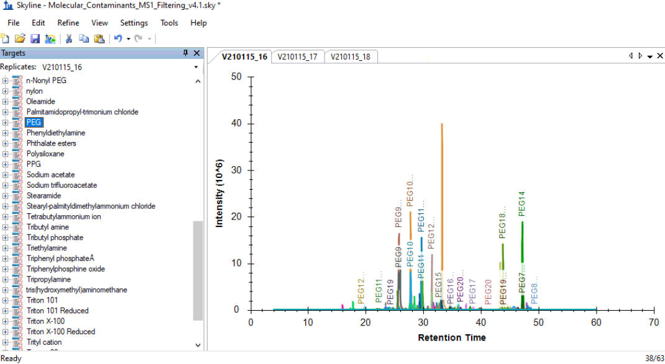

1. Export the report by selecting ***File /Export / Report…***, select the report PeakAreas_Contaminants, navigate to the desired location and export the report as .csv (Note: use Language = English)

|  |  |
| --- | --- |
|  |  |

Contamination assessment using HowDirty

1. Open R in your IDE of preference (e.g., RStudio) and set the working directory to the desired folder (e.g., where the PeakAreas_Contaminants.csv is stored).

setwd(“C:/Users/Name/ExampleHowDirty”)

Alternatively, from RStudio, you can create a project: ***File / New Project / Existing Directory / Browse / (select location) / Create Project***

1. Load the HowDirty package

library(HowDirty)

1. Create the sample annotation or experiment design file using the code below. If a file_report_skyline is provided (PeakAreas_Contaminants.csv), the ReplicateNameSkyline and Sample columns are populated with the unique(input$Replicate.Name). If not, only the column headers are provided.

get_annotation_template(file_report_skyline = "PeakAreas_Contaminants.csv")

1. Open the samples_annotation file in Excel (or R) and modify it if necessary.

ReplicateNameSkyline: must contain the Replicate.Name entries from the Skyline output

Do not modify it if the HowDirty template is generated as described in point 13.

Condition: Condition or group of each sample. Conditions are used for grouped statistics and plots.

Sample: sample name or code can be different from ReplicateNameSkyline

DilutionFactor: If the sample was diluted, this factor can be used to multiply the abundance results. Use carefully since abundance may not scale in the same proportions for all the contaminants.

1. Create a HowDirty template by using the code below; this will automatically save the template with the name entered (e.g., “example.Rmd”)

HowDirty::get_report_template(file = "example")

Alternatively, open a HowDirty.Rmd file from previous analysis and save it with another name

1. Open the .Rmd file
2. Fill the parameters in the header and “knit” (compile) the report. There are two options for this (see screenshots below).

This may take some minutes, depending on the computer used and the number of samples

Reference threshold file: see section 4 for instructions to create the instrument-specific reference file. If it is not available, or you are aiming to generate it, keep the parameter as FALSE. This will instruct HowDirty to use thresholds based on our training dataset using an Ultimate3000 coupled to an Exploris 480.

* 1. Click on “Knit with parameters”
  2. Fill out the parameters **values** manually, then click “Knit”  
     The parameters are in the header of the document after “params:”   
     The values are entered **after “value: ”**Do not modify the text after “label: ” or “input: ”

|  |  |  |
| --- | --- | --- |
| a |  |  |
| b |  | |

1. When the report is finished, it will open in R. You can navigate through it in that window or open it in any browser.

Creation of instrument-specific reference threshold files

HowDirty can be used to generate lab- and instrument-specific contamination thresholds. To establish thresholds that represent the normal status of sample chemical background on a LC-MS instrument platform, it is recommended to generate a reference dataset. This can be done by processing files acquired over an extended time period (e.g., spanning multiple months) including samples of diverse origins.

1. Follow instruction in steps 1 to 7 to import the raw files from LC-MS analyses that represent the general usage of the instrument (e.g., spanning two months of analyses).
2. Carefully evaluate the feature assignment following the advice in step 7.

Since this dataset will be used as a reference, it is especially important to thoroughly review it

1. Export the Skyline report following step 8.
2. Process the file using HowDirty as indicated in steps 9 to 16 following these considerations:
   1. In the parameters (step 15) set Reference threshold file: FALSE
   2. In the parameters (step 15) set Export interactive plots: FALSE

This optional, but creating the interactive plots for a large dataset would take longer and create a heavier html file

1. Use the resulting Excel file as input for Reference threshold file (RefThresholdsFile) in your future analyses

References

[1] L.K. Pino, B.C. Searle, J.G. Bollinger, B. Nunn, B. MacLean, M.J. MacCoss, The Skyline ecosystem: Informatics for quantitative mass spectrometry proteomics, Mass Spectrom. Rev. 39 (2020) 229–244. https://doi.org/10.1002/mas.21540.

[2] B. MacLean, D.M. Tomazela, N. Shulman, M. Chambers, G.L. Finney, B. Frewen, R. Kern, D.L. Tabb, D.C. Liebler, M.J. MacCoss, Skyline: an open source document editor for creating and analyzing targeted proteomics experiments, Bioinformatics. 26 (2010) 966–968. https://doi.org/10.1093/bioinformatics/btq054.

[3] M.J. Rardin, Rapid Assessment of Contaminants and Interferences in Mass Spectrometry Data Using Skyline, J. Am. Soc. Mass Spectrom. 29 (2018) 1327–1330. https://doi.org/10.1007/s13361-018-1940-z.