- A multi-item order where all items succeed (CONFIRMED)
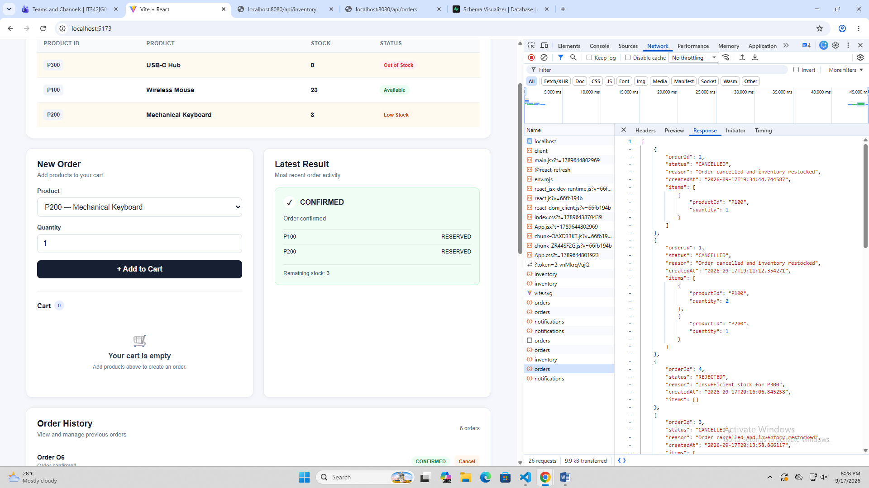

- A multi-item order where one item fails and the whole order is REJECTED with no partial reservation
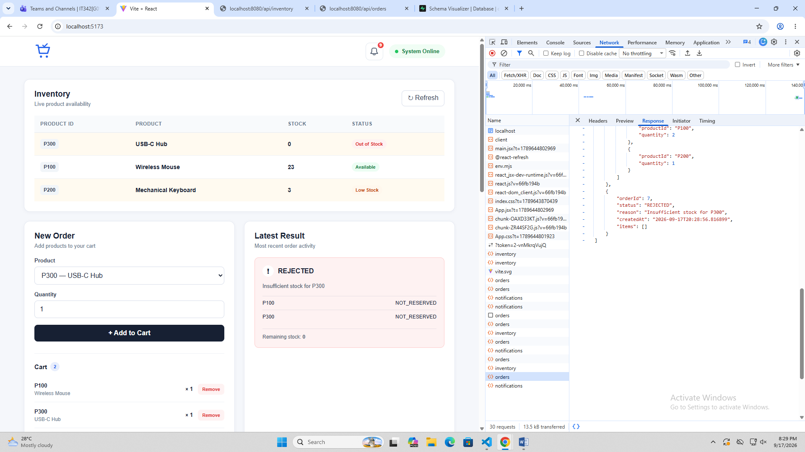

- A cancel with restock reflected in GET /api/inventory afterward
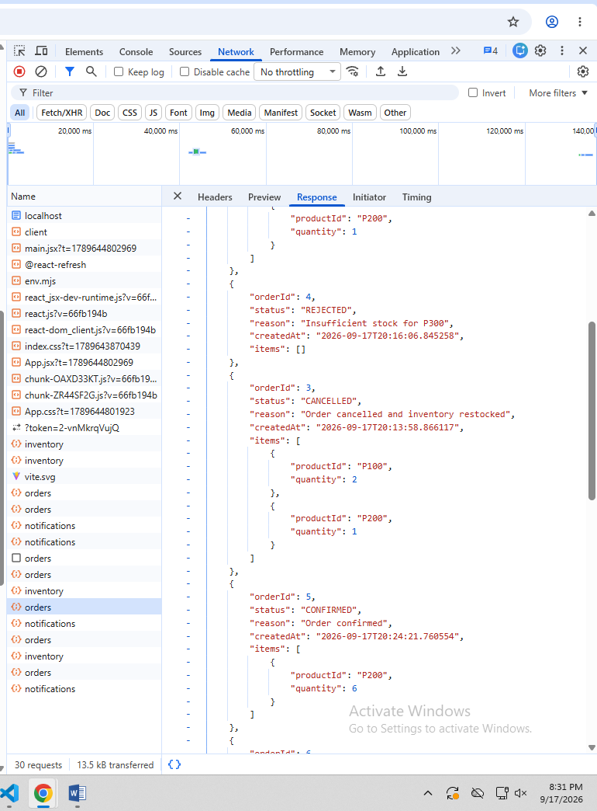

- The notification feed showing a confirmed order, a rejected order, and a low-stock alert
