SHOP ORDER SYSTEM
Project Documentation and Test Evidence
React + Vite Frontend | Spring Boot Backend | Supabase PostgreSQL Database

1. Project Description
The Shop Order System is a web-based ordering application that allows a user to select a product, enter a quantity, and submit an order. The backend checks the available inventory before confirming or rejecting the order. Confirmed orders reduce available stock, while rejected orders do not reserve inventory.

2. Technologies Used
- Frontend: React, Vite, JavaScript, Fetch API
- Backend: Java, Spring Boot, Spring Data JPA, Maven
- Database: Supabase PostgreSQL

3. System Modules

3.1 Shop / Order Module
Package: edu.cit.gabutan.shop
The Order module receives order requests, checks inventory through the InventoryService interface, processes the order, saves the result, and returns the order status and inventory information.

3.2 Inventory Module
Package: edu.cit.gabutan.inventory
The Inventory module retrieves products, checks available stock, reserves stock for valid orders, and updates the remaining quantity.

4. Database
The system uses Supabase PostgreSQL. The database contains the inventory and orders tables.

4.1 Inventory Data
Product ID | Product | Initial Stock
P100 | Wireless Mouse | 25
P200 | Mechanical Keyboard | 10
P300 | USB-C Hub | 0

4.2 Orders Table
The orders table stores the order ID, product ID, quantity, status, reason, and creation time. Testing produced both CONFIRMED and REJECTED order records.

5. API
Endpoint: POST /api/orders
Request:
{ "productId": "P100", "quantity": 1 }
The API returns the order status, reason, and current inventory information.

6. Test Results

6.1 Confirmed Order Test
Product: P100 – Wireless Mouse
Quantity: 1
Result: CONFIRMED
Reason: Order confirmed
The submitted order was successfully processed and the remaining inventory was returned by the API.

6.2 Rejected Order Test
Product: P300 – USB-C Hub
Quantity: 1
Result: REJECTED
Reason: Insufficient stock
Remaining Stock: 0
The order was rejected because the product had zero available stock.

7. Network/API Evidence
The browser Network tab was used to verify the POST /api/orders requests and their responses. The evidence shows successful processing of a confirmed order and rejection of an order with insufficient stock.

8.1 Evidence
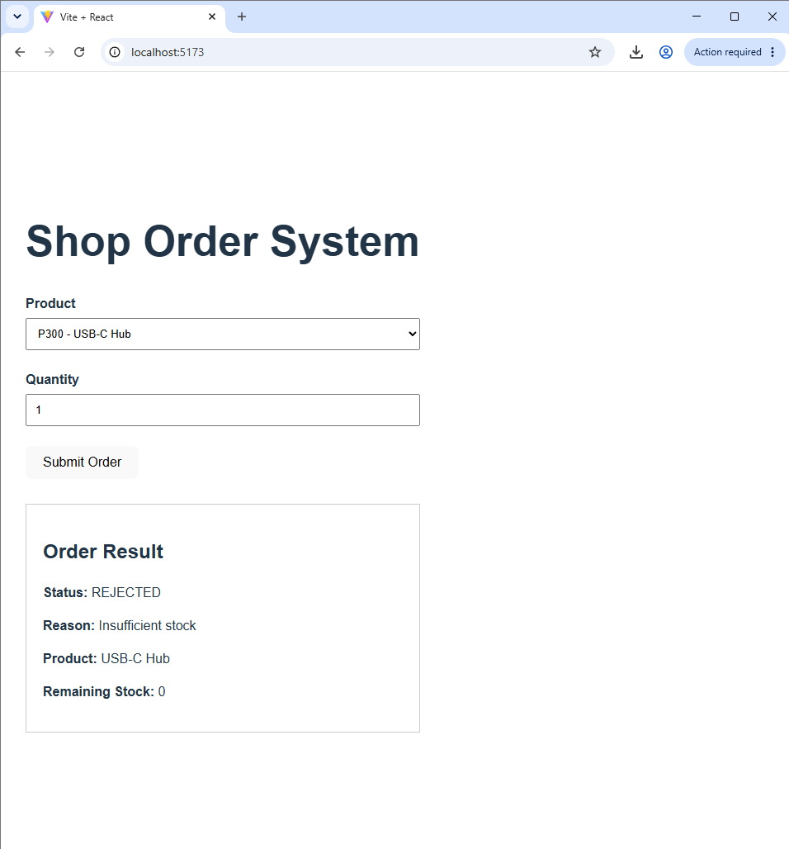
Figure 1. Rejected order for P300 – USB-C Hub.

8.2 Evidence
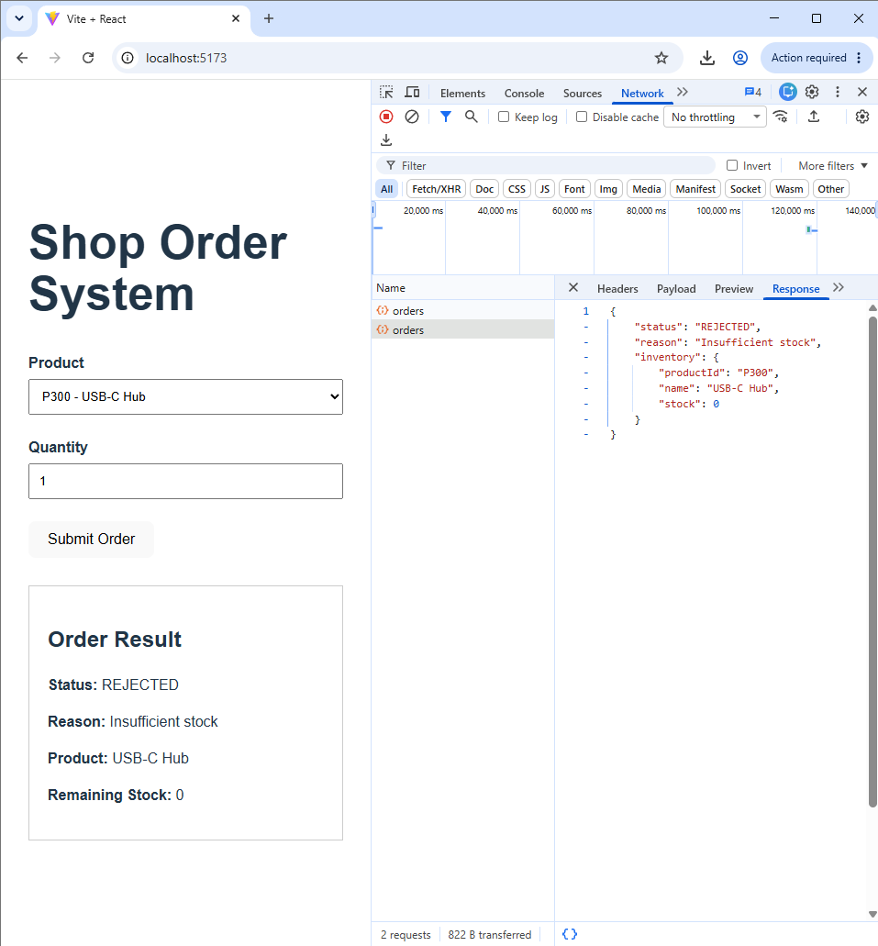
Figure 2. Confirmed order for P100 – Wireless Mouse and API response.

8.3 Evidence
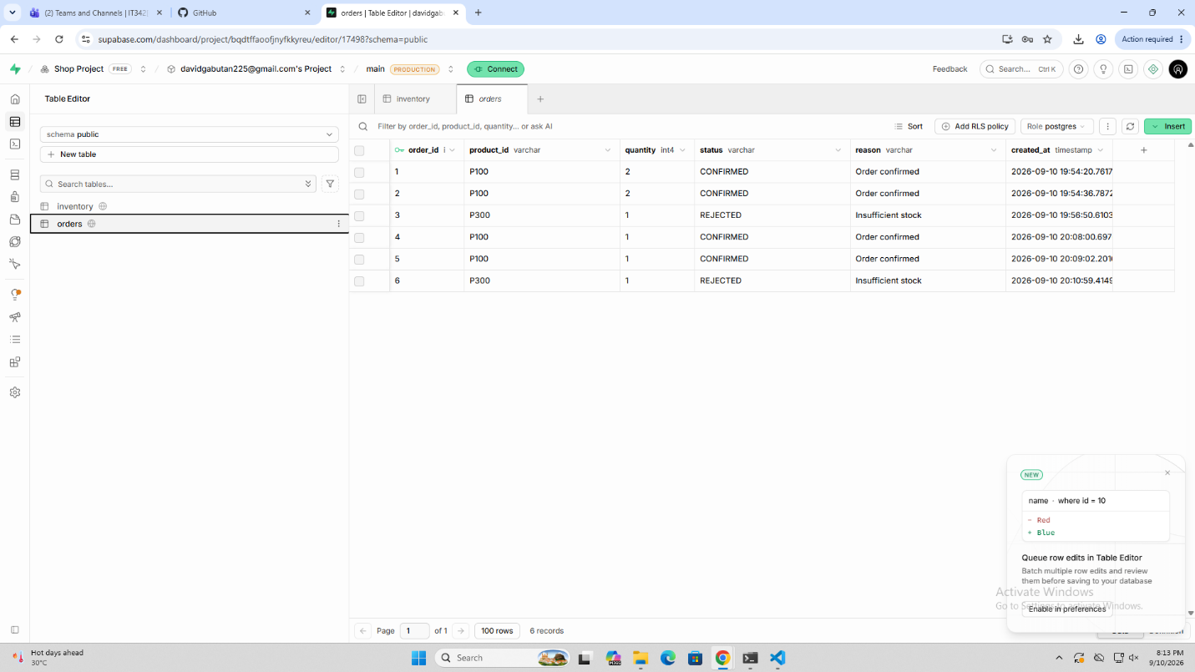
Figure 3. Supabase inventory table.

8.4 Evidence
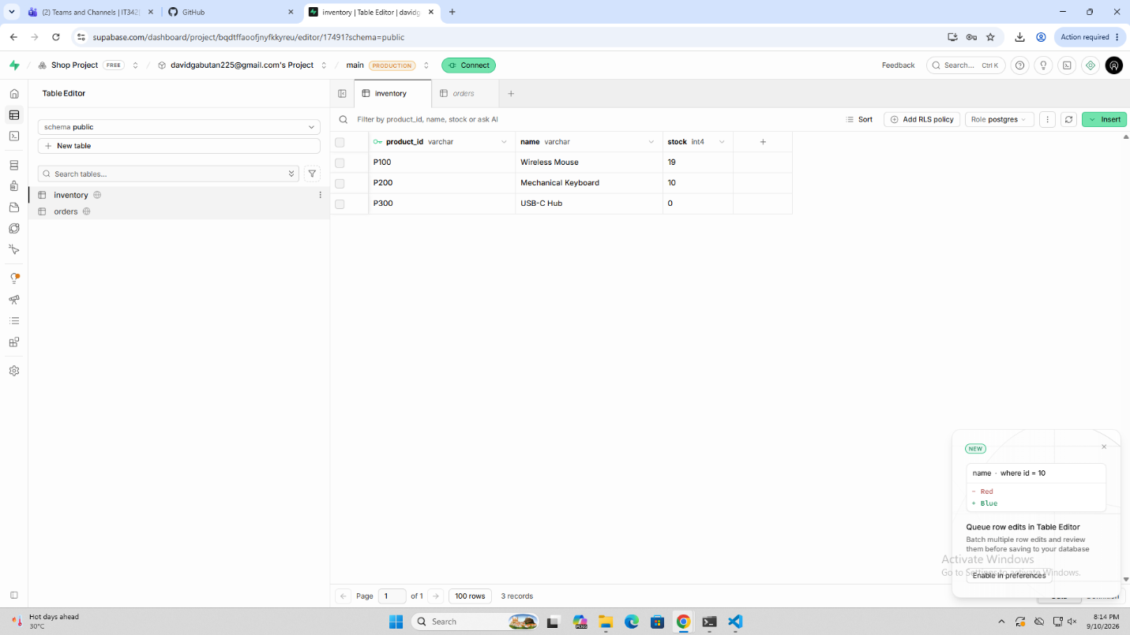
Figure 4. Supabase orders table.

8.5 Evidence
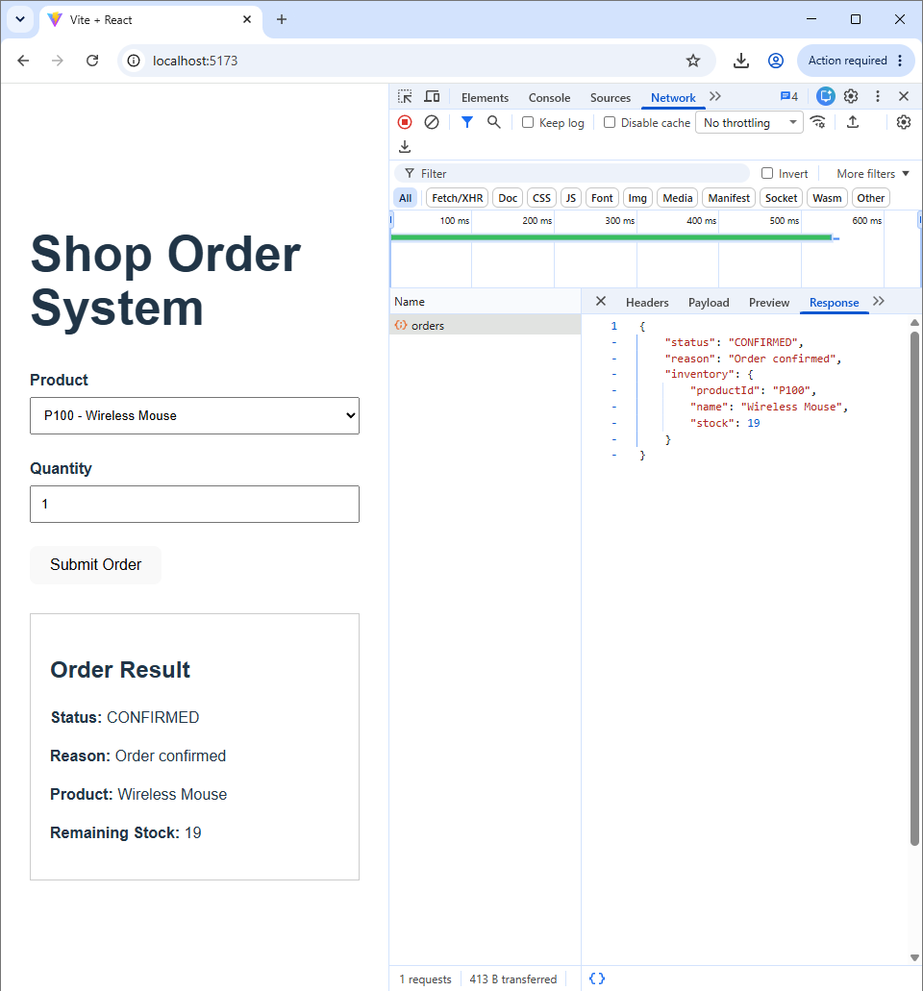
Figure 5. Rejected P300 order and API response in the Network tab.

9. Reflection
This project helped demonstrate how a frontend, backend, and database work together in one system. The React frontend sends an order request to the Spring Boot backend, while the backend checks and updates inventory before returning the result. Testing both confirmed and rejected orders showed how the system handles different inventory conditions.

10. Conclusion
The Shop Order System successfully demonstrates an end-to-end ordering flow using React, Spring Boot, and Supabase PostgreSQL. The test evidence confirms that available products can be ordered successfully, insufficient-stock orders are rejected, inventory is updated for successful orders, and order results are stored in the database.

