Lab 3

1. **Add new products**

If add a new row where there is any non-null column with null value, the error information will be thrown out when you click “Save” or “MovePreviose” button.

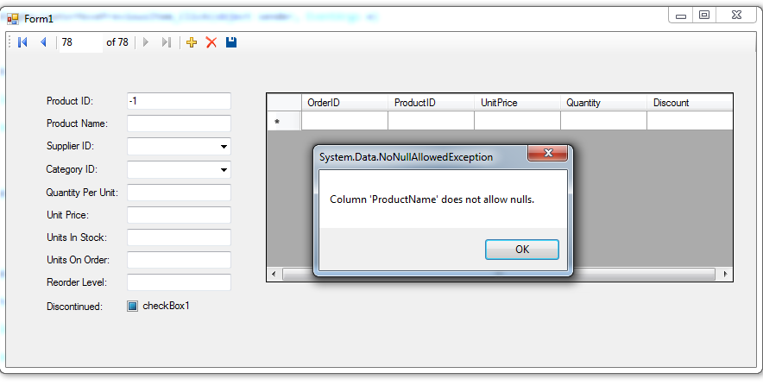

**Figure 1: Column ‘Product Name’ is assigned to be Null value**

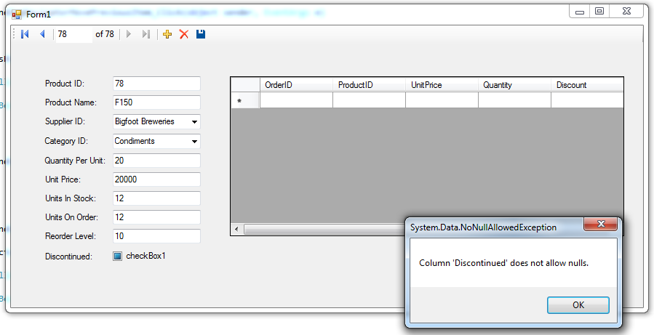

**Figure 2: Column ‘Discontinued’ is assigned to be Null value**

If all of columns in the new recorder meet the constrains, this new recorder will be successfully added to database.

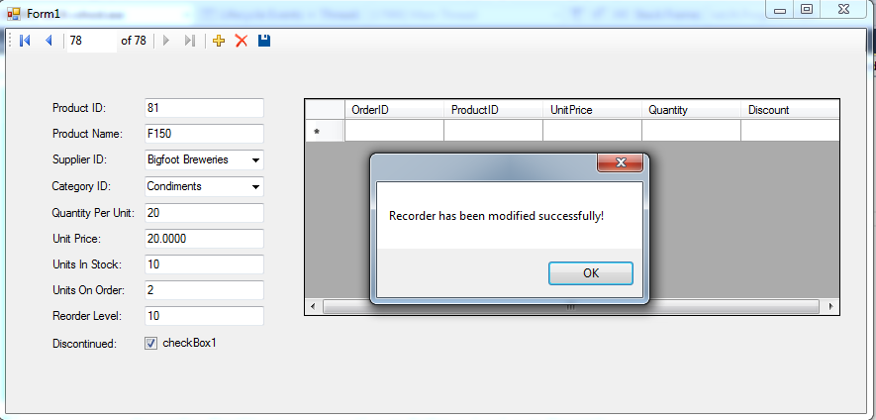

**Figure 3: Add a new product recorder successfully**

1. Delete Recorder

If the deleting target recorder includes any filed which refers to other table,

Deleting action will throw a database error.

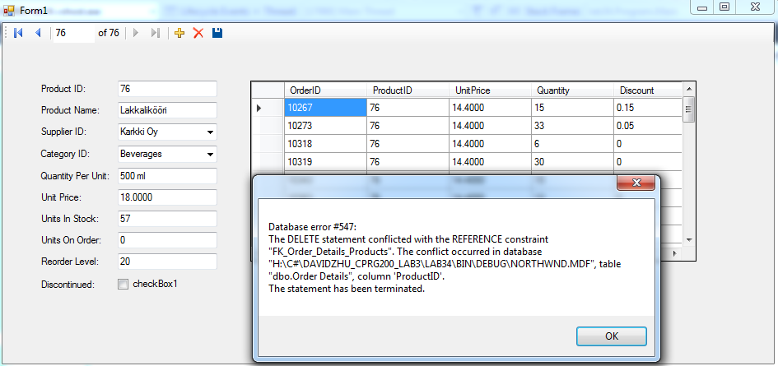

**Figure 4: delete a recorder which includes referred field**

1. Update Recorder

If update

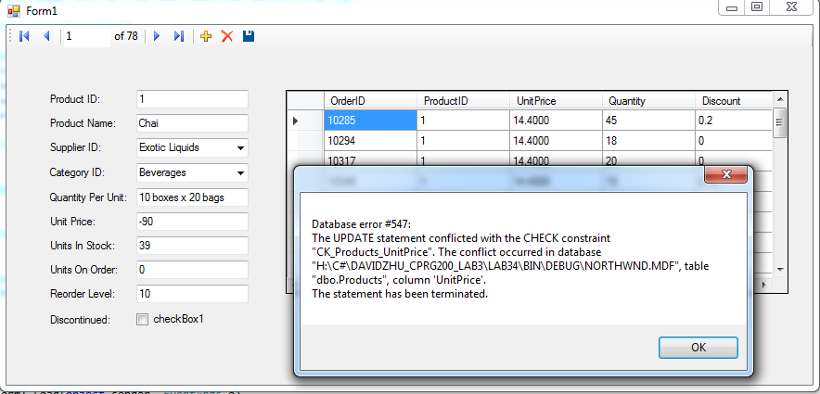

**Figure 5: update failure due to Unit Price with negative value -90**

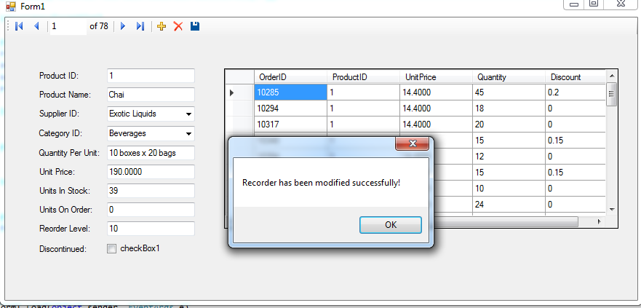

**Figure 6: update success when set Unit Price equals to 190**