Table S1: Taxa from the dataset with non-adult individuals
Taxon | N | Life stage
Boa constrictor | 4 | Juvenile-young adult
Elaphe quatuorlineata | 2 | Young adult
Eunectes murinus | 1 | Juvenile
Eunectes notaeus | 1 | Juvenile
Liasis olivaceus | 2 | Young adult
Malayopython reticulatus | 3 | Young adult
Pituophis melanoleucus | 2 | Juvenile
Python sebae | 2 | Juvenile

Table S2: Definitions of habitat groups
Habitat group | Definition
Terrestrial | Species that crawl on the ground and that rarely climb.
Sand-dwelling | Species that live in sandy environments such as deserts and dunes.
Semi-arboreal | Species that are terrestrial but with the ability to climb and move freely in vegetation.
Arboreal | Species that live mostly in trees and rarely come down to the ground.
Semi-aquatic | Species that depend on aquatic areas, mainly to feed on aquatic prey, but are generalist enough to leave these areas without difficulty.
Aquatic | Species that depend nearly exclusively on water.
Semi-fossorial | Species that live underground opportunistically or seek their food in an underground environment such as leaf litter, roots, rocks, etc...
Fossorial | Species that live exclusively underground.

Table S3: Morphological traits collected for morphometric analysis
Trait | Definition
SVL | Snout-vent length: distance from the tip of the snout to the cloaca.
TL | Total length
HL | Head length: distance from the back of the parietal to the tip of the snout.
HW | Head width: width at the widest point of the head.
HH | Head height: height at the tallest part of the head.
Jaw | Jaw length: distance from the back of the retroarticular process to the tip of the mandible.
Quadrate | Quadrate length
Inter-nostril distance | Distance between the two nostrils
Inter-ocular distance | Distance between the two eyes
Rostro-ocular distance | Distance between the eyes and the snout
Midbody width | Width at the level of the middle of the body
Cloacal width | Width at the level of the cloaca
Neck width | Width at the level of the neck

Table S4: Taxa from the dataset replaced by non-measured closely related taxa occurring in the phylogenetic tree
Taxon | Replacement taxon
Atheris mongoensis | Atheris rungweensis (Collet & Trape, 2020)
Atractaspis reticulata | Atractaspis aterrima (Portillo et al., 2019)
Atractus tamessari | Atractus dunni (Arteaga et al., 2022)
Atractus crassicaudatus | Atractus wagleri (Arteaga et al., 2022)
Grayia caesar | Grayia tholloni (Chaney et al., 2021)
Lamprophis littoralis | Boaedon radfordi (Hallermann et al., 2020)
Limnophis bicolor | Natriciteres fuliginoides (Deepak et al., 2021)
Liophis taeniurus | Erythrolamprus juliae (Kalki et al., 2020)
Lycodon cardamomensis | Lycodon stormi (Daltry & Wuster, 2002)
Macrocalamus schulzi | Oreocalamus hanitschi (Quah et al., 2020)
Naja nana | Naja multifasciata (Wallach et al., 2009)
Philothamnus irregularis | Philothamnus angolensis (Trape et al., 2021)
Toxicodryas adamanteus | Toxicodryas pulverulenta (Badjedjea et al., 2023)
Crotaphopeltis degeni | Crotaphopeltis tornieri (Engelbrecht et al., 2020)

References

Arteaga, A., Quezada, A., Vieira, J., & Guayasamin, J. M. (2022). Leaving no stone unturned: Three additional new species of Atractus ground snakes (Serpentes, Colubridae) from Ecuador discovered using a biogeographical approach. ZooKeys, 1121, 175–210.

Badjedjea, G., Akuboy, J. B., Colyn, M., & Pauwels, O. S. G. (2023). Reptile fauna of Kungulu and Mbiye Islands, Upper Congo River: Current knowledge and new records. Bulletin of the Chicago Herpetological Society, 58(1), 1–11.

Chaney, T., Pauwels, O. S., Nagy, Z. T., Gvoždík, V., Kusamba, C., Badjedjea, G., Masudi, F. M., Ernst, R., & Greenbaum, E. (2021). Phylogenetics and integrative taxonomy of African water snakes (Squamata: Colubridae: Grayia). Poster P93. 2021 Joint Meeting of Ichthyologists and Herpetologists, Phoenix, Arizona. Unpublished.

Collet, M., & Trape, J. F. (2020). Une nouvelle espèce du genre Atheris Cope, 1862, de la province de l’Équateur en République Démocratique du Congo (Squamata: Viperidae). Bulletin de la Société Herpétologique de France, 173, 27–40.

Daltry, J. C., & Wüster, W. (2002). A new species of wolf snake (Serpentes: Colubridae: Lycodon) from the Cardamom Mountains, southwestern Cambodia. Herpetologica, 58(4), 498–504.

Deepak, V., Maddock, S. T., Williams, R., Nagy, Z. T., Conradie, W., Rocha, S., Harris, D. J., Perera, A., Gvoždík, V., Doherty-Bone, T. M., Kamei, R. G., Menegon, M., Labisko, J., Morel, C., Cooper, N., Day, J. J., & Gower, D. J. (2021). Molecular phylogenetics of sub-Saharan African natricine snakes, and the biogeographic origins of the Seychelles endemic Lycognathophis seychellensis. Molecular Phylogenetics and Evolution, 161, 107152.

Engelbrecht, H. M., Branch, W. R., & Tolley, K. A. (2021). Snakes on an African plain: The radiation of Crotaphopeltis and Philothamnus into open habitat (Serpentes: Colubridae). PeerJ, 9, e11728.

Hallermann, J., Ceríaco, L. M. P., Schmitz, A., Ernst, R., Conradie, W., Verburgt, L., Marques, M. P., & Bauer, A. M. (2020). A review of the Angolan house snakes, genus Boaedon Duméril, Bibron & Duméril (1854) (Serpentes: Lamprophiidae), with description of three new species in the Boaedon fuliginosus (Boie, 1827) species complex. African Journal of Herpetology, 69(1), 29–78.

Kalki, Y., Gowda, S., Agnivamshi, M., Singh, K., Patel, H., & Mirza, Z. A. (2020). On the taxonomy and systematics of the recently described Lycodon deccanensis Ganesh, Deuti, Punith, Achyuthan, Mallik, Adhikari, Vogel, 2020 (Serpentes: Colubridae) from India. Evolutionary Systematics, 4(2), 109–118.

Portillo, F., Stanley, E. L., Branch, W. R., Conradie, W., Rödel, M.-O., Penner, J., Barej, M. F., Kusamba, C., Muninga, W. M., Aristote, M. M., … Bauer, A. M. (2019). Evolutionary history of burrowing asps (Lamprophiidae: Atractaspidinae) with emphasis on fang evolution and prey selection. PLoS ONE, 14(4), e0214889.

Trape, J. F., Hughes, B., Collet, M., & Mediannikov, O. (2021). A molecular phylogeny of the snakes of the Philothamnus heterodermus (Hallowell, 1857) (Squamata: Colubridae: Colubrinae) species group with the description of two new species. Bulletin de la Société Herpétologique de France, 179, 27–42.

Wallach, V., Wüster, W., & Broadley, D. G. (2009). In praise of subgenera: Taxonomic status of cobras of the genus Naja Laurenti (Serpentes: Elapidae). Zootaxa, 2236(1), 26–36.
Figure S1: Repetition test results showing ten juvenile specimens of Trimeresurus albolabris on the PCA plot, indicating consistent morphological clustering with only minor overlap between individuals.
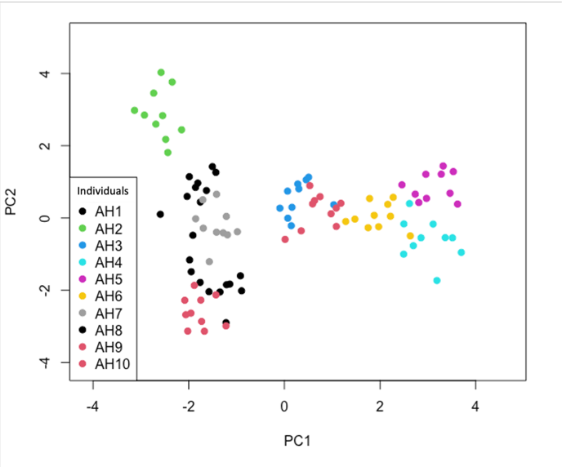

Figure S2: Phylomorphospace illustrating body and head shape variation across 432 species of snakes. The phylogeny is plotted in the morphospace described by axes 1 and 3. Nodes are colored based on symmetric rates ancestral-state estimation for habit mapped to the phylogeny.
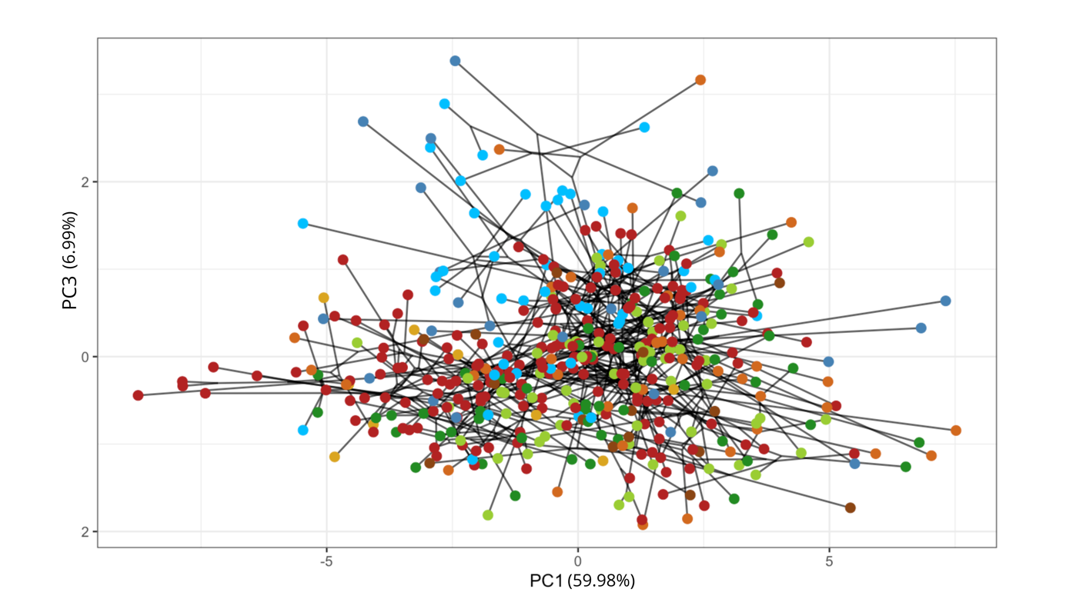

Figure S3: Phylomorphospace illustrating body and head shape variation across 432 species of snakes. The phylogeny is plotted in the morphospace described by axes 1 and 4. Nodes are colored based on symmetric rates ancestral-state estimation for habit mapped to the phylogeny.
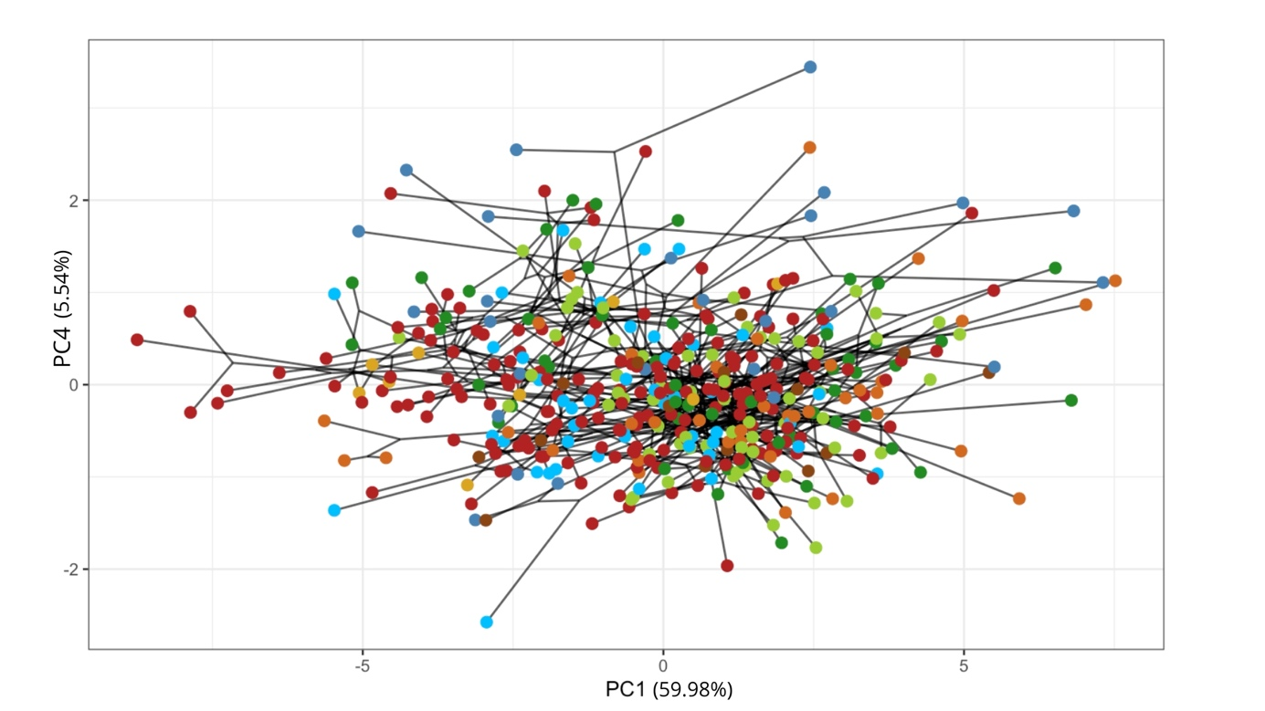
Figure S4: Panels for each subset of habitat types, illustrating body and head shape variation across 432 species of snakes. The phylogeny is plotted in the morphospace described by axes 1 and 2. Nodes are colored based on symmetric rates ancestral-state estimation for habit mapped to the phylogeny.

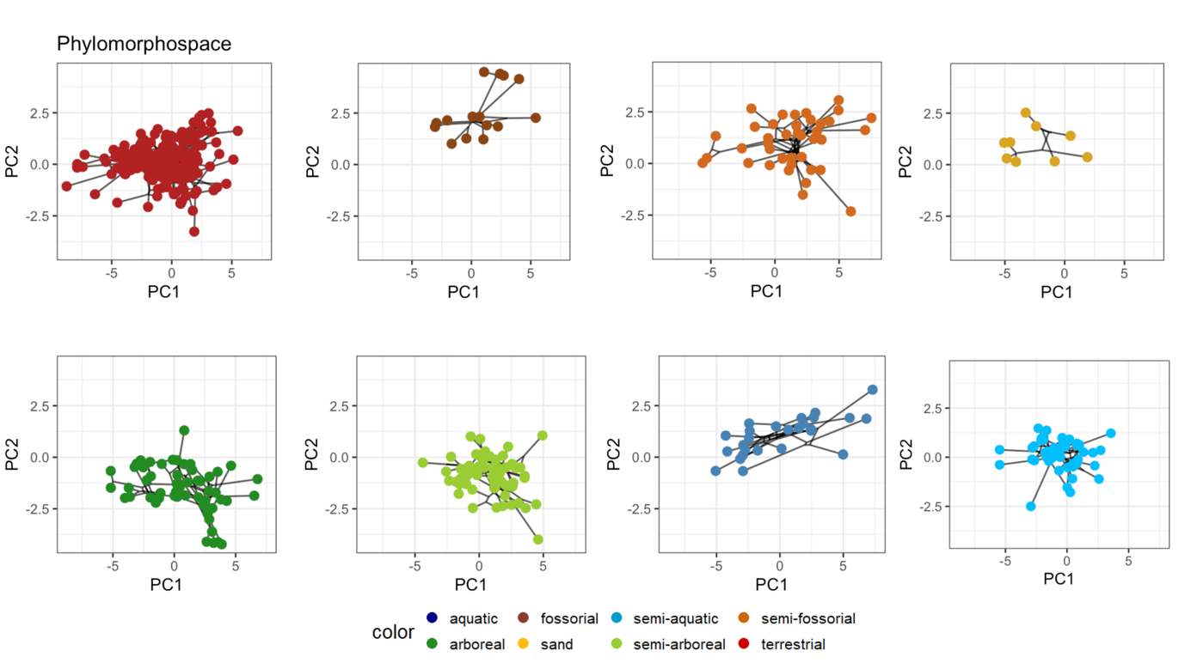
Figure S5: Panels for each subset of habitat types, illustrating body and head shape variation across 432 species of snakes. The phylogeny is plotted in the morphospace described by axes 1 and 3. Nodes are colored based on symmetric rates ancestral-state estimation for habit mapped to the phylogeny.
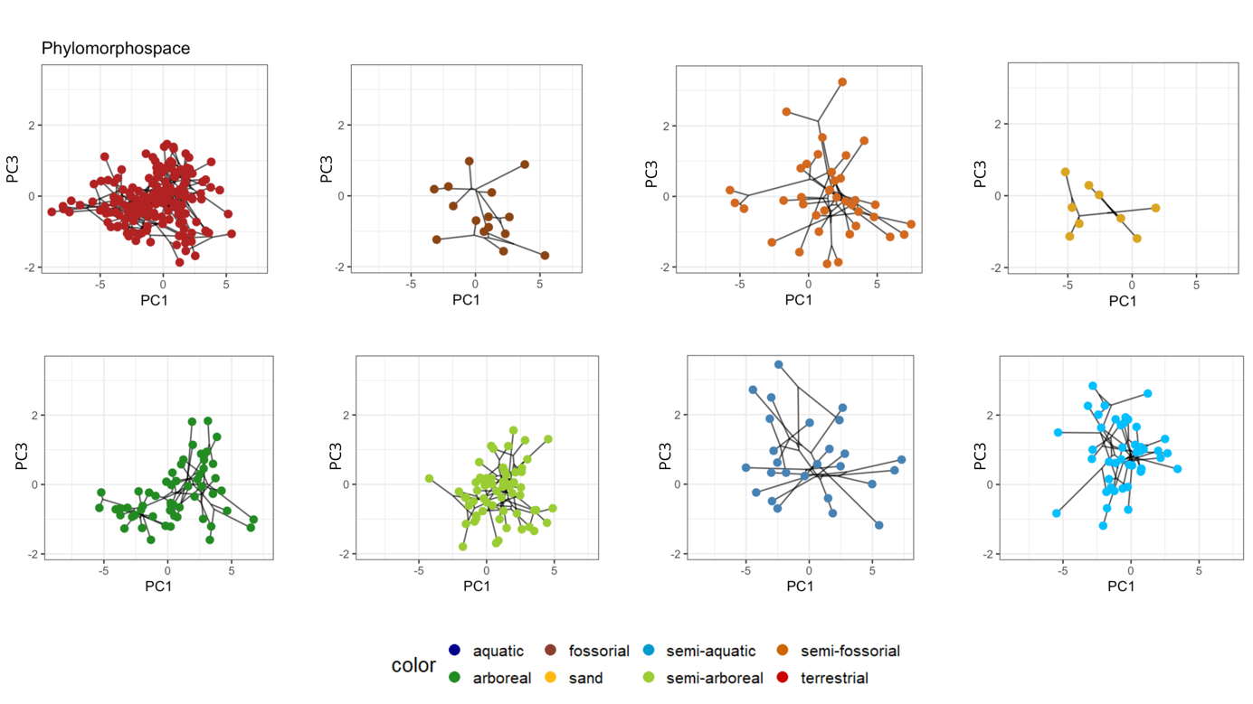
Figure S6: Panels for each subset of habitat types, illustrating body and head shape variation across 432 species of snakes. The phylogeny is plotted in the morphospace described by axes 2 and 3. Nodes are colored based on symmetric rates ancestral-state estimation for habit mapped to the phylogeny.

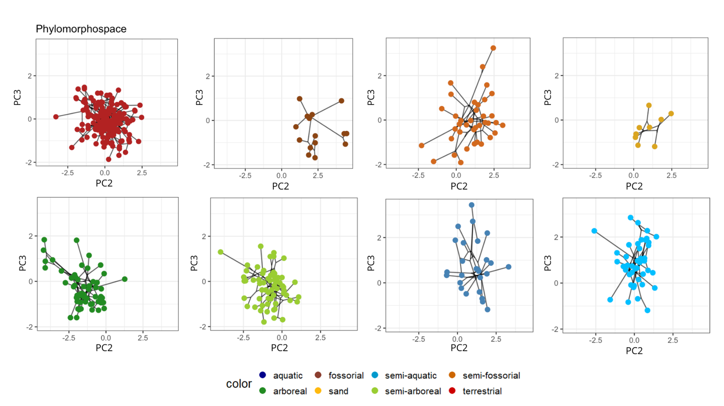

Table S5: Comparison of multivariate evolutionary models (BM1, OU1, BMM, and OUM) fitted to PC1–PC2 head shape data across ecological niche regimes. BM1: single-rate Brownian motion; OU1: single-optimum Ornstein-Uhlenbeck; BMM: multiple-rate Brownian motion; OUM: multiple-optimum Ornstein-Uhlenbeck. Columns show AIC mean, AIC standard deviation, delta and weight of each model.

Model fit | AIC mean | AIC SD | delta | weight
BM1 | 3235.96 | NA | 203.59 | 6.16e-45
OU1 | 3151.22 | NA | 118.85 | 1.55e-26
BMM | 3032.37 | 8.5518 | 0.00000 | 9.97e-01
OUM | 3044.25 | 14.44 | 11.87 | 2.64e-03

Table S6: Multivariate regression results of morphological traits against size and habitat based on Log-Shape Ratio data. Statistics include degrees of freedom (d.f.), R-squared (Rsq), the F-value, and the P-value from LSR analysis.

Model | df | Rsq | F | P
Snout-vent length | 1 | 0.72 | 1165.75 | P < 0.01
Ecological group | 7 | 0.02 | 3.72 | P < 0.01
Interaction | 7 | 0.01 | 3.0 | P < 0.01

Table S7: Pairwise comparisons of allometric slopes among habitat groups based on Log-Shape Ratio data. Statistics were calculated using 1,000 permutations and include the effect size (d), the standardized test statistic (Z), and the P-value.

Pairs | d | Z | P
Aquatic - Arboreal | 2.34 | 1.80 | P < 0.05
Aquatic - Fossorial | 2.17 | -0.09 | 0.53
Aquatic – Sand-dwelling | 2.80 | -0.23 | 0.59
Aquatic – Semi-aquatic | 2.12 | 1.64 | P < 0.05
Aquatic – Semi-arboreal | 2.45 | 1.41 | 0.07
Aquatic – Semi-fossorial | 1.43 | 0.67 | 0.28
Aquatic – Terrestrial | 2.39 | 2.04 | P < 0.05
Arboreal – Fossorial | 1.47 | -0.64 | 0.72
Arboreal – Sand-dwelling | 2.09 | -0.59 | 0.71
Arboreal – Semi-aquatic | 0.77 | 0.43 | 0.35
Arboreal – Semi-arboreal | 0.46 | -1.13 | 0.86
Arboreal – Semi-fossorial | 1.0 | 0.53 | 0.32
Arboreal – Terrestrial | 0.35 | -0.82 | 0.77
Fossorial – Sand-dwelling | 1.49 | -1.27 | 0.90
Fossorial – Semi-aquatic | 1.62 | -0.39 | 0.63
Fossorial – Semi-arboreal | 1.47 | -0.47 | 0.65
Fossorial – Semi-fossorial | 1.25 | -0.89 | 0.79
Fossorial – Terrestrial | 1.34 | -0.77 | 0.77
Sand-dwelling – Semi-aquatic | 2.26 | -0.38 | 0.63
Sand-dwelling – Semi-arboreal | 2.22 | -0.21 | 0.57
Sand-dwelling – Semi-fossorial | 2.09 | -0.45 | 0.65
Sand-dwelling – Terrestrial | 2.03 | -0.62 | 0.70
Semi-aquatic – Semi-arboreal | 0.69 | -0.1 | 0.54
Semi-aquatic – Semi-fossorial | 0.89 | 0.50 | 0.33
Semi-aquatic – Terrestrial | 0.67 | 0.92 | 0.20
Semi-arboreal – Semi-fossorial | 1.11 | 0.75 | 0.26
Semi-arboreal – Terrestrial | 0.31 | -1.43 | 0.92
Semi-fossorial – Terrestrial | 1.02 | 0.92 | 0.20

Figure S7: Multivariate evolutionary allometry. Regression scores from Phylogenetic Generalized Least Squares (PGLS) regression plotted against snout-vent length (log-SVL). The plot illustrates the significant interaction between size and ecology. Colors correspond to habitat groups.
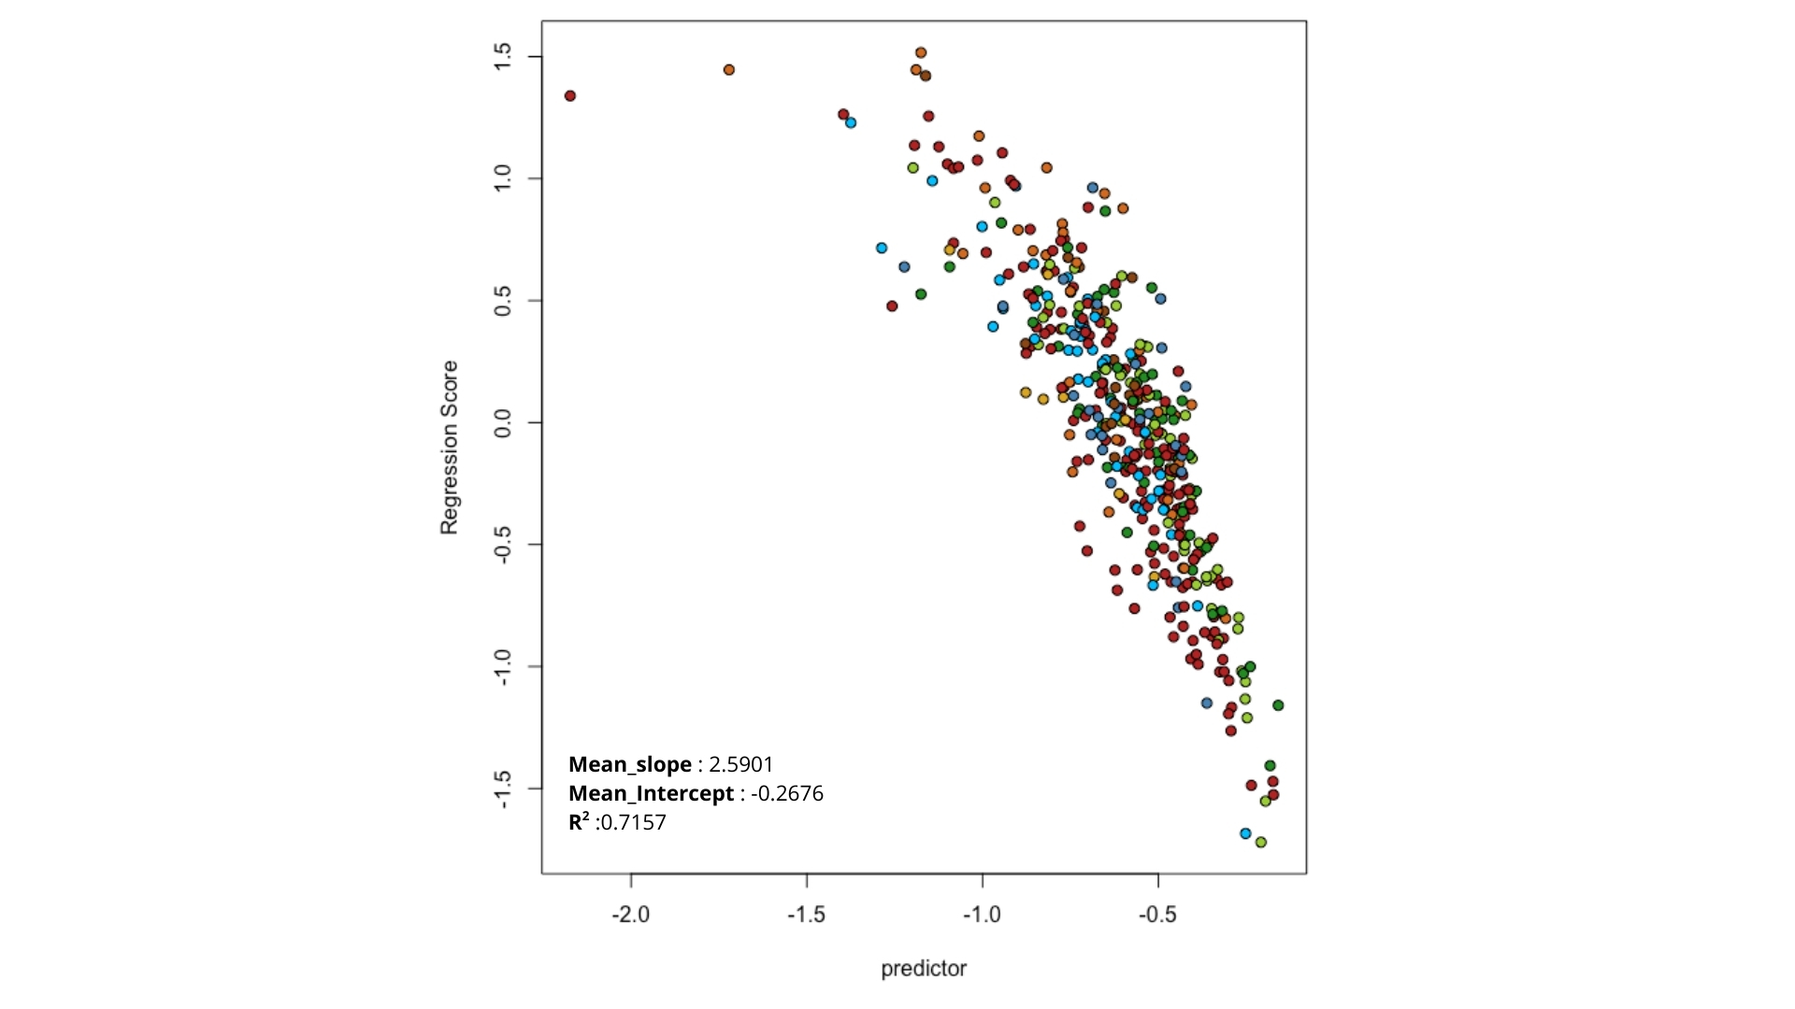

Table S8: Morphological disparity results based on Log-Shape Ratio data. Disparity was quantified as the sum of variances. The table reports the number of species (N), the observed disparity (obs), and the median value from 1,000 bootstrap replicates (bs.median).

Habitat use | N | obs | bs.median
Arboreal | 55 | 0.145 | 0.141
Semi-arboreal | 64 | 0.091 | 0.088
Aquatic | 26 | 0.405 | 0.383
Semi-aquatic | 47 | 0.148 | 0.145
Fossorial | 15 | 0.271 | 0.262
Semi-fossorial | 40 | 0.287 | 0.268
Sand | 9 | 0.094 | 0.085
Terrestrial | 177 | 0.127 | 0.127

Table S9: Comparison of evolutionary models for morphological traits across habitat groups based on Log-Shape Ratio data. The table reports the fit scores (AICc) for different models of trait evolution: Brownian Motion with a single rate (BM1), Ornstein-Uhlenbeck with a single optimum (OU1), Brownian Motion with multiple rates (BMM), and Ornstein-Uhlenbeck with multiple optima (OUM). Values for each habitat group were derived from the principal components (PCs) of the Log-Shape Ratio data. "Nc" indicates models that did not converge.

PCs | BM1 | OU1 | BMM | OUM
PC1 – PC2 | 3181.5 | 3123.9 | 3066.0 | 3020.0
PC1 – PC3 | 4129.6 | 4045.1 | 3967.0 | 3918.4
PC1 – PC4 | 5082.6 | 4934.2 | Nc | 4842.0

