**Sea of Geese**

**User Manual**

Welcome to our game – Sea of Geese! In this game, you’ll take the role of a seafaring adventurer from the University of York as you try to establish control of the campus buildings and make a lot of money in the process.

To begin, double click the executable: SeaOfGeese.exe

This will load you into the game, where you’ll be presented with a menu like this:



Press “New Game” to begin a new game or “Exit” to exit the game entirely.

Once you’ve loaded into the game, use the arrow keys to move your boat throughout the map. Collide with an enemy ship to begin combat with them.

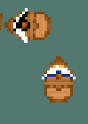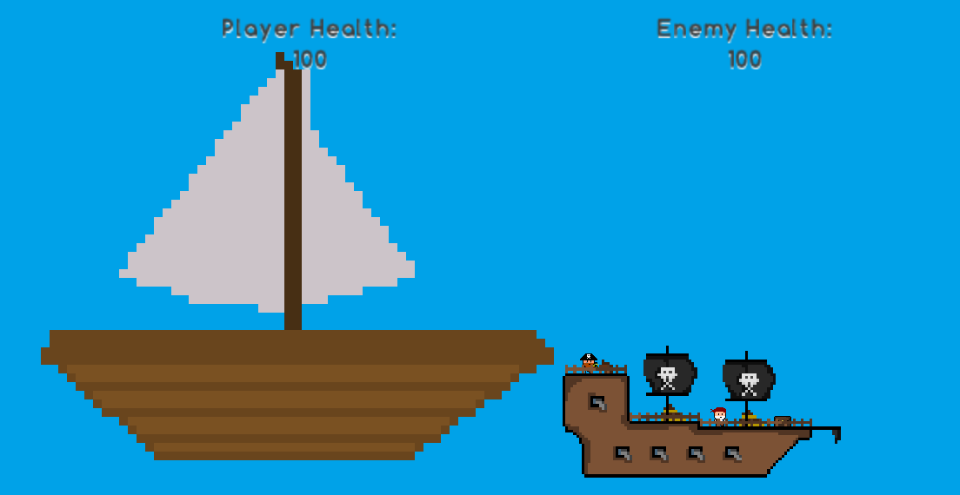

To attack, press the Attack button, which will deal damage to the enemy. Press the special attack button to make your next attack deal double damage, stacking. Watch out though, because the enemy will attack back.

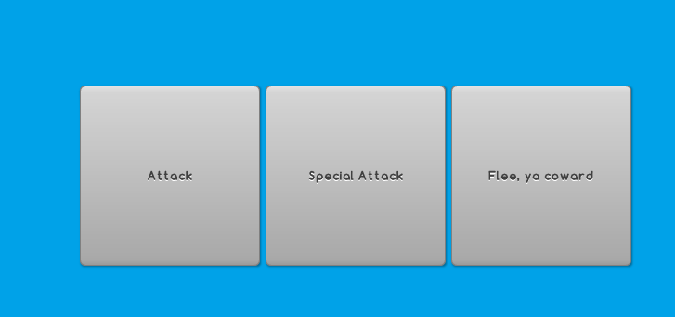

If you think that the enemy is too much for you, press “Flee” to run away from the fight.

If you lose all of your health, then it's game over for you.

The main purpose of this game is to defeat the colleges and departments located around the map. Collide with the docks on each island to begin the battle. Beating a college will turn it into a friendly college, allowing you to heal there for free by returning to it.

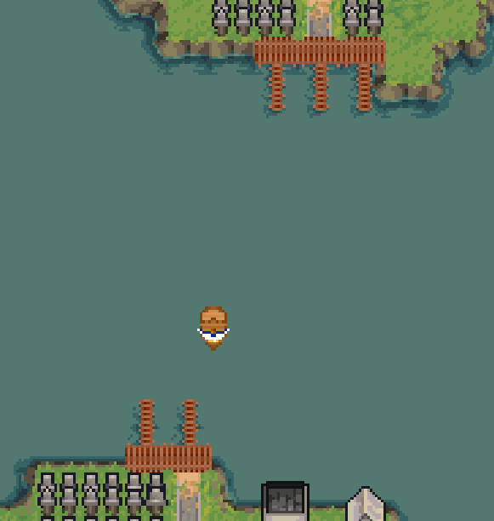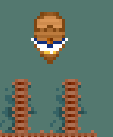

Beat the Halifax building in order to win!

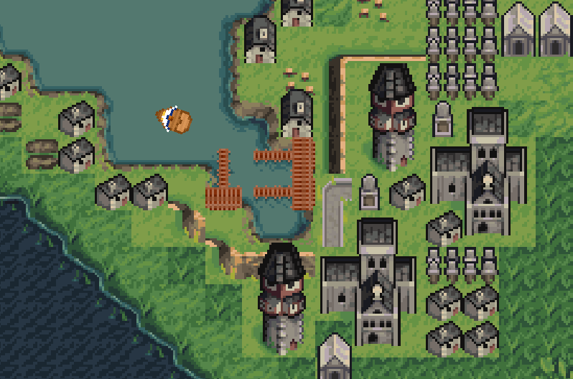

Press escape at any time in order to quit the game.