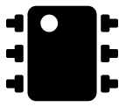
MUX DISPLAY
Version 0.1
Author: David Vitale
Getting Started

NOTE: This setup has only been tested on Windows 7 machines.

Plug the device into the computer. Assuming all correct drivers are installed, the device should get assigned a COM port. On a Windows machine, you can look at what COM port Windows assigns to the device by opening the Device Manager and finding the device. Here is a guide on how to open the Device Manager: https://technet.microsoft.com/en-us/library/cc754081.aspx
When the device manager is open, navigate to Ports as seen here:
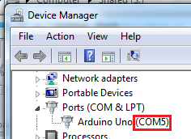

As you can see, there is only one COM port: COM5. If you see multiple COM ports, unplug your device and see which COM port goes away: that is your device. Plug it back in, and make sure no other program is using that COM device.

You are now ready to open up the MUX DISPLAY program! In the same directory as this manual, press the "mux_display" shortcut. If the program doesn't open, navigate to src/dist/ then press mux_display.exe

When the program opens, you should see a prompt similar to this:
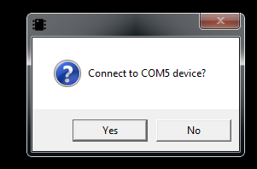

If this is the correct COM port, press "Yes". If not, press "No". You should cycle through all available COM ports until you arrive at the one you found.

The program should connect to the device, and you should see graph data populate in a few seconds. The following is a breakdown of how to operate the program:

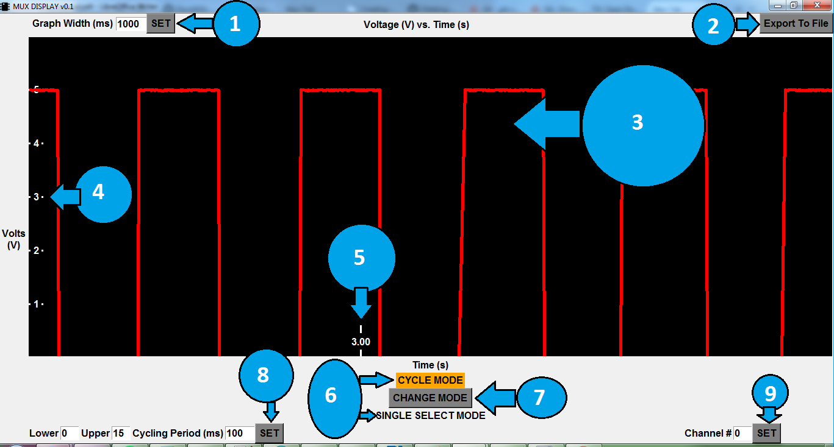
1 | "Graph Width" means how 'wide' the graph is with respect to time. It's default value, 1000 milliseconds (1 second) means that 1 second of information is being presented on the screen. To change it, change the number in the textbox and press SET to see your change enacted.  If you want to "zoom in" so you can see more details on a curve, change the value to a smaller number. If you feel the graph is moving too quickly, change the value to a higher value.
2 | The Export To File button will save all information since the start of the session into a .csv file to be opened up in Microsoft Excel or other software. Press this button, and wait until a popup message tells you if the file was written succesfully or not. If no popup message appears, check the console window for any errors raised. All files are saved in src/dist/exported_files or in the directory where the program is running.
3 | The red lines on the black background is the continually updated output information. It is voltage as a function of time.
4 | These are the voltage axis labels. As you can see, all outputs are between 0-5V volts. There is about 5mV of resolution available.
5 | These are the moving time axis labels, in seconds. The voltage is sampled somewhere between 500->1000Hz, meaning around 1ms of time resolution.
6 | This device is capable of operating in two modes: CYCLE MODE or SINGLE SELECT MODE. The highlighted selection is what mode you are currently in.  CYCLE MODE lets you choose a range of MUX inputs to cycle through at a set rate. SINGLE SELECT MODE lets you choose 1 channel at a time and stay there.
7 | Pressing this button will switch you between CYCLE MODE and SINGLE SELECT MODE. You will only be able to see the controls for what mode you are currently in, the other controls will be hidden.  Note that this button just switches between the modes, you must still press SET for your respective mode to enact the changes.
8 | Configuration options for CYCLE MODE. Change any numbers in the textboxes, then press SET to start cycling mode with those parameters.  PARAMETERS  Lower -> The 0-based lower bound of MUX inputs to cycle through  Upper -> The 0-based upper bound of MUX inputs to cycle through  For example, if Lower is 0 and Upper is 15, the program will cycle through range b0000 -> b1111.  If Lower is 7 and Upper is 12, the program will cycle through range b0111->b1100  Cycle Period (ms) -> The amount of time, in ms, to "stay" at each MUX input before cycling to the next.  For example, if Cycle Period is 100ms, the program will change inputs 10 times a second.
9 | Configuration options for SINGLE SELECT MODE. Change any numbers in the textbox, then press SET to change to start single select mode with those parameters.  PARAMETERS  Channel # -> The channel number you wish to look exclusively at.  For example, if Channel# is 3, the program will output b0011 to the multiplexer, staying on that channel until something else changes it.

Serial Only Program

You can directly connect to the device via serial and interface with it that way. Open puTTY or any other serial program, find the COM port of the device, and choose 115200 for the BAUD.

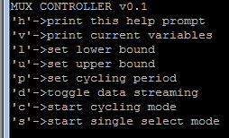
When connected, you will probably see a large stream of data characters. Send a 'd' to toggle that off. You can then press 'h' to display the help prompt.

You can't see a graph through serial, but you can controll all other functionality of the program through this menu-driven system.

Modifying the Source

All source code is included for you to make modifications as you wish.

The microcontroller program was written in C/C++ using the Arduino IDE software. It is flashed to a 328P SoC with the Arduino Bootloader on it. To modify the source code, simply download Arduino IDE, make any changes, and press the "Upload" button to see them enacted on the computer.
Download Arduino IDE -> https://www.arduino.cc/en/Main/Software
Arduino Getting Started -> https://www.arduino.cc/en/Guide/HomePage

The desktop software is written in Python3.4, using tkinter as the GUI controller and pySerial as the serial controller. To modify the source, download any version of Python 3.X. Make any modifications in your IDE of choice, then run "python mux_controller.py" to run it.
Download latest python 3.X -> https://www.python.org/downloads/

It is made into a standalone executable using py2serial (in other words, target computers don't need to have python installed for the program to work). To do that, download the Python 3.X version of py2serial. Go to the src directory, and the run this command: "py -3.4 create_standalone_executable.py py2exe". The standalone executable will be located in src/dist/mutex_display.exe. Note that you most likely need python3.4 to create the standalone executable (at the time of writing this manual).
Download python3.4 -> thttps://www.python.org/download/releases/3.4.0/
Download py2serial -> https://pypi.python.org/pypi/py2exe
This manual was created in LibreOffice.

