Title: Reduction steps of Flash Process on BMW ACSM5
Purpose : Save time & reducing the manual job required for flashing.
Approach: Script based solution for file handling and xml generation

Project BMW Airbag | Author
Project name: BMW ACSM5 | Name: David Szurovecz
DG number: D4-271599 | Segment / Dept.: CES

Distribution (persons or teams to be informed)
Name/Team: | Role: | Name: | Role:

Document Release
by review (without further approval)
by review and approval (approver(s) below if applicable)
Name: | Dept.: | Date: | Signature or ESign reference

Document History
Version | Maturity | Date | Author, Department | Main Changes (e.g. CR number)
0.2 |  | 2017-10-24 | David Szurovecz, CES-HC

Table of Content
1 Requirements and Design 3
1.1 Core Requirements: 3

Requirements and Design

Flashing with E-Sys
E-Sys needs a correct populating with data for programming and encoding. Also necessary is a core program system that provides the services for communication and logistic. For the populating with data a PDX template is necessary with populating of communication (diagnosis, protocol, connection information) for the board net system. The software logistics provides this template. In this template the developer inserts his software to be transferred in E-Sys into PDX-Charger in the form of SWEs. The SWEs are generated from SWE-Generator.
The PSdZ ("Programmiersystem der Zukunft" programming system of the future) provides the services necessary for programming and encoding. For the implementation of the communication services PSdZ uses the D-Server; for the implementation of the logistic services KIS(compatibility and information system [still not completed]) is used. The implementation on the CanCard interface happens directly by the D-Server, the implementation of the communication over Ethernet/ZGW happens by the B2V-Server (BusinessToVehicle).To realize programming and/or encoding the developer needs a TAL (transaction list) which contains at least one SWDeploy transaction (for programming SWEs) or one CDDeploy transaction (for encoding). Furthermore a FA ("Fahrzeugauftrag" vehicle order) is necessary.
E-Sys provides the TAL-Editor and FA/FP-Editor for creation and editing of TALs and FAs, besides the module TAL-Calculating for calculating a TAL from a pair of actual system installation table ("SVT-Ist") and reference system installation table ("SVT-Soll"); SVT abbreviates "System-Verbau-Tabelle". Also in the module VCM all elements (TAL, FA, SVT-Ist and SVT-Soll) of theVCM (Vehicle Configuration Management) can be read.
E-Sys provides an own module Coding for encoding. Here the codable states are detected and executed in the module TAL- Processing. This coding data can be inspected in E-Sys in CAF-Viewer (CAF=CodingApplicationFile). The coding data read out from the ECU can be inspected and changed in the format of a FDL (Function Data List) in FDL-Editor.[E-SYS Help File]
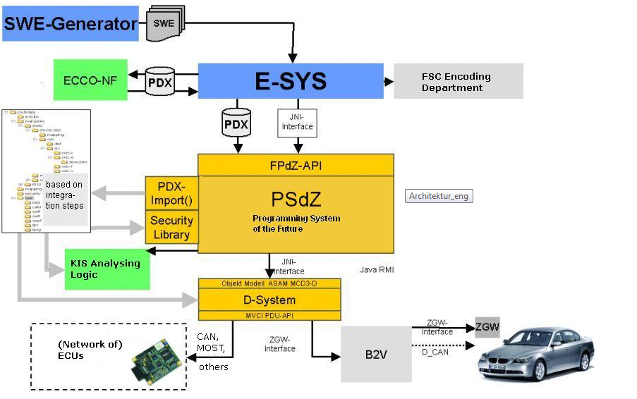
Figure 1. Architecture of Systems during Flash

Flashing Process:
The following steps required for flashing:
- Download SW and ODX template from MKS
- Copy CAF Files , SWFL,BTLD, ODX template to specified folder
- Create TAL file to the specified folder.
- Run E-SYS
- Import PSDZ,CAF-s,SWFL,BTLD & start Flashing

Preparing for flashing:
The first 3 steps from 1.2 subchapter can be easily automated. However downloading from MKS is not part of the automation process. The most time saving achievable with TAL File modifying and file managing.
However MVC-PDU-API might be works well if we are looking for further automation levels.

Requirements:
- Script must parse parameters from file name: SW version, BTLD version parameter files identifiers.
- Script must create TAL File to the specified folder.
- Script must copy the required files to the specific folder.

2. Implementation
The Function is implemented as a sheet in the Testlist Creator Application.

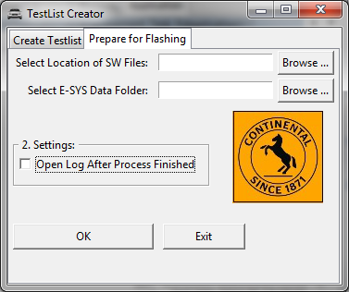
Figure 2. The Application

