**Page 108 Question 12**

1. 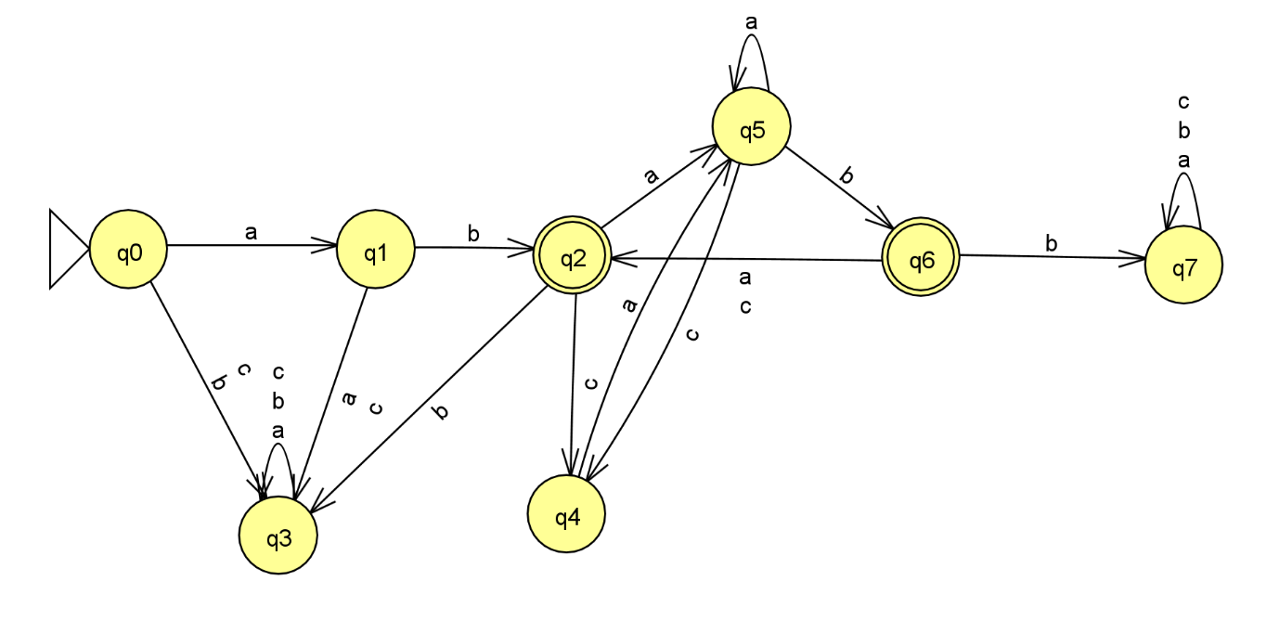

1. 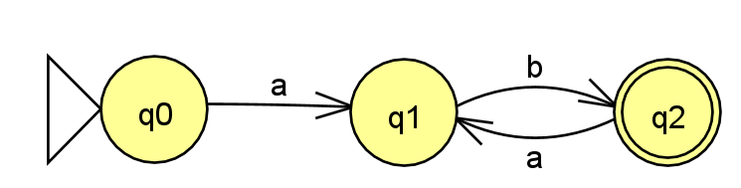

1. L1 · L2 = {}