**Page 108,Q 11:**

1. ε ∈ L1, when n,m,x = 0 -> {((ab)0 · c)0 · a0} = ε
2. abc ∈ L2, when n = 1 -> {a · b1 · c · b0} = abc
3. R(L2) = {bn-1· c· bn· a | n>0}
4. R(L3) = {w | w contains bc} and L4{w | w contains bbc} R(L3) ∩

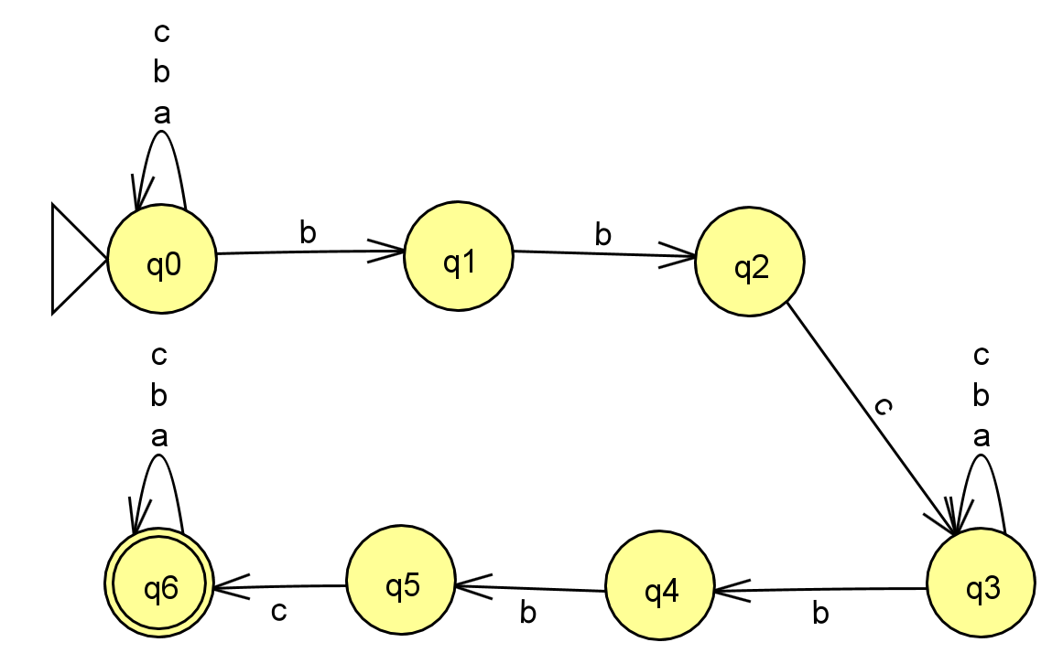L4 = R(L3) because R(L3) ⊃ L4

1. L1
3. L1 · L2 = {((ab)n · c)m · ax+1 · bk · c · bk-1 | n,k>0, m,x ≥ 0}
4. L3 = {W1 · cb · W2| W1,W2 are words from the abc{a,b,c}}, L3 · L1 = { W1 · cb · W2 · ((ab)n · c)m · ax |n>0, m,x ≥ 0, W1,W2 are words from the abc{a,b,c}}