# Institute of Technology Tallaght Dublin

**Department of Computing**



**CA Title:**  Analysing usage of a single processor on a Linux VM

**Module:** Enterprise Applications Architecture

**Lecturer:** John Burns

**Student Name:** David Kiernan

**Student Number:** X00093830

**Due Date:**  19th December 2016

**Operating System Used**

The Operating system that was used was the “Fedora (64 bit) that was provided in the module.

It was configured in the following format

* Base Memory of 5011 MB
* Processor 1 CPU
* Execution Cap 100 %

Hard disk was SATA Port 0 with the following

* Format was Normal(VMDK)
* Virtual size: 19.25 GB
* Actual size: 9.73 GB

Which was dynamically allocated storage.

The loadtest.C was ran on the single CPU provided, in the runtest.sh it will only run on a single processor even if the machine is using a multi-core processor.

**Utilisation (ui)**

The Utilisation of the CPU is the busy time of the CPU. It can be in the form of a percentage or in the form **0.0 < ui < 1.0**

This means that the utilisation of the resource must be between value of 0.0 and 1.0 but can never be greater than 1.0 or less than 0.0.

To calculate ui: [(100 – idle) / 100]

This is the format that will be displayed in this report.

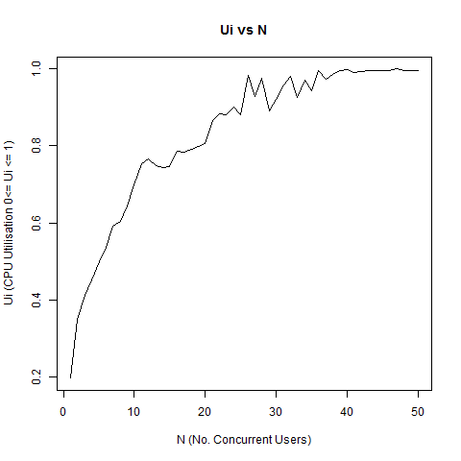

**Sample output**

The follow table is just a sample of what the image above contains

|  |  |  |  |  |
| --- | --- | --- | --- | --- |
| Co (Transactions) | N  (concurrent users) | CPU Idle  % | Ui %  100 – CPU Idle | Ui  Ui % / 100 |
| 41 | 1 | 80.38 | 19.62 | 0.1962 |
| 283 | 25 | 11.90 | 88.10 | 0.8810 |
| 327 | 35 | 5.72 | 94.28 | 0.9428 |
| 348 | 49 | 0.40 | 99.60 | 0.9960 |

**Summary**

This is a summary of the ui

|  |  |  |  |  |  |
| --- | --- | --- | --- | --- | --- |
| Min | 1st Qu. | Median | Mean | 3rd Qu | Max |
| 0.1962 | 0.7509 | 0.8960 | 0.8301 | 0.9904 | 1.0 |

**Analysis**

N is the number of concurrent users, and as N increases, the more the utilisation of the resource occurs. CPU saturation is starting, when N is at 20, the utilisation of the resource is approx. 0.80 which is 80% and only increases and when N is 36 the utilisation never drops below 0.99 which is 99% of the resource is being used.

This tend occurs due to only using a single CPU to process the information, thus when N is at twenty, there is twenty users of this CPU at a single time, so it’s processing all the transactions for the twenty users.

**Throughput (xo)**

This is the system throughput, the amount of transactions per second that the system can do.

It calculated: throughput = Number of Transactions / Time

Where Time is the length of the observation period.

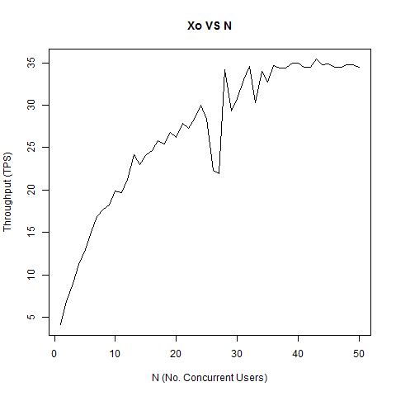

**Sample output**

The follow table is just a sample of what the image above contains

|  |  |  |
| --- | --- | --- |
| Co (Transactions) | Time in seconds | Throughput  Xo |
| 41 | 10 | 4.1 |
| 283 | 10 | 28.3 |
| 327 | 10 | 32.7 |
| 348 | 10 | 34.8 |

**Summary**

This is a summary of the xo

|  |  |  |  |  |  |
| --- | --- | --- | --- | --- | --- |
| Min | 1st Qu. | Median | Mean | 3rd Qu | Max |
| 4.10 | 22.00 | 28.30 | 26.77 | 34.50 | 35.40 |

**Analysis**

The system has a Max throughput of 35.40 tps, meaning that for this system no matter what value N is, the throughput saturates at 35.40 transactions per second.

The mean average of is 26.77 tps, meaning that on average the system can deal with 26.77 transactions per second, which depending on the value of N is good if N is low but if N if high like 50, then there will be a delay for the users of the system as it process each user transaction.

Between N being at 26 – 27 the throughput drops to approx. 23 tps, this could mean that there was not that many transactions going through the system.

**Service Demand (Di) Di  = Ui / Xo**

It is a measure of how much time in seconds that one transaction requires of a specific resource.

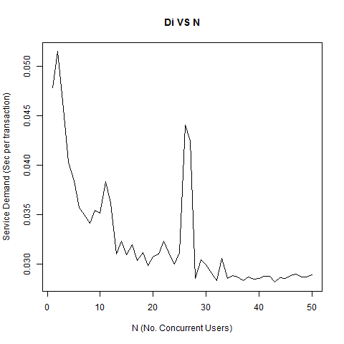

**Sample output**

The follow table is just a sample of what the image above contains

|  |  |  |
| --- | --- | --- |
| Ui | Xo | Di |
| 0.1962 | 4.1 | 0.0478 |
| 0.5919 | 16.9 | 0.0350 |
| 0.9970 | 34.9 | 0.0287 |
| 1.0 | 34.5 | 0.2899 |

**Summary**

This is a summary of the ui

|  |  |  |  |  |  |
| --- | --- | --- | --- | --- | --- |
| Min | 1st Qu. | Median | Mean | 3rd Qu | Max |
| 0.02816 | 0.02871 | 0.03048 | 0.3255 | 0.03480 | 0.05150 |

**Analysis**

The trend of the graph is that as N increases the Service Demand time decreases, this is due to the CPU serving different concurrent users so it may round robin, if the CPU is doing round robin that it will take longer to complete a single transaction.

At its fastest the service demand take 5150 milliseconds or 0.05150 second to complete the transaction.

When N is at approx. 42 due to round robin it is taking approx. 0.02816 seconds to complete the transaction.

There is a spike in which the Service Demand takes approx. 0.0441 seconds to complete the transaction when N is at 26 to 27. This could be due to transaction being small enough that the CPU processes quickly.

**Interactive Response Time (R)**

The interactive response time was calculated manipulating Little’s Law (R = N / Xo)

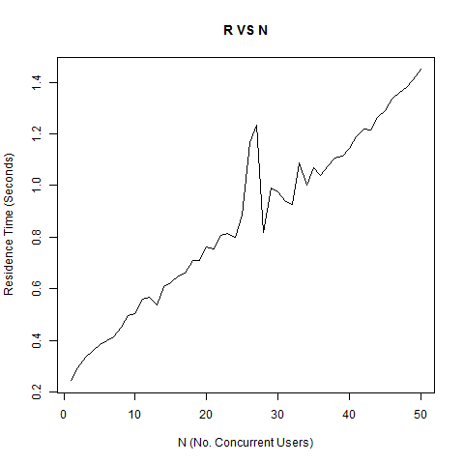

**Sample output**

The follow table is just a sample of what the image above contains

|  |  |  |
| --- | --- | --- |
| N | Xo | Di |
| 1 | 4.1 | 0.2439 |
| 31 | 33.0 | 0.9394 |
| 35 | 32.7 | 1.0703 |
| 50 | 34.5 | 1.4493 |

**Summary**

This is a summary of the R

|  |  |  |  |  |  |
| --- | --- | --- | --- | --- | --- |
| Min | 1st Qu. | Median | Mean | 3rd Qu | Max |
| 0.2439 | 0.5767 | 0.8511 | 0.8620 | 1.1360 | 1.4490 |

**Analysis**

Response time is the time it takes for the request to be answered by the system.

It is almost a linear progression (straight Line) as N is increased.

When N is approx. 25 to 27 there is a surge in the response time, this could be due to switching the processing of transactions which were larger transactions or that there was an increase in the utilisation of the CPU that caused this.

Thus it could be said that as the response time is dependent on both the number of concurrent users and the utilisation of the CPU, so if either of these increase or decrease, so too will the response time.