

**Caliber Athena**

Contents

1 Caliber Athena Extractor 3

1.1 Description 3

1.2 Pre-requistes 3

1.3 Database Schema 4

1.3.1 SQL Query Example 4

1.4 Installation 5

1.5 Configuraton 5

1.5.1 Configure Batch File Information 6

1.5.2 Example of Email: 9

1.5.3 Versant Database User 11

1.6 First Extraction 11

1.6.1 Creating SQL Tables 11

1.6.2 Tune Extraction 11

1.6.3 Running for first time 12

1.7 Schedule the Extraction 13

1.8 Disaster Recovery 13

1.8.1 Single Project Extraction 13

1.9 Log Files 13

1.9.1 Extraction Summary Log 13

1.9.2 Project Extraction Log 15

1.10 Additional Extractions 15

1.10.1 Baseline Information Report 15

1.10.2 Map \ Share Extraction 15

1.10.3 Visualize Extraction 16

1.10.4 Silk Central Extraction 16

1.10.5 User Defined Attributes Extraction 16

1.10.6 User Access Extraction 16

1.11 Additional Tool 17

1.11.1 Import Project 17

1.12 Database Maintenance 18

# Caliber Athena Extractor

## Description

The Caliber Athena Extractor is a multithreaded extraction tool that extracts data from the Caliber Versant Database to a SQL Server. The extractor uses the Caliber SDK and the Java Versant Interface.

The extractor will extract only the tip revisions of requirement. The tip revision is the current requirement version referenced by the baseline.

The extractor can be configurated to extract the data for the current baselines only or for all baseline.

The first time the extractor is ran all projects will be extracted. Subsequent extractions will extract data from the last extraction time (Delta Extraction).

## Pre-requistes

The application requires the following:

* SQL Server Instance to connect to
* Caliber Server Installed
* StarTeam 13.0 SDK or later
* JRE installation. 64 bit for the Caliber 64 bit server or 32 bit for the Caliber 32 bit server
* Copy of the 64 bit or 32 bit jvi80fe.dll to copy into the Caliber Versant instance e.g. C:\Borland\CaliberRMServer\Versant\8_0_2\NT\Bin
* [Microsoft Visual C++ 2010 Redistributable Package (x64)](http://www.microsoft.com/en-us/download/details.aspx?id=14632)

## Database Schema

The schema below shows how the data is organsied. The tree table always controls the query as it refers to the requirement linked to a baseline. The ProjectBaseline is a View created during the first extract, this maintain a link table between the Project_INFO table and the Baseline_INFO table.

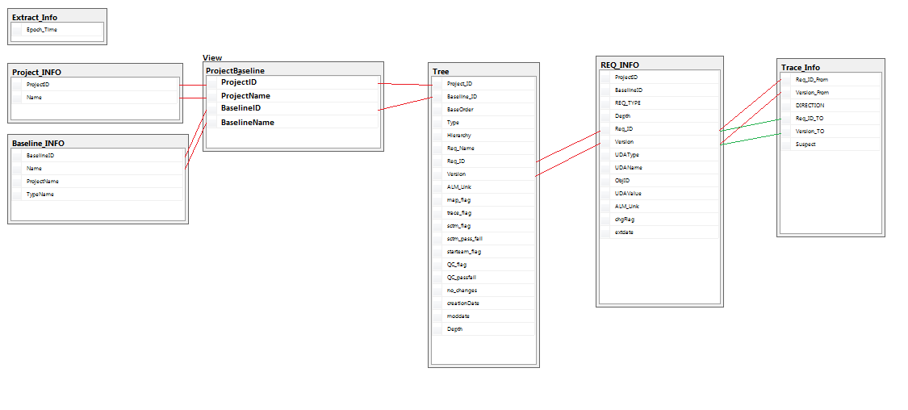

### SQL Query Example

Example SQL to report on a project baseline.

SELECT

Tree.*,ProjectBaseline.*,REQ_INFO.*

FROM Tree

JOIN ProjectBaseline on Tree.Project_ID=ProjectBaseline.ProjectID

AND

Tree.Baseline_ID=ProjectBaseline.BaseLineID

JOIN

REQ_INFO on REQ_INFO.Req_ID=Tree.Req_ID

AND

REQ_INFO.Version=Tree.Version

WHERE ProjectBaseline.ProjectName='Address Book'

AND

ProjectBaseline.BaselineName='Current Baseline'

## Installation

The files for Caliber Athena come as a zip file. The files require to unzipped into the C drive of the target machine i.e. C:\CaliberRM_Athena

## Configuraton

The Extractor AthenaBatchCreator tool enable the creation and configuation of all batch files. The AthenaBatchCreator is located in C:\CaliberRM_Athena\CaliberRM_Athena_Creator x86

Run the application by double clicking the AthenaBatchCreator.jar. The Following dialogue should appear

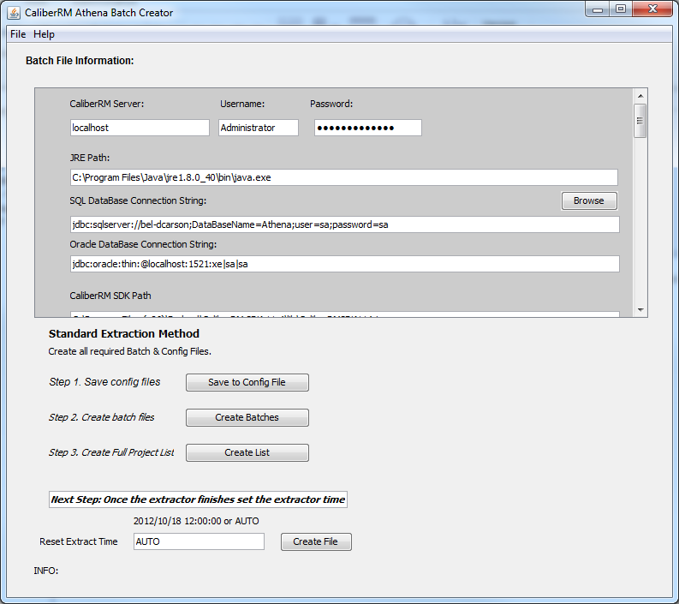

### Configure Batch File Information

Enter the required fields for the Extractor by browsing to the file or filling in the details. If the fields is unknown leave as is.

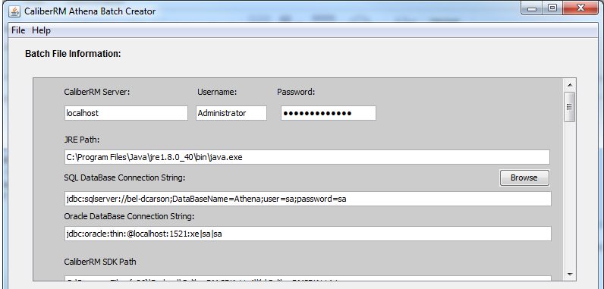

#### Save Configuration

Save the configuration by clicking the "Save to Config File" button

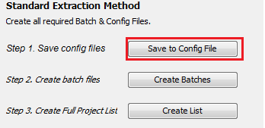

#### Create Batch File

Create batch file by clicking the "Create Batches" Button

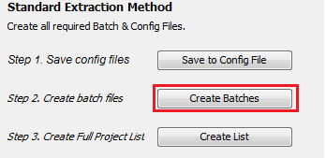

#### Create Project List

Create project list if required by clicking the "Create List" Button

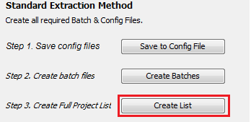

N.B. This is only required if the "ignore project list" checkbox is not checked

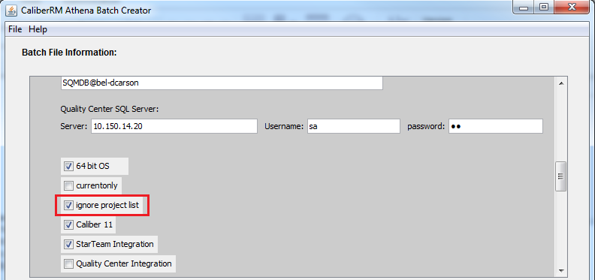

#### Create Custom Extract Time

The Extraction time can be set via the "Extractor AthenaBatchCreator tool" tool. The AthenaBatchCreator is located in C:\CaliberRM_Athena\CaliberRM_Athena_Creator x86.

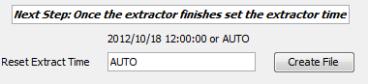

Normally this is set to Auto. This means when the "ResetExtractTime64.bat" file is ran the extraction time is set to start of the current day. All changes from midnight yesterday to now will be extracted.

The extraction time can be set to any date using the format "yyyy/MM/dd hh:mm:ss". All changes from that datetime to now will be extracted.

#### Excluding Projects

To exclude any project from the extract the project name requires to be entered into the Exclusion list file. The "Exclusion.txt" file is located in "C:\CaliberRM_Athena"

#### Silk Central Projects

To include any Silk Central Projects entered into the SCTMprojects.txt file the project names. The file is located in "C:\CaliberRM_Athena"

#### Email Notification

Email Notification for the extraction is setup using a text file located "C:\CaliberRM_Athena" called "emailconfig.txt". This contains all the required details to send a summary email once the extraction finishes

<email server>

<user name>

<password>

<port>

<from email address>

<verification (True or False)>

<List of email addresses (comma delimited list)>

If the username and password are not required, please put in blank lines and set the verification to false

### **Example of Email:**

**Extraction Requirement Change Summary**

|  |  |  |  |  |  |  |  |  |
| --- | --- | --- | --- | --- | --- | --- | --- | --- |
| **Project** | **Baseline** | **No. Reqs Before** | **No. Reqs Total** | **Total Updated** | **Total New** | **% Unchanged** | **% Created** | **Extraction Date** |
| X100 Droid | Current Baseline | 76 | 76 | 8 | 0 | 89.47 | 0.00 | 2015-09-09 16:53:53 |
| X100 Droid | Deleted View | N/A | 7 | N/A | N/A | N/A | N/A | 2015-09-09 16:53:53 |
| X100 Droid | Test | N/A | 79 | N/A | N/A | N/A | N/A | 2015-09-09 16:53:53 |
| Order Processing | Current Baseline | 126 | 126 | 10 | 0 | 92.06 | 0.00 | 2015-09-09 16:53:53 |
| Address Book | Current Baseline | 16 | 17 | 1 | 1 | 94.12 | 5.88 | 2015-09-09 16:53:53 |

Product Version: 11.4 (11.4.4.257)  
Started: 11/09/2015 10:17:32  
Connected  
1441814033  
Extract_Time 2015/09/09 16:53:53  
--->1441814033  
No.of Versant objects to query40  
Length with duplicates 34  
Length without duplicates 5  
[101,250, 101,102, 105,110, 103,105, 101,101]  
1441814033  
Number of Project Baselines: 5  
[1] FINISHED-->:Address Book~105~,Current Baseline~110~ Tree Regeneration Complete! 0 2015/09/11 10:17:34  
[2] FINISHED-->:X100 Droid~101~,Test~250~ Tree Regeneration Complete! 1 2015/09/11 10:17:35  
[3] .FINISHED-->:Order Processing~103~,Current Baseline~105~ Tree Regeneration Complete! 1 2015/09/11 10:17:36  
[4] FINISHED-->:X100 Droid~101~,Current Baseline~101~ Tree Regeneration Complete! 1 2015/09/11 10:17:37  
[5] FINISHED-->:X100 Droid~101~,Deleted View~102~ Tree Regeneration Complete! 0 2015/09/11 10:17:39  
Finished all threads  
Finished monitoring threads: 11/09/2015 10:17:39  
  
Cleaning up any duplicates  
Cleaned duplicate projects  
Cleaned duplicate Baselines  
Cleaned duplicate Requirement info  
Cleaned duplicate Trace info  
  
SUMMARY  
------------------------------------------------------------------------------------  
Extraction Finished: 5/5 []  
Started: 11/09/2015 10:17:32  
Finished: 11/09/2015 10:17:39  
Overall Seconds: 6  
------------------------------------------------------------------------------------

#### Enable & Disable Email Notification

Modify the GetCheckPointDelta.bat file

To turn off email notification change EMAIL to NOEMAIL

To turn on email notification change NOEMAIL to EMAIL

### Versant Database User

The user used to query the Versant Database requires to be configured. This requires to be the same as the Caliber user as configured for the Batch files.  i.e. same userid and password

This is achieved using the following commands run from a command prompt

dbuser -add -n admin SQMDB

## First Extraction

### Creating SQL Tables

The tables require to be created in the SQL Database. This is achieved by running the "CreateDropTables.bat" file located in "C:\CaliberRM_Athena\Batches64"

#### SQL Indexes

To help with performance the following indexes are created by the CreateDropTables.bat file

CREATE INDEX Tree_Index  
ON Tree (Project_ID,Baseline_ID,Req_ID,Version)

CREATE INDEX Req_Index  
ON REQ_INFO (ProjectID,BaselineID,Req_ID)

CREATE INDEX Req_Test  
ON REQ_INFO (Req_ID,Version)

### Tune Extraction

As the extractor is a Multithreaded appplication the number of threads that the application creates can be set to increase performance. By default this is set to 5. This figure may need to be increased or reduced depending on the amount of RAM available on the machine.

The "GetCheckPointDelta.bat" file located in directory "C:\CaliberRM_Athena\Batches64" will need to be modified by changing the 3rd parameter marked in red

"C:\\Program Files\\Java\\jre1.8.0_40\\bin\\java.exe" -classpath "C:\\Program Files (x86)\\Borland\\CaliberRM SDK 11.4\\lib\\CaliberRMSDK114.jar;C:\\Program Files\\Borland\\StarTeam SDK 14.0\\lib\\starteam140.jar;C:\\CaliberRM_Athena\\sqljdbc_4.0\\enu\\sqljdbc4.jar;c:\CaliberRM_Athena\Classes64\jvi80.jar;.\classes;c:\CaliberRM_Athena\Classes64" MultiThread.MultiThreadPool jdbc:sqlserver://localhost;DataBaseName=Athena;user=sa;password=sa [SQMDB@localhost](mailto:SQMDB@localhost) 5 All 10 "C:\CaliberRM_Athena\Exclusion.txt" localhost Administrator Administrator FirstTime noRemoveDups C:\CaliberRM_Athena C:\CaliberRM_Athena\Batches64\ReloadBaselineMaster.txt

### Running for first time

To start the extractor for the first time double click on the "GetCheckPointDelta.bat" file located in directory "C:\CaliberRM_Athena\Batches64".

The first extract will take some time depending on the size of the database. Typically a 100Gb database will take approximately 2 - 3 days to extract depending on the number of threads set for the extraction and the amount of data stored in the requirements i.e. large description, large number of UDAs etc..

Once the extraction is finished the extraction time is updated in the database. This is set to the time the extraction started.

Typically the first extraction is done on a staging system due to the duration of the extraction and then pointed to the production system. The extraction time may need set after this extraction has finished, please see [Setting Extraction Time](alm://caliberrm!BEL-DCARSON.microfocus.com_20000_129/513;ns=requirement)

## Schedule the Extraction

The extraction can be scheduled through the Windows Task Scheduler.

<http://windows.microsoft.com/en-gb/windows/schedule-task#1TC=windows-7>

## Disaster Recovery

If the extraction fails for any reason the extraction can be started again from the last known successful extraction. To achieve this the extraction time requires to be updated. See requirement [Create Custom Extract Time](alm://caliberrm!BEL-DCARSON.microfocus.com_20000_129/513;ns=requirement)

### Single Project Extraction

To extract the data for a single project the "ReloadBaselineMaster.txt" can be copied and renamed as "ReloadBaselineMaster.bat". The file will then need to be modified replacing the "projID" text with the Project ID and the "baseID" text with the Baseline ID for the Project, Baseline you wish to extract.

## Log Files

### Extraction Summary Log

After each extraction an extraction summary is created. The file name is in the format

"ExtractLogDAY-MONTH-YEAR_HOUR_MINUTE_SECOND.log

The file is located in "C:\CaliberRM_Athena\logs" directory

The file contains all the summary information from the multithreaded extraction.

Example of File:

Started: 31/07/2015 22:47:28  
Connected  
0  
Extract_Time 1970/01/01 01:00:00  
First Time ,1970/01/01 01:00:00  
No of Projects: 7  
Length with duplicates 20  
Length without duplicates 20  
[103,105, 105,158, 102,103, 129,237, 101,101, 105,157, 103,113, 105,155, 102,117, 107,121, 105,116, 102,112, 103,109, 107,168, 105,110, 105,236, 104,107, 105,156, 101,235, 107,119]  
0  
Number of Project Baselines: 20  
FINISHED-->:Address Book(105),Submitted(158) Tree Regeneration Complete! 3  
FINISHED-->:Caliber Athena(129),Current Baseline(237) Tree Regeneration Complete! 4  
FINISHED-->:Address Book(105),Test 3(157) Tree Regeneration Complete! 0  
FINISHED-->:Address Book(105),Test1(155) Tree Regeneration Complete! 0  
FINISHED-->:Automated Teller Machine(102),a1(117) Tree Regeneration Complete! 2  
FINISHED-->:Automated Teller Machine(102),Current Baseline(103) Tree Regeneration Complete! 13  
FINISHED-->:Address Book(105),New Project Baseline(116) Tree Regeneration Complete! 0  
FINISHED-->:X100 Droid(101),Current Baseline(101) Tree Regeneration Complete! 20  
FINISHED-->:StarTeam Real Time Log Parser(107),Sprint 1(121) Tree Regeneration Complete! 9  
FINISHED-->:Automated Teller Machine(102),Version 1.0(112) Tree Regeneration Complete! 4  
FINISHED-->:Order Processing(103),Initial Requirements(109) Tree Regeneration Complete! 1  
FINISHED-->:Address Book(105),Sprints(236) Tree Regeneration Complete! 0  
FINISHED-->:Address Book(105),Current Baseline(110) Tree Regeneration Complete! 2  
.FINISHED-->:Order Processing(103),Current Baseline(105) Tree Regeneration Complete! 27  
FINISHED-->:Company Standards(104),Current Baseline(107) Tree Regeneration Complete! 1  
.FINISHED-->:Order Processing(103),Version 1.0(113) Tree Regeneration Complete! 21  
FINISHED-->:Address Book(105),Test 2(156) Tree Regeneration Complete! 0  
FINISHED-->:X100 Droid(101),Submitted3(235) Tree Regeneration Complete! 1  
FINISHED-->:StarTeam Real Time Log Parser(107),Sprint 2(168) Tree Regeneration Complete! 8  
FINISHED-->:StarTeam Real Time Log Parser(107),Current Baseline(119) Tree Regeneration Complete! 13  
Finished all threads  
Finished monitoring threads: 31/07/2015 22:48:12

Remove Duplicates not set!

SUMMARY  
------------------------------------------------------------------------------------  
Extraction Finished: 20/20 []  
Started: 31/07/2015 22:47:28  
Finished: 31/07/2015 22:48:12  
Overall Seconds: 44  
------------------------------------------------------------------------------------

### Project Extraction Log

Each project extracted creates its own log on the "C:\CaliberRM_Athena\logs" directory in the following format

"DeltaProgressPROJECTID_BASELINEID.txt"

Example of File Output:

Reloading Tree Called  
Processing 7 Objects  
Reloading Tree Finished

## Additional Extractions

These additional extraction can be scheduled to run in addition to the main extraction. An example batch file "UPDATEALL64.bat" showing how to run a number of extraction together can be found in the "C:\CaliberRM_Athena" directory

### Baseline Information Report

This summaries the Baseline information and requires to be run after the extraction. This will create the "Baseline_Creation_INFO" in your database. Please see example below.

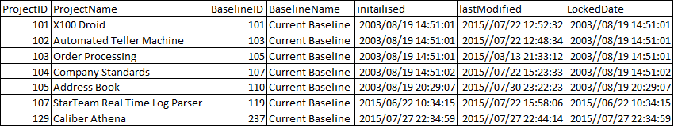

The Batch file "BaselineInfoReport.bat" creates this report in the "C:\CaliberRM_Athena\Batches64" directory

### Map \ Share Extraction

This updates the database with map and share information. This is controlled by the "MapShare64.bat" file located in the "C:\CaliberRM_Athena\Batches64" directory.

### Visualize Extraction

This updates the database with the Visualization information. This is controlled by the "ExtractViz.bat" file located in the "C:\CaliberRM_Athena\Batches64" directory.

N.B. This application uses the MManager account

### Silk Central Extraction

This updates the database with the SCTM trace information. This is controlled by the "SCTMTraces64.bat" file located in the "C:\CaliberRM_Athena\Batches64" directory.

### User Defined Attributes Extraction

This updates the database with the User Defined Attribute (UDA) information. This is controlled by the "UDAExtract64.bat" file located in the "C:\CaliberRM_Athena\Batches64" directory.

This create the UDA_INFO table

### User Access Extraction

This updates the database with the Project Group Assignment for All Projects. This is controlled by the "UserAccess64.bat" file located in the "C:\CaliberRM_Athena\Batches64" directory.

This create the User_Access table

## Additional Tool

### Import Project

The extracted data can be used to create new projects in Caliber. The project can be based on a current or custom baseline. This is controlled by the "ImportProject.bat" file located in "C:\CaliberRM_Athena\Batches64".

The parameters marked red require to be modified i.e. target project name, target baseline name, new project name

"C:\\Program Files\\Java\\jre1.8.0_40\\bin\\java.exe" -classpath "C:\\Program Files (x86)\\Borland\\CaliberRM SDK 11.4\\lib\\CaliberRMSDK114.jar;C:\\Program Files\\Borland\\StarTeam SDK 14.0\\lib\\starteam140.jar;C:\\CaliberRM_Athena\\sqljdbc_4.0\\enu\\sqljdbc4.jar;c:\CaliberRM_Athena\Classes64\jvi80.jar;;.\classes;c:\CaliberRM_Athena\Classes64" importProject localhost Administrator Administrator jdbc:sqlserver://bel-dcarson;DataBaseName=Athena;user=sa;password=sa "Address Book" "Current Baseline" "Address Book2"

N.B. The requirement type requires to exist in the Caliber server

**Batch file parameters:**

<Caliber Server>

<Username>

<Password>

<SQL connection string>

<target project>

<target baseline>

<new project name>

## Database Maintenance

As the extractor is multi threaded application, under certain circumstances duplicate records can be created. The duplicates can be remove by running the following SQL statements

**Remove Duplicate Projects**

DELETE Project_INFO FROM Project_INFO

LEFT OUTER JOIN

(SELECT MIN(RowId) as RowId, ProjectID, Name FROM Project_INFO GROUP BY ProjectID, Name) as KeepRows ON Project_INFO.RowId = KeepRows.RowId WHERE KeepRows.RowId IS NULL

Alter TABLE Project_INFO ADD RowId int not null identity(1,1) primary key

**Remove Duplicate Requirements**

DELETE [REQ_INFO] FROM [REQ_INFO]

LEFT OUTER JOIN

(SELECT MIN(RowId) as RowId, Req_ID, Version, UDAName, UDAValue FROM [REQ_INFO] GROUP BY Req_ID, Version, UDAName, UDAValue) as KeepRows ON [REQ_INFO].RowId = KeepRows.RowId WHERE KeepRows.RowId IS NULL

Alter TABLE [REQ_INFO] ADD RowId int not null identity(1,1) primary key